JavaParser1.5:
- A Java 1.5 Parser with AST generation and visitor support. The AST records the source code structure, javadoc and comments. It is also possible to change the AST nodes or create new ones to modify the source code.
HomePage: https://code.google.com/p/javaparser/
Issue46: https://code.google.com/p/javaparser/issues/detail?id=46
Problem: Using javaParser to parse a java file with more than 1 class comment, some comments are missing in the generated compilation unit.
What steps will reproduce the problem?
1. Create a Java like this:
/*
* Comment 1
*/

/*
* Comment 2
*/

/*
* Comment 3
*/

package net.perfectbug.test;

public class Test {

}
2. Parse it with JavaParser.
3. Use CompilationUnit.toString() to get the parsed source code.

What is the expected output? What do you see instead?
Expected:
All comments should be print.
Observation:
Not comments are print.
And CompilationUnit.comments only contains comment 3. It doesn't contains neither comment 1 nor comment 2.

Run ZiYuan:
- Prepare:
From the description, add a new test for the issue:
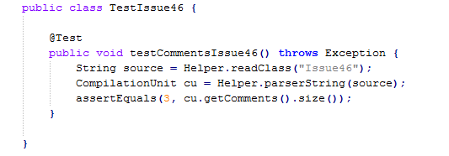
Then we select some existing relevant test cases in the JavaParser source code (selecte class japa.parser.ast.test.TestDumper.java).
Parameters for running:
TESTCASES = japa.parser.ast.test.TestDumper.testJavadoc, japa.parser.ast.test.TestDumper.testComments, japa.parser.ast.test.TestDumper.testClassComments, japa.parser.ast.test.TestDumper.testDumpVisitor, japa.parser.ast.test.TestIssue46.testCommentsIssue46
ANALYZING_PACKAGES = japa.parser (the highest level of JavaParser package hierachy)
And other parameter (ex: classpaths,..) in order for ZiYuan to execute the tests.
- Process & Runing result:
  - Fault localization:
First of all, run all testcases and get failure traces from fail tests.
Then basing on these failure traces, a dynamic slicer (javaSlicer) will be applied to trace back all relevant statements of the bug in the source code.
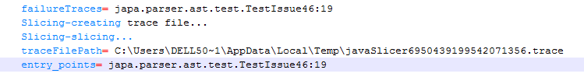
=> we get 312 lines of 7 classes (including test class, because we only filter by package name)
japa.parser.ASTParserTokenManager: 158
japa.parser.ASTParser : 108
japa.parser.JavaCharStream: 31
japa.parser.ast.test.Helper : 5
japa.parser.JavaParser: 5
japa.parser.ast.CompilationUnit: 2
japa.parser.ast.test.TestIssue46 : 3
After slicing, all test cases will be executed and coverage tool (jacoco) is used for recording execution coverage data of all classes appeared in slicing result.
From the execution coverage data, suspiciousness of each above line will be calculated based on selected algorithm for fault localization (JACCARD, TARANTULA, OCHIAI).
=> suspiciousness of those lines are in the range: {1.0, 0.8, 0.66, 0.57, 0.5}
2.2. Machine Learning:
At this stage, from the suspiciousness result, we decide which lines we should learn and what to learn. Then from that, a breakpoint will be created for each selected line with needed information (class, lineNumber, variables). And in order to collect executing data for variables at each breakpoint, we run all testcase in debug mode. After the execution, all variable values for each breakpoint will be divided into pass/fail groups (according to test result) which will be passed to svm to learn.
2.2.1. Init breakpoints from suspiciousness result:
- Select lines from highes ranks:
By default, we select lines with suspiciousness in first 3 ranks (17 lines):
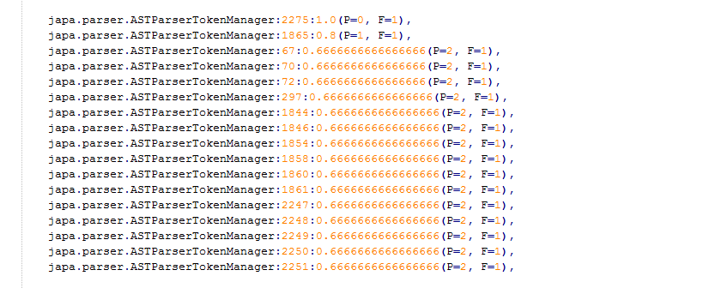
- Group continuous lines:
To avoid the case that we might learn same thing for multiple line, we group continuous lines and only keep the first and last breakpoint . The result after grouping, we keep these 14 lines:
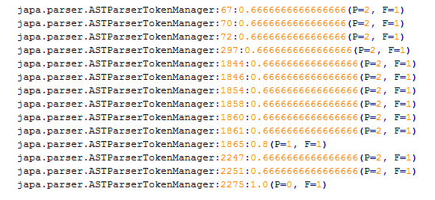
- Collect variable to learn: only variables appearing in the statement at the current line will be collected to learn.
2.2.2. Collect variable runtime values at each breakpoint by running testcases in debug mode:
First of all, the analyzed classes will be slightly modified by adding some dummy statements and new locations will be calculated to add breakpoints to make sure that we can collect all variable values after statements at selected lines are executed.
- Collect value:
+ Number
+ String: collect length, isEmpty
+ Array: length, array element
+ Object: isNull, object fields (restricted by retrieveLevel)
- From collected values of each breakpoint:
+ If the data only contains pass values, it means the line is only covered by pass testcases: we consider the line is not a bug.
+ If the data only contains fail values, it means the line is only covered by fail testcases: this line is likely a bug.
+ Otherwise, all variables will be treated as features to learn, value in passed value list will be added to the datapoint with category = POSITIVE, and value in failed value list will be added to the datapoint with category = NEGATIVE.
2.2.3. Learning
- For each breakpoint:
+ Boolean value: all boolean variable will be learned separately first. If we have a nice result, then we keep the predicate and stop learning.
+ Number value: apply feature selection and selective sampling to learn.
This implementation iterates on all possible subsets of 1, 2 to n features getting from the existing features. It then uses an instance of the default SVM Machine implementation to learn on the subset. If it gets a predicate with high accuracy, the machine tries to tune the logic using selective sampling until we cannot get any better predicate. At any point, it get a stable predicate with high accuracy, the proccess will stop, and the predicate is returned.
- Selective sampling:
From the current divider, we apply linear solver to select new data for learning features, and also adding more new samples by randomly selecting a value for some features (the value is in the range calculated from orginal collected data) and applying linear solver to get value for other features.
The selected sample then will be verified to determine the category for the new datapoint.
- Verify new datapoint from selective sampling:
We run testcases again in debug mode and suspend at the current breakpoint to change the runtime value of the feature and verify how the test result changes.
+ If test pass: value will be added into pass value list.
+ If test fail: check whether the stack trace is the same with the original failure stacktrace or not. If they are the same, then the test fails at the same point, the test value will be added into fail value list. Otherwise, the test after instrument fails at another place, which is considered as invalid, we ignore it.
This is what we get after learning:
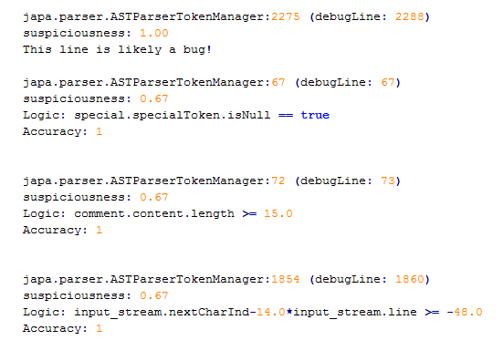
Line 2275: only fail testcases go through, so it is likely a bug.
Line 67: we try to learn from boolean value first, and already get a good predicate.
Line 72: we still not handle selective sampling for String yet, variable length cannot be changed, so we cannot get rid of this divider using selective sampling.
Line 1854: selective sampling does not work well for this case because, whatever we change these two values, the program will throw exception somewhere else, the test result for new sampling will fail at verification step, no more points added to learn a new predicate.
Fix bug from the running result:
Without any idea about the code of JavaParser, but from information we get after running ZiYuan, we debug the fail test (TestIssue46) and add breakpoints at those lines (ASTParserTokenManager:2275, ASTParserTokenManager:72, ASTParserTokenManager: 67, ASTParserTokenManager:1854)
And we soon releazed that the bug is really around line 67 of class ASTParserTokenManager. And this is the problem:
Javaparser parses a java file into a CompilationUnit, and the variable comments in the code (as below) store comments for the whole CompilationUnit. And the error happens for all kind of Token special with special.specialToken != null which means the source has more than 1 comment before a node (statement, method, class,..).

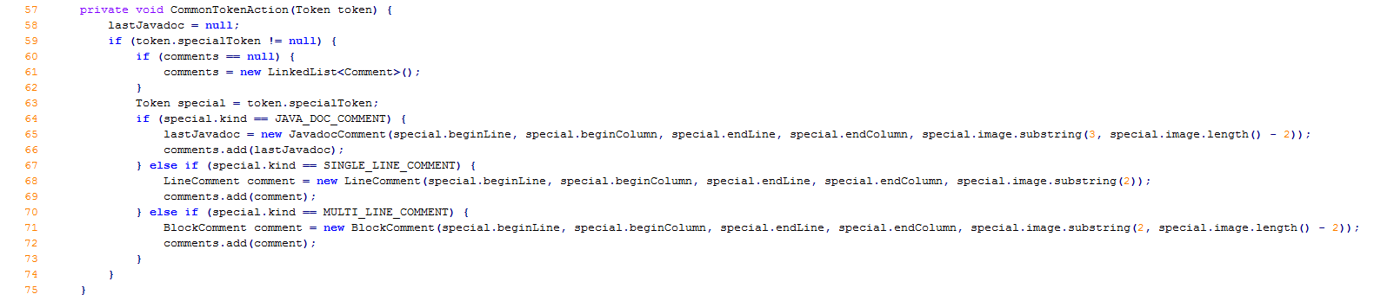
And line 2275 is actually where special.specialToken is set to a value which makes special.specialToken != null at line 67. Of course, bug is not at line 2275, but it also help us understand the bug.

Fix:
while (special.specialToken != null) {
special = special.specialToken;
}
while (special != null) {
if (special.kind == JAVA_DOC_COMMENT) {
lastJavadoc = new JavadocComment(special.beginLine,
special.beginColumn, special.endLine,
special.endColumn, special.image.substring(3,
special.image.length() - 2));
comments.add(lastJavadoc);
} else if (special.kind == SINGLE_LINE_COMMENT) {
LineComment comment = new LineComment(special.beginLine,
special.beginColumn, special.endLine,
special.endColumn, special.image.substring(2));
comments.add(comment);
} else if (special.kind == MULTI_LINE_COMMENT) {
BlockComment comment = new BlockComment(special.beginLine,
special.beginColumn, special.endLine,
special.endColumn, special.image.substring(2,
special.image.length() - 2));
comments.add(comment);
}
special = special.next;
}

