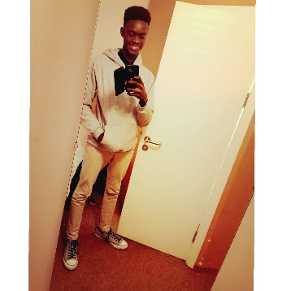**Fafowora Olasunkanmi**

**Front-End Web Developer**

Phone: 09091546573

Email: sunkanmifafowora@gmail.com

*GitHub:*

https://github.com/sunkanmii

**EDUCATION**

|  |  |
| --- | --- |
| SCHOOL | University of Lagos |
| Faculty | Sciences |
| Department | Computer sciences |
| Level | 200 |
| Best Course so far | Java |