Handwritten Digit Recognition on MNIST
A feedforward neural network built with TensorFlow / Keras, and a comparison of two hidden-layer sizes

1. Introduction
Recognising handwritten digits is a classic benchmark in machine learning and a good first test for any neural-network workflow. This report documents a notebook that trains a small fully connected network on the MNIST dataset using TensorFlow/Keras. The aim was to (i) build a classifier that maps a 28×28 grayscale image to one of the digits 0–9, (ii) measure how well it generalises to unseen images, and (iii) test whether a smaller network, with half the hidden units, can do nearly as well.

2. Dataset
MNIST was loaded directly through tf.keras.datasets. It contains 60,000 training images and 10,000 test images; each is a 28×28 grayscale image of a single handwritten digit with an integer label from 0 to 9. Pixel values range from 0 to 255. During training, 10% of the training set (6,000 images) was held out as a validation set, leaving 54,000 images for weight updates. The 10,000 test images were kept aside and used only for the final evaluation.
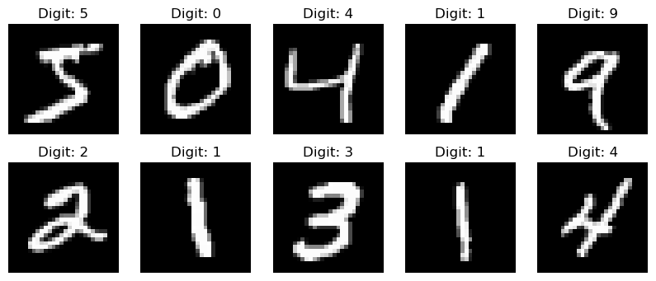
Figure 1. The first ten training images with their labels.

3. Methodology
Preprocessing. Pixel values were divided by 255 so every input lies between 0 and 1. This keeps the input scale small and makes gradient-based training more stable.
Model architecture. Both models are Keras Sequential networks with the same structure. The only difference is the width of the hidden layer.
Layer | Model 1 | Model 2 | Purpose
Flatten | 784 inputs | 784 inputs | Image to vector
Dense + ReLU | 128 units | 64 units | Feature learning
Dropout | rate 0.2 | rate 0.2 | Regularisation
Dense + Softmax | 10 units | 10 units | Class probabilities
Trainable parameters | 101,770 | 50,890
Table 1. Architecture of the two models.
Training setup. Both models were compiled with the Adam optimiser and sparse categorical cross-entropy loss, with accuracy as the metric. Each was trained for 5 epochs using Keras’s default batch size of 32 (1,688 steps per epoch on the 54,000 training images). Training ran on CPU under Python 3.13 on Windows, taking roughly 13–21 seconds per epoch.

4. Results
4.1 Model 1 (128 hidden units)
Model 1 learned quickly. Validation accuracy was already 96.08% after the first epoch and rose steadily to 97.80% by epoch 5, while validation loss fell from 0.1375 to 0.0719. On the held-out test set it reached an accuracy of 97.49% with a loss of 0.0796.
Epoch | Train acc. | Val. acc. | Train loss | Val. loss
1 | 90.69% | 96.08% | 0.3168 | 0.1375
2 | 95.45% | 96.85% | 0.1530 | 0.1070
3 | 96.59% | 97.38% | 0.1141 | 0.0863
4 | 97.07% | 97.53% | 0.0934 | 0.0809
5 | 97.49% | 97.80% | 0.0795 | 0.0719
Table 2. Epoch-by-epoch training history of Model 1.
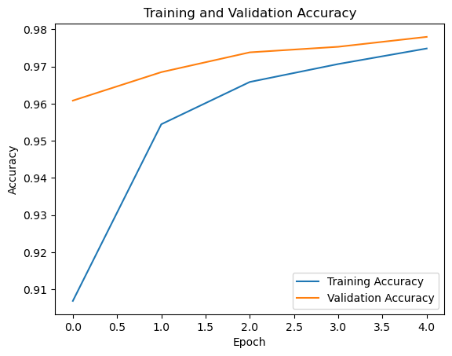  Figure 2. Training and validation accuracy. | 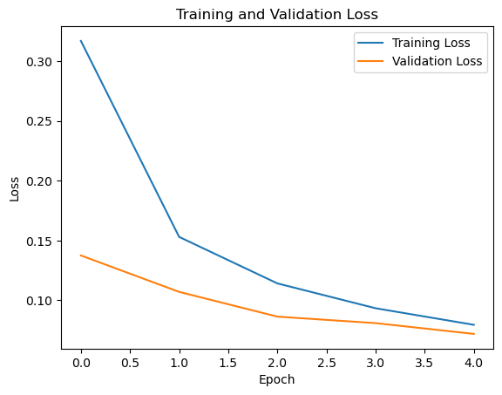  Figure 3. Training and validation loss.
Training and validation curves track each other closely and both are still improving at epoch 5, so there is no sign of overfitting. As a quick sanity check, the model predicted the first five test images (7, 2, 1, 0, 4) and matched all five true labels (Figure 4).
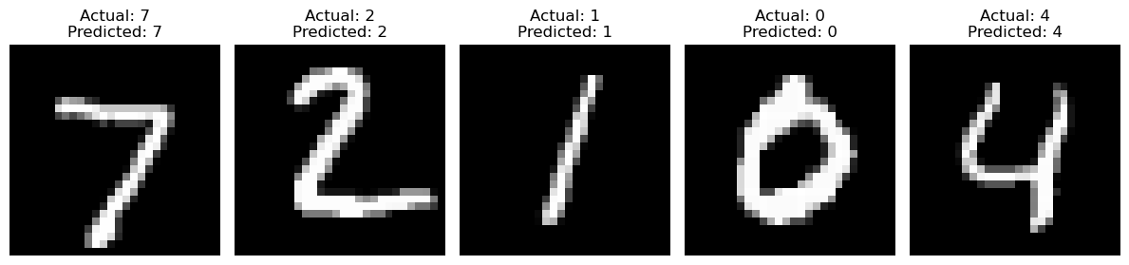
Figure 4. Actual vs. predicted labels for the first five test images.
4.2 Model comparison
Model 2 halves the hidden layer to 64 units and was trained with identical settings. Table 3 compares the two.
Metric | Model 1 (128) | Model 2 (64)
Trainable parameters | 101,770 | 50,890
Final training accuracy (epoch 5) | 97.49% | 96.15%
Final validation accuracy | 97.80% | 97.38%
Final validation loss | 0.0719 | 0.0813
Test accuracy | 97.49% | 96.95%
Test loss | 0.0796 | 0.0982
Approx. misclassified test images* | 251 | 305
Table 3. Side-by-side results. *Derived from test accuracy on 10,000 images.

5. Discussion
- Accuracy vs. size. Cutting the parameter count by half cost about 0.54 percentage points of test accuracy (97.49% → 96.95%), or roughly 54 extra errors out of 10,000. The smaller model is cheaper to store and run, so the right choice depends on whether that small accuracy loss matters for the application.
- Validation above training accuracy. In early epochs, validation accuracy is higher than training accuracy. This is expected: dropout is active during training but switched off during validation, and Keras reports training accuracy averaged over the whole epoch while the weights are still improving.
- Generalisation. Test accuracy (97.49%) is close to validation accuracy (97.80%), which suggests the validation score was a reasonable preview of performance on unseen data.
- Underfitting rather than overfitting. Because loss was still falling at epoch 5, both models would likely gain from further training.

6. Limitations and Future Work
The results come from a single 5-epoch run per model with no fixed random seed, so a difference of around half a percentage point should be confirmed with repeated runs before drawing firm conclusions. Only five predictions were inspected by eye, and no confusion matrix or per-class metrics were computed, so it is not known which digits are confused most often. Natural next steps are:
- training for more epochs with early stopping on validation loss;
- adding a confusion matrix and per-class precision/recall to find the hardest digits;
- trying a convolutional neural network (CNN), which exploits image structure and generally outperforms fully connected networks on MNIST;
- replacing input_shape in the first layer with an explicit Input layer, which removes the Keras warning shown in the notebook.

7. Conclusion
A simple network with one 128-unit hidden layer and dropout classified 97.49% of the MNIST test images correctly after only five epochs, and a network half its size still reached 96.95%. The training curves were smooth and showed no overfitting, so there is clear headroom for improvement through longer training or a convolutional architecture.

