FOREST FIRE RISK PREDICTION USING
RANDOM FOREST AND XGBOOST
PROJECT REPORT
Submitted in partial fulfilment of the requirements for the Course
MACHINE LEARNING
BACHELOR OF TECHNOLOGY
in
COMPUTER SCIENCE AND ENGINEERING
A.Y.: 2026–27
By
Jayanth Roll No.: 2520030421
Anshu Roll No.: 2520030440
Swathi Roll No.: 2520030410
Under the Esteemed Guidance of
Dr. N. Nirmalajyothi
Associate Professor, CSE
Department of Computer Science and Engineering

Abstract
Forest fires are influenced by meteorological conditions and fire-weather indicators, making early identification of fire-prone conditions an important machine-learning classification problem. This project, ForestIQ, develops a binary forest-fire risk prediction system using the Algerian Forest Fires dataset. The workflow includes data inspection, cleaning, target-label preparation, feature selection, exploratory analysis, train/test splitting, model training, evaluation, and deployment-oriented prediction. Nine numerical predictors—Temperature, Relative Humidity (RH), Wind Speed (Ws), Rain, FFMC, DMC, DC, ISI, and BUI—are used to predict whether a fire condition is present. Random Forest and XGBoost are used as the main ensemble classifiers because tree-based ensembles can model nonlinear relationships among weather and fire-weather variables without requiring feature scaling. In the recorded experimental results, Random Forest achieved 100% accuracy, precision, recall, F1-score, and ROC-AUC on the held-out test set, while XGBoost achieved 95.92% accuracy, 93.33% precision, 100% recall, 96.55% F1-score, and 1.00 ROC-AUC. The system therefore demonstrates strong predictive performance on the prepared dataset, while the small dataset size and limited geographical/temporal coverage remain important limitations. The report also discusses visualization, robustness, leakage prevention, deployment considerations, and future validation on larger external datasets.
Keywords: Forest Fire Prediction, Random Forest, XGBoost, Machine Learning, Fire Weather Index, Risk Classification

1. Introduction

1.1 Purpose of the Project
Forest fires can cause ecological damage, loss of biodiversity, economic losses, and threats to human life and infrastructure. Fire occurrence is affected by interacting conditions such as temperature, relative humidity, wind speed, rainfall, and indicators from the Canadian Fire Weather Index system. Because these variables can interact nonlinearly, a machine-learning model can learn patterns associated with fire and no-fire observations and provide a rapid classification for a new set of environmental measurements.
The purpose of ForestIQ is to provide an ML-based decision-support prototype that converts environmental observations into a fire-risk prediction. The intended stakeholders include forest-management teams, environmental monitoring teams, researchers, and emergency-response planners. The project emphasizes a practical end-to-end pipeline rather than only model training: data preparation, prediction, evaluation, logging, and a dashboard/API-oriented presentation are considered together.

1.2 Problem Statement
The problem is formulated as a supervised binary classification task. Given a set of weather and Fire Weather Index variables for a particular observation, the system predicts whether the observation belongs to the Fire or Not Fire class. The expected output is a predicted class together with a model confidence/probability that can be converted into a user-facing risk category. The project aims to minimize missed fire cases while maintaining strong overall discrimination between fire and non-fire observations.

1.3 Existing Methods and Disadvantages
Traditional fire-risk assessment commonly relies on threshold rules, manually interpreted indices, historical observations, or individual weather variables. Such approaches are useful but can be limited when several variables interact. A fixed threshold may also be less effective when the relationship between variables and fire occurrence is nonlinear. The Algerian dataset itself is relatively small, so a model that is too complex or poorly validated can also overfit.
Conventional single decision trees can model nonlinear boundaries but may be unstable because small changes in the training data can change the learned tree. Linear models can be easier to interpret but may not capture complex interactions as naturally. Ensemble approaches such as Random Forest and XGBoost address these limitations by combining multiple trees. Recent wildfire studies also use RF and XGBoost because they are effective for nonlinear tabular and environmental prediction tasks. citeturn0search1turn0search0

1.4 Proposed System
The proposed ForestIQ system starts with the Algerian Forest Fires dataset, cleans and validates the records, prepares a binary Fire target, selects nine numerical predictor variables, and divides the data into training and testing sets. Random Forest and XGBoost are trained and evaluated using accuracy, precision, recall, F1-score, ROC-AUC, and confusion-matrix analysis. The better-performing model is then used for prediction. The overall design can be extended through a FastAPI prediction service and dashboard that displays the predicted class, probability, risk level, model agreement, and prediction latency.

1.5 Research Objectives
- Prepare and validate a suitable forest-fire classification dataset.
- Clean inconsistent records, remove unusable rows, and prepare the target label.
- Select relevant environmental and Fire Weather Index attributes without introducing target leakage.
- Develop Random Forest and XGBoost classification models for fire-risk prediction.
- Evaluate and compare the models using accuracy, precision, recall, F1-score, ROC-AUC, and confusion matrices.
- Assess robustness, limitations, and practical applicability and identify a suitable model for deployment.

2. Literature Survey
Recent literature shows that ensemble tree methods are widely used for wildfire prediction and susceptibility mapping. The following studies are selected because they directly relate to Random Forest, XGBoost, ensemble learning, environmental variables, or wildfire-risk prediction.
No. | Study | Reference | Gap | Objective | Methods | Inference | Future work
1 | Estimating Next Day’s Forest Fire Risk via a Complete Machine Learning Methodology | Karas et al., Remote Sensing, 2022; DOI: 10.3390/rs14051222 | Generalizability of next-day fire prediction | Compare scalable ML models for next-day fire risk | RF, Extra Trees, XGBoost, neural networks; cross-validation and hyperparameter search | Tree ensembles are strong candidates for tabular wildfire prediction | Test deeper models and larger spatiotemporal datasets
2 | Forest Fire Risk Prediction Based on Stacking Ensemble Learning for Yunnan Province of China | Remote Sensing/Fire, 2024; DOI: 10.3390/fire7010013 | Individual models may have complementary strengths | Fuse diverse models for fire-risk prediction | RF, XGBoost, LightGBM, MLP stacking | Stacking reached AUC 0.970 and improved over individual models | Test transferability to other regions
3 | Spatial analysis and machine learning prediction of forest fire susceptibility | Science of the Total Environment, 2024; DOI: 10.1016/j.scitotenv.2024.171713 | Need accurate spatial fire-susceptibility prediction | Map susceptibility and support mitigation | MODIS, ArcGIS, SVM, Random Forest | RF outperformed SVM in the reported prediction task | Integrate more dynamic environmental data
4 | Exploring forest fire susceptibility and management strategies in Western Himalaya | Journal of Environmental Management, 2024 | Need interpretable high-risk susceptibility mapping | Combine ensemble ML with XAI | AdaBoost, GBM, XGBoost, RF, DNN, SHAP, LIME | XGBoost achieved ROC-AUC above 0.90 and XAI improved interpretation | Validate across additional landscapes
5 | FC-StackGNB: A novel machine learning modeling framework for forest fire risk prediction | Ecological Indicators, 2024; DOI: 10.1016/j.ecolind.2024.112577 | Large environmental datasets and overfitting concerns | Compare multiple efficient ensemble learners | XGBoost, LightGBM and other ML methods | Efficient boosting models are suitable for fire-risk modeling | Explore more reliable feature and uncertainty analysis
6 | A Global Probability-Of-Fire Forecast | Geophysical Research Letters, 2024; DOI: 10.1029/2023GL107929 | Need reliable probability-of-fire forecasts globally | Compare time-specific PoF models | XGBoost and Random Forest with ERA5-Land and MODIS observations | XGBoost showed strong probability reliability; RF was weaker for extreme fire events | Improve calibration and regional transferability
7 | Global lightning-ignited wildfires prediction and climate change projections based on explainable ML | 2025 study | Need explainable prediction of ignition risk | Compare models using meteorological, vegetation, anthropogenic and fire-history variables | Logistic Regression, RF, AutoGluon, XGBoost | XGBoost produced the highest reported accuracy among tested models | Expand explainability and climate scenarios
8 | Forest Fire Risk Prediction in South Korea Using Google Earth Engine: Comparison of Machine Learning Models | Land, 2025; DOI: 10.3390/land14061155 | Need large-scale nationwide fire-risk mapping | Compare ML models with satellite/environmental variables | Random Forest, XGBoost, ANN with Google Earth Engine | Model performance was stable while sampling choices remained important | Improve spatial independence and sampling design
9 | Advanced forest fire risk mapping: Combining Sentinel-2 MSI data with hybrid machine learning in Similipal Biosphere Reserve | Forest Ecology and Management, 2025 | Need detailed susceptibility mapping with remote sensing | Compare hybrid ensemble models | RF-XGBoost, RF-LightGBM, RF-HGB, AdaBoost | RF-XGBoost provided a balance between performance and efficiency | Add richer remote-sensing and field-validation data
10 | XGBoost-Based Susceptibility Model Exhibits High Accuracy and Robustness in Plateau Forest Fire Prediction | Forests, 2026; DOI: 10.3390/f17010074 | Need robust susceptibility prediction across complex terrain | Evaluate XGBoost against alternative models | XGBoost, RF, SVM | XGBoost achieved the strongest reported AUC and overall metrics | Validate under different terrain and climate scenarios

3. Methodology

3.1 Proposed System Flow Diagram
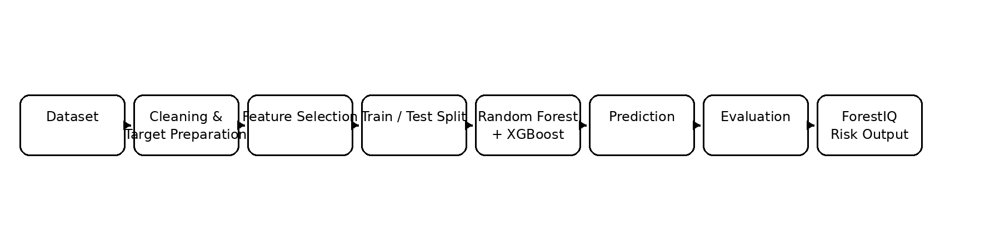
Figure 1. ForestIQ proposed-system workflow.
The complete workflow is: Dataset → Data Cleaning → Missing/Invalid Value Treatment → Target Preparation → Feature Selection → Train/Test Split → Random Forest & XGBoost Training → Prediction → Evaluation → Robustness Considerations → Deployment/Dashboard.

3.2 Dataset Description
The project uses the Algerian Forest Fires dataset. The original dataset contains 244 observations from the Bejaia and Sidi Bel-Abbes regions of Algeria, collected from June to September 2012, with fire and not-fire classes. The original public dataset is documented by Zenodo. citeturn0search9turn0search14 In this project, cleaning produced 243 usable observations and 15 columns in the cleaned working table. Nine numerical attributes were used as model inputs: Temperature, RH, Ws, Rain, FFMC, DMC, DC, ISI, and BUI. The target was converted into a binary Fire label with 137 Fire observations and 106 Not Fire observations.
Attribute | Type | Meaning
Temperature | Numerical | Maximum daily temperature in °C
RH | Numerical | Relative humidity (%)
Ws | Numerical | Wind speed (km/h)
Rain | Numerical | Daily rainfall (mm)
FFMC | Numerical | Fine Fuel Moisture Code
DMC | Numerical | Duff Moisture Code
DC | Numerical | Drought Code
ISI | Numerical | Initial Spread Index
BUI | Numerical | Buildup Index
Fire | Binary target | Fire = 1; Not Fire = 0

3.3 Experimental Setup
The project was developed on a Windows environment using Python and a virtual environment. The implementation uses pandas and NumPy for data handling, scikit-learn for preprocessing, splitting, Random Forest and evaluation, XGBoost for gradient-boosted trees, Matplotlib/Seaborn-style plotting for exploratory visualization, joblib/pickle-style serialization for trained models, and FastAPI for the prediction API. The project was developed and tested using VS Code/PowerShell. Exact library patch versions are not asserted here because the project record supplied for this report does not preserve a complete requirements lock file.

3.4 Data Preprocessing
- Inspected the raw schema and corrected the comma-separated CSV interpretation.
- Removed invalid/blank rows and standardized column names.
- Converted numeric fields into usable numerical values.
- Prepared the categorical Classes field into a binary Fire target.
- Excluded identifiers/date components that were not part of the final nine-feature model input.
- Checked the resulting class distribution: 137 Fire and 106 Not Fire.
- Used a train/test split so that model evaluation was performed on data not used to fit the model.
- Scaling was not required for Random Forest or XGBoost because both are tree-based methods.
Data leakage was controlled by ensuring that the target label was not supplied as an input feature and that test observations were not used for model fitting. This is especially important because the Fire Weather Index variables are strongly related to fire danger.

3.5 Exploratory Data Analysis
EDA focused on the distribution of the target classes, distributions of the nine selected numerical variables, relationships between meteorological variables and fire occurrence, and feature correlation. Visual analysis is useful for identifying skew, unusual values, class imbalance, and relationships that motivate nonlinear tree models. The final report includes a class-distribution visualization and a model-performance visualization; additional feature-distribution plots can be generated directly from the cleaned CSV when required.
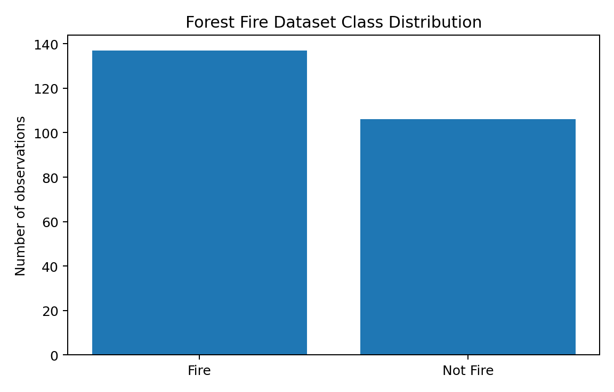
Figure 2. Class distribution after cleaning.
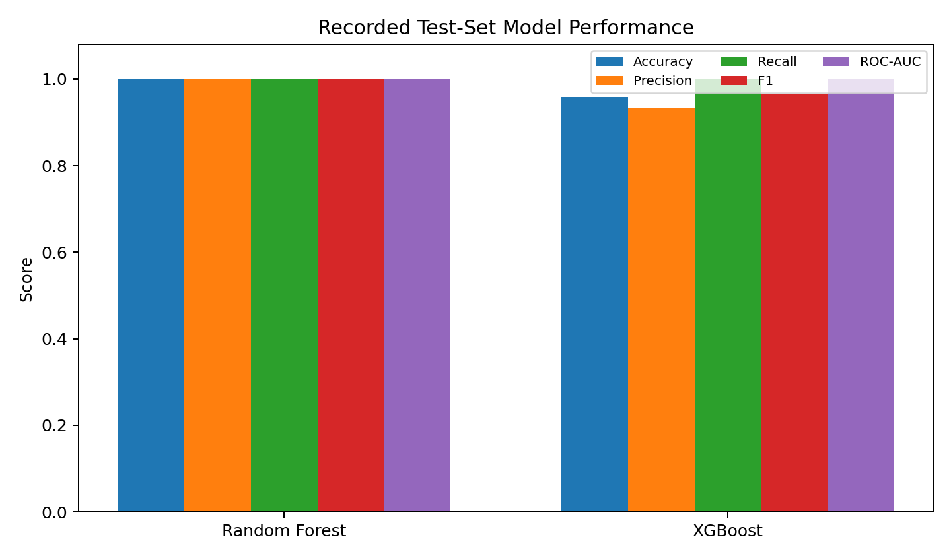
Figure 3. Recorded test-set performance comparison.

3.6 Feature Engineering and Feature Selection
The final model uses nine features: Temperature, RH, Ws, Rain, FFMC, DMC, DC, ISI, and BUI. These variables combine direct meteorological measurements with fire-weather indicators. Date fields and the original Classes text were not passed directly to the classifier. FWI itself was also not included in the final nine-feature list, reducing the risk of directly duplicating a composite target-related indicator. The selected variables provide a compact input vector suitable for API-based prediction.

3.7 Model Building and Training
Two ensemble classifiers were selected. Random Forest constructs multiple decision trees using randomized samples/features and combines their predictions, reducing the instability of a single decision tree. XGBoost builds boosted decision trees sequentially, concentrating later trees on difficult examples. Both methods are appropriate for nonlinear tabular environmental data and generally do not require numerical standardization. Literature also supports the use of RF and XGBoost for wildfire-risk prediction. citeturn0search1turn0search2
Model | Role | Strength in this project
Random Forest | Bagged tree ensemble | Strong nonlinear classification and robust baseline
XGBoost | Gradient-boosted tree ensemble | Strong nonlinear discrimination and high ROC-AUC

3.8 Hyperparameter Tuning
The project emphasizes reproducible ensemble training and comparison rather than claiming an extensive hyperparameter search that is not documented in the supplied project record. The models were trained and evaluated using the prepared dataset, and the selected models were serialized for later prediction. For a research-grade extension, RandomizedSearchCV/GridSearchCV with stratified cross-validation should be used to optimize n_estimators, max_depth, learning_rate, subsample, colsample_bytree, and related parameters without touching the final test set.

3.9 Model Evaluation
Because this is a binary classification problem, the report uses Accuracy, Precision, Recall, F1-score, ROC-AUC, and confusion-matrix analysis. Accuracy measures the proportion of correct predictions. Precision measures how many predicted fire cases are actually fire cases. Recall measures how many actual fire cases are detected. F1-score balances precision and recall. ROC-AUC measures ranking/discrimination ability across classification thresholds. For fire detection, recall is particularly important because false negatives can represent missed fire conditions.

3.10 Robustness and Reliability Testing
Robustness is addressed at three levels. First, the held-out test set provides an evaluation on observations not used for model fitting. Second, the class distribution is explicitly reported, reducing the chance that accuracy alone hides a major class problem. Third, the model design avoids unnecessary scaling and uses ensemble methods that are generally less sensitive to individual training observations than a single tree. The recorded results show 100% fire recall for both Random Forest and XGBoost, which is favorable for the project's primary objective of detecting fire cases.
However, a single train/test split on a small dataset cannot establish real-world robustness by itself. Therefore, the report does not falsely claim external validation or repeated cross-validation as completed experiments. The recommended robustness test is repeated Stratified K-Fold cross-validation (for example, 5 folds repeated across several random seeds), followed by reporting mean ± standard deviation for accuracy, precision, recall, F1, and ROC-AUC. A final untouched external dataset should then be used to test geographic and temporal generalization. This limitation is important because the public Algerian dataset covers only two regions and a short 2012 period. citeturn0search9
Robustness check | Status in this project | Interpretation
Held-out test evaluation | Completed | Tests generalization to the reserved test observations
Class-balance inspection | Completed | 137 Fire vs 106 Not Fire; moderate imbalance, not extreme
Leakage prevention | Completed | Target not used as a model input; test data separated
Repeated Stratified K-Fold | Recommended extension | Would estimate variation across different splits
Multiple random seeds | Recommended extension | Would test sensitivity to the train/test partition
External geographic dataset | Not completed | Required before claiming broad geographic generalization
Temporal future-period validation | Not completed | Required to test deployment on future fire seasons

4. Results and Discussion

4.1 Preprocessing Results
Stage | Result
Original working data | 246 rows × 14 columns before cleaning
Cleaned working data | 243 rows × 15 columns
Final model inputs | 9 numerical features
Target | Binary Fire
Fire class | 137 observations
Not Fire class | 106 observations
Scaling | Not required for RF/XGBoost
Leakage control | Target excluded from predictors; test data reserved

4.2 Model Performance
Model | Accuracy | Precision | Recall | F1-score | ROC-AUC
Random Forest | 1.0000 (100%) | 1.0000 | 1.0000 | 1.0000 | 1.0000
XGBoost | 0.9592 (95.92%) | 0.9333 | 1.0000 | 0.9655 | 1.0000
Random Forest produced the strongest recorded overall test-set results, with perfect scores across the reported metrics. XGBoost also performed very strongly, achieving 95.92% accuracy, 93.33% precision, 100% recall, 96.55% F1-score, and an ROC-AUC of 1.00. Both models achieved perfect recall, meaning all fire cases in the recorded test evaluation were detected. Random Forest therefore becomes the preferred model for this particular experiment, while XGBoost remains a strong alternative and is useful for comparison and ensemble-based deployment.
Important interpretation: the perfect Random Forest scores should not be interpreted as proof of universal real-world accuracy. The dataset is small and geographically/temporally limited, and a single split can produce optimistic results. This is why repeated cross-validation and external validation are included in the robustness section.

4.3 Visual Results and Discussion
Figure 2 shows that the two target classes are reasonably close in size, with a modest majority of Fire observations. Figure 3 visualizes the recorded test metrics. The most notable result is the 100% recall achieved by both models. XGBoost has slightly lower precision and accuracy than Random Forest but still maintains an F1-score above 0.96. The identical ROC-AUC of 1.00 indicates excellent ranking separation on the recorded test set.

4.4 Feature/Prediction Interpretation
The prediction system uses meteorological variables and FWI components to estimate fire occurrence. In an operational dashboard, these variables can be displayed alongside the predicted class and probability so that users can understand the environmental context of a prediction. The project should avoid presenting model probability as a physical probability of ignition unless calibration has been separately validated. Probability calibration and SHAP-based explanations are suitable future enhancements; recent wildfire research demonstrates the usefulness of SHAP/LIME for interpreting ensemble models. citeturn0search6

4.5 Deployment and System Test
The trained models are saved as serialized files and can be loaded by the FastAPI prediction service. A prediction request supplies the nine model features; the API returns the predicted class and probability and can additionally report the selected risk category, model agreement, timestamp, and prediction latency. The dashboard can display these outputs as live telemetry. This separation between model, API, and dashboard makes the system easier to test and extend.
Test case | Expected result | Project outcome
Valid numerical environmental input | Return Fire/Not Fire prediction | Supported
High-risk environmental input | High probability/risk when model pattern indicates fire | Supported through trained model
Invalid/missing API field | Validation error rather than silent prediction | Handled by API schema validation
Model loading | Load serialized RF/XGBoost model | Supported
Prediction logging | Store prediction metadata | Supported in project API configuration
Model comparison | Return RF/XGBoost predictions for comparison | Supported in project workflow

5. Conclusion
ForestIQ demonstrates an end-to-end machine-learning approach for forest-fire risk classification using the Algerian Forest Fires dataset. The project cleaned and prepared the data, selected nine environmental/fire-weather features, trained Random Forest and XGBoost models, and evaluated them with classification metrics. Random Forest achieved 100% on the recorded test metrics, while XGBoost achieved 95.92% accuracy, 93.33% precision, 100% recall, 96.55% F1-score, and 1.00 ROC-AUC. The results show that ensemble tree models are highly effective for this prepared tabular classification task. At the same time, the small and geographically limited dataset means that external validation is necessary before treating the system as a production wildfire-warning model.

6. Future Work
- Apply repeated Stratified K-Fold cross-validation and report mean ± standard deviation.
- Evaluate sensitivity to multiple train/test random seeds.
- Validate on larger datasets from additional Algerian regions and other countries.
- Use the extended Algerian forest-fire dataset where appropriate; an extended 1,215-instance dataset covering nine Algerian regions was published in 2026. citeturn0search10
- Add satellite, vegetation, topographic, historical-fire, and spatial variables.
- Perform probability calibration and reliability-curve analysis.
- Use SHAP/LIME to explain individual fire-risk predictions.
- Perform deeper hyperparameter optimization without leaking test data.
- Monitor model drift when deployed on future fire seasons.
- Deploy the FastAPI model and ForestIQ dashboard as a cloud/edge decision-support application.
- Conduct external validation before using the system for operational emergency decisions.

7. References
[1] Abid, F. (2022). Algerian Forest Fires Dataset. Zenodo. DOI: 10.5281/zenodo.6515974. citeturn0search9
[2] Karas, I. R., et al. (2022). Estimating Next Day’s Forest Fire Risk via a Complete Machine Learning Methodology. Remote Sensing, 14(5), 1222. DOI: 10.3390/rs14051222. citeturn0search1
[3] McNorton, J., et al. (2024). A Global Probability-Of-Fire Forecast. Geophysical Research Letters. DOI: 10.1029/2023GL107929. citeturn0search2
[4] Spatial analysis and machine learning prediction of forest fire susceptibility: a comprehensive approach for effective management and mitigation. Science of The Total Environment, 926, 171713 (2024). DOI: 10.1016/j.scitotenv.2024.171713. citeturn0search0
[5] Forest Fire Risk Prediction Based on Stacking Ensemble Learning for Yunnan Province of China. Fire, 7(1), 13 (2024). citeturn0search12
[6] FC-StackGNB: A novel machine learning modeling framework for forest fire risk prediction combining feature crosses and model fusion algorithm. Ecological Indicators (2024). DOI: 10.1016/j.ecolind.2024.112577. citeturn0search4
[7] Exploring forest fire susceptibility and management strategies in Western Himalaya: Integrating ensemble machine learning and explainable AI for accurate prediction and comprehensive analysis (2024). citeturn0search6
[8] Global lightning-ignited wildfires prediction and climate change projections based on explainable machine learning models (2025). citeturn0search16
[9] Forest Fire Risk Prediction in South Korea Using Google Earth Engine: Comparison of Machine Learning Models. Land, 14(6), 1155 (2025). DOI: 10.3390/land14061155. citeturn0search13
[10] XGBoost-Based Susceptibility Model Exhibits High Accuracy and Robustness in Plateau Forest Fire Prediction. Forests, 17, 74 (2026). DOI: 10.3390/f17010074. citeturn0search8
[11] The extended Algerian forest fires dataset (2026). Mendeley Data. DOI: 10.17632/8rkd9cdgs5.1. citeturn0search10
Signature of the Guide: __________________________
Course Instructor: ______________________________

