AGENTIC ARCHITECTURE PATTERNS
Complete Python Implementations + Industry Usage
Every Pattern · Full Code · Real Use Cases · Perplexity · ChatGPT · Claude

April 2025 | Production-Ready Reference for AI Engineers & Architects

PART A — SINGLE-AGENT PATTERNS

Pattern 1: ReAct (Reasoning + Acting)

What Is It?
ReAct interleaves Thought (explicit reasoning) and Action (tool call) in a loop, making the agent's reasoning transparent and controllable. Each iteration: think → act → observe → repeat until goal achieved.

Architectural Diagram — ReAct
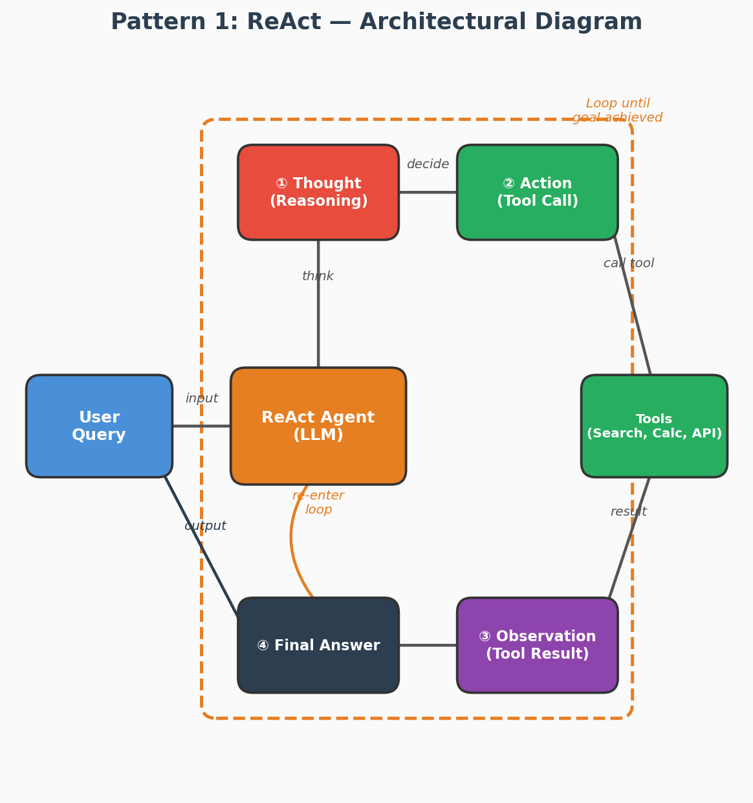
Figure 1: ReAct pattern — The agent loops through Thought (reasoning), Action (tool call), and Observation (tool result) until the goal is achieved.
Use Case — E-Commerce Product Advisor
Scenario: A customer asks an e-commerce chatbot, "Find me a waterproof Bluetooth speaker under $50 with good bass."
How ReAct Handles It:
Step 1 — Thought: The agent reasons: "I need to search the product catalog for Bluetooth speakers that are waterproof, under $50, and known for good bass quality."
Step 2 — Action: The agent calls the search_catalog tool with filters: category='Bluetooth Speakers', max_price=50, features=['waterproof', 'bass boost'].
Step 3 — Observation: The tool returns 5 matching products with ratings and prices.
Step 4 — Thought: "I have 5 results. Let me check stock availability for the top-rated one and get detailed reviews."
Step 5 — Action: Calls check_stock(product_id='SP-2847') and get_reviews(product_id='SP-2847', filter='bass').
Step 6 — Observation: Product is in stock; 4.5-star average with reviewers praising bass quality.
Step 7 — Final Answer: "I found the SoundMax Pro X — a waterproof Bluetooth speaker at $42.99 with 4.5 stars. Reviewers specifically highlight its deep bass. It's in stock and eligible for free shipping."
Why ReAct? Each reasoning step is transparent and auditable. The agent dynamically decides which tools to call based on intermediate results, making it ideal for multi-step information gathering with tools.

When to Use ReAct
✅ Tasks requiring 2-10 sequential steps with tool lookups
✅ Customer support, research Q&A, coding assistance, data lookup
✅ When transparency of reasoning is important for debugging or trust
❌ Avoid for purely generative tasks needing no tools

Complete Python Implementation
react_agent.py — Full ReAct Agent with Tool Registry
import anthropic, json, re
from typing import Any, Callable
from dataclasses import dataclass

@dataclass
class Tool:
name: str
description: str
input_schema: dict
fn: Callable

class ReActAgent:
"""
ReAct Agent — Reasoning + Acting loop.
Interleaves THOUGHT → ACTION → OBSERVATION until task complete.
"""
def __init__(self, tools: list[Tool], model='claude-sonnet-4-20250514', max_steps=10):
self.client = anthropic.Anthropic()
self.model = model
self.tools = {t.name: t for t in tools}
self.max_steps = max_steps

def _build_tool_specs(self) -> list[dict]:
return [{'name': t.name, 'description': t.description,
'input_schema': t.input_schema}
for t in self.tools.values()]

def run(self, goal: str) -> str:
messages = [{'role': 'user', 'content': goal}]
system = (
'You are a ReAct agent. For every step, FIRST write your Thought '
'(reasoning about what to do), then call a tool (Action), then review '
'the result (Observation). Repeat until you can give a Final Answer.'
)
for step in range(self.max_steps):
response = self.client.messages.create(
model=self.model, system=system,
tools=self._build_tool_specs(), messages=messages, max_tokens=4096
)
# ── Collect tool calls from response ──
tool_uses = [b for b in response.content if b.type == 'tool_use']
text_parts = [b for b in response.content if b.type == 'text']

if response.stop_reason == 'end_turn' or not tool_uses:
return text_parts[0].text if text_parts else ''

# ── Add assistant message ──
messages.append({'role': 'assistant', 'content': response.content})

# ── Execute each tool call and collect results ──
tool_results = []
for tu in tool_uses:
print(f'[ReAct] Step {step+1} → Tool: {tu.name}({tu.input})')
try:
result = self.tools[tu.name].fn(**tu.input)
except Exception as e:
result = f'ERROR: {e}'
tool_results.append({
'type': 'tool_result',
'tool_use_id': tu.id,
'content': str(result)[:3000] # truncate large outputs
})

messages.append({'role': 'user', 'content': tool_results})

return 'Max steps reached without final answer.'

# ── Tool definitions (use-case: financial research bot) ──────────────────
import requests

def search_web(query: str) -> str:
"""Simulated — replace with SerpAPI / Tavily in production."""
return f'Top results for "{query}": [Article1: AI stocks surge...] [Article2: Fed rate impact...]'

def get_stock_price(ticker: str) -> dict:
"""Simulated — replace with yfinance or Alpha Vantage."""
prices = {'NVDA': 875.4, 'MSFT': 415.2, 'GOOG': 175.6}
return {'ticker': ticker, 'price': prices.get(ticker.upper(), 'NOT FOUND'), 'currency': 'USD'}

def calculate(expression: str) -> float:
"""Safe math evaluator."""
allowed = set('0123456789+-*/.() ')
if not all(c in allowed for c in expression):
raise ValueError('Invalid expression')
return eval(expression)

tools = [
Tool('search_web', 'Search the web for current news and data.',
{'type':'object','properties':{'query':{'type':'string'}},'required':['query']},
search_web),
Tool('get_stock_price', 'Get the current stock price for a ticker symbol.',
{'type':'object','properties':{'ticker':{'type':'string','description':'e.g. NVDA, MSFT'}},'required':['ticker']},
get_stock_price),
Tool('calculate', 'Evaluate a math expression.',
{'type':'object','properties':{'expression':{'type':'string'}},'required':['expression']},
calculate),
]

# ── Run it ────────────────────────────────────────────────────────────────
if __name__ == '__main__':
agent = ReActAgent(tools)
result = agent.run(
'What is the combined value of 10 shares of NVDA and 5 shares of MSFT?'
' Also search for the latest news on both companies.'
)
print('\n=== FINAL ANSWER ===\n', result)

Industry Use Cases — ReAct Pattern
Domain | Use Case | Tools Used
E-Commerce | Product recommendation + inventory check | search_catalog, check_stock, get_price
Healthcare | Clinical Q&A + literature lookup | search_pubmed, get_drug_info, calculate_dose
Finance | Portfolio analysis + news correlation | get_stock, search_news, calculate
HR | Resume screening + job matching | parse_resume, search_jd, score_match
DevOps | Incident response + log analysis | query_logs, check_metrics, run_playbook

Pattern 2: Plan-and-Execute

What Is It?
A Planner LLM first creates a complete task plan (numbered steps). An Executor then carries out each step, optionally using a cheaper/faster model. A Replanner checks whether the plan should be updated after each step. This separation of concerns improves efficiency and traceability for long multi-step tasks.

Architectural Diagram — Plan-and-Execute
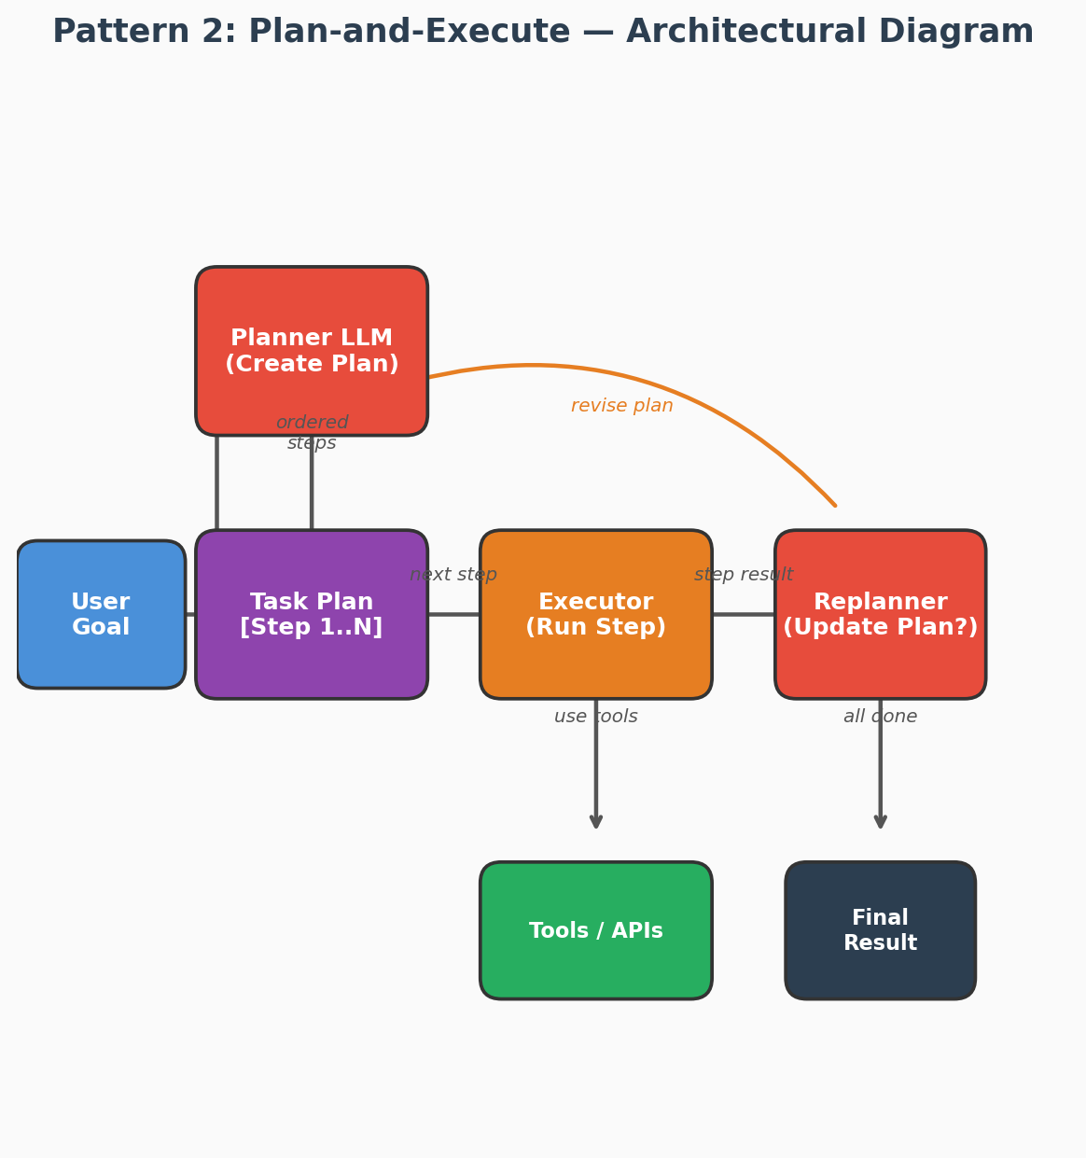
Figure 2: Plan-and-Execute pattern — A Planner creates an ordered task list, an Executor runs each step, and a Replanner adjusts the plan after each step if needed.
Use Case — Automated Market Research Report
Scenario: A product manager asks, "Generate a competitive analysis report for our new AI writing tool, comparing it with Jasper, Copy.ai, and Writesonic."
How Plan-and-Execute Handles It:
Planner Output:
Step 1: Gather feature lists for each competitor from their websites.
Step 2: Collect pricing data and plan tiers for each competitor.
Step 3: Analyze user reviews from G2 and Capterra for sentiment and top complaints.
Step 4: Compare features, pricing, and sentiment in a structured table.
Step 5: Write executive summary with strategic recommendations.
Step 6: Format and compile the final report.
Executor runs Step 1 → scrapes feature pages. Replanner checks: "Step 1 complete. Jasper has a new enterprise tier not in original plan. Adding Step 2a: investigate Jasper enterprise offering."
The Executor continues through each step. After Step 3, the Replanner notices: "Review sentiment for Writesonic is overwhelmingly about their recent API — adding Step 3a: analyze API-specific feedback."
Final output: A 15-page structured report delivered to the product manager.
Why Plan-and-Execute? Complex research tasks with many sequential steps benefit from explicit planning. The Replanner adapts the plan as new information emerges, without losing the overall structure.

When to Use Plan-and-Execute
✅ Complex research tasks, report generation, data pipelines (10-30 steps)
✅ When you want human-readable task plans before execution starts
✅ When steps are largely sequential with clear dependencies
❌ Avoid when the task is highly dynamic and requires constant replanning

Complete Python Implementation
plan_execute_agent.py — Planner + Executor + Replanner
import anthropic, json
from dataclasses import dataclass, field
from enum import Enum

class TaskStatus(Enum):
PENDING = 'pending'
IN_PROGRESS = 'in_progress'
DONE = 'done'
FAILED = 'failed'

@dataclass
class TaskStep:
id: int
description: str
status: TaskStatus = TaskStatus.PENDING
result: str = ''
tool_hint: str = '' # optional: hint for which tool to use

@dataclass
class Plan:
goal: str
steps: list[TaskStep] = field(default_factory=list)

def pending_steps(self):
return [s for s in self.steps if s.status == TaskStatus.PENDING]

def summary(self) -> str:
lines = [f'Goal: {self.goal}']
for s in self.steps:
icon = {'pending':'⏳','in_progress':'🔄','done':'✅','failed':'❌'}[s.status.value]
lines.append(f' {icon} Step {s.id}: {s.description}')
if s.result: lines.append(f' → {s.result[:200]}')
return '\n'.join(lines)

class PlanAndExecuteAgent:
"""
Plan-and-Execute Pattern.
Planner LLM → creates Plan → Executor LLM → executes each step → Replanner checks.
"""
def __init__(self, tools: dict, planner_model='claude-sonnet-4-20250514',
executor_model='claude-haiku-4-5-20251001'):
self.client = anthropic.Anthropic()
self.planner_model = planner_model
self.executor_model = executor_model
self.tools = tools

# ── PHASE 1: Planning ─────────────────────────────────────────────
def plan(self, goal: str) -> Plan:
prompt = f'''You are a task planner. Break the following goal into
a numbered list of atomic steps. Each step must be independently executable.
Return ONLY valid JSON: {{"steps": [{{"id":1, "description":"...", "tool_hint":"..."}}]}}

Goal: {goal}'''
resp = self.client.messages.create(
model=self.planner_model,
messages=[{'role':'user','content':prompt}],
max_tokens=2048
)
raw = resp.content[0].text.strip()
# strip markdown fences if present
if raw.startswith('```'): raw = raw.split('```')[1].lstrip('json').strip()
data = json.loads(raw)
steps = [TaskStep(id=s['id'], description=s['description'],
tool_hint=s.get('tool_hint',''))
for s in data['steps']]
return Plan(goal=goal, steps=steps)

# ── PHASE 2: Execute one step ─────────────────────────────────────
def execute_step(self, step: TaskStep, context: str) -> str:
tool_specs = [{'name':n,'description':t['description'],'input_schema':t['schema']}
for n,t in self.tools.items()]
prompt = f'''Previous context:\n{context}\n\nNow execute this step:
{step.description}
Tool hint: {step.tool_hint}
Use a tool if needed or answer directly. Be concise.'''
messages = [{'role':'user','content':prompt}]
for _ in range(3): # allow up to 3 tool calls per step
resp = self.client.messages.create(
model=self.executor_model, messages=messages,
tools=tool_specs, max_tokens=1024
)
tool_uses = [b for b in resp.content if b.type=='tool_use']
if resp.stop_reason=='end_turn' or not tool_uses:
texts = [b.text for b in resp.content if b.type=='text']
return texts[0] if texts else 'Done.'
messages.append({'role':'assistant','content':resp.content})
results = []
for tu in tool_uses:
fn_result = self.tools[tu.name]['fn'](**tu.input)
results.append({'type':'tool_result','tool_use_id':tu.id,'content':str(fn_result)[:2000]})
messages.append({'role':'user','content':results})
return 'Step completed (max tool loops reached).'

# ── PHASE 3: Replan check ─────────────────────────────────────────
def should_replan(self, plan: Plan, last_result: str) -> bool:
prompt = f'''Plan so far:\n{plan.summary()}\n\nLast result: {last_result}
Does the plan need to change based on this result?
Reply with ONLY 'yes' or 'no'.'''
resp = self.client.messages.create(
model=self.planner_model,
messages=[{'role':'user','content':prompt}],
max_tokens=10
)
return 'yes' in resp.content[0].text.lower()

# ── MAIN RUN ──────────────────────────────────────────────────────
def run(self, goal: str) -> str:
print(f'[Planner] Creating plan for: {goal}')
plan = self.plan(goal)
print(plan.summary())
context_parts = []

for step in plan.steps:
step.status = TaskStatus.IN_PROGRESS
print(f'\n[Executor] Running Step {step.id}: {step.description}')
try:
result = self.execute_step(step, '\n'.join(context_parts[-5:]))
step.result = result
step.status = TaskStatus.DONE
context_parts.append(f'Step {step.id} result: {result}')
print(f' → {result[:200]}')
except Exception as e:
step.result = str(e)
step.status = TaskStatus.FAILED
print(f' ✗ Failed: {e}')

if self.should_replan(plan, step.result):
print('[Replanner] Updating plan...')
remaining_goal = f'Remaining: {goal}. Done so far: {chr(10).join(context_parts)}'
new_plan = self.plan(remaining_goal)
plan.steps.extend(new_plan.steps) # append new steps

# ── Synthesize final answer ────────────────────────────────
synthesis_prompt = f'Goal: {goal}\n\nResults:\n' + '\n'.join(context_parts)
synthesis_prompt += '\n\nWrite a comprehensive, structured final answer.'
final = self.client.messages.create(
model=self.planner_model,
messages=[{'role':'user','content':synthesis_prompt}],
max_tokens=2048
)
return final.content[0].text

# ── Tools (use-case: market research report) ─────────────────────────────
TOOLS = {
'search_market_data': {
'description': 'Search for market size, trends, and competitive landscape data.',
'schema': {'type':'object','properties':{'sector':{'type':'string'}},'required':['sector']},
'fn': lambda sector: f'Market data for {sector}: $450B by 2028, CAGR 18%, key players: AWS, Azure, GCP'
},
'get_competitor_info': {
'description': 'Get detailed info on a specific competitor.',
'schema': {'type':'object','properties':{'company':{'type':'string'}},'required':['company']},
'fn': lambda company: f'{company} info: Revenue $52B, 35% market share, expanding into APAC'
},
'fetch_industry_report': {
'description': 'Fetch a published industry analyst report.',
'schema': {'type':'object','properties':{'report_name':{'type':'string'}},'required':['report_name']},
'fn': lambda report_name: f'Report "{report_name}": Cloud AI adoption at 67%, budget up 40% YoY'
},
}

if __name__ == '__main__':
agent = PlanAndExecuteAgent(TOOLS)
result = agent.run(
'Create a comprehensive market analysis report for the Cloud AI industry in 2025.'
)
print('\n=== FINAL REPORT ===\n', result)

Pattern 3: Reflexion (Self-Reflecting Agent)

What Is It?
After each attempt, the agent evaluates its own output against the goal, generates a verbal self-critique (reflection), stores it in memory, and retries with the accumulated reflections injected into the next attempt. This enables within-session and cross-session learning without fine-tuning.

Architectural Diagram — Reflexion
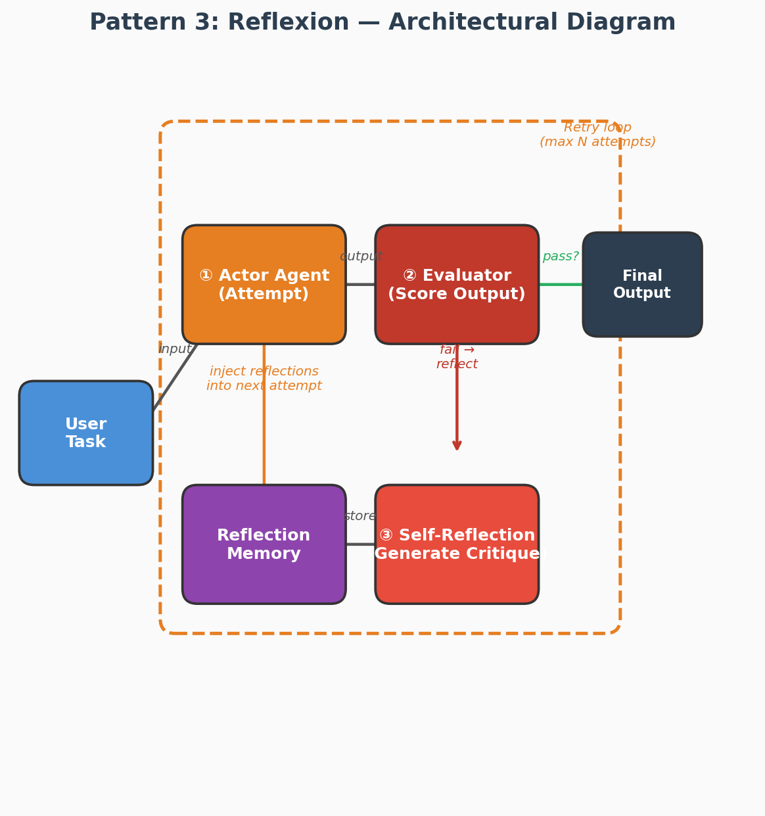
Figure 3: Reflexion pattern — The agent attempts a task, evaluates its output, generates a self-critique, stores it in memory, and retries with accumulated reflections.
Use Case — AI Code Debugging Assistant
Scenario: A developer pastes a buggy Python function and asks, "Fix this function that should return the top K frequent elements from a list, but it's failing on edge cases."
How Reflexion Handles It:
Attempt 1: The agent generates a fix using collections.Counter and heapq.nlargest.
Evaluation: Runs against 10 test cases — passes 8/10. Fails on empty list and single-element input.
Reflection: "My solution doesn't handle edge cases: empty input returns an error instead of [], and k > len(list) causes an index error. I need to add input validation at the start."
Attempt 2: The agent rewrites with edge-case guards (reflections injected into the prompt).
Evaluation: Runs against 10 test cases — passes 10/10.
Result: Returns the corrected code with explanations of what was wrong.
Why Reflexion? Code debugging benefits enormously from self-evaluation against concrete test cases. The verbal self-critique acts as a learning signal, enabling the agent to systematically fix issues rather than randomly regenerating code. This pattern is used by Cursor, Aider, and Claude Code for iterative code repair.

When to Use Reflexion
✅ Code generation where correctness can be verified by running tests
✅ Writing tasks requiring iterative quality refinement
✅ Tasks with clear success/failure criteria (unit tests, assertions, schemas)
❌ Avoid for tasks without a measurable quality signal

Complete Python Implementation
reflexion_agent.py — Try → Evaluate → Reflect → Retry Loop
import anthropic, subprocess, tempfile, os, json
from dataclasses import dataclass

@dataclass
class TrialRecord:
trial: int
output: str
evaluation: str # 'pass' or 'fail'
score: float # 0.0 - 1.0
reflection: str # verbal self-critique

class ReflexionAgent:
"""
Reflexion Pattern: attempt → evaluate → reflect → retry.
Use case: Python code generation with test verification.
"""
def __init__(self, model='claude-sonnet-4-20250514', max_trials=4):
self.client = anthropic.Anthropic()
self.model = model
self.max_trials = max_trials
self.memory: list[TrialRecord] = []

def _attempt(self, task: str, reflections: list[str]) -> str:
system = (
'You are an expert Python developer. Write clean, correct, runnable Python code.'
' Return ONLY the Python code, no markdown, no explanation.'
)
reflection_block = ''
if reflections:
refl_text = chr(10).join(f'Trial {i+1} reflection: {r}'
for i,r in enumerate(reflections))
reflection_block = (
f'\n\nYOUR PREVIOUS ATTEMPTS FAILED. Here are your self-reflections:\n{refl_text}'
'\n\nUse these reflections to write a BETTER solution this time.'
)
prompt = f'Task: {task}{reflection_block}'
resp = self.client.messages.create(
model=self.model,
messages=[{'role':'user','content':prompt}],
system=system,
max_tokens=2048
)
return resp.content[0].text.strip()

def _evaluate(self, code: str, task: str, test_cases: list[dict]) -> tuple[str,float]:
"""Run provided test cases against the generated code. Returns (status, score)."""
passed = 0
with tempfile.NamedTemporaryFile(suffix='.py', mode='w', delete=False) as f:
f.write(code + '\n')
for i, tc in enumerate(test_cases):
f.write(f"\n# Test {i}\ntry:\n")
f.write(f" result = {tc['call']}\n")
f.write(f" assert result == {repr(tc['expected'])}, f'Got {{result}}'\n")
f.write(f" print('PASS {i}')\n")
f.write(f"except Exception as e:\n print(f'FAIL {i}: {{e}}')\n")
fname = f.name
try:
result = subprocess.run(['python', fname], capture_output=True,
text=True, timeout=10)
output = result.stdout + result.stderr
except subprocess.TimeoutExpired:
output = 'TIMEOUT'
finally:
os.unlink(fname)
passed = output.count('PASS')
score = passed / max(len(test_cases), 1)
return ('pass' if score == 1.0 else 'fail', score)

def _reflect(self, task: str, code: str, test_output: str) -> str:
prompt = (
f'Task:\n{task}\n\n'
f'Your code:\n```python\n{code}\n```\n\n'
f'Test output:\n{test_output}\n\n'
'Write a concise self-reflection: What went wrong? What specific changes '
'will fix the failures? Be concrete and actionable (max 150 words).'
)
resp = self.client.messages.create(
model=self.model,
messages=[{'role':'user','content':prompt}],
max_tokens=300
)
return resp.content[0].text.strip()

def run(self, task: str, test_cases: list[dict]) -> str:
reflections = []
for trial in range(1, self.max_trials + 1):
print(f'\n[Reflexion] Trial {trial}/{self.max_trials}')
code = self._attempt(task, reflections)
status, score = self._evaluate(code, task, test_cases)
print(f' Score: {score*100:.0f}% Status: {status}')

if status == 'pass':
print(' ✅ All tests passed!')
return code

reflection = self._reflect(task, code, f'Score: {score}')
reflections.append(reflection)
print(f' Reflection: {reflection[:120]}...')
self.memory.append(TrialRecord(trial, code, status, score, reflection))

# Return best attempt
best = max(self.memory, key=lambda r: r.score)
print(f'\n[Reflexion] Returning best attempt (score={best.score*100:.0f}%)')
return best.output

# ── Use-Case: Code generation with test verification ──────────────────────
if __name__ == '__main__':
agent = ReflexionAgent(max_trials=4)

task = '''
Write a Python function `merge_sorted_lists(l1, l2)` that merges two sorted
lists into one sorted list WITHOUT using sort() or sorted().
'''

tests = [
{'call': 'merge_sorted_lists([1,3,5],[2,4,6])', 'expected': [1,2,3,4,5,6]},
{'call': 'merge_sorted_lists([],[1,2])', 'expected': [1,2]},
{'call': 'merge_sorted_lists([1],[1])', 'expected': [1,1]},
{'call': 'merge_sorted_lists([1,2,3],[])', 'expected': [1,2,3]},
]

final_code = agent.run(task, tests)
print('\n=== FINAL CODE ===\n', final_code)

Pattern 4: RAG Agent (Retrieval-Augmented Generation)

What Is It?
The agent uses a vector store as its primary knowledge tool. When a user asks a question, the agent first retrieves semantically relevant documents, then reasons over them to generate a grounded, citation-backed answer. More advanced variants use iterative retrieval — the agent retrieves, reasons, decides if more retrieval is needed, and loops.

Architectural Diagram — RAG Agent
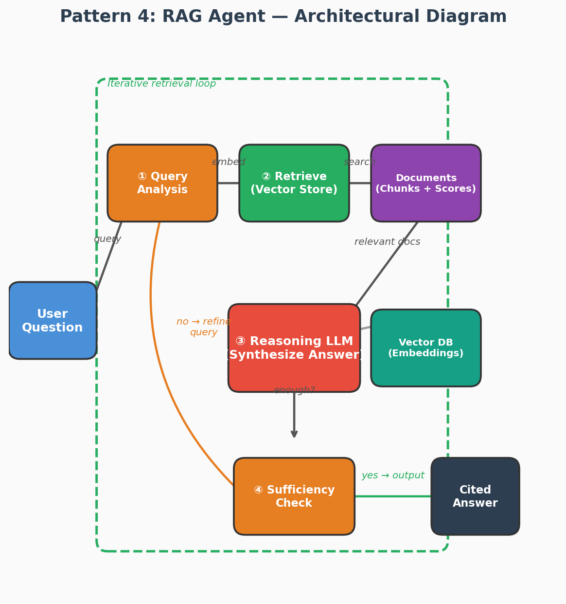
Figure 4: RAG Agent pattern — The agent queries a vector store, retrieves relevant documents, reasons over them, checks sufficiency, and iterates if needed before producing a cited answer.
Use Case — Enterprise HR Policy Assistant
Scenario: An employee asks, "If I'm relocating from the New York office to the London office, what visa sponsorship does the company provide, and how does it affect my stock vesting schedule?"
How the RAG Agent Handles It:
Step 1 — Query Analysis: The agent decomposes this into two sub-queries: (a) international relocation visa policy, (b) stock vesting during international transfer.
Step 2 — Retrieval (Round 1): Searches the HR knowledge base vector store.
• Retrieves: "International Relocation Policy v3.2" (Section 4: Visa Sponsorship) — relevance score 0.94
• Retrieves: "Equity Compensation Handbook" (Section 7: Cross-Border Transfers) — relevance score 0.89
Step 3 — Reasoning: Synthesizes answer for visa policy. But notes the equity doc doesn't cover UK-specific tax implications.
Step 4 — Sufficiency Check: "I have visa info but missing UK tax treatment for RSUs. Need another retrieval."
Step 5 — Retrieval (Round 2): Refines query to "UK RSU tax treatment international transfer."
• Retrieves: "Global Equity Tax Guide — United Kingdom" — relevance score 0.91
Step 6 — Final Answer: Provides a comprehensive, cited response covering visa sponsorship (citing Policy v3.2, §4.2), vesting continuation (citing Equity Handbook, §7.1), and UK tax implications (citing Tax Guide, §3).
Why RAG Agent? The iterative retrieval loop ensures completeness. Unlike single-pass RAG, the agent recognizes when its first retrieval is insufficient and autonomously refines its search — critical for complex, multi-faceted enterprise questions.

When to Use RAG Agent
✅ Enterprise knowledge base Q&A (internal docs, policies, manuals)
✅ Legal research, medical literature review, technical support
✅ Any scenario where the LLM needs external, up-to-date, or proprietary knowledge
❌ Avoid when knowledge fits in the context window directly

Complete Python Implementation
rag_agent.py — Iterative RAG with Vector Store + Citation Tracking
import anthropic, json
from dataclasses import dataclass
import numpy as np

@dataclass
class Document:
id: str
content: str
metadata: dict

class SimpleVectorStore:
"""
In-memory vector store (demo). In production use: pgvector, Qdrant, Pinecone.
We use a simple TF-IDF-like cosine sim for the example (no external deps).
"""
def __init__(self):
self.docs: list[Document] = []
self._matrix = None
self._vocab: dict = {}

def _vectorize(self, text: str) -> np.ndarray:
words = text.lower().split()
vec = np.zeros(len(self._vocab))
for w in words:
if w in self._vocab:
vec[self._vocab[w]] += 1
norm = np.linalg.norm(vec)
return vec / norm if norm > 0 else vec

def build_index(self, docs: list[Document]):
self.docs = docs
all_words = set()
for d in docs:
all_words.update(d.content.lower().split())
self._vocab = {w:i for i,w in enumerate(sorted(all_words))}
self._matrix = np.stack([self._vectorize(d.content) for d in docs])

def search(self, query: str, top_k: int = 3) -> list[tuple[Document, float]]:
q_vec = self._vectorize(query)
scores = self._matrix @ q_vec
top_idx = np.argsort(scores)[::-1][:top_k]
return [(self.docs[i], float(scores[i])) for i in top_idx if scores[i] > 0]

class RAGAgent:
"""
RAG Agent with iterative retrieval.
Retrieves → reasons → decides if more retrieval needed → answers with citations.
"""
def __init__(self, vector_store: SimpleVectorStore, model='claude-sonnet-4-20250514',
max_retrieval_rounds=3):
self.client = anthropic.Anthropic()
self.model = model
self.vs = vector_store
self.max_rounds = max_retrieval_rounds

def run(self, question: str) -> dict:
retrieved: list[Document] = []
queries_used: list[str] = [question]

for round_num in range(self.max_rounds):
# ── Retrieve ──────────────────────────────────────────────
results = self.vs.search(queries_used[-1], top_k=3)
for doc, score in results:
if doc.id not in {d.id for d in retrieved}:
retrieved.append(doc)
print(f'[RAG] Round {round_num+1}: retrieved {len(results)} docs')

# ── Reason & decide ───────────────────────────────────────
context = '\n\n'.join(
f'[{i+1}] (id:{d.id}) {d.content}'
for i, d in enumerate(retrieved)
)
decision_prompt = (
f'Question: {question}\n\nContext documents:\n{context}\n\n'
'Can you answer the question fully based on this context?\n'
'If yes, reply with: ANSWER: <your answer with [n] citations>\n'
'If you need more info, reply with: SEARCH: <refined search query>'
)
resp = self.client.messages.create(
model=self.model,
messages=[{'role':'user','content':decision_prompt}],
max_tokens=1024
)
reply = resp.content[0].text.strip()

if reply.startswith('ANSWER:'):
answer = reply[7:].strip()
citations = [d.id for d in retrieved]
return {'answer': answer, 'citations': citations,
'rounds': round_num+1, 'docs_used': len(retrieved)}
elif reply.startswith('SEARCH:'):
new_query = reply[7:].strip()
queries_used.append(new_query)
print(f' Refined query: {new_query}')
else:
break # unexpected response, return what we have

# Fallback: generate answer with all retrieved context
context = '\n\n'.join(f'[{i+1}] {d.content}' for i,d in enumerate(retrieved))
final_resp = self.client.messages.create(
model=self.model,
messages=[{'role':'user','content':f'Q: {question}\nContext:\n{context}\nAnswer:'}],
max_tokens=1024
)
return {'answer': final_resp.content[0].text, 'citations': [d.id for d in retrieved],
'rounds': self.max_rounds, 'docs_used': len(retrieved)}

# ── Use-Case: Internal HR policy Q&A ─────────────────────────────────────
if __name__ == '__main__':
docs = [
Document('hr-001', 'Employees are entitled to 21 days paid annual leave per year. Leave must be applied 2 weeks in advance.', {'source':'HR Policy v3.2'}),
Document('hr-002', 'Remote work is allowed up to 3 days per week. Core hours are 10am-4pm local time.', {'source':'WFH Policy 2024'}),
Document('hr-003', 'Performance reviews are conducted twice yearly: June and December. Ratings: Exceeds, Meets, Below expectations.', {'source':'Performance Guide'}),
Document('hr-004', 'Medical insurance covers employee and spouse. Dental and vision are optional add-ons at employee expense.', {'source':'Benefits Handbook'}),
Document('hr-005', 'The notice period for resignation is 30 days for staff, 60 days for managers and above.', {'source':'Employment Contract v2'}),
]
store = SimpleVectorStore()
store.build_index(docs)

agent = RAGAgent(store)
result = agent.run('How many leave days do I get and what is the remote work policy?')
print(f'\nAnswer: {result["answer"]}')
print(f'Citations: {result["citations"]}')
print(f'Retrieval rounds: {result["rounds"]}')

Pattern 5: LATS (Language Agent Tree Search)

What Is It?
LATS combines LLM generation with Monte Carlo Tree Search (MCTS). At each decision point, the agent generates N candidate actions, evaluates their expected value with a value function (also LLM-powered), expands the best candidate, and backtracks when needed. This produces significantly higher quality results for complex optimization problems at the cost of more LLM calls.

Architectural Diagram — LATS
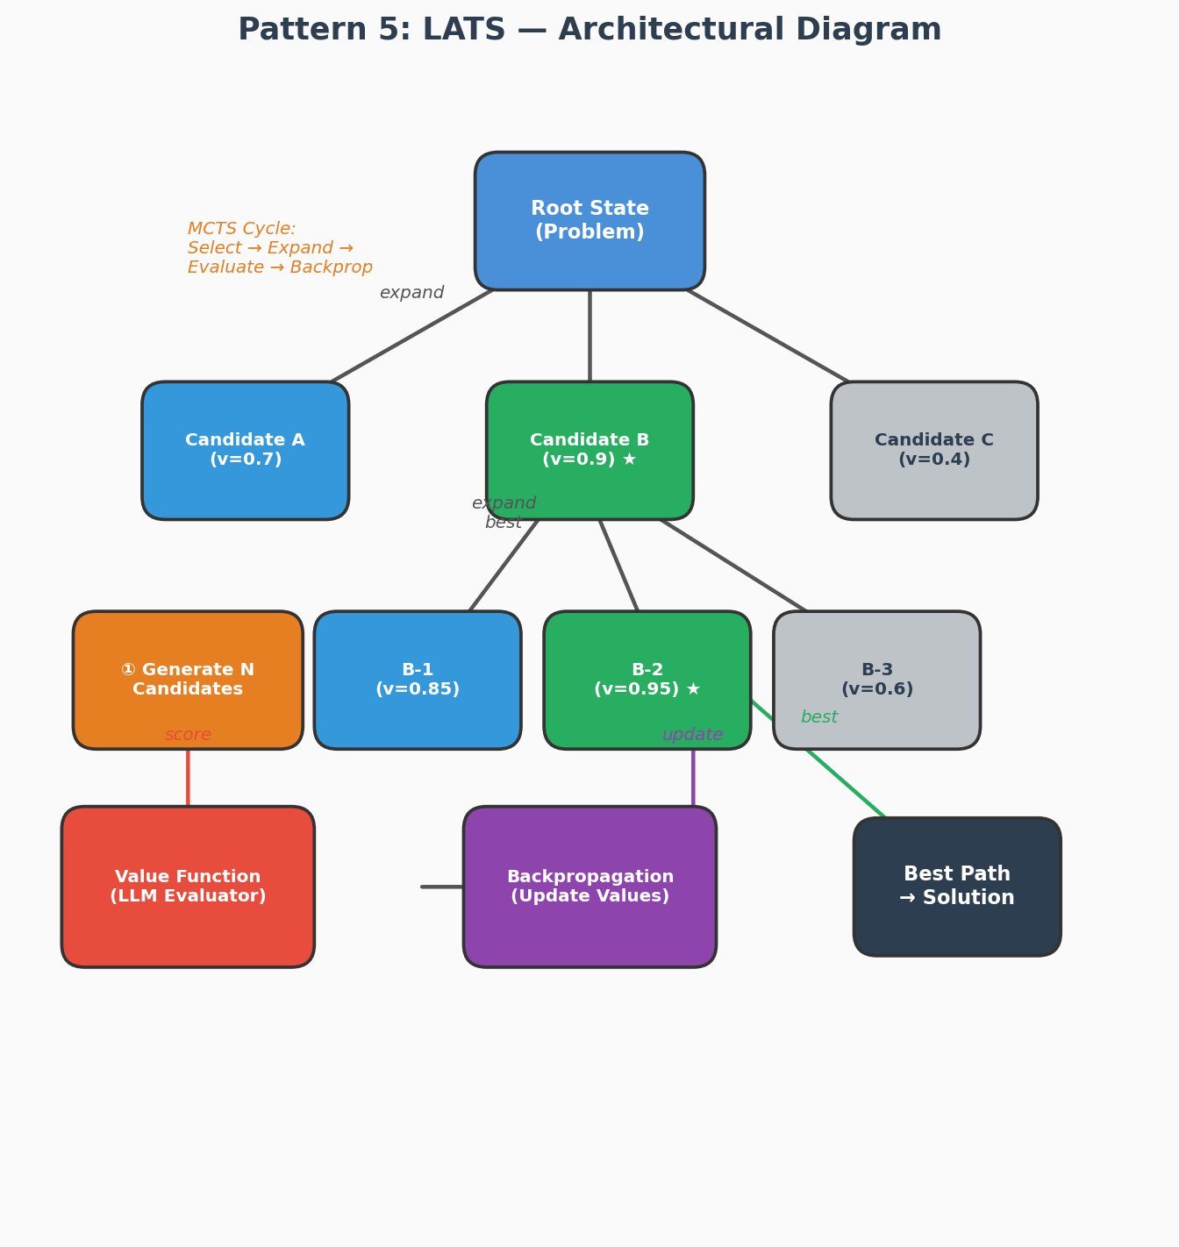
Figure 5: LATS pattern — Monte Carlo Tree Search guides the agent through candidate generation, value evaluation, expansion of the best path, and backpropagation of scores.
Use Case — Strategic Business Decision Planning
Scenario: A startup CEO asks, "We have $2M in runway. Should we (A) expand to the EU market, (B) build an enterprise sales team, or (C) invest in product R&D for our AI features?"
How LATS Handles It:
Root State: Current company position — $2M runway, 500 users, strong product-market fit in US SMB.
Expansion (Level 1): LLM generates 3 candidate strategies:
• Candidate A (EU Expansion): v = 0.6 — High market potential but regulatory complexity (GDPR, localization costs).
• Candidate B (Enterprise Sales): v = 0.8 — Proven demand from inbound leads, faster revenue, but long sales cycles.
• Candidate C (R&D Investment): v = 0.5 — Strengthens product moat, but delays revenue growth.
Select Best → Expand (Level 2): Agent expands Candidate B (highest value):
• B-1 (Hire 3 AEs + SDR team): v = 0.75 — Fast ramp but high burn rate.
• B-2 (Hire 1 AE + partner channel): v = 0.90 — Lower cost, leverages existing partnerships.
• B-3 (Outbound-only, no new hires): v = 0.55 — Low cost but slow.
Backpropagation: B-2's high value (0.90) propagates up, confirming Candidate B as optimal path.
Final Recommendation: "Pursue enterprise sales through a hybrid model — hire 1 senior AE and activate 3 partner channels. Expected ROI: 4x within 12 months, preserving 60% of runway as buffer."
Why LATS? Strategic decisions have branching consequences. LATS systematically explores the decision tree, evaluates each branch with an LLM-powered value function, and backtracks from dead ends — producing significantly higher-quality strategic recommendations than single-pass reasoning.

When to Use LATS
✅ Complex reasoning tasks: theorem proving, strategic planning, puzzle solving
✅ Code debugging where multiple fix approaches need exploration
✅ Decision trees with high branching factor and need for backtracking
❌ Avoid for time-sensitive tasks (slow due to multiple LLM calls per step)

Complete Python Implementation
lats_agent.py — LLM + Monte Carlo Tree Search
import anthropic, math, json
from dataclasses import dataclass, field
from typing import Optional

@dataclass
class Node:
state: str # current task state / partial solution
action: str = '' # action that led to this state
parent: Optional['Node'] = None
children: list['Node'] = field(default_factory=list)
visits: int = 0
value: float = 0.0 # cumulative value
is_terminal: bool = False
solution: str = ''

@property
def uct_score(self) -> float:
"""Upper Confidence Bound for Trees."""
if self.visits == 0:
return float('inf')
exploit = self.value / self.visits
explore = 1.41 * math.sqrt(math.log(self.parent.visits) / self.visits)
return exploit + explore

class LATSAgent:
"""
Language Agent Tree Search (LATS).
Generates candidate actions, evaluates them, selects best branch, backtracks.
Use case: Complex multi-step reasoning / code debugging.
"""
def __init__(self, model='claude-sonnet-4-20250514',
n_candidates=3, max_iterations=12, depth_limit=5):
self.client = anthropic.Anthropic()
self.model = model
self.n_candidates = n_candidates
self.max_iterations = max_iterations
self.depth_limit = depth_limit

def _generate_candidates(self, goal: str, state: str, depth: int) -> list[str]:
"""Generate N candidate next actions."""
prompt = (
f'Goal: {goal}\nCurrent state:\n{state}\n\n'
f'Generate exactly {self.n_candidates} DIFFERENT candidate next steps.'
f' Return as JSON: {{"candidates": ["step1", "step2", "step3"]}}'
f' Depth: {depth}/{self.depth_limit}. If close to done, use fewer, terminal steps.'
)
resp = self.client.messages.create(
model=self.model,
messages=[{'role':'user','content':prompt}],
max_tokens=512
)
raw = resp.content[0].text.strip()
if raw.startswith('```'): raw = raw.split('```')[1].lstrip('json')
try:
return json.loads(raw)['candidates']
except:
return [raw]

def _evaluate(self, goal: str, state: str) -> tuple[float, bool, str]:
"""Score the current state. Returns (score 0-1, is_terminal, solution)."""
prompt = (
f'Goal: {goal}\nCurrent state:\n{state}\n\n'
'Evaluate this state. Return JSON: '
'{"score": 0.0-1.0, "is_complete": bool, "solution": "<if complete>", "reasoning": "..."}'
' Score 1.0 = goal fully achieved. 0.0 = completely off track.'
)
resp = self.client.messages.create(
model=self.model,
messages=[{'role':'user','content':prompt}],
max_tokens=400
)
raw = resp.content[0].text.strip()
if raw.startswith('```'): raw = raw.split('```')[1].lstrip('json')
try:
data = json.loads(raw)
return data['score'], data['is_complete'], data.get('solution','')
except:
return 0.5, False, ''

def _apply_action(self, state: str, action: str, goal: str) -> str:
"""Apply action to state, producing new state."""
prompt = (
f'Goal: {goal}\nCurrent state:\n{state}\n\n'
f'Apply this action: {action}\n\n'
'What is the resulting new state? Describe it concisely.'
)
resp = self.client.messages.create(
model=self.model,
messages=[{'role':'user','content':prompt}],
max_tokens=512
)
return resp.content[0].text.strip()

def _select(self, node: Node) -> Node:
"""UCT selection: traverse tree selecting highest UCT score."""
while node.children:
node = max(node.children, key=lambda n: n.uct_score)
return node

def _backpropagate(self, node: Node, value: float):
while node:
node.visits += 1
node.value += value
node = node.parent

def run(self, goal: str) -> str:
root = Node(state=f'Starting task: {goal}')
root.visits = 1
best_solution = ''
best_score = 0.0

for iteration in range(self.max_iterations):
# ── 1. Select ──────────────────────────────────────────
leaf = self._select(root)

# ── 2. Expand ──────────────────────────────────────────
depth = 0
node = leaf
while node.parent:
depth += 1; node = node.parent

if depth < self.depth_limit and not leaf.is_terminal:
candidates = self._generate_candidates(goal, leaf.state, depth)
for action in candidates:
new_state = self._apply_action(leaf.state, action, goal)
score, is_term, solution = self._evaluate(goal, new_state)
child = Node(state=new_state, action=action,
parent=leaf, is_terminal=is_term,
solution=solution)
leaf.children.append(child)
if score > best_score:
best_score = score
best_solution = solution or new_state
if is_term and score >= 0.9:
print(f'[LATS] ✅ Solution found at iteration {iteration+1}!')
return solution
# ── 3. Simulate & Backpropagate ────────────────
self._backpropagate(child, score)

print(f'[LATS] Iter {iteration+1}: best score={best_score:.2f}')

return best_solution or f'Best partial solution (score={best_score:.2f}): found in search tree.'

if __name__ == '__main__':
agent = LATSAgent(n_candidates=3, max_iterations=8)
result = agent.run(
'Debug and fix this buggy Python function: '
'def fibonacci(n): return fibonacci(n-1) + fibonacci(n-2) '
'# Missing base case, causes infinite recursion'
)
print('\n=== LATS SOLUTION ===\n', result)

PART B — MULTI-AGENT PATTERNS

Pattern 6: Orchestrator-Worker (Hierarchical MAS)

What Is It?
An Orchestrator agent receives the top-level goal, decomposes it, and dispatches sub-tasks to specialized Worker agents — potentially in parallel. Workers return results to the Orchestrator, which synthesizes them. This is the most widely used production MAS pattern.

Architectural Diagram — Orchestrator-Worker
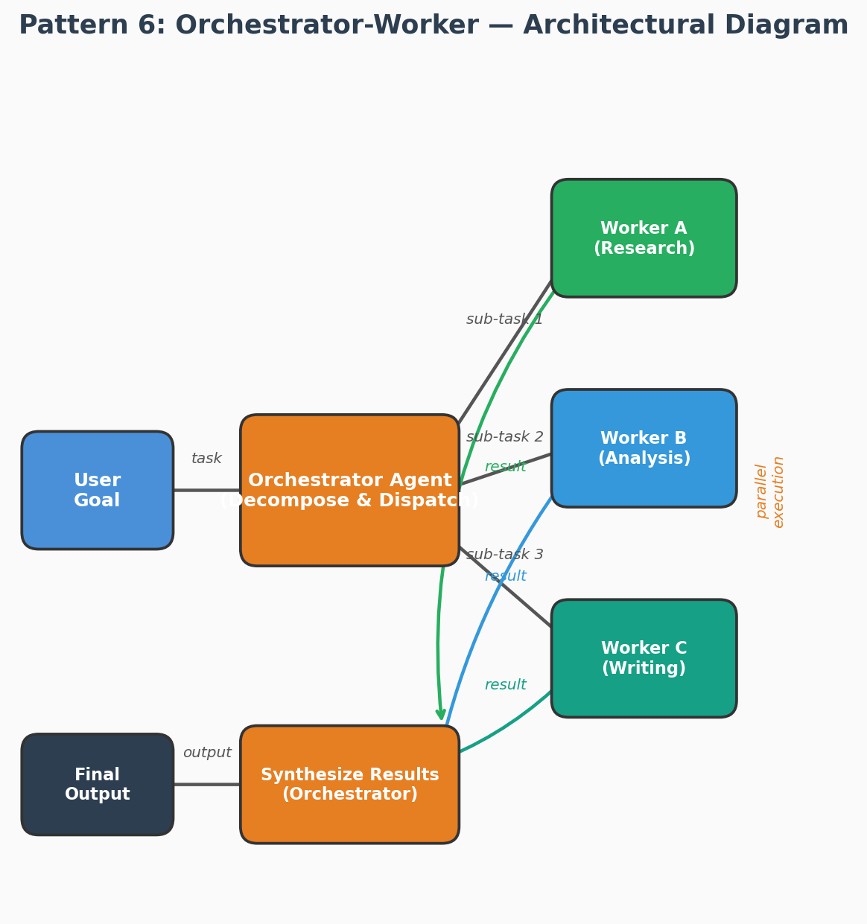
Figure 6: Orchestrator-Worker pattern — The Orchestrator decomposes a goal into sub-tasks, dispatches them to specialized Workers (potentially in parallel), and synthesizes the results.
Use Case — Automated Due Diligence Report
Scenario: A venture capital firm asks, "Perform due diligence on startup 'DataMesh AI' for our Series A investment decision."
How Orchestrator-Worker Handles It:
Orchestrator receives the goal and decomposes it into 4 parallel sub-tasks:
Worker A (Financial Analyst): Analyzes DataMesh AI's financials — revenue growth (340% YoY), burn rate ($180K/month), unit economics (LTV:CAC = 4.2:1), and runway projection (14 months).
Worker B (Market Researcher): Researches the data mesh market — $4.2B TAM by 2027, 3 direct competitors, DataMesh AI's differentiation (real-time streaming support).
Worker C (Technical Reviewer): Evaluates the tech stack — modern architecture (Rust + Python), 98.9% uptime SLA, SOC 2 Type II certified, strong IP portfolio (2 patents pending).
Worker D (Legal Analyst): Reviews corporate structure, cap table (clean), outstanding litigation (none), and key contract risks (1 customer = 35% revenue — concentration risk).
All 4 workers execute in parallel and return results to the Orchestrator.
Orchestrator Synthesis: Combines all findings into a structured due diligence report with a final recommendation: "Recommend investment at $12M pre-money valuation. Key risk: customer concentration. Mitigation: require diversification milestone in term sheet."
Why Orchestrator-Worker? Due diligence requires multiple specialized analyses running in parallel. The Orchestrator ensures nothing is missed while Workers focus on their domain expertise. This is the most widely used production MAS pattern.

Complete Python Implementation
orchestrator_worker.py — Dynamic Agent Swarm with Parallel Execution
import anthropic, asyncio, json
from dataclasses import dataclass, field
from concurrent.futures import ThreadPoolExecutor, as_completed
from typing import Optional

@dataclass
class AgentTask:
id: str
description: str
agent_type: str # 'researcher', 'coder', 'writer', 'analyst'
dependencies: list[str] = field(default_factory=list)
result: Optional[str] = None

class WorkerAgent:
"""Specialized worker with a focused system prompt and tool set."""
PERSONAS = {
'researcher': ('You are a research specialist. Use search tools to find accurate, ',
'current information. Cite your sources.'),
'coder': ('You are a senior Python developer. Write clean, tested, production-',
'ready code with docstrings and error handling.'),
'writer': ('You are a professional technical writer. Create clear, structured, ',
'engaging content optimized for the target audience.'),
'analyst': ('You are a data analyst. Extract insights, identify patterns, ',
'and present findings with supporting evidence.'),
'reviewer': ('You are a quality reviewer. Check for accuracy, completeness, ',
'consistency, and flag any issues you find.'),
}

def __init__(self, agent_type: str, model='claude-haiku-4-5-20251001'):
self.client = anthropic.Anthropic()
self.agent_type = agent_type
self.model = model
self.system = ' '.join(self.PERSONAS.get(agent_type, ('You are a helpful AI agent.',)))

def run(self, task: str, context: str = '') -> str:
prompt = task
if context:
prompt = f'Context from other agents:\n{context}\n\nYour task: {task}'
resp = self.client.messages.create(
model=self.model, system=self.system,
messages=[{'role':'user','content':prompt}],
max_tokens=2048
)
return resp.content[0].text

class OrchestratorAgent:
"""
Orchestrator-Worker Pattern.
Decomposes goal → dispatches parallel tasks → collects results → synthesizes.
"""
def __init__(self, model='claude-sonnet-4-20250514', max_workers=4):
self.client = anthropic.Anthropic()
self.model = model
self.workers = {t: WorkerAgent(t) for t in WorkerAgent.PERSONAS}
self.executor = ThreadPoolExecutor(max_workers=max_workers)

def _decompose(self, goal: str) -> list[AgentTask]:
prompt = (
f'Decompose this goal into parallel sub-tasks for a multi-agent team.\n'
f'Goal: {goal}\n\n'
f'Available agent types: researcher, coder, writer, analyst, reviewer\n\n'
'Return ONLY JSON: {"tasks": [{"id":"t1","description":"...",',
'"agent_type":"researcher","dependencies":[]}]}'
)
resp = self.client.messages.create(
model=self.model,
messages=[{'role':'user','content':prompt}],
max_tokens=1024
)
raw = resp.content[0].text.strip()
if raw.startswith('```'): raw = raw.split('```')[1].lstrip('json')
data = json.loads(raw)
return [AgentTask(**t) for t in data['tasks']]

def _can_run(self, task: AgentTask, completed: set[str]) -> bool:
return all(dep in completed for dep in task.dependencies)

def run(self, goal: str) -> str:
print(f'[Orchestrator] Decomposing: {goal}')
tasks = self._decompose(goal)
print(f'[Orchestrator] Created {len(tasks)} tasks:')
for t in tasks: print(f' [{t.agent_type}] {t.id}: {t.description[:80]}')

completed: dict[str, str] = {} # id → result
remaining = tasks.copy()

while remaining:
# Find all tasks whose deps are satisfied
runnable = [t for t in remaining if self._can_run(t, set(completed.keys()))]
if not runnable:
print('[Orchestrator] ⚠️ Dependency deadlock — running all remaining tasks')
runnable = remaining

print(f'\n[Orchestrator] Running {len(runnable)} tasks in parallel...')
futures = {}
for task in runnable:
context = '\n'.join(
f'{dep}: {completed[dep][:500]}' for dep in task.dependencies if dep in completed
)
worker = self.workers.get(task.agent_type, self.workers['researcher'])
future = self.executor.submit(worker.run, task.description, context)
futures[future] = task

for future in as_completed(futures):
task = futures[future]
try:
result = future.result(timeout=60)
task.result = result
completed[task.id] = result
print(f' ✅ {task.id} ({task.agent_type}) done: {result[:100]}...')
except Exception as e:
completed[task.id] = f'FAILED: {e}'
print(f' ❌ {task.id} failed: {e}')
finally:
remaining.remove(task)

# ── Synthesize ────────────────────────────────────────────
results_block = '\n\n'.join(f'=== {t.id} ({t.agent_type}) ===\n{t.result}'
for t in tasks if t.result)
synthesis_prompt = (
f'Original goal: {goal}\n\n'
f'Agent results:\n{results_block}\n\n'
'Synthesize all results into a single, comprehensive, well-structured response.'
)
final = self.client.messages.create(
model=self.model,
messages=[{'role':'user','content':synthesis_prompt}],
max_tokens=3000
)
return final.content[0].text

if __name__ == '__main__':
orch = OrchestratorAgent()
result = orch.run(
'Build a comprehensive competitive analysis of AI coding assistants: '
'GitHub Copilot, Cursor, and Claude Code. Include features, pricing, '
'strengths/weaknesses, and code examples of each in action.'
)
print('\n=== FINAL OUTPUT ===\n', result)

Pattern 7: Agent Pipeline (Sequential Chain)

What Is It?
Agents are arranged in a linear sequence. Each agent takes the output of the previous agent as its input, applies its specialized transformation, and passes the result forward. This maps directly to data engineering pipelines and is ideal for document processing, content generation, and ETL workflows.

Architectural Diagram — Agent Pipeline
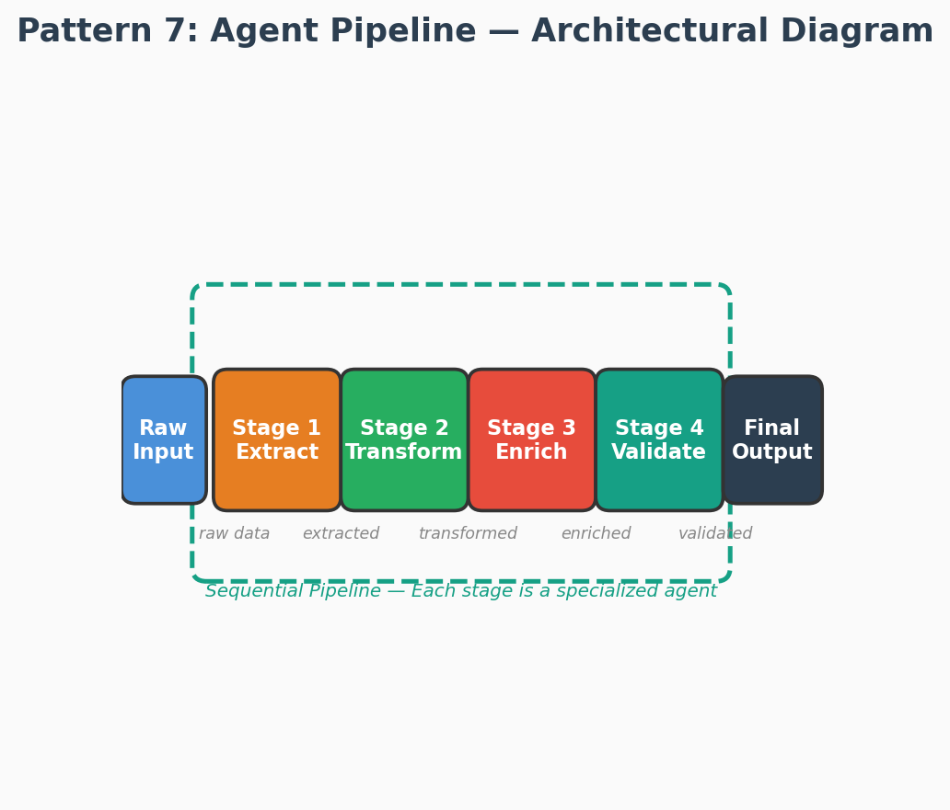
Figure 7: Agent Pipeline pattern — Agents are arranged in a linear sequence, each transforming the output of the previous stage and passing it forward.
Use Case — Automated Content Publishing Pipeline
Scenario: A media company needs to process raw news articles from wire services into polished, SEO-optimized web articles with translations.
How the Agent Pipeline Handles It:
Stage 1 — Extract Agent:
Input: Raw wire service article (AP/Reuters format).
Output: Structured data — headline, byline, body text, entities (people, places, orgs), dateline.
Stage 2 — Transform Agent:
Input: Structured article data.
Output: Rewritten article in the publication's house style — shorter paragraphs, active voice, pull quotes identified, reading level adjusted to Grade 8.
Stage 3 — Enrich Agent:
Input: Rewritten article.
Output: SEO-optimized version — meta description, keyword tags, internal links to related articles, Open Graph tags, suggested hero image from stock library.
Stage 4 — Validate Agent:
Input: Enriched article.
Output: Fact-checked article — entity names verified against knowledge base, statistics cross-referenced, plagiarism score computed (must be < 5%), editorial guidelines compliance check.
Final Output: Publication-ready article pushed to CMS with all metadata.
Why Agent Pipeline? Content processing is naturally sequential — each stage builds on the previous one. The pipeline is predictable, easy to debug (inspect output at any stage), and each agent can be independently tested and improved. This maps directly to ETL workflows in data engineering.

Complete Python Implementation
pipeline_agent.py — Configurable Multi-Stage Agent Pipeline
import anthropic
from dataclasses import dataclass
from typing import Callable, Any
import time

@dataclass
class PipelineStage:
name: str
system_prompt: str
user_template: str # use {input} placeholder
model: str = 'claude-haiku-4-5-20251001'
post_process: Callable = None # optional transform fn

@dataclass
class StageResult:
stage: str
input_tokens: int
output_tokens: int
latency_ms: float
output: Any

class AgentPipeline:
"""
Pipeline Pattern: sequential agent stages with monitoring.
Each stage transforms the previous output.
Includes: retry logic, result logging, latency tracking.
"""
def __init__(self, stages: list[PipelineStage]):
self.client = anthropic.Anthropic()
self.stages = stages
self.results: list[StageResult] = []

def _run_stage(self, stage: PipelineStage, input_data: str,
retries: int = 2) -> str:
for attempt in range(retries + 1):
try:
t0 = time.time()
prompt = stage.user_template.replace('{input}', input_data)
resp = self.client.messages.create(
model=stage.model, system=stage.system_prompt,
messages=[{'role':'user','content':prompt}],
max_tokens=2048
)
output = resp.content[0].text
latency = (time.time() - t0) * 1000
if stage.post_process:
output = stage.post_process(output)
self.results.append(StageResult(
stage=stage.name,
input_tokens=resp.usage.input_tokens,
output_tokens=resp.usage.output_tokens,
latency_ms=latency,
output=output
))
return output
except Exception as e:
if attempt == retries: raise
print(f' [Pipeline] Stage {stage.name} failed (attempt {attempt+1}): {e}')
time.sleep(2 ** attempt)

def run(self, initial_input: str) -> str:
current = initial_input
for stage in self.stages:
print(f'[Pipeline] Stage: {stage.name}')
current = self._run_stage(stage, current)
print(f' Output preview: {str(current)[:120]}...')
return current

def report(self) -> str:
total_tokens = sum(r.input_tokens + r.output_tokens for r in self.results)
total_latency = sum(r.latency_ms for r in self.results)
lines = ['=== Pipeline Execution Report ===']
for r in self.results:
lines.append(f'Stage: {r.stage:<20} Tokens: {r.input_tokens+r.output_tokens:<8} Latency: {r.latency_ms:.0f}ms')
lines.append(f'TOTAL: tokens={total_tokens}, latency={total_latency:.0f}ms')
return '\n'.join(lines)

# ── Use-Case: Customer Review Analysis Pipeline ───────────────────────────
stages = [
PipelineStage(
name='Extract',
system_prompt='You are a data extraction specialist. Extract structured data from raw text.',
user_template='Extract all customer reviews from this raw text. Return a clean numbered list:\n{input}',
),
PipelineStage(
name='Classify',
system_prompt='You are a sentiment analyst. Classify each review as POSITIVE/NEGATIVE/NEUTRAL and identify the main topic.',
user_template='Classify each review below. Format: [ID] SENTIMENT | TOPIC | Key phrase\n{input}',
),
PipelineStage(
name='Summarize',
system_prompt='You are an insights specialist. Synthesize classified data into actionable business insights.',
user_template='Based on these classified reviews, provide:\n1. Overall sentiment breakdown\n2. Top 3 praised aspects\n3. Top 3 pain points\n4. Recommended actions\n\nData:\n{input}',
),
PipelineStage(
name='Report',
system_prompt='You are a business report writer. Write executive-level reports.',
user_template='Format these insights as a professional 1-page executive summary with: Header, Key Metrics, Findings, Recommendations.\n\nInsights:\n{input}',
),
]

if __name__ == '__main__':
raw_reviews = '''
John: Product quality is excellent but shipping took 3 weeks. Very disappointed with delivery.
Sarah: Amazing product! Fast delivery, exactly as described. Will buy again!
Mike: App crashes constantly. Support team was helpful though.
Priya: Value for money is great. Interface could be more intuitive.
'''
pipeline = AgentPipeline(stages)
final_report = pipeline.run(raw_reviews)
print(final_report)
print('\n' + pipeline.report())

Pattern 8: Actor-Critic (Generator + Evaluator)

What Is It?
An Actor agent generates outputs. A Critic agent evaluates them against a rubric and provides specific, actionable feedback. The Actor revises based on the critique. This loop continues until the quality threshold is met or max iterations are reached — producing significantly higher quality outputs than a single-pass generation.

Architectural Diagram — Actor-Critic
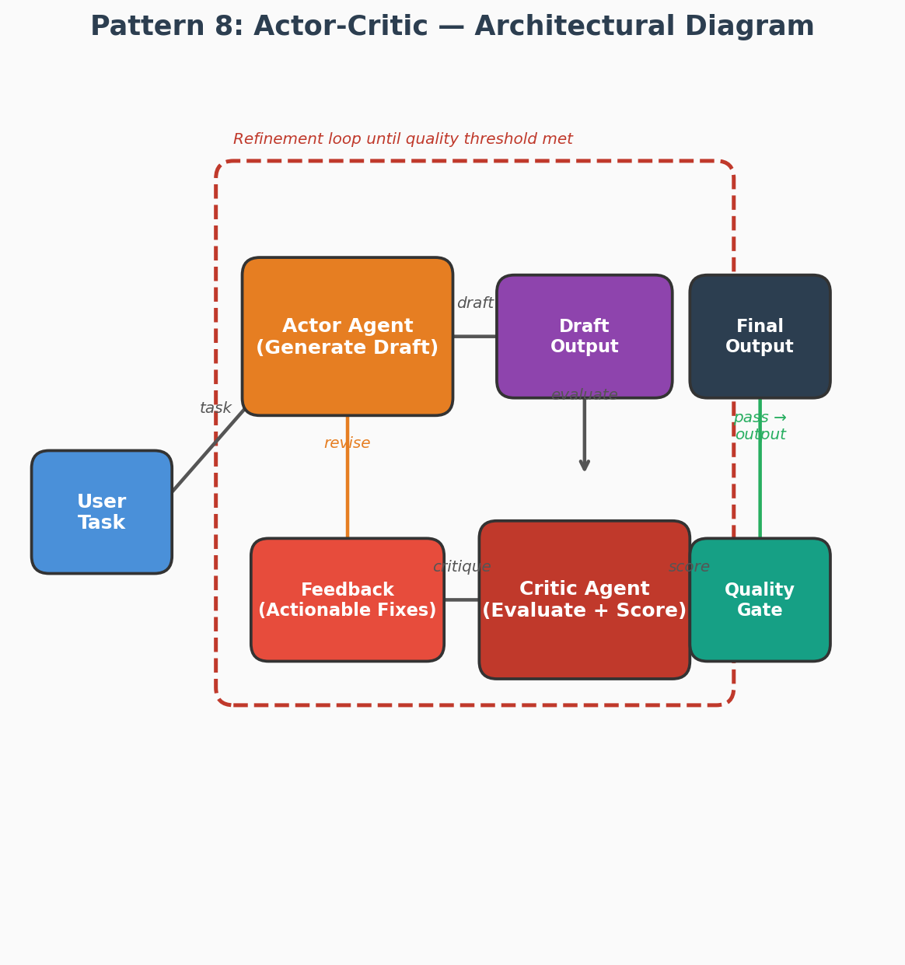
Figure 8: Actor-Critic pattern — The Actor generates drafts, the Critic evaluates and provides actionable feedback, and the loop continues until a quality threshold is met.
Use Case — Legal Contract Drafting
Scenario: A corporate lawyer asks, "Draft a SaaS Master Service Agreement (MSA) for our enterprise client, including data processing addendum, SLA terms, and liability caps."
How Actor-Critic Handles It:
Iteration 1:
Actor generates a 12-page MSA draft covering all requested sections.
Critic evaluates against a rubric:
• Completeness: 7/10 — Missing force majeure clause and data breach notification timeline.
• Legal accuracy: 8/10 — Liability cap language is ambiguous; could be interpreted as unlimited for IP indemnification.
• Compliance: 6/10 — GDPR Article 28 processor obligations not fully addressed in DPA.
• Readability: 9/10 — Clear structure and plain language.
Overall score: 7.5/10 (threshold: 8.5)
Feedback: "Add force majeure clause (Section 11). Clarify liability cap to explicitly exclude IP indemnification. Expand DPA Section 3 to include Article 28(3)(a-h) processor obligations."
Iteration 2:
Actor revises the draft incorporating all feedback.
Critic re-evaluates:
• Completeness: 9/10 — All sections present.
• Legal accuracy: 9/10 — Liability language now precise.
• Compliance: 9/10 — GDPR obligations fully addressed.
• Readability: 9/10 — Maintained clarity.
Overall score: 9.0/10 — Passes threshold.
Final Output: Polished MSA ready for attorney review.
Why Actor-Critic? Legal documents require iterative refinement against multiple quality dimensions. The Critic provides structured, rubric-based feedback that the Actor can act on precisely — producing significantly higher quality output than single-pass generation. This pattern is used in Harvey AI and Ironclad for legal document generation.

Complete Python Implementation
actor_critic_agent.py — Generator + Evaluator Refinement Loop
import anthropic, json
from dataclasses import dataclass

@dataclass
class EvaluationResult:
overall_score: float # 0-10
scores: dict # {dimension: score}
strengths: list[str]
weaknesses: list[str]
specific_suggestions: list[str]
approved: bool

class ActorCriticAgent:
"""
Actor-Critic Pattern.
Actor generates → Critic evaluates with rubric → Actor revises → repeat.
Configured with custom rubric dimensions for any domain.
"""
def __init__(self, rubric: dict, actor_model='claude-sonnet-4-20250514',
critic_model='claude-sonnet-4-20250514',
threshold=7.5, max_rounds=4):
"""
rubric: dict of {dimension_name: description}
e.g. {'accuracy': 'Is the content factually correct?',
'clarity': 'Is the writing clear and well-structured?'}
"""
self.client = anthropic.Anthropic()
self.rubric = rubric
self.actor_model = actor_model
self.critic_model = critic_model
self.threshold = threshold
self.max_rounds = max_rounds

def _generate(self, task: str, previous: str = '', feedback: str = '') -> str:
system = 'You are an expert content creator. Produce high-quality, precise outputs.'
if feedback:
prompt = (
f'Task: {task}\n\n'
f'Your previous attempt:\n{previous}\n\n'
f'Critic feedback:\n{feedback}\n\n'
'Revise your output addressing ALL the specific suggestions above. '
'Show clear improvement over the previous version.'
)
else:
prompt = f'Task: {task}'
resp = self.client.messages.create(
model=self.actor_model, system=system,
messages=[{'role':'user','content':prompt}],
max_tokens=2048
)
return resp.content[0].text

def _critique(self, task: str, content: str) -> EvaluationResult:
rubric_str = '\n'.join(f'- {k}: {v}' for k,v in self.rubric.items())
prompt = (
f'Task: {task}\n\nContent to evaluate:\n{content}\n\n'
f'Evaluation rubric:\n{rubric_str}\n\n'
f'Score each dimension 0-10. Threshold for approval: {self.threshold}/10.\n'
'Return ONLY JSON: {"scores":{"dim":score}, "overall_score":float, '
'"strengths":[str], "weaknesses":[str], "specific_suggestions":[str], '
'"approved": bool}'
)
resp = self.client.messages.create(
model=self.critic_model,
messages=[{'role':'user','content':prompt}],
max_tokens=1024
)
raw = resp.content[0].text.strip()
if raw.startswith('```'): raw = raw.split('```')[1].lstrip('json')
data = json.loads(raw)
return EvaluationResult(
overall_score=data['overall_score'],
scores=data['scores'],
strengths=data.get('strengths',[]),
weaknesses=data.get('weaknesses',[]),
specific_suggestions=data.get('specific_suggestions',[]),
approved=data['approved']
)

def run(self, task: str) -> tuple[str, list[EvaluationResult]]:
content = ''
evaluations = []
feedback_text = ''

for round_num in range(self.max_rounds):
print(f'\n[Actor-Critic] Round {round_num+1}')
# ── Actor generates ───────────────────────────────────
content = self._generate(task, content, feedback_text)
print(f' [Actor] Generated: {content[:150]}...')

# ── Critic evaluates ──────────────────────────────────
eval_result = self._critique(task, content)
evaluations.append(eval_result)
print(f' [Critic] Score: {eval_result.overall_score:.1f}/10 | Approved: {eval_result.approved}')
print(f' Strengths: {eval_result.strengths[:2]}')
print(f' Suggestions: {eval_result.specific_suggestions[:2]}')

if eval_result.approved:
print(' ✅ Quality threshold met!')
return content, evaluations

# Prepare feedback for next round
feedback_text = (
f'Score: {eval_result.overall_score:.1f}/10\n'
f'Weaknesses: {chr(10).join(eval_result.weaknesses)}\n'
f'Must fix: {chr(10).join(eval_result.specific_suggestions)}'
)

print(f'[Actor-Critic] Max rounds reached. Best score: {max(e.overall_score for e in evaluations):.1f}')
return content, evaluations

# ── Use-Case: Technical blog post generation ──────────────────────────────
if __name__ == '__main__':
rubric = {
'technical_accuracy': 'Are all technical claims correct and current?',
'clarity': 'Is the writing clear, jargon-free, and well-structured?',
'depth': 'Does it go beyond surface level with concrete examples?',
'seo_quality': 'Does it naturally include relevant keywords and good headers?',
'engagement': 'Is the opening hook compelling? Will readers finish the post?',
}
agent = ActorCriticAgent(rubric=rubric, threshold=7.5)
task = ('Write a 600-word technical blog post titled "Why Your AI Agent Fails in Production"'
' targeting senior engineers who have deployed LLM agents. Include specific failure'
' modes, code snippets, and actionable solutions.')
final_content, history = agent.run(task)
print('\n=== FINAL POST ===\n', final_content)

Pattern 9: Event-Driven Multi-Agent System

What Is It?
Agents communicate by publishing and subscribing to events on a shared event bus rather than calling each other directly. Each agent listens for events it can handle, processes them, and publishes new events. This produces a highly decoupled, resilient, and scalable architecture ideal for async workflows and microservice-based AI systems.

Architectural Diagram — Event-Driven MAS
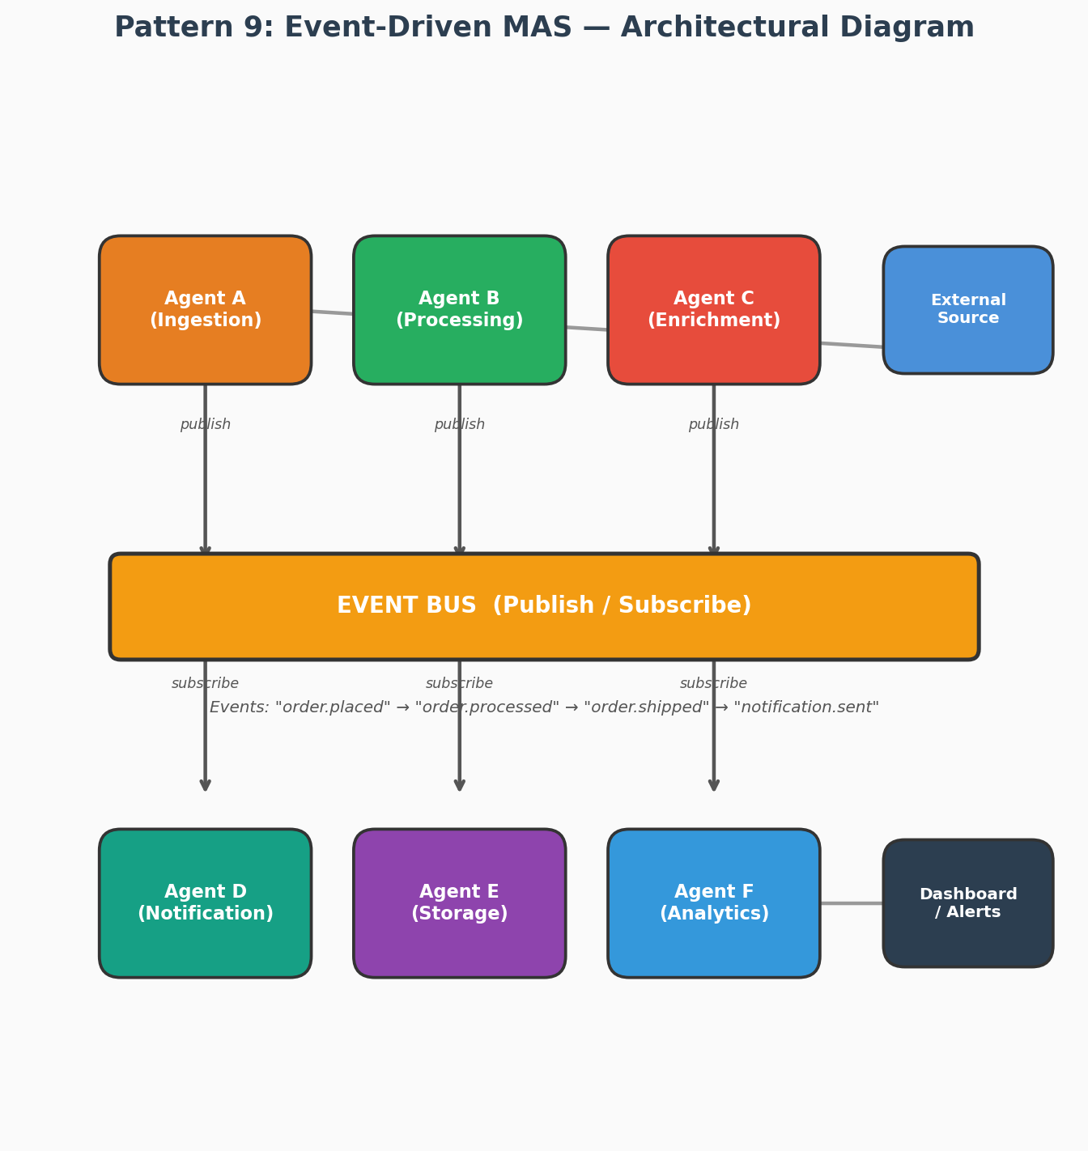
Figure 9: Event-Driven MAS pattern — Agents communicate via a shared Event Bus using publish/subscribe, enabling highly decoupled, resilient, and scalable architectures.
Use Case — E-Commerce Order Fulfillment System
Scenario: An e-commerce platform processes thousands of orders per hour. Each order triggers a cascade of actions: payment processing, inventory update, warehouse picking, shipping, and customer notification.
How Event-Driven MAS Handles It:
A customer places an order. The system publishes an "order.placed" event to the Event Bus.
Agent A (Payment Processor):
Subscribes to: "order.placed"
Action: Validates payment method, charges the card, applies discount codes.
Publishes: "payment.confirmed" (or "payment.failed").
Agent B (Inventory Manager):
Subscribes to: "payment.confirmed"
Action: Reserves inventory, updates stock counts, flags low-stock items.
Publishes: "inventory.reserved".
Agent C (Warehouse Agent):
Subscribes to: "inventory.reserved"
Action: Generates pick list, assigns to warehouse zone, optimizes picking route.
Publishes: "order.picked".
Agent D (Shipping Agent):
Subscribes to: "order.picked"
Action: Selects carrier (cheapest for delivery SLA), generates shipping label, schedules pickup.
Publishes: "order.shipped" with tracking number.
Agent E (Notification Agent):
Subscribes to: "payment.confirmed", "order.shipped", "order.delivered"
Action: Sends email/SMS at each stage with relevant details and tracking links.
Agent F (Analytics Agent):
Subscribes to: ALL events
Action: Records metrics — order processing time, fulfillment SLA compliance, carrier performance.
Why Event-Driven MAS? Order fulfillment is inherently asynchronous with many independent services. Agents are fully decoupled — adding a new agent (e.g., Fraud Detection) requires zero changes to existing agents. If one agent fails (e.g., Notification), orders still process. This pattern scales horizontally and is resilient to partial failures.

Complete Python Implementation
event_driven_mas.py — Event Bus + Agent Microservices
import anthropic, asyncio, json, uuid
from dataclasses import dataclass, field
from collections import defaultdict
from datetime import datetime
from typing import Callable, Awaitable

@dataclass
class Event:
id: str = field(default_factory=lambda: str(uuid.uuid4())[:8])
type: str = ''
payload: dict = field(default_factory=dict)
source_agent: str = ''
timestamp: str = field(default_factory=lambda: datetime.utcnow().isoformat())
correlation_id: str = '' # links events in the same workflow

class EventBus:
"""In-process async event bus. In production use Redis Streams or Kafka."""
def __init__(self):
self._subs: dict[str, list[Callable]] = defaultdict(list)
self._log: list[Event] = []

def subscribe(self, event_type: str, handler: Callable[[Event], Awaitable]):
self._subs[event_type].append(handler)

async def publish(self, event: Event):
self._log.append(event)
print(f'[Bus] {event.source_agent} → {event.type} (corr:{event.correlation_id[:6]})')
handlers = self._subs.get(event.type, [])
await asyncio.gather(*[h(event) for h in handlers])

def replay(self) -> list[str]:
return [f'{e.timestamp[:19]} | {e.source_agent:<15} | {e.type}' for e in self._log]

class EventDrivenAgent:
"""Base class for event-driven agents."""
def __init__(self, name: str, bus: EventBus, system_prompt: str,
model='claude-haiku-4-5-20251001'):
self.name = name
self.bus = bus
self.client = anthropic.Anthropic()
self.system = system_prompt
self.model = model

async def call_llm(self, prompt: str) -> str:
resp = await asyncio.get_event_loop().run_in_executor(
None,
lambda: self.client.messages.create(
model=self.model, system=self.system,
messages=[{'role':'user','content':prompt}],
max_tokens=1024
)
)
return resp.content[0].text

async def emit(self, event_type: str, payload: dict, corr_id: str):
await self.bus.publish(Event(
type=event_type, payload=payload,
source_agent=self.name, correlation_id=corr_id
))

# ── Concrete Agents ───────────────────────────────────────────────────────
class IntakeAgent(EventDrivenAgent):
"""Receives raw user requests, classifies them, emits typed task events."""
async def handle_user_request(self, event: Event):
req = event.payload['request']
classification = await self.call_llm(
f'Classify this request into ONE category: data_analysis, content_writing, code_generation, research\n\nRequest: {req}\n\nReturn ONLY the category name.'
)
category = classification.strip().lower()
await self.emit(f'task.{category}',
{'request': req, 'priority': event.payload.get('priority','normal')},
event.correlation_id or event.id)

class ResearchAgent(EventDrivenAgent):
async def handle_research(self, event: Event):
result = await self.call_llm(
f'Research and provide a comprehensive answer for:\n{event.payload["request"]}'
)
await self.emit('task.completed',
{'result': result, 'type': 'research'},
event.correlation_id)

class CodeAgent(EventDrivenAgent):
async def handle_code(self, event: Event):
result = await self.call_llm(
f'Write clean, production-ready Python code for:\n{event.payload["request"]}'
)
await self.emit('task.review_needed',
{'code': result, 'original_request': event.payload['request']},
event.correlation_id)

class ReviewAgent(EventDrivenAgent):
async def handle_review(self, event: Event):
reviewed = await self.call_llm(
f'Review this code for bugs, security issues, and style. Suggest improvements.\n\nCode:\n{event.payload["code"]}'
)
await self.emit('task.completed',
{'result': event.payload['code'], 'review': reviewed, 'type': 'code'},
event.correlation_id)

class DeliveryAgent(EventDrivenAgent):
def __init__(self, *args, **kwargs):
super().__init__(*args, **kwargs)
self.completed: list[dict] = []
async def handle_complete(self, event: Event):
self.completed.append(event.payload)
print(f'\n✅ [Delivery] Task complete (type={event.payload.get("type")}): {str(event.payload.get("result",""))[:200]}')

async def main():
bus = EventBus()

# ── Wire up agents ────────────────────────────────────────────────────
intake = IntakeAgent('intake', bus, 'You classify user requests.')
research = ResearchAgent('research',bus, 'You are an expert researcher.')
coder = CodeAgent('coder', bus, 'You are a senior Python developer.')
reviewer = ReviewAgent('reviewer', bus, 'You review code for quality and security.')
delivery = DeliveryAgent('delivery',bus, 'You handle task delivery.')

bus.subscribe('user.request', intake.handle_user_request)
bus.subscribe('task.research', research.handle_research)
bus.subscribe('task.code_generation', coder.handle_code)
bus.subscribe('task.review_needed', reviewer.handle_review)
bus.subscribe('task.completed', delivery.handle_complete)

# ── Send requests ─────────────────────────────────────────────────────
await bus.publish(Event(type='user.request',
payload={'request': 'What is the CAP theorem in distributed systems?', 'priority':'high'},
source_agent='user', correlation_id='req-001'))

await bus.publish(Event(type='user.request',
payload={'request': 'Write a Redis cache decorator for Python functions', 'priority':'normal'},
source_agent='user', correlation_id='req-002'))

await asyncio.sleep(0.5) # allow async tasks to complete
print('\n=== Event Log ===\n' + '\n'.join(bus.replay()))

if __name__ == '__main__':
asyncio.run(main())

PART C — INDUSTRY PATTERNS BY DOMAIN

Most-Used Patterns Across Industry Domains
Based on production deployments and published case studies (2024-2025), this section maps each industry vertical to the agentic patterns that deliver the most value in real-world deployments.

Software Engineering & DevOps
Pattern | Use Case | Real-World Deployment
Plan-and-Execute | Autonomous PR: analyze issue → write code → test → open PR | GitHub Copilot Workspace, Devin, SWE-agent
Reflexion | Code debugging: attempt fix → run tests → reflect → retry | Cursor, Aider, Claude Code
Orchestrator-Worker | CI/CD agents: TestAgent + SecurityAgent + DeployAgent in parallel | Harness AI, Buildkite Pipelines
Actor-Critic | Code review: CoderAgent writes, ReviewerAgent critiques, iterates | Amazon CodeWhisperer, GitLab Duo
ReAct | SRE incident response: query metrics → analyze → run remediation | PagerDuty AI, Moogsoft, Opsgenie AI

Finance & Banking
Pattern | Use Case | Real-World Deployment
Orchestrator-Worker | Earnings analysis: DataAgent + AnalystAgent + ReportAgent | Bloomberg Terminal AI, Refinitiv
RAG Agent | Regulatory Q&A: query policy docs + compliance knowledge base | JPMorgan COIN, Goldman Sachs MDA
Pipeline | Transaction fraud detection: extract → enrich → score → alert | Stripe Radar AI, Mastercard Decision Intelligence
ReAct | Portfolio monitoring: check price → evaluate → rebalance | BlackRock Aladdin, Betterment AI
Plan-and-Execute | Financial report generation: multi-source data collection + synthesis | Workiva, Narrative Science (Qlik)

Healthcare & Life Sciences
Pattern | Use Case | Real-World Deployment
RAG Agent | Clinical decision support: patient data + medical literature | Epic Systems AI, IBM Watson Health
Orchestrator-Worker | Drug discovery: MoleculeAgent + ProteinAgent + SafetyAgent | Insilico Medicine, Recursion Pharmaceuticals
Pipeline | Medical coding: extract diagnosis → map ICD-10 → validate → submit | Nuance DAX, 3M AI Coding
Actor-Critic | Radiology report: AI reads scan → specialist reviews → finalizes | Aidoc, Rad AI, Enlitic
Plan-and-Execute | Clinical trial matching: decompose criteria → query patients → rank | TriNetX, Medidata AI

E-Commerce & Retail
Pattern | Use Case | Real-World Deployment
ReAct | Product search + recommendations: query catalog + user history | Amazon Rufus, Shopify Sidekick
Pipeline | Review processing: extract → classify → summarize → dashboard | Bazaarvoice AI, Yotpo AI
Orchestrator-Worker | Dynamic pricing: PriceAgent + CompetitorAgent + MarginAgent | Dynamic Yield, Boomerang Commerce
Actor-Critic | Ad copy generation: Writer generates → Optimizer critiques | Persado, Phrasee, Albert.ai
Event-Driven | Real-time inventory alerts: monitor → detect low stock → reorder | Blue Yonder, o9 Solutions

Legal & Compliance
Pattern | Use Case | Real-World Deployment
RAG Agent | Contract Q&A: query contract clauses + regulation knowledge base | Harvey AI, Ironclad AI, Spellbook
Orchestrator-Worker | Due diligence: DocumentAgent + RiskAgent + SummaryAgent | Kira Systems, Luminance
Actor-Critic | Brief drafting: LegalWriter generates → CritiquAgent checks citations | Harvey, Casetext CoCounsel
Plan-and-Execute | Regulatory filing: research requirements → draft → review → submit | Riskonnect, Compliance.ai
Pipeline | E-discovery: extract → privilege review → classify → produce | Relativity, Everlaw AI

Customer Service & Support
Pattern | Use Case | Real-World Deployment
ReAct | Ticket resolution: understand issue → query KB → draft response | Zendesk AI, Intercom Fin, Freshdesk Freddy
Orchestrator-Worker | Complex issue: TriageAgent + PolicyAgent + ResponseAgent | Salesforce Einstein, ServiceNow AI
RAG Agent | Knowledge base Q&A: semantic search over support docs | Notion AI, Guru, Confluence AI
Event-Driven | Escalation workflow: classify → route → notify → resolve | NICE CXone, Genesys AI
Pipeline | CSAT analysis: collect → analyze → categorize → report | Medallia AI, Qualtrics XM

Data Engineering & Analytics
Pattern | Use Case | Real-World Deployment
ReAct | NL-to-SQL: understand query → generate SQL → execute → explain | Databricks AI, Snowflake Cortex, ThoughtSpot
Plan-and-Execute | ELT pipeline generation: analyze source → design pipeline → generate code | dbt Copilot, Fivetran AI
Orchestrator-Worker | Data quality: ProfileAgent + AnomalyAgent + RemediationAgent | Monte Carlo AI, Great Expectations AI
Pipeline | Report automation: fetch data → analyze → visualize → distribute | Tableau AI, Power BI Copilot
Actor-Critic | Dashboard design: Generator creates → UX agent critiques → refines | Hex AI, Sigma AI

PART D — PATTERNS IN AI PLATFORMS

Agentic Patterns in Perplexity AI

Architecture Overview
Perplexity AI is a search-focused AI assistant that answers questions with real-time web citations. Its architecture is optimized for low-latency, high-accuracy retrieval-augmented generation at scale. Every response involves a sophisticated multi-step agent pipeline.

Perplexity's Core Pattern: Parallel RAG Pipeline
1. QUERY UNDERSTANDING: The input query is expanded, disambiguated, and decomposed into sub-queries.
2. PARALLEL WEB RETRIEVAL: Multiple search queries execute simultaneously across Bing/Google APIs + Perplexity's own web crawler.
3. SNIPPET EXTRACTION: A document processing pipeline extracts and ranks relevant passages from retrieved pages.
4. ITERATIVE CONTEXT BUILDING: The system decides if enough context has been gathered or if additional targeted searches are needed (ReAct-style loop).
5. GROUNDED GENERATION: The LLM generates a response with inline citations, strictly grounded in retrieved sources.
6. CITATION VERIFICATION: Post-generation, each claim is verified against its cited source.

Patterns Used in Perplexity
Pattern | Where Used | Implementation Details
Iterative RAG (ReAct) | Core search loop | Query → retrieve → evaluate coverage → refine query → retrieve again → answer
Pipeline | Full request processing | Query expansion → multi-source retrieval → extraction → ranking → generation → verification
Orchestrator-Worker | Multi-source search | SearchOrchestrator dispatches to: WebWorker, AcademicWorker, NewsWorker, VideoWorker in parallel
Plan-and-Execute | Perplexity Pro deep research | Planner creates 10-20 step research plan; executor processes each step with targeted web searches
Actor-Critic | Citation quality | Generator produces response; Verifier checks each citation is accurate; regenerates if not

Perplexity Deep Research — Full Python Simulation
perplexity_deep_research.py — Simulated Perplexity-Style Research Agent
import anthropic, json
from concurrent.futures import ThreadPoolExecutor, as_completed
from dataclasses import dataclass

@dataclass
class SearchResult:
url: str
title: str
snippet: str
source_type: str # 'web', 'academic', 'news'

class PerplexityStyleAgent:
"""
Simulates Perplexity's deep research pattern:
Multi-source parallel retrieval + iterative refinement + grounded generation.
"""
def __init__(self, model='claude-sonnet-4-20250514'):
self.client = anthropic.Anthropic()
self.model = model

def _expand_query(self, query: str) -> list[str]:
"""Generate diverse sub-queries for better coverage."""
resp = self.client.messages.create(
model=self.model,
messages=[{'role':'user','content':
f'Generate 4 diverse search queries to comprehensively answer: "{query}"\n'
'Include: factual, recent news, academic/technical, and a counter-perspective angle.\n'
'Return JSON: {"queries": ["q1","q2","q3","q4"]}'}],
max_tokens=300
)
raw = resp.content[0].text.strip()
if raw.startswith('```'): raw = raw.split('```')[1].lstrip('json')
return json.loads(raw)['queries']

def _simulate_search(self, query: str, source: str) -> list[SearchResult]:
"""Simulated search — replace with real APIs (Tavily, SerpAPI, etc)."""
return [SearchResult(
url=f'https://example-{source}.com/{i}',
title=f'[{source.upper()}] Result {i} for: {query[:40]}',
snippet=f'This article discusses {query}. Key finding: researchers have found that AI adoption has grown 340% since 2022 in enterprise contexts, with multi-agent systems being the fastest growing segment.',
source_type=source
) for i in range(1, 4)]

def _parallel_search(self, queries: list[str]) -> list[SearchResult]:
"""Execute searches in parallel across multiple source types."""
all_results = []
with ThreadPoolExecutor(max_workers=8) as ex:
futures = []
for q in queries:
for source in ['web', 'news', 'academic']:
futures.append(ex.submit(self._simulate_search, q, source))
for f in as_completed(futures):
all_results.extend(f.result())
return all_results

def _assess_coverage(self, query: str, results: list[SearchResult]) -> tuple[bool, str]:
"""Decide if we have enough info or need more targeted searches."""
snippets = '\n'.join(f'- {r.snippet[:200]}' for r in results[:10])
resp = self.client.messages.create(
model=self.model,
messages=[{'role':'user','content':
f'Query: {query}\n\nAvailable context snippets:\n{snippets}\n\n'
'Is the context sufficient to give a comprehensive, accurate answer?\n'
'JSON: {"sufficient": bool, "missing_aspect": "what topic needs more research"}'}],
max_tokens=200
)
raw = resp.content[0].text.strip()
if raw.startswith('```'): raw = raw.split('```')[1].lstrip('json')
data = json.loads(raw)
return data['sufficient'], data.get('missing_aspect','')

def _generate_cited_answer(self, query: str, results: list[SearchResult]) -> str:
"""Generate answer with inline citations."""
context = '\n'.join(
f'[{i+1}] Source: {r.url}\nTitle: {r.title}\nContent: {r.snippet}'
for i, r in enumerate(results[:12])
)
resp = self.client.messages.create(
model=self.model, system=(
'You are a research AI. Answer questions with inline citations [n].'
' Every factual claim must cite a source. Be comprehensive and structured.'
),
messages=[{'role':'user','content':
f'Question: {query}\n\nSources:\n{context}\n\n'
'Write a comprehensive answer with inline citations [1], [2], etc.'}],
max_tokens=2048
)
return resp.content[0].text

def research(self, query: str, max_refinement_rounds: int = 2) -> dict:
print(f'[Perplexity] Query: {query}')

# Phase 1: Query expansion
sub_queries = self._expand_query(query)
print(f' Expanded to {len(sub_queries)} sub-queries')

# Phase 2: Parallel multi-source retrieval
all_results = self._parallel_search(sub_queries)
print(f' Retrieved {len(all_results)} total sources')

# Phase 3: Iterative coverage assessment + refinement
for round_num in range(max_refinement_rounds):
sufficient, missing = self._assess_coverage(query, all_results)
if sufficient:
print(f' Coverage sufficient after {round_num} refinement rounds')
break
print(f' Refining search for: {missing}')
extra = self._parallel_search([missing])
all_results.extend(extra)

# Phase 4: Grounded generation with citations
answer = self._generate_cited_answer(query, all_results)
sources = list({r.url for r in all_results[:12]})

return {
'answer': answer,
'sources_used': len(sources),
'total_retrieved': len(all_results),
'source_urls': sources,
}

if __name__ == '__main__':
agent = PerplexityStyleAgent()
result = agent.research('What are the most effective agentic AI patterns used in production in 2025?')
print(f'\n=== ANSWER ===\n{result["answer"]}')
print(f'\nSources used: {result["sources_used"]} | Total retrieved: {result["total_retrieved"]}')

Agentic Patterns in ChatGPT / OpenAI

Architecture Overview
ChatGPT with tools (GPT-4o) and the OpenAI Assistants API use a sophisticated combination of agentic patterns. The system is designed around a persistent Assistant abstraction with Threads (conversation state), Runs (agent execution sessions), and a pluggable tool ecosystem.

OpenAI Assistants API — Key Pattern Components
Thread: Persistent conversation + memory across sessions (episodic memory pattern)
Assistant: LLM + system prompt + tool definitions (single or multi-agent actor)
Run: One execution cycle of the ReAct loop (observe → reason → act → observe)
Tool Calls: Structured function calling with status tracking (tool_use pattern)
File Search: Built-in RAG over uploaded documents (RAG agent pattern)
Code Interpreter: Sandboxed Python execution (tool-augmented ReAct)

Patterns Used in ChatGPT / OpenAI
Pattern | Where Used | Implementation Details
ReAct | Core ChatGPT tool use | GPT-4o decides which tool to call, observes result, decides next action in a loop
RAG Agent | File Search in Assistants API | Vector store built from uploaded docs; automatic retrieval injected into context
Plan-and-Execute | ChatGPT Deep Research | Creates multi-step research plan, executes each step with web search tools
Orchestrator-Worker | Multi-agent framework (preview) | Orchestrator Assistant delegates to specialist Assistants via Handoffs API
Pipeline | GPT Builder workflows | Sequential: user input → GPT action → API call → response formatting → output
Actor-Critic | DALL-E integration | Text prompt → image generation → critique for prompt improvement

OpenAI-Style Multi-Agent with Handoffs — Python Implementation
openai_style_handoffs.py — Triage Agent + Specialist Agents with Handoffs
import anthropic, json
from dataclasses import dataclass
from typing import Optional

@dataclass
class HandoffSignal:
target_agent: str
reason: str
context: str

class SpecialistAgent:
"""Base for specialist agents that can signal handoffs."""
def __init__(self, name: str, system: str, can_handle: list[str],
model='claude-haiku-4-5-20251001'):
self.name = name
self.system = system
self.can_handle = can_handle
self.client = anthropic.Anthropic()
self.model = model

def run(self, user_msg: str, context: str = '') -> tuple[str, Optional[HandoffSignal]]:
HANDOFF_TOOL = {
'name': 'handoff_to_agent',
'description': 'Transfer the conversation to a more appropriate specialist.',
'input_schema': {'type':'object',
'properties': {
'target_agent': {'type':'string','enum':['billing','tech_support','account','general']},
'reason': {'type':'string'},
'context_summary': {'type':'string'}
},
'required': ['target_agent','reason','context_summary']}
}
full_prompt = f'{context}\n\nUser: {user_msg}' if context else user_msg
messages = [{'role':'user','content':full_prompt}]

for _ in range(3):
resp = self.client.messages.create(
model=self.model, system=self.system,
tools=[HANDOFF_TOOL], messages=messages, max_tokens=1024
)
tool_uses = [b for b in resp.content if b.type=='tool_use']
text_parts= [b for b in resp.content if b.type=='text']

if tool_uses:
tu = tool_uses[0]
return '', HandoffSignal(
target_agent=tu.input['target_agent'],
reason=tu.input['reason'],
context=tu.input['context_summary']
)
if resp.stop_reason == 'end_turn':
return (text_parts[0].text if text_parts else ''), None
messages.append({'role':'assistant','content':resp.content})
return 'Unable to process.', None

class TriageOrchestrator:
"""
OpenAI-style orchestrator with handoffs.
Routes conversations to specialist agents, handles handoffs dynamically.
"""
def __init__(self):
self.agents = {
'triage': SpecialistAgent(
'triage', 'You are a customer service triage agent. Assess the user request and either handle simple queries yourself or transfer to the right specialist: billing, tech_support, account, or general.',
['all']
),
'billing': SpecialistAgent(
'billing', 'You are a billing specialist. Handle payment issues, invoices, refunds, and subscription changes with empathy and efficiency.',
['billing', 'payment', 'invoice', 'refund']
),
'tech_support': SpecialistAgent(
'tech_support', 'You are a tier-2 technical support engineer. Diagnose and resolve technical issues with detailed troubleshooting steps.',
['error', 'bug', 'crash', 'performance', 'integration']
),
'account': SpecialistAgent(
'account', 'You are an account management specialist. Handle account settings, user permissions, data privacy, and account closure.',
['account', 'password', 'settings', 'data', 'delete']
),
'general': SpecialistAgent(
'general', 'You are a general support agent. Help with product questions, feature requests, and general inquiries.',
['how', 'what', 'feature', 'product']
),
}
self.conversation_history: list[str] = []
self.max_handoffs = 3

def chat(self, user_message: str) -> str:
self.conversation_history.append(f'User: {user_message}')
current_agent_name = 'triage'
context = '\n'.join(self.conversation_history[-5:])

for hop in range(self.max_handoffs):
agent = self.agents[current_agent_name]
print(f'[Orchestrator] Routing to: {agent.name}')
response, handoff = agent.run(user_message, context)

if handoff:
print(f' [Handoff] {agent.name} → {handoff.target_agent}: {handoff.reason}')
context = f'Context: {handoff.context}\n' + context
current_agent_name = handoff.target_agent
continue

self.conversation_history.append(f'{agent.name}: {response}')
return f'[{agent.name.upper()}] {response}'

return '[Support] Request escalated to human agent.'

if __name__ == '__main__':
bot = TriageOrchestrator()
queries = [
'I was charged twice for my subscription last month!',
'My API integration keeps returning 401 errors after the latest update.',
'How do I export all my data before closing my account?',
]
for q in queries:
print(f'\n>>> User: {q}')
resp = bot.chat(q)
print(f'>>> {resp}')

Agentic Patterns in Claude (Anthropic)

Architecture Overview
Anthropic's Claude is designed with a safety-first agentic architecture. Claude's agent capabilities are exposed through three primary interfaces: the Claude.ai consumer product, the Claude API with native tool use, and Claude Code — a fully autonomous coding agent. Each interface implements distinct agentic patterns.

Claude's Distinctive Architecture Features
Feature | Description & Pattern Implication
Extended Thinking | Internal CoT scratchpad before responding. Enables deep deliberative planning without exposing raw reasoning to users. Used in LATS-style search.
Model Context Protocol (MCP) | Standardized tool/resource protocol. Every MCP server is a tool provider — enables plug-and-play RAG, database access, and external API integration.
Computer Use | Claude can control a computer's UI — click, type, screenshot. Enables fully autonomous multi-step workflows (ReAct at the OS level).
Claude Code | Autonomous coding agent with CLAUDE.md configuration, Git integration, and persistent codebase understanding across sessions.
Prompt Caching | Large system prompts / knowledge bases are cached across requests — enabling cost-efficient RAG and long system prompts for complex agent personas.
Constitutional AI | Safety layer integrated into all agent actions — agents refuse harmful tool calls, escalate appropriately, and maintain safe defaults.

Patterns Used in Claude
Pattern | Where Used | Claude-Specific Implementation
ReAct | Claude.ai with Search + tools | Native tool_use blocks in API; parallel tool calls in single response for efficiency
Extended Thinking + LATS | Complex reasoning tasks | thinking block enables internal MCTS-like exploration; best for architecture design, math, strategy
RAG (via MCP) | Claude.ai Projects + MCP servers | Knowledge base via MCP filesystem/database servers; Prompt Caching for 90% cache hit rate on large docs
Orchestrator-Worker | Claude Code multi-file edits | Orchestrator understands the full codebase; Workers handle individual file edits, tests, commits
Reflexion | Claude Code debugging loop | Run tests → analyze failures → reflect → fix → repeat (automated via hooks)
Plan-and-Execute | Claude Code project init | CLAUDE.md defines project plan; Claude executes step by step, checking off tasks
Actor-Critic | Anthropic internal pipelines | Constitutional AI acts as Critic; Actor generates; safety layer provides structured critique
Computer Use (Novel) | Claude.ai Max, API | ReAct pattern extended to computer UI — screenshot → reason → click/type → observe

Claude Code Architecture — Full Python Simulation
claude_code_style_agent.py — Autonomous Coding Agent with CLAUDE.md + Hooks
import anthropic, subprocess, os, json, hashlib
from pathlib import Path
from dataclasses import dataclass
from typing import Optional

@dataclass
class ClaudeConfig:
"""Simulates CLAUDE.md configuration."""
project_name: str
tech_stack: list[str]
test_command: str
lint_command: str
conventions: list[str]
forbidden_patterns: list[str]

class HookSystem:
"""
Simulates Claude Code's hook system.
PreToolUse: validates before tool call.
PostToolUse: processes after tool result.
"""
def __init__(self, config: ClaudeConfig):
self.config = config

def pre_tool_use(self, tool_name: str, tool_input: dict) -> tuple[bool, str]:
"""Return (allow, reason)."""
if tool_name == 'write_file':
content = tool_input.get('content','')
for pattern in self.config.forbidden_patterns:
if pattern.lower() in content.lower():
return False, f'Hook BLOCKED: forbidden pattern "{pattern}" in code'
if tool_name == 'bash' and 'rm -rf /' in tool_input.get('command',''):
return False, 'Hook BLOCKED: destructive command rejected'
return True, 'ok'

def post_tool_use(self, tool_name: str, result: str) -> str:
if tool_name == 'write_file':
return result + '\n[Hook] File write logged to audit trail.'
return result

class ClaudeCodeStyleAgent:
"""
Simulates Claude Code's autonomous coding agent pattern:
- ReAct loop with file system + bash tools
- CLAUDE.md config awareness
- Pre/Post hooks for safety
- Reflexion via test-fail-fix loop
"""
TOOLS = [
{'name':'read_file','description':'Read a file from the workspace.',
'input_schema':{'type':'object','properties':{'path':{'type':'string'}},'required':['path']}},
{'name':'write_file','description':'Write or update a file.',
'input_schema':{'type':'object','properties':{'path':{'type':'string'},'content':{'type':'string'}},'required':['path','content']}},
{'name':'bash','description':'Execute a bash command (tests, git, etc.)',
'input_schema':{'type':'object','properties':{'command':{'type':'string'}},'required':['command']}},
{'name':'list_files','description':'List files in a directory.',
'input_schema':{'type':'object','properties':{'directory':{'type':'string'}},'required':['directory']}},
]

def __init__(self, workspace: str, config: ClaudeConfig,
model='claude-sonnet-4-20250514'):
self.client = anthropic.Anthropic()
self.model = model
self.workspace = Path(workspace)
self.config = config
self.hooks = HookSystem(config)
self.workspace.mkdir(parents=True, exist_ok=True)

def _build_system(self) -> str:
return (
f'You are Claude Code, an autonomous coding agent.\n\n'
f'PROJECT: {self.config.project_name}\n'
f'TECH STACK: {', '.join(self.config.tech_stack)}\n'
f'TEST COMMAND: {self.config.test_command}\n'
f'LINT COMMAND: {self.config.lint_command}\n'
f'CONVENTIONS:\n' + '\n'.join(f'- {c}' for c in self.config.conventions) + '\n\n'
'When writing code: always write tests first, then implementation. '
'After writing files, run tests and fix any failures before finishing. '
'Never stop until all tests pass.'
)

def _execute_tool(self, name: str, inp: dict) -> str:
# ── Pre-hook ─────────────────────────────────────────────
allowed, reason = self.hooks.pre_tool_use(name, inp)
if not allowed:
return f'BLOCKED: {reason}'

# ── Execute ───────────────────────────────────────────────
if name == 'read_file':
p = self.workspace / inp['path']
result = p.read_text() if p.exists() else f'File not found: {inp["path"]}'
elif name == 'write_file':
p = self.workspace / inp['path']
p.parent.mkdir(parents=True, exist_ok=True)
p.write_text(inp['content'])
result = f'Written {len(inp["content"])} chars to {inp["path"]}'
elif name == 'bash':
try:
r = subprocess.run(inp['command'], shell=True, capture_output=True,
text=True, cwd=str(self.workspace), timeout=15)
result = (r.stdout + r.stderr)[:2000] or '(no output)'
except subprocess.TimeoutExpired:
result = 'TIMEOUT'
elif name == 'list_files':
d = self.workspace / inp['directory']
result = str(list(d.glob('*'))) if d.exists() else 'Directory not found'
else:
result = f'Unknown tool: {name}'

# ── Post-hook ─────────────────────────────────────────────
return self.hooks.post_tool_use(name, result)

def run(self, task: str, max_steps: int = 20) -> str:
messages = [{'role':'user','content':task}]
system = self._build_system()

for step in range(max_steps):
resp = self.client.messages.create(
model=self.model, system=system,
tools=self.TOOLS, messages=messages, max_tokens=4096
)
tool_uses = [b for b in resp.content if b.type=='tool_use']
text_parts = [b for b in resp.content if b.type=='text']

if resp.stop_reason == 'end_turn' or not tool_uses:
return text_parts[0].text if text_parts else 'Task completed.'

messages.append({'role':'assistant','content':resp.content})
results = []
for tu in tool_uses:
print(f'[Claude Code] Step {step+1}: {tu.name}({list(tu.input.keys())})')
result = self._execute_tool(tu.name, tu.input)
print(f' → {result[:100]}')
results.append({'type':'tool_result','tool_use_id':tu.id,'content':result})
messages.append({'role':'user','content':results})

return 'Max steps reached.'

if __name__ == '__main__':
config = ClaudeConfig(
project_name='FastAPI User Service',
tech_stack=['Python 3.12', 'FastAPI', 'SQLAlchemy', 'pytest'],
test_command='python -m pytest tests/ -v',
lint_command='ruff check .',
conventions=['Use type hints everywhere', 'Docstrings on all public methods',
'Test file names: test_*.py', 'Async endpoints only'],
forbidden_patterns=['password', 'secret', 'hardcoded_key'],
)
agent = ClaudeCodeStyleAgent(workspace='/tmp/claude_workspace', config=config)
result = agent.run(
'Create a FastAPI endpoint GET /users/{id} that returns a user by ID. '
'Include the Pydantic model, SQLAlchemy model, and full pytest test suite.'
)
print(result)

FINAL REFERENCE — PATTERN SELECTION GUIDE

Quick-Reference: Pattern Selection Matrix
Use this table to quickly identify the right pattern for any use case.

Pattern | Complexity | Latency | Cost | Best For | Avoid When
ReAct | Low | Low | Low | Tool-based Q&A | Pure generation tasks
Plan-Execute | Med | Med | Med | Complex research | Highly dynamic tasks
Reflexion | Med | Med | Med | Code gen, writing | No quality signal
RAG Agent | Low | Low | Low | Knowledge Q&A | Fits in context window
LATS | High | High | High | Optimization, debug | Latency-sensitive tasks
Orchestrator-Worker | High | Low* | High | Parallel complex tasks | Simple sequential tasks
Pipeline | Med | Med | Med | Data processing | Tasks needing backtrack
Actor-Critic | Med | Med | Med | Quality-critical content | Simple, fast tasks
Event-Driven | High | Low* | Med | Async workflows | Simple synchronous tasks

* Low latency through parallelism, though coordination overhead adds some delay.

— Agentic Architecture Patterns: Complete Python Reference —
9 Patterns · Full Code · Industry Deployments · Perplexity · ChatGPT · Claude

