**Covid-19 Bot Challenge**

**Problem Statement:**

* Build the end to end chat bot in 2 platforms
* Capture User Name, Email, Phone and Location of user and provide COVID cases in their location
* Send email to user with precautions and detailed report of the cases
* Integration with other channels like Facebook, Telegram etc
* All conversations to be stored in Data Base
* Show Map wise case details to user in case he requested that

**Data Collection:**

* India State wise data and City wise confirmed cases have been taken from <https://api.covid19india.org> site
* Zip code to City to State mapping information has been captured from Web and used in case user enters any pin code information to look up corresponding City Info

**APIs Developed/Exposed:**

* <https://wrcofd1ig5.execute-api.us-east-1.amazonaws.com/covidapi/zip/530043> takes zip code as an input and returns any exact matched location and corresponding “confirmed” cases in the corresponding city
* <https://wrcofd1ig5.execute-api.us-east-1.amazonaws.com/covidapi/city/Visakhapatnam> takes city name as input and returns any exact or multiple similar matched details along with its state cases information
* <https://wrcofd1ig5.execute-api.us-east-1.amazonaws.com/covidapi/statename/Andhra%20Pradesh> takes state name as input and returns any exact or multiple similar matched details
* <https://wrcofd1ig5.execute-api.us-east-1.amazonaws.com/covidapi/users/lex> returns the input user details for the “Lex Bot”. Similarly <https://wrcofd1ig5.execute-api.us-east-1.amazonaws.com/covidapi/users/dialogflow> returns the inputted user details for the “Dialog Flow” bot
* <https://wrcofd1ig5.execute-api.us-east-1.amazonaws.com/covidapi/conversations/lex> and <https://wrcofd1ig5.execute-api.us-east-1.amazonaws.com/covidapi/conversations/dialogflow> returns the user conversation details wrt queries about COVID cases
* Clustered maps are exposed based on number of cases
  + City wise across India
    - <https://ineuron-chatbot.s3.amazonaws.com/city-all.html>
  + Different states within India
    - <https://ineuron-chatbot.s3.amazonaws.com/state-recovered.html>
    - <https://ineuron-chatbot.s3.amazonaws.com/state-deaths.html>
    - <https://ineuron-chatbot.s3.amazonaws.com/state-confirmed.html>
    - <https://ineuron-chatbot.s3.amazonaws.com/state-all.html>
    - <https://ineuron-chatbot.s3.amazonaws.com/state-active.html>
  + Different countries across globe
    - <https://ineuron-chatbot.s3.amazonaws.com/country-recovered.html>
    - <https://ineuron-chatbot.s3.amazonaws.com/country-deaths.html>
    - <https://ineuron-chatbot.s3.amazonaws.com/country-all.html>
    - <https://ineuron-chatbot.s3.amazonaws.com/country-active.html>

**Main Features**

* Searching for cases based on **Zip Code**
* **Similar match** logic based on City or State Name entered by User. In case, there are any close similar matches for user entered City or State, those information are returned to the user
* User details and Conversations are **persisted in Data Base** and details are exposed via APIs
* Mail is sent to user using the initial contact information shared which has the precautions in the body of the email along with an attachment
* The mail also has **“dynamic” state level case information** (that is queried LIVE) – on Lex Bot
* **Static map** returned to user when queried for COVID cases about a specific location, zip code, City or State within India – On Dialog Flow Bot
* User presented with link to dynamic **“clustered” map** that has details around cases across cities/states within India and across different countries in the world

**Dialog Flow Screenshots**

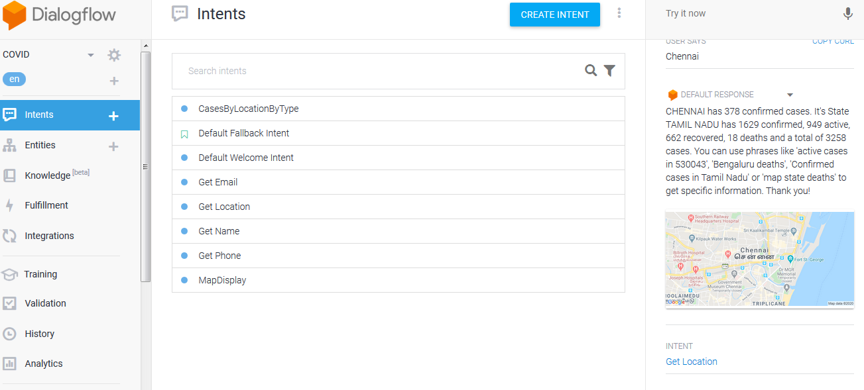

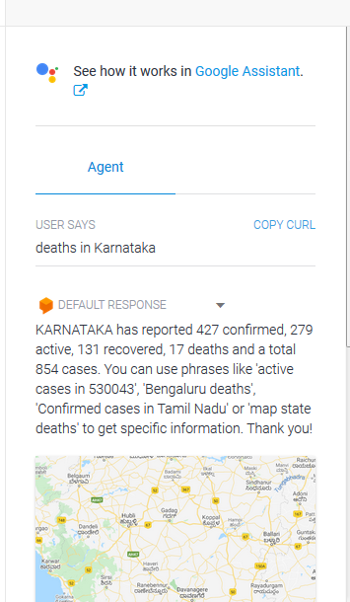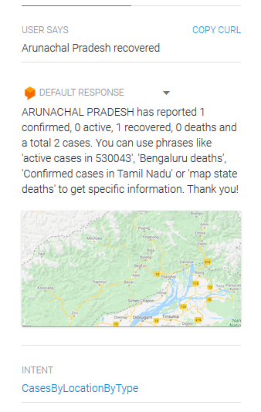

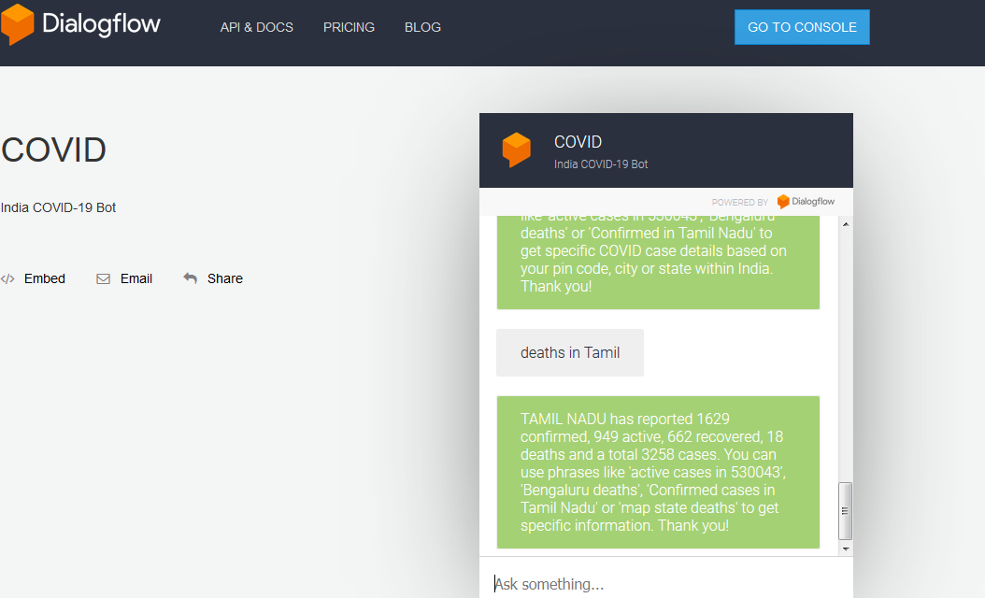

**URL -** [**https://bot.dialogflow.com/9fb70160-1e5e-49fe-a992-79a7aa149719**](https://bot.dialogflow.com/9fb70160-1e5e-49fe-a992-79a7aa149719)

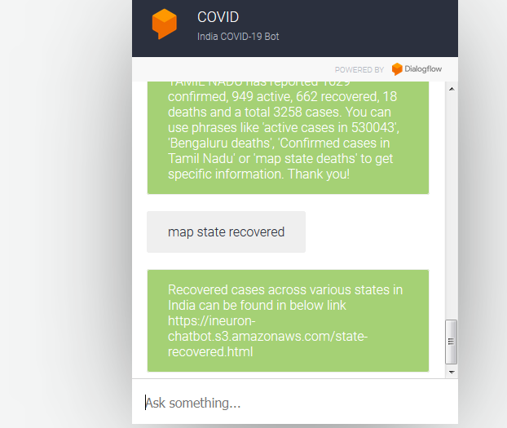

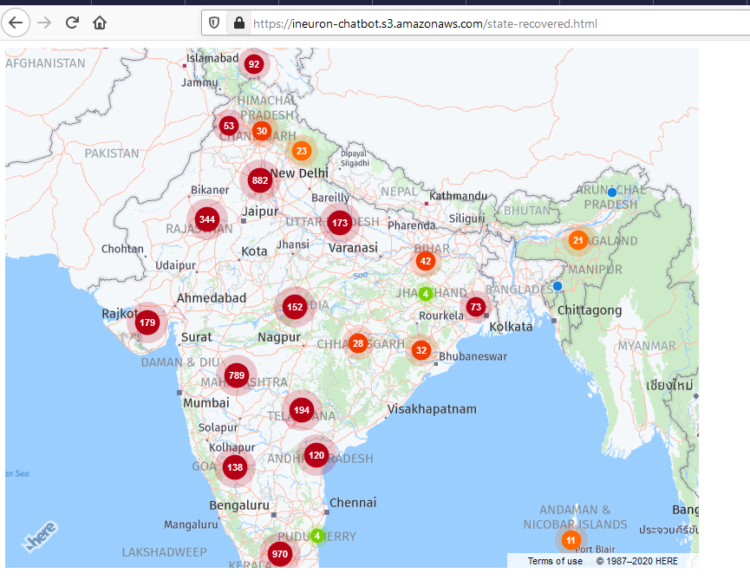

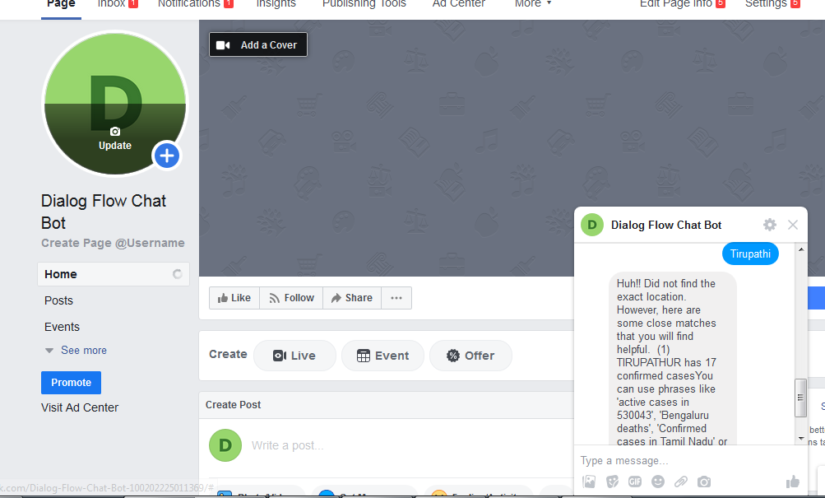

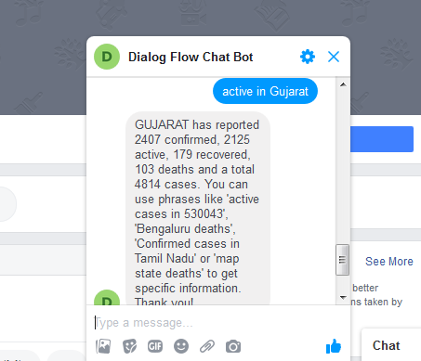

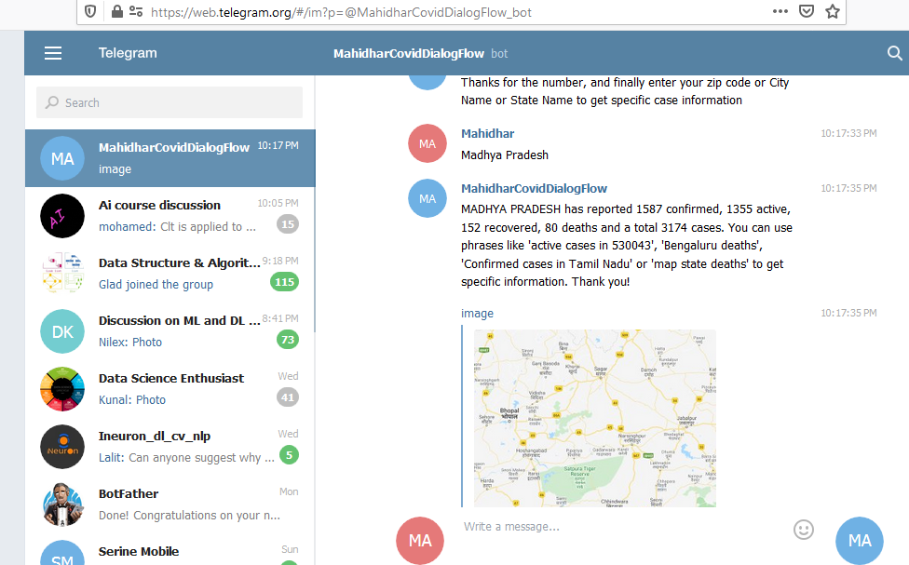

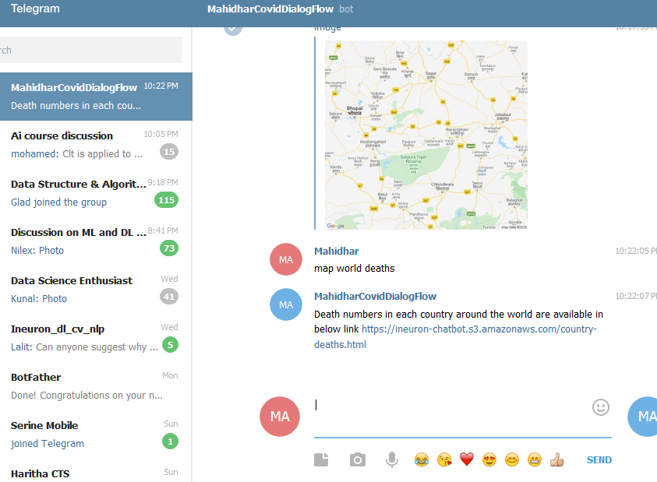

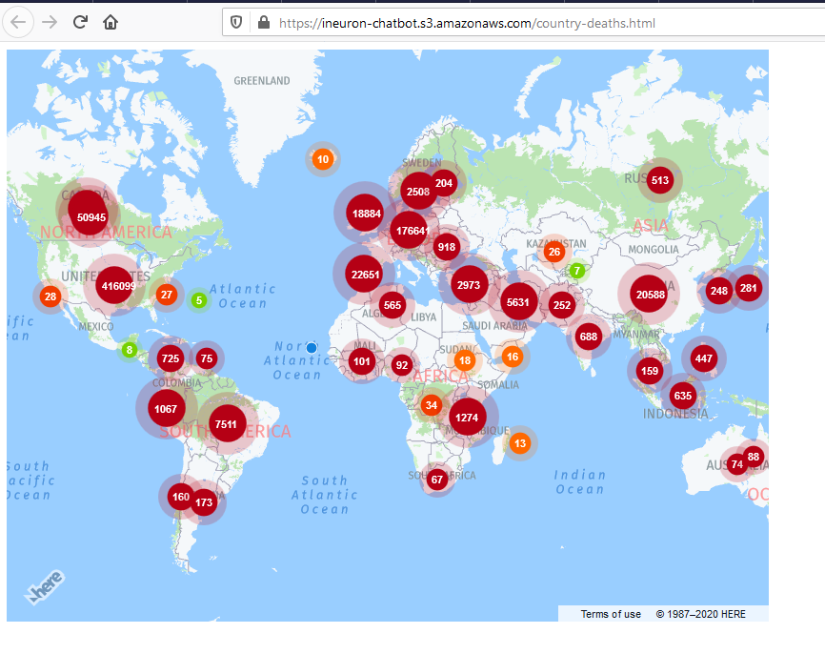

**Lex Screenshots**

