PROJECT AND CODING GUIDE
Bank Agentic AI Project
How the parts of the solution work together, how the code is organised, and the technology behind each layer

Item | Detail
Audience | Architects, developers, reviewers and technical stakeholders
Companion document | Technical Design Document (requirements, architecture, risk and security)
Source code | github.com/sunkarmil-stack/bank-contact-centre-agent
Language and size | Python 3.11+ · 75 source files · about 7,400 lines (including 1,200 lines of tests)
Version | 1.1 (October 2026)

Contents
1. The solution at a glance
2. Technology stack
3. Repository structure
4. How the segments work together
5. Coding walkthrough by segment
6. Cross-cutting code: security, resilience, persistence, telemetry
7. Configuration and environments
8. Testing and quality engineering
9. Build, CI/CD and deployment
10. Developer workflow and extending the solution
Appendix. Code reading order

1. The solution at a glance
The solution is an agentic AI assistant for a bank contact centre. It is built as five cooperating services around one idea: language models decide *what was asked*, while ordinary, testable code decides *what is allowed to happen*.
Segment | Role in one sentence | Main code
API gateway | Front door: checks who is calling and lets only valid traffic in | services/gateway/app.py
Agent API | Runs the conversation: orchestrator, specialist agents, human review, response checks | ccagent/api/app.py, ccagent/service.py, ccagent/agents/
MCP tool service | The only door from the agents to business systems | ccagent/mcp_server/server.py
Customer service | System of record for client profile, transactions and card status | services/customer_service/app.py
Case service | Case management for complaints, disputes and fraud referrals | services/case_service/app.py
Shared foundations | Security, persistence, telemetry, resilience, configuration | ccagent/security, persistence, telemetry.py, resilience.py, config.py
Demo console | One-page UI for calls, architecture, reviews, KPIs and audit | static/console.html

The coding philosophy in three rules
1. The graph is code, not a prompt. Routing, approvals and fallbacks are explicit Python, so they can be unit-tested and validated. 2. The model never holds the keys. Identity, client, purpose and approval travel in signed tokens created by code. 3. Every boundary checks again. Each service re-verifies what reaches it, so one bug cannot widen access.

2. Technology stack
Every layer uses a mainstream, well-supported technology. The production choices are Microsoft Azure services, matching the bank's cloud platform.
Layer | Technology | Used for | Where in code
Language and runtime | Python 3.11+ (asyncio) | All services; async I/O for model, tool and HTTP calls | Everywhere
Agent orchestration | LangGraph 1.x | StateGraph, conditional routing, interrupt/resume for human review, checkpointer, store | ccagent/agents/graph.py
LLM framework | LangChain Core 1.x, langchain-openai | Chat model interface, retrievers, documents, message trimming | ccagent/llm, integrations/knowledge.py
Models | Azure OpenAI in Microsoft Foundry; deterministic offline model | Intent classification, grounded drafting, call summaries | llm/factory.py, llm/offline_model.py
Foundry SDK | azure-ai-projects, azure-ai-evaluation | Endpoint discovery, connections, tracing, model-graded evaluation | llm/foundry.py, evals/foundry_eval.py
Tool protocol | Model Context Protocol (MCP) Python SDK 2.x | Governed tool server and client, Streamable HTTP transport | mcp_server/, agents/tool_gateway.py
Knowledge retrieval | Azure AI Search (hybrid + semantic); BM25 offline | Retrieval-augmented generation with security trimming | integrations/knowledge.py
Web services | FastAPI, Uvicorn, Pydantic 2 | All HTTP APIs, request validation, response models | api/app.py, services/*
HTTP client | httpx (async) | Gateway proxying, service-to-service calls | services/gateway, integrations/*
Identity | Microsoft Entra ID, PyJWT | User tokens (RS256 via JWKS), service and delegation tokens | security/auth.py, tokens.py, service_tokens.py
Cryptography | cryptography (AES-256-GCM) | Encryption of conversation checkpoints | persistence/checkpoint.py
Persistence | SQLite (WAL) locally, PostgreSQL in production; aiosqlite | Checkpoints, long-term memory, run registry, audit log, cases | persistence/*
Secrets | Azure Key Vault | Signing and encryption keys, database credentials | secrets.py
Observability | OpenTelemetry, OpenInference, LangSmith, Azure Monitor | Traces, metrics, LLM-aware spans, anonymised LLM tracing | telemetry.py
Testing | pytest, Playwright | 88 automated tests, browser checks of the console | tests/
Delivery | Docker, GitHub Actions, Bicep, Azure Container Apps, GitHub Pages | Build, test, deploy, publish | Dockerfile, .github/, deploy/
Front end | Plain HTML, CSS and JavaScript (no framework) | Demo console in live and replay modes | static/console.html

3. Repository structure
Repository layout
bank-contact-centre-agent/
├── ccagent/ core platform (Agent API + MCP tool service)
│ ├── agents/ graph.py, state.py, tool_gateway.py
│ ├── api/app.py HTTP API, middleware, demo console route
│ ├── service.py run lifecycle, protected review/resume, explainability
│ ├── mcp_server/ server.py (tools), __main__.py (HTTP service)
│ ├── integrations/ customer.py, cases.py, knowledge.py (adapters)
│ ├── llm/ factory, foundry, structured, prompts, offline model
│ ├── security/ auth, tokens, service tokens, pii, guardrails, limits
│ ├── persistence/ checkpoint.py (encrypted), runs.py, audit.py, db.py
│ ├── ops/ routing.py, qa.py, kpis.py, workforce.py (Erlang C)
│ └── config, container, resilience, telemetry, logging
├── services/ independently deployable services
│ ├── gateway/app.py API gateway
│ ├── customer_service/app.py customer system of record
│ ├── case_service/app.py case management
│ └── common.py shared middleware, errors, health, metrics
├── static/ console.html, demo recording, demo page
├── data/ synthetic customers and knowledge base
├── evals/ golden dataset, thresholds, gate, LangSmith/Foundry
├── tests/ 88 tests across 9 suites
├── scripts/ run_all, record_demo, build_demo_page, demo, purge
├── deploy/ azure/main.bicep, setup script, otel config
├── docs/ design documents
├── .github/workflows/ ci.yml, pages.yml, deploy-azure.yml
└── Dockerfile · docker-compose.yml · requirements*.txt · Makefile

Area | Lines of Python | Share
Core platform (ccagent) | 4,671 | 63%
Services (gateway, customer, case) | 580 | 8%
Tests | 1,184 | 16%
Scripts (launcher, recorder, page builder) | 573 | 8%
Evaluation | 354 | 5%

4. How the segments work together

4.1 Code map
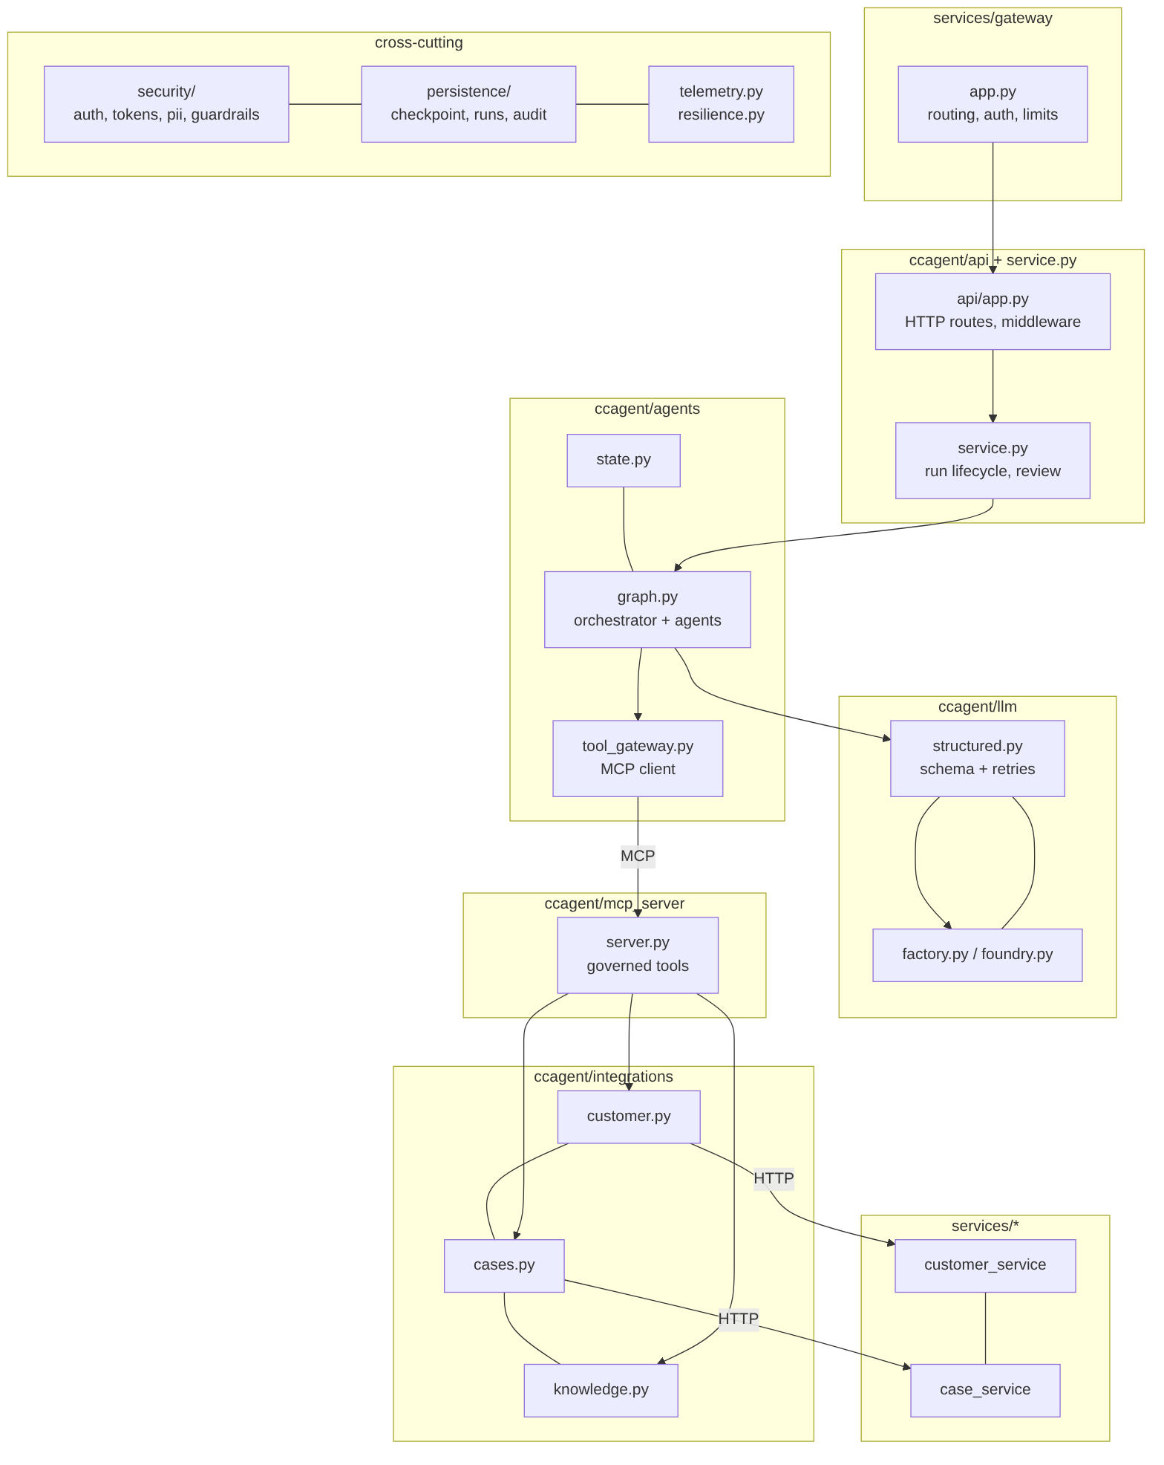
Figure 1. Modules and the direction of calls between them.

4.2 One request through the code
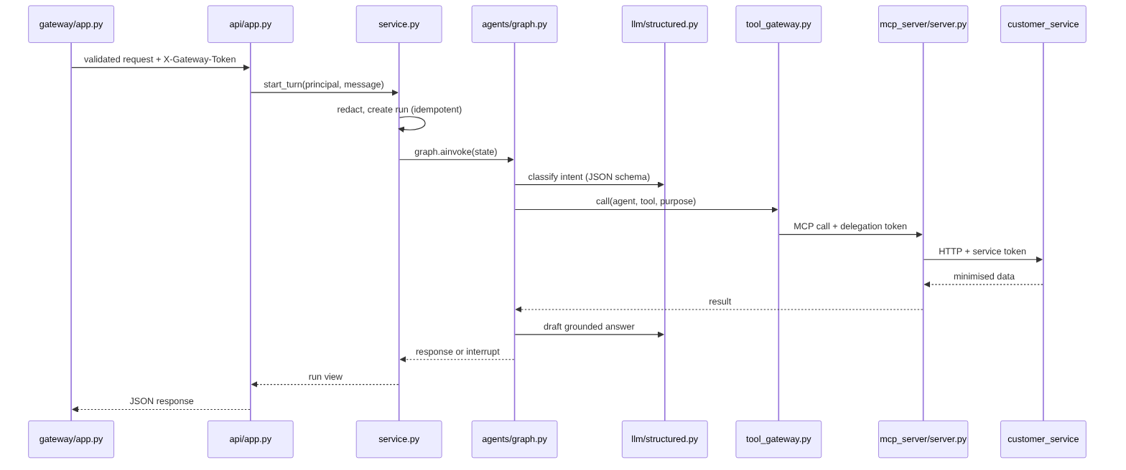
Figure 2. A caller's message travelling through the modules.
- services/gateway/app.py validates the sign-in token, applies rate limits, strips spoofable headers and forwards the request with a signed X-Gateway-Token and a correlation ID.
- ccagent/api/app.py checks the gateway token, authenticates the user again, and calls the service layer.
- ccagent/service.py redacts identifiers, creates or replays the run (idempotency), and invokes the LangGraph graph.
- ccagent/agents/graph.py runs the nodes: input guard, memory, orchestrator, a specialist agent, optional human review, responder and finalize.
- ccagent/llm/structured.py makes each model call return validated JSON, retrying with a correction prompt when needed.
- ccagent/agents/tool_gateway.py turns every tool use into an MCP call carrying a freshly signed delegation token.
- ccagent/mcp_server/server.py verifies the token and calls the system of record through an adapter in ccagent/integrations/.
- services/customer_service and services/case_service verify the service, delegation and approval tokens again before reading or changing data.
- Every step writes to the shared audit log and emits OpenTelemetry spans tied together by the correlation ID.

4.3 Contracts between segments
From → To | Protocol | Credentials carried | Contract
Channel → Gateway | HTTPS / JSON | User sign-in token (Entra ID) | /v1/* REST API, Idempotency-Key header
Gateway → Agent API | HTTP / JSON | User token + X-Gateway-Token (api.ingress) | Same REST API, correlation ID added
Agent API → MCP tools | MCP over Streamable HTTP | Delegation token per tool call; approval token for changes | Five tools with typed arguments, structured results
MCP → Customer service | HTTP / JSON | Service token (customer.read / customer.cards.lock) + delegation + approval | /customers/{ref}/profile, /transactions, /cards/{id}/lock
MCP → Case service | HTTP / JSON | Service token (cases.write) + delegation (+ approval) | POST /cases with Idempotency-Key
Agent API → Case service | HTTP / JSON | Service token (cases.read) | GET /cases for supervisor reporting
All services → Audit store | SQL | Database identity | Append-only, hash-chained rows labelled with the service name

4.4 Composition root
ccagent/container.py is the single place where configuration becomes objects. It chooses the in-process or HTTP version of each backend, opens the encrypted checkpointer and store, builds the MCP server (or points at the remote one), creates the tool gateway and model, and compiles the graph. Swapping a local component for an Azure service is a configuration change, not a code change.
ccagent/container.py (simplified)
if settings.mcp_mode == "http":
target = settings.mcp_url # separate MCP tool service
else:
customers, cases, retriever = build_tool_backends(settings, secrets, db, audit)
target = build_mcp_server(ToolServices(customers, cases, retriever, tokens, audit))

gateway = MCPToolGateway(target, tokens, audit, timeout_s=..., max_retries=...)
async with open_memory(settings, secrets) as (checkpointer, store):
graph = build_graph(GraphDeps(settings, model, gateway, audit)).compile(
checkpointer=checkpointer, store=store)

5. Coding walkthrough by segment

5.1 Agent orchestration (LangGraph)
The conversation is a StateGraph over a typed state (CallState). Each node is an async function that returns a partial state update; edges decide what runs next. Routing is plain Python, so it is fully testable.
ccagent/agents/graph.py: wiring the graph
g.add_edge(START, "input_guard")
g.add_conditional_edges("input_guard", after_guard, ["load_memory", "finalize"])
g.add_edge("load_memory", "orchestrator")
g.add_conditional_edges("orchestrator", route_after_orchestrator,
["knowledge_agent", "account_agent", "card_agent", "dispute_agent",
"complaint_agent", "escalation_agent", "step_up"])
for n in ("card_agent", "dispute_agent"):
g.add_conditional_edges(n, route_after_action_agent,
["human_review", "execute_action", "responder"])
g.add_conditional_edges("human_review", route_after_review, ["execute_action", "responder"])
g.add_edge("execute_action", "responder")
g.add_edge("responder", "finalize")
g.add_edge("finalize", END)

ccagent/agents/graph.py: deterministic routing
def route_after_orchestrator(state: CallState) -> str:
intent = state["intent"]
if intent in ESCALATE_INTENTS or state.get("vulnerability"):
return "escalation_agent"
if state["confidence"] < s.intent_confidence_floor:
return "escalation_agent" # unsure? hand to a person
if intent in AUTH_REQUIRED_INTENTS and int(state.get("cust_auth_level", 0)) < 1:
return "step_up" # verify identity first
return {"account_inquiry": "account_agent", "card_lost_stolen": "card_agent",
"transaction_dispute": "dispute_agent", "complaint": "complaint_agent",
}.get(intent, "knowledge_agent")

5.2 Human-in-the-loop (interrupt and resume)
The human_review node calls LangGraph's interrupt(). The graph stops, the state is checkpointed (encrypted), and the API returns awaiting_review with the interrupt ID and the action hash. When a reviewer approves, the service resumes the same thread with Command(resume=…) on any server.
ccagent/agents/graph.py: pausing for a person
decision = interrupt({
"kind": "approval_required",
"run_id": state["run_id"],
"action": action,
"action_hash": action_hash(action), # SHA-256 of the exact action
"display": state["proposed_action"].get("display"),
"requested_by": state["principal"]["sub"],
})
# resumed here after approval; checks are repeated inside the graph
if decision.get("reviewer") == state["principal"]["sub"]:
raise PermissionError("four-eyes violation")
ccagent/service.py protects the resume path: reviewer role, requester cannot approve, interrupt ID and action hash must match, and an optimistic-concurrency update ensures only one reviewer can claim the run. It then mints an approval token bound to the run and the action.

5.3 Structured model calls
ccagent/llm/structured.py (simplified)
async def invoke_structured(model, messages, schema, *, name, timeout_s, max_attempts=3):
convo = list(messages)
for attempt in range(1, max_attempts + 1):
msg = await call_with_resilience(lambda: model.ainvoke(convo),
timeout_s=timeout_s, max_retries=1)
try:
return schema.model_validate_json(_extract_json(msg.content))
except (ValidationError, ValueError):
convo += [msg, HumanMessage("Correction: reply with ONLY valid JSON ...")]
raise OutputValidationError(...) # caller falls back to a person
Prompts are versioned in ccagent/llm/prompts.py; the version is recorded on every call for model-risk traceability. ccagent/llm/factory.py returns either the Azure OpenAI client (Entra ID token, temperature 0, JSON mode) or the deterministic offline model used in tests.

5.4 Tool gateway and MCP server
ccagent/agents/tool_gateway.py
async def call(self, agent, tool, session, purpose, **arguments):
if tool not in AGENT_TOOL_ALLOWLIST.get(agent, set()):
raise ToolNotPermitted(f"{agent} is not permitted to call {tool}")
if tool in KEYED_TOOLS and not arguments.get("idempotency_key"):
raise ValueError(f"{tool} requires an idempotency_key")
token = self._tokens.mint_delegation( # identity comes from the session,
on_behalf_of=session.on_behalf_of, # never from the model
customer_ref=session.customer_ref, cust_auth_level=session.cust_auth_level,
purpose=purpose, correlation_id=session.correlation_id, tool=tool)
... # timeout, bounded retry, circuit breaker, OpenInference TOOL span, audit

ccagent/mcp_server/server.py (simplified)
@mcp.tool(name="lock_card")
async def lock_card(delegation_token, card_id, idempotency_key, run_id, approval_token=None):
claims = verify(delegation_token, "lock_card")
action = {"type": "lock_card", "customer_ref": claims["customer_ref"], "card_id": card_id}
if not approval_token:
return _error("approval_required", "card lock requires reviewer approval")
approval = svc.tokens.verify_approval(approval_token, run_id=run_id, action=action)
if approval["sub"] == claims["sub"]:
return _error("forbidden", "four-eyes violation")
return await svc.customers.lock_card(claims["customer_ref"], card_id, ctx, idempotency_key)

5.5 Microservices (systems of record)
Each microservice is a small FastAPI app that trusts nothing upstream. A request must carry a service token for the right audience and permission, the end user's delegation token for the right tool and the same client, and, for changes, an approval token. Refusals are written to the audit log.
services/customer_service/app.py (simplified)
@app.post("/customers/{customer_ref}/cards/{card_id}/lock")
async def lock(customer_ref, card_id, request, idempotency_key=Header(None, alias="Idempotency-Key")):
ctx, claims = context(request, "lock_card", "customer.cards.lock") # workload + user
approval = request.headers.get("x-approval-token")
approved = user_tokens.verify_approval(approval, run_id=ctx.run_id,
action={"type": "lock_card", "customer_ref": customer_ref, "card_id": card_id})
if approved["sub"] == claims["sub"]:
raise ServiceError(403, "four_eyes_violation", "requester cannot approve own action")
return await store.lock_card(customer_ref, card_id, ctx, idempotency_key)

5.6 API gateway
The gateway is a thin, policy-only proxy built on FastAPI and httpx. It holds no business logic.
Policy | Implementation
Deny by default | A route table; unknown paths return 404 before any upstream call
Authentication at the edge | Token validated with the same validator the API uses (Entra ID JWKS in production)
Rate limiting | Token buckets per user; per visitor on public routes; failed demo sign-ins counted separately
Header hygiene | Client-supplied X-Delegation-*, X-Approval-*, X-Gateway-*, X-Forwarded-* removed; names normalised
Proof of entry | Short-lived X-Gateway-Token with permission api.ingress; the API refuses /v1 without it
Resilience and visibility | 502/504 mapping, per-route latency metrics, aggregated health of all five services

5.7 Retrieval (RAG)
Retrievers subclass LangChain's BaseRetriever, so the agents do not care whether results come from Azure AI Search or the offline BM25 index. The Azure retriever sends a hybrid (keyword and vector) query with semantic ranking and an OData filter for audience and classification, authenticated with a managed identity. Retrieved chunks are filtered for embedded instructions and wrapped in data markers before reaching the model.

5.8 Contact-centre operations code
Module | What it computes
ops/routing.py | Queue, skill, priority and answer target per intent; vulnerability and negative sentiment adjust priority
ops/qa.py | QA scorecard per call; scores below 80 flagged for human QA
ops/kpis.py | Containment, escalation, guardrail blocks, review approval rate, QA, complaint SLA breaches
ops/workforce.py | Erlang C staffing with service level, occupancy cap, shrinkage and AI-containment what-if

5.9 Demo console
static/console.html is a single, framework-free page with five views: Call desk, Architecture, Review queue, Supervisor, and Audit and controls. It runs in two modes from the same code: live, calling the gateway, and replay, using a recording of real runs embedded in the page for GitHub Pages. An adapter object hides the difference from the rest of the UI.

6. Cross-cutting code

6.1 Security modules
Module | Responsibility
security/auth.py | User token validation: Entra ID (RS256, JWKS, issuer, audience) or dev tokens; app roles to a Principal
security/tokens.py | Delegation tokens (per tool call) and approval tokens (bound to run and action hash)
security/service_tokens.py | Workload identity: which service may call which audience with which permission
security/pii.py | Detection and redaction of card numbers (Luhn-checked), SIN, email, phone, postal code, account, date of birth
security/guardrails.py | Injection screening, retrieved-content filtering, spotlighting, output validation
security/ratelimit.py | Token-bucket rate limiter

6.2 Resilience
ccagent/agents/tool_gateway.py
result = await call_with_resilience(
lambda: self._raw_call(tool, args),
timeout_s=self._timeout_s, # every outbound call has a timeout
max_retries=retries, # only transient errors, only safe or keyed calls
breaker=breaker) # opens after repeated failures -> fallback

6.3 Persistence
Store | Technology | Detail
Conversation checkpoints | LangGraph AsyncSqliteSaver / AsyncPostgresSaver | EncryptedSerializer with AES-256-GCM; key version in the cipher name for rotation
Long-term memory | LangGraph store with TTL | Namespace ("customers", ref, "interactions"); 90-day expiry
Run registry | SQL table | Status, pending interrupt, action hash, reviewer; optimistic concurrency with a version column
Audit log | SQL table, hash chain | Each row's SHA-256 covers its content and the previous hash; verify_chain() detects tampering
ccagent/persistence/checkpoint.py
def encrypt(self, plaintext: bytes) -> tuple[str, bytes]:
nonce = os.urandom(12)
ct = AESGCM(self._keys[self._active]).encrypt(nonce, plaintext, None)
return f"aesgcm-{self._active}", nonce + ct

6.4 Telemetry
telemetry.py wraps OpenTelemetry spans with OpenInference span kinds (AGENT, TOOL, RETRIEVER, LLM, GUARDRAIL, CHAIN) and redacts every attribute. LangChain calls are auto-instrumented. LangSmith receives traces only through a client configured with a PII anonymiser. Exporters are selected by configuration: console, OTLP (collector, Phoenix) or Azure Monitor discovered from the Foundry project.

7. Configuration and environments
All settings come from environment variables (twelve-factor) and are read once into an immutable Settings object in config.py. The same code runs everywhere; only configuration changes.
Setting | Local | Public demo | Production
CCAGENT_ENV | local | demo | prod
CCAGENT_LLM_PROVIDER | offline | offline | azure_foundry
CCAGENT_RETRIEVER | local | local | azure_ai_search
CCAGENT_CUSTOMER_SERVICE / CASE_SERVICE | mock / local or http | http | http
CCAGENT_MCP_MODE | inprocess or http | http | http
CCAGENT_PERSISTENCE | sqlite | sqlite | postgres
CCAGENT_AUTH_MODE | dev | dev + passcode | entra
CCAGENT_SERVICE_AUTH | local | local (deploy-time keys) | azure (managed identity)
CCAGENT_REQUIRE_GATEWAY | optional | true | true
Fail-fast guard: validate_for_environment() refuses to start in production with any local or mock component, and refuses to start the public demo without a passcode.

8. Testing and quality engineering
Test file | Tests | Focus
test_flows.py | 17 | Every scenario through the real graph, tools and store; memory; thread binding; explainability
test_security.py | 22 | Redaction, injection, output rules, token binding, forged/expired tokens, production guard
test_mcp_and_persistence.py | 9 | MCP authorisation, purpose, allow-lists, approval, encryption at rest, restart/resume, audit tamper
test_api.py | 9 | Authentication, roles, idempotency, protected review, rate and size limits
test_gateway.py | 7 | Edge policies, header hygiene, ingress proof, upstream failure handling
test_microservices.py | 8 | Zero-trust checks in customer and case services
test_stack.py | 5 | All five services as real processes, including an outage
test_public_demo.py | 7 | Passcode, brute-force limit, successful sign-ins not limited
test_ops.py | 4 | Erlang C reference value, routing, QA scoring
Evaluation gate (evals/run_eval.py): 25 golden cases covering intents, routing, human-review precision and recall, injection blocking, false blocks, sensitive-data leakage, citations, escalation, step-up and latency. Thresholds live in thresholds.json; the script exits non-zero on any miss, which fails the pipeline. The same dataset runs as a LangSmith experiment and, for knowledge answers, through Microsoft Foundry's model-graded evaluators.
Determinism: tests use a real LangChain BaseChatModel that is rule-based and offline, so the full code path (prompt, model call, JSON validation, retry) is exercised with repeatable results and no data leaving the machine.

9. Build, CI/CD and deployment
Workflow | Trigger | Steps
ci.yml | Every push and pull request | Static check, lint and security scan, dependency audit, 88 tests, evaluation gate, secret scan, container build and image scan
pages.yml | Changes to the demo page or recording; manual | Optionally re-record from the five services; build the page; block secrets and listed names; publish to GitHub Pages
deploy-azure.yml | Push to main (when enabled); manual | Tests and gate; build and push image to GitHub Container Registry; Bicep deploy with OpenID Connect; smoke test
Container image: one image for all services (Dockerfile); each service starts with a different command. Azure: deploy/azure/main.bicep defines a Log Analytics workspace, a Container Apps environment and one app whose five containers share a private network and data volume; only the gateway has public ingress.
Local launcher output
python -m scripts.run_all
✓ customer-service http://127.0.0.1:8101
✓ case-service http://127.0.0.1:8102
✓ mcp-tool-service http://127.0.0.1:8765
✓ agent-api http://127.0.0.1:8080
✓ api-gateway http://127.0.0.1:8000
All services up. Open the demo: http://127.0.0.1:8000/console

10. Developer workflow and extending the solution

10.1 Everyday commands
Task | Command
Install | pip install -r requirements.txt
Run tests | pytest -q
Run the evaluation gate | python -m evals.run_eval
Start all five services | python -m scripts.run_all
Single process for development | uvicorn ccagent.api.app:create_app --factory --port 8080
Re-record and rebuild the demo page | python -m scripts.record_demo && python -m scripts.build_demo_page

10.2 Adding a new intent and agent
- Add the intent to the classifier schema (llm/structured.py) and prompt (llm/prompts.py).
- Add a route in ops/routing.py (queue, priority, SLAs).
- Write the agent node in agents/graph.py, add it to route_after_orchestrator, and wire its edges.
- Give the agent a tool allow-list entry in agents/tool_gateway.py, granting only what it needs.
- Add golden cases to evals/golden_dataset.jsonl and flow tests in tests/test_flows.py.
- Run tests and the gate; record a new demo scenario in ccagent/demo_scenarios.py if it should appear in the console.

10.3 Adding a new enterprise system
- Write an adapter in integrations/ with an in-process and an HTTP implementation.
- Expose it as an MCP tool in mcp_server/server.py with a declared purpose, minimum verification level, idempotency and audit.
- Add the workload permission in security/service_tokens.py and enforce it in the system's API.
- Add tests for allowed and refused access, then wire configuration in container.py.

Appendix. Code reading order
For a reviewer new to the code, this order gives the clearest picture in about an hour:
- README.md: overview and how to run
- ccagent/agents/graph.py: the whole conversation in one file
- ccagent/service.py: run lifecycle and protected review
- ccagent/agents/tool_gateway.py and ccagent/mcp_server/server.py: the governed tool boundary
- services/customer_service/app.py: zero trust at the system of record
- services/gateway/app.py: edge policies
- ccagent/security/ and ccagent/persistence/: tokens, redaction, encryption, audit
- tests/test_flows.py and tests/test_stack.py: the behaviour, proven

