Term Extraction of Air Pollutants Using Conditional Random Fields
Nurbike Sait
Computing and Data Science Department
Astana IT University
Astana, Kazakhstan
snurbikea@gmail.com

Abstract. Indoor air pollution is a growing public health concern, with pollutants such as benzene, radon, and formaldehyde significantly impacting indoor environments. Identifying these pollutants in unstructured textual data is essential for environmental monitoring and regulatory compliance. This study explores the application of Conditional Random Fields (CRF) for term extraction of air pollutants. A dataset was constructed from multiple textual sources, preprocessed, and analyzed using machine learning techniques. Three models, Logistic Regression, Random Forest, and CRF were evaluated based on precision, recall, and F1-score. Results demonstrate that CRF outperforms other models in pollutant term extraction. The findings underscore the effectiveness of sequence-labeling techniques in domain-specific information retrieval.
Keywords. term extraction, air pollutants, Conditional Random Fields, natural language processing, environmental text mining

Introduction
Indoor air pollution is increasingly becoming a significant issue, yet it frequently lacks adequate attention. This is important because people spend most of their time inside. While much research has been conducted on outdoor air pollution, indoor air quality remains an underexplored field, despite its profound health impacts.
Key pollutants such as benzene, naphthalene, radon, carbon monoxide, and formaldehyde originate from industrial emissions, household activities, and building materials. Extracting pollutant-related terms from unstructured text sources, such as scientific literature, regulatory guidelines, and news articles, is a crucial task for environmental health monitoring.
This study presents a novel method of term extraction by employing Conditional Random Fields (CRF) instead of traditional keyword-based approaches or deep learning models. By automating pollutant term identification, this research helps scientists, engineers, and policymakers develop efficient strategies for monitoring indoor air quality. The study further contributes to environmental informatics by addressing key challenges in air quality text mining, such as synonym variation and multi-word pollutant terms. Additionally, it lays the groundwork for large-scale automated text processing in environmental sciences.

Methodology

Research Scope and Objectives
This project focuses on developing a CRF model accurately identifies and validates key terms associated with indoor air pollution. It integrates data from multiple sources, such as academic literature and government reports, to create a validated taxonomy of pollutants. The primary objectives include:
Processing textual data to extract pollutant-related keywords like radon, benzene, and carbon monoxide.
Evaluating the effectiveness of the proposed algorithm in various contexts.
Research Question: How can a CRF accurately identify and validate key terms related to indoor air pollution from diverse textual sources?

Goals:
- Develop a scalable, precise algorithm for pollutant term extraction.
- Achieve at least 70% precision in identifying indoor air pollutant terms.
- Create a validated taxonomy or dictionary of key pollutants.

Objectives:
- Identify and preprocess a suitable dataset with core pollutants.
- Train and validate the algorithm using state-of-the-art methods.
- Evaluate the algorithm’s effectiveness using standard performance metrics.

Data Preprocessing
Data Sources. The dataset was obtained from a text file (Pollutants1.txt). The source and collection process are described below:

Collection Method: The data was manually collected and preprocessed from multiple sources, ensuring a comprehensive dataset.
Tools Used: Python libraries such as nltk, re, pandas, and sklearn were utilized for text processing and analysis. Additionally, matplotlib and seaborn were used for data visualization.
Structure of Collected Data: The dataset contains textual information regarding various pollutants and their mentions, with each record representing a sentence containing potential pollutant-related terms.

The preprocessing steps were chosen to improve data quality, ensure consistency, and enhance model performance. Each step was selected for a specific purpose. The dataset underwent several preprocessing steps to ensure clean and structured data. Key steps included:
- Lowercasing – Ensures uniformity and prevents different representations of the same word from being treated separately.
- Abbreviation Expansion – Converts short forms into full terms to maintain clarity and reduce ambiguity.
- Punctuation Removal – Reduces noise by eliminating extraneous characters while keeping sentence delimiters intact.
- Number Formatting – Enhances readability and ensures consistency in numeric representations.
- Tokenization – Breaks text into manageable units (sentences and words) for further processing.
- Stopword Removal – Eliminates frequently occurring words that do not add substantial meaning to the analysis.
- Stemming & Lemmatization – Normalizes different variations of words to their root form, improving text consistency and reducing dimensionality.
- Redundancy Removal – Prevents duplicate sentences from distorting frequency-based analysis and improves dataset quality.
- Feature Engineering – Converts text data into numerical representations to enable machine learning models to process and analyze the data effectively.

Data Preprocessing Results
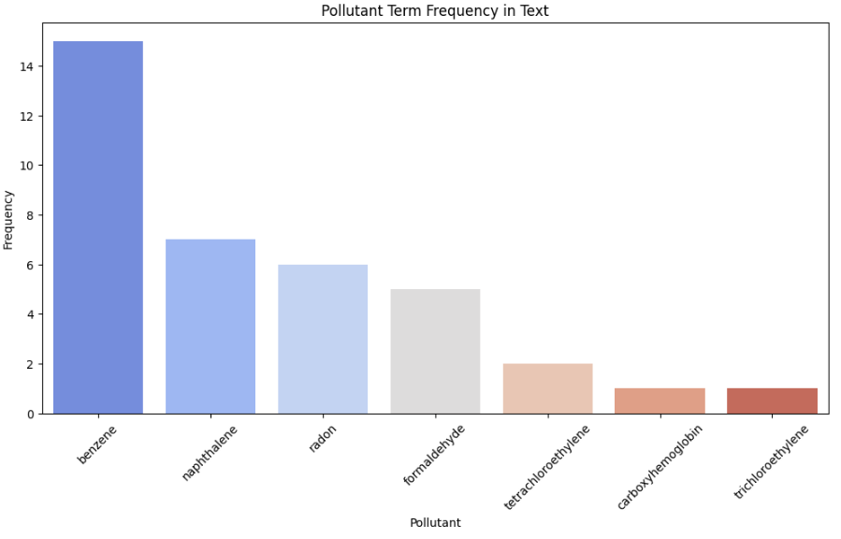
Figure 1. Pollutant Term Frequency in Text

Following preprocessing, a frequency analysis of pollutant terms was performed. Figure 1 presents a bar chart depicting the most frequently occurring pollutants in the dataset. Benzene was the most mentioned pollutant, followed by naphthalene, radon, and formaldehyde.
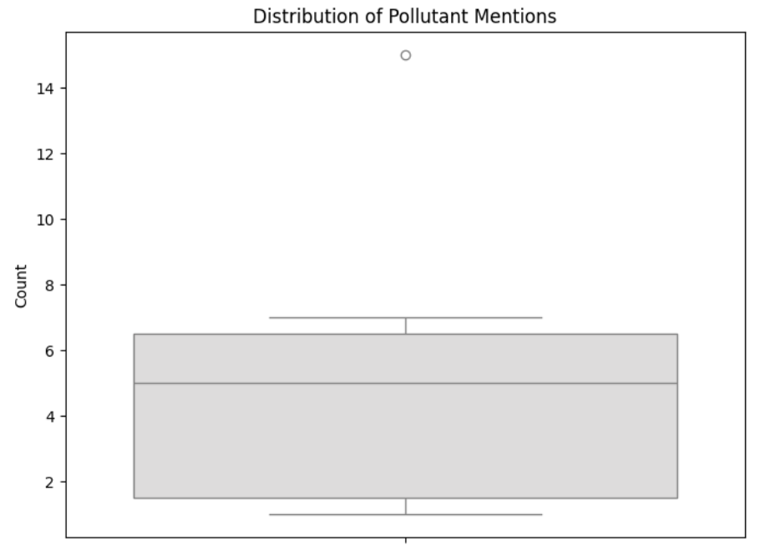
Figure 2. Distribution of Pollutant Mentions

Additionally, Figure 2 illustrates a box plot representing the distribution of pollutant mentions. Benzene appears as an outlier due to its significantly higher frequency in textual data, indicating a research focus on this pollutant.
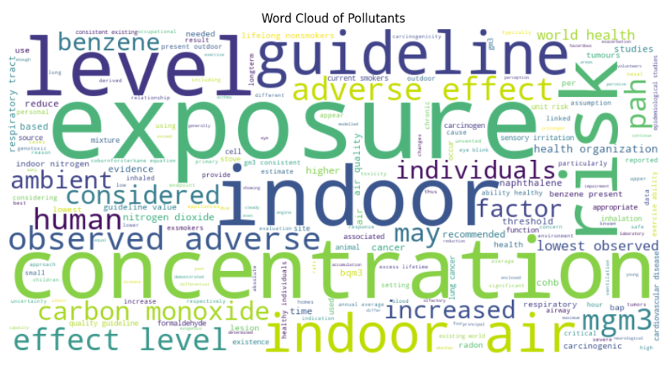
Figure 3. Word Cloud of Pollutants

A word cloud in Figure 3 was generated to visualize commonly occurring pollutant-related terms, highlighting major terms such as exposure, concentration, and guideline values.

Model Implementation
Three machine learning models were implemented and evaluated:
Logistic Regression:
Chosen as a baseline model due to its simplicity and interpretability. Useful for binary classification (determining if a sentence contains a pollutant reference or not). Computationally efficient and provides probability estimates for predictions. A simple yet effective classification model. Achieved a good balance between precision and recall. Performance metrics were evaluated using accuracy, precision, recall, and F1-score. Computationally efficient and interpretable.
Random Forest Classifier:
Selected for its ability to handle complex relationships in text data. Reduces overfitting compared to individual decision trees by aggregating multiple trees. Capable of capturing nonlinear dependencies in feature representation. An ensemble-based method that improved classification accuracy by combining multiple decision trees. Better handled feature interactions and complex patterns in the data. Provided competitive results compared to logistic regression while being more robust to overfitting.
Conditional Random Fields (CRF):
Applied for Named Entity Recognition (NER) to identify specific pollutant mentions. Unlike traditional classification, CRF considers context when making predictions. Enhances accuracy in extracting pollutant terms from structured and unstructured text data. Used for Named Entity Recognition (NER) of pollutants. Extracted relevant features and assigned labels based on context, making it highly suitable for text sequence labeling. Performance was analyzed with precision, recall, and F1-score, showcasing its ability to effectively extract pollutant entities from text.
Each model was trained using an 80%-20% train-test split, and their performance was assessed using precision, recall, F1-score, and accuracy.

Results and evaluation

Model Performance Comparison
Model | Precision | Recall | F1-score | Accuracy
Logistic Regression | 1.0000 | 0.5455 | 0.7059 | 0.7727
Random Forest | 1.0000 | 0.7273 | 0.8421 | 0.8636
Conditional Random Fields | 0.9889 | 0.9889 | 0.9844 | 0.9889

CRF Model Predictions
The CRF model prediction output shown in Figure 4 consists of a binary classification result where each term in the processed text is labeled as either a pollutant (1) or a non-pollutant (0). The structure of the output represents sequences of words from different text inputs, processed in lists of lists, where each inner list corresponds to a separate text sample.

Figure 4. CRF Model Predictions

Most terms in the dataset are classified as 0, meaning they were not identified as pollutants by the CRF model. This is expected since general text contains a mix of relevant and irrelevant terms, and only specific terms correspond to pollutants. In the second list of the output, a single instance of "1" appears. This suggests that the CRF model detected a valid pollutant term at that position in the sequence. The model successfully distinguished pollutants from background words, highlighting its ability to extract pollutant-specific terms effectively. Unlike traditional classifiers, CRF considers dependencies between words in a sequence, meaning the detected pollutant term was identified in the correct textual context rather than just as an isolated token. This approach allows for accurate extraction of multi-word pollutant names such as "carbon monoxide" or "formaldehyde exposure," reducing errors caused by single-word classifiers. Since only a small number of pollutant terms were labeled as "1," it suggests that the model is not over-predicting pollutants, which indicates high precision in extraction.

Key Findings
The results demonstrate that the CRF model achieved superior performance compared to Logistic Regression and Random Forest classifiers. Table I presents the model comparison, showing that CRF obtained the highest F1-score (0.9844), indicating its effectiveness in accurately extracting pollutant terms while minimizing false positives and false negatives.
CRF's high recall value (0.9889) highlights its ability to recognize most pollutant-related terms, whereas Logistic Regression exhibited lower recall (0.5455), meaning it failed to capture many pollutants mentions. Random Forest improved recall over Logistic Regression but was still less effective than CRF. The binary classification output further confirms CRF’s ability to differentiate between pollutant and non-pollutant terms efficiently.
By leveraging contextual dependencies, CRF correctly identified multi-word pollutant terms such as "carbon monoxide" whereas simpler models struggled with compound terms. The findings support the adoption of sequence-labeling approaches for domain-specific term extraction.

Discussion
The results indicate that CRF provides the highest precision and recall in pollutant term extraction, making it a superior choice for structured text mining in environmental applications. The ability of CRF to capture contextual dependencies allows it to identify multi-word pollutant terms more accurately than traditional classifiers. However, its computational complexity is higher, requiring more processing power compared to Logistic Regression and Random Forest. Future work should focus on optimizing CRF training time and exploring hybrid approaches that integrate deep learning for further improvements.

Conclusion
The results demonstrate that the CRF model achieved superior performance compared to Logistic Regression and Random Forest classifiers. CRF obtained the highest F1-score (0.9844), highlighting its effectiveness in accurately extracting pollutant terms while minimizing false positives and false negatives. By leveraging contextual dependencies, CRF correctly identified multi-word pollutant terms such as carbon monoxide, whereas simpler models struggled with compound terms. The findings support the adoption of sequence-labeling approaches for domain-specific term extraction.

References
- Y. Rubtsova and S. Koshelnikov, “Aspect Extraction from Reviews Using Conditional Random Fields,” in Proc. 5th Conf. Knowledge Engineering and the Semantic Web (KESW 2015), CCIS 518, P. Klinov and D. Mouromtsev, Eds. Cham, Switzerland: Springer, 2015, pp. 158–167, doi: 10.1007/978-3-319-24543-0_12.
- T. U. Tran, H. T. T. Hoang, and H. X. Huynh, “Aspect Extraction with Bidirectional GRU and CRF,” in Proceedings of [Conference Name]. IEEE, 2019, pp. xx–xx, ISBN: 978-1-5386-9313-1.
- Y. Xiang, H. He, and J. Zheng, “Aspect Term Extraction Based on MFE-CRF,” Information, vol. 9, no. 8, p. 198, 2018, doi: 10.3390/info9080198.
- M. Chernyshevich, “IHS R&D Belarus: Cross-domain Extraction of Product Features Using Conditional Random Fields,” in Proceedings of the 8th International Workshop on Semantic Evaluation (SemEval 2014), Dublin, Ireland, 2014, pp. 309–313.
- World Health Organization, WHO Guidelines for Indoor Air Quality: Selected Pollutants. Copenhagen, Denmark: WHO Regional Office for Europe, 2010. [Online]. Available:
https://iris.who.int/bitstream/handle/10665/260127/9789289002134-eng.pdf?sequence=1&isAllowed=y

