# Introduction

The restaurant reservation system is designed to streamline the process of managing table reservations for a restaurant chain. The system caters to both guest users and registered users, offering a seamless experience for reserving tables. This report provides an overview of the key features, database structure, and the implementation details of the reservation system.

# Abstract

The reservation system consists of two main user categories: guest users and registered users. Guest users can make reservations without logging in, while registered users benefit from additional features such as a preferred diner number, earned points, and a preferred payment method. The system allows users to search for available tables based on date, time, and the number of guests. It also handles scenarios where a requested table size is not directly available by combining multiple smaller tables.

The system tracks high-traffic days, imposing a hold fee for specific dates that require a valid credit card for reservation. Users are notified of potential no-show charges, reinforcing commitment to reserved tables.

# Implementation

## Database Structure

The MySQL database is designed to store user information, reservations, high-traffic days, and table details. Key tables include:

* Users Table:
* user_id (Primary Key)
* name, email, phone, mailing_address, billing_address
* preferred_diner_number, earned_points, preferred_payment_method
* password_hash, created_at, updated_at
* Reservations Table:
* reservation_id (Primary Key)
* user_id (Foreign Key referencing Users table)
* table_id (Foreign Key referencing Tables table)
* reservation_date, reservation_time, num_of_guests
* is_guest_user, requires_credit_card, no_show_charge
* created_at, updated_at
* High Traffic Days Table:
* day (Primary Key)
* hold_fee_required, created_at, updated_at
* Tables Table:
* table_id (Primary Key)
* capacity, is_combinable
* created_at, updated_at, is_booked

# Web Application

The web application is developed using Flask, a Python web framework. Key routes and features include:

**Home Page:**

* Displays links to Login, Register, and Home (index.html).

**Login Page:**

* Allows users to log in with email/phone and password.
* Stores user_id in session upon successful login.

**Registration Page:**

* Collects user details and stores them in the Users table.

**Reservation Page:**

* Displays available tables and allows users to reserve based on date, time, and guests.
* Dashboard:
* Provides a centralized hub for users with links to Reserve, Add Table, View Reservations, and Logout.

**Add Table:**

* Allows administrators to add tables with specified capacity and combinable status.
* View Reservations:
* Displays a table of reservation data with details such as reservation_id, user_id, table_id, date, time, and guests.

# Conclusion

The restaurant reservation system efficiently manages table reservations, offering a user-friendly experience for guests and providing administrators with tools to oversee reservations and generate reports. The system enhances the overall dining experience by ensuring smooth reservation processes and effective utilization of available tables. Further enhancements and optimizations can be explored based on user feedback and evolving requirements.

## Contribution

|  |  |  |
| --- | --- | --- |
| Group Member Name | What is your contribution? | Discussion Notes |
|  | Meghana Rajamoori 999902694 | Contributed to the frontend design and Bootstrap styling of web pages (HTML/CSS). Actively participated in the conceptualization and planning of the reservation system. Assisted in the creation of the database schema. Met regularly to discuss design choices and user experience. Provided feedback on system features and enhancements. |
|  | Devidutt eluri 999902982 | Implemented the Flask web application, including route handling and database interactions. Focused on backend development and integration with MySQL. Worked on the creation of SQL queries for table operations. Collaborated on troubleshooting and debugging backend issues. Shared insights on optimizing database queries for better performance. |
|  | SUNKESULA YESWANTH 999903673 | Played a key role in the design and implementation of the reservation logic. Worked on the integration of reservation and table booking features. Contributed to the generation of reports for administrators. Actively participated in brainstorming sessions to improve reservation system features. Discussed the implementation of logic for combining tables. |

## Screenshots

## Home Page:

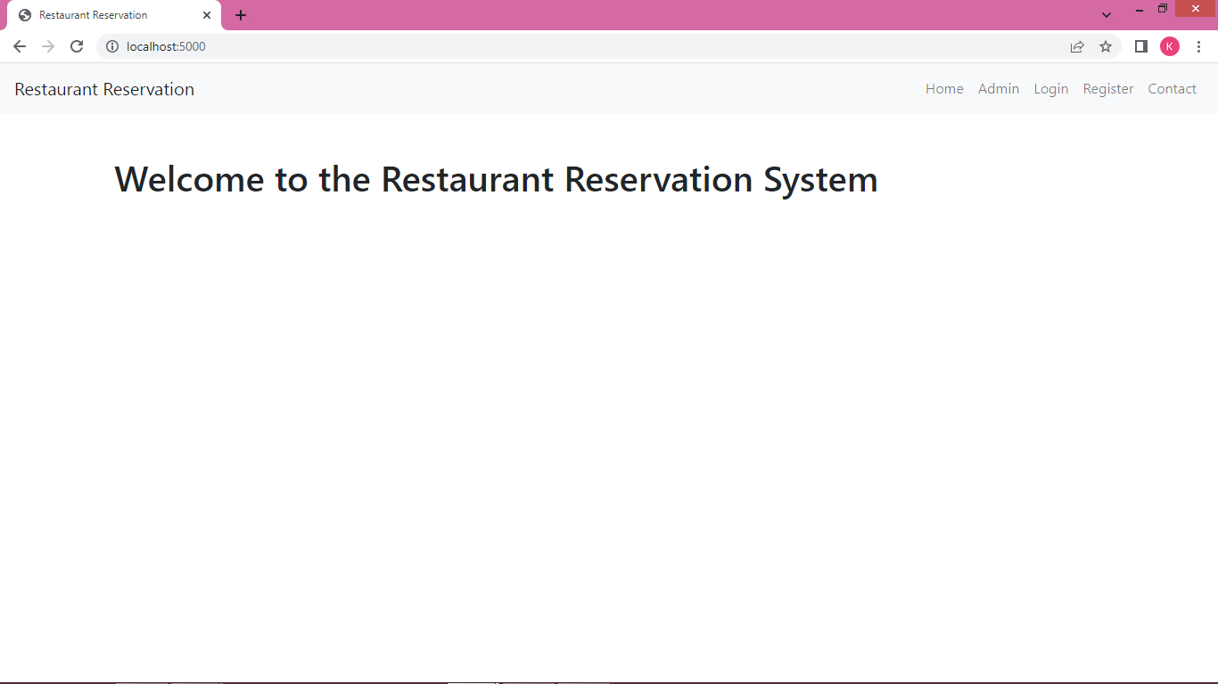

## User Login

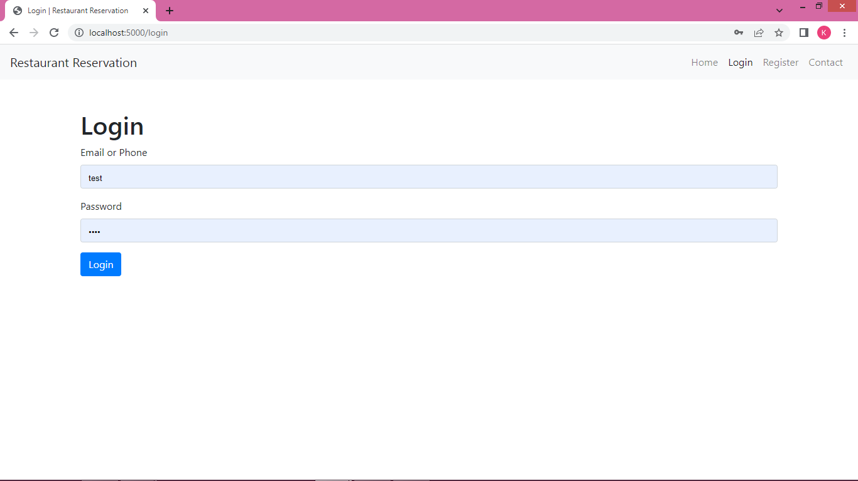

## Register

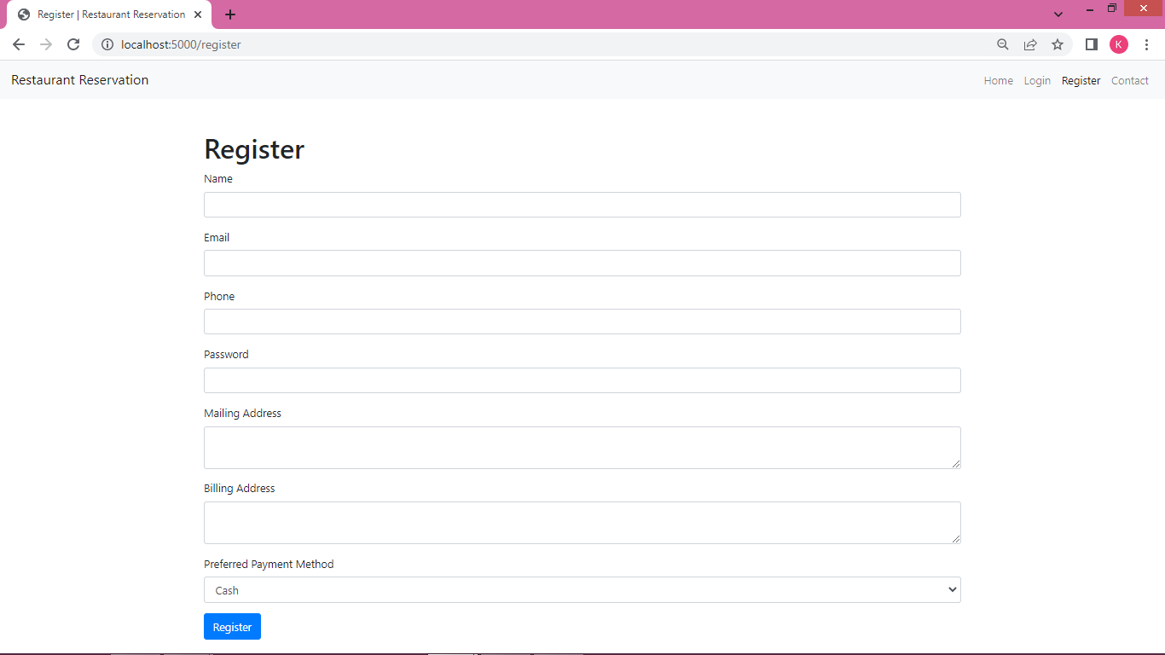

## Admin Login

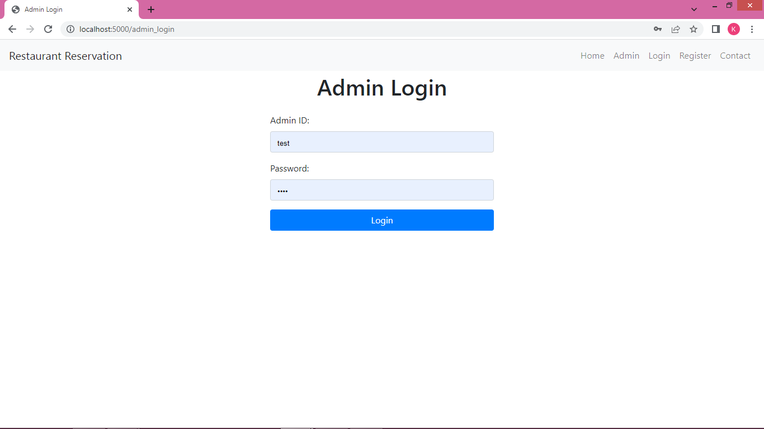

## User Dashboard

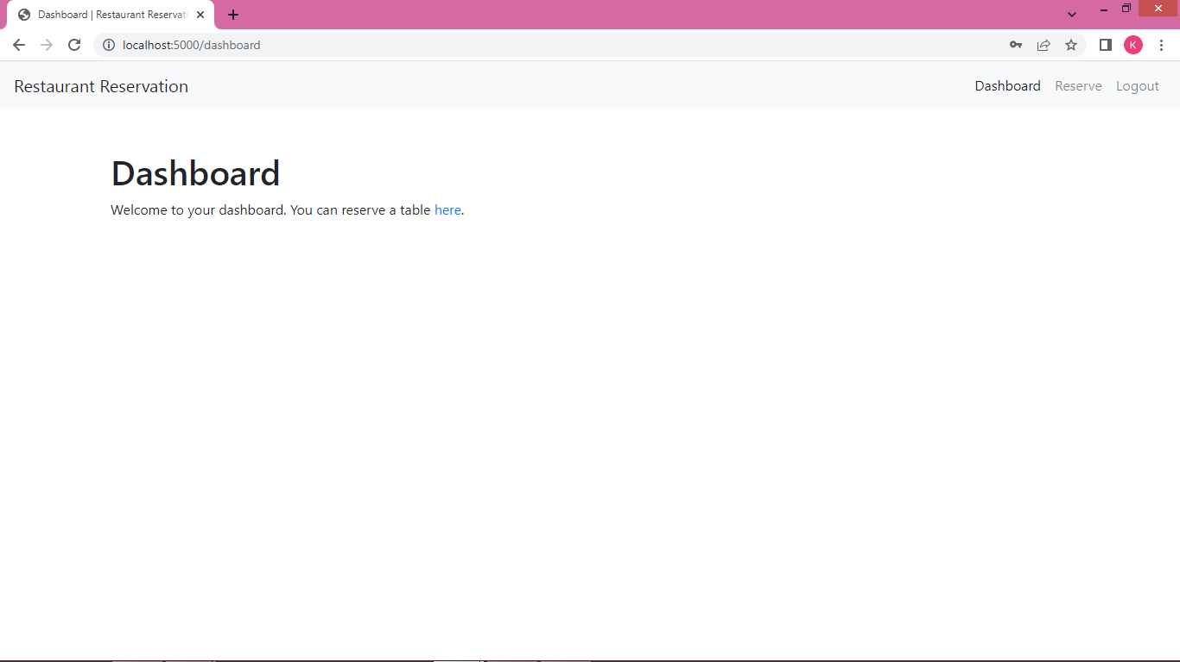

## Reservation

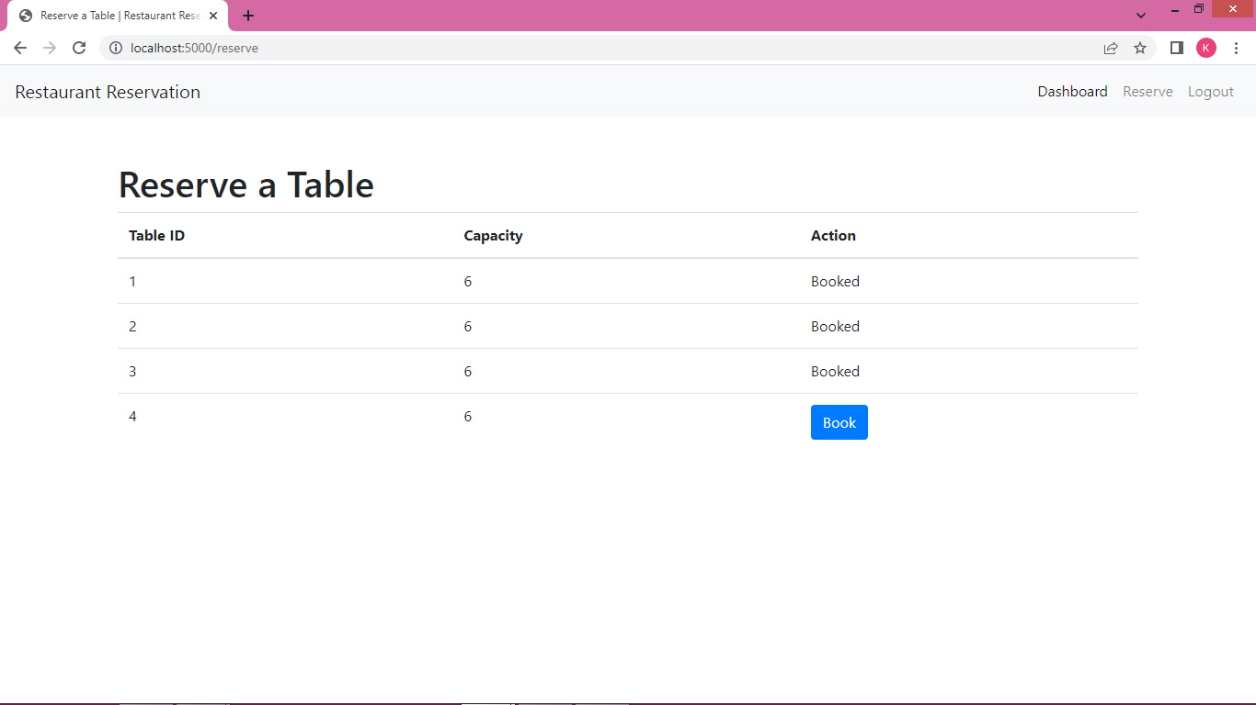

## Book Table

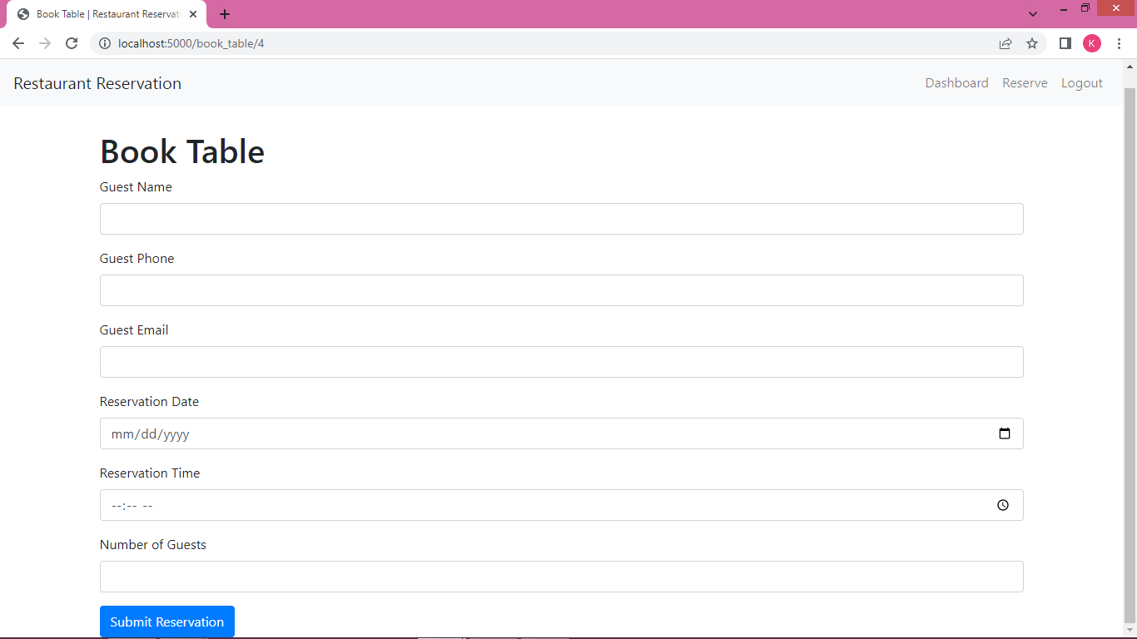

## Admin home

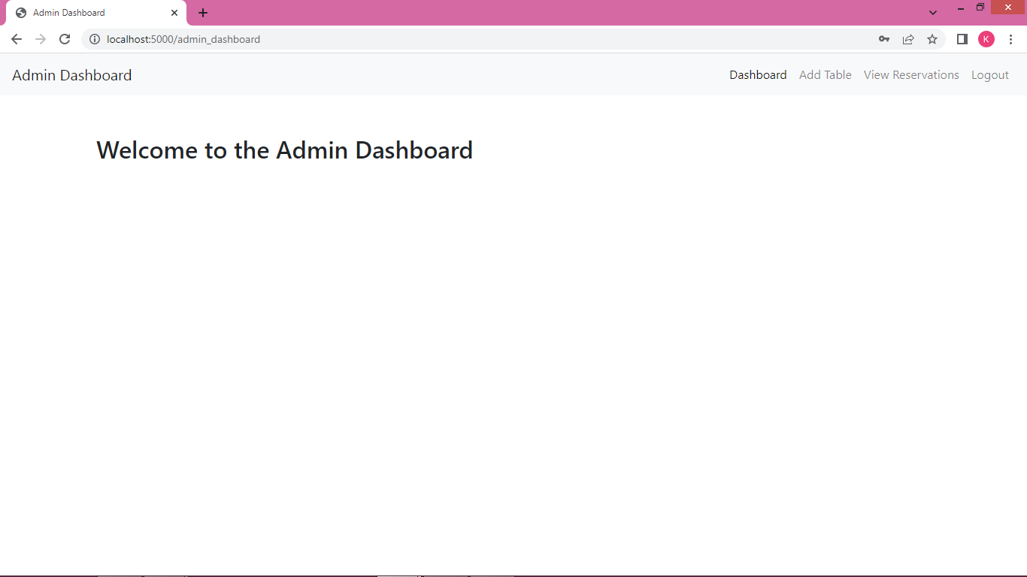

## Adding Table:

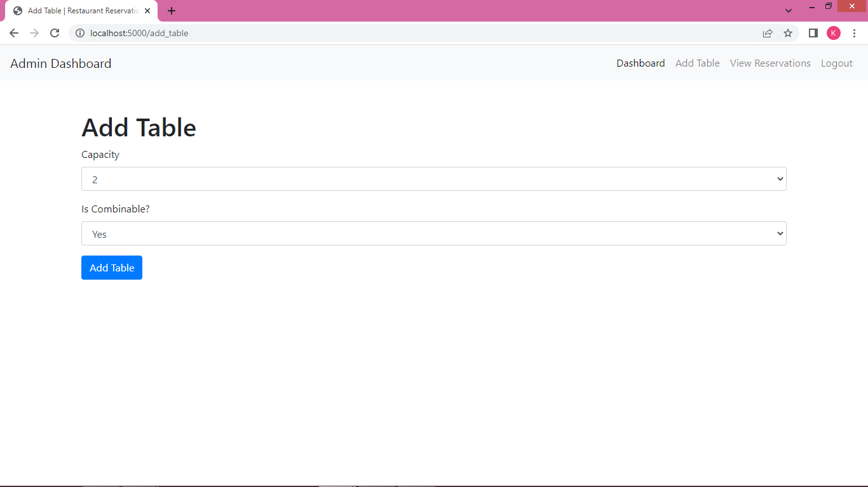

## Reservations

