Site 1: <http://www.worlditfoundation.org.bd/admin/login/>

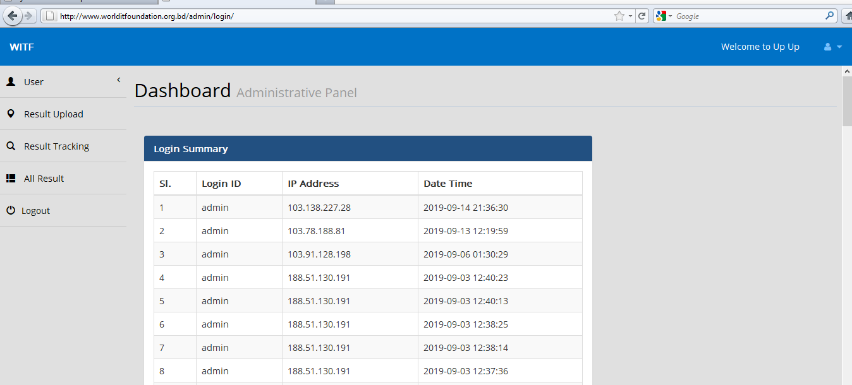

Site 2: <http://www.hotelrayas.com/admin/>

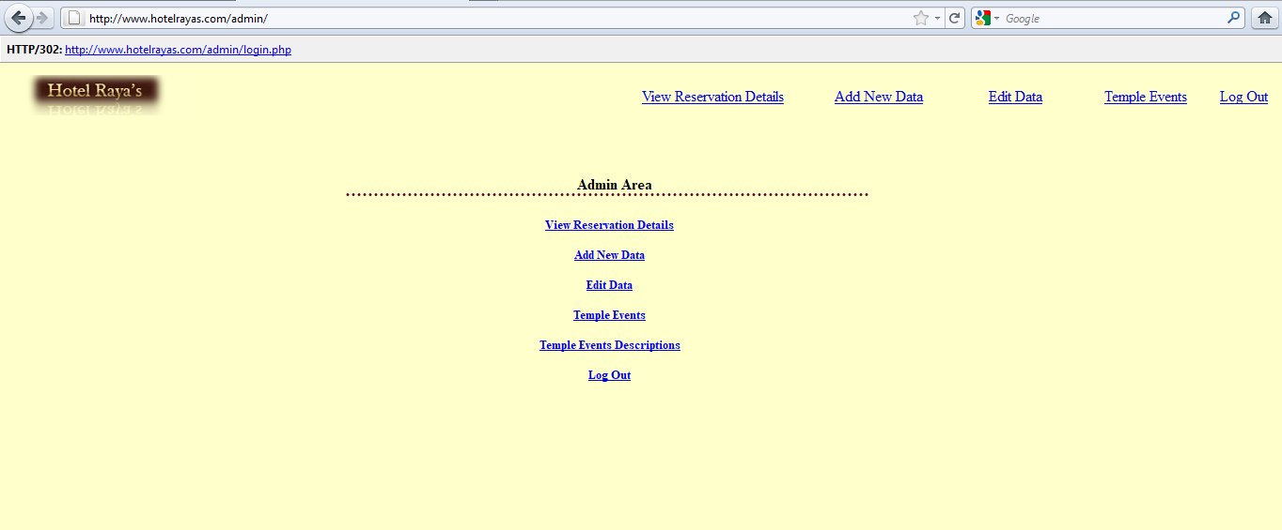

Site 3: <http://pawcab.com/admin/>

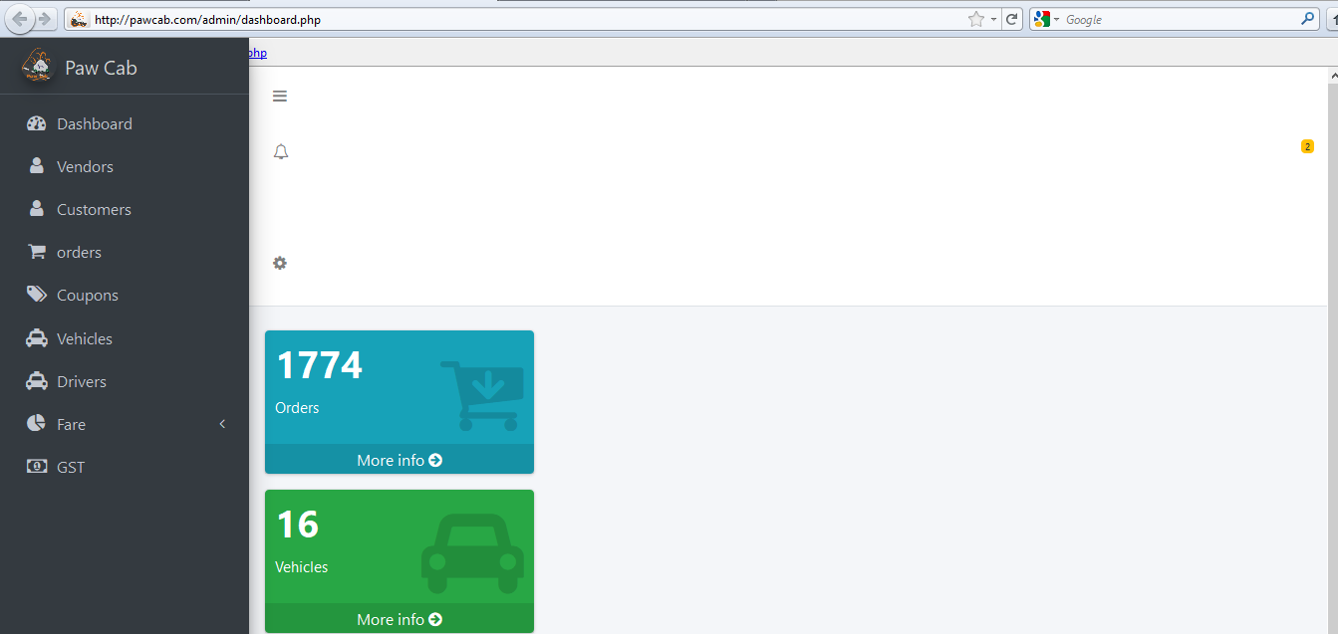

Site 4: <http://www.thurmanconnection.com/admin/>

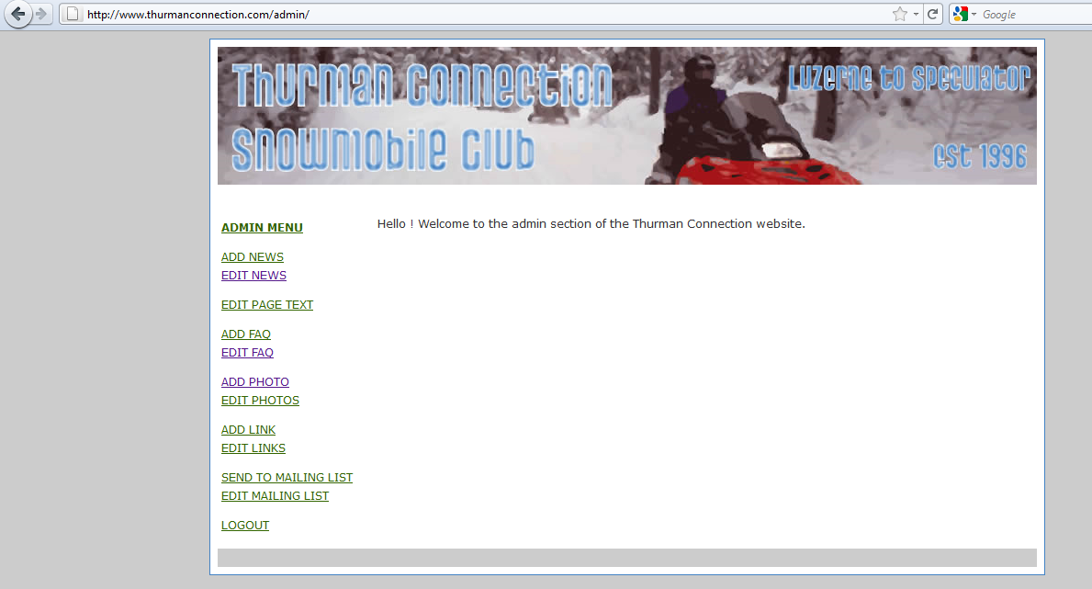

Site 5: <http://www.oneforall.asia/admin>

