A Project Report for CSN-300 (Lab-Based Project) of Spring Semester 2020-2021 On

Applications of AI for Target Identification with Microwave Imaging System

Submitted by

Aanand Vishnu Nambudiripad (18114001)

anambudiripad@cs.iitr.ac.in

Subhash Suryawanshi (18114076)

ssuryawanshi@cs.iitr.ac.in

Supervised by

Prof. Dharmendra Singh



Department of Computer Science and Engineering

Indian Institute of Technology (IIT) Roorkee

May 27, 2021

Abstract

In recent years, there has been continuous development in machine learning technology and this has also lead to a new standard in Target recognition with respect to Synthetic Aperture Radar (SAR) images. SAR is a field that has a lot of promise and is currently attracting a lot of research interest. Researchers are particularly interested in using machine learning to analyse and interact with SAR videos. We analysed SAR photographs of Roorkee obtained from two separate sources: Sentinel-1 and ALOS PALSAR. Railway line tracks and urban structures surrounded by foliage were identified as targets. In this method, we used a variety of machine learning techniques. This project has limitless applications, for example, on the oceans, where ships can be identified and tracked by their wakes. In addition, regular leakage from oil storage facilities is commonly observed. This could reveal more about the oil companies.

1

Contents

1 Introduction 1

2 Literature Review 2

3 Problem Statement 3

4 Methodology 6

5 Simulation Results 9

6 Conclusions 9

1 Introduction

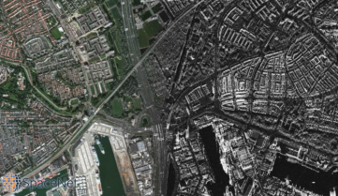

Figure 1: Satellite Image of Earth.

When asked to consider a ”satellite see,” the tremendous majority conceptualize just like the cleared exterior of the Image given over. The figure is a photograph taken with a very high shutter. Be that as it may, it isn’t the as it were way to see earth’s atmosphere from a plane or a satellite.

**What Is Synthetic Aperture Radar and How Does It Work?**

Synthetic aperture radar [1] (SAR) could be a way of making pictures of Radio waves. The frequency of the radio waves is much lower than the frequency of visible light. As we see within the figure underneath these this wavelength drop inside the microwave parcel of the range,

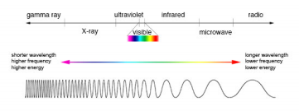

Figure 2: Electromagnetic spectrum.

RADAR (RAdio Detection And Ranging) creates radio waves and telecasts it from the antenna to the desired object. The radar may or may not receive the radio waves back, depending on the shape and attributes of the desired object. This gotten flag will be traversing for some time

1

which depends on the desired object’s distance from the receiver wire. H polarisation and V polarisation is utilised by the radar process. It has 4 distinctive channels:

HH - for horizontal transmit and horizontal receive,(HH)

VV - for vertical transmit and vertical receive,(VV)

HV - for horizontal transmit and vertical receive(HV), and

VH - for vertical transmit and horizontal receive (VH).

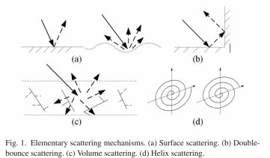

Surface, double-bounce, volume, and helix scattering [2] components are used individually to portray the interaction between objects and radar waves in urban and conventional enviroments. Bragg scatter from a to some degree rough surface, even- or double-bounce scatter from a pair of orthogonal surfaces with contrasting dielectric constants, and canopy scatters from a cloud of arbitrarily situated dipoles, individually, induce surface, double-bounce, and volume scrambling. The modern man-made structures create helix diffusing.

2 Literature Review

The first paper [3] proposed a system for SAR (Synthetic Opening Radar) ATR (Automatic Target Recognition) by matching the ASCs (Attributed Diffusing Centers) The second paper considered an approach for SAR ATR (Automatic Target Recognition) through matching the ASCs (Attributed Diffusing Centers). The approach they used was to classify each ASC into one of two regions using an approach that uses a point of differentiation rather than just matching the ASC point features to the target region. The spatial locations, relative amplitudes, and lengths of various binary regions of a discrete ASC are determined by zones and shapes of those regions. The test is then mapped to a binary target area based on the formats being compared:-

1.The proposed approach outperforms state-of-the-art approaches; the methods are effective for recognising errands that are often the desired object under SOC, and it has a PCC of 98 per cent %

2.Under different setup variations, significant depression point difference, noise contamination, and partial occlusion, the proposed approaches work better.

3.The robustness and viability of the procedures should be increased.

In the Second paper, [4] In the second paper, They were able to develop a lightweight Convolution Neural Network which is based on optical attention and depth-wise distinct convolution of Synthetic Aperture Radar pictures goal classification. A modern WDM loss function is used to unravel the data asymmetry between knowledge sets. In the end, they tested their models using a pair of datasets: MSTAR and OpenSARShip.The MSTAR database experiments revealed that, as compared to the CNN model without visual focus, their structures achieve better recognition accuracy, demonstrating that the representation capability of CNN can be improved by providing visual consideration components. The use of depthwise separable convolution will reduce the size of the model and the time it takes to iterate. The aim of the OpenSARShip dataset experiments is to compare the ability of a few methods to manage unbalanced data. Furthermore, the findings show that using a combination of re-sampling functions and the WDM feature to diminish the influence of knowledge shortcomings within the recognition process is more efficient. There were some flaws in the conclusion: -

Networks are vulnerable to noise to some extent, and there is still the opportunity to improve in this area.

2.If there is a difference in the size of the input images, the identification results would be affected, so the pictures must all be the same size.

3.Because the deep network requires a vast amount of data to plan, its implementations are limited to some extent. A need then arises for a weak machine learning algorithm that may be supervised or unsupervised. since this will improve recognition intelligence while reducing dependency on training data.

3 Problem Statement

Target Identification Using Artificial Intelligence and a Microwave Imaging System Our mission is to classify railway tracks and urban areas among tall vegetated areas using Sentinel-1 and PALSAR Synthetic Aperture Radar images of Roorkee (IITR Main Building). There are in the data images .tiff files from which data must be extracted since the SAR data set contains data in various TH-RX polarisation variations. Finally, a machine learning model that recognises train tracks and urban areas is built using data collection.

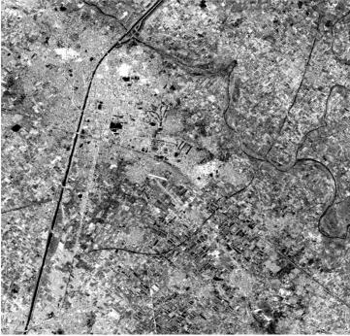Figure 3: Sentinel 1 Data (C Band)

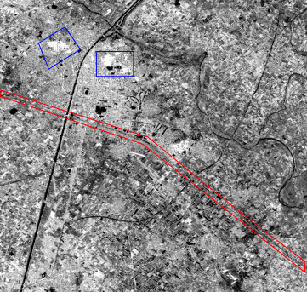

Figure 4: Blue Areas shows Urban Building surrounded by tall vegetation (Civil Hospital and IITR Main Building)

Red Areas Shows the Railway Track

4 Methodology

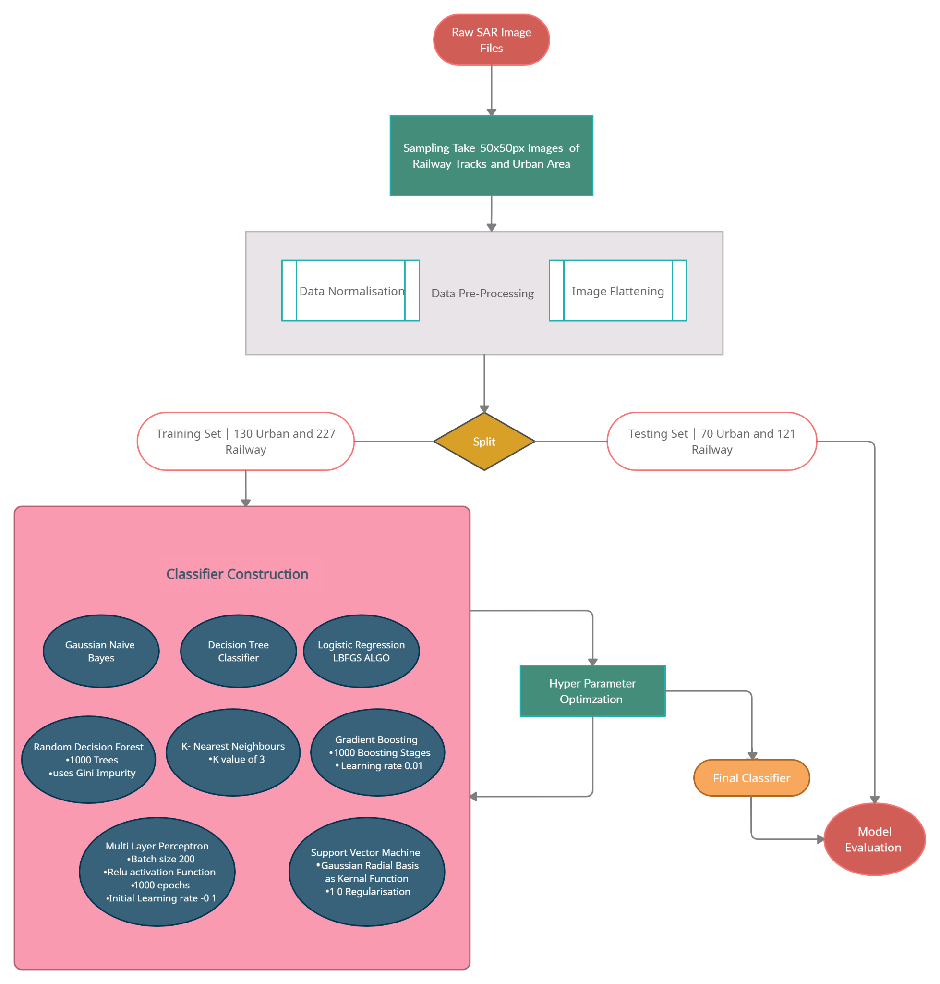

Figure 5: Methodology Flowchart

Two high-resolution SAR images of Roorkee were sent to us by two separate sources: ALOS2 PALSAR and Sentinel 1. The ALOS2 PALSAR data was in the L band, with four measured bands 3 in the dB scale for HH, HV, VV, and VH polarisations. Sentinel 1 data consisted of VH and VV polarisation data in linear and dB sizes and was collected in the C band. We had to correctly classify and mark two items from this data: railway line tracks and an urban building or area between tall vegetated areas. As a result, we broke down the initial big images into tiny 50x50 pixel images and selected those that contained an object from our target groups. These images were created, and we manually labelled and sorted them into separate classes, resulting in labelled data for these two classes.



Figure 6: SAR image of Railway track

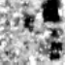

Figure 7: SAR image of the urban building surrounded by a tall vegetated area

In VV polarisation, the back dispersed return is more prevalent for the railway line route, while in HH polarisation, the urban buildings are more prominent. As a result, we used VV polarised images for railway track objects and HH polarised images for urban building objects to generate the labelled results. For target recognition, we used machine learning. We started with 200 images of urban structures and 348 images of railway tracks.The data was then divided into research and teaching parts, with 65 per cent of the data being training and 35 percent being testing. The research and training data were chosen at random. We performed scaling of the data set in terms of features. Data values were normalised such that they varied between 0 and 1 after the two-dimensional images were flattened into a one-dimensional array. The mean of the data was then set to 0 using standardisation. Then, in order to find a strong classifier, we used eight different machine learning models and algorithms. The eight models were as follows:

1. Gaussian Naive Bayes - The dataset is believed to be distributed Gaussianly in Gaus sian Naive Bayes. It’s a supervised machine learning algorithm that makes the naive assertion that all the variables’ features are conditionally independent. Despite its sim plicity, it is extremely quick and fairly precise.

2. Decision Tree Classifier - Decision Trees are a supervised machine learning algorithm that is non-parametric. The model forecasts the outcome by using decision rules based on the data’s characteristics. Data is classified using decision trees by sorting it from root to leaf node, with each data instance being checked against the attribute defined by the nodes along the way. We used information entropy as a criterion for judging the consistency of a split in our implementation. There is no optimum depth for the decision tree. When looking for the right split, the number of features weighed may be as high as the number of features.

3. Logistic Regression -For supervised classification in machine learning Logistic regression algorithm is utilized.. Logistic regression is similar to linear regression except that it uses a sigmoid function to generate a probabilistic value between 0 and 1 instead of fitting a regression line. We used the limited memory BFGS (L-BFGS) algorithm in our implementation, which is similar to the Broyden–Fletcher–Goldfarb–Shanno algorithm. The power of regularisation was set to one.

4. Random Decision Forest -Another machine learning technique or algorithm that we used is Random Decision Forest its a algorithm that employs an ensemble learning ap proach to create multiple decision trees that each operate on a subset of the dataset and uses averaging to increase predictive precision and minimise over-fitting. It produces bet ter outcomes since a group of lowly correlated trees working together outperforms any single tree. Each individual tree may have a flaw, but the group as a whole has negligible flaws as long as none of the trees err in the same direction. The number of trees in our implementation is 1000. The Gini impurity is used to assess a split’s consistency.

5. Gradient Boosting - Gradient Boosting is a set of slow prediction models, most com monly decision trees. Boosting is a technique for turning vulnerable students into good ones. The aim of gradient boosting is to reduce the model’s loss function by using gradient descent to include vulnerable learners. The poor learners are selfish decision trees with split points based on purity scores such as Gini or minimum loss, and all learners are given equal weight. The number of boosting stages in our implementation of Gradient Boosting is 1000, and the learning rate is 0.01. Specific regression estimators do not have a maximal depth.

6. Multilayer Perceptron - A multilayer perceptron is a feedforward artificial neural net work with a large number of layers. They are made up of an input layer that accepts a signal or data, an output layer that allows a forecast, and a number of hidden layers in between. Each neuron in the hidden layer uses a weighted linear summation followed by ”non-linear activation function” to convert output from the previous layer.Our implemen tation of the Multilayer Perceptron Classifier uses stochastic gradient descent and has two hidden layers. Its activation function is the rectified linear unit function (relu). A batch size of 200 is used. It has a steady learning rate and an initial learning rate of 0.1. It will last 1000 epochs.

7. Support Vector Machines - Support Vector Machine forms a part of the group of supervised machine learning algorithms and it is mainly used for classification problems, Kernel functions are used to map and transform the input data into a new form that is linearly separable in the new form. The distance between the hyperplane and the data is maximised by selecting a hyperplane that splits the data into separate groups.We used a Gaussian Radial Basis Function as our kernel function in this case. We’ve set the regularisation parameter to 1.0. This approach worked well for classifying the results.

8. K-Nearest Neighbours - K Nearest Neighbors is a machine learning algorithm that is supervised. It’s non-parametric, which means it makes no predictions about the data or how it’s distributed. The provided data point is compared to its K closest neighbours, and it is assigned to the class that has the most members of its K neighbours. In our implementation of the K Nearest Neighbours algorithm, we took into account the three closest neighbours, each of whom was assigned equal weightage.

5 Simulation Results

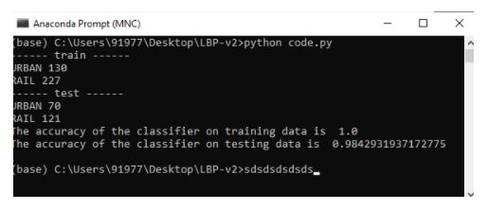Figure 8: Terminal Snippet

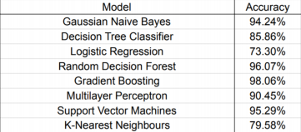6 Conclusions

We learned a lot about SAR images and different machine learning models through this extensive and enlightening project.

Our best accuracy was 98.06% using the Gradient Boosting model, with good accuracy achieved also using Support Vector Machines and Random Decision Forest Classifiers. We believe that by increasing our data-set, our accuracy could increase further. We might try using more models and techniques in our future research into this topic.

References

[1] L. Potter and R. Moses, “Attributed scattering centers for sar atr,” *IEEE Transactions on Image Processing*, vol. 6, no. 1, pp. 79–91, 1997.

[2] B. Zou, Y. Zhang, N. Cao, and P. Nghia, “A four-component decomposition model for polsar data using asymmetric scattering component,” *IEEE Journal of Selected Topics in Applied Earth Observations and Remote Sensing*, vol. 8, pp. 1–11, 03 2015.

[3] J. Tan, X. Fan, S. Wang, and Y. Ren, “Target recognition of sar images via matching attributed scattering centers with binary target region,” *Sensors*, vol. 18, p. 3019, 09 2018.

[4] J. Sun, C. Qu, J. Li, and S. Peng, “A lightweight convolutional neural network based on visual attention for sar image target classification,” *Sensors*, vol. 18, p. 3039, 09 2018.