title: Technical Report author: md-to-docx

Document Compiler Architecture
This report describes the architecture of an open-source document compiler that transforms Markdown and AI-generated content into professional Word documents.

Executive Summary
Modern teams write in Markdown — from GitHub READMEs to ChatGPT exports. Delivering polished Word documents still requires manual copy-paste and formatting. A document compiler automates this pipeline while preserving structure, tables, code blocks, and CJK typography.
Key insight: Treat Markdown → DOCX as a compilation step, not a one-off export.

Architecture
The system follows a linear pipeline with optional diagram rendering:
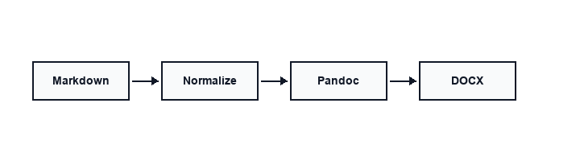

Pipeline Stages
Stage | Input | Output | Notes
Normalize | Raw .md | Cleaned .md | Fix tables, headings, blank lines
Mermaid (optional) | ```mermaid blocks | PNG images | Requires mmdc when fences present
Pandoc | GFM Markdown | .docx | Reference template + Lua filter
Post-check | .docx | Verified output | Source .md unchanged (SHA256)

Component Responsibilities
- CLI layer — discovers files, handles batch conversion, --dry-run, --output-dir
- Normalizer — CJK-aware heading numbers, list spacing, code fence fixes
- Converter — orchestrates pandoc subprocess with bundled assets
- Reference template — YaHei body, Consolas code, compact table style

Implementation Details

Normalization Rules
The normalizer applies deterministic transforms before pandoc sees the file:
class MarkdownNormalizer:
def normalize(self, text: str) -> str:
text = self._fix_tables(text)
text = self._fix_headings(text)
text = self._fix_code_blocks(text)
return text

Pandoc Invocation
pandoc input.md \
- -from gfm+yaml_metadata_block \
- -to docx \
- -reference-doc reference-wecom.docx \
- -lua-filter wecom-layout.lua \
- -dpi 150

Performance Characteristics
Metric | Value | Environment
Single file (< 50 KB) | < 2 s | macOS, pandoc 3.x
Batch 100 files | < 3 min | SSD, no Mermaid
Mermaid per diagram | 3–8 s | Depends on mmdc + browser

Security Considerations
- Source files are never modified in place
- Temporary files use a predictable prefix and are cleaned up
- No network calls during conversion (offline-first)
- Subprocess isolation for pandoc and mmdc

Internationalization
The reference template sets zh-CN theme language and uses Microsoft YaHei for body text. English headings and code remain in Consolas. Mixed Chinese/English paragraphs render correctly without manual font switching.

中文混排示例
本编译器支持中英文混排：标题可以是 English，正文可以是中文，表格和代码块保持统一风格。这对于技术团队撰写 bilingual 文档非常实用。

Future Work
- Native Document AST (v0.2) — reduce pandoc coupling
- Template presets — academic, business, API reference
- Table of contents generation
- OMML math support

Conclusion
A focused document compiler turns AI-era Markdown workflows into deliverable Word documents with one command. The architecture prioritizes reliability, offline operation, and CJK typography over feature breadth.

References
- Pandoc User's Guide — https://pandoc.org/MANUAL.html
- GitHub Flavored Markdown Spec
- Office Open XML (OOXML) standard

