Technical Report

Contents
Table of Contents

1 Document Compiler Architecture
This report describes the architecture of an open-source document compiler that transforms Markdown and AI-generated content into professional Word documents.

1.1 Executive Summary
Modern teams write in Markdown — from GitHub READMEs to ChatGPT exports. Delivering polished Word documents still requires manual copy-paste and formatting. A document compiler automates this pipeline while preserving structure, tables, code blocks, and CJK typography.
Key insight: Treat Markdown → DOCX as a compilation step, not a one-off export.

1.2 Architecture
The system follows a linear pipeline with optional diagram rendering:
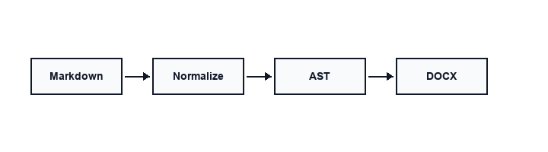
Figure 1. Architecture

1.2.1 Pipeline Stages
Stage | Input | Output | Notes
Normalize | Raw .md | Cleaned .md | Fix tables, headings, blank lines
Parse | Cleaned .md | Document AST | markdown-it-py + plugins
Transform | Document AST | Enriched AST | TOC, numbering, Mermaid/math/captions
Render | Document AST | .docx | python-docx + reference template

1.2.2 Component Responsibilities
- CLI layer — discovers files, handles batch conversion, --dry-run, --output-dir
- Normalizer — CJK-aware heading numbers, list spacing, code fence fixes
- Converter — parses Markdown to Document AST and renders DOCX
- Reference template — YaHei body, Consolas code, compact table style

1.3 Implementation Details

1.3.1 Normalization Rules
The normalizer applies deterministic transforms before parsing:

class MarkdownNormalizer:
def normalize(self, text: str) -> str:
text = self._fix_tables(text)
text = self._fix_headings(text)
text = self._fix_code_blocks(text)
return text

1.3.2 Native Invocation

./bin/convert input.md --preset technical --toc --numbering

1.4 Performance Characteristics
Metric | Value | Environment
Single file (< 50 KB) | < 2 s | macOS, Python 3.10+
Batch 100 files | < 3 min | SSD, no Mermaid
Mermaid per diagram | 3–8 s | Depends on mmdc + browser

1.5 Security Considerations
- Source files are never modified in place
- Temporary files use a predictable prefix and are cleaned up
- No network calls during conversion (offline-first)
- Optional Mermaid rendering via mmdc

1.6 Internationalization
The reference template sets zh-CN theme language and uses Microsoft YaHei for body text. English headings and code remain in Consolas. Mixed Chinese/English paragraphs render correctly without manual font switching.

1.6.1 中文混排示例
本编译器支持中英文混排：标题可以是 English，正文可以是中文，表格和代码块保持统一风格。这对于技术团队撰写 bilingual 文档非常实用。

1.7 Future Work
- Additional template presets and plugin hooks
- Template presets — academic, business, API reference
- Table of contents generation
- OMML math support

1.8 Conclusion
A focused document compiler turns AI-era Markdown workflows into deliverable Word documents with one command. The architecture prioritizes reliability, offline operation, and CJK typography over feature breadth.

1.9 References
- md-to-docx documentation — https://github.com/sunliang11/md-to-docx
- GitHub Flavored Markdown Spec
- Office Open XML (OOXML) standard

