

U.S. Department of Justice
FOIA Annual Report IEPD

Revision 2
November 10, 2010
Change History
Revision | Date | Author | Description of Revision
1 | October 31, 2010 | Eric Jakstadt | Initial draft. Corresponds to version 1.02 of the FOIA Annual Report schema.
2 | November 10, 2010 | Eric Jakstadt | Revise based on feedback. Corresponds to version 1.03 of the FOIA Annual Report schema.

1 Introduction 6
1.1 Intended IEP Usage 6
1.1.1 FOIA.gov Website 6
1.1.2 Offline Processing 6
2 FOIA Annual Report Excel Workbook 7
3 Mapping Spreadsheet 8
4 General Structure of Conformant Documents 9
4.1 Header Information 11
4.1.1 DocumentApplicationName 11
4.1.2 DocumentCreationDate 11
4.1.3 DocumentDescriptionText 11
4.1.4 Organization 11
4.1.4.1 OrganizationSubUnit 12
4.1.5 DocumentFiscalYearDate 12
4.1.6 Corresponding FOIA Workbook View 12
4.2 Report Sections 13
4.2.1 Typical Structure of a Report Section 14
4.2.1.1 Top Level Element - ProcessedRequestSection 15
4.2.1.2 Data Element – ProcessingStatistics 16
4.2.1.3 Associations – ProcessingStatisticsOrganizationAssociation 17
4.2.1.4 Footnotes - FootnoteText 18
4.2.1.5 Corresponding FOIA Workbook View 18
5 Report Section Details 20
5.1 Section IV - Exemption3StatuteSection 20
5.1.1 Business Rules 20
5.1.2 Discussion 20
5.2 Section V.A – ProcessedRequestSection 23
5.2.1 Business Rules 23
5.2.2 Discussion 23
5.3 Section V.B.1 - RequestDispositionSection 24
5.3.1 Business Rules 24
5.3.2 Discussion 24
5.4 Section V.B.2 - RequestDenialOtherReasonSection 27
5.4.1 Business Rules 27
5.4.2 Discussion 28
5.5 Section V.B.3 - RequestDispositionAppliedExemptionsSection 28
5.5.1 Business Rules 28
5.6 Section VI.A - ProcessedAppealSection 28
5.6.1 Discussion 29
5.7 Section VI.B - AppealDispositionSection 29
5.7.1 Business Rules 29
5.8 Section VI.C.1 - AppealDispositionAppliedExemptionsSection 29
5.8.1 Business Rules 29
5.9 Section VI.C.2 - AppealNonExemptionDenialSection 29
5.9.1 Business Rules 29
5.10 Section VI.C.3 - AppealDenialOtherReasonSection 30
5.10.1 Discussion 30
5.11 Section VI.C.4 - AppealResponseTimeSection 30
5.11.1 Business Rules 30
5.11.2 Discussion 30
5.12 Section VI.C.5 - OldestPendingAppealSection 31
5.12.1 Business Rules 32
5.12.2 Discussion 32
5.13 Section VII.A - ProcessedResponseTimeSection 34
5.13.1 Business Rules 34
5.13.2 Discussion 34
5.14 Section VII.B - InformationGrantedResponseTimeSection 35
5.14.1 Discussion 35
5.15 Section VII.C.1 - SimpleResponseTimeIncrementsSection 35
5.15.1 Discussion 35
5.16 Section VII.C.2 - ComplexResponseTimeIncrementsSection 35
5.16.1 Discussion 35
5.17 Section VII.C.3 - ExpeditedResponseTimeIncrementsSection 35
5.17.1 Discussion 36
5.18 Section VII.D - PendingPerfectedRequestsSection 36
5.18.1 Business Rules 36
5.19 Section VII.E - OldestPendingRequestSection 36
5.19.1 Discussion 36
5.20 Section VIII.A - ExpeditedProcessingSection 36
5.20.1 Business Rules 37
5.21 Section VIII.B - FeeWaiverSection 37
5.21.1 Business Rules 37
5.22 Section IX - PersonnelAndCostSection 37
5.22.1 Business Rules 37
5.23 Section X - FeesCollectedSection 37
5.23.1 Business Rules 37
5.24 Section XII.A - BacklogSection 38
5.24.1 Business Rules 38
5.25 Section XII.B - ProcessedConsultationSection 38
5.25.1 Discussion 38
5.26 Section XII.C - OldestPendingConsultationSection 38
5.26.1 Discussion 38
5.27 Section XII.D.1 - ProcessedRequestComparisonSection 38
5.27.1 Business Rules 38
5.28 Section XII.D.2 - BackloggedRequestComparisonSection 39
5.28.1 Business Rules 39
5.29 Section XII.E.1 - ProcessedAppealComparisonSection 39
5.29.1 Discussion 39
5.30 Section XII.E.2 – BackloggedAppealComparisonSection 39
5.30.1 Business Rules 40
6 Works Cited 41

Introduction
Federal agencies publish FOIA information in accordance with guidelines prepared by the U. S. Department of Justice Office of Information and Privacy (see “FOIA Guidance Document” in Works Cited). These guidelines describe the format and meaning of FOIA annual report information.
The FOIA Annual Report Information Exchange Package (IEP) which is described in this document allows agency FOIA annual report information to be represented and exchanged in a standardized machine-readable format. This XML schema closely follows the structure and terminology of the guidance document, and conforms to the NIEM standard (http://niem.gov).
This document describes version 1.03 of the FOIA Annual Report IEP, which is the latest version as of this writing.

Intended IEP Usage

FOIA.gov Website
The Department of Justice is developing a website (http://foia.gov) for the display information about FOIA requests and other attributes. The objective is to provide the public information about FOIA administration from across the government. The information will also be timely and relevant. The Department’s goal is to become transparent about FOIA administration and this can be accomplished through an effective web presence.
The FOIA.gov website is to be a Dashboard that is highly configurable and data-driven. It will allow users to:
- Sort, compare, and filter annual FOIA compliance data from 92 federal agencies and their sub-agencies and view it in easy-to-read and understandable formats (tables, charts, graphs).
- Compare the data from year to year and across agencies and sub agencies.
- Make basic calculations based on the raw data (e.g., what percentage agency x’s backlog is in relation to the backlog of the entire federal government).
Agencies submit their FOIA information to FOIA.gov as XML documents conforming to the FOIA Annual Report IEP.

Offline Processing
All agency data available through reports and graphs on FOIA.gov is also available for public download as XML documents conforming to the FOIA Annual Report IEP. This enables any kind of offline processing, storage, comparison, or mash up which may be desired.

FOIA Annual Report Excel Workbook
The Department of Justice has also prepared an Excel workbook which can be used to create and modify XML documents conforming to the FOIA Annual Report IEP. This workbook is included as an artifact in the IEPD package (tools/FoiaAnnualReport-v1.0.xlt). Some agencies use this workbook to prepare FOIA annual reports. Other agencies have modified FOIA tracking systems to export as XML instance documents conforming to this IEPD. The Excel workbook is included with the IEPD since it will likely be a useful tool for any organization working with the FOIA Annual Report IEP.

Mapping Spreadsheet
Another artifact included in the IEPD is the mapping spreadsheet (FoiaAnnualReportStructure.xls in documentation/master). The FOIA Annual Report IEP defines a large number of types and elements in the XSD schema files. Thus it is difficult to visualize the structure and interrelationships of the various types and elements simply by studying the schemas. The mapping spreadsheet has an entry for each FOIA type. The types are ordered in the spreadsheet in roughly the order they appear in a typical FOIA Annual Report IEP, which in turn closely follows the order of the FOIA Guidance Document (see Works Cited). It shows how types and elements are related, and references the section of the guidance document where they are used.
The table below lists the columns presented in the mapping spreadsheet and describes their meanings. For each FOIA type the following information is presented:
Column | Description
Type | The name of the type described by the other columns. We’ll refer to this as the “type under consideration”.
Extension of Type | The type from which the type under consideration derives, if any.
Elements of Type | Elements in the foia namespace which are of the type under consideration.
Section Where Used | Guidance document sections in which the type under consideration is used.
Contained Elements | Elements which are contained within the type under consideration.
Contained Element Type | For each “contained element” in the previous column, the type is given.

General Structure of Conformant Documents
This section presents a high-level overview of FOIA Annual Report IEP documents.
Figure 1 shows a UML diagram of the top-level structure. Figure 2 shows a small sample conformant document. This sample is a small portion pulled from the 2009 Department of Justice FOIA annual report, which is used throughout this document as a sample. The full 2009 DOJ report is included in the IEPD package as a sample.
FOIA Annual Report IEP documents consist of context-setting header information, followed by a series of 30 report sections. The report sections directly correspond to the format and order of information presented in the FOIA guidance document (see Works Cited).
Figure 1 – High-level structure of FOIA Annual Report Information Exchange Package (IEP)
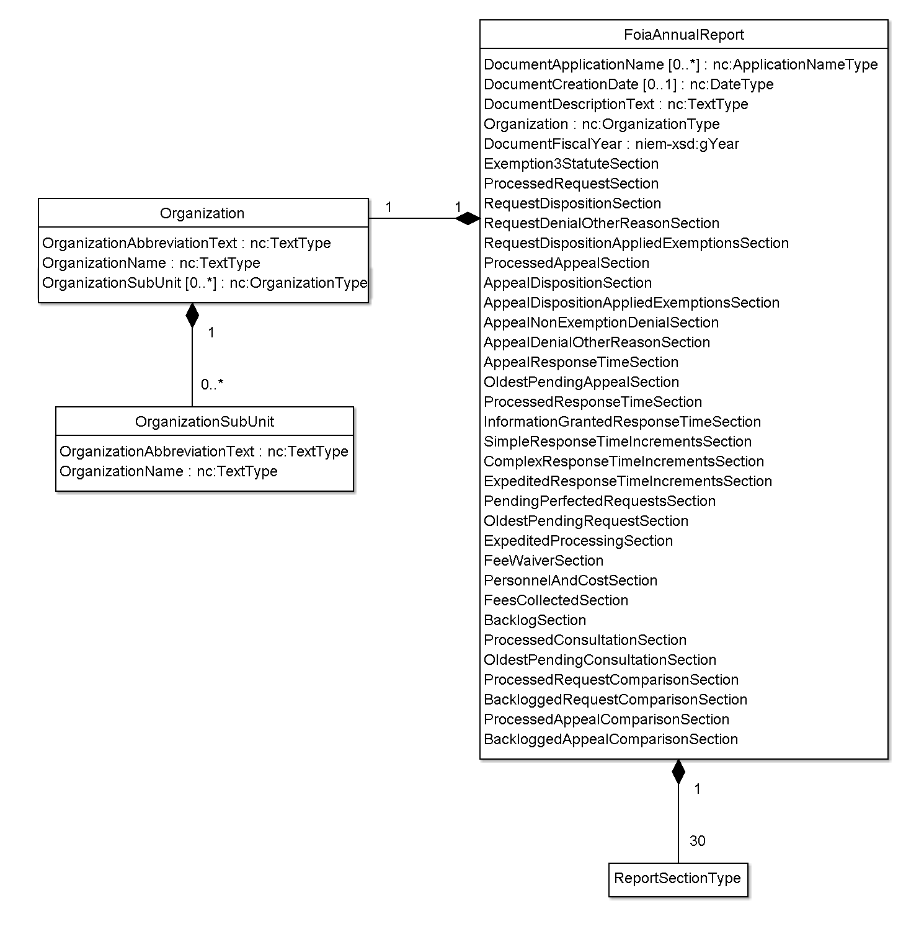
Figure 2 – Small Sample Conformant Document
1 <?xml version="1.0"?>
2 <iepd:FoiaAnnualReport xmlns:iepd="http://leisp.usdoj.gov/niem/FoiaAnnualReport/exchange/1.03" xsi:schemaLocation="http://leisp.usdoj.gov/niem/FoiaAnnualReport/exchange/1.03 ../schema/exchange/FoiaAnnualReport.xsd" xmlns:foia="http://leisp.usdoj.gov/niem/FoiaAnnualReport/extension/1.03" xmlns:i="http://niem.gov/niem/appinfo/2.0" xmlns:j="http://niem.gov/niem/domains/jxdm/4.1" xmlns:nc="http://niem.gov/niem/niem-core/2.0" xmlns:s="http://niem.gov/niem/structures/2.0" xmlns:xsi="http://www.w3.org/2001/XMLSchema-instance">
3 <nc:DocumentApplicationName nc:applicationVersionText="1.1">FOIA Annual Report Workbook</nc:DocumentApplicationName>
4 <nc:DocumentCreationDate>
5 <nc:Date>2010-04-08</nc:Date>
6 </nc:DocumentCreationDate>
7 <nc:DocumentDescriptionText>FOIA Annual Report</nc:DocumentDescriptionText>
8 <nc:Organization s:id="ORG0">
9 <nc:OrganizationAbbreviationText>DOJ</nc:OrganizationAbbreviationText>
10 <nc:OrganizationName>U.S. Department of Justice</nc:OrganizationName>
11 <nc:OrganizationSubUnit s:id="ORG1">
12 <nc:OrganizationAbbreviationText>Office of the AG</nc:OrganizationAbbreviationText>
13 <nc:OrganizationName>Office of the Attorney General</nc:OrganizationName>
14 </nc:OrganizationSubUnit>
15 <nc:OrganizationSubUnit s:id="ORG2">
16 <nc:OrganizationAbbreviationText>Office of the DAG</nc:OrganizationAbbreviationText>
17 <nc:OrganizationName>Office of the Deputy Attorney General</nc:OrganizationName>
18 </nc:OrganizationSubUnit>
19 <nc:OrganizationSubUnit s:id="ORG3">
20 <nc:OrganizationAbbreviationText>Office of the Assoc. AG</nc:OrganizationAbbreviationText>
21 <nc:OrganizationName>Office of the Associate Attorney General</nc:OrganizationName>
22 </nc:OrganizationSubUnit>
23 </nc:Organization>
24 <foia:DocumentFiscalYearDate>2009</foia:DocumentFiscalYearDate>
25 <foia:Exemption3StatuteSection/>
26 <foia:ProcessedRequestSection>
27 <foia:ProcessingStatistics s:id="PS1">
28 <foia:ProcessingStatisticsPendingAtStartQuantity>102</foia:ProcessingStatisticsPendingAtStartQuantity>
29 <foia:ProcessingStatisticsReceivedQuantity>264</foia:ProcessingStatisticsReceivedQuantity>
30 <foia:ProcessingStatisticsProcessedQuantity>237</foia:ProcessingStatisticsProcessedQuantity>
31 <foia:ProcessingStatisticsPendingAtEndQuantity>129</foia:ProcessingStatisticsPendingAtEndQuantity>
32 </foia:ProcessingStatistics>
33 <foia:ProcessingStatistics s:id="PS2">
34 <foia:ProcessingStatisticsPendingAtStartQuantity>65</foia:ProcessingStatisticsPendingAtStartQuantity>
35 <foia:ProcessingStatisticsReceivedQuantity>117</foia:ProcessingStatisticsReceivedQuantity>
36 <foia:ProcessingStatisticsProcessedQuantity>98</foia:ProcessingStatisticsProcessedQuantity>
37 <foia:ProcessingStatisticsPendingAtEndQuantity>84</foia:ProcessingStatisticsPendingAtEndQuantity>
38 </foia:ProcessingStatistics>
39 <foia:ProcessingStatistics s:id="PS3">
40 <foia:ProcessingStatisticsPendingAtStartQuantity>11</foia:ProcessingStatisticsPendingAtStartQuantity>
41 <foia:ProcessingStatisticsReceivedQuantity>48</foia:ProcessingStatisticsReceivedQuantity>
42 <foia:ProcessingStatisticsProcessedQuantity>45</foia:ProcessingStatisticsProcessedQuantity>
43 <foia:ProcessingStatisticsPendingAtEndQuantity>14</foia:ProcessingStatisticsPendingAtEndQuantity>
44 </foia:ProcessingStatistics>
45 <foia:ProcessingStatistics s:id="PS0">
46 <foia:ProcessingStatisticsPendingAtStartQuantity>178</foia:ProcessingStatisticsPendingAtStartQuantity>
47 <foia:ProcessingStatisticsReceivedQuantity>429</foia:ProcessingStatisticsReceivedQuantity>
48 <foia:ProcessingStatisticsProcessedQuantity>380</foia:ProcessingStatisticsProcessedQuantity>
49 <foia:ProcessingStatisticsPendingAtEndQuantity>227</foia:ProcessingStatisticsPendingAtEndQuantity>
50 </foia:ProcessingStatistics>
51 <foia:ProcessingStatisticsOrganizationAssociation>
52 <foia:ComponentDataReference s:ref="PS1"/>
53 <nc:OrganizationReference s:ref="ORG1"/>
54 </foia:ProcessingStatisticsOrganizationAssociation>
55 <foia:ProcessingStatisticsOrganizationAssociation>
56 <foia:ComponentDataReference s:ref="PS2"/>
57 <nc:OrganizationReference s:ref="ORG2"/>
58 </foia:ProcessingStatisticsOrganizationAssociation>
59 <foia:ProcessingStatisticsOrganizationAssociation>
60 <foia:ComponentDataReference s:ref="PS3"/>
61 <nc:OrganizationReference s:ref="ORG3"/>
62 </foia:ProcessingStatisticsOrganizationAssociation>
63 <foia:ProcessingStatisticsOrganizationAssociation>
64 <foia:ComponentDataReference s:ref="PS0"/>
65 <nc:OrganizationReference s:ref="ORG0"/>
66 </foia:ProcessingStatisticsOrganizationAssociation>
67 <foia:FootnoteText>After reviewing its database, BOP adjusted the number of requests pending as of the start of Fiscal Year 2009</foia:FootnoteText>
68 </foia:ProcessedRequestSection>
69 <foia:RequestDispositionSection/>
70 <foia:RequestDenialOtherReasonSection/>
71 <foia:RequestDispositionAppliedExemptionsSection/>
72 <foia:ProcessedAppealSection/>
73 <foia:AppealDispositionSection/>
74 <foia:AppealDispositionAppliedExemptionsSection/>
75 <foia:AppealNonExemptionDenialSection/>
76 <foia:AppealDenialOtherReasonSection/>
77 <foia:AppealResponseTimeSection/>
78 <foia:OldestPendingAppealSection/>
79 <foia:ProcessedResponseTimeSection/>
80 <foia:InformationGrantedResponseTimeSection/>
81 <foia:SimpleResponseTimeIncrementsSection/>
82 <foia:ComplexResponseTimeIncrementsSection/>
83 <foia:ExpeditedResponseTimeIncrementsSection/>
84 <foia:PendingPerfectedRequestsSection/>
85 <foia:OldestPendingRequestSection/>
86 <foia:ExpeditedProcessingSection/>
87 <foia:FeeWaiverSection/>
88 <foia:PersonnelAndCostSection/>
89 <foia:FeesCollectedSection/>
90 <foia:BacklogSection/>
91 <foia:ProcessedConsultationSection/>
92 <foia:OldestPendingConsultationSection/>
93 <foia:ProcessedRequestComparisonSection/>
94 <foia:BackloggedRequestComparisonSection/>
95 <foia:ProcessedAppealComparisonSection/>
96 <foia:BackloggedAppealComparisonSection/>
97 </iepd:FoiaAnnualReport>

Header Information

DocumentApplicationName
The first element is DocumentApplicationName, which is of type nc:ApplicationNameType. As you can see from the cardinality shown in Figure 1, this is an optional element. It also allows an optional attribute applicationVersionText. A sample can be seen at line 3 of Figure 2. This element allows an IEP instance document to be tagged with the application/version which created the document. It is purely informative. Application authors are free to describe the application and version in any manner they choose. There is no registry kept of known applications. Other applications which ingest the IEP should not change their behavior based on this element.

DocumentCreationDate
DocumentCreationDate is another optional element, of type nc:DateType. A sample can be seen at lines 4-6 of Figure 2. This element records the date when the document was created by the application, if the application chooses to record that information.

DocumentDescriptionText
DocumentDescriptionText is the first mandatory element. A sample can be seen at line 7 of Figure 2. It is a free-format description of the instance document. The Excel workbook currently always uses “FOIA Annual Report” as the value of this element, but other applications may choose to describe the instance document in other ways.

Organization
The mandatory Organization element, of type nc:OrganizationType, provides the name of the reporting agency, and defines any sub-organizations (i.e. components, offices, divisions) for which the annual report provides broken-out information. A sample can be seen at lines 8-23 of Figure 2.
The Organization element must be tagged with an s:id attribute defining a value by which the organization will be referenced from elsewhere in the instance document. This value must be unique within the instance document. NIEM Associations are used throughout the FOIA IEP to associate data elements with organizations. See section 5.5 of the NIEM User Guide (see Works Cited) for more information on NIEM Associations.
Nested within the Organization element, an OrganizationAbbreviationText and an OrganizationName element must be defined. OrganizationName contains the full name of the reporting agency. OrganizationAbbreviationText contains an abbreviation which may be used by an application for display purposes. The FOIA Excel workbook uses the abbreviation throughout whenever a reference to the agency is displayed.

OrganizationSubUnit
Optionally, nested within the Organization element, any number of sub-organizations (i.e. components, offices, divisions) for which the annual report provides broken-out information may be defined. For each such sub-organization, an OrganizationSubUnit element must be defined, each in turn containing OrganizationAbbreviationText and OrganizationName elements as described above in the context of the agency level. Each OrganizationSubUnit element must also be tagged with an s:id attribute defining a unique value by which the sub-organization will be referenced from elsewhere in the instance document.

DocumentFiscalYearDate
DocumentFiscalYearDate is a mandatory element. A sample can be seen at line 24 of Figure 2. It provides the fiscal year to which the instance document pertains. Fiscal year 2009 refers to the period from October 1, 2008 through September 30, 2009.

Corresponding FOIA Workbook View
As another view to aid in understanding the meaning of the instance document, Figure 3 below shows how the FOIA workbook displays header information of the instance document presented in Figure 2.
Figure 3 - Header Information in FOIA Workbook
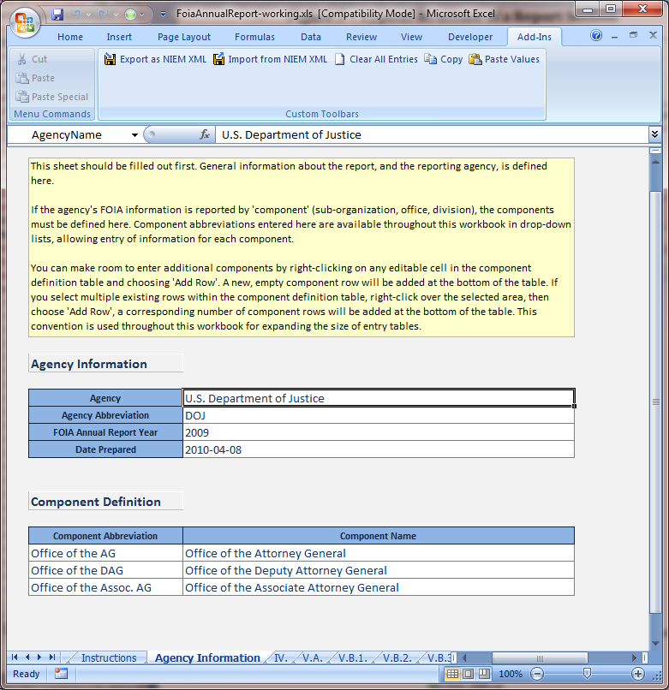

Report Sections
As illustrated in the FoiaAnnualReport element of Figure 1, following DocumentFiscalYearDate are 30 mandatory report sections.
Each of these sections must be present, in the stated order. The order matches that presented in the guidance document (see Works Cited). Section 3 (Mapping Spreadsheet) describes another FOIA Annual Report IEPD artifact which can be used to map IEP element names to specific numbered sections of the guidance document.
In Figure 2, all report sections are empty except for ProcessedRequestSection, which contains a small amount of sample data to be discussed below. All report sections can be empty and still validate against the IEP XML schema, although the report may not make sense according to business rules. This brings up a distinction that is important to understand. The IEP XML schema validates numerous important structural aspects of a FOIA Annual Report IEP. This goes a long way toward ensuring that the report is valid and ingestible by other applications, but there are numerous business rules defined in the guidance document that are not a good fit for validation using XML schema. The NIEM User Guide (see Works Cited) addresses this topic by stating:
Business rules can be validated outside of XML schema by embedding them in applications, XML Stylesheets (XSLT), Schematron (an assertion language), or other methods. ……. This illustrates the notion that there are many different ways of dealing with constraints and business rules. An XML schema may not be the most powerful or rigorous method of defining such constraints, but it can be sufficient for validating common kinds of constraints.
The FOIA workbook validates numerous business rules defined in the guidance document (see Works Cited) which are not validated by the XML schema itself. Section 5 (Report Section Details) contains a sub-section for each of the 30 report sections. These sub-sections enumerate the key business rules defined in the guidance document, as implemented in the FOIA workbook. The FOIA workbook will not write an IEP instance document unless it both validates against the XML schema, and obeys these business rules. It may prove to be a useful tool for any organization developing an application which creates FOIA Annual Report IEP documents. Generated documents can be loaded into the FOIA workbook to determine whether they validate against all these structural and business rules.
It should be understood that the guidance document and other information published by the U. S. Department of Justice Office of Information and Privacy (http://www.justice.gov/oip/oip.html), not this document, are the ultimate sources for business rules related to FOIA Annual Reports.

Typical Structure of a Report Section
Next we look closely at the internal structure of a typical report section, using ProcessedRequestSection as illustrated in lines 26-68 of Figure 2 as an example. Here we go into great detail on ProcessedRequestSection, illustrating along the way how to make use of the mapping spreadsheet, and examining patterns which are used in all 30 report sections.
This document will not dissect all report sections to this degree. It is not intended as exhaustive reference for each and every type and element. The mapping spreadsheet and the xml schemas themselves are intended to be referenced for this detailed information. Instead, this document strives to present high-level structure, explain patterns which are used repeatedly, and illustrate how to make use of other artifacts to obtain detailed information necessary to produce or consume IEP documents. Thus, sub-sections of section 5 (Report Section Details) only cover business rules and anything else not easily understood from the mapping spreadsheet and schemas.
Figure 4 below presents a UML diagram showing the structure of ProcessedRequestSection. The subsections below refer back to this.
Figure 4 – Typical Structure of a Report Section
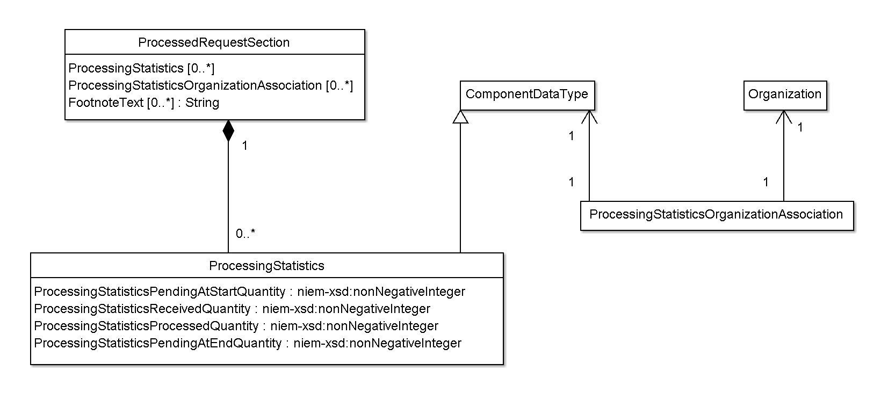

Top Level Element - ProcessedRequestSection
The top-level element of each report section:
- Has an element name which ends with “Section”
- Is of a type which derives from ReportSectionType. The type name ends with “SectionType”.
- Contains
  - a series of data elements (ProcessingStatistics in this example)
  - followed by a series of associations which tie each data element to an organization (i.e. component or agency overall) defined in the header section (ProcessingStatisticsOrganizationAssociation in this example)
  - followed by a series of footnotes (FootnoteText)
Referencing the mapping spreadsheet or the schema files themselves, you will see that the element ProcessedRequestSection is of type ProcessedSectionType. Since the mapping spreadsheet is organized by type, it is ProcessedSectionType you will want to look up there, to find the following information:
Column | Description
Type | ProcessedSectionType
Extension of Type | ReportSectionType
Elements of Type | ProcessedRequestSection  ProcessedAppealSection  ProcessedConsultationSection
Section Where Used | V.A  VI.A  XII.B
Contained Elements | ProcessingStatistics (type ProcessingStatisticsType)  ProcessingStatisticsOrganizationAssociation (type ComponentDataOrganizationAssociationType)  FootnoteText (type nc:TextType)

The corresponding definition from FoiaAnnualReportExtensions.xsd is shown in Figure 5.
Figure 5 - XML Schema Definition of ProcessedSectionType
1 <xsd:complexType name="ProcessedSectionType">
2 <xsd:annotation>
3 <xsd:documentation>A data type for a report section describing processing statistics for requests, appeals, or consultations over the course of the fiscal year. Corresponds to sections V.A, VI.A, and VII.B of the guidance document.</xsd:documentation>
4 </xsd:annotation>
5 <xsd:complexContent>
6 <xsd:extension base="foia:ReportSectionType">
7 <xsd:sequence>
8 <xsd:element ref="foia:ProcessingStatistics" minOccurs="0" maxOccurs="unbounded"/>
9 <xsd:element ref="foia:ProcessingStatisticsOrganizationAssociation" minOccurs="0" maxOccurs="unbounded"/>
10 <xsd:element ref="foia:FootnoteText" minOccurs="0" maxOccurs="unbounded"/>
11 </xsd:sequence>
12 </xsd:extension>
13 </xsd:complexContent>
14 </xsd:complexType>

There are several things to observe in this information:
- ProcessedSectionType is derived from ReportSectionType. This is true of all report sections.
- ProcessedSectionType is used for 3 different report sections, which correspond to sections V.A, VI.A, and XII.B of the guidance document. This of course means that each of those report sections has exactly identical structure.
- ProcessingStatistics is the “data element” for this report section. You can see in Figure 2 and Figure 4 that this is the element which embeds the actual data values. More on this in section 4.2.1.2 below
- ProcessingStatisticsOrganizationAssociation is the association element for this type. You can see in Figure 2 and Figure 4 that this associates a ProcessingStatistics element with an Organization or OrganizationSubUnit. More on this in section 4.2.1.3 below.

Data Element – ProcessingStatistics
The first child elements of a typical report section is a series of elements containing data values, derived from ComponentDataType, each with an s:id attribute as discussed in section 4.1.4 above. An example can be seen at lines 27-50 of Figure 2.The s:id attribute tags each data element with a unique id, allowing associations to reference data elements as discussed in section 4.2.1.3 below.
The following table presents the information available in the mapping spreadsheet for the data element (ProcessingStatistics) associated with our example report section (ProcessedRequestSection).

Column | Description
Type | ProcessingStatisticsType
Extension of Type | ComponentDataType
Elements of Type | ProcessingStatistics
Section Where Used | V.A  VI.A  XII.B
Contained Elements | ProcessingStatisticsPendingAtStartQuantity (type niem-xsd:nonNegativeInteger)  ProcessingStatisticsReceivedQuantity (type niem-xsd:nonNegativeInteger)  ProcessingStatisticsProcessedQuantity (type niem-xsd:nonNegativeInteger)  ProcessingStatisticsPendingAtEndQuantity (type niem-xsd:nonNegativeInteger)

The corresponding definition from FoiaAnnualReportExtensions.xsd is shown in Figure 6.

Figure 6 - XML Schema Definition of ProcessingStatisticsType
1 <xsd:complexType name="ProcessingStatisticsType">
2 <xsd:annotation>
3 <xsd:documentation>A data type describing processing statistics for different types of items (requests, appeals, consultations) over the course of the fiscal year.</xsd:documentation>
4 </xsd:annotation>
5 <xsd:complexContent>
6 <xsd:extension base="foia:ComponentDataType">
7 <xsd:sequence>
8 <xsd:element ref="foia:ProcessingStatisticsPendingAtStartQuantity"/>
9 <xsd:element ref="foia:ProcessingStatisticsReceivedQuantity"/>
10 <xsd:element ref="foia:ProcessingStatisticsProcessedQuantity"/>
11 <xsd:element ref="foia:ProcessingStatisticsPendingAtEndQuantity"/>
12 </xsd:sequence>
13 </xsd:extension>
14 </xsd:complexContent>
15 </xsd:complexType>

It should be easy to see the relationship between this information and the example instance document in Figure 2. You can learn the data types of the contained elements (niem-xsd:nonNegativeInteger) from either the mapping spreadsheet or from the schema files. From the schema files you can also see that all of these contained elements are required.
If the instance document does not define any OrganizationSubUnits (see section 4.1.4.1), the document only presents aggregate information for the entire agency. In this case, the typical report section will only have a single data element, associated with the Organization element in the header.
On the other hand, if the agency does define OrganizationSubUnits (which is the typical case), the typical report section will have a data element for each component (OrganizationSubUnit) relevant for the section, followed by an additional data element containing “Agency Overall” information which is typically some sort of summation of all the component data elements. In some report sections, the agency overall information can be calculated from the component information, but it should be included even in this case. Some report sections have additional considerations related to handling of agency overall entries, discussed in the guidance document (see Works Cited), and in the detailed sub-sections of section 5 (Report Section Details).

Associations – ProcessingStatisticsOrganizationAssociation
After the data elements, a typical report section contains a series of associations of type ComponentDataOrganizationAssociationType. An example can be seen at lines 51-66 of Figure 2. The purpose of these is simply to associate each data element with an agency (Organization) or component (OrganizationSubUnit).
You can see from the schema definitions shown in Figure 7 and Figure 8 below that these associations simply reference an Organization and a ComponentDataType. This type is used for all typical associations in the FOIA IEP, since all data elements derive from ComponentDataType.
Background information on NIEM Associations can be found in section 5.5 of the NIEM User Guide (see Works Cited).
Figure 7 - XML Schema Definition of ComponentDataOrganizationAssociationType
1 <xsd:complexType name="ComponentDataOrganizationAssociationType">
2 <xsd:annotation>
3 <xsd:documentation>A data type for a relationship between a set of data and a "component" (agency, sub-organization, office, or division).</xsd:documentation>
4 <xsd:appinfo>
5 <i:Base i:namespace="http://niem.gov/niem/niem-core/2.0" i:name="AssociationType"/>
6 </xsd:appinfo>
7 </xsd:annotation>
8 <xsd:complexContent>
9 <xsd:extension base="nc:AssociationType">
10 <xsd:sequence>
11 <xsd:element ref="foia:ComponentDataReference"/>
12 <xsd:element ref="nc:OrganizationReference"/>
13 </xsd:sequence>
14 </xsd:extension>
15 </xsd:complexContent>
16 </xsd:complexType>

Figure 8 - XML Schema Definition of ComponentDataReference
1 <xsd:element name="ComponentDataReference" type="s:ReferenceType">
2 <xsd:annotation>
3 <xsd:documentation>A set of data associated with a "component" (agency, sub-organization, office, or division).</xsd:documentation>
4 <xsd:appinfo>
5 <i:ReferenceTarget i:name="ComponentDataType"/>
6 </xsd:appinfo>
7 </xsd:annotation>
8 </xsd:element>

Footnotes - FootnoteText
After the associations, a typical report section contains a series of zero or more FootnoteText elements. An example can be seen at line 67 of Figure 2. These are simply explanatory notes associated with the report section, intended for interpretation by human readers only. Applications which read FOIA annual report IEP instance documents and display, compare, graph, or mash up the data, do not attempt to interpret or act on these footnotes in any manner, other than possibly displaying them for interpretation by human readers in appropriate contexts.
Hence, every effort should be made by producers of IEP instance documents to make the data as accurate and meaningful as possible without relying on footnotes. If footnotes are necessary, recognize that they will only be meaningful to human readers. Include enough information within the wording of the footnote itself to allow a human reader to understand the portion of the report section data to which the footnote pertains.

Corresponding FOIA Workbook View
As another view to aid in understanding the meaning of the instance document, Figure 9 below shows how the FOIA workbook displays section V.A. (ProcessedRequestSection) of the instance document presented in Figure 2.

Figure 9 - Report Section V.A. in FOIA Workbook
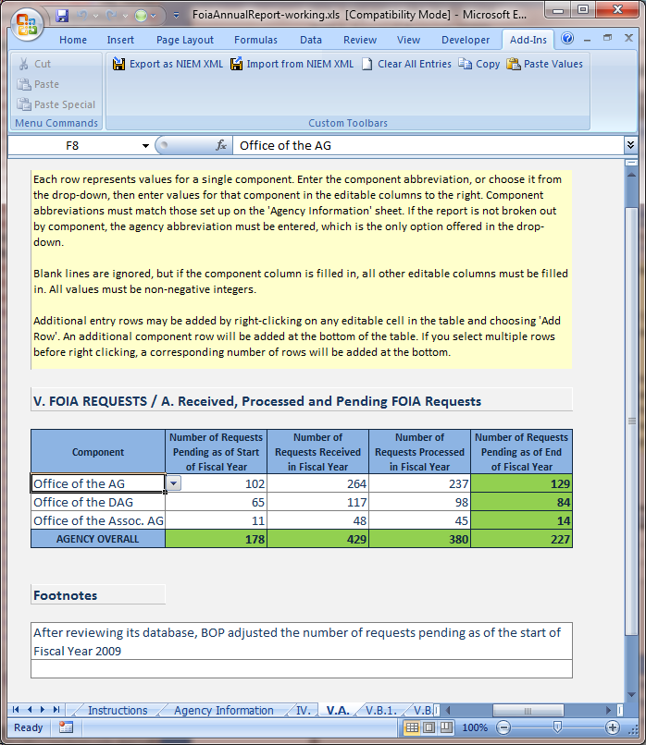

Report Section Details

Section IV - Exemption3StatuteSection
Top Level Element | Exemption3StatuteSection (type Exemption3StatuteSectionType)
Data Element | ReliedUponStatute (type ReliedUponStatuteType)
Association Element | ReliedUponStatuteOrganizationAssociation (type ReliedUponStatuteOrganizationAssociationType)

Business Rules
- None

Discussion
As if to illustrate the saying “there is an exception to every rule”, it so happens that the first report section is one of the few with some deviations from the pattern explained in section 4.2.1. In most report sections, each OrganizationSubUnit is associated with 0 or 1 data elements. In the FOIA workbook, this is reflected in the fact that the leftmost column of most worksheets allows selection of the component, and choosing the same component on multiple rows is disallowed. However, as you can see in Figure 12 below (which again shows an extract from the DOJ 2009 report), in Exemption3StatuteSection, the statute description is the leftmost column, and a component may rely upon multiple statutes. Also notice in Figure 12 that the count in the 5th column is associated with the component, and that there may be more than one component/count combination associated with a statute.
As a result, in XML schema terms, Exemption3StatuteSection deviates from the normal pattern in the following ways:
- Rather than being of type ComponentDataOrganizationAssociationType, ReliedUponStatuteOrganizationAssociation is of type ReliedUponStatuteOrganizationAssociationType, which derives from ComponentDataOrganizationAssociationType, but adds the ReliedUponStatuteQuantity element which is of type niem-xsd:nonNegativeInteger. In simple terms, this allows the count of the number of times a component (or agency) relied upon a statute to be a characteristic or attribute of the association.
- It is common for multiple ReliedUponStatuteOrganizationAssociation elements to reference the same ReliedUponStatute element.
Figure 10 below shows a UML diagram of the structure of Exemption3StatuteSection. Figure 11 is an extract from 2009 DOJ report showing what this section looks like in an instance document. Figure 12 shows how the FOIA workbook presents the data from Figure 11.
Figure 10 - Structure of Exemption3StatuteSection
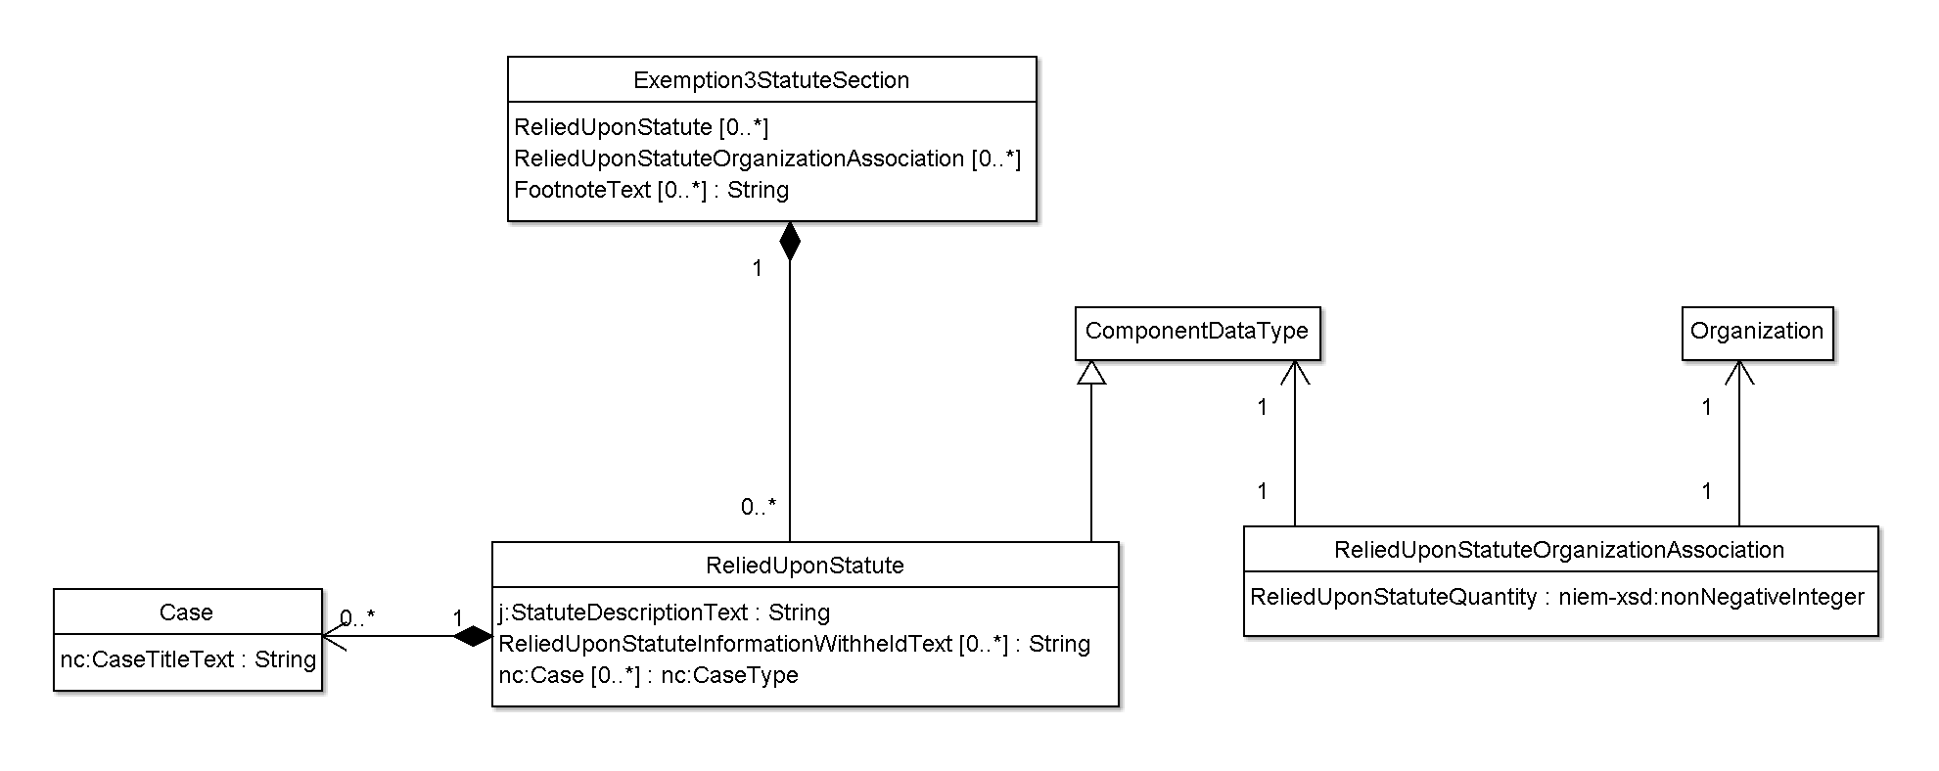
Figure 11 - Sample Exemption3StatuteSection
1 <foia:Exemption3StatuteSection>
2 <foia:ReliedUponStatute s:id="ES8">
3 <j:StatuteDescriptionText>5 U.S.C. app. § 107</j:StatuteDescriptionText>
4 <foia:ReliedUponStatuteInformationWithheldText>Confidential Conflict of Interest Certification reports</foia:ReliedUponStatuteInformationWithheldText>
5 <foia:ReliedUponStatuteInformationWithheldText>financial disclosure information pertaining to certain government employees</foia:ReliedUponStatuteInformationWithheldText>
6 <nc:Case>
7 <nc:CaseTitleText>Meyerhoff v. EPA, 958 F.2d 1498 (9th Cir. 1992)</nc:CaseTitleText>
8 </nc:Case>
9 <nc:Case>
10 <nc:CaseTitleText>Glascoe v. DOJ, No. 04-0486, 2005 WL 1139269 (D.D.C. May 15, 2005)</nc:CaseTitleText>
11 </nc:Case>
12 </foia:ReliedUponStatute>
13 <foia:ReliedUponStatute s:id="ES10">
14 <j:StatuteDescriptionText>8 U.S.C. § 1158</j:StatuteDescriptionText>
15 <foia:ReliedUponStatuteInformationWithheldText>Records pertaining to asylum and withholding of removal</foia:ReliedUponStatuteInformationWithheldText>
16 </foia:ReliedUponStatute>
17 <foia:ReliedUponStatute s:id="ES16">
18 <j:StatuteDescriptionText>18 U.S.C. § 798</j:StatuteDescriptionText>
19 <foia:ReliedUponStatuteInformationWithheldText>Certain classified information pertaining to communications intelligence and cryptographic devices of the United States or any foreign government</foia:ReliedUponStatuteInformationWithheldText>
20 <nc:Case>
21 <nc:CaseTitleText>N.Y. Times Co. v. DOD, 499 F. Supp. 2d 501 (S.D.N.Y. 2007)</nc:CaseTitleText>
22 </nc:Case>
23 <nc:Case>
24 <nc:CaseTitleText>Winter v. NSA, 569 F.Supp 545 (S.D. Cal. 1983)</nc:CaseTitleText>
25 </nc:Case>
26 </foia:ReliedUponStatute>
27 <foia:ReliedUponStatuteOrganizationAssociation>
28 <foia:ComponentDataReference s:ref="ES8"/>
29 <nc:OrganizationReference s:ref="ORG14"/>
30 <foia:ReliedUponStatuteQuantity>40</foia:ReliedUponStatuteQuantity>
31 </foia:ReliedUponStatuteOrganizationAssociation>
32 <foia:ReliedUponStatuteOrganizationAssociation>
33 <foia:ComponentDataReference s:ref="ES8"/>
34 <nc:OrganizationReference s:ref="ORG0"/>
35 <foia:ReliedUponStatuteQuantity>40</foia:ReliedUponStatuteQuantity>
36 </foia:ReliedUponStatuteOrganizationAssociation>
37 <foia:ReliedUponStatuteOrganizationAssociation>
38 <foia:ComponentDataReference s:ref="ES10"/>
39 <nc:OrganizationReference s:ref="ORG13"/>
40 <foia:ReliedUponStatuteQuantity>1</foia:ReliedUponStatuteQuantity>
41 </foia:ReliedUponStatuteOrganizationAssociation>
42 <foia:ReliedUponStatuteOrganizationAssociation>
43 <foia:ComponentDataReference s:ref="ES10"/>
44 <nc:OrganizationReference s:ref="ORG0"/>
45 <foia:ReliedUponStatuteQuantity>1</foia:ReliedUponStatuteQuantity>
46 </foia:ReliedUponStatuteOrganizationAssociation>
47 <foia:ReliedUponStatuteOrganizationAssociation>
48 <foia:ComponentDataReference s:ref="ES16"/>
49 <nc:OrganizationReference s:ref="ORG1"/>
50 <foia:ReliedUponStatuteQuantity>1</foia:ReliedUponStatuteQuantity>
51 </foia:ReliedUponStatuteOrganizationAssociation>
52 <foia:ReliedUponStatuteOrganizationAssociation>
53 <foia:ComponentDataReference s:ref="ES16"/>
54 <nc:OrganizationReference s:ref="ORG2"/>
55 <foia:ReliedUponStatuteQuantity>1</foia:ReliedUponStatuteQuantity>
56 </foia:ReliedUponStatuteOrganizationAssociation>
57 <foia:ReliedUponStatuteOrganizationAssociation>
58 <foia:ComponentDataReference s:ref="ES16"/>
59 <nc:OrganizationReference s:ref="ORG16"/>
60 <foia:ReliedUponStatuteQuantity>1</foia:ReliedUponStatuteQuantity>
61 </foia:ReliedUponStatuteOrganizationAssociation>
62 <foia:ReliedUponStatuteOrganizationAssociation>
63 <foia:ComponentDataReference s:ref="ES16"/>
64 <nc:OrganizationReference s:ref="ORG30"/>
65 <foia:ReliedUponStatuteQuantity>1</foia:ReliedUponStatuteQuantity>
66 </foia:ReliedUponStatuteOrganizationAssociation>
67 <foia:ReliedUponStatuteOrganizationAssociation>
68 <foia:ComponentDataReference s:ref="ES16"/>
69 <nc:OrganizationReference s:ref="ORG29"/>
70 <foia:ReliedUponStatuteQuantity>1</foia:ReliedUponStatuteQuantity>
71 </foia:ReliedUponStatuteOrganizationAssociation>
72 <foia:ReliedUponStatuteOrganizationAssociation>
73 <foia:ComponentDataReference s:ref="ES16"/>
74 <nc:OrganizationReference s:ref="ORG0"/>
75 <foia:ReliedUponStatuteQuantity>1</foia:ReliedUponStatuteQuantity>
76 </foia:ReliedUponStatuteOrganizationAssociation>
77 </foia:Exemption3StatuteSection>
Figure 12 - Report Section IV in FOIA Workbook
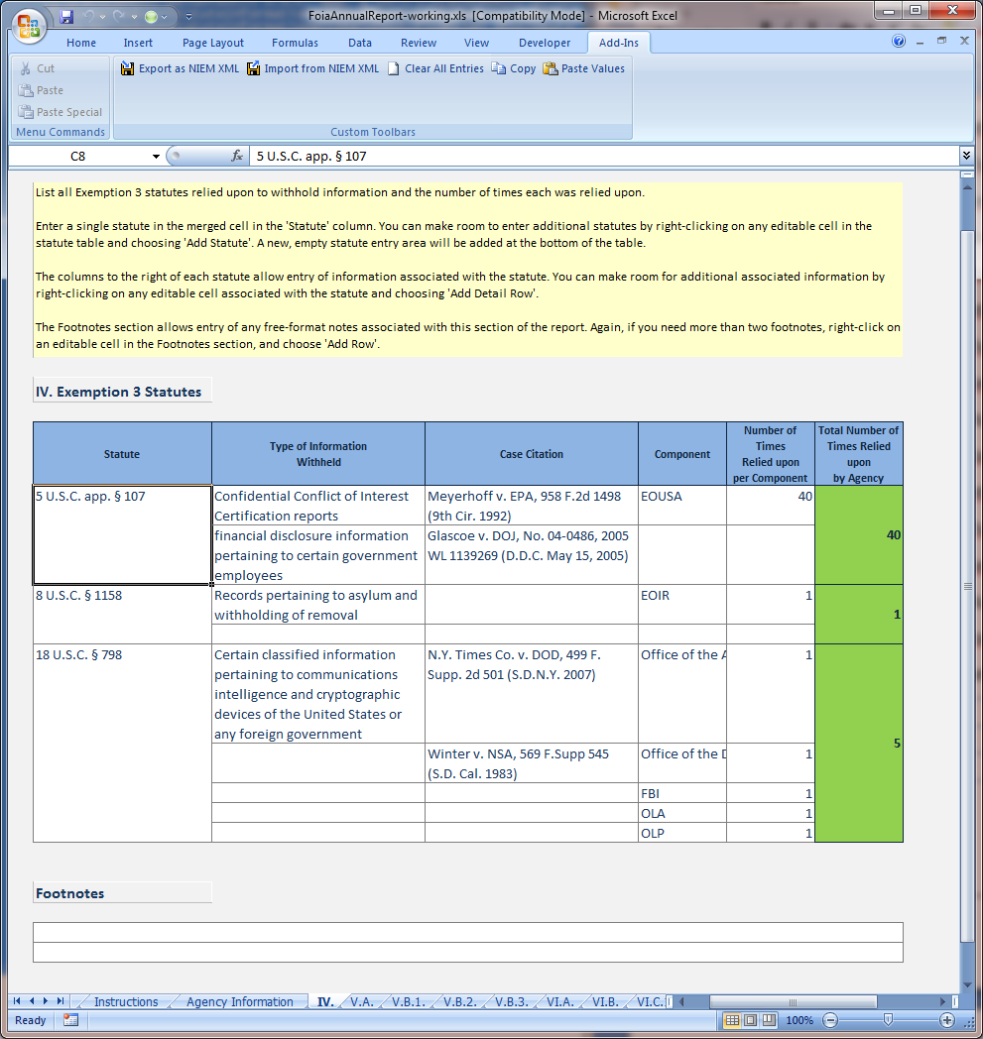

Section V.A – ProcessedRequestSection
Top Level Element | ProcessedRequestSection (type ProcessedSectionType)
Data Element | ProcessingStatistics (type ProcessingStatisticsType)
Association Element | ProcessingStatisticsOrganizationAssociation (type ComponentDataOrganizationAssociationType)

Business Rules
- ProcessingStatisticsPendingAtEndQuantity must equal ProcessingStatisticsPendingAtStartQuantity + ProcessingStatisticsReceivedQuantity - ProcessingStatisticsProcessedQuantity

Discussion
Section V.A. is covered in depth in section 4.2.1 (Typical Structure of a Report Section) above.

Section V.B.1 - RequestDispositionSection
Top Level Element | RequestDispositionSection (type RequestDispositionSectionType)
Data Element | RequestDisposition (type RequestDispositionType)
Association Element | RequestDispositionOrganizationAssociation (type ComponentDataOrganizationAssociationType)

Business Rules
- RequestDispositionTotalQuantity must equal the sum of all other values in the RequestDisposition element. This value must also match ProcessingStatisticsProcessedQuantity for the same component in section V.A. (ProcessedRequestSection).

Discussion
RequestDispositionSection is the first section to make use of an additional pattern which has not yet been introduced – the use of an enumerated code type. The guidance document defines 9 pre-defined reasons for denial other than exemptions. Rather than defining an explicit element for each of these 9 reasons, NonExemptionDenialReasonCode uses an xsd:enumeration. Any denial reason used by a RequestDisposition is included in a NonExemptionDenial element with a reason code and associated quantity. Any reasons which are not used are simply omitted. Figure 14 and Figure 15 provide an example in the usual format.
Figure 13 - Structure of RequestDispositionSection
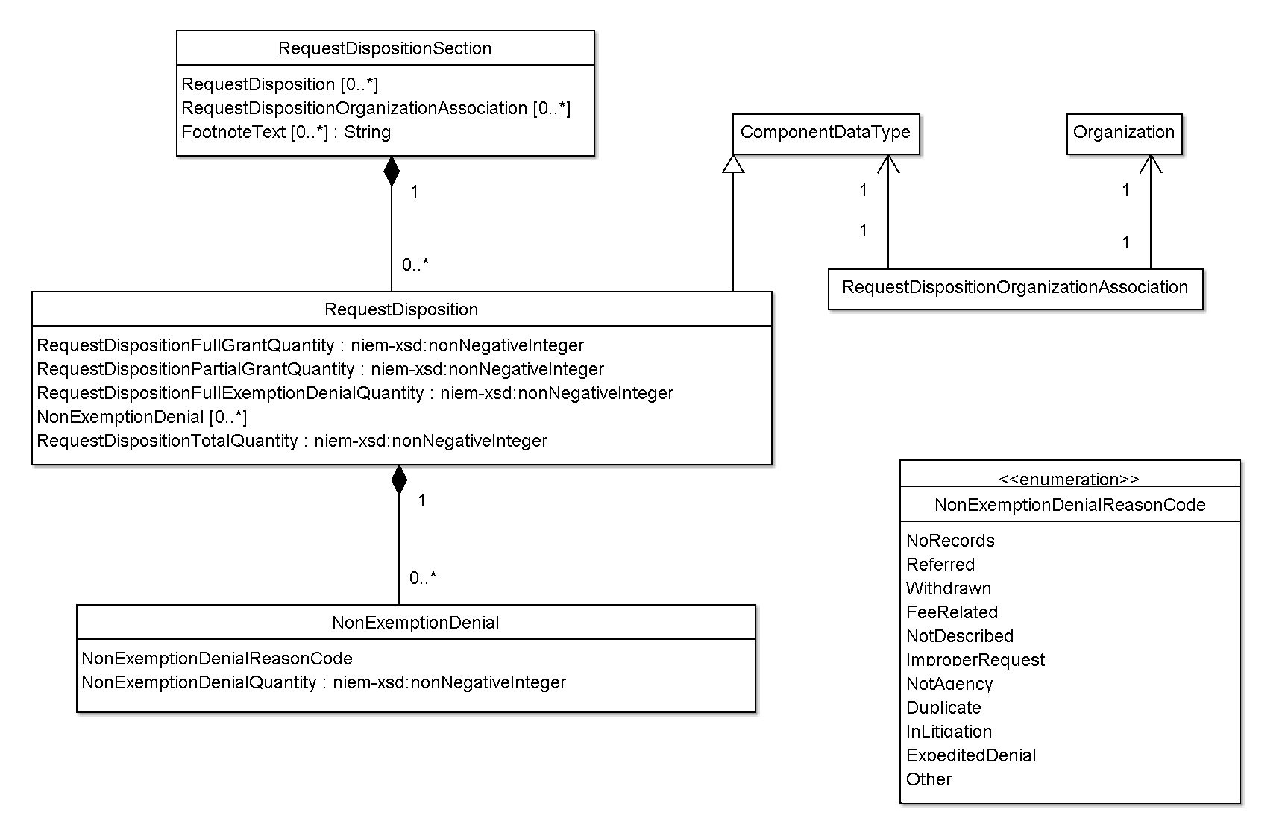
Figure 14 - Sample RequestDispositionSection
1 <foia:RequestDispositionSection>
2 <foia:RequestDisposition s:id="RD1">
3 <foia:RequestDispositionFullGrantQuantity>31</foia:RequestDispositionFullGrantQuantity>
4 <foia:RequestDispositionPartialGrantQuantity>22</foia:RequestDispositionPartialGrantQuantity>
5 <foia:RequestDispositionFullExemptionDenialQuantity>6</foia:RequestDispositionFullExemptionDenialQuantity>
6 <foia:NonExemptionDenial>
7 <foia:NonExemptionDenialReasonCode>NoRecords</foia:NonExemptionDenialReasonCode>
8 <foia:NonExemptionDenialQuantity>92</foia:NonExemptionDenialQuantity>
9 </foia:NonExemptionDenial>
10 <foia:NonExemptionDenial>
11 <foia:NonExemptionDenialReasonCode>Referred</foia:NonExemptionDenialReasonCode>
12 <foia:NonExemptionDenialQuantity>8</foia:NonExemptionDenialQuantity>
13 </foia:NonExemptionDenial>
14 <foia:NonExemptionDenial>
15 <foia:NonExemptionDenialReasonCode>Withdrawn</foia:NonExemptionDenialReasonCode>
16 <foia:NonExemptionDenialQuantity>10</foia:NonExemptionDenialQuantity>
17 </foia:NonExemptionDenial>
18 <foia:NonExemptionDenial>
19 <foia:NonExemptionDenialReasonCode>ImproperRequest</foia:NonExemptionDenialReasonCode>
20 <foia:NonExemptionDenialQuantity>17</foia:NonExemptionDenialQuantity>
21 </foia:NonExemptionDenial>
22 <foia:NonExemptionDenial>
23 <foia:NonExemptionDenialReasonCode>NotAgency</foia:NonExemptionDenialReasonCode>
24 <foia:NonExemptionDenialQuantity>2</foia:NonExemptionDenialQuantity>
25 </foia:NonExemptionDenial>
26 <foia:NonExemptionDenial>
27 <foia:NonExemptionDenialReasonCode>Duplicate</foia:NonExemptionDenialReasonCode>
28 <foia:NonExemptionDenialQuantity>5</foia:NonExemptionDenialQuantity>
29 </foia:NonExemptionDenial>
30 <foia:NonExemptionDenial>
31 <foia:NonExemptionDenialReasonCode>Other</foia:NonExemptionDenialReasonCode>
32 <foia:NonExemptionDenialQuantity>44</foia:NonExemptionDenialQuantity>
33 </foia:NonExemptionDenial>
34 <foia:RequestDispositionTotalQuantity>237</foia:RequestDispositionTotalQuantity>
35 </foia:RequestDisposition>
36 <foia:RequestDisposition s:id="RD2">
37 <foia:RequestDispositionFullGrantQuantity>10</foia:RequestDispositionFullGrantQuantity>
38 <foia:RequestDispositionPartialGrantQuantity>13</foia:RequestDispositionPartialGrantQuantity>
39 <foia:RequestDispositionFullExemptionDenialQuantity>5</foia:RequestDispositionFullExemptionDenialQuantity>
40 <foia:NonExemptionDenial>
41 <foia:NonExemptionDenialReasonCode>NoRecords</foia:NonExemptionDenialReasonCode>
42 <foia:NonExemptionDenialQuantity>41</foia:NonExemptionDenialQuantity>
43 </foia:NonExemptionDenial>
44 <foia:NonExemptionDenial>
45 <foia:NonExemptionDenialReasonCode>Referred</foia:NonExemptionDenialReasonCode>
46 <foia:NonExemptionDenialQuantity>6</foia:NonExemptionDenialQuantity>
47 </foia:NonExemptionDenial>
48 <foia:NonExemptionDenial>
49 <foia:NonExemptionDenialReasonCode>Withdrawn</foia:NonExemptionDenialReasonCode>
50 <foia:NonExemptionDenialQuantity>5</foia:NonExemptionDenialQuantity>
51 </foia:NonExemptionDenial>
52 <foia:NonExemptionDenial>
53 <foia:NonExemptionDenialReasonCode>ImproperRequest</foia:NonExemptionDenialReasonCode>
54 <foia:NonExemptionDenialQuantity>9</foia:NonExemptionDenialQuantity>
55 </foia:NonExemptionDenial>
56 <foia:NonExemptionDenial>
57 <foia:NonExemptionDenialReasonCode>NotAgency</foia:NonExemptionDenialReasonCode>
58 <foia:NonExemptionDenialQuantity>1</foia:NonExemptionDenialQuantity>
59 </foia:NonExemptionDenial>
60 <foia:NonExemptionDenial>
61 <foia:NonExemptionDenialReasonCode>Duplicate</foia:NonExemptionDenialReasonCode>
62 <foia:NonExemptionDenialQuantity>1</foia:NonExemptionDenialQuantity>
63 </foia:NonExemptionDenial>
64 <foia:NonExemptionDenial>
65 <foia:NonExemptionDenialReasonCode>Other</foia:NonExemptionDenialReasonCode>
66 <foia:NonExemptionDenialQuantity>7</foia:NonExemptionDenialQuantity>
67 </foia:NonExemptionDenial>
68 <foia:RequestDispositionTotalQuantity>98</foia:RequestDispositionTotalQuantity>
69 </foia:RequestDisposition>
70 <foia:RequestDisposition s:id="RD0">
71 <foia:RequestDispositionFullGrantQuantity>41</foia:RequestDispositionFullGrantQuantity>
72 <foia:RequestDispositionPartialGrantQuantity>35</foia:RequestDispositionPartialGrantQuantity>
73 <foia:RequestDispositionFullExemptionDenialQuantity>11</foia:RequestDispositionFullExemptionDenialQuantity>
74 <foia:NonExemptionDenial>
75 <foia:NonExemptionDenialReasonCode>NoRecords</foia:NonExemptionDenialReasonCode>
76 <foia:NonExemptionDenialQuantity>133</foia:NonExemptionDenialQuantity>
77 </foia:NonExemptionDenial>
78 <foia:NonExemptionDenial>
79 <foia:NonExemptionDenialReasonCode>Referred</foia:NonExemptionDenialReasonCode>
80 <foia:NonExemptionDenialQuantity>14</foia:NonExemptionDenialQuantity>
81 </foia:NonExemptionDenial>
82 <foia:NonExemptionDenial>
83 <foia:NonExemptionDenialReasonCode>Withdrawn</foia:NonExemptionDenialReasonCode>
84 <foia:NonExemptionDenialQuantity>15</foia:NonExemptionDenialQuantity>
85 </foia:NonExemptionDenial>
86 <foia:NonExemptionDenial>
87 <foia:NonExemptionDenialReasonCode>ImproperRequest</foia:NonExemptionDenialReasonCode>
88 <foia:NonExemptionDenialQuantity>26</foia:NonExemptionDenialQuantity>
89 </foia:NonExemptionDenial>
90 <foia:NonExemptionDenial>
91 <foia:NonExemptionDenialReasonCode>NotAgency</foia:NonExemptionDenialReasonCode>
92 <foia:NonExemptionDenialQuantity>3</foia:NonExemptionDenialQuantity>
93 </foia:NonExemptionDenial>
94 <foia:NonExemptionDenial>
95 <foia:NonExemptionDenialReasonCode>Duplicate</foia:NonExemptionDenialReasonCode>
96 <foia:NonExemptionDenialQuantity>6</foia:NonExemptionDenialQuantity>
97 </foia:NonExemptionDenial>
98 <foia:NonExemptionDenial>
99 <foia:NonExemptionDenialReasonCode>Other</foia:NonExemptionDenialReasonCode>
100 <foia:NonExemptionDenialQuantity>51</foia:NonExemptionDenialQuantity>
101 </foia:NonExemptionDenial>
102 <foia:RequestDispositionTotalQuantity>335</foia:RequestDispositionTotalQuantity>
103 </foia:RequestDisposition>
104 <foia:RequestDispositionOrganizationAssociation>
105 <foia:ComponentDataReference s:ref="RD1"/>
106 <nc:OrganizationReference s:ref="ORG1"/>
107 </foia:RequestDispositionOrganizationAssociation>
108 <foia:RequestDispositionOrganizationAssociation>
109 <foia:ComponentDataReference s:ref="RD2"/>
110 <nc:OrganizationReference s:ref="ORG2"/>
111 </foia:RequestDispositionOrganizationAssociation>
112 <foia:RequestDispositionOrganizationAssociation>
113 <foia:ComponentDataReference s:ref="RD0"/>
114 <nc:OrganizationReference s:ref="ORG0"/>
115 </foia:RequestDispositionOrganizationAssociation>
116 </foia:RequestDispositionSection>

Figure 15 - Report Section V.B.1 in FOIA Workbook
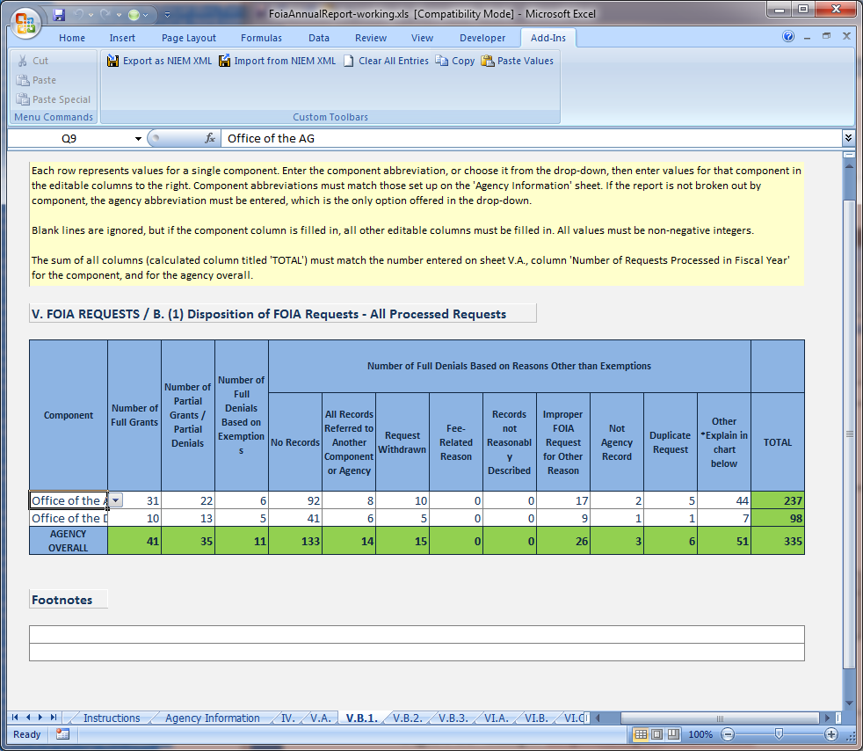

Section V.B.2 - RequestDenialOtherReasonSection
Top Level Element | RequestDenialOtherReasonSection (type OtherDenialReasonSectionType)
Data Element | ComponentOtherDenialReason (type ComponentOtherDenialReasonType)
Association Element | OtherDenialReasonOrganizationAssociation (type ComponentDataOrganizationAssociationType)

Business Rules
- ComponentOtherDenialReasonQuantity within each ComponentOtherDenialReason must match the value for the corresponding component or agency overall in section V.B.1., which is represented within a NonExemptionDenial element with NonExemptionDenialReasonCode of “Other”. If this value is omitted or zero in section V.B.1. for a component, the entire data element (ComponentOtherDenialReason) for that component may be omitted from section V.B.2.
- ComponentOtherDenialReasonQuantity must equal the sum of all OtherDenialReasonQuantity values within all embedded OtherDenialReason elements.
- Agency Overall entry (ComponentOtherDenialReason element) must be present, and ComponentOtherDenialReasonQuantity within it must equal the sum of ComponentOtherDenialReasonQuantity of all component entries. If the report has no OrganizationSubUnit entries, then the Agency Overall entry should be the only ComponentOtherDenialReason element in this section. If the report does have OrganizationSubUnit entries, the agency overall entry should not contain any OtherDenialReason entries. In this case the agency overall entry only serves to contain the total ComponentOtherDenialReasonQuantity for the entire agency.

Discussion
Figure 16 - Structure of RequestDenialOtherReasonSection
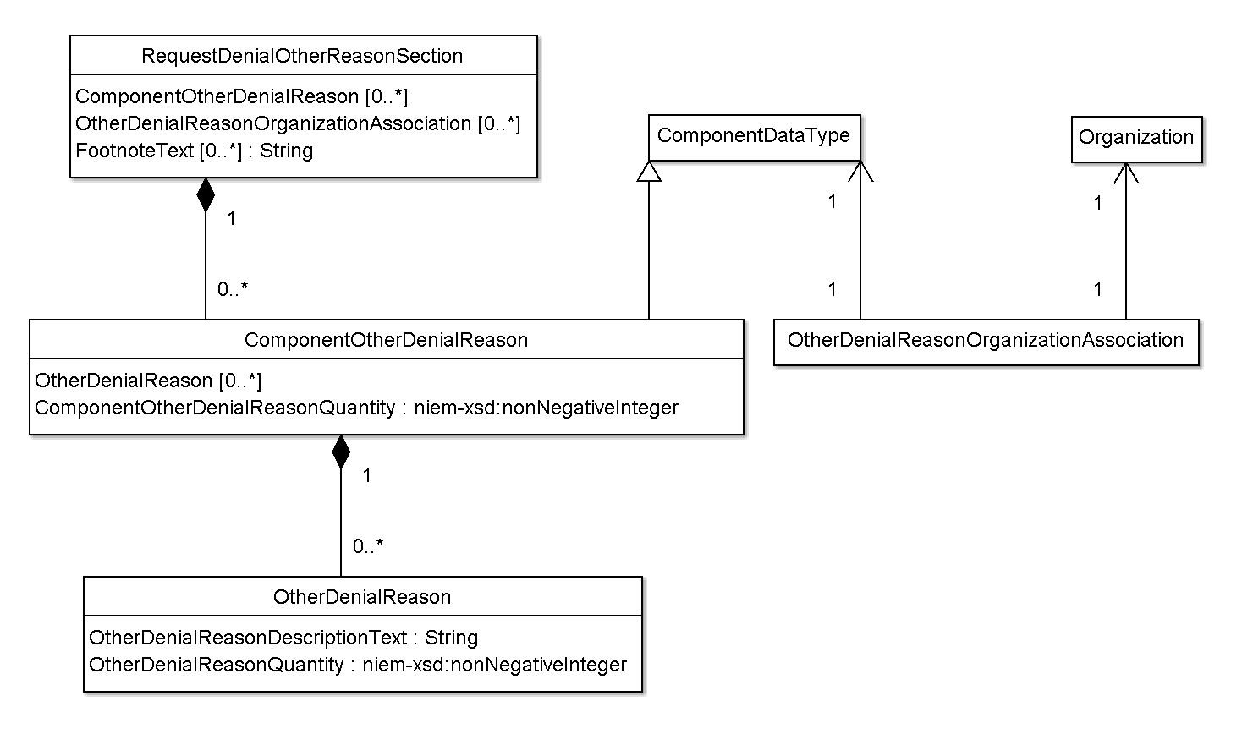

Section V.B.3 - RequestDispositionAppliedExemptionsSection
Top Level Element | RequestDispositionAppliedExemptionsSection (type RequestDispositionAppliedExemptionsSectionType)
Data Element | ComponentAppliedExemptions (type ComponentAppliedExemptionsType)
Association Element | ComponentAppliedExemptionsOrganizationAssociation (type ComponentDataOrganizationAssociationType)

Business Rules
- As introduced in section 5.3 (Section V.B.1 - RequestDispositionSection) above, RequestDispositionAppliedExemptionsSection makes use of an enumerated code type. If a component or agency does not make use of an exemption, the entry should simply be omitted.

Section VI.A - ProcessedAppealSection
Top Level Element | ProcessedAppealSection (type ProcessedSectionType)
Data Element | ProcessingStatistics (type ProcessingStatisticsType)
Association Element | ProcessingStatisticsOrganizationAssociation (type ComponentDataOrganizationAssociationType)

Discussion
ProcessedAppealSection uses the same elements and has the same associated business rules as Section V.A – ProcessedRequestSectionSection V.A – ProcessedRequestSection. Please refer there for details.

Section VI.B - AppealDispositionSection
Top Level Element | AppealDispositionSection (type AppealDispositionSectionType)
Data Element | AppealDisposition (type AppealDispositionType)
Association Element | AppealDispositionOrganizationAssociation (type ComponentDataOrganizationAssociationType)

Business Rules
- AppealDispositionTotalQuantity must equal the sum of all other values in the AppealDisposition element. This value must also match ProcessingStatisticsProcessedQuantity for the same component in section VI.A. (ProcessedAppealSection).

Section VI.C.1 - AppealDispositionAppliedExemptionsSection
Top Level Element | AppealDispositionAppliedExemptionsSection (type AppealDispositionAppliedExemptionsSectionType)
Data Element | ComponentAppliedExemptions (type ComponentAppliedExemptionsType)
Association Element | ComponentAppliedExemptionsOrganizationAssociation (type ComponentDataOrganizationAssociationType)

Business Rules
- As introduced in section 5.3 (Section V.B.1 - RequestDispositionSection) above, AppealDispositionAppliedExemptionsSection makes use of an enumerated code type. If a component or agency does not make use of an exemption, the entry should simply be omitted.

Section VI.C.2 - AppealNonExemptionDenialSection
Top Level Element | AppealNonExemptionDenialSection (type AppealNonExemptionDenialSectionType)
Data Element | AppealNonExemptionDenial (type AppealNonExemptionDenialType)
Association Element | AppealNonExemptionDenialOrganizationAssociation (type ComponentDataOrganizationAssociationType)

Business Rules
- None

Section VI.C.3 - AppealDenialOtherReasonSection
Top Level Element | AppealDenialOtherReasonSection (type OtherDenialReasonSectionType)
Data Element | ComponentOtherDenialReason (type ComponentOtherDenialReasonType)
Association Element | OtherDenialReasonOrganizationAssociation (type ComponentDataOrganizationAssociationType)

Discussion
AppealDenialOtherReasonSection uses the same elements and has the same associated business rules as Section V.B.2 - RequestDenialOtherReasonSection. Please refer there for details.

Section VI.C.4 - AppealResponseTimeSection
Top Level Element | AppealResponseTimeSection (type AppealResponseTimeSectionType)
Data Element | ResponseTime (type ResponseTimeType)
Association Element | ResponseTimeOrganizationAssociation

Business Rules
- The ResponseTime element must contain values for median, average, lowest, and highest, even though this is not currently enforced by the xml schema.

Discussion
This is the first section to make use of a NIEM substitution group. See section 5.7 of the NIEM User Guide (see Works Cited) for background information. Each of the four values in each ResponseTime element (median, average, lowest, highest), may be either:
- A decimal value using an element whose name ends with “Value” (e.g. ResponseTimeMedianDaysValue).
- The code “LT1” using an element whose name ends with “Code” (e.g. ResponseTimeMedianDaysCode). This is a special value indicating a response time of less than one day, without specifying an exact value. The FOIA workbook displays these values as “<1”. Please see point two at http://www.justice.gov/oip/foiapost/2009foiapost1.htm for more information on these special values.
Figure 17 shows a sample portion from an instance document. shows how the corresponding information is displayed in the FOIA workbook.
Figure 17 - Sample AppealResponseTimeSection
1 <foia:AppealResponseTimeSection>
2 <foia:ResponseTime s:id="ART1">
3 <foia:ResponseTimeMedianDaysValue>54</foia:ResponseTimeMedianDaysValue>
4 <foia:ResponseTimeAverageDaysValue>79.45</foia:ResponseTimeAverageDaysValue>
5 <foia:ResponseTimeLowestDaysCode>LT1</foia:ResponseTimeLowestDaysCode>
6 <foia:ResponseTimeHighestDaysValue>475</foia:ResponseTimeHighestDaysValue>
7 </foia:ResponseTime>
8 <foia:ResponseTime s:id="ART2">
9 <foia:ResponseTimeMedianDaysValue>8</foia:ResponseTimeMedianDaysValue>
10 <foia:ResponseTimeAverageDaysValue>24</foia:ResponseTimeAverageDaysValue>
11 <foia:ResponseTimeLowestDaysValue>1</foia:ResponseTimeLowestDaysValue>
12 <foia:ResponseTimeHighestDaysValue>113</foia:ResponseTimeHighestDaysValue>
13 </foia:ResponseTime>
14 <foia:ResponseTime s:id="ART0">
15 <foia:ResponseTimeMedianDaysValue>54</foia:ResponseTimeMedianDaysValue>
16 <foia:ResponseTimeAverageDaysValue>79.24</foia:ResponseTimeAverageDaysValue>
17 <foia:ResponseTimeLowestDaysCode>LT1</foia:ResponseTimeLowestDaysCode>
18 <foia:ResponseTimeHighestDaysValue>475</foia:ResponseTimeHighestDaysValue>
19 </foia:ResponseTime>
20 <foia:ResponseTimeOrganizationAssociation>
21 <foia:ComponentDataReference s:ref="ART1"/>
22 <nc:OrganizationReference s:ref="ORG23"/>
23 </foia:ResponseTimeOrganizationAssociation>
24 <foia:ResponseTimeOrganizationAssociation>
25 <foia:ComponentDataReference s:ref="ART2"/>
26 <nc:OrganizationReference s:ref="ORG40"/>
27 </foia:ResponseTimeOrganizationAssociation>
28 <foia:ResponseTimeOrganizationAssociation>
29 <foia:ComponentDataReference s:ref="ART0"/>
30 <nc:OrganizationReference s:ref="ORG0"/>
31 </foia:ResponseTimeOrganizationAssociation>
32 </foia:AppealResponseTimeSection>

Figure 18 - Report Section VI.C.4 in FOIA Workbook
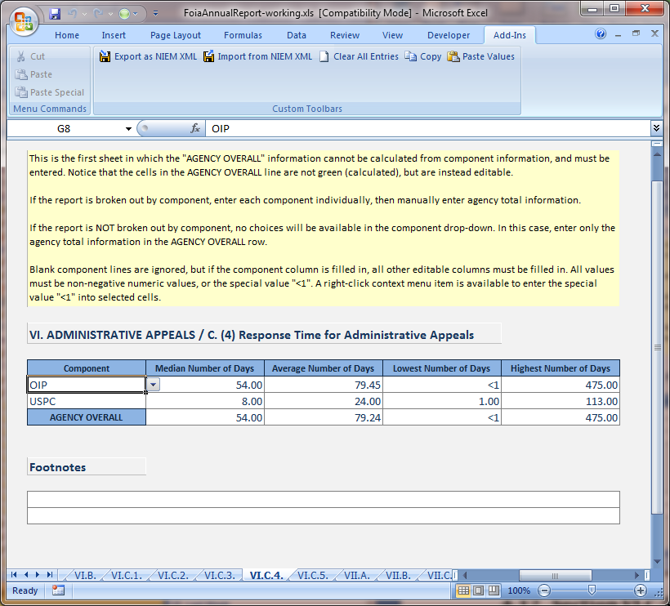

Section VI.C.5 - OldestPendingAppealSection
Top Level Element | OldestPendingAppealSection (type OldestPendingItemSectionType)
Data Element | OldestPendingItems (type OldestPendingItemsType)
Association Element | OldestPendingItemsOrganizationAssociation (type ComponentDataOrganizationAssociationType)

Business Rules
- Within an OldestPendingItems element, OldItem elements must be ordered by increasing date, and consequently, also be decreasing number of pending days. This simply means that the oldest item must be listed first, followed by the 2nd oldest, and so on.
- A component or agency may not have ten appeals pending. In such a case, OldestPendingItems will have fewer than ten OldItem child elements.

Discussion
Figure 19 shows a sample portion from an instance document. Figure 20 shows how the corresponding information is displayed in the FOIA workbook. Notice that the sample violates the ordering business rule, which is why the cell is colored red in the FOIA workbook.
Figure 19 - Sample OldestPendingAppealSection
1 <foia:OldestPendingAppealSection>
2 <foia:OldestPendingItems s:id="OPA8">
3 <foia:OldItem>
4 <foia:OldItemReceiptDate>2008-10-08</foia:OldItemReceiptDate>
5 <foia:OldItemPendingDaysQuantity>250</foia:OldItemPendingDaysQuantity>
6 </foia:OldItem>
7 <foia:OldItem>
8 <foia:OldItemReceiptDate>2008-10-08</foia:OldItemReceiptDate>
9 <foia:OldItemPendingDaysQuantity>247</foia:OldItemPendingDaysQuantity>
10 </foia:OldItem>
11 <foia:OldItem>
12 <foia:OldItemReceiptDate>2008-10-16</foia:OldItemReceiptDate>
13 <foia:OldItemPendingDaysQuantity>242</foia:OldItemPendingDaysQuantity>
14 </foia:OldItem>
15 <foia:OldItem>
16 <foia:OldItemReceiptDate>2008-10-16</foia:OldItemReceiptDate>
17 <foia:OldItemPendingDaysQuantity>242</foia:OldItemPendingDaysQuantity>
18 </foia:OldItem>
19 <foia:OldItem>
20 <foia:OldItemReceiptDate>2008-10-16</foia:OldItemReceiptDate>
21 <foia:OldItemPendingDaysQuantity>242</foia:OldItemPendingDaysQuantity>
22 </foia:OldItem>
23 <foia:OldItem>
24 <foia:OldItemReceiptDate>2008-10-16</foia:OldItemReceiptDate>
25 <foia:OldItemPendingDaysQuantity>242</foia:OldItemPendingDaysQuantity>
26 </foia:OldItem>
27 <foia:OldItem>
28 <foia:OldItemReceiptDate>2008-10-16</foia:OldItemReceiptDate>
29 <foia:OldItemPendingDaysQuantity>242</foia:OldItemPendingDaysQuantity>
30 </foia:OldItem>
31 <foia:OldItem>
32 <foia:OldItemReceiptDate>2008-10-16</foia:OldItemReceiptDate>
33 <foia:OldItemPendingDaysQuantity>242</foia:OldItemPendingDaysQuantity>
34 </foia:OldItem>
35 <foia:OldItem>
36 <foia:OldItemReceiptDate>2008-10-20</foia:OldItemReceiptDate>
37 <foia:OldItemPendingDaysQuantity>240</foia:OldItemPendingDaysQuantity>
38 </foia:OldItem>
39 <foia:OldItem>
40 <foia:OldItemReceiptDate>2008-10-20</foia:OldItemReceiptDate>
41 <foia:OldItemPendingDaysQuantity>240</foia:OldItemPendingDaysQuantity>
42 </foia:OldItem>
43 </foia:OldestPendingItems>
44 <foia:OldestPendingItems s:id="OPA10">
45 <foia:OldItem>
46 <foia:OldItemReceiptDate>2009-09-25</foia:OldItemReceiptDate>
47 <foia:OldItemPendingDaysQuantity>4</foia:OldItemPendingDaysQuantity>
48 </foia:OldItem>
49 <foia:OldItem>
50 <foia:OldItemReceiptDate>2009-09-23</foia:OldItemReceiptDate>
51 <foia:OldItemPendingDaysQuantity>3</foia:OldItemPendingDaysQuantity>
52 </foia:OldItem>
53 </foia:OldestPendingItems>
54 <foia:OldestPendingItems s:id="OPA12">
55 <foia:OldItem>
56 <foia:OldItemReceiptDate>2008-10-08</foia:OldItemReceiptDate>
57 <foia:OldItemPendingDaysQuantity>250</foia:OldItemPendingDaysQuantity>
58 </foia:OldItem>
59 <foia:OldItem>
60 <foia:OldItemReceiptDate>2008-10-08</foia:OldItemReceiptDate>
61 <foia:OldItemPendingDaysQuantity>247</foia:OldItemPendingDaysQuantity>
62 </foia:OldItem>
63 <foia:OldItem>
64 <foia:OldItemReceiptDate>2008-10-16</foia:OldItemReceiptDate>
65 <foia:OldItemPendingDaysQuantity>242</foia:OldItemPendingDaysQuantity>
66 </foia:OldItem>
67 <foia:OldItem>
68 <foia:OldItemReceiptDate>2008-10-16</foia:OldItemReceiptDate>
69 <foia:OldItemPendingDaysQuantity>242</foia:OldItemPendingDaysQuantity>
70 </foia:OldItem>
71 <foia:OldItem>
72 <foia:OldItemReceiptDate>2008-10-16</foia:OldItemReceiptDate>
73 <foia:OldItemPendingDaysQuantity>242</foia:OldItemPendingDaysQuantity>
74 </foia:OldItem>
75 <foia:OldItem>
76 <foia:OldItemReceiptDate>2008-10-16</foia:OldItemReceiptDate>
77 <foia:OldItemPendingDaysQuantity>242</foia:OldItemPendingDaysQuantity>
78 </foia:OldItem>
79 <foia:OldItem>
80 <foia:OldItemReceiptDate>2008-10-16</foia:OldItemReceiptDate>
81 <foia:OldItemPendingDaysQuantity>242</foia:OldItemPendingDaysQuantity>
82 </foia:OldItem>
83 <foia:OldItem>
84 <foia:OldItemReceiptDate>2008-10-16</foia:OldItemReceiptDate>
85 <foia:OldItemPendingDaysQuantity>242</foia:OldItemPendingDaysQuantity>
86 </foia:OldItem>
87 <foia:OldItem>
88 <foia:OldItemReceiptDate>2008-10-20</foia:OldItemReceiptDate>
89 <foia:OldItemPendingDaysQuantity>240</foia:OldItemPendingDaysQuantity>
90 </foia:OldItem>
91 <foia:OldItem>
92 <foia:OldItemReceiptDate>2008-10-20</foia:OldItemReceiptDate>
93 <foia:OldItemPendingDaysQuantity>240</foia:OldItemPendingDaysQuantity>
94 </foia:OldItem>
95 </foia:OldestPendingItems>
96 <foia:OldestPendingItemsOrganizationAssociation>
97 <foia:ComponentDataReference s:ref="OPA8"/>
98 <nc:OrganizationReference s:ref="ORG23"/>
99 </foia:OldestPendingItemsOrganizationAssociation>
100 <foia:OldestPendingItemsOrganizationAssociation>
101 <foia:ComponentDataReference s:ref="OPA10"/>
102 <nc:OrganizationReference s:ref="ORG40"/>
103 </foia:OldestPendingItemsOrganizationAssociation>
104 <foia:OldestPendingItemsOrganizationAssociation>
105 <foia:ComponentDataReference s:ref="OPA12"/>
106 <nc:OrganizationReference s:ref="ORG0"/>
107 </foia:OldestPendingItemsOrganizationAssociation>
108 </foia:OldestPendingAppealSection>

Figure 20 - Report Section VI.C.5 in FOIA Workbook
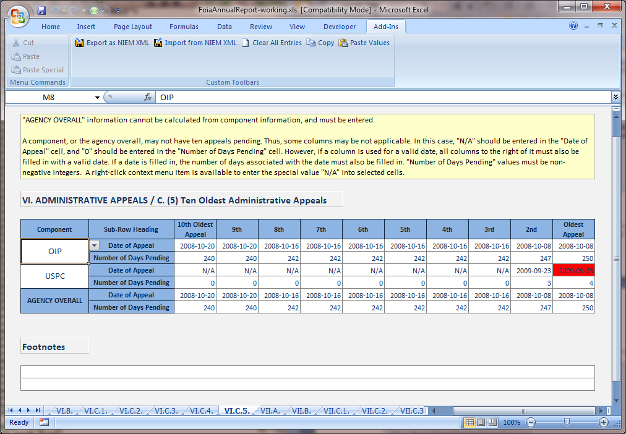

Section VII.A - ProcessedResponseTimeSection
Top Level Element | ProcessedResponseTimeSection (type ProcessedResponseTimeSectionType)
Data Element | ProcessedResponseTime (type ProcessedResponseTimeType)
Association Element | ProcessedResponseTimeOrganizationAssociation (type ComponentDataOrganizationAssociationType)

Business Rules
- Within elements of type ResponseTimeType, individual values (i.e. Median, Average, Lowest, Highest) may be omitted, indicating the value is N/A (not applicable). Note that this has a different meaning from an entry of zero.

Discussion
ProcessedResponseTime has three child elements (SimpleResponseTime, ComplexResponseTime, ExpeditedResponseTime) which are each of type ResponseTimeType. The discussion regarding the usage of “<1” values in ResponseTimeType in Section VI.C.4 - AppealResponseTimeSection thus applies here as well.

Section VII.B - InformationGrantedResponseTimeSection
Top Level Element | InformationGrantedResponseTimeSection (type ProcessedResponseTimeSectionType)
Data Element | ProcessedResponseTime (type ProcessedResponseTimeType)
Association Element | ProcessedResponseTimeOrganizationAssociation (type ComponentDataOrganizationAssociationType)

Discussion
InformationGrantedResponseTimeSection uses the same elements and has the same associated business rules as Section VII.A - ProcessedResponseTimeSection. Please refer there for details.

Section VII.C.1 - SimpleResponseTimeIncrementsSection
Top Level Element | SimpleResponseTimeIncrementsSection (type ResponseTimeIncrementsSectionType)
Data Element | ComponentResponseTimeIncrements (type ComponentResponseTimeIncrementsType)
Association Element | ResponseTimeIncrementsOrganizationAssociation (type ComponentDataOrganizationAssociationType)

Discussion
ResponseTimeIncrementsSectionType makes use of an enumerated code type for definition of the thirteen designated time increments. This pattern has been seen in previously-discussed sections.

Section VII.C.2 - ComplexResponseTimeIncrementsSection
Top Level Element | ComplexResponseTimeIncrementsSection (type ResponseTimeIncrementsSectionType)
Data Element | ComponentResponseTimeIncrements (type ComponentResponseTimeIncrementsType)
Association Element | ResponseTimeIncrementsOrganizationAssociation (type ComponentDataOrganizationAssociationType)

Discussion
ComplexResponseTimeIncrementsSection uses the same elements and has the same associated business rules as Section VII.C.1 - SimpleResponseTimeIncrementsSection. Please refer there for details.

Section VII.C.3 - ExpeditedResponseTimeIncrementsSection
Top Level Element | ExpeditedResponseTimeIncrementsSection (type ResponseTimeIncrementsSectionType)
Data Element | ComponentResponseTimeIncrements (type ComponentResponseTimeIncrementsType)
Association Element | ResponseTimeIncrementsOrganizationAssociation (type ComponentDataOrganizationAssociationType)

Discussion
ExpeditedResponseTimeIncrementsSection uses the same elements and has the same associated business rules as Section VII.C.1 - SimpleResponseTimeIncrementsSection. Please refer there for details.

Section VII.D - PendingPerfectedRequestsSection
Top Level Element | PendingPerfectedRequestsSection (type PendingPerfectedRequestsSectionType)
Data Element | PendingPerfectedRequests (type PendingPerfectedRequestsType)
Association Element | PendingPerfectedRequestsOrganizationAssociation (type ComponentDataOrganizationAssociationType)

Business Rules
- Within elements of type PendingRequestStatisticsType, PendingRequestMedianDaysValue and PendingRequestAverageDaysValue may be omitted, indicating the value is N/A (not applicable). Note that this has a different meaning from an entry of zero.

Section VII.E - OldestPendingRequestSection
Top Level Element | OldestPendingRequestSection (type OldestPendingItemSectionType)
Data Element | OldestPendingItems (type OldestPendingItemsType)
Association Element | OldestPendingItemsOrganizationAssociation (type ComponentDataOrganizationAssociationType)

Discussion
OldestPendingRequestSection uses the same elements and has the same associated business rules as Section VI.C.5 - OldestPendingAppealSection. Please refer there for details.

Section VIII.A - ExpeditedProcessingSection
Top Level Element | ExpeditedProcessingSection (type ExpeditedProcessingSectionType)
Data Element | ExpeditedProcessing (type ExpeditedProcessingType)
Association Element | ExpeditedProcessingOrganizationAssociation (type ComponentDataOrganizationAssociationType)

Business Rules
- Within ExpeditedProcessing elements, AdjudicationMedianDaysValue, AdjudicationAverageDaysValue, and AdjudicationWithinTenDaysQuantity may be omitted, indicating the value is N/A (not applicable). Note that this has a different meaning from an entry of zero.

Section VIII.B - FeeWaiverSection
Top Level Element | FeeWaiverSection (type FeeWaiverSectionType)
Data Element | FeeWaiver (type FeeWaiverType)
Association Element | FeeWaiverOrganizationAssociation (type ComponentDataOrganizationAssociationType)

Business Rules
- Within FeeWaiver elements, AdjudicationMedianDaysValue and AdjudicationAverageDaysValue may be omitted, indicating the value is N/A (not applicable). Note that this has a different meaning from an entry of zero.

Section IX - PersonnelAndCostSection
Top Level Element | PersonnelAndCostSection (type PersonnelAndCostSectionType)
Data Element | PersonnelAndCost (type PersonnelAndCostType)
Association Element | PersonnelAndCostOrganizationAssociation (type ComponentDataOrganizationAssociationType)

Business Rules
- Within PersonnelAndCost elements, TotalFullTimeStaffQuantity must equal the sum of FullTimeEmployeeQuantity and EquivalentFullTimeEmployeeQuantity, and TotalCostAmount must equal the sum of ProcessingCostAmount and LitigationCostAmount.

Section X - FeesCollectedSection
Top Level Element | FeesCollectedSection (type FeesCollectedSectionType)
Data Element | FeesCollected (type FeesCollectedType)
Association Element | FeesCollectedOrganizationAssociation (type ComponentDataOrganizationAssociationType)

Business Rules
- Within each FeesCollected element, FeesCollectedCostPercent must equal FeesCollectedAmount as a percentage of the corresponding ProcessingCostAmount value from section XI, represented as a NIEM nc:PercentageType.

Section XII.A - BacklogSection
Top Level Element | BacklogSection (type BacklogSectionType)
Data Element | Backlog (type BacklogType)
Association Element | BacklogOrganizationAssociation (type ComponentDataOrganizationAssociationType)

Business Rules
- Within Backlog elements, BackloggedAppealQuantity may be omitted, indicating the value is N/A (not applicable). Note that this has a different meaning from an entry of zero.

Section XII.B - ProcessedConsultationSection
Top Level Element | ProcessedConsultationSection (type ProcessedSectionType)
Data Element | ProcessingStatistics (type ProcessingStatisticsType)
Association Element | ProcessingStatisticsOrganizationAssociation (type ComponentDataOrganizationAssociationType)

Discussion
ProcessedConsultationSection uses the same elements and has the same associated business rules as Section V.A – ProcessedRequestSection. Please refer there for details.

Section XII.C - OldestPendingConsultationSection
Top Level Element | OldestPendingConsultationSection (type OldestPendingItemSectionType)
Data Element | OldestPendingItems (type OldestPendingItemsType)
Association Element | OldestPendingItemsOrganizationAssociation (type ComponentDataOrganizationAssociationType)

Discussion
OldestPendingConsultationSection uses the same elements and has the same associated business rules as Section VI.C.5 - OldestPendingAppealSection. Please refer there for details.

Section XII.D.1 - ProcessedRequestComparisonSection
Top Level Element | ProcessedRequestComparisonSection (type ProcessingComparisonSectionType)
Data Element | ProcessingComparison (type ProcessingComparisonType)
Association Element | ProcessingComparisonOrganizationAssociation (type ComponentDataOrganizationAssociationType)

Business Rules
- Within ProcessingComparison elements:
  - ItemsReceivedCurrentYearQuantity must match the ProcessingStatisticsReceivedQuantity value from Section V.A – ProcessedRequestSection for the corresponding agency or component.
  - ItemsProcessedCurrentYearQuantity must match the ProcessingStatisticsProcessedQuantity value from Section V.A – ProcessedRequestSection for the corresponding agency or component.
  - ItemsReceivedLastYearQuantity and ItemsProcessedLastYearQuantity must agree with values reported for the previous fiscal year.

Section XII.D.2 - BackloggedRequestComparisonSection
Top Level Element | BackloggedRequestComparisonSection (type BacklogComparisonSectionType)
Data Element | BacklogComparison (type BacklogComparisonType)
Association Element | BacklogComparisonOrganizationAssociation (type ComponentDataOrganizationAssociationType)

Business Rules
- Within BacklogComparison elements:
  - BacklogCurrentYearQuantity must match the BackloggedRequestQuantity value from Section XII.A - BacklogSection for the corresponding agency or component.
  - BacklogLastYearQuantity must agree with values reported for the previous fiscal year.

Section XII.E.1 - ProcessedAppealComparisonSection
Top Level Element | ProcessedAppealComparisonSection (type ProcessingComparisonSectionType)
Data Element | ProcessingComparison (type ProcessingComparisonType)
Association Element | ProcessingComparisonOrganizationAssociation (type ComponentDataOrganizationAssociationType)

Discussion
ProcessedAppealComparisonSection uses the same elements and has the same associated business rules as Section XII.D.1 - ProcessedRequestComparisonSection. Please refer there for details.

Section XII.E.2 – BackloggedAppealComparisonSection
Top Level Element | BackloggedAppealComparisonSection (type BacklogComparisonSectionType)
Data Element | BacklogComparison (type BacklogComparisonType)
Association Element | BacklogComparisonOrganizationAssociation (type ComponentDataOrganizationAssociationType)

Business Rules
- Within BacklogComparison elements:
  - BacklogCurrentYearQuantity must match the BackloggedAppealQuantity value from Section XII.A - BacklogSection for the corresponding agency or component.
  - BacklogLastYearQuantity must agree with values reported for the previous fiscal year.

Works Cited
FOIA Guidance Document. (n.d.). Retrieved from http://www.justice.gov/oip/foiapost/guidance-annualreport-052008.pdf
NIEM User Guide. (n.d.). Retrieved from http://www.niem.gov/pdf/NIEM_User_Guide.pdf

