查看数据库编码：show create database db_name;

mysql> show create database ziliao;

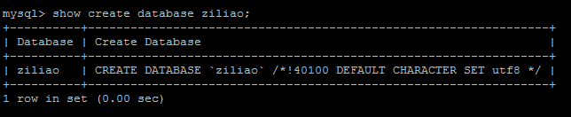

查看表编码：show create table table_name;

mysql> show create table shoujihao\G;

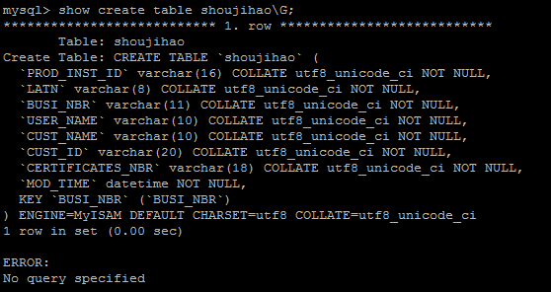查看字段编码 >show full columns from table_name;

mysql> show full columns from shoujihao;

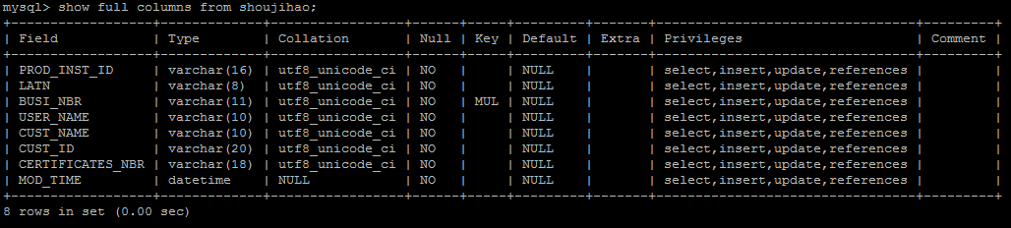

修改数据库字符集：

ALTER DATABASE db_name DEFAULT CHARACTER SET character_name [COLLATE ...];

把表默认的字符集和所有字符列（CHAR,VARCHAR,TEXT）改为新的字符集：

ALTER TABLE tbl_name CONVERT TO CHARACTER SET character_name [COLLATE ...]

如：ALTER TABLE logtest CONVERT TO CHARACTER SET utf8 COLLATE utf8_general_ci;

只是修改表的默认字符集：

ALTER TABLE tbl_name DEFAULT CHARACTER SET character_name [COLLATE...];

如：ALTER TABLE logtest DEFAULT CHARACTER SET utf8 COLLATE utf8_general_ci;

修改字段的字符集：

ALTER TABLE tbl_name CHANGE c_name c_name CHARACTER SET character_name [COLLATE ...];

如：ALTER TABLE logtest CHANGE title title VARCHAR(100) CHARACTER SET utf8 COLLATE utf8_general_ci;

mysql> show variables like 'character_set%';

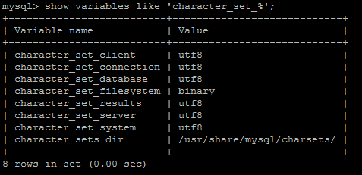

[root@aliyun ~]# vi /etc/my.cnf

[mysqld]

datadir=/var/lib/mysql

socket=/var/lib/mysql/mysql.sock

user=mysql

default-character-set=utf8

init_connect='SET NAMES utf8'

# Disabling symbolic-links is recommended to prevent assorted security risks

symbolic-links=0

[mysqld_safe]

log-error=/var/log/mysqld.log

pid-file=/var/run/mysqld/mysqld.pid