查看数据库编码：show create database db_name;
mysql> show create database ziliao;
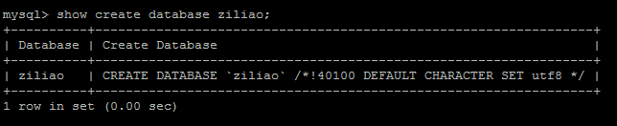
查看表编码：show create table table_name;
mysql> show create table shoujihao\G;
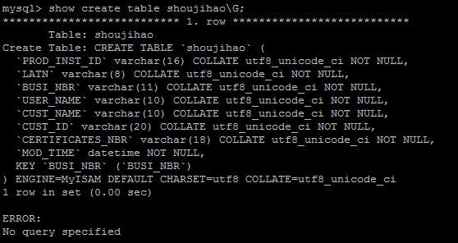查看字段编码 >show full columns from table_name;
mysql> show full columns from shoujihao;
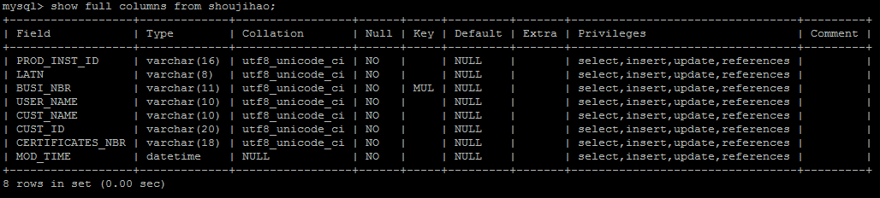
修改数据库字符集：
ALTER DATABASE db_name DEFAULT CHARACTER SET character_name [COLLATE ...];
把表默认的字符集和所有字符列（CHAR,VARCHAR,TEXT）改为新的字符集：
ALTER TABLE tbl_name CONVERT TO CHARACTER SET character_name [COLLATE ...]
如：ALTER TABLE logtest CONVERT TO CHARACTER SET utf8 COLLATE utf8_general_ci;

只是修改表的默认字符集：
ALTER TABLE tbl_name DEFAULT CHARACTER SET character_name [COLLATE...];
如：ALTER TABLE logtest DEFAULT CHARACTER SET utf8 COLLATE utf8_general_ci;

修改字段的字符集：
ALTER TABLE tbl_name CHANGE c_name c_name CHARACTER SET character_name [COLLATE ...];
如：ALTER TABLE logtest CHANGE title title VARCHAR(100) CHARACTER SET utf8 COLLATE utf8_general_ci;

mysql> show variables like 'character_set%';
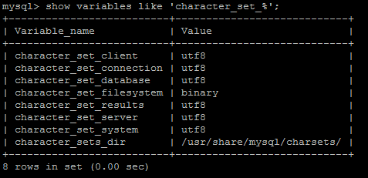

[root@aliyun ~]# vi /etc/my.cnf
[mysqld]
datadir=/var/lib/mysql
socket=/var/lib/mysql/mysql.sock
user=mysql
default-character-set=utf8
init_connect='SET NAMES utf8'
# Disabling symbolic-links is recommended to prevent assorted security risks
symbolic-links=0

[mysqld_safe]
log-error=/var/log/mysqld.log
pid-file=/var/run/mysqld/mysqld.pid

