1.在线报表配置说明，在DEV 10.17.2.24环境有样列(关系客户服务_Pro)，如下图：
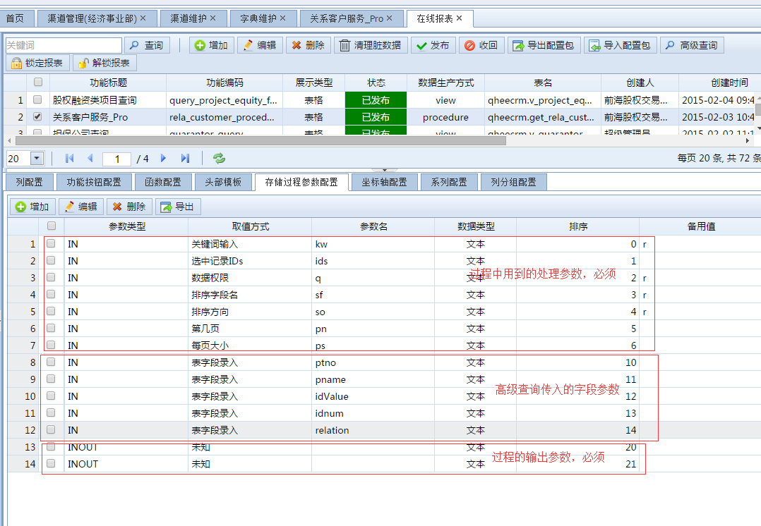

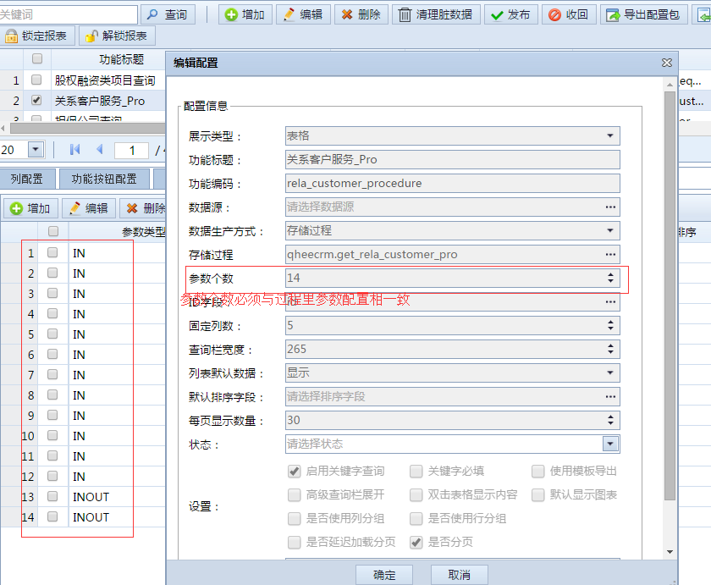

- 存储过程样列

USE qheecrm;

-- 创建关系客户服务过程 get_rela_customer_pro
CREATE DEFINER=`qheecrm`@`%` PROCEDURE `get_rela_customer_pro`(IN kw varchar(255),IN ids varchar(255), IN q text, IN sf varchar(255), IN so varchar(255), IN pn varchar(10), IN ps varchar(10), INOUT res text, INOUT total varchar(10))
begin

DECLARE v_sf varchar(255) DEFAULT 'partnerid';
DECLARE v_so varchar(255) DEFAULT 'desc';
DECLARE v_pn int DEFAULT 1;
DECLARE v_ps int DEFAULT 40;
DECLARE v_sql_0 text;
DECLARE v_sql_1 text;
DECLARE v_sql_2 text DEFAULT '';
DECLARE v_sql_3 text;
DECLARE v_from INT DEFAULT 0;
DECLARE v_where text DEFAULT '1=1';

IF sf is not null and sf != '' and sf != 'r' THEN
IF so is not null and so != '' and so != 'r' THEN
SET v_sf = sf;
SET v_so = so;
SET v_sql_2 = CONCAT(' ORDER BY ', sf,' ',so);
END IF;
END IF;

IF pn is not null and pn > 0 THEN
SET v_pn = pn;
END IF;
IF ps is not null and ps > 0 THEN
SET v_ps = ps;
END IF;

SET v_from = (v_pn-1)*v_ps;

IF kw is not null and kw != '' THEN
SET v_where = CONCAT('(pname like \'%', kw, '%\' or ptno like \'%',kw,'%\' or idValue like \'%',kw,'%\' or idnum like \'%',kw,'%\' or relation like \'%',kw,'%\')');
END IF;

-- 导出时候多选 ids条件
IF ids is not null and ids != '' THEN
SET v_where = CONCAT(v_where, ' and id in(', ids ,') ');
END IF;

-- 若权限过滤条件不为空，考虑进来
IF q is not null and q != '' and q != 'r' THEN
SET v_where = CONCAT(v_where, ' and ( ', q, ' ) ');
END IF;

-- SET v_sql_0 = CONCAT(' FROM demo_master WHERE ', v_where, ' ORDER BY ', v_sf,' ', v_so);

SET v_sql_1 = '
select
t0.id AS partnerroleId,
t0.partnerid AS partnerid,
p.id AS id,
p.ptno AS ptno,
p.pname AS pname,
p.ptype AS ptype,
p.idtype AS idtype,
p.idtype_value AS idValue,
p.idnum AS idnum,
p.islocalcom AS islocalcom,
p.datasource AS datasource,
p.pid AS pid,
p.delflag AS delflag,
p.delist AS delist,
p.delisttime AS delisttime,
t4.areaname AS pareaname,
t6.relation AS relation,
t7.level_name AS level_name,
t8.tname AS teamName,
t9.typename AS typename,
t3.entcode AS entcode,
t3.regfund AS regfund,
t0.tenant_code AS tenant_code,
t3.unitpro AS unitpro,
tcp.cname AS cname,
tcp.cjob AS cjob,
tcp.cert_no AS mainidnum,
tcp.gender AS gender,
tcp.telephone AS telephone,
tcp.email AS email,
rtask.createperson AS scheduleCreator,
rtask.starttime AS scheduleCreateTime,
pun.count AS punishCount,
town.townName AS townName,
office.officeName AS officeName,
buzc.buztypeid AS buztypeid,
buzc.buzname AS buzname,
tpe.event_time AS eventTtime,
t11.dict_code AS idtypeDesc,
t12.dict_code AS delistDesc,
t13.dict_code AS ptypeName,
(case when (pun.count > 0) then \'有处罚\' else \'无处罚\' end) AS punishInfoDesc,
tenant.name AS tenantName,
vrt.tenant_name AS relevanceTenant
from refer_partner tt
right join qheecrm.atzpartnerrole t0 ON tt.atzpartner_id=t0.partnerid and ((t0.delflag = 0) and (t0.roleid = 5))
left join qheecrm.atzpartner p ON (t0.partnerid = p.id)
left join atzcorinfo t3 on tt.atzcorinfo_id=t3.id
left join atzarea t4 on tt.area_id=t4.id
left join refer_managerela t5 on tt.atzpartner_id=t5.atzpartner_id
left join atzteamemp t6 on t5.atzteamemp_id=t6.id
left join emp_agent_level t7 on t5.emp_agent_level_id=t7.id
left join atzteam t8 on t5.atzteam_id=t8.id
left join atzcontactper tcp on tt.atzcontactper_id=tcp.id
left join atztradetype t9 on tt.atztradetype_id=t9.id
LEFT JOIN (select * from qheecrm.v_rela_dict where p_dict_value = \'customer_type\') t11 ON p.ptype = t11.dict_value
LEFT JOIN (select * from qheecrm.v_rela_dict where p_dict_value = \'listing_status\') t12 ON p.delist = t12.dict_value
LEFT JOIN (select * from qheecrm.v_rela_dict where p_dict_value = \'id_type\') t13 ON p.idtype = t13.dict_value
left join crm_solidbase_db.sys_tenant tenant ON (tenant.code = t0.tenant_code)
left join partner_events tpe ON tpe.partner_id = tt.atzpartner_id AND tpe.event_type = \'list_over_time\' and tpe.buztypeid in (1 , 8, 9, 10)
left join qheecrm.v_rela_atztask_list rtask ON (t0.partnerid = rtask.partnerid)
left join qheecrm.v_rela_punish_info pun ON (t0.partnerid = pun.partnerid)
left join qheecrm.v_rela_town_info town ON (t0.partnerid = town.partnerid)
left join qheecrm.v_rela_office_info office ON (t0.partnerid = office.partnerid)
left join qheecrm.v_relevance_tenant vrt ON (vrt.partner_id = t0.partnerid)
left join qheecrm.v_rela_buztype_list buzc ON ((t0.partnerid = buzc.partnerid))
where 1=1 and t0.delflag=0 and t0.roleid=5
order by t0.partnerid';

-- 查询总数sql

SET v_sql_3 = '
select
p.ptno AS ptno,
p.id AS id,
p.pname AS pname,
t0.partnerid AS partnerid,
p.idtype_value AS idValue,
p.idnum AS idnum,
t0.tenant_code AS tenant_code,
t6.relation AS relation
from refer_partner tt
right join qheecrm.atzpartnerrole t0 ON tt.atzpartner_id=t0.partnerid and ((t0.delflag = 0) and (t0.roleid = 5))
left join qheecrm.atzpartner p ON (t0.partnerid = p.id)
left join atzcorinfo t3 on tt.atzcorinfo_id=t3.id
left join atzarea t4 on tt.area_id=t4.id
left join refer_managerela t5 on tt.atzpartner_id=t5.atzpartner_id
left join atzteamemp t6 on t5.atzteamemp_id=t6.id
left join emp_agent_level t7 on t5.emp_agent_level_id=t7.id
left join atzteam t8 on t5.atzteam_id=t8.id
left join atzcontactper tcp on tt.atzcontactper_id=tcp.id
left join atztradetype t9 on tt.atztradetype_id=t9.id
LEFT JOIN (select * from qheecrm.v_rela_dict where p_dict_value = \'customer_type\') t11 ON p.ptype = t11.dict_value
LEFT JOIN (select * from qheecrm.v_rela_dict where p_dict_value = \'listing_status\') t12 ON p.delist = t12.dict_value
LEFT JOIN (select * from qheecrm.v_rela_dict where p_dict_value = \'id_type\') t13 ON p.idtype = t13.dict_value
left join crm_solidbase_db.sys_tenant tenant ON (tenant.code = t0.tenant_code)
left join partner_events tpe ON tpe.partner_id = tt.atzpartner_id AND tpe.event_type = \'list_over_time\' and tpe.buztypeid in (1 , 8, 9, 10)
left join qheecrm.v_rela_atztask_list rtask ON (t0.partnerid = rtask.partnerid)
left join qheecrm.v_rela_punish_info pun ON (t0.partnerid = pun.partnerid)
left join qheecrm.v_rela_town_info town ON (t0.partnerid = town.partnerid)
left join qheecrm.v_rela_office_info office ON (t0.partnerid = office.partnerid)
left join qheecrm.v_relevance_tenant vrt ON (vrt.partner_id = t0.partnerid)
left join qheecrm.v_rela_buztype_list buzc ON ((t0.partnerid = buzc.partnerid))
where 1=1 and t0.delflag=0 and t0.roleid=5';

-- 如果不是页面传过来的 显示数量 ，则为导出查询全部的
IF v_ps is not null and v_ps = 40 THEN
SET v_sql_1 = CONCAT('SELECT * FROM (', v_sql_1,' ) t0 where ',v_where, v_sql_2);
ELSE
SET v_sql_1 = CONCAT('SELECT * FROM (', v_sql_1,' ) t0 where ',v_where, v_sql_2,' LIMIT ', v_from,',', v_ps);
END IF;

SET v_sql_3 = CONCAT('SELECT count(1) as total FROM (', v_sql_3,' ) t0 where ',v_where);

SET @sql1 = v_sql_1;
SET @sql3 = v_sql_3;
PREPARE sl FROM @sql1;
EXECUTE sl;
DEALLOCATE PREPARE sl;
PREPARE sl FROM @sql3;
EXECUTE sl;
DEALLOCATE PREPARE sl;
end;

