HTML/CSS course

Assignment 1

Overview

We will use HTML5 structure and text tags by creating a ‘city introduction’ page

Task

Creating a page “mycity.html”

The page will include:

* A picture
* A page title
* And several entries.
* A footer

Output

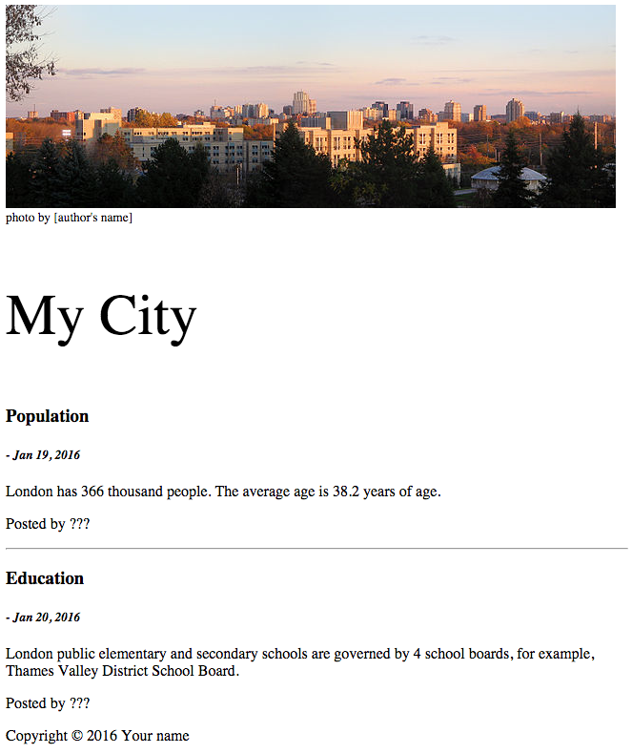

Your page doesn’t need to be exactly same as the following picture.

Materials and tools

You can download pictures from Wikipedia (https://en.wikipedia.org/wiki/London,_Ontario)

The pictures in Wikipedia are usually free to use, but you should include author’s name in the page. Just a simple description will be good such as ‘photo by John’.