HTML/CSS course

Teens Programming

Assignment 14

Overview

Practice responsive layout design and use flexible box

Output

When viewport width < 600px

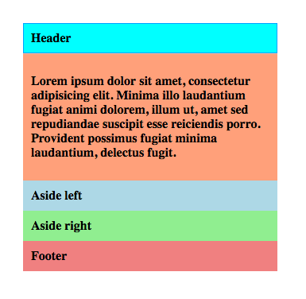

When viewport width >= 600px

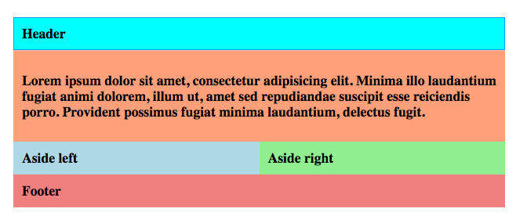

When viewport width >=800px

