HTML/CSS course

Assignment 2

Overview

We will mainly use HTML5 list tags by creating a recipe page.

Task

* Spend 5 minutes to figure out what food is your favorite?
* Ask your parents or google search to find the food recipe.
* (Optional) Cooking with your parents. You may develop new recipe during the process.
* Describe your recipe in the web page.

Page name: favorite_food.html

The page will include:

* A title of the recipe
* A picture of the food you cooked with your parents or a picture you find from web (make sure to use it legally)
* A picture caption to describe the recipe
* A section for Ingredients
  + Use unordered list to list items
* A section for directions
  + Use ordered list to list steps

Submission

Commit your code to github. The page will be generated by github page service.

Materials and tools

You can finish the page using the ‘structure’, ‘text’, ‘figure’, ‘img’ and list tags.

The Brackets is your editor. You use git commands to manage the source code, and commit them to github.

Notes

* This assignment is due before the next class
* Preparing all your questions for our class
* I will review the code with you and answer all your questions

Page sample

Soup

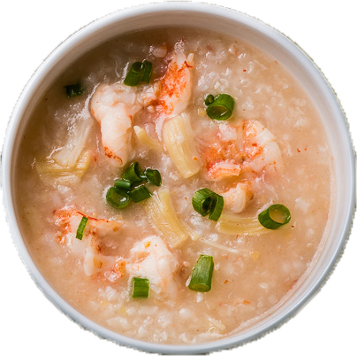

Recipe by: [your name]

A **seafood congee** is the rice soup consisting of shrimp, rice, green onion and salt. It is unbelievably delicious and easy to cook.

Ingredients:

* Rice
* Shrimp
* Green onion
* Salt

Directions:

1. Cook a regular rice soup
2. When the rice soup is cooked, add shrimp to the soup
3. Cook the soup until the shrimp is cooked
4. Add proper amount of salt
5. Add green onion, stir a few times
6. The delicious seafood congee is ready to serve