HTML/CSS course

Assignment 1

Overview

We will use HTML5 structure and text tags by creating a ‘city introduction’ page in github pages.

Task

Creating a page about London city.

The page will include:

* A picture
* A page title
* And several entries. Each entry includes:
  + Entry title
  + The date to indicate when the entry is written
  + The content of the entry
  + Who post the entry
* A footer

Output

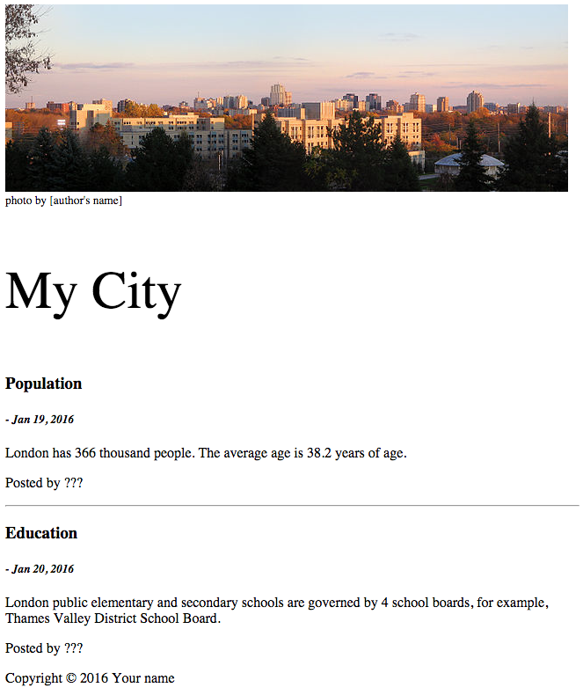

Your page doesn’t need to be exactly same as the following picture, as long as you write information described in the ‘Task’ section. Try your best to make the page content organized.

Submission

After you finish your page, you should commit the code to github. The page will be generated by github.

I will browse your pages from your website.

Presentation

(Not required)

Materials and tools

You can download pictures from Wikipedia (https://en.wikipedia.org/wiki/London,_Ontario)

The pictures in Wikipedia are usually free to use, but you should include author’s name in the page. Just a simple description will be good such as ‘photo by John’.

You can finish the page using the ‘structure’, ‘text’ tags and ‘img’ tag .

The Brackets is your editor. You use git commands to manage the source code, and push them to github.com.

Notes

Don’t afraid to make mistakes. We learn from mistakes. No mistakes, no progress.

* This assignment is due before the next class.
* Preparing all your questions for our class.
* I will review the code with you and answer all your questions.