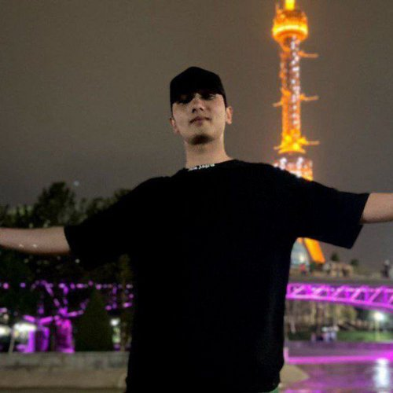 |  | Savriyev Sunnat Sobir o'g'li  Male, 23 years, born on 23 November 2002  +998 (93) 1090508 — preferred means of communication  sunnatchiksavriyev@gmail.com  Reside in: Tashkent  Citizenship: Uzbekistan, work permit at: Uzbekistan  Not ready to relocate, not ready for business trips
Desired position and salary
Backend-разработчик
Specializations:
— Programmer, developer

Employment: full time
Work schedule: full day
travel time to work: any
Work experience —1 year
June 2025 — till now  7 months |  | Toshkent Metropoliteni DUK  Backend-разработчик  python projects
June 2024 — October 2024  5 months |  | UNICON-SOFT  Tashkent  Educational Institutions  • Research, Scientific, Academic Activity  Backend-разработчик  python , django projects
Education
Master
2025 |  | Toshkent Axborot Texnologiyalari Universiteti  Telekommunikatsiya, injiner
2024 |  | Toshkent Axborot Texnologiyalari Universiteti  Telekommunikatsiya, Python developer
Skills
Languages |  | Uzbek — Native  English — B2 — Upper Intermediate
Skills |  | Git PostgreSQL Python Docker Английский язык

