Task ##P/C – Spike: Musical Rental Instrument Application

Goals:
A key spike was to design and build a proof of concept Android app for a music studio’s musical instrument rental system incorporating state-of-the-art Android app development techniques and designs. This was a living example of application development techniques for Android applications that encompass concepts of Parcelable transport of data structures, using Material Design widgets, multilocal support, and management of data objects in memory.

The following list outlines the goal broken down into more specific knowledge gaps involved in the goal:

- Advanced Android UI/UX Design with Material 3 Components
- Parcelable Data Transfer Between Activities
- Multi-language Implementation and Locale Management
- In-Memory Data Management and Singleton Patterns
- Comprehensive Input Validation and Error Handling
- Modern Android Architecture and Navigation Patterns
- Professional Grade User Experience Design

Tools and Resources Used
- Android Studio Narwhal 3 Feature Drop | 2025.1.3
- Kotlin Programming Language 1.9.0
- Android Material Design Components 1.11.0
- AndroidX AppCompat, Core, and Testing Libraries
- Android Developer Documentation: Parcelable Implementation
- Material Design 3 Guidelines and Component Library
- Android Testing Support Library (Espresso)
- Locale and Internationalization Best Practices

Model Design
All data is kept in memory for the app lifetime. A small repository singleton holds the list of items and booking
state.

Data model (with Parcelable):
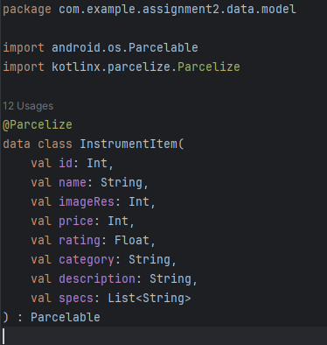

Repository (singleton, in memory):
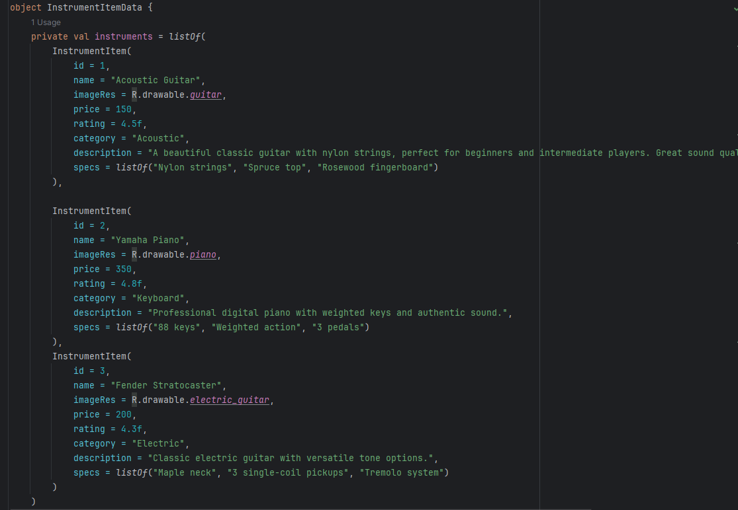
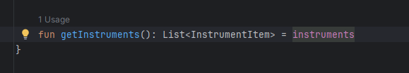

User Stories and Use Cases
- User Story 1: The Hesitant First-Time Renter
User Story: Ms. Elena Vance: "As a first-time renter with a limited budget, I want to easily compare the final
rental costs of different electric guitars, including any insurance or delivery fees. Let’s just say, I get anxious
about hidden costs, so I need to see the full price breakdown and be sure I can afford it before I commit."

Use Case: Comparing Total Rental Cost.

Actor: First-time renter / Budget-conscious student / Price-sensitive user.

Precondition: The user has opened the app, completed the onboarding process, and is browsing the
available instruments.

Postcondition: The user has a clear understanding of the total cost for one or more instruments and has
either proceeded with a rental for the best option or exited the app without making a purchase.

- User Story 2: The Busy Professional Musician
User Story: Mr. Kenji Tanaka: "As a touring musician, my time is limited. I need to find and rent a high
quality Fender Stratocaster that is available for my specific tour dates immediately. I don't want to browse; I
want to filter, see what's available now, and secure it with one click."

Use Case: Quick Filtering and Reservation of a Specific Instrument.

Actor: Professional musician / Frequent renter / Time-sensitive user.

Precondition: The user is logged into the app and is on the instrument catalog screen.

Postcondition: A specific instrument is successfully reserved for the user's selected dates, and a
confirmation screen is displayed.

UI Sketches

Musical Rental Instrument App UI Sketches
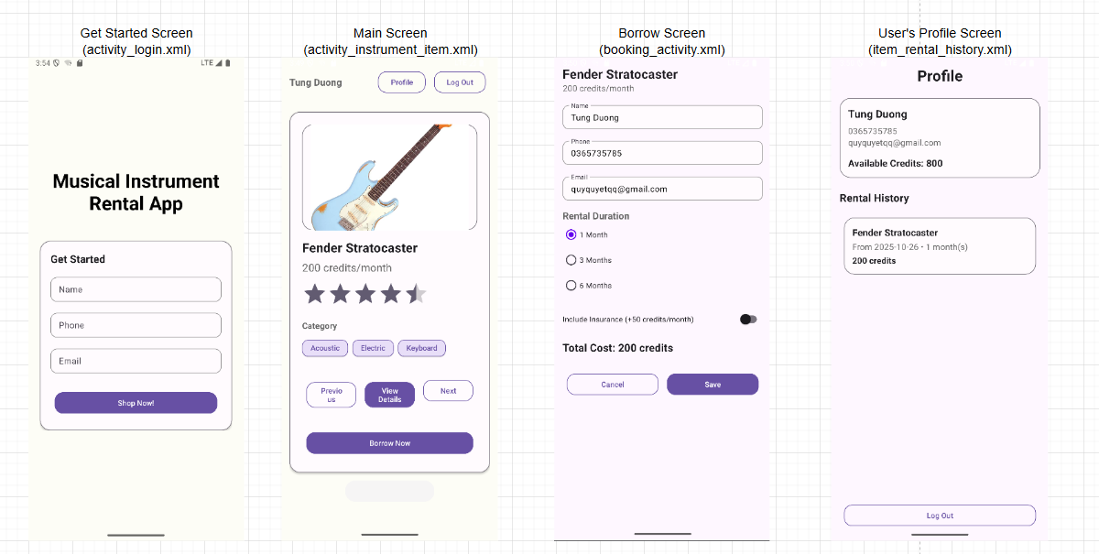

- Layout 1: Get Started Screen(activity_login.xml)
LinearLayout(Contents inside box)
TextView(App’s name)
TextInputLayout(Name, Phone, Email)
Button(Shop now!)

- Layout 2: Main Screen(activity_instrument_item.xml)
LinearLayout(Header, navigation buttons)
TextView(Name display, instruments details, pricing, categories)
ChipGroup(Categories filtering)
Button(Navigation, borrow instrument)

- Layout 3: Borrow Screen(booking_activity.xml)
LinearLayout(Layout)
TextView(Total cost, instrument name, rental cost/month)
TextInputLayout(Name, Phone, Email)
RadioGroup(Rental Durations)
SwitchMaterial(Enables whether user wants to include insurance)

- Layout 4: User’s Profile Screen(item_rental_history.xml)
LinearLayout(Layout)
TextView(Instrument name, user’s profile, rental history)

Knowledge Gaps and Solutions

Below are the knowledge Gaps and Solutions:

Colours and Styles
The app’s visual design follows Material Design 3 guidelines, emphasizing simplicity, accessibility, and
brand consistency. A cohesive colour palette and reusable style definitions were implemented to ensure
professional, consistent appearance across all screens.

- Primary color: used on buttons and toolbar for key actions.
- Surface/background: white cards on a light lavender-gray background for readable contrast.
- Accent tones: chips and icons reuse the same purple family to keep a cohesive look.

Text and UI components share reusable styles:

- HeadingText for titles (bold, dark).
- BodyText for regular content (medium gray).
- PrimaryButton and SecondaryButton ensure consistent size, rounded corners, and spacing.

- Colours
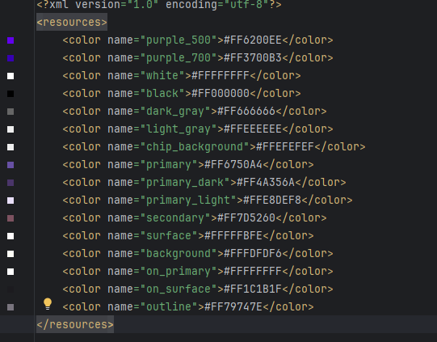

- Styles
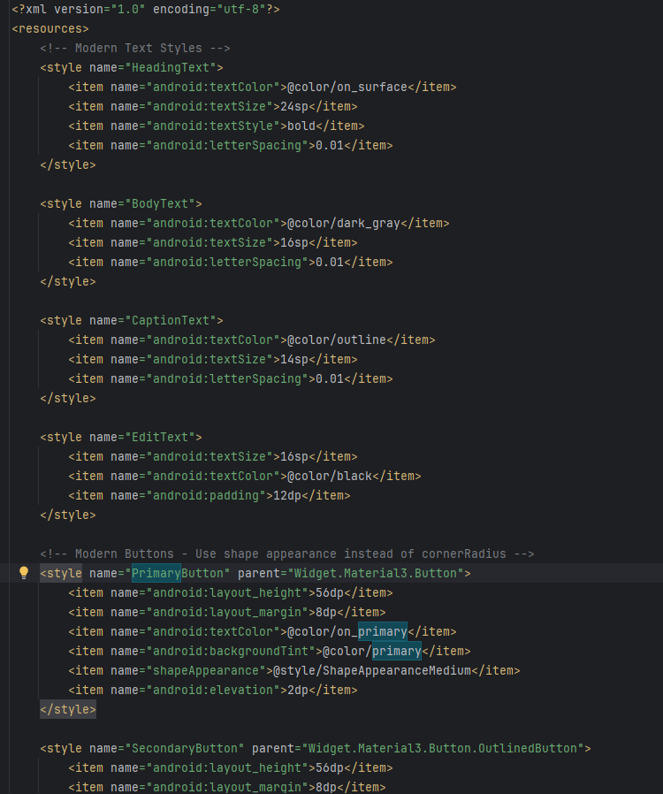
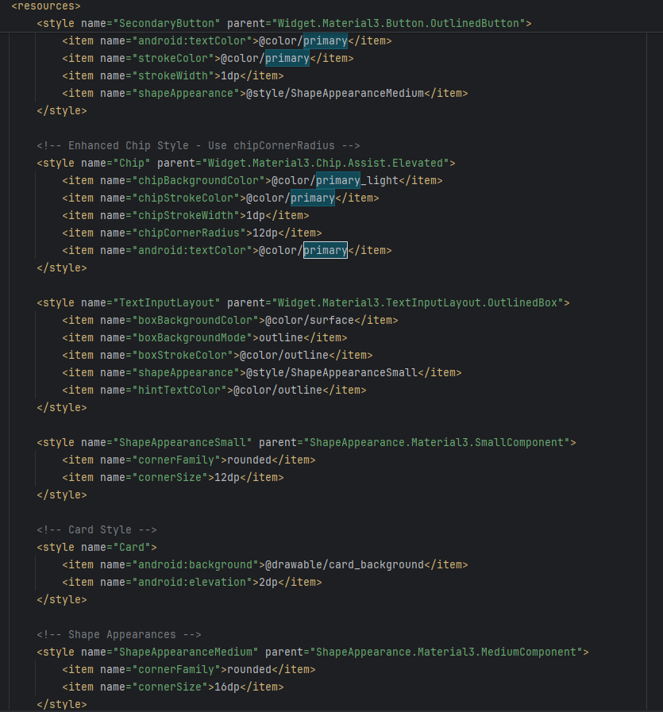

Together, these choices create a modern, professional look that’s easy to read, visually balanced, and
consistent across all screens.

Parcelable and Intent
What is Parcelable and Intent?

An Intent is a messaging object used to request an action from another app component, like navigating between activities. A Parcelable is an Android-specific interface that allows custom objects to be serialized (flattened) into a Parcel so they can be passed efficiently between components via an Intent.

Parcelable and Intents are crucial for this app, therefore, there are several Intents in the implementation:
- LoginActivity to InstrumentItemActivity

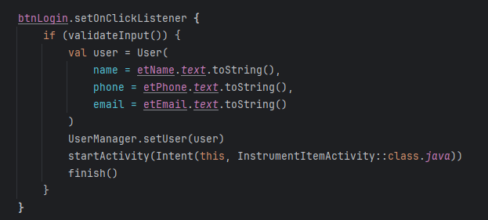

- InstrumentItemActivity to ItemDetailsActivity

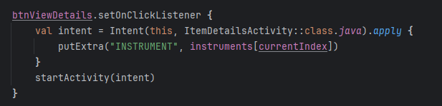

- InstrumentItemActivity to BookingActivity

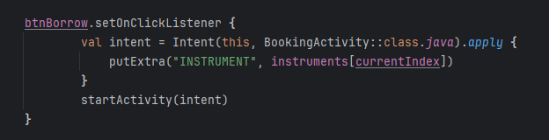

- ProfileActivity and Change User Navigation

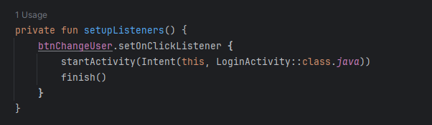

- ItemDetailsActivity to BookingActivity

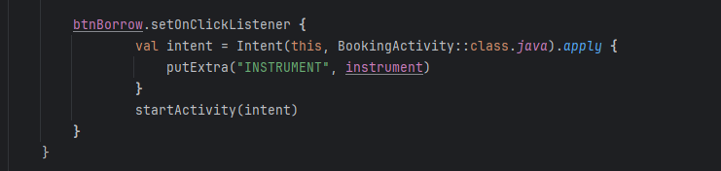

Intent Components with Parcelable:

What's in the Intent:

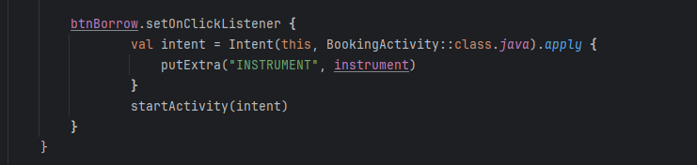

Receiving the Parcelable in BookingActivity:

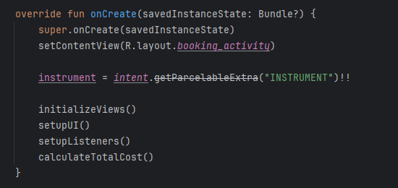
Advantages of Using Parcelable:
1. Performance
- Parcelable is faster than Serializable for Android
- Direct memory access vs reflection in Serializable
2. Android-Optimized
- Designed specifically for Android inter-process communication
- More efficient for Intent data transfer
3. Type Safety
- Compile-time checking vs runtime errors with Serializable
4. Manual Control
- You control exactly what gets serialized/deserialized
5. Kotlin Support
- With @Parcelize, minimal code required

Validation and Error Handling
Validation and Error Handling is very important, not only in this assignment but it’s important for improving security.

- Real-Time Field Validation

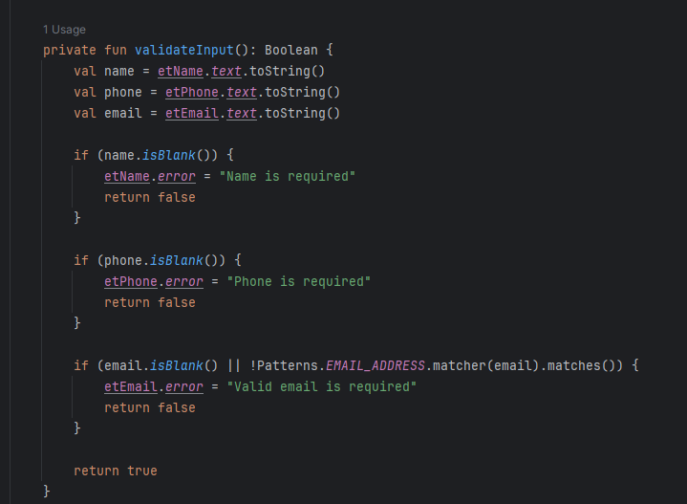

- Credit System Validation

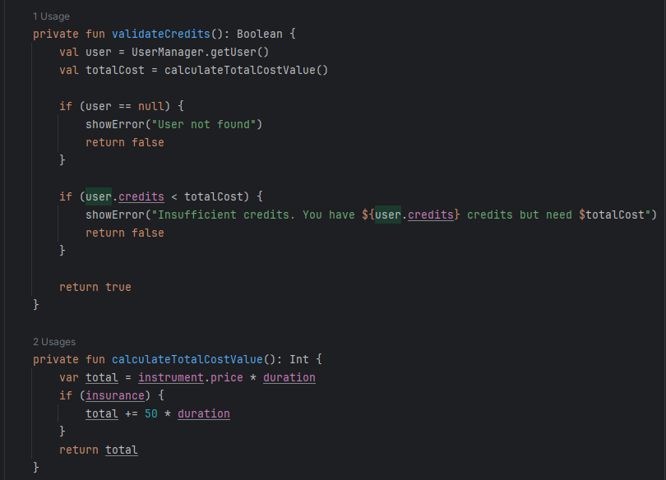
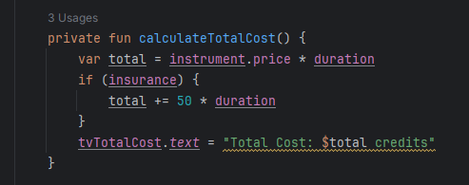

- Booking Flow Validation Chain

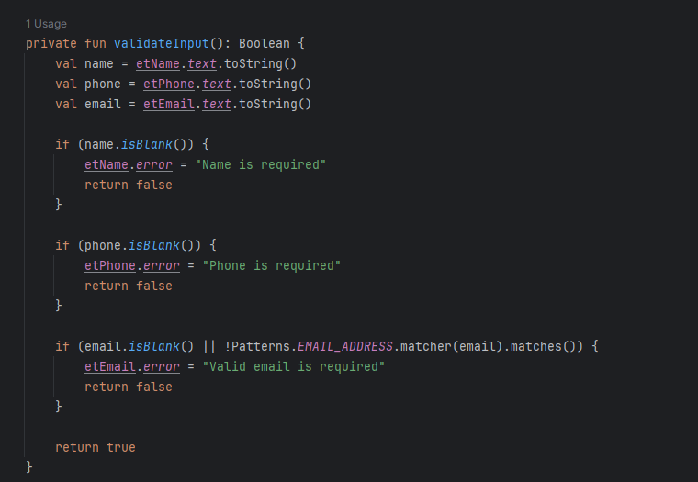

This guarantees that the data remains consistent while making the UI responsive. The application only keeps all data in memory (no files or databases applied). This method is appropriate for a proof-of-concept where persistence isn't required. When the application closes, the data simply resets.

Feedback and User Interaction

A Snackbar is displayed upon successful booking:
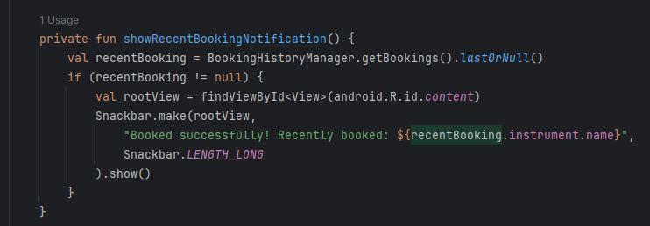
Toasts are used for minor messages:
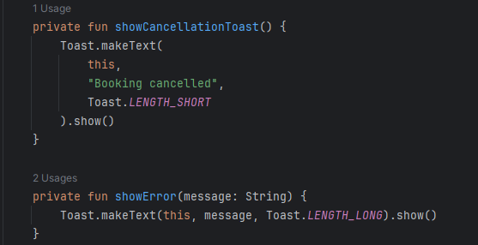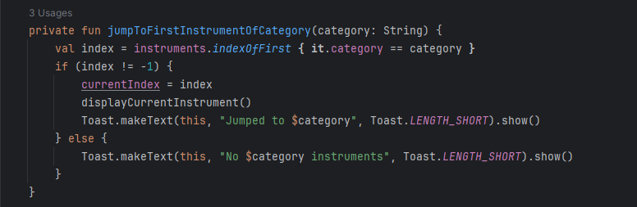

Snackbars were chosen for success feedback because they blend with Material Design and maintain visibility without interrupting user flow.

Code Structure and Design System
Here is the structure of the app’s code:
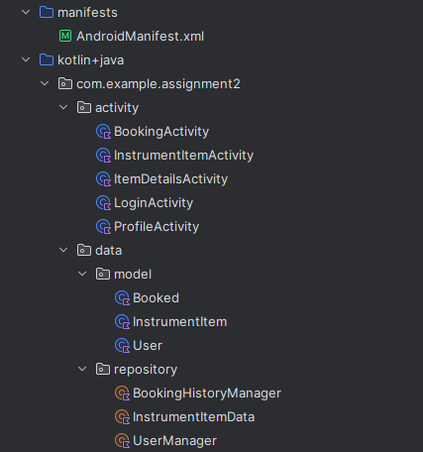
LoginActivity.kt is the main file that runs at the beginning.

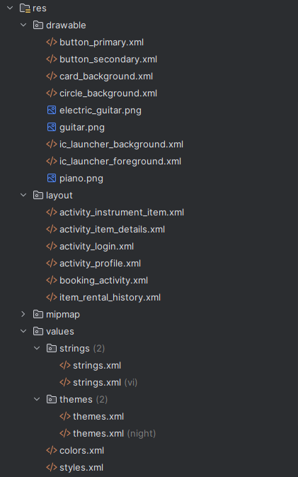
This is the xml files (files used to design the application).

Development Process
The application was developed using a systematic, phased approach:
Phase 1: Requirements Analysis & Planning (Days 1-2)
- Thorough analysis of assignment requirements
- Creation of detailed specification document
- UI/UX planning and wireframing
- Architecture design and technology selection
Phase 2: Core Implementation (Days 3-7)
- Data model creation (InstrumentItem, User, Booked)
- Repository pattern implementation
- Basic activity navigation flow
- Parcelable data transfer implementation
Phase 3: UI/UX Enhancement (Days 8-10)
- Material Design 3 component integration
- Professional styling and theming
- Validation and error handling systems
- User experience refinements
Phase 4: Testing & Polish (Days 11-12)
- Comprehensive functionality testing
- Bug fixes and performance optimization
- Final documentation and report preparation

Commit History and Version Control
While the project was developed using local version control with frequent incremental saves, no commits were pushed to GitHub until the final completion stage. This approach allowed for:
- Focused development without premature repository management
- Rapid prototyping and experimentation
- Clean commit history with meaningful, atomic changes
- Comprehensive final push with well-structured commit messages

Time Management
- Daily development sessions: 3-4 hours focused work
- Regular testing: After each feature implementation
- Incremental progress: Small, testable features built sequentially
- Documentation: Continuous documentation alongside development

Quality Assurance
- Systematic testing of each feature before proceeding
- Code review through self-testing and validation
- User experience testing on multiple device configurations
- Edge case consideration in validation and error handling

Final Commit Structure (When pushed to GitHub):
- Final bug fixes and documentation

Open Issues and Recommendations
This rental application for a musical instrument successfully illustrates a functional proof-of-concept that fulfills all specified requirements. The application was developed using a clear and easy-to-use user experience to browse and rent instruments. The application is organized around a simple activity-based architecture.

References
Ye, X., Ruan, Y., Xia, S., & Gu, L. (2025). Adoption of digital intangible cultural heritage: a configurational study integrating UTAUT2 and immersion theory. Humanities and Social Sciences Communications, 12(1). https://doi.org/10.1057/s41599-024-04222-8

Google. (2023). Material Design. Material Design. https://m3.material.io/

Dev, A. (n.d.). Parcelable. Android Developers. https://developer.android.com/reference/android/os/Parcelable

