**SEO Audit**

Web Page: [**https://friendsfries.ca**](https://friendsfries.ca)

Tools Used: SEMRUSH, LIGHTHOUSE, MYSITEAUDITOR

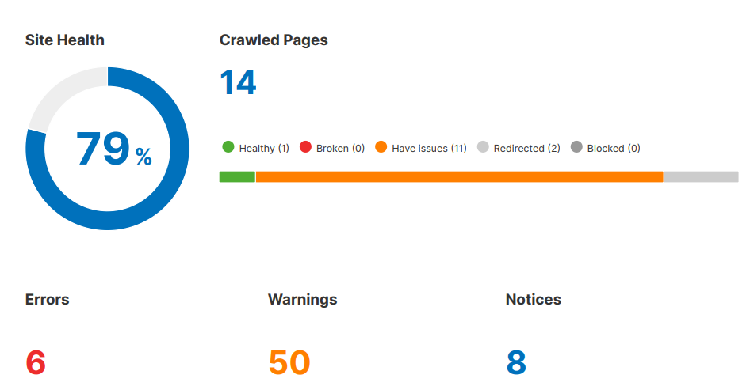

- SEMRUSH

- Lighthouse

**Technicals:**

1. Site Speed

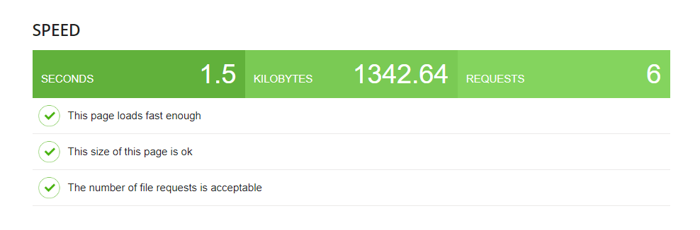

1. Mobile-Friendliness

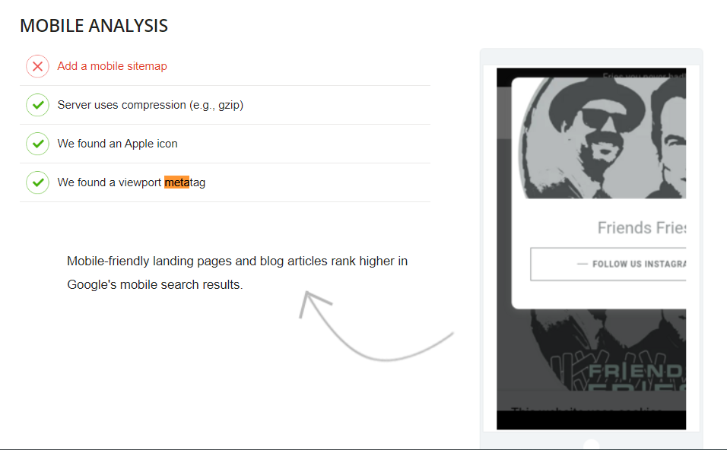

The mobile analysis of the website suggests implementing a mobile sitemap and utilizing compression like gzip for faster load times. Essential elements such as an Apple icon and viewport metatag are present. It underscores the importance of mobile-friendly content for higher rankings in Google's mobile search results. These insights emphasize the need for mobile optimization to enhance user experience and visibility in mobile search rankings.

1. URL Structure

The website's URL is SEO-friendly.

1. Indexability

The site's indexability analysis reveals that out of 14 pages, 10 are indexable, while 4 are non-indexable. There is minimal crawl budget waste, with only temporary and permanent redirects, along with a small number of instances of duplicate content. Additionally, there are no issues with pages canonical to other pages, large page sizes, slow page load speeds, or crawling blocks, indicating efficient site management. Overall, the site is well-optimized for search engine crawling and indexing, maximizing visibility while minimizing waste.

**On-Page Elements:**

1. Meta Tags

The Meta Data Analyzer provides key insights into metadata and page attributes. The Page Title "friendsfries.ca" is 15 characters long, while the Meta Viewport setting "width=device-width, initial-scale=1" spans 35 characters. Notably, there are no specified Meta Description or Keywords. The webpage has 27 URLs, totaling 108.27 KiB.These metrics emphasize efficient metadata usage and rapid page loading, crucial for user experience and search engine optimization.

1. Heading Structure

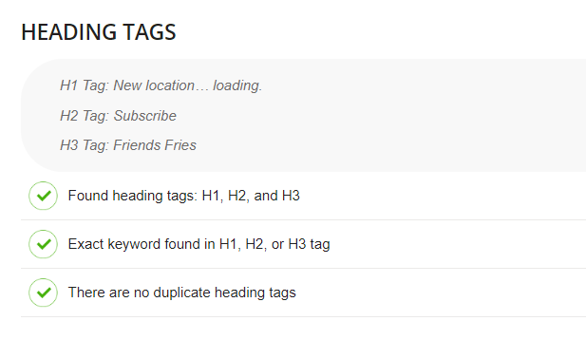

Heading tags on the webpage include H1, H2, and H3 tags. The H1 tag features "New location… loading," while the H2 tag is "Subscribe," and the H3 tag is "Friends Fries." Notably, the exact keyword appears in the H3 tag. Furthermore, more content.

1. Content Quality

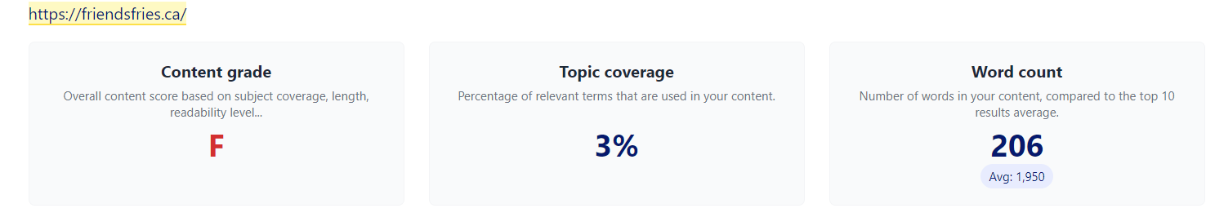

The content grade for friendsfries.ca is "F," indicating low subject coverage, length, and readability level. The content's topic coverage is only 3%, with a word count of 206 compared to the top 10 results' average of 1,950 words. This suggests potential shortcomings in content quality and relevance for search engine rankings.

**Off-Page Factors:**

1. Backlink Profile

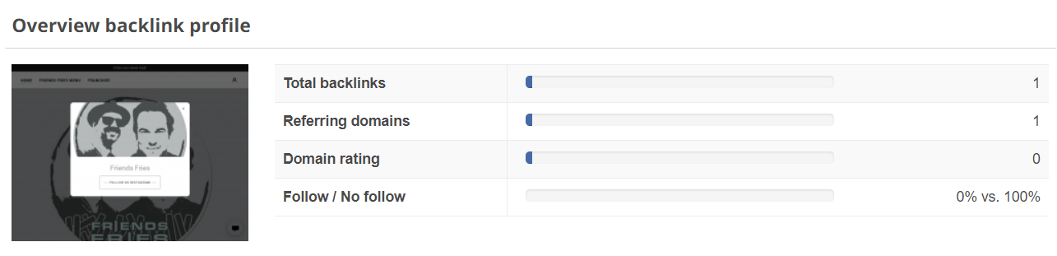

The backlink profile for friendsfries.ca is minimal, with only 1 backlink from 1 referring domain and a domain rating of 0. All backlinks are marked as "No follow," indicating limited authority passed from the linking site. This suggests a weak backlink profile, potentially affecting the website's search engine rankings and authority.

1. Social Media Presence

No fb, only Instagram icon, not readable.

**Developments:**

1. Technical Optimization:
   * Implement XML Sitemap: Create a map of your website's pages to help search engines find and understand your content easily.

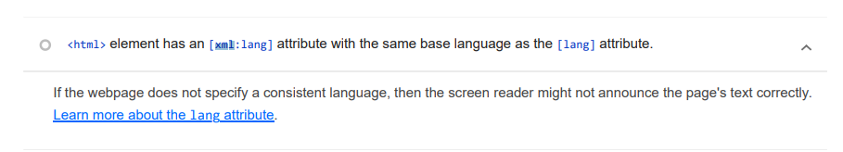

* + Optimize Site Speed: Make your website load faster by reducing image sizes and using faster servers.

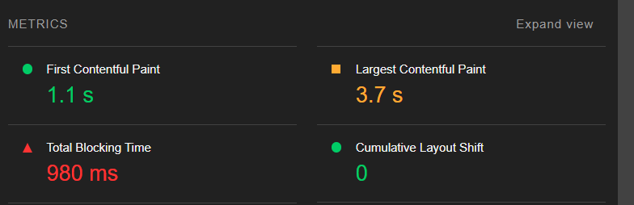

* + Mobile-Friendly Design: Have to ensure your website looks good and works well on mobile phones and tablets.

1. On-Page Optimization: 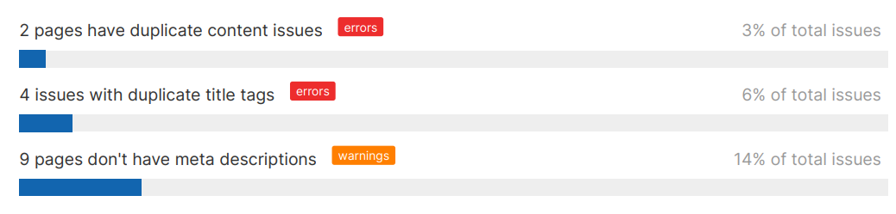
   * Keyword Research
   * Optimize Meta Tags
   * Improve Heading Structure
   * Content Optimization
   * Internal Linking

1. Off-Page Optimization:
   * Build High-Quality Backlinks: Get other websites to link to yours to show that your content is trustworthy.
   * Social Media Engagement: Be active on social media and share your website content to reach more people.

1. Content Strategy:
   * Create High-Quality Content: Write articles, make videos, or create other content that people will find useful and interesting.
   * Optimize Multimedia Content: Use images, videos, and other media in your content to make it more engaging.
2. Monitoring and Analysis:
   * Track Performance Metrics: Keep an eye on how many people visit your website, where they come from, and what they do there.
   * Regular Audits and Adjustments: Check your website regularly to see if anything needs fixing or improving based on how people are using it.