Noter (læsning til Fagprojekt)

Machine Bias (<https://www.propublica.org/article/machine-bias-risk-assessments-in-criminal-sentencing>)

* COMPAS scores are risk assessments, which are increasingly common in courtrooms across the US. They are used to inform decisions about who can be set free at every stage of the criminal justice system.
* The states which uses this algorithm: **Arizona**, Colorado, Delaware, **Kentucky**, Louisiana, Oklahoma, Virginia, Washington and Wisconsin**.
* In 2014, then U.S. Attorney General Eric Holder warned that the risk scores might be injecting bias into the courts. He called for the U.S. Sentencing Commission to study their use. “Although these measures were crafted with the best of intentions, I am concerned that they inadvertently undermine our efforts to ensure individualized and equal justice,” he said, adding, “they may exacerbate unwarranted and unjust disparities that are already far too common in our criminal justice system and in our society.” (The US sentencing Commission did not launch a study of the risk scores, but ProPublica did)
* the risk scores assigned to more than 7,000 people arrested in Broward County, Florida, in 2013 and 2014 and checked to see how many were charged with new crimes over the next two years.
  + Broward County, Flordia:
    - Southeastern
    - 2018 census: 1,863,780
    - Racial Makeup: 39.2% Caucasian, 26.5% Hispanic/Latino, 28.2% African American, 3.5% Asian, rest: others
    - <https://statisticalatlas.com/county/Florida/Broward-County/Race-and-Ethnicity>
* The score proved remarkably unreliable in forecasting violent crime: Only 20 percent of the people predicted to commit violent crimes went on to do so.
* full range of crimes were taken into account — including misdemeanors such as driving with an expired license — the algorithm was somewhat more accurate than a coin flip. Of those deemed likely to re-offend, 61 percent were arrested for any subsequent crimes within two years.
* The United States locks up far more people than any other country, a disproportionate number of them black
  + 2.2 million in prison (6.8 million correctional population)
  + 34% are African American (in the 6.8 million)
    - <https://www.naacp.org/criminal-justice-fact-sheet/>
  + 13% of the American population is African American
    - <https://www.census.gov/quickfacts/fact/table/US/PST045218>
* Race, nationality and skin color were often used in making such predictions until about the 1970s, when it became politically unacceptable, according to a [survey of risk assessment tools](https://papers.ssrn.com/sol3/papers.cfm?abstract_id=1677654) by Columbia University law professor Bernard Harcourt.
* Dozens of risk assessments are being used across the nation — some created by for-profit companies such as Northpointe and others by nonprofit organizations. (One tool being used in states including Kentucky and Arizona, called the Public Safety Assessment, was developed by the Laura and John Arnold Foundation, which also is a funder of ProPublica.)
* Most modern risk tools were originally designed to provide judges with insight into the types of treatment that an individual might need — from drug treatment to mental health counseling.
* “A guy who has molested a small child every day for a year could still come out as a low risk because he probably has a job,” Boessenecker said. “Meanwhile, a drunk guy will look high risk because he’s homeless. These risk factors don’t tell you whether the guy ought to go to prison or not; the risk factors tell you more about what the probation conditions ought to be.” – Boessenecker
* 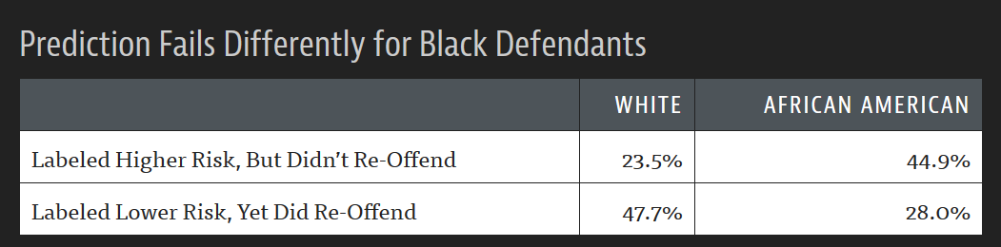Brennan said it is difficult to construct a score that doesn’t include items that can be correlated with race — such as poverty, joblessness and social marginalization. “If those are omitted from your risk assessment, accuracy goes down,” he said. (Brennan: one of the founders of Northpointe)
* ProPublica’s analysis reveals that higher Northpointe scores are slightly correlated with longer pretrial incarceration in Broward County. But there are many reasons that could be true other than judges being swayed by the scores — people with higher risk scores may also be poorer and have difficulty paying bond, for example.

How we Analysed the COMPAS Recidivism Algorithm (<https://www.propublica.org/article/how-we-analyzed-the-compas-recidivism-algorithm>)

* Recidivist: criminals who re-offend.
* COMPAS (which stands for Correctional Offender Management Profiling for Alternative Sanctions)
* Assessed 10,000 criminal defendants in Broward County, Florida – comparing defendants scores and what occurred after two years
* After the two years, the score correctly predicted an offender’s recidivism 61 percent of the time, but was only correct in its predictions of violent recidivism 20 percent of the time.
* The analysis (conclusion):
  + Black defendants were often predicted to be at a higher risk of recidivism than they actually were. The analysis found that black defendants who did not recidivate over a two-year period were nearly twice as likely to be misclassified as higher risk compared to their white counterparts (45 percent vs. 23 percent)
  + White defendants were often predicted to be less risky than they were. The analysis found that white defendants who re-offended within the next two years were mistakenly labeled low risk almost twice as often as black re-offenders (48 percent vs. 28 percent).
  + The analysis also showed that even when controlling for prior crimes, future recidivism, age, and gender, black defendants were 45 percent more likely to be assigned higher risk scores than white defendants.
  + Black defendants were also twice as likely as white defendants to be misclassified as being a higher risk of violent recidivism. And white violent recidivists were 63 percent more likely to have been misclassified as a low risk of violent recidivism, compared with black violent recidivists.
  + The violent recidivism analysis also showed that even when controlling for prior crimes, future recidivism, age, and gender, black defendants were 77 percent more likely to be assigned higher risk scores than white defendants.
* [A 2013 study](https://www.researchgate.net/publication/258920739_Thirty_Years_of_Research_on_the_Level_of_Service_Scales_A_Meta-Analytic_Examination_of_Predictive_Accuracy_and_Sources_of_Variability) analyzed the predictive validity among various races for another score called the Level of Service Inventory, one of the most popular commercial risk scores from Multi-Health Systems. That study found that “ethnic minorities have higher LS scores than nonminorities.” The study authors, who are Canadian, noted that racial disparities were more consistently found in the U.S. than in Canada. “One possibility may be that systematic bias within the justice system may distort the measurement of ‘true’ recidivism,” they wrote. (study: github - Thirty Years of Research on the Level of Service Scales: A Meta-Analytic Examination of Predictive Accuracy and Sources of Variability)
* Because Broward County primarily uses the score to determine whether to release or detain a defendant before his or her trial, we discarded scores that were assessed at parole, probation or other stages in the criminal justice system. That left us with 11,757 people who were assessed at the pretrial stage.
* Three COMPAS scores: “Risk of Recidivism,” “Risk of Violence” and “Risk of Failure to Appear.”