ELEC 4700 - Assignment 1

# Electron Modeling

1. The thermal velocity is
2. If then the mean free path is [1]

1. Please see code on GitHub. The required figures can be seen below

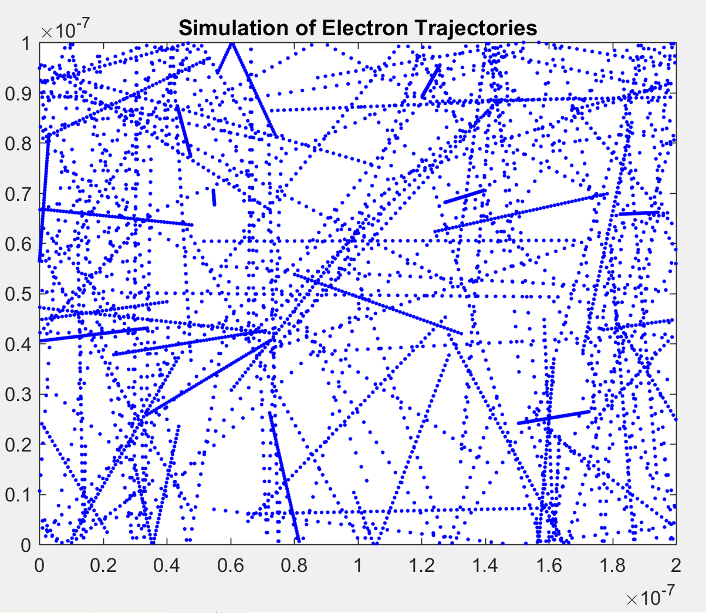

Figure : Particle trajectories

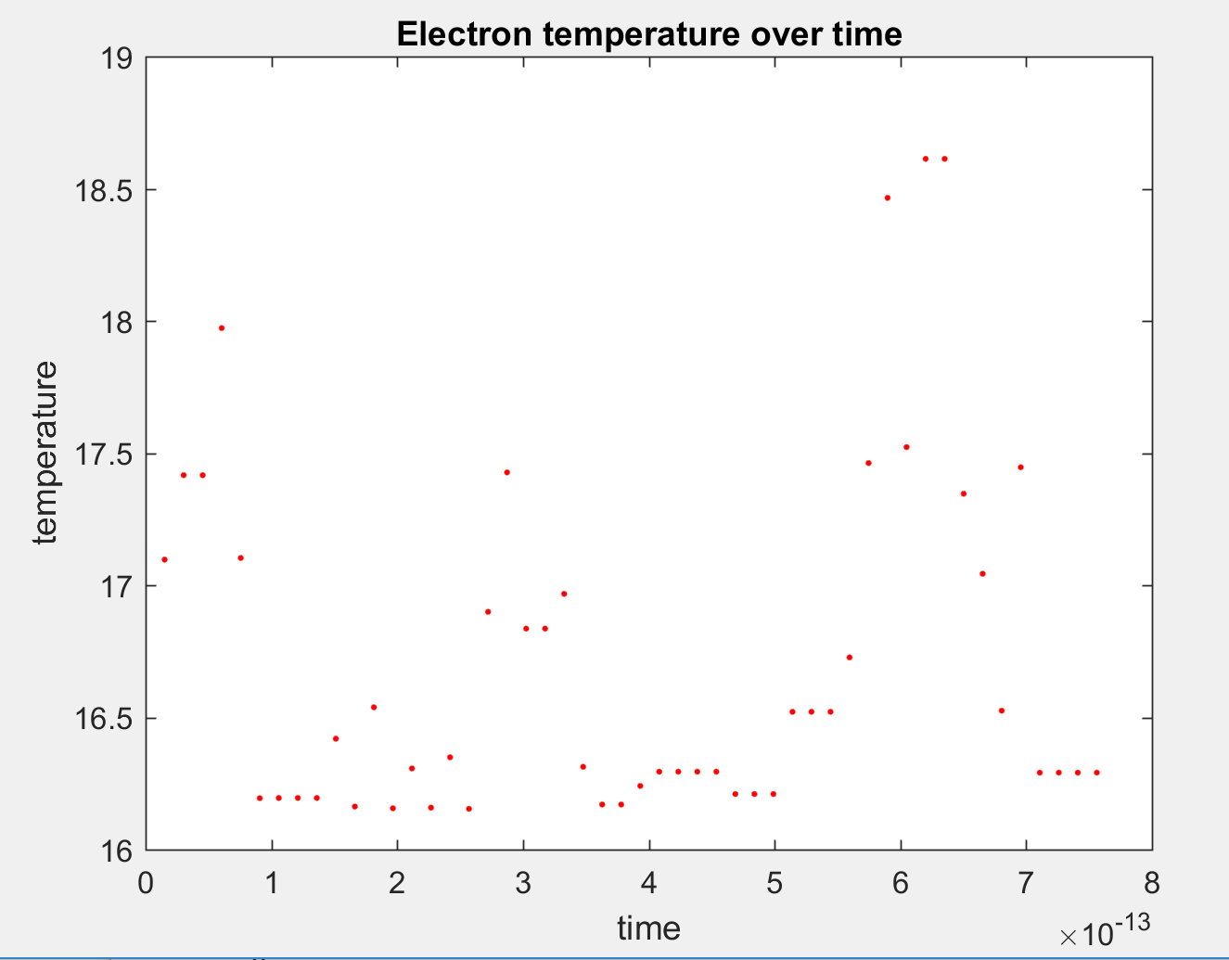

Figure : Temperature plot

# Collisions with Mean Free Path

MBfunc = @(c) 4*pi.*c^2*(Melectron/(2*pi*k*T))^(3/2)*exp(-Melectron.*c^2/(2*k*T))

1. Maxwell Boltzmann distribution:

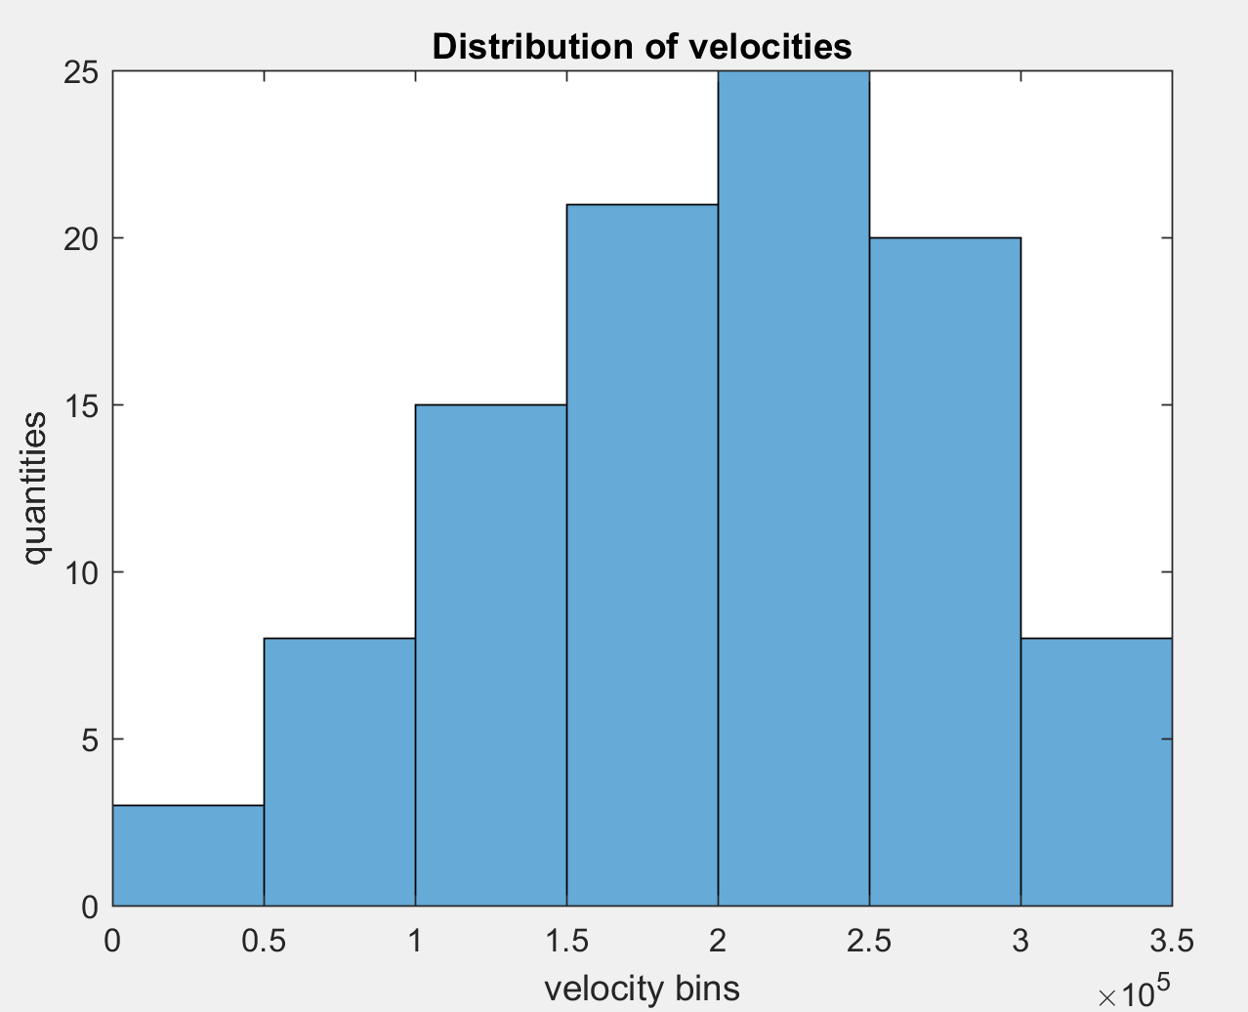

Figure : Histogram showing distribution of velocities

1. Scattering of particles with probability

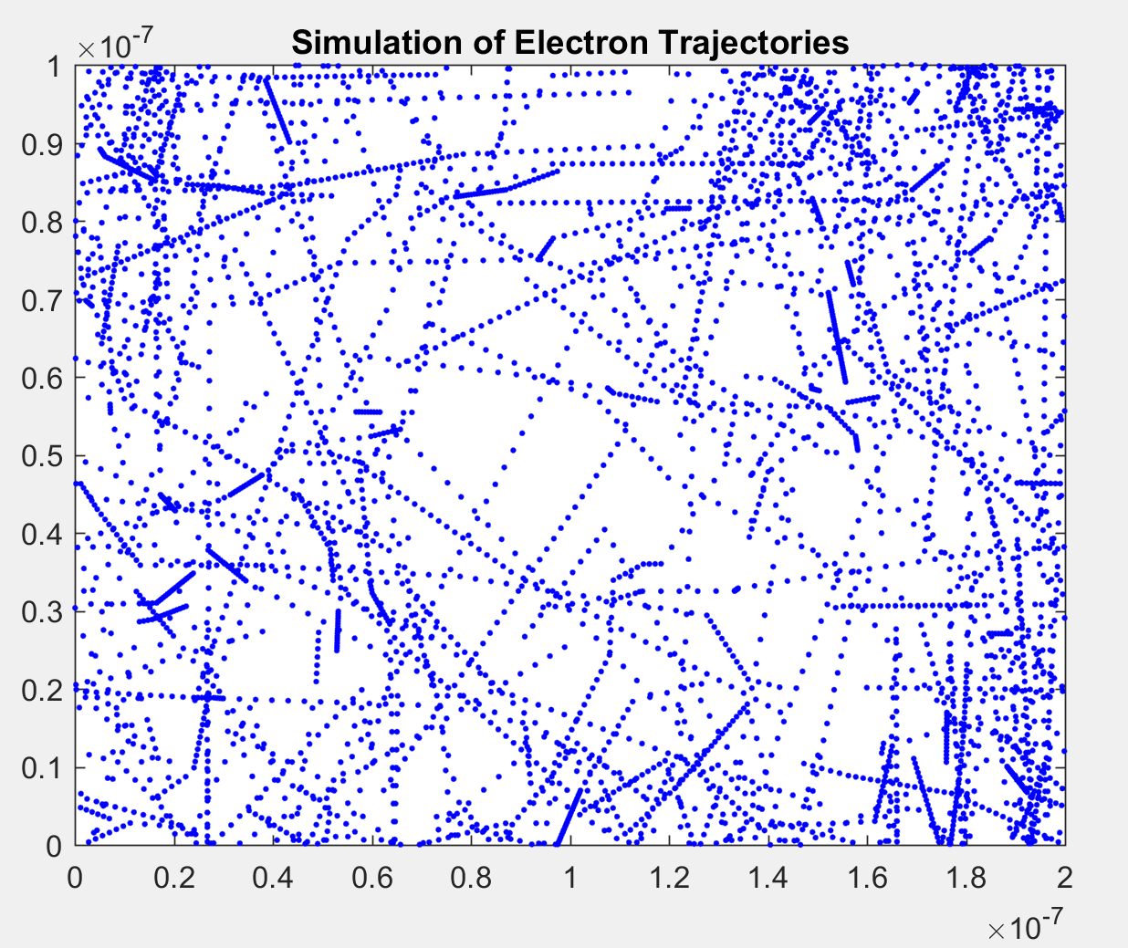

Figure : Scattering particles based on probability given above

1. Temperature change over time can be seen in the figure below

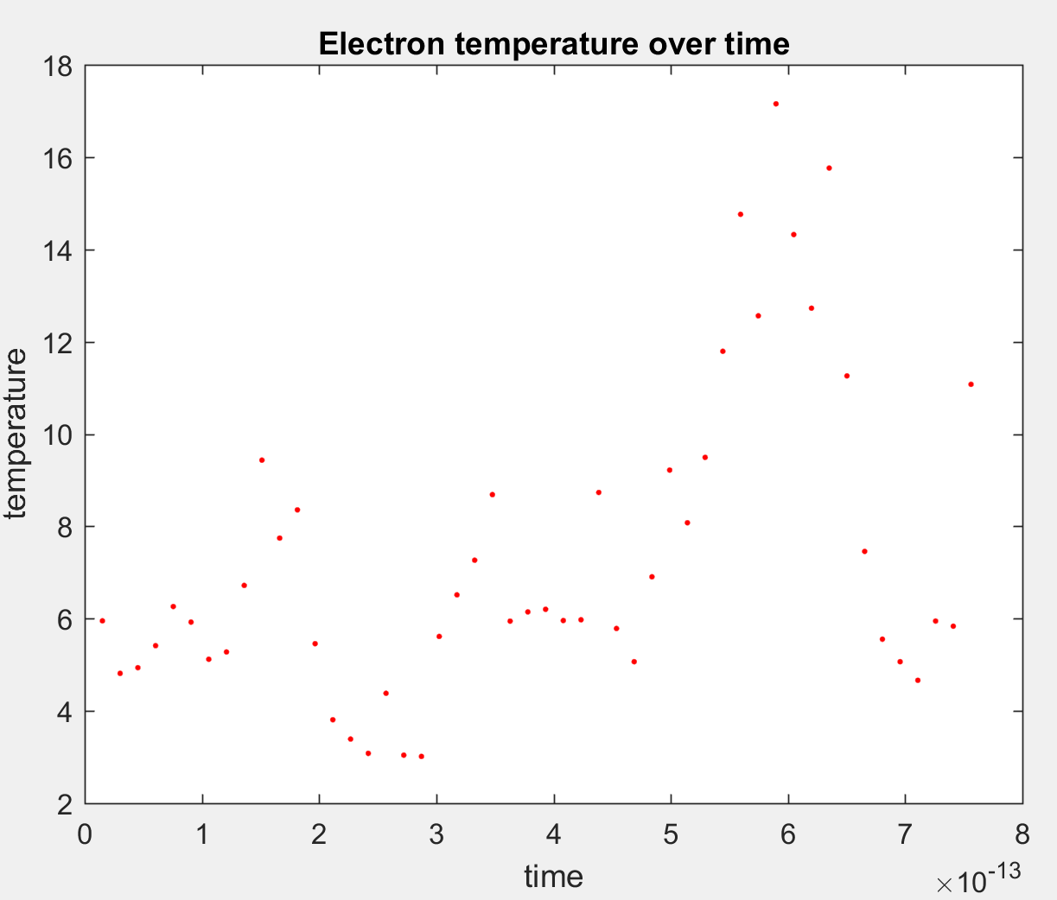

Figure : Temperature change over time of scattering particles

1. Measurement of the MFP

# Enhancement

1. Particle trajectories must move around the “boxes”. Partially successful since the particle still go through the sides of the boxes, however they are stopped with thermal diffusion on the inner sides of the bottle neck.

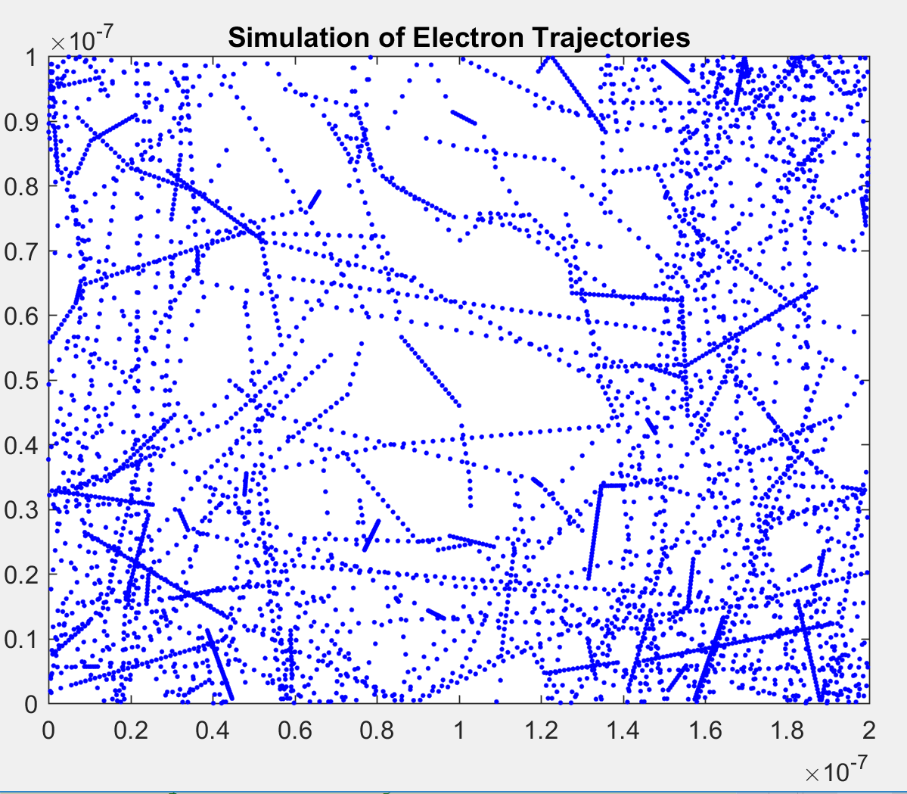

Figure : Rectangular bottleneck for the particles

3) Electron density map

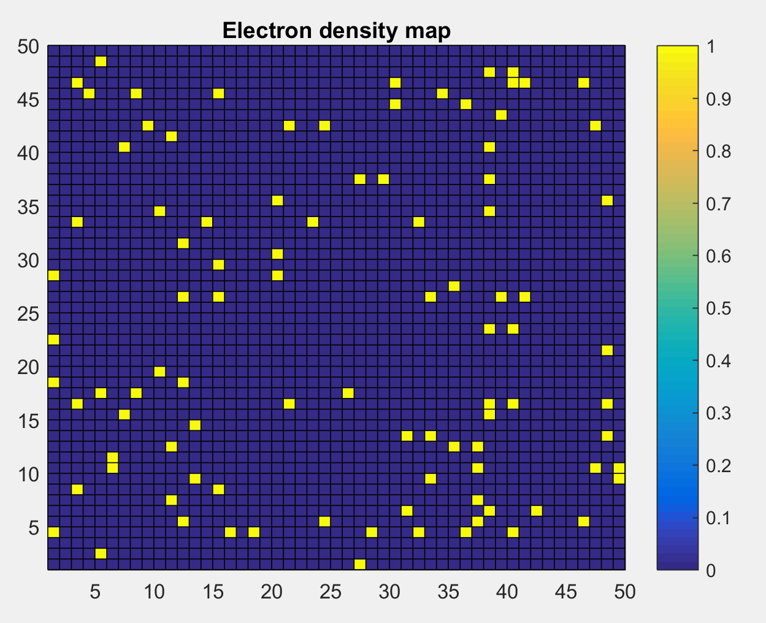

Figure : Electron density map

1. Temperature map

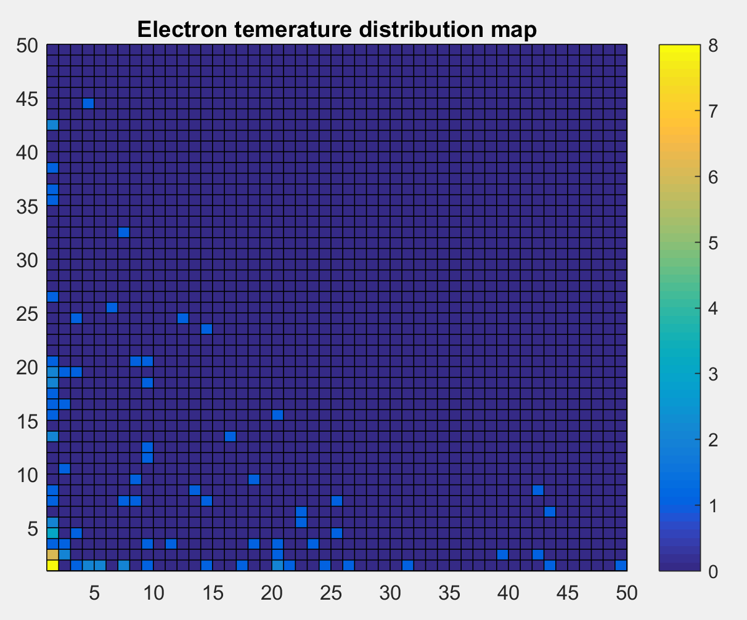

Figure : Temperature map displayed with colours

# References

[1] Wikipedia “Mean Free Path”, [Available: February 3 2018] Online: https://en.wikipedia.org/wiki/Mean_free_path