responsive, runs in every browser

container(div) – leave space in left and right side

display-1(text) – Make text larger

lead (p) – Make first para bigger

font-weight-bold

font-italic, font-lowercase, text-uppercase, text-capitalize

list-unstyled(ul)

list-inline-item(li) – display list item horizontally

text-justify(p), text-left, text-center, text-right

text-sm-right – small 576px

text-md-right – medium 768px

text-lg-right – Large 992px

text-xl-right – extra-large 1200px

Table:

Align-baseline, align-top, align-text-top

d-inline(text) – block level element leave blocking

d-block(text) – inline level element grasp block

d-inline-block(div) - block level element leave blocking

float-left, float-right, float-none (text) – Leave margin from all side

float-sm-left, float-lg-right, float-md-none (text)

clearfix – undo the changes after float right

sticky-top – stick to top while scrolling

fixed-top, fixed-bottom – fix item to top and bottom

text-primary – text color change to primary

bg-primary – background blue

info-light blue

success-green

warning-orange

danger-red

dark-grey

invisible – element gets invisible

m-5 – margin 5px

mb-0 – margin bottom 0px

mt-7 – margin top 7px

mr-2 – margin right 2px

mx-5 – margin left and right 5px

my-5 – margin top and bottom 5px

p-5 – padding 5px

pb-0 – padding bottom 0px

pt-7 – padding top 7px

pr-2 – padding right 2px

px-5 – padding left and right 5px

py-5 – padding top and bottom 5px

w-25 – width 25%

h-50 – height 50%

btn – element gets button shape

btn btn-primary – element gets button shape and color

btn btn-outline-primary – mouse hover: gets color otherwise blank

btn-lg – make buttons larger

btn-sm – make button smaller

btn-block – take full width

active – make elements highlight

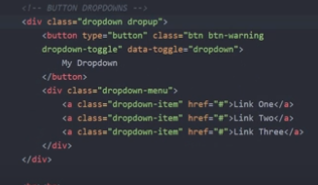

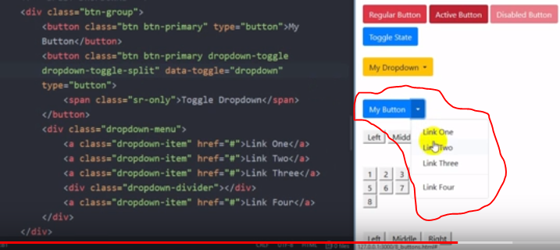

btn-group-vertical – make all the button vertical inside a div

navbar(nav) – send container on the right

navbar-light(nav) – make title dark

navbar-expand-sm(nav) – shows element in a vertical way up to small device

container(div)

navbar-brand(a) – Make the logo or link larger

navbar-nav(ul) – align container item in a horizontal way

nav-item(li)

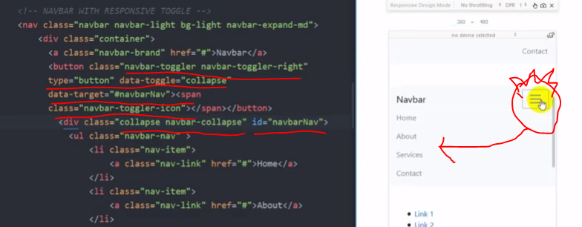

nav-link(a) – create margin in x axis

ml-auto – margin left auto, left side full margin

collapse navbar-collapse – hide the elements

form-control(input) – make input styled

form-inline(form) – to make elements in one line

mx-auto – margin left right auto, go to middle

justify-content-center – same as above

nav-pills(ul) – get a background to active item

flex-column(ul) – make list show in vertical way

nav-fill – width gets fill with item with same margin all side

list-group(ul) – leaves margin and padding

list-group-item(li) – gets a structure

list-group-item list-group-item-action (li, a under ul) – by hover it gets a background

list-group-item list-group-item-action list-group-item-primary (li, a under ul) – by hover it gets a background

badge badge-primary align-top (span) – creates badge

breadcrumb(ul/ol) – make list item in one line

breadcrumb-item (li) – gets a slash ‘/’ between every list

form-group(div) – gets margin all side

form-control(input) - gets a break and full width

form-text text-muted(text) – opacity reduced

readonly – attribute in input tag

disable – attribute in button tag

form-control is-valid(input) – show a message that is hidden below

valid-feedback(text) – if valid the hide the text

form-control is-invalid(input) – show a message that is hidden below

invalid-feedback(text) – if valid the hide the text

input-group(div) – reduce margin between elements

input-group-prepend (div under div) – to erase margin between addon and input

input-group-text – make text as addon

alert alert-success(div) – gets margin, success background

alert-link(a) – link designed

close(button) – send cross button to the right +

data-dismiss=” alert” (same button) – to hide onclick+

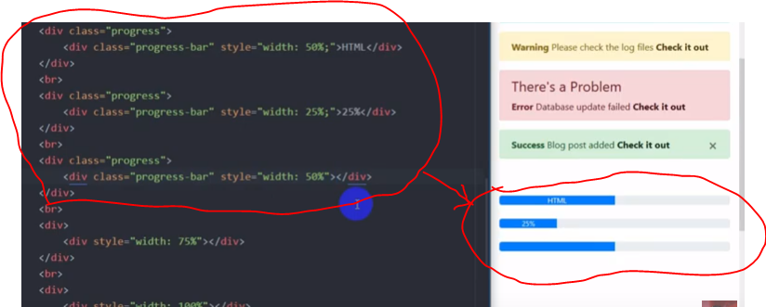alert-dismissable fade show(div) – to hide div

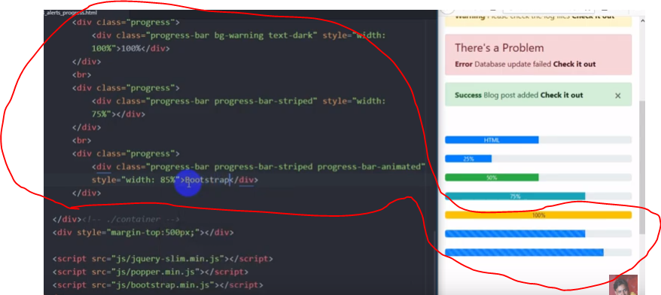

table

table(table) – gets styled shape

table table-dark (table, thead, tbody, tr, td) – gets bg color

table table-bordered, table - striped(table) – gets border and row gets highlighted

table table-hover(table) – on hover gets a bg

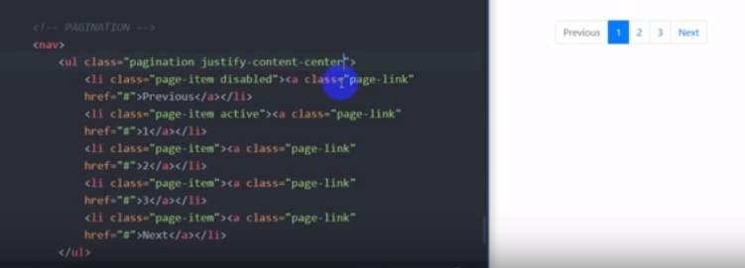

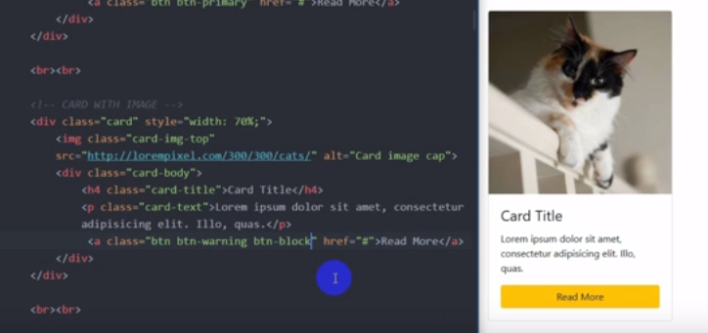Cards

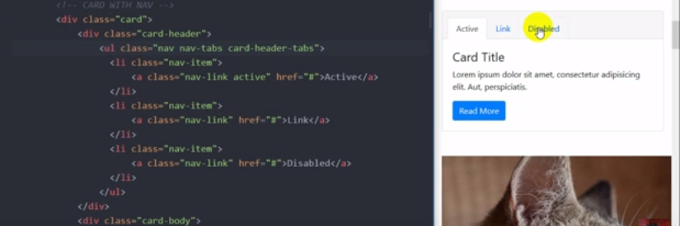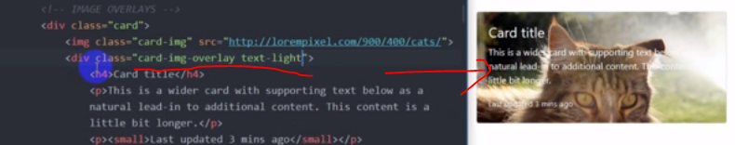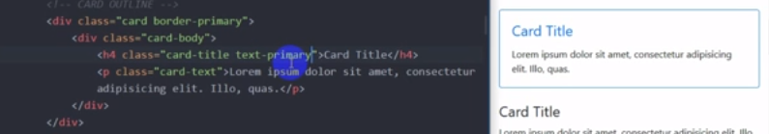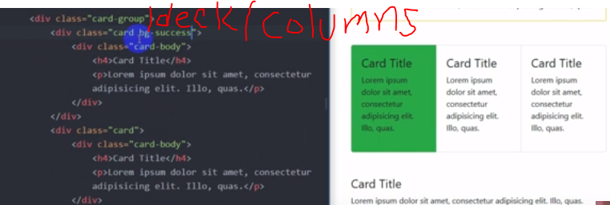

Media Object

Media(div) – make all elements in one line

d-flex(img) – pore janbo

media-body (body div) – gets styled

grid item

row(div) – first div

col-2-12(div) – under parent div

col-12 col-sm-3 col-md-4 col-lg-6(child div) – for different size of wind it gets diff type of col size

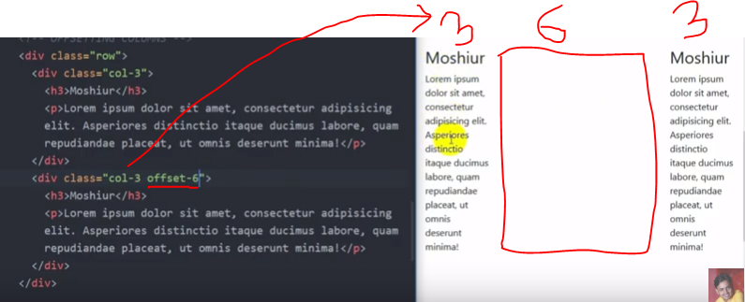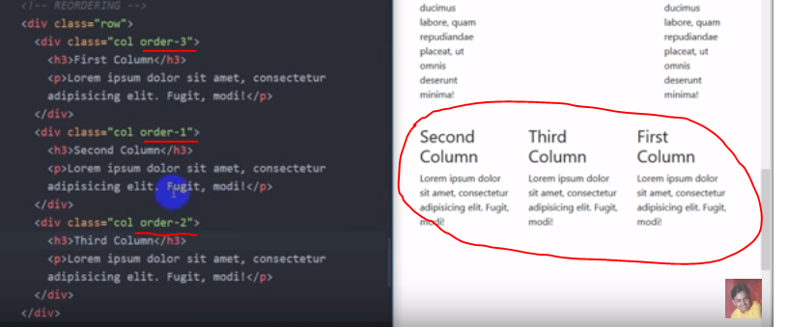

row align-items-start/center/end (parent div) – to get text alignment

align-self-start/center/end (child div) – to get column alignment

row justify-content-center (parent div) – to make all column in center

row justify-content-between (parent div) – to make col go both side and create space between them

row no-gutters (parent div) – to avoid unnecessary margin between column

Flexbox

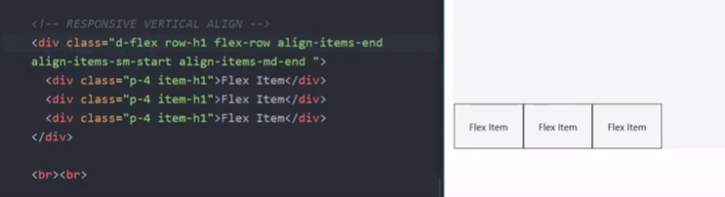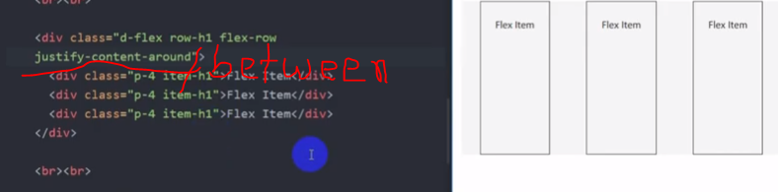

Carousel Slider

Img-fluid(img) – it wraps the container size

Go see html file