Private & Public

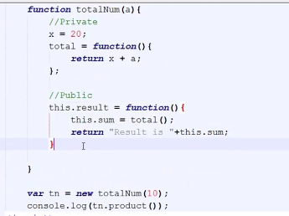

Static method

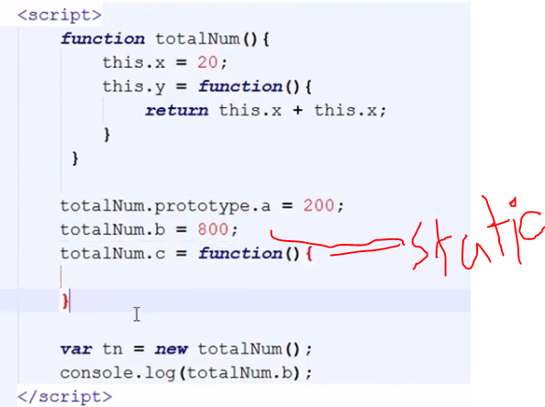

Date & Time

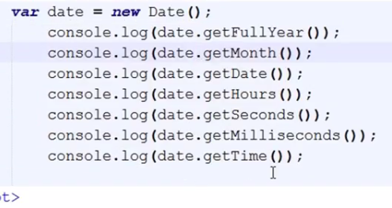

=

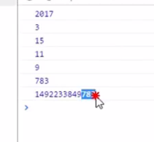

Reverse a string

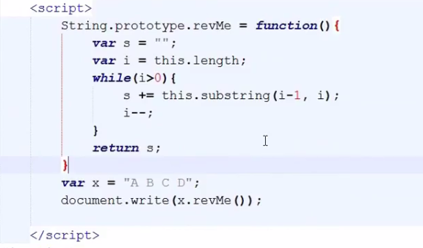

Timeout

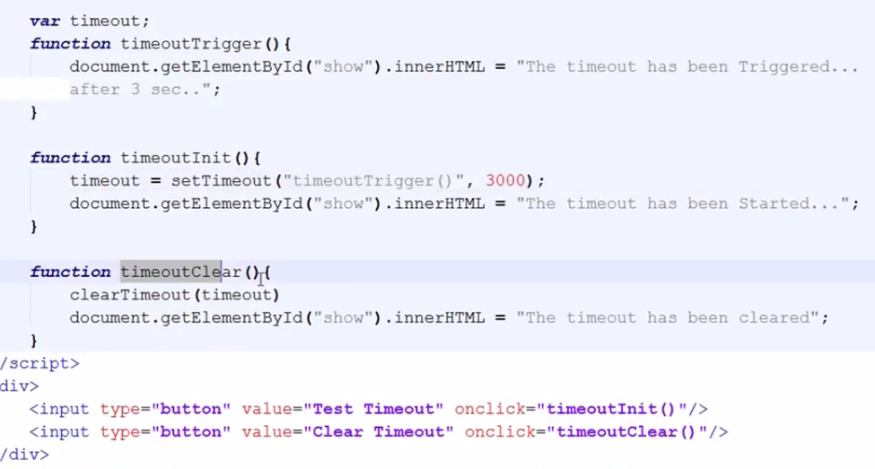

Countdown

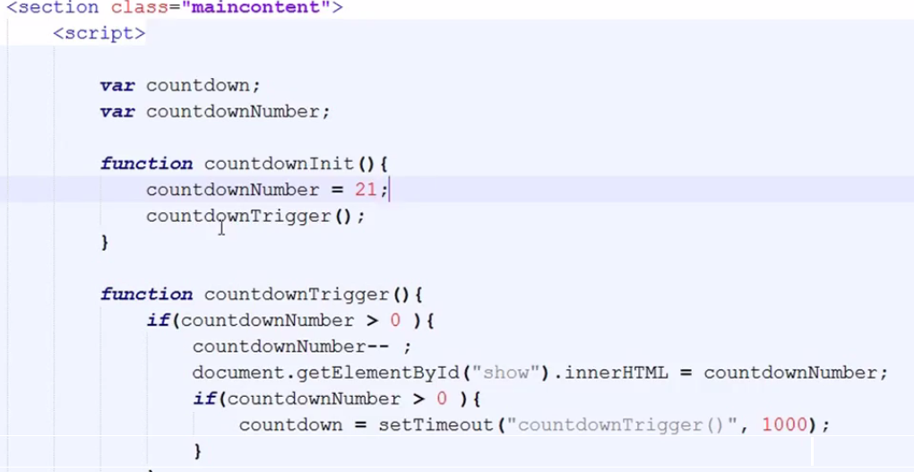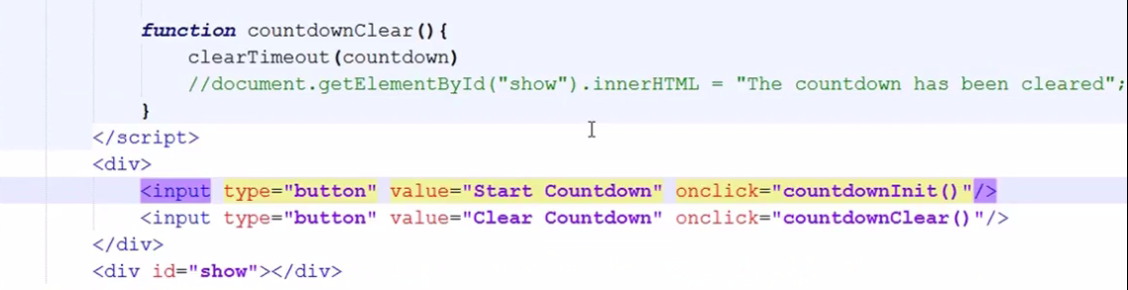

Interval

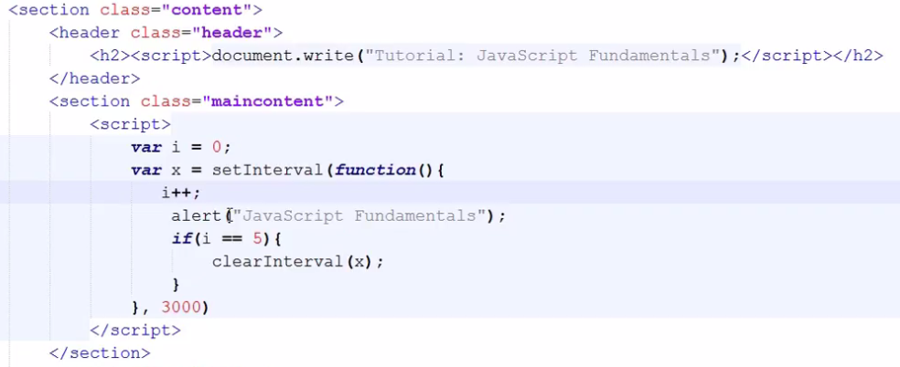

Clock

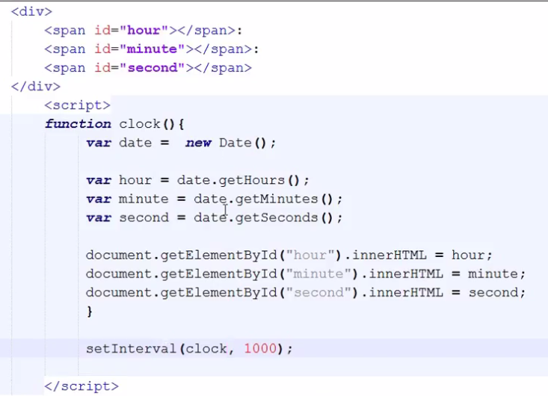

Fade in Out Image or anything

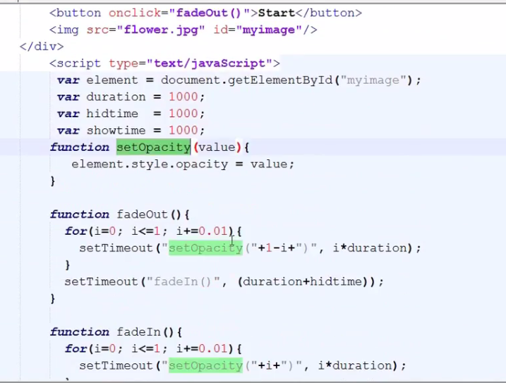

Find a value index in a string or list

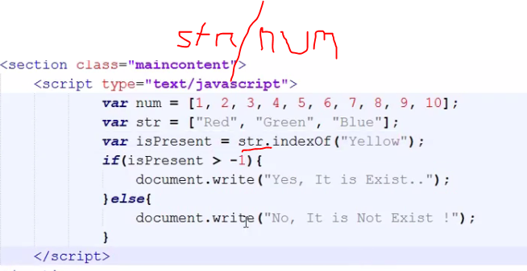

Pop-up Window

Alert(“Message”); doesn’t return anything

Confirm (“yes or no”); return true or false value

Prompt(“message”); return user input

== -> check only value not data type

=== -> check value along with data type

Hosting Variable & Function

Any variable will be called hosting variable if that variable was declared inside a function and under a condition. If we declare any variable under function js takes the variable in the beginning of that particular function.

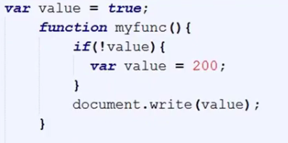

If we call a function and that function is embedded after “return false” then js take the function in the beginning of that particular function.

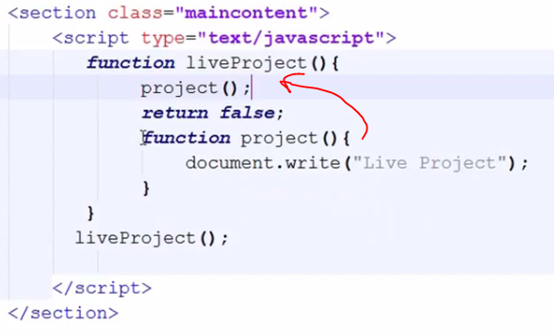

Truth and Equality

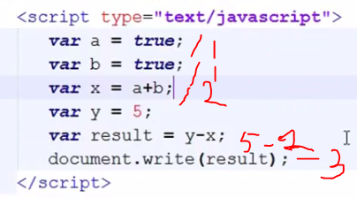

Instance

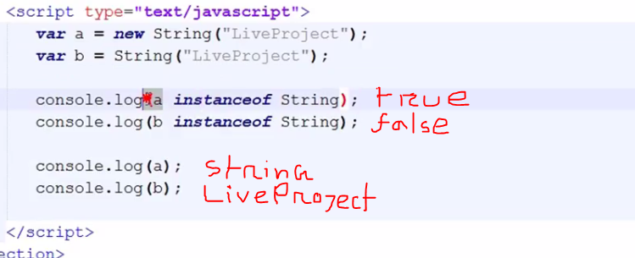

Recursion

