Database

* Abbreviation
* Unprocessed or Meaningless fact = DATA
* Processed or Meaningful fact = INFORMATION
* Grid of data = DATABASE
* Database = DB/db
* Field = Column
* Record = Row
* Database Management System = DBMS
* Structured Query Language = SQL
* Cross-Platform, Apache, MySQL, PHP, Perl = XAMPP

There are two types of db and they are:

1. General DB
2. Relational DB

**General DB:**

DB having one table or having multiple tables but no relations among themselves is called general db.

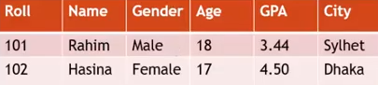

**Relational DB:**

DB having multiple tables and having relations among themselves is called relational db.

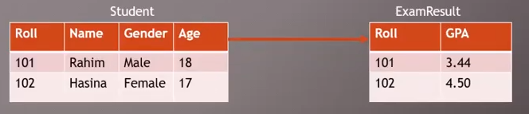

* Keys:

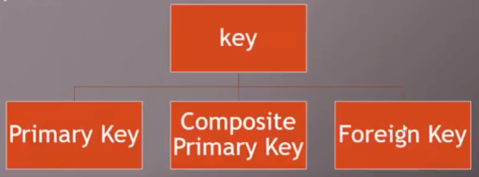

**Primary Key:**

Primary key is that column which has unique value(s).

**Composite Key:**

When you get confuse about selecting primary key then you can combine two column and they will be called as composite key.

**Foreign Key:**

If general column of one table is considered as primary key of another table then that general column will be called as Foreign key.

* Database Relation:

There are 3 types of db relation and they are:

1. One-to-One
2. One-to-Many
3. Many-to-Many

* Query:

The way of finding particular data from vast amount of data is called query.

* Query is not case-sensitive
* Ends with a semi-colon (;)
* SQL Statement:

1. **DML (Data Manipulation Language)**

* Create
* Read
* Update
* Delete

1. **DDL (Data Definition Language)**

* Create
* Alter
* Drop

1. **DCL (Data Control Language)**

* Grant (Access privilege to user)
* Revoke (Take back that accessibility)

1. **DTL (Data Transaction Language)**

* Commit (Change data and save permanently)
* Rollback (Ctrl+Z)
* Savepoint (To save data up to specific point)

**DBMS**

* A DBMS is a software that enables user to create and maintain database.

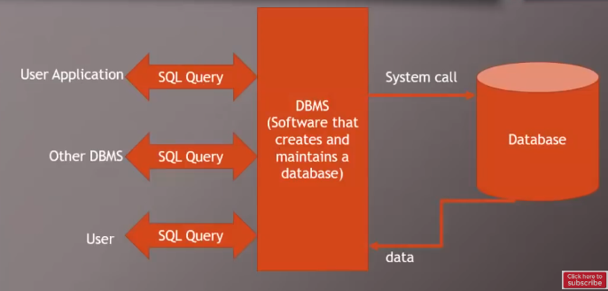

**Structure of Query Documentation:**

1. Query
2. Description
3. Example Image

* SHOW DATABASES;
* Shows all the databases in mySQL.
* CREATE DATABASE x;
* Creates db named ‘x’
* DROP DATABASE x;
* Deletes db named ‘x’
* CREATE TABLE x (

Column_name data_type (size),

Column_name data_type (size),

Column_name data_type (size),

…

Column_name data_type (size)

);

* Creates table named ‘x’ with column

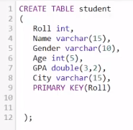

* RENAME TABLE old_name TO ­new_name;
* Rename the table
* DROP TABLE x;
* Deletes the table named ‘x’
* INSERT INTO table_name (column_name1, column_name2) VALUES (‘value1’, ‘value2’);
* Inserts values into table

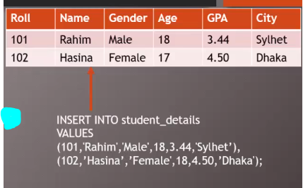

* SELECT column_name FROM table_name;
* Selects single column from a table
* SELECT column1, column2, column3 FROM table_name;
* Selects multiple columns from a table
* SELECT * FROM table_name;
* Selects all columns from a table
* SELECT DISTINCT column_name FROM table_name;
* Filters unique data from a column
* SELECT * FROM table_name LIMIT 5;
* Shows data up to 5 rows
* SELECT * FROM table_name LIMIT 2,5;
* Shows 5 rows skipping first 2 rows
* SELECT column_name FROM table_name ORDER BY column_name;
* Filters column value in ascending order (if character then it sorts alphabetically A-Z/a-z)
* SELECT column1, column2 FROM table_name ORDER BY column_name DESC;
* Filters column value in descending order (if character then it sorts alphabetically Z-A/z-a)
* SELECT column_name FROM table_name WHERE condition;
* Filters data according to conditions



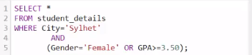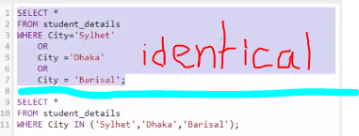

* SELECT * FROM table_name WHERE column_name LIKE ‘S%’;
* Filters data that starts with ‘S’
* SELECT * FROM table_name WHERE column_name LIKE ‘%S’;
* Filters data that ends with ‘S’
* SELECT * FROM table_name WHERE column_name LIKE ‘_S%’;
* Filters data that has second alphabet ‘S’
* 
* Customize or Rename column name while display
* 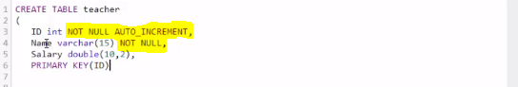
* We use NOT NULL where data must need and AUTO INCREENT to increase integer value by one automatically
* UPDATE table_name SET column1 = value1, column2 = value2… WHERE condition;
* Updates value.
* DELETE FROM table_name WHERE condition;
* Deletes row from table according to condition
* 
* 
* 
* 







$e^{x}$

* 
* Add column to a table
* ALTER TABLE table_name CHANGE old_name new_name data_type(size);
* Rename column name
* ALTER TABLE table_name DROP COLUMN column_name;
* Deletes column
* 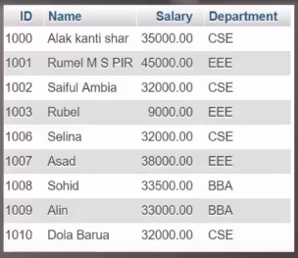
* 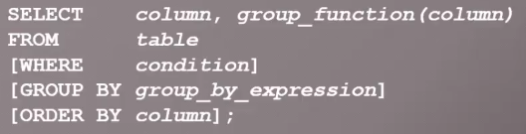
* Have to follow this order WHERE>GROUP BY>ORDER BY
* 
* 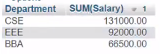
* TRUNCATE TABLE table_name;
* Deletes all records leaving field
* 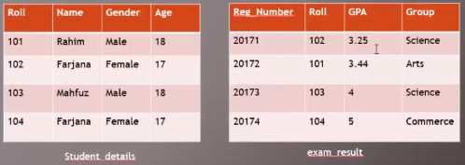
* 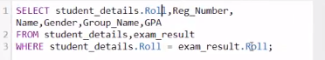
* 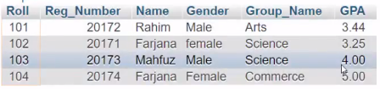

Identical of above example

* 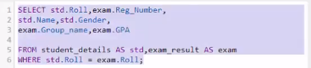

Identical of above example and uses of JOIN clause

* 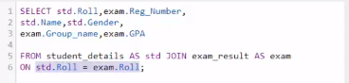
* 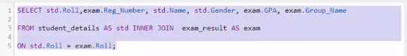
* Returns only those values only which matches the conditions
* 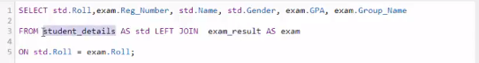
* Returns all value of left table and from right table it returns the values that matches the conditions
* 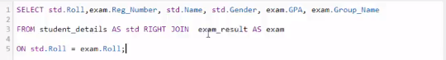
* Returns all value of right table and from left table it returns the values that matches the conditions
* 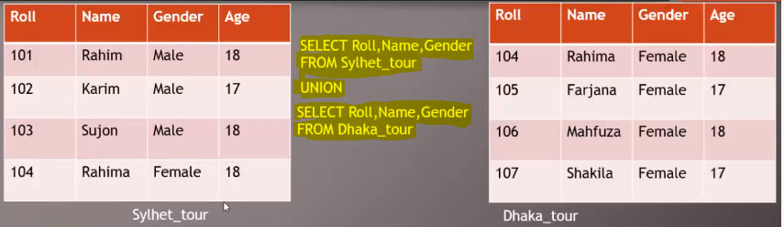
* Add value of two table leaving the common values
* 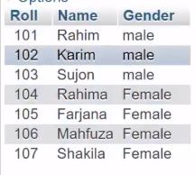
* 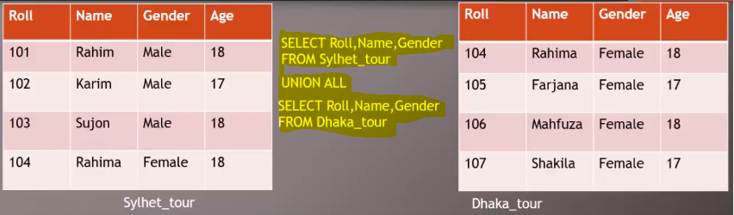
* Add values of two table
* 
 