Q1) Write a simple poem and represent it as a web page. Give a title for the poem.

Make rhyming words in the poem as bold.

<!DOCTYPE html>

<html lang="en">

<head>

<meta charset="UTF-8">

<meta name="viewport" content="width=device-width, initial-scale=1.0">

<title>fool's poem</title>

<style>

.container {

display: flex;

justify-content: center;

align-items: center;

height: 100vh;

text-align: center;

}

.centered-content {

width: 80%;

max-width: 800px;

padding: 20px;

background-color: #f0f0f0;

}

p {

text-align: center;

background-color: lightblue;

padding: 20px;

border-radius: 10px;

}

</style>

</head>

<body>

<center><h1>NURSERY HAIKKU</h1></center>

<p>

Humpty Dumpty sat on a wall, <br>

Humpty Dumpty had a great fall. <br>

All the king's horses and all the king's men <br>

Couldn't put Humpty together again.

</p>

</body>

</html>

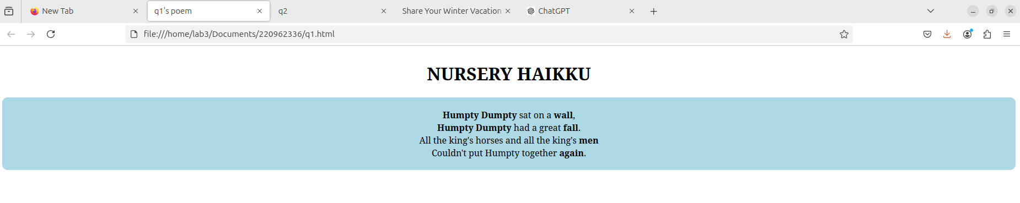

Q2) Assume you have brought a new car. Write down the list of additional

accessories you need for the car as an unordered list in HTML. Also, list the

travel plans on the car as an ordered list.

<!DOCTYPE html>

<html lang="en">

<head>

<meta charset="UTF-8">

<meta name="viewport" content="width=device-width, initial-scale=1.0">

<title>q2</title>

</head>

<body>

<ul>

<li>Floor Mats</li>

<li>Car Seat Covers</li>

<li>Sun Shades for Windows</li>

<li>Phone Mount</li>

<li>Car Air Freshener</li>

<li>Car Organizer</li>

<li>Dash Cam</li>

<li>Seat Belt Adjuster</li>

<li>Blind Spot Mirrors</li>

</ul>

<ol>

<li>Drive to the beach for a weekend getaway.</li>

<li>Visit a national park for a hiking trip.</li>

<li>Take a cross-country road trip to explore new cities.</li>

<li>Weekend visit to family or friends in another state.</li>

<li>Attend a music festival in a neighboring town.</li>

<li>Drive through the mountains to see the fall colors.</li>

<li>Plan a camping trip with the car for overnight stays.</li>

<li>Go on a long-distance drive to a historical town.</li>

<li>Participate in a car rally or road event.</li>

<li>Travel to a nearby vineyard for wine tasting and tours.</li>

</ol>

</body>

</html>

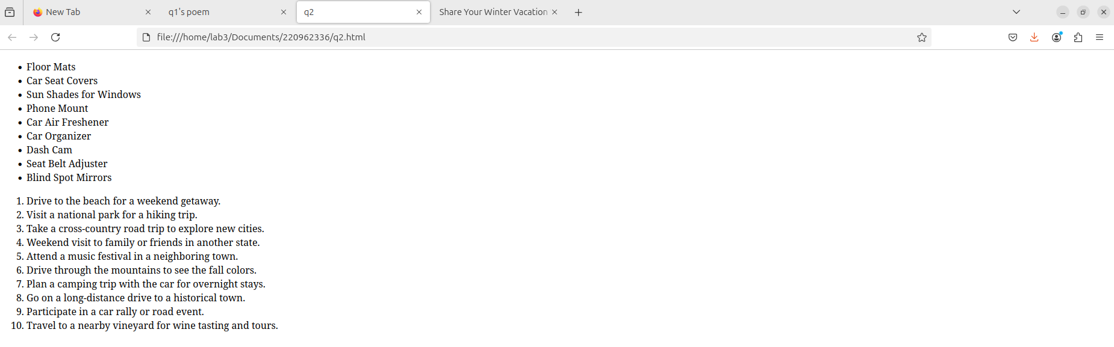

Q3) Complete the following website name “Share your Winter Vacation Videos”.

The required video files are located inside the compressed folder “Week 1

Assignment Files/Media/”.

<!DOCTYPE html>

<html lang="en">

<head>

<meta charset="UTF-8">

<meta name="viewport" content="width=device-width, initial-scale=1.0">

<title>Share Your Winter Vacation Videos</title>

</head>

<body>

<header>

<h1>Share Your Winter Vacation Videos</h1>

<p>Upload or view videos of your winter vacation memories!</p>

</header>

<section style="text-align: center;">

<h2>Winter Vacation Videos</h2>

<figure style="display: inline-block; margin: 10px; width : 30%">

<video width ="100%" controls>

<source src="video1.mp4" type="video/mp4">

Your browser does not support the video tag.

</video>

<p>Winter Vacation in the Mountains</p>

</figure>

<figure style="display: inline-block; margin: 10px; width : 30%">

<video width ="100%" controls>

<source src="video2.mp4" type="video/mp4">

Your browser does not support the video tag.

</video>

<p>Winter Road Trip Adventure</p>

</figure>

<figure style="display: inline-block; margin: 10px; width : 30%">

<video width ="100%" controls>

<source src="video3.mp4" type="video/mp4">

Your browser does not support the video tag.

</video>

<p>Winter view</p>

</figure>

</section>

</body>

</html>

