1) Design the student bio-data form using button, label, textbox, radio button, table and

checkbox using CSS.

Code:

<!DOCTYPE html>

<html lang="en">

<head>

<meta charset="UTF-8">

<meta name="viewport" content="width=device-width, initial-scale=1.0">

<title>Student Bio-Data Form</title>

<style>

body {

font-family: Arial, sans-serif;

margin: 0;

padding: 0;

background-color: #f4f4f9;

display: flex;

justify-content: center;

align-items: center;

height: 100vh;

}

.form-container {

background-color: white;

padding: 20px;

border-radius: 8px;

box-shadow: 0 0 10px rgba(0, 0, 0, 0.1);

width: 50%;

}

h2 {

text-align: center;

margin-bottom: 20px;

}

table {

width: 100%;

margin-bottom: 20px;

border-collapse: collapse;

}

td, th {

padding: 10px;

text-align: left;

border: 1px solid #ddd;

}

input[type="text"], input[type="email"], input[type="tel"], textarea {

width: 100%;

padding: 8px;

margin: 8px 0;

border: 1px solid #ddd;

border-radius: 4px;

}

input[type="radio"], input[type="checkbox"] {

margin-right: 8px;

}

label {

font-size: 16px;

margin-bottom: 8px;

display: block;

}

.form-group {

margin-bottom: 15px;

}

.button-group {

text-align: center;

}

input[type="submit"], input[type="reset"] {

background-color: #4CAF50;

color: white;

padding: 10px 20px;

border: none;

border-radius: 4px;

cursor: pointer;

margin: 10px;

}

input[type="submit"]:hover, input[type="reset"]:hover {

background-color: #45a049;

}

.checkbox-group {

display: flex;

flex-wrap: wrap;

}

.checkbox-group label {

width: 45%;

margin-right: 20px;

}

textarea {

height: 100px;

}

</style>

</head>

<body>

<div class="form-container">

<h2>Student Bio-Data Form</h2>

<form action="#" method="post">

<!-- Student Details Table -->

<table>

<tr>

<th colspan="2">Personal Information</th>

</tr>

<tr>

<td><label for="name">Full Name:</label></td>

<td><input type="text" id="name" name="name" required></td>

</tr>

<tr>

<td><label for="email">Email:</label></td>

<td><input type="email" id="email" name="email" required></td>

</tr>

<tr>

<td><label for="phone">Phone Number:</label></td>

<td><input type="tel" id="phone" name="phone" required></td>

</tr>

<tr>

<td><label for="address">Address:</label></td>

<td><textarea id="address" name="address" required></textarea></td>

</tr>

<tr>

<td><label>Gender:</label></td>

<td>

<label for="male">

<input type="radio" id="male" name="gender" value="Male"> Male

</label>

<label for="female">

<input type="radio" id="female" name="gender" value="Female"> Female

</label>

</td>

</tr>

<tr>

<td><label>Hobbies:</label></td>

<td class="checkbox-group">

<label><input type="checkbox" name="hobbies" value="Reading"> Reading</label>

<label><input type="checkbox" name="hobbies" value="Sports"> Sports</label>

<label><input type="checkbox" name="hobbies" value="Music"> Music</label>

<label><input type="checkbox" name="hobbies" value="Traveling"> Traveling</label>

<label><input type="checkbox" name="hobbies" value="Coding"> Coding</label>

</td>

</tr>

</table>

<!-- Submit and Reset Buttons -->

<div class="button-group">

<input type="submit" value="Submit">

<input type="reset" value="Reset">

</div>

</form>

</div>

</body>

</html>

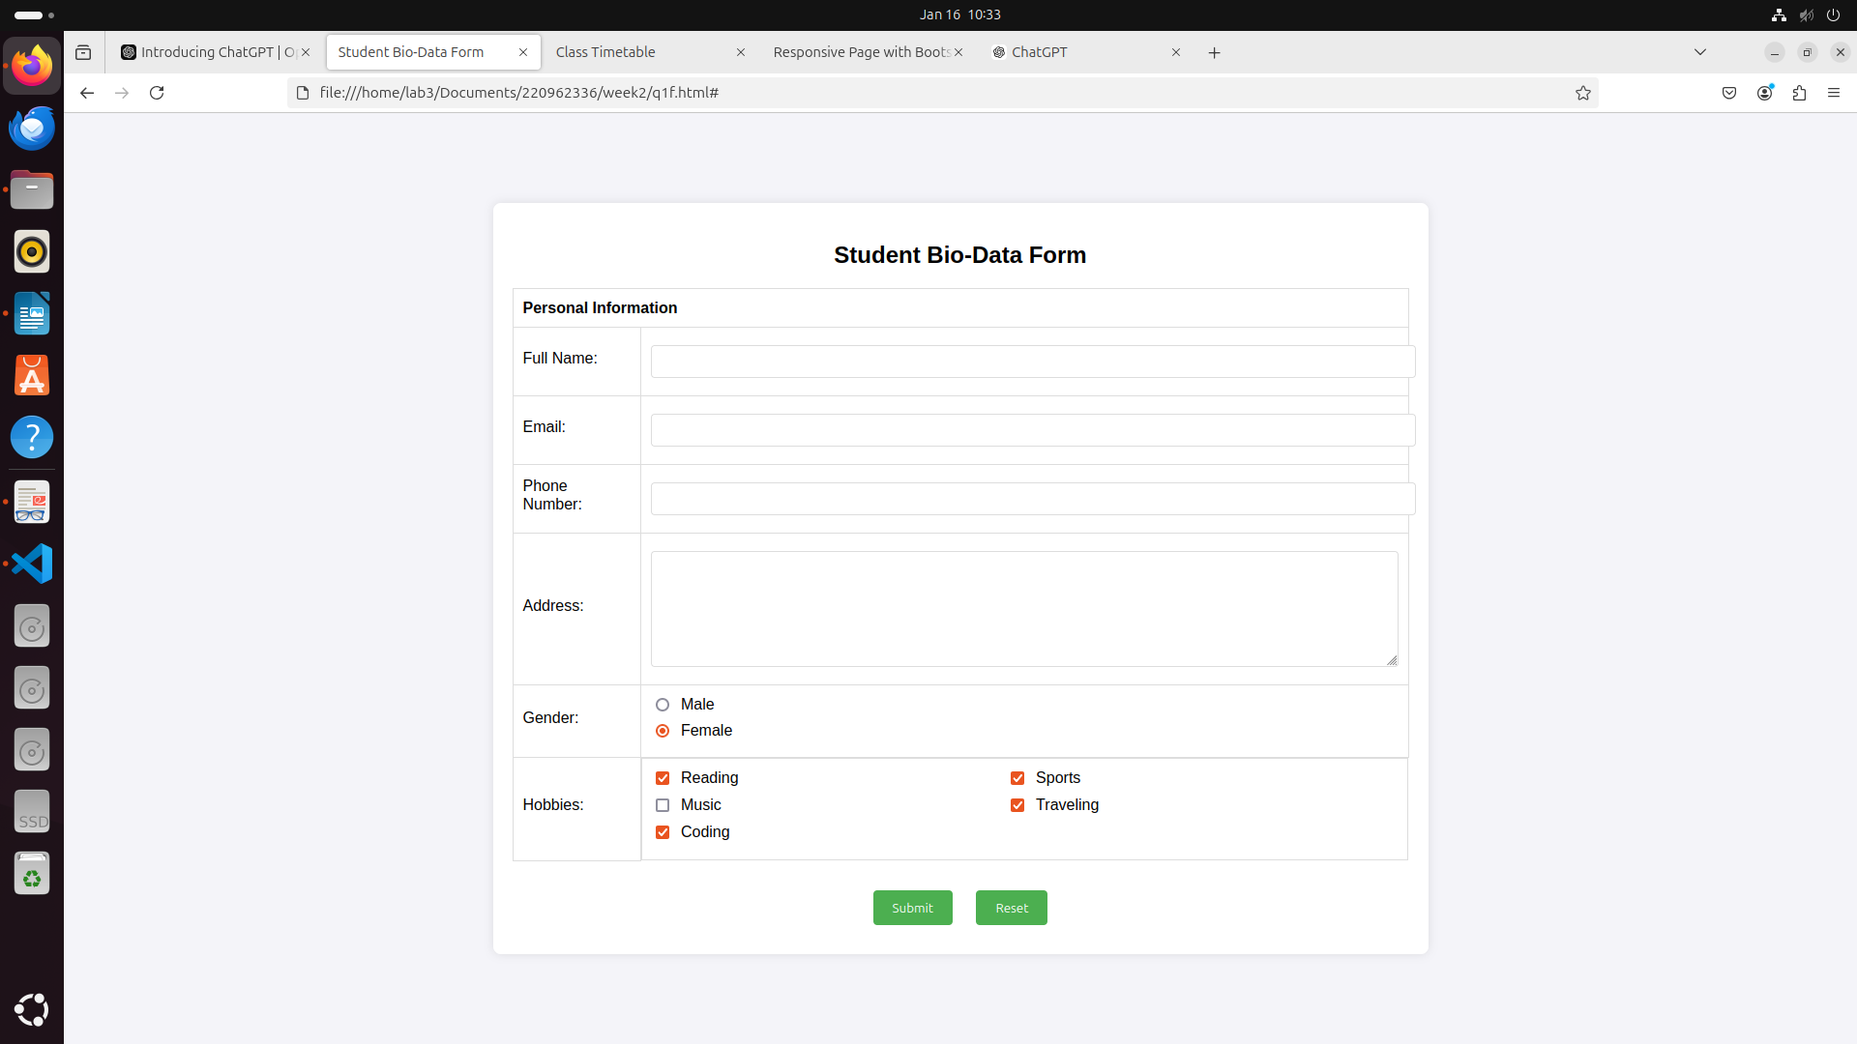

3) Create a web page using bootstrap as mentioned. Divide the page in to 2 parts top and

bottom, then divide the bottom into 3 parts and design each top and bottom part using

different input groups, input, badges, buttons and button groups. Make the design more

attractive using bootstrap.

Code:

<!DOCTYPE html>

<html lang="en">

<head>

<meta charset="UTF-8">

<meta name="viewport" content="width=device-width, initial-scale=1.0">

<title>Responsive Page with Bootstrap</title>

<!-- Bootstrap CSS -->

<link href="https://stackpath.bootstrapcdn.com/bootstrap/4.5.2/css/bootstrap.min.css" rel="stylesheet">

<style>

body {

padding-top: 20px;

}

.section {

padding: 20px;

margin-bottom: 20px;

border: 1px solid #ddd;

border-radius: 10px;

}

.top-section {

background-color: #f8f9fa;

}

.bottom-section {

background-color: #e9ecef;

}

.bottom-part {

margin-top: 20px;

}

</style>

</head>

<body>

<!-- Top Section -->

<div class="container top-section">

<div class="row">

<div class="col-md-12">

<div class="section text-center">

<h2>Top Section</h2>

<p>Welcome to the top section of the page.</p>

<!-- Input Group Example -->

<div class="input-group mb-3">

<div class="input-group-prepend">

<span class="input-group-text" id="basic-addon1">@</span>

</div>

<input type="text" class="form-control" placeholder="Username" aria-label="Username" aria-describedby="basic-addon1">

</div>

<!-- Badge Example -->

<div>

<span class="badge badge-primary">New Feature</span>

</div>

<!-- Button Example -->

<div class="mt-3">

<button class="btn btn-success">Get Started</button>

</div>

</div>

</div>

</div>

</div>

<!-- Bottom Section -->

<div class="container bottom-section">

<div class="row">

<div class="col-md-4 bottom-part">

<div class="section">

<h4>Left Part</h4>

<!-- Input Group with Button -->

<div class="input-group">

<input type="text" class="form-control" placeholder="Search..." aria-label="Search">

<div class="input-group-append">

<button class="btn btn-primary" type="button">Search</button>

</div>

</div>

</div>

</div>

<div class="col-md-4 bottom-part">

<div class="section">

<h4>Center Part</h4>

<!-- Button Group -->

<div class="btn-group" role="group" aria-label="Basic example">

<button type="button" class="btn btn-info">Option 1</button>

<button type="button" class="btn btn-info">Option 2</button>

<button type="button" class="btn btn-info">Option 3</button>

</div>

<!-- Badge Example in Bottom -->

<div class="mt-3">

<span class="badge badge-secondary">Important</span>

</div>

</div>

</div>

<div class="col-md-4 bottom-part">

<div class="section">

<h4>Right Part</h4>

<!-- Input Example -->

<input type="text" class="form-control mb-3" placeholder="Your email">

<!-- Button Example -->

<button class="btn btn-warning">Submit</button>

</div>

</div>

</div>

</div>

<!-- Bootstrap JS and Dependencies -->

<script src="https://code.jquery.com/jquery-3.5.1.slim.min.js"></script>

<script src="https://cdn.jsdelivr.net/npm/@popperjs/core@2.5.3/dist/umd/popper.min.js"></script>

<script src="https://stackpath.bootstrapcdn.com/bootstrap/4.5.2/js/bootstrap.min.js"></script>

</body>

</html>

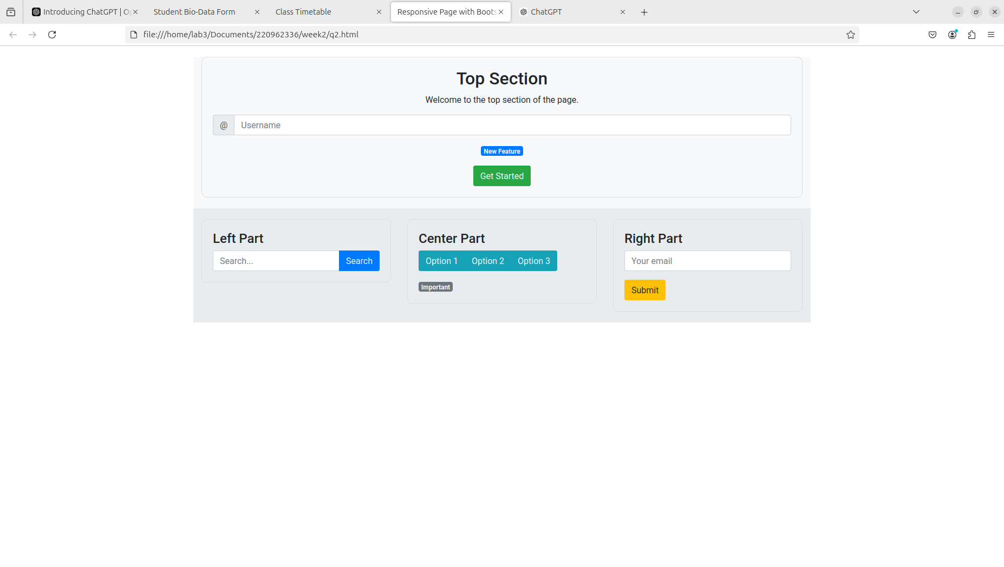

4. Design your class timetable using bootstrap table and carousel.

Code:

<!DOCTYPE html>

<html lang="en">

<head>

<meta charset="UTF-8">

<meta name="viewport" content="width=device-width, initial-scale=1.0">

<title>Class Timetable</title>

<!-- Bootstrap CSS -->

<link href="https://stackpath.bootstrapcdn.com/bootstrap/4.5.2/css/bootstrap.min.css" rel="stylesheet">

<style>

body {

background-color: #f4f4f9;

font-family: Arial, sans-serif;

padding-top: 50px;

}

.container {

margin-top: 30px;

}

.carousel-item {

padding: 20px;

background-color: #ffffff;

box-shadow: 0 4px 8px rgba(0, 0, 0, 0.1);

border-radius: 8px;

}

.table th, .table td {

text-align: center;

}

.table {

background-color: #ffffff;

box-shadow: 0 4px 8px rgba(0, 0, 0, 0.1);

border-radius: 8px;

}

.week-header {

background-color: #007bff;

color: white;

font-size: 20px;

font-weight: bold;

}

.carousel-control-prev, .carousel-control-next {

filter: invert(100%);

}

.carousel-indicators li {

background-color: #007bff;

}

.carousel-indicators .active {

background-color: #0056b3;

}

</style>

</head>

<body>

<div class="container">

<h2 class="text-center">Class Timetable</h2>

<!-- Carousel for switching between weeks -->

<div id="timetableCarousel" class="carousel slide" data-ride="carousel">

<ol class="carousel-indicators">

<li data-target="#timetableCarousel" data-slide-to="0" class="active"></li>

<li data-target="#timetableCarousel" data-slide-to="1"></li>

<li data-target="#timetableCarousel" data-slide-to="2"></li>

</ol>

<div class="carousel-inner">

<!-- Week 1 -->

<div class="carousel-item active">

<h3 class="text-center week-header">Week 1</h3>

<table class="table">

<thead>

<tr>

<th>Time</th>

<th>Monday</th>

<th>Tuesday</th>

<th>Wednesday</th>

<th>Thursday</th>

<th>Friday</th>

</tr>

</thead>

<tbody>

<tr>

<td>9:00 AM - 10:00 AM</td>

<td>Math</td>

<td>English</td>

<td>History</td>

<td>Science</td>

<td>PE</td>

</tr>

<tr>

<td>10:30 AM - 11:30 AM</td>

<td>Physics</td>

<td>Geography</td>

<td>Chemistry</td>

<td>Biology</td>

<td>Math</td>

</tr>

<tr>

<td>12:00 PM - 1:00 PM</td>

<td>History</td>

<td>Music</td>

<td>English</td>

<td>Art</td>

<td>PE</td>

</tr>

</tbody>

</table>

</div>

<!-- Week 2 -->

<div class="carousel-item">

<h3 class="text-center week-header">Week 2</h3>

<table class="table">

<thead>

<tr>

<th>Time</th>

<th>Monday</th>

<th>Thursday</th>

<th>Friday</th>

</tr>

</thead>

<tbody>

<tr>

<td>9:00 AM - 10:00 AM</td>

<td>Math</td>

<td>Science</td>

<td>History</td>

<td>Music</td>

<td>PE</td>

</tr>

<tr>

<td>10:30 AM - 11:30 AM</td>

<td>Geography</td>

<td>Physics</td>

<td>Math</td>

<td>Biology</td>

<td>English</td>

</tr>

<tr>

<td>12:00 PM - 1:00 PM</td>

<td>Art</td>

<td>English</td>

<td>PE</td>

<td>Chemistry</td>

<td>History</td>

</tr>

</tbody>

</table>

</div>

<!-- Week 3 -->

<div class="carousel-item">

<h3 class="text-center week-header">Week 3</h3>

<table class="table">

<thead>

<tr>

<th>Time</th>

<th>Monday</th>

<th>Tuesday</th>

<th>Wednesday</th>

<th>Thursday</th>

<th>Friday</th>

</tr>

</thead>

<tbody>

<tr>

<td>9:00 AM - 10:00 AM</td>

<td>Math</td>

<td>English</td>

<td>Physics</td>

<td>Art</td>

<td>PE</td>

</tr>

<tr>

<td>10:30 AM - 11:30 AM</td>

<td>Geography</td>

<td>History</td>

<td>Math</td>

<td>Chemistry</td>

<td>Science</td>

</tr>

<tr>

<td>12:00 PM - 1:00 PM</td>

<td>Music</td>

<td>Biology</td>

<td>English</td>

<td>History</td>

<td>PE</td>

</tr>

</tbody>

</table>

</div>

</div>

<!-- Carousel Controls -->

<a class="carousel-control-prev" href="#timetableCarousel" role="button" data-slide="prev">

<span class="carousel-control-prev-icon" aria-hidden="true"></span>

<span class="sr-only">Previous</span>

</a>

<a class="carousel-control-next" href="#timetableCarousel" role="button" data-slide="next">

<span class="carousel-control-next-icon" aria-hidden="true"></span>

<span class="sr-only">Next</span>

</a>

</div>

</div>

<!-- Bootstrap JS, Popper.js, and jQuery -->

<script src="https://code.jquery.com/jquery-3.5.1.slim.min.js"></script>

<script src="https://cdn.jsdelivr.net/npm/@popperjs/core@2.5.4/dist/umd/popper.min.js"></script>

<script src="https://stackpath.bootstrapcdn.com/bootstrap/4.5.2/js/bootstrap.min.js"></script>

</body>

</html><th>Tuesday</th>

<th>Wednesday</th>

<th>Thursday</th>

<th>Friday</th>

</tr>

</thead>

<tbody>

<tr>

<td>9:00 AM - 10:00 AM</td>

<td>Math</td>

<td>Science</td>

<td>History</td>

<td>Music</td>

<td>PE</td>

</tr>

<tr>

<td>10:30 AM - 11:30 AM</td>

<td>Geography</td>

<td>Physics</td>

<td>Math</td>

<td>Biology</td>

<td>English</td>

</tr>

<tr>

<td>12:00 PM - 1:00 PM</td>

<td>Art</td>

<td>English</td>

<td>PE</td>

<td>Chemistry</td>

<td>History</td>

</tr>

</tbody>

</table>

</div>

<!-- Week 3 -->

<div class="carousel-item">

<h3 class="text-center week-header">Week 3</h3>

<table class="table">

<thead>

<tr>

<th>Time</th>

<th>Monday</th>

<th>Tuesday</th>

<th>Wednesday</th>

<th>Thursday</th>

<th>Friday</th>

</tr>

</thead>

<tbody>

<tr>

<td>9:00 AM - 10:00 AM</td>

<td>Math</td>

<td>English</td>

<td>Physics</td>

<td>Art</td>

<td>PE</td>

</tr>

<tr>

<td>10:30 AM - 11:30 AM</td>

<td>Geography</td>

<td>History</td>

<td>Math</td>

<td>Chemistry</td>

<td>Science</td>

</tr>

<tr>

<td>12:00 PM - 1:00 PM</td>

<td>Music</td>

<td>Biology</td>

<td>English</td>

<td>History</td>

<td>PE</td>

</tr>

</tbody>

</table>

</div>

</div>

<!-- Carousel Controls -->

<a class="carousel-control-prev" href="#timetableCarousel" role="button" data-slide="prev">

<span class="carousel-control-prev-icon" aria-hidden="true"></span>

<span class="sr-only">Previous</span>

</a>

<a class="carousel-control-next" href="#timetableCarousel" role="button" data-slide="next">

<span class="carousel-control-next-icon" aria-hidden="true"></span>

<span class="sr-only">Next</span>

</a>

</div>

</div>

<!-- Bootstrap JS, Popper.js, and jQuery -->

<script src="https://code.jquery.com/jquery-3.5.1.slim.min.js"></script>

<script src="https://cdn.jsdelivr.net/npm/@popperjs/core@2.5.4/dist/umd/popper.min.js"></script>

<script src="https://stackpath.bootstrapcdn.com/bootstrap/4.5.2/js/bootstrap.min.js"></script>

</body>

</html>

