1)

<!DOCTYPE html>

<html lang="en">

<head>

<meta charset="UTF-8">

<meta name="viewport" content="width=device-width, initial-scale=1.0">

<title>Online Quiz</title>

<style>

body {

font-family: Arial, sans-serif;

background-color: #f4f4f9;

display: flex;

justify-content: center;

align-items: center;

height: 100vh;

margin: 0;

}

#quiz-container {

background-color: white;

padding: 20px;

border-radius: 10px;

box-shadow: 0 0 15px rgba(0, 0, 0, 0.1);

width: 300px;

}

button {

background-color: #4CAF50;

color: white;

border: none;

padding: 10px 20px;

cursor: pointer;

border-radius: 5px;

margin-top: 15px;

}

button:hover {

background-color: #45a049;

opacity: 0.8;

}

button:active {

background-color: #45a049;

opacity: 0.2;

}

#options {

margin-top: 15px;

}

#options button {

display: block;

margin: 5px 0;

width: 100%;

text-align: left;

}

h3 {

margin-top: 20px;

}

.feedback {

margin-top: 10px;

font-weight: bold;

padding: 5px;

}

.correct {

color: green;

}

.incorrect {

color: red;

}

</style>

</head>

<body>

<div id="quiz-container">

<h2>Online Quiz</h2>

<div id="question-container">

<div id="question"></div>

<div id="options"></div>

<div id="feedback" class="feedback" style="display:none;"></div>

</div>

<button id="next-button" onclick="nextQuestion()" style="display:none;">Next</button>

<div id="result-container" style="display: none;">

<h3>Your Score: <span id="score"></span></h3>

<button onclick="restartQuiz()">Restart Quiz</button>

</div>

</div>

<script>

const questions = [

{

question: "What is the capital of France?",

options: ["Berlin", "Madrid", "Paris", "Lisbon"],

correctAnswer: "Paris"

},

{

question: "Which planet is known as the Red Planet?",

options: ["Earth", "Mars", "Jupiter", "Saturn"],

correctAnswer: "Mars"

},

{

question: "Who wrote 'Romeo and Juliet'?",

options: ["Shakespeare", "Dickens", "Hemingway", "Austen"],

correctAnswer: "Shakespeare"

},

{

question: "What is the largest ocean on Earth?",

options: ["Atlantic", "Indian", "Arctic", "Pacific"],

correctAnswer: "Pacific"

}

];

let currentQuestionIndex = 0;

let score = 0;

function loadQuestion() {

const currentQuestion = questions[currentQuestionIndex];

document.getElementById("question").textContent = currentQuestion.question;

const optionsContainer = document.getElementById("options");

optionsContainer.innerHTML = '';

currentQuestion.options.forEach(option => {

const button = document.createElement('button');

button.textContent = option;

button.onclick = () => checkAnswer(option);

optionsContainer.appendChild(button);

});

document.getElementById("feedback").style.display = 'none';

document.getElementById("next-button").style.display = 'none';

}

function checkAnswer(selectedOption) {

const correctAnswer = questions[currentQuestionIndex].correctAnswer;

const feedbackElement = document.getElementById("feedback");

if (selectedOption === correctAnswer) {

score++;

feedbackElement.textContent = "Correct!";

feedbackElement.className = "feedback correct";

} else {

feedbackElement.textContent = "Incorrect!";

feedbackElement.className = "feedback incorrect";

}

feedbackElement.style.display = 'block';

document.getElementById("next-button").style.display = 'inline';

const options = document.querySelectorAll('#options button');

options.forEach(option => option.disabled = true);

}

function nextQuestion() {

currentQuestionIndex++;

if (currentQuestionIndex < questions.length) {

loadQuestion();

} else {

showResult();

}

}

function showResult() {

document.getElementById("quiz-container").style.display = "none";

const resultContainer = document.getElementById("result-container");

resultContainer.style.display = "block";

document.getElementById("score").textContent = score + " / " + questions.length;

}

function restartQuiz() {

currentQuestionIndex = 0;

score = 0;

document.getElementById("quiz-container").style.display = "block";

document.getElementById("result-container").style.display = "none";

loadQuestion();

}

loadQuestion();

</script>

</body>

</html>

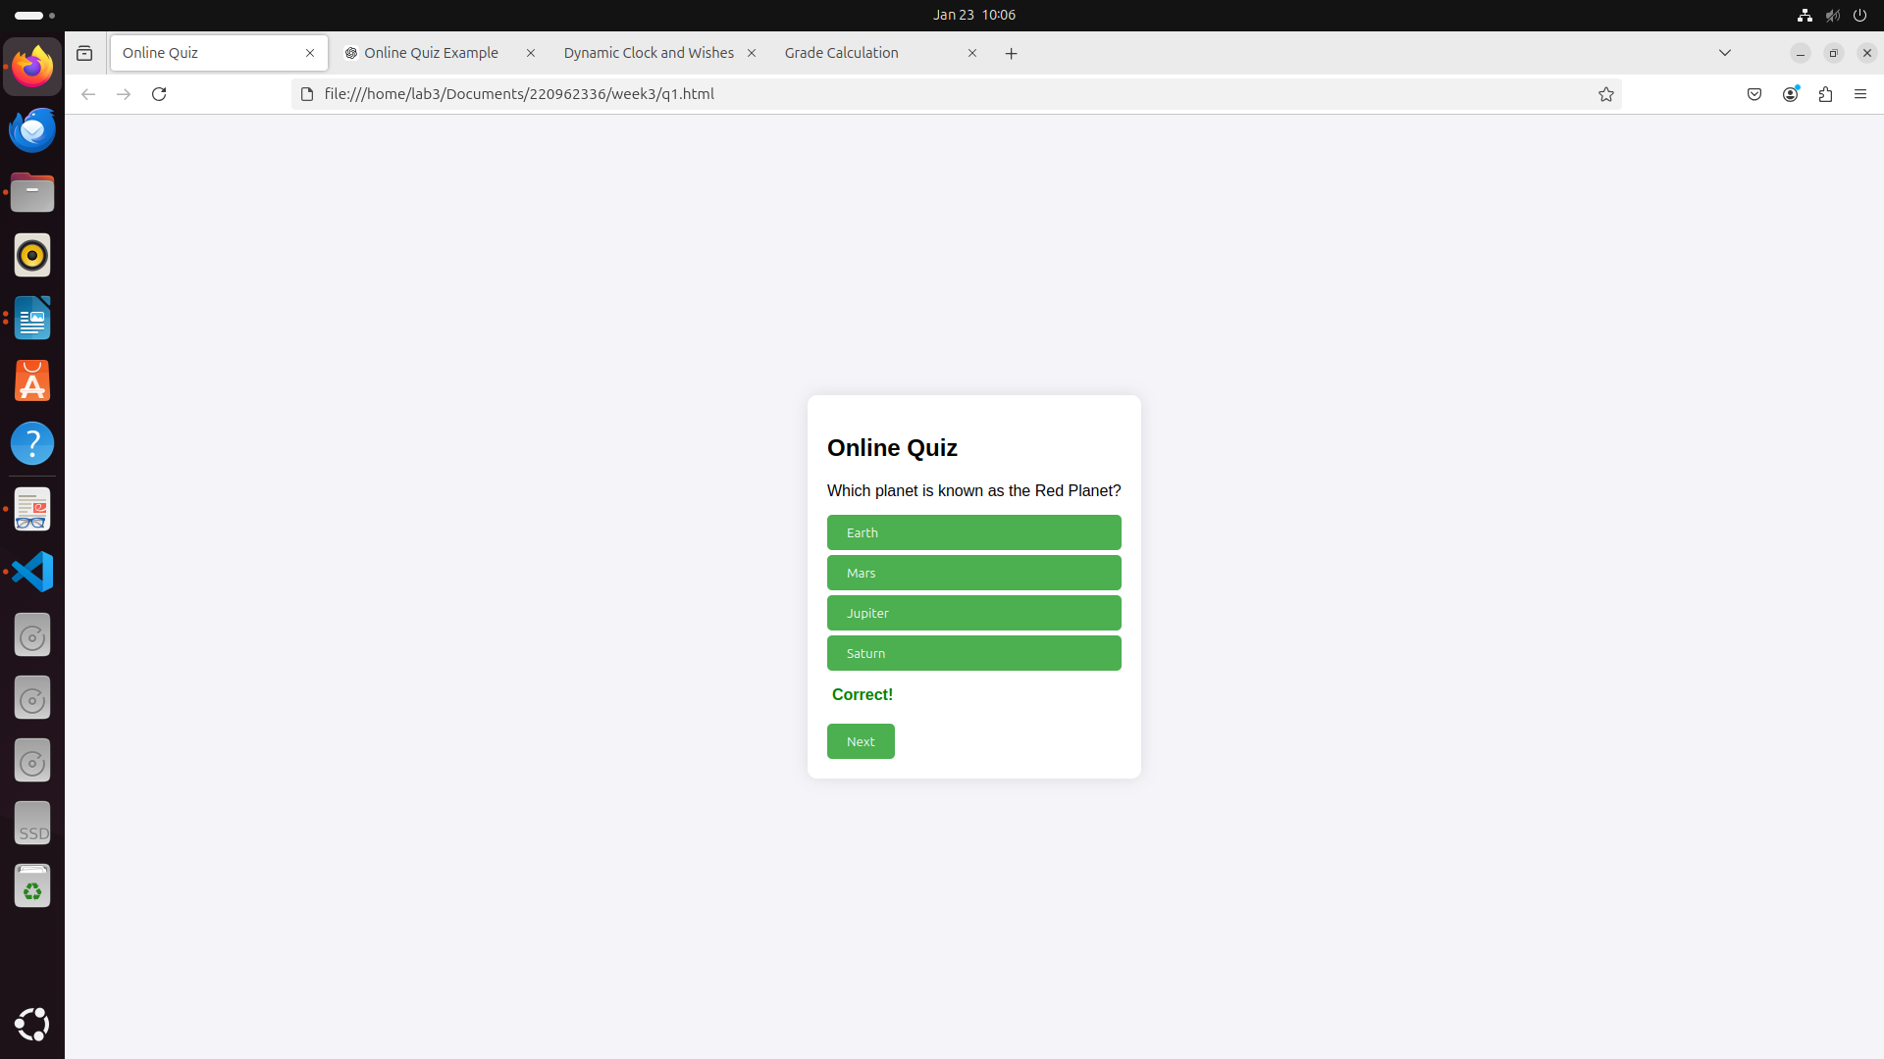

2)code:

<!DOCTYPE html>

<html lang="en">

<head>

<meta charset="UTF-8">

<meta name="viewport" content="width=device-width, initial-scale=1.0">

<title>Dynamic Clock and Wishes</title>

<style>

body {

font-family: 'Arial', sans-serif;

background-color: #f0f8ff;

display: flex;

justify-content: center;

align-items: center;

height: 100vh;

margin: 0;

flex-direction: column;

}

.clock {

font-size: 60px;

font-weight: bold;

color: #333;

margin-bottom: 20px;

}

.greeting {

font-size: 24px;

color: #333;

margin-bottom: 40px;

}

.container {

text-align: center;

padding: 30px;

border-radius: 10px;

background-color: #ffffff;

box-shadow: 0 4px 10px rgba(0, 0, 0, 0.1);

}

.greeting span {

font-weight: bold;

}

#clock {

font-size: 50px;

color: #ff6347;

}

</style>

</head>

<body>

<div class="container">

<div id="greeting" class="greeting"></div>

<div id="clock" class="clock"></div>

</div>

<script>

function getGreeting() {

const now = new Date();

const hours = now.getHours();

let greeting = '';

if (hours >= 0 && hours < 12) {

greeting = 'Good Morning';

} else if (hours >= 12 && hours < 17) {

greeting = 'Good Afternoon';

} else if (hours >= 17 && hours < 21) {

greeting = 'Good Evening';

} else {

greeting = 'Good Night';

}

alert(greeting);

document.getElementById("greeting").innerHTML = `<span>${greeting}</span>, welcome to our website!`;

}

function startClock() {

setInterval(() => {

const now = new Date();

const hours = String(now.getHours()).padStart(2, '0');

const minutes = String(now.getMinutes()).padStart(2, '0');

const seconds = String(now.getSeconds()).padStart(2, '0');

document.getElementById("clock").textContent = `${hours}:${minutes}:${seconds}`;

}, 1000);

}

getGreeting();

startClock();

</script>

</body>

</html>

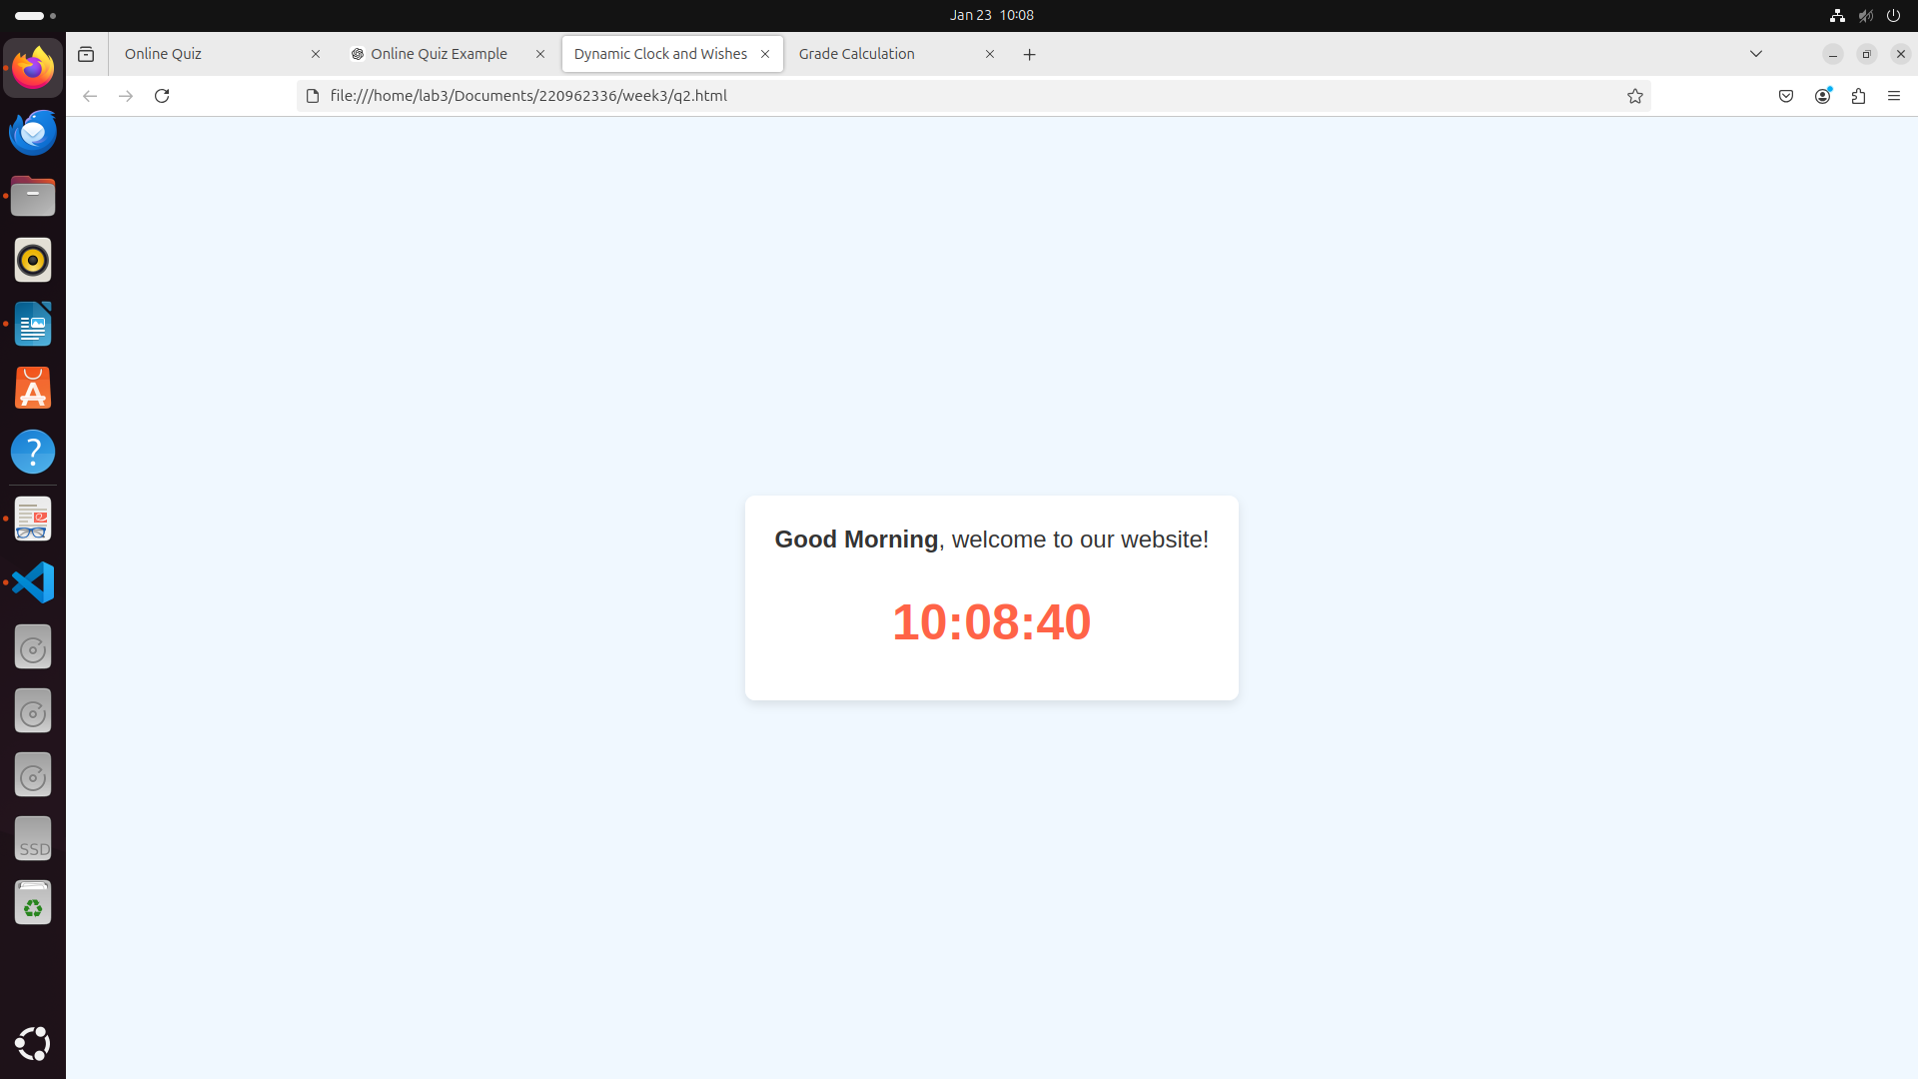3)code:

<!DOCTYPE html>

<html lang="en">

<head>

<meta charset="UTF-8">

<meta name="viewport" content="width=device-width, initial-scale=1.0">

<title>Grade Calculation</title>

<style>

body {

font-family: Arial, sans-serif;

background-color: #f9f9f9;

display: flex;

justify-content: center;

align-items: center;

height: 100vh;

margin: 0;

flex-direction: column;

}

.container {

background-color: white;

padding: 30px;

border-radius: 10px;

box-shadow: 0 4px 10px rgba(0, 0, 0, 0.1);

width: 350px;

}

h2 {

text-align: center;

margin-bottom: 20px;

}

.input-group {

margin-bottom: 10px;

}

label {

font-size: 16px;

}

input {

width: 100%;

padding: 8px;

font-size: 14px;

margin-top: 5px;

border: 1px solid #ddd;

border-radius: 5px;

}

button {

width: 100%;

padding: 10px;

background-color: #4CAF50;

color: white;

border: none;

border-radius: 5px;

cursor: pointer;

font-size: 16px;

}

button:hover {

background-color: #45a049;

}

#result {

margin-top: 20px;

font-size: 18px;

font-weight: bold;

color: #333;

}

</style>

</head>

<body>

<div class="container">

<h2>Grade Calculator</h2>

<div class="input-group">

<label for="subject1">Subject 1 Marks:</label>

<input type="number" id="subject1" placeholder="Enter marks">

</div>

<div class="input-group">

<label for="subject2">Subject 2 Marks:</label>

<input type="number" id="subject2" placeholder="Enter marks">

</div>

<div class="input-group">

<label for="subject3">Subject 3 Marks:</label>

<input type="number" id="subject3" placeholder="Enter marks">

</div>

<div class="input-group">

<label for="subject4">Subject 4 Marks:</label>

<input type="number" id="subject4" placeholder="Enter marks">

</div>

<button onclick="calculateGrade()">Calculate Grade</button>

<div id="result"></div>

</div>

<script>

function calculateGrade() {

const subject1 = parseFloat(document.getElementById("subject1").value);

const subject2 = parseFloat(document.getElementById("subject2").value);

const subject3 = parseFloat(document.getElementById("subject3").value);

const subject4 = parseFloat(document.getElementById("subject4").value);

if (isNaN(subject1) || isNaN(subject2) || isNaN(subject3) || isNaN(subject4)) {

document.getElementById("result").textContent = "Please enter valid marks for all subjects!";

document.getElementById("result").style.color = "red";

return;

}

const average = (subject1 + subject2 + subject3 + subject4) / 4;

let grade = '';

if (average > 90) {

grade = 'A';

} else if (average > 80) {

grade = 'B';

} else if (average > 70) {

grade = 'C';

} else if (average > 60) {

grade = 'D';

} else {

grade = 'F';

}

document.getElementById("result").textContent = `Average Marks: ${average.toFixed(2)}\nGrade: ${grade}`;

document.getElementById("result").style.color = "green";

}

</script>

</body>

</html>

