1)

code:

<!DOCTYPE html>

<html lang="en">

<head>

<meta charset="UTF-8">

<meta name="viewport" content="width=device-width, initial-scale=1.0">

<title>Centered Table & Image Movement</title>

<script src="https://code.jquery.com/jquery-3.6.0.min.js"></script>

<style>

body {

font-family: Arial, sans-serif;

text-align: center;

margin: 0;

padding: 0;

height: 100vh;

display: flex;

flex-direction: column;

justify-content: center;

align-items: center;

background-color: #f8f9fa;

}

.container {

display: flex;

flex-direction: column;

align-items: center;

position: relative;

transition: transform 0.8s ease-in-out;

background: white;

padding: 20px;

border-radius: 10px;

box-shadow: 0px 4px 10px rgba(0, 0, 0, 0.2);

}

table {

width: 400px;

border-collapse: collapse;

margin-bottom: 15px;

border-radius: 8px;

overflow: hidden;

}

th, td {

border: 1px solid #ddd;

padding: 12px;

text-align: center;

font-size: 16px;

}

/\* Alternating row colors \*/

tr:nth-child(even) {

background-color: #f2f2f2;

}

tr:nth-child(odd) {

background-color: #d3d3d3;

}

th {

background-color: #007bff;

color: white;

}

/\* Rectangular Image \*/

img {

width: 225px;

height: 225px; /\* 16:9 aspect ratio \*/

display: block;

border-radius: 10px;

box-shadow: 0px 3px 8px rgba(0, 0, 0, 0.3);

}

button {

margin-top: 20px;

padding: 12px 25px;

font-size: 18px;

border: none;

cursor: pointer;

background-color: #007bff;

color: white;

border-radius: 5px;

transition: background 0.3s;

box-shadow: 0px 4px 6px rgba(0, 0, 0, 0.2);

}

button:hover {

background-color: #00b327;

}

</style>

</head>

<body>

<div class="container">

<table>

<tr>

<th>Col 1</th>

<th>Col 2</th>

<th>Col 3</th>

</tr>

<tr>

<td>A</td>

<td>B</td>

<td>C</td>

</tr>

<tr>

<td>D</td>

<td>E</td>

<td>F</td>

</tr>

<tr>

<td>G</td>

<td>H</td>

<td>I</td>

</tr>

</table>

<img src="https://whitedotpublishers.com/wp-content/uploads/2022/05/male-placeholder-image-800x800.jpeg" alt="Dynamic Image">

</div>

<button id="moveBtn">Move Table & Image</button>

<script>

$(document).ready(function() {

let moved = false; // Track movement state

$("#moveBtn").click(function() {

if (moved) {

$(".container").css("transform", "translateX(0)"); // Move back

} else {

$(".container").css("transform", "translateX(-200px)"); // Move left

}

moved = !moved; // Toggle state

});

});

</script>

</body>

</html>

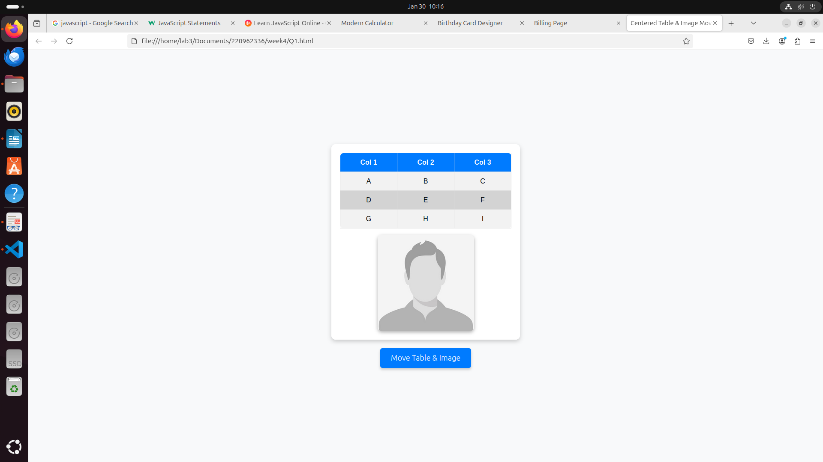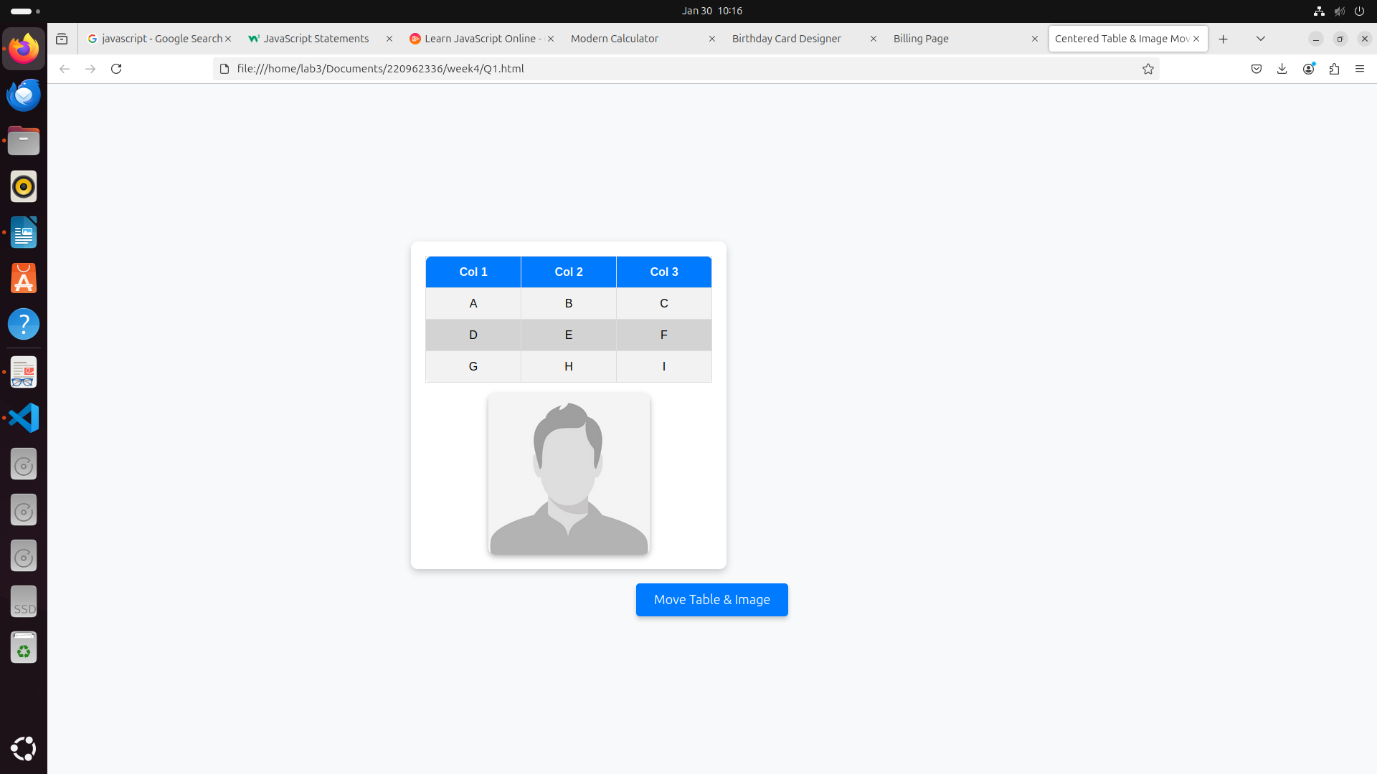2)

code:

<!DOCTYPE html>

<html lang="en">

<head>

<meta charset="UTF-8">

<meta name="viewport" content="width=device-width, initial-scale=1.0">

<title>Modern Calculator</title>

<script src="https://code.jquery.com/jquery-3.6.0.min.js"></script>

<style>

body {

display: flex;

justify-content: center;

align-items: center;

height: 100vh;

background: #1e1e1e;

font-family: Arial, sans-serif;

}

.calculator {

width: 300px;

background: #2c2c2c;

padding: 20px;

border-radius: 15px;

box-shadow: 0px 4px 10px rgba(0, 0, 0, 0.3);

}

.screen {

width: 280px;

height: 60px;

text-align: right;

padding: 10px;

font-size: 24px;

border: none;

border-radius: 10px;

background: #444;

color: #fff;

margin-bottom: 10px;

}

.buttons {

display: grid;

grid-template-columns: repeat(4, 1fr);

gap: 10px;

}

button {

width: 100%;

height: 60px;

font-size: 18px;

border: none;

border-radius: 10px;

cursor: pointer;

background: #666;

color: white;

transition: 0.3s;

}

button:hover {

background: #888;

}

.operator {

background: #ff9500;

}

.operator:hover {

background: #ffb700;

}

</style>

</head>

<body>

<div class="calculator">

<input type="text" class="screen" id="display" readonly>

<div class="buttons">

<button class="clear">C</button>

<button class="operator" data-value="/">÷</button>

<button class="operator" data-value="\*">×</button>

<button class="operator" data-value="-">−</button>

<button data-value="7">7</button>

<button data-value="8">8</button>

<button data-value="9">9</button>

<button class="operator" data-value="+">+</button>

<button data-value="4">4</button>

<button data-value="5">5</button>

<button data-value="6">6</button>

<button data-value="1">1</button>

<button data-value="2">2</button>

<button data-value="3">3</button>

<button data-value="0">0</button>

<button data-value=".">.</button>

<button class="equal">=</button>

</div>

</div>

<script>

$(document).ready(function() {

let screen = $("#display");

let currentInput = "";

$("button").click(function() {

let value = $(this).attr("data-value");

if ($(this).hasClass("clear")) {

currentInput = "";

} else if ($(this).hasClass("equal")) {

try {

currentInput = eval(currentInput).toString();

} catch {

currentInput = "Error";

}

} else {

currentInput += value;

}

screen.val(currentInput);

});

});

</script>

</body>

</html>

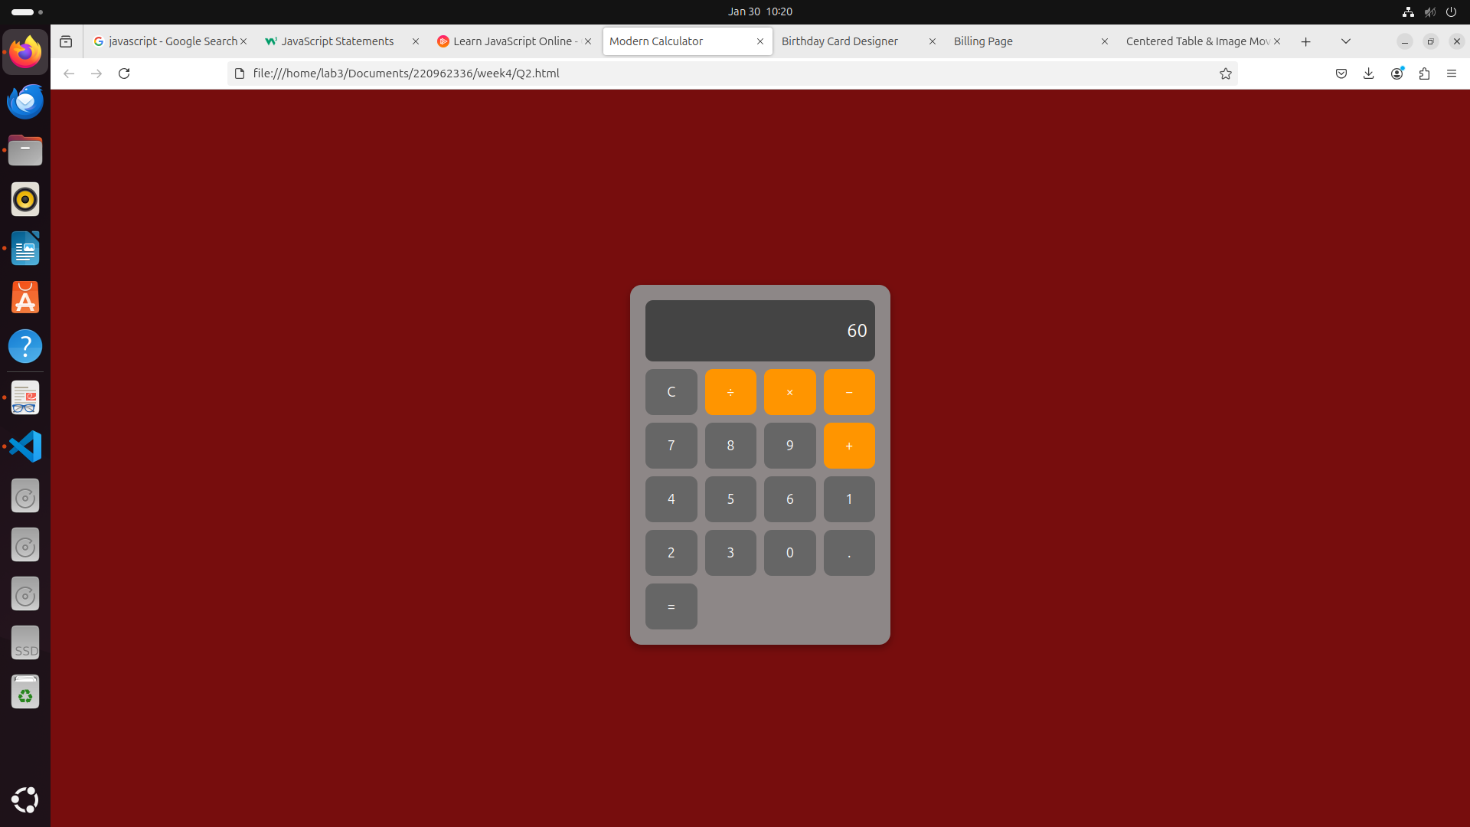

3)

code:

<!DOCTYPE html>

<html lang="en">

<head>

<meta charset="UTF-8">

<meta name="viewport" content="width=device-width, initial-scale=1.0">

<title>Birthday Card Designer</title>

<script src="https://code.jquery.com/jquery-3.6.0.min.js"></script>

<style>

body {

font-family: Arial, sans-serif;

}

#container {

display: flex;

}

#controls {

width: 300px;

padding: 10px;

border-right: 2px solid #ccc;

}

#card {

width: 300px;

height: 400px;

border: 2px solid black;

text-align: center;

padding: 20px;

display: flex;

flex-direction: column;

justify-content: center;

align-items: center;

background-color: yellow;

}

.border-none {

border: none;

}

.border-double {

border: 5px double black;

}

.border-solid {

border: 5px solid black;

}

img {

width: 100px;

height: auto;

}

</style>

</head>

<body>

<div id="container">

<div id="controls">

<label>Choose a background color:</label>

<select id="bgColor">

<option value="yellow">Yellow</option>

<option value="pink">Pink</option>

<option value="lightblue">Light Blue</option>

</select><br><br>

<label>Choose a font:</label>

<select id="fontFamily">

<option value="Verdana">Verdana</option>

<option value="Arial">Arial</option>

<option value="Times New Roman">Times New Roman</option>

</select><br><br>

<label>Specify a numeric font size:</label>

<input type="number" id="fontSize" value="25"><br><br>

<label>Choose a border style:</label><br>

<input type="radio" name="borderStyle" value="none" checked> None

<input type="radio" name="borderStyle" value="double"> Double

<input type="radio" name="borderStyle" value="solid"> Solid<br><br>

<input type="checkbox" id="addImage" checked> Add the Default Picture<br><br>

<label>Enter the greeting text below:</label><br>

<textarea id="greetingText" rows="3">Happy Birthday, and many more</textarea><br><br>

<button id="updateCard">Update</button>

</div>

<div id="card">

<p id="greeting">Happy Birthday, and many more</p>

<img id="cakeImage" src="https://files.creamats.com/cache/products/images/2/j/a/600x600/0/5/673f3ddc07046fac67f1033e99bae8821ef675/80605-birthday-stamp.webp" alt="Birthday Cake">

</div>

</div>

<script>

$(document).ready(function () {

$('#updateCard').click(function () {

// Update background color

$('#card').css('background-color', $('#bgColor').val());

// Update font style and size

$('#greeting').css({

'font-family': $('#fontFamily').val(),

'font-size': $('#fontSize').val() + 'px'

});

// Update border style

let borderClass = $('input[name="borderStyle"]:checked').val();

$('#card').removeClass('border-none border-double border-solid').addClass('border-' + borderClass);

// Update greeting text

$('#greeting').text($('#greetingText').val());

// Toggle image

if ($('#addImage').is(':checked')) {

$('#cakeImage').show();

} else {

$('#cakeImage').hide();

}

});

});

</script>

</body>

</html>

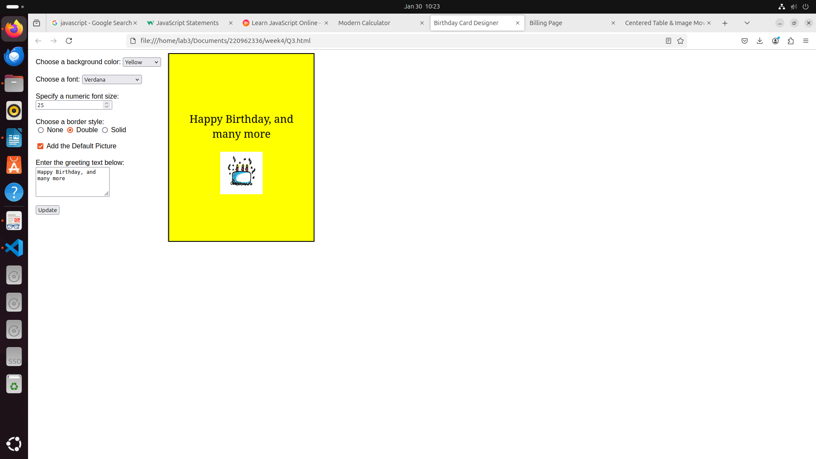4)

code:

<!DOCTYPE html>

<html lang="en">

<head>

<meta charset="UTF-8">

<meta name="viewport" content="width=device-width, initial-scale=1.0">

<title>Billing Page</title>

<script src="https://code.jquery.com/jquery-3.6.0.min.js"></script>

<style>

body {

font-family: 'Arial', sans-serif;

background: #f4f4f4;

display: flex;

justify-content: center;

align-items: center;

height: 100vh;

}

.container {

background: #ffffff;

padding: 20px;

border-radius: 12px;

box-shadow: 0 4px 10px rgba(0, 0, 0, 0.1);

text-align: center;

width: 300px;

}

h2 {

margin-bottom: 15px;

color: #333;

}

label {

font-weight: bold;

display: block;

margin: 10px 0 5px;

}

select, input, button {

width: 100%;

padding: 10px;

margin-bottom: 10px;

border-radius: 8px;

border: 1px solid #ccc;

font-size: 14px;

box-sizing: border-box;

}

input[type="radio"] {

width: auto;

margin-right: 5px;

}

button {

background: #007bff;

color: white;

border: none;

cursor: pointer;

transition: 0.3s;

}

button:hover {

background: #0056b3;

}

</style>

</head>

<body>

<div class="container">

<h2>Billing System</h2>

<label for="brand">Select Brand:</label>

<select id="brand">

<option value="HP">HP</option>

<option value="Nokia">Nokia</option>

<option value="Samsung">Samsung</option>

<option value="Motorola">Motorola</option>

<option value="Apple">Apple</option>

</select>

<label>Select Product Type:</label>

<input type="radio" name="product" id="mobile" value="mobile"> Mobile

<input type="radio" name="product" id="laptop" value="laptop"> Laptop

<label for="quantity">Enter Quantity:</label>

<input type="number" id="quantity" min="1" value="1">

<button id="produceBill">Produce Bill</button>

</div>

<script>

$(document).ready(function(){

const prices = {

'HP': { mobile: 500, laptop: 1000 },

'Nokia': { mobile: 400, laptop: 900 },

'Samsung': { mobile: 600, laptop: 1100 },

'Motorola': { mobile: 450, laptop: 950 },

'Apple': { mobile: 800, laptop: 1500 }

};

$('#produceBill').click(function(){

let brand = $('#brand').val();

let quantity = parseInt($('#quantity').val());

let productType = $('input[name="product"]:checked').val();

if (!productType) {

alert('Please select a product type.');

return;

}

let total = prices[brand][productType] \* quantity;

alert('Total Amount: $' + total);

});

});

</script>

</body>

</html>

