- Simplified Structure

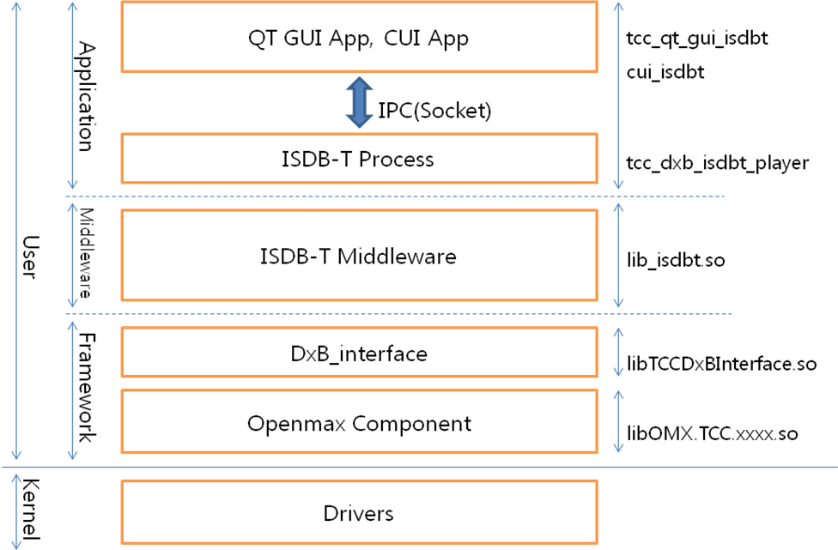

- BSP patch

ISDB-T SDK is developed based on Linux Platfrom Release 4.
And BSP Patch should be applied to excute ISDB-T application.

- Description of SDK Tree

Folder Name | Description
framework | Openmax component, DxB_interface
middleware | Middleware
os | os dependent code for android/linux
linux/application | test application
linux/build | Built library files is located to here temporarily
linux/proprierary | prebuild library in located.
linux/system | header/library releated with linux system
linux/TCC_893X_Output | temporarily result of build will be copied

- How to download ISDB-T SDK

ISDB-T SDK should be downloaded separately from Linux Platform SDK.
This can be downloaded as below.
cd PLATFORM_ROOT
git clone ssh://git.telechips.com/linuxplatform/linux/dxb.git

- How to enable ISDB-T application

At Linux Platform SDK, ISDB-T application is disable as default.
Option should be enabled as below before building.

app/frameworks/config
###########################################################
# BROADCAST (DXB)
###########################################################

TCC_BROADCAST = Y

ifeq ($(TCC_BROADCAST),Y)
BROADCAST_ISDBT_FULLSEG = Y
endif

- How to build SDK

- Patch or code modify should be applied before building.
Patch can be released separately.
- Build environment setting should be done before building.
Source buildscript/init-linux-platform-env [BuildDir]
or
Source [BuildDir]/config-build-env
- Build ‘dxb’ folder before building Linux platform.
Then result will be placed to ‘[BuildDir]/tccdxb’.
cd PLATFORM_ROOT/dxb/linux
make
- Build Linux platform.
Follow instruction of Linux Platform
build-platform-all
or
etc...

- How to update

Follow updating instruction of Linux Platform.

- How to excute ISDB-T Application

At Linux Platform SDK, ISDB-T Icon is not shown in launcher as default.
If patch is applied, then VIDEO ICON is replace to ISDB-T ICON.
Touch Icon, then ISDB-T app will be started.

- How to excute ISDB-T without GUI (through CUI application)

User can test IPC command one by one with CUI app.

- First, disable launching QT launcher. Modify as below
Target board : /nand1/tcc_api.sh
#if [ -f $APP_PATH/tcclauncher ] && [ -f $QTDIR/lib/libQt5Gui.so ]; then
# tcclauncher -platform directfb &
#elif [ -f $APP_PATH/tcclauncher ]; then
# tcclauncher -qws &
#fi

- After booting, excute CUI application.
About CUI command, refer “Ch 10. CUI commands”.
Target board : command line
cd nand1
./tcc_cui_isdbt.sh

- CUI commands

< CUI Command List >
This list can be shown with ‘help’ command.
help : list of CUI command
exit : exit application
scan : scan
scanstop : scan cancel
set : play program
playstop: Play program stop
dualset : change Fullseg/Oneseg
show : show program list

< Command description >
scan -t [type:0,1,2,4,5,6] -n [country:0,1] -a [areacode] -c [ch no] -o [opt]
-t : scan_type
-n : country code
-a : areacoode
-c : channel number (physical frequency number)
-o : option (refer below description in case of scan_type =4,5,6)

* [initial scan]
* scan_type = 0
* country_code = 0 (Japan) or 1 (Brazil)
* area_code, channel_num, options - not used
* [rescan]
* scan_type = 1
* country_code = 0 (Japan) or 1 (Brazil)
* area_code, channel_num, options - not used
* [area_scan]
* scan_type=2
* country_code = 0 (Japan) or 1 (Brazil)
* area_code = code for selected area
* channel_num, options - not used
* [manual scan]
* scan_type = 4
* country_code = 0 (Japan) or 1 (Brazil)
* area_code - not used
* channel_num = no. of select channel to scan
* options = bit0 1 - delete channel DB before to scan channels.
* 0 - preserve channel DB
* [autosearch]
* search any channels from the next of current channel in specified direction.
* scan_type =5
* country_code = 0 (Japan) or 1 (Brazil)
* area_code - not used
* channel_num - current channel number. -1 means no channel was selected.
* options - direction. 0=down (forwarding to lower UHF channel no.), 1=up (increasing UHF channel no)
* [custom scan]
* scan_type = 6
* country_code = search kind
* 1 = relay station, 2 = affiliation station
* area_code = pointer to list of channels.
* channel_num = pointer to list of transport_stream_id. A value of transport_stream_id is same with network_id in terrestrial broadcasting system.
* option = repeatibility
* 0 = infinite
* n = n times

Ex) scan -t 4 -n 0 -c 2 -o 1
Manual scan, frequency channel #2 (485143kHz), clear DB
If parameter is 0, it can be skipped.
Just type ‘scan’, then ‘initial scan’ will be proceed.

scanstop
No parameter

set -m [mainRowID] -s [subRowID] -a [audioIndex] -v [videoIndex] -n [audioMode] -i [ch_index]
-m : RowID(_id field value) in channelDB of Main program(Fullseg)
-s : RowID in channelDB of Sub program(Oneseg)
-a : Index of audio track to be played, default=0
-v : Index of video track to be played, default=0
-n : dualmono mode
-i : channel to be displayed ( 0=fullseg, 1=oneseg )

Ex) set -m 3 -s 5 -a 0 -v 0 -n 0 -i 0
Simply, set -m 3 -s 5
mainRowID and subRowID should be checked from program list by ‘show’ command.

playstop
No parameter

dualset -i [index(0,1)]
-i : fullseg(=0) or 1seg(=1)

show
No parameter

Program list will be shown as below
================================================================
PROGRAM LIST [Number of Channels = 3]
================================================================
Row Ch 3Dg Svc Svc PMT Prog
ID Num Num Typ ID PID Name
-----------------------------------------------------------------------------------
1 2 711 1 59296 80 [Gazeta HD] 47 61 7A 65 74 61 20 48 44 00
2 2 711 192 59320 8136 [Gazeta 1SEG] 47 61 7A 65 74 61 20 31 53 45 47 00
3 3 31 1 33792 496 [NHKAm9g1þL>8E20] 4E 48 4B 41 6D 39 67 31 C3 BE …
4 3 32 1 33793 1008 [NHKAm9g2þL>8E20] 4E 48 4B 41 6D 39 67 32 C3 BE …
5 3 631 192 34176 8136 [NHK7HBSGþL>8E20] 4E 48 4B 37 48 42 53 47 C3 BE …
6 6 21 1 2056 496 [NHK650i1þBg:e] 4E 48 4B 36 35 30 69 31 C3 BE 42 67 …
7 6 22 1 2057 1008 [NHK650i2þBg:e] 4E 48 4B 36 35 30 69 32 C3 BE 42 67 …
8 6 23 1 2058 1264 [NHK650i3þBg:e] 4E 48 4B 36 35 30 69 33 C3 BE 42 67 …
9 6 621 192 2440 8136 [NHK7HBS2] 4E 48 4B 37 48 42 53 32 00
================================================================

RowID means index of sqliteDB. This parameter is used for ‘set’ command.
ChNum means Physical channel index(Frequency). ‘3’ means CH 16(491.143MHz).

