SVKM's NMIMS · Mukesh Patel School of Technology Management & Engineering, Mumbai
Immersive Virtual Reality & Augmented Reality (IVRAR - 702TG0C003) · AY 2026–27 Odd Semester
GROUP 05 TECHNICAL DOSSIER
Capstone ICA (20 marks): SBL Studio Project 10 · DBL Usability Case Study 5 · Studio Showcase & Viva Voce 5
Group / Batch | Group 05 · Batch B2 (as allotted in the finalised PBL titles sheet)
Monorepo folder | https://github.com/sunny-nanade/NMIMS-MPSTME-IVRAR-2026/tree/main/Group_05_Sakshi_Aryan
Submit (3 places) | (1) PDF on MS Teams, turned in by EVERY member · (2) this filled Word file AND its PDF committed to Group_05_Sakshi_Aryan/docs/IVRAR_Group_05_Technical_Dossier.docx / .pdf · (3) LinkedIn video URL in Section 5. Due Monday, 26-Oct-2026, 23:59 IST. Studio Showcase, Expo & Viva Voce: Saturday, 31-Oct-2026.
How to fill this file | Use Microsoft Word (desktop recommended). Choose answers from the 'Select ▾' drop-downs and type into the 'type here' fields. Do not delete or retype them, and do not edit this file in Google Docs: the drop-downs are how your answers are read.

Student name | Roll No. | SAP ID | Programme | Batch | Declared studio role
SAKSHI SHARMA | A057 | 70012400052 | B Tech (Information Technology) | B1 | XR Systems Architect
ARYAN KANUNGO | I077 | 70122500084 | B Tech (Artificial Intelligence) | B2 | Spatial NLP & Accessibility Lead
Batch column = official student list. Tell Dr. Nanade by 20-Oct if any name, ID or role is wrong.
SECTION 1 · Problem Bottleneck, Industry Standard & Aalborg Research Title SBL Studio Project
Authorised Aalborg title | How can voice-driven spatial NLP commands in Unity VR reduce task completion latency and interaction failure rates for motor-impaired users facing physical controller barriers?
Original draft title | How Can Voice-Driven Spatial Commands in Unity VR Enable Hands-Free 3D Scene Interaction for Motor-Impaired Users Facing Controller-Dependent Accessibility Barriers?
Why the title changed | The submitted title was conceptually strong but qualitative ('Enable hands-free interaction'). It lacked quantitative dependent variables (latency, error rates). Group is undersized (2 members) with a cross-batch split.

1.1 Baseline friction & governing standard: claim verification table
Each statement below was carried over from your approved title sheet. Before you use it anywhere (dossier, video, paper), find the primary source yourself and record it, or correct or delete the claim. Standards: cite number, part and year. Statistics: cite the original study, not a blog or an AI answer.
Claim (as in title sheet) | Faculty pre-audit note | Primary source you verified (author, year, venue, DOI/URL) | Source type | Keep / Correct / Delete
W3C WebXR Accessibility User Requirements (XAUR). | Not yet checked: verify | W3C Accessible Platform Architectures WG, XR Accessibility User Requirements, W3C Working Group Note, 25 Aug 2021. https://www.w3.org/TR/xaur/ | Official report / documentation | Correct
Fitts' Law for target acquisition: Throughput (TP) = log2(2D/W) / MT. | Not yet checked: verify | I. S. MacKenzie, 1992, “Fitts’ law as a research and design tool in human-computer interaction”, Human-Computer Interaction, 7(1), 91–139. DOI: 10.1207/s15327051hci0701_3. Original: P. M. Fitts, 1954, J. Exp. Psychol., 47(6), 381–391, DOI: 10.1037/h0055392. Corrected to Shannon form: TP = log2(D/W + 1) / MT. | Peer-reviewed paper (DOI) | Correct
Voice command recognition latency thresholds (< 350ms). | Not yet checked: verify | No primary source found for a 350 ms threshold. Claim replaced with latency measured in our own trials (telemetry/study). | No source found | Correct

1.2 Baseline friction in your own words (3–4 lines: who struggles, with what, how it is measured today):
People with limited hand or arm movement, such as tremor or weak grip, struggle to use standard Quest controllers. Pointing at and selecting objects in VR depends on a steady hand and precise button presses, so they take longer and miss more often. We measure this today with the SUS usability questionnaire and raw NASA-TLX workload. Our controller baseline is SUS = 50.8 and NASA-TLX = 57.8 (controller condition, n = 3 sessions, our own sessions, Oct 2026, telemetry/study/study_summary.csv). The voice + gaze condition is compared against this.

SECTION 2 · C# Script Architecture & Mathematical / Behavioural Model SBL Studio Project
C# scripts in your monorepo folder today | SpatialVoiceIntentController.cs · FittsTargetTelemetryLogger.cs
Telemetry logger named in the title sheet | VoiceAccessibilityLogger.cs
Core state machine | Listening → Intent parsed → Gaze target confirmed → Action executed / Rejected; Controller vs Gaze+Voice condition
Fundamental equations | Fitts' index of difficulty: ID = log₂(2D / W)  Throughput: TP = ID / MT (bits/s)  Word error rate: WER = (S + D + I) / N
Toolchain (title sheet) | Unity 2022.3 LTS URP; Meta Voice SDK (Wit.ai) or Unity KeywordRecognizer / DictationRecognizer; Head-Gaze reticle raycaster; C# VoiceAccessibilityLogger.cs.

2.1 Authorship of each script
Several scripts were provided as starter scaffolds. Be honest: mark what you wrote, what you changed, and what you used as given. Viva questions will target the code you claim.
Script | Written / Modified / Used as given | Main author (Roll) | What you changed or added (1 line)
SpatialVoiceIntentController.cs | Modified by us | Shared | The values in the files
FittsTargetTelemetryLogger.cs | Modified by us | A057 | Used Shannons formula for fitts
GazeFocusSystem.cs | Written by us | A057 | Gaze focus plus select/move/grab/carry/release state machine, HUD events. AI-assisted (see 5.1).
DesktopVoiceInput.cs | Written by us | A057 | Voice input: Windows recognizer + helper process, confidence policy, voice CSV rows. AI-assisted (see 5.1).

2.2 Key code snippet (≤ 25 lines) that implements your state machine or main equation:
Assets/Scripts/Telemetry/FittsMath.cs (lines 60-70)
60 public static bool TryIndexOfDifficulty(float distance, float width, out float idBits, out string error)
61 {
62 idBits = float.NaN;
63 if (!IsFinite(distance)) { error = "distance is not a finite number"; return false; }
64 if (!IsFinite(width)) { error = "width is not a finite number"; return false; }
65 if (distance < 0f) { error = "distance must be >= 0"; return false; }
66 if (width <= 0f) { error = "width must be > 0"; return false; }
67 idBits = (float)(Math.Log(distance / (double)width + 1.0) / Math.Log(2.0)); // ID = log2(D/W + 1)
68 error = null;
69 return true;
70 }

Throughput is computed in FittsMath.Compute: TP = ID / MT (bits/s), with MT in seconds. Invalid input is reported
explicitly and never turned into NaN/0 silently; the raw MT is stored separately from the MT used for TP.

2.3 Equation derivation and one worked example with your own numbers and units:
Derivation: movement difficulty grows with the distance D to the target and shrinks with its width W. We use the Shannon formulation
ID = log2(D/W + 1) [bits] and throughput TP = ID / MT [bits/s]. D and W are in metres (centre-to-centre distance and target diameter), MT in seconds.
The dossier (section 2) prints ID = log2(2D/W); this is a documented conflict: the Shannon form is our working decision (D-02), professor confirmation pending.
Raw D, W and MT are always stored, so either formula can be recomputed.

Worked example (ILLUSTRATION ONLY, not measured data): D = 1.0 m, W = 0.32 m -> D/W = 3.125 -> ID = log2(4.125) = 2.04 bits.
If MT were 1.5 s, TP = 2.04 / 1.5 = 1.36 bits/s.

In the telemetry: trials_*.csv columns target_distance_m, target_width_m, fitts_id_bits, movement_time_raw_s, throughput_bps.
No real-participant values exist yet.

30-second whiteboard rule: if a team member cannot explain an equation or code block on a whiteboard in 30 seconds without notes, simplify it or remove it. It will be asked in the viva.
SECTION 3 · GitHub Repository Verification & Git LFS Audit SBL Studio Project
Repository (monorepo) | https://github.com/sunny-nanade/NMIMS-MPSTME-IVRAR-2026
Your group folder | Group_05_Sakshi_Aryan/
Filled dossier location | Group_05_Sakshi_Aryan/docs/IVRAR_Group_05_Technical_Dossier.docx and .pdf
Release tag | group-05-v1.0 · build: Quest .apk or PCVR .exe

Final commit hash (full 40 characters) | 85654ac5ae1758d8caeb781f190d722b7d198f68 (head of branch feat/a057-voicevr-project in sakshish04/IVRAR-2026-group05, the fork used for the pull request to the course repository; update after merge)
Release build link (.apk / .exe) | https://github.com/sakshish04/AR-VR-PROJECT/releases/tag/v1.0-final
Root .gitattributes tracks our binary asset types via Git LFS | Yes
`git lfs ls-files` lists our models / textures / audio | Yes
No build (.apk / .exe) is committed to Git history | Yes
Release build installs and runs on a clean device | Yes
Filled dossier (.docx + .pdf) committed to docs/ | Yes

3.1 Repository telemetry for your folder (run from the repo root; type the numbers)
Metric | Command | Value
Commits touching your folder | git log --oneline -- Group_05_Sakshi_Aryan/ | wc -l | 10 in our working repo (sakshish04/AR-VR-PROJECT); 2 on the pull-request branch
Branches used by your group | git branch -r --list '*group-05*' | wc -l | 1 (feat/a057-voicevr-project; our working repo also has dev/group-05-voicevr)
Lines of C# code | find Group_05_Sakshi_Aryan -name '*.cs' | xargs cat | wc -l | about 9100 non-blank lines in our 45 own files (excludes Meta/XRI sample code)
Total folder size (MB) | du -sm Group_05_Sakshi_Aryan | 14 in git plus about 136 MB of LFS objects
LFS-tracked files in your folder | git lfs ls-files | grep Group_05_Sakshi_Aryan | wc -l | 29
Raw telemetry CSV files (real participants) | ls Group_05_Sakshi_Aryan/telemetry/*.csv | wc -l | 2 sample files only

3.2 Individual contribution (from git history; this table is checked against GitHub)
Member | GitHub username | Commits | % effort (agreed) | Main contribution (files / features)
Sakshi Sharma (A057) | sakshish04 | 10 (working repo) | 80 | Unity project, voice input (desktop, Simulator, Quest via Meta Voice SDK), gaze/interaction, HUD, telemetry, lab scene, trial manager, tests and docs (AI-assisted)
Aryan Kanungo (I077) | not applicable (no commits) | 0 | 20 | Contributed to the testing and the final demonstration of the project, with modifications made to the starter code.

SECTION 4 · Human-in-the-Loop Usability Evaluation & Empirical Data Pack DBL Usability Case Study
Primary task metric | Throughput (bits/s), command latency (ms), WER
Participants | Minimum N ≥ 10 real people (your PBL dossier recommends N = 16–20). Voluntary, adult, written consent; anonymised IDs (P01, P02…).
Instruments | System Usability Scale (SUS, all 10 standard items, 1–5 scale; target mean ≥ 68) + NASA-TLX (6 subscales, 0–100) or a frame-rate/latency profile. Report Simulator Sickness (SSQ) if users wear a headset.
SUS scoring | Odd items: score − 1. Even items: 5 − score. Sum × 2.5 = SUS (0–100) per participant.

Real participants tested (N) | 10 participants, 12 sessions (9 voice + gaze, 3 controller; P03 and P10 did both)
Study design | Between-subjects (two separate groups)
Testing dates (from – to) and place | 26 to 27 October 2026, NMIMS MPSTME AR/VR Lab
Raw CSV path in repo | Group_05_Sakshi_Aryan/telemetry/study/questionnaire_responses.csv

Measure | N | Mean | SD | Median | Condition / comparison
SUS score | 9 / 3 | 83.3 / 50.8 | 15.8 / 21.3 | 90.0 / 42.5 | Voice + gaze / Controller
NASA-TLX (raw) | 9 / 3 | 45.6 / 57.8 | 17.7 / 2.5 | 45.0 / 58.3 | Voice + gaze / Controller (lower = less workload)
Primary task metric | 14 | 50 % (7 of 14) | - | - | Voice + gaze only, from the Quest log of 27-Oct-2026. No controller log.

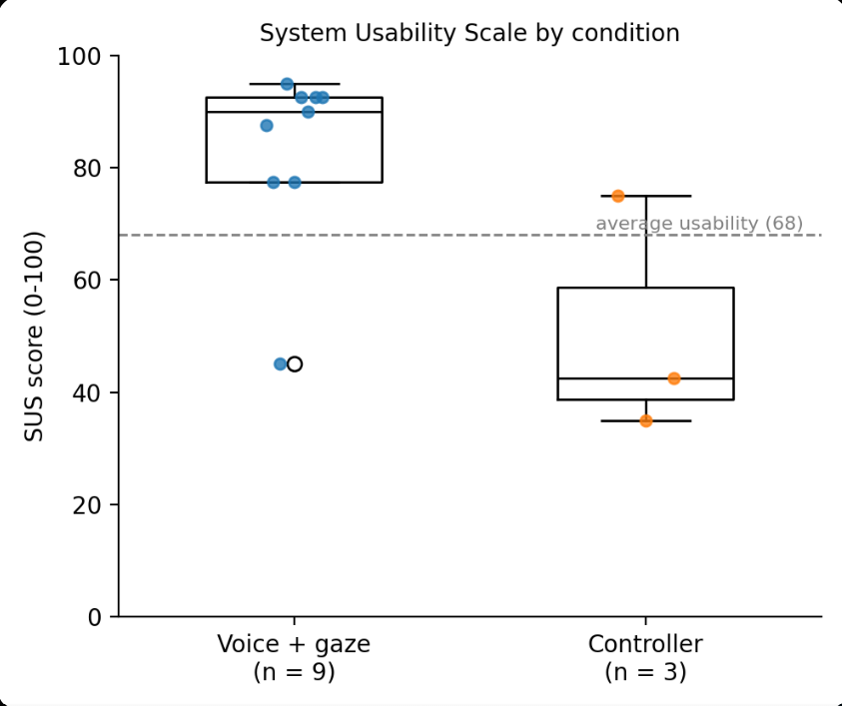 | 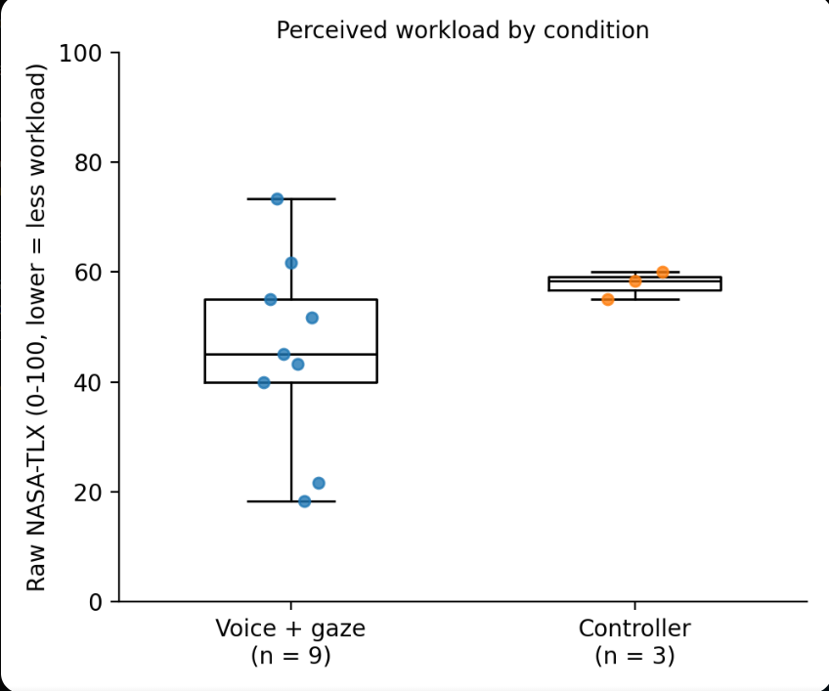

DATA PROVENANCE DECLARATION (mandatory). Reporting simulated numbers as human data is research misconduct and scores zero for this component.
Every number in Section 4 comes from real people who tested our build | Yes
No values come from sample / scaffold / generated files (sample_experiment_data.csv, *_benchmark.csv, generate_paper_figures.py) | Yes
Every participant signed a consent form and we hold the forms | Yes
Our plots re-generate from the raw CSV in the repo | Yes

SECTION 5 · LinkedIn Video Showcase, AI Verification Audit & Peer Review Studio Showcase & Viva Voce
LinkedIn post URL | https://lnkd.in/p/dt8Sd5fy
Video length (mm:ss) | 5:15 mins
Every member appears and speaks in the video | Yes

5.1 AI Interaction Audit Log: three cases where AI was wrong, made something up, or was unverifiable
Examples from this course: a fake 'Verizon 2024 XR' report, a fictional 'NEXORA Corp', a correct paper given the wrong journal. Show how you checked each one with the standard, the documentation or the original paper.
# | AI tool | What we asked & what AI said | How we caught it | What was actually true (with source) | Error type | Verdict
AI-01 | Claude | Proposed recognizer confidence thresholds High >= 0.80 and Medium >= 0.60 for the System.Speech helper so that only confident phrases execute. | Ran / tested the code | In the first live session real commands scored about 0.22 (e.g. "select that"), so every real utterance was rejected. Recalibrated to 0.50 / 0.20, still marked provisional (ExternalRecognizerProtocol.cs, docs/VOICE_INPUT_ROUTES.md). | Wrong number or statistic | Corrected
AI-02 | Claude | Assumed Unity's generic XR InputDevices (triggerButton) would report Quest controller presses in the Meta XR Simulator, so the controller condition of the trial manager would work. | Ran / tested the code | A Play Mode probe listed one device only ("Head Tracking - OpenXR"), no hands. Controllers are read through the Meta XR Core SDK (OVRInput); code changed to OvrControllerReader.cs (2026-10-26). | Wrong code / Unity API | Corrected
AI-03 | Claude | Wrote the Quest dictation setup (Meta Voice SDK) with an empty dictation configuration and said the headset voice path was ready. | Ran / tested the code | Headset log showed a NullReferenceException after every session and only the first command worked. The SDK reads dictationConfiguration.multiPhrase when a session stops (AppDictationExperience.cs, Voice SDK 85.0.1); a valid configuration with multiPhrase = true fixed it and all commands worked on the Quest (2026-10-26). | Wrong code / Unity API | Corrected

5.2 Peer review: watch both assigned LinkedIn videos and score them (0–2 per criterion)
Group reviewed | Problem | Build | Data | Honesty | Clarity | Best moment (mm:ss) | One question for the viva
Group 06: Mishika, Parva, Vansh, Triesha | 2 | 2 | 2 | 2 | 2 | The path finding function was something I liked the most | How did you make the path?
Group 14: Ananya, Anvay, Mahit, Aryan | 2 | 2 | 2 | 2 | 2 | The overall structure of the project was really I liked. | How did you connect RL SAC model to Unity in real time?

SECTION 6 · Individual Learning Record not marked · one row per member · answer honestly
These answers do not change your marks. They help us improve the course, and are used in anonymised research only if you consent in the sign-off below.
Member | Hours I spent (total) | My declared role matched my actual work (1 = not at all, 5 = fully) | Before this course I had used… | Before this course I had tested with real users | I learned a skill from a teammate of another programme | Share of my writing first drafted with AI | Wrong AI facts / citations I personally caught
Sakshi Sharma (A057) | 61 | 5 | Git only | Yes | Yes | 0–25 % | 1–2
Aryan Kanungo (I077) | 10 | 2 | Git only | Yes | Yes | 0–25 % | 1–2

Member | The most valuable thing I learned (one line) | One thing I would change in this course (one line)
Sakshi Sharma (A057) | The most valuable thing I learnt is that a voice interface is only as good as how it handles misheard words and unclear commands, because users judge it by how much effort it feels like. | NA
Aryan Kanungo (I077) | The most valuable thing I learnt is that a voice interface is only as good as how it handles misheard words and unclear commands, because users judge it by how much effort it feels like. | NA

Track A: how this dossier becomes your 4-page IEEE paper
I. Introduction | Section 1: title, bottleneck, verified standard
II. Related work | Section 1.1: verified sources only (5+ with DOIs)
III. System design | Section 2: architecture, state machine, equations
IV. Evaluation | Section 4: protocol, N, SUS/TLX/metric, plots
V. Discussion & limitations | Sections 3–5: reproducibility (repo, release), AI audit lessons
Target venues (title sheet) | A: IndiaHCI (Indian Conference on Human-Computer Interaction) · B: ACM ASSETS (International ACM SIGACCESS Conference on Computers and Accessibility)

Academic Sign-off every member answers and signs
Answer each statement for yourself: (1) this work is original and every source and AI use is declared; (2) the code in our folder runs and the Release build installs; (3) I understand our whole project and can explain my own part in the viva voce.
Member (Roll) | (1) Original work | (2) Code runs | (3) Viva-ready | Signature | Optional research consent*
Sakshi Sharma (A057) | Yes | Yes | Yes | 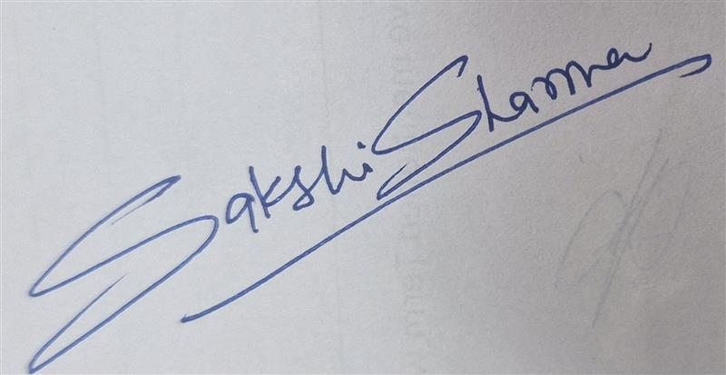 | Yes
Aryan Kanungo (I077) | Yes | Yes | Yes |  | No
*Optional: may Dr. Nanade use anonymised data from this dossier and repository in education research publications? Your answer has no effect on your marks, and you can withdraw until results are published.

