SVKM's NMIMS · Mukesh Patel School of Technology Management & Engineering, Mumbai
Immersive Virtual Reality & Augmented Reality (IVRAR - 702TG0C003) · AY 2026–27 Odd Semester
GROUP 10 TECHNICAL DOSSIER
Capstone ICA (20 marks): SBL Studio Project 10 · DBL Usability Case Study 5 · Studio Showcase & Viva Voce 5
Group / Batch | Group 10 · Batch B2 (as allotted in the finalised PBL titles sheet)
Monorepo folder | https://github.com/sunny-nanade/NMIMS-MPSTME-IVRAR-2026/tree/main/Group_10_Devraj_Aaryesh_Jiya
Submit (3 places) | (1) PDF on MS Teams, turned in by EVERY member · (2) this filled Word file AND its PDF committed to Group_10_Devraj_Aaryesh_Jiya/docs/IVRAR_Group_10_Technical_Dossier.docx / .pdf · (3) LinkedIn video URL in Section 5. Due Monday, 26-Oct-2026, 23:59 IST. Studio Showcase, Expo & Viva Voce: Saturday, 31-Oct-2026.
How to fill this file | Use Microsoft Word (desktop recommended). Choose answers from the 'Select ▾' drop-downs and type into the 'type here' fields. Do not delete or retype them, and do not edit this file in Google Docs: the drop-downs are how your answers are read.

Student name | Roll No. | SAP ID | Programme | Batch | Declared studio role
DEVRAJ GHUMARE | R014 | 70512400047 | MBA (Tech) (Artificial Intelligence) | B2 | Computer Vision Pipeline Lead
AARYESH PATHARE | R045 | 70512400057 | MBA (Tech) (Artificial Intelligence) | B2 | XR Systems Architect
JIYA SAXENA | R054 | 70512400056 | MBA (Tech) (Artificial Intelligence) | B2 | Gesture Recognition Specialist
Batch column = official student list. Tell Dr. Nanade by 20-Oct if any name, ID or role is wrong.
SECTION 1 · Problem Bottleneck, Industry Standard & Aalborg Research Title SBL Studio Project
Authorised Aalborg title | Controller-Free Architectural Room Authoring in VR Using Markerless MediaPipe Hand Tracking and Gesture-Driven Interaction  Revised after the course faculty approved a change of topic: markerless MediaPipe hand tracking replaced the colour/fiducial marker pipeline. Previous authorised title: "How can an OpenCV-based color and fiducial hand-tracking pipeline integrated with Unity VR achieve sub-15ms latency and gesture recognition accuracy for architectural 3D model reviews without dedicated 6-DoF controllers?"
Original draft title | Architects conducting VR design reviews need to overcome controller-based usability and accessibility barriers that make it difficult for clients to naturally explore and evaluate architectural designs.
Why the title changed | The submitted text was a casual proposal paragraph ('Architects struggle... by integrating OpenCV we can create an accessible experience'). It lacked an interrogative form and concrete latency/accuracy targets.

1.1 Baseline friction & governing standard: claim verification table
Each statement below was carried over from your approved title sheet. Before you use it anywhere (dossier, video, paper), find the primary source yourself and record it, or correct or delete the claim. Standards: cite number, part and year. Statistics: cite the original study, not a blog or an AI answer.
Claim (as in title sheet) | Faculty pre-audit note | Primary source you verified (author, year, venue, DOI/URL) | Source type | Keep / Correct / Delete
Motion-to-photon latency in VR must remain <= 15-20ms to prevent jitter and dissociation. | Not yet checked: verify | Stauffert, Niebling & Latoschik (2020), "Latency and Cybersickness: Impact, Causes, and Measures. A Review", Frontiers in Virtual Reality 1, doi:10.3389/frvir.2020.582204. It gives no single threshold: <50 ms to feel responsive, <20 ms recommended (Carmack 2013, online). Claim reworded. | Peer-reviewed paper (DOI) | Correct
Fitts' Law spatial object manipulation throughput. | Not yet checked: verify | Fitts (1954), J. Experimental Psychology 47(6), 381-391, doi:10.1037/h0055392. We do not measure throughput, so the claim is removed. | Peer-reviewed paper (DOI) | Delete
HSV thresholding on standard webcams takes < 5ms CPU time. | Not yet checked: verify | No source found. Belonged to the dropped colour-marker pipeline; we now report measured MediaPipe detection time instead. | No source found | Delete

1.2 Baseline friction in your own words (3–4 lines: who struggles, with what, how it is measured today):
Who struggles: people laying out or building a 3D space in VR (architecture students, first-time VR users) who must hold controllers and press buttons to place points and confirm them. Without controllers that confirmation signal disappears: a pinch has no click, a webcam gives no direct depth, and smoothing adds lag.
How it is measured today: usability with the System Usability Scale (SUS), where about 68 is the commonly cited average (Sauro & Lewis, Quantifying the User Experience, 2nd ed., 2016). Our own starting point: the first pipeline showed 60-100 ms latency on the HUD and about 15 fps in dim light (own measurement); this project reduces that and reports user-rated usability against the SUS benchmark of 68.

SECTION 2 · C# Script Architecture & Mathematical / Behavioural Model SBL Studio Project
C# scripts in your monorepo folder today | ARVR_Project/Assets/Group10Gestures/ (Core, Filtering, Providers, Recognition, Interaction, UI) · Python: ARVR_Project/Group10Gestures~/tools/mediapipe_sender.py · starter scaffolds ColorMarkerHandTracker.cs and ArchitecturalModelGestureController.cs in Assets/Scripts (not used)
Telemetry logger named in the title sheet | Interaction/TrialLogger.cs writes TrialData/g10_trials.csv (replaces HandTrackingTelemetryLogger.cs from the title sheet)
Core state machine | No hand → Tracking → Gesture committed (pinch / point / fist / peace / thumbs-up / open palm, 3-frame debounce) → Build state Drawing → Extruding → Room complete → Colour; mode cycle Edit → Color → View; tracking lost resets to None
Fundamental equations | Pipeline latency = t_unity_receive − t_python_stamp (ms)  One Euro filter cut-off: f_c = f_c,min + β · |dx/dt|  Pinch ratio = ‖p4 − p8‖ / ‖p0 − p9‖ (enter < 0.35, exit > 0.50)
Toolchain (title sheet) | Python MediaPipe Hand Landmarker on the webcam → JSON over UDP (127.0.0.1:5005) → Unity 6000.5.8f1 (URP 17.5.0, Meta XR SDK 207.0.1, OpenXR 1.17.1); One Euro jitter filter; TrialLogger.cs CSV

2.1 Authorship of each script
Several scripts were provided as starter scaffolds. Be honest: mark what you wrote, what you changed, and what you used as given. Viva questions will target the code you claim.
Script | Written / Modified / Used as given | Main author (Roll) | What you changed or added (1 line)
ColorMarkerHandTracker.cs | Deleted / not used | R014 | Starter scaffold for the dropped colour-marker topic; not used or built on.
ArchitecturalModelGestureController.cs | Deleted / not used | R054 | Starter scaffold; replaced by Recognition/ and Interaction/ scripts.
Interaction/: RoomBuilderController, RoomMeshBuilder, InteractionBootstrap, XRGuidePanel, TrialLogger | Written by us | R045 | Room-authoring logic: corners, extrusion, painting, modes, in-headset guide, trial CSV.
Filtering/HandFilter.cs, tools/mediapipe_sender.py | Modified by us | Shared | Retuned One Euro parameters (min cut-off 1.5 Hz, beta 25); sender: MJPG capture, buffer 1, Detect-ms overlay.
Providers/, Recognition/, Core/, Filtering/OneEuroFilter.cs, UI/ | Written by us | Shared | Webcam and Meta XR hand providers, gesture recognizer (R054), webcam pipeline (R014).

2.2 Key code snippet (≤ 25 lines) that implements your state machine or main equation:
RoomBuilderController.cs, lines 910-919 (R045): held-gesture shortcuts
// The pose must be held steadily before it counts (the shared recognizer can flicker for single frames).
if (g == GestureType.None || _offFired) return;
if (Time.time - _offSince < _shortcutHold) return;
if (Time.time - _lastShortcutTime < _shortcutCooldown) return;
_offFired = true;

if (g == GestureType.Fist)
{
if (_mode == InteractionMode.View) { _lastShortcutTime = Time.time; ResetView(); }
else if (_mode == InteractionMode.Edit) { _lastShortcutTime = Time.time; Undo(); }
}
// Same pattern for Peace (delete last room) and ThumbsUp (close room), lines 921-930.

2.3 Equation derivation and one worked example with your own numbers and units:
One Euro filter (Casiez, Roussel & Vogel, CHI 2012; HandFilter.cs): cut-off f_c = f_c,min + beta * |dx/dt|, with dx/dt = joint speed in m/s. Settings: f_c,min = 1.5 Hz (hand at rest, strong smoothing), beta = 25 (cut-off opens up when the hand moves, so little lag).
Worked example (illustrative values, not measured data): hand speed 0.3 m/s gives f_c = 1.5 + 25 x 0.3 = 9.0 Hz. With the original beta = 0.005 the same hand gives 1.5 + 0.005 x 0.3 = 1.5015 Hz: the filter never opened and the hand felt about 0.5 s late (see AI-02).
Pinch ratio (GestureRecognizer.cs): pinch = ||p4 - p8|| / ||p0 - p9|| (thumb tip to index tip, divided by wrist to middle-MCP distance). Enter pinch below 0.35, leave only above 0.50 (hysteresis). Example: 0.025 m / 0.09 m = 0.28, so pinch is entered.
In the telemetry CSV: latency (t_unity_receive - t_python_stamp, webcam only) is logged as mean_latency_ms and p95_latency_ms, with mean_fps, min_fps and tracking_lost_s. The filter and pinch ratio are internal and not logged.

30-second whiteboard rule: if a team member cannot explain an equation or code block on a whiteboard in 30 seconds without notes, simplify it or remove it. It will be asked in the viva.
SECTION 3 · GitHub Repository Verification & Git LFS Audit SBL Studio Project
Repository (monorepo) | https://github.com/sunny-nanade/NMIMS-MPSTME-IVRAR-2026
Your group folder | Group_10_Devraj_Aaryesh_Jiya/
Filled dossier location | Group_10_Devraj_Aaryesh_Jiya/docs/IVRAR_Group_10_Technical_Dossier.docx and .pdf
Release tag | group-10-v1.0 · build: PCVR .exe + Python MediaPipe bridge (Quest 2 .apk also built)

Final commit hash (full 40 characters) | 03c7d14b492c8c971ec65694eda705cf333b0931
Release build link (.apk / .exe) | https://github.com/Aaryupat10/NMIMS-MPSTME-IVRAR-2026/releases/tag/group-10-v1.0
Root .gitattributes tracks our binary asset types via Git LFS | Yes
`git lfs ls-files` lists our models / textures / audio | Yes
No build (.apk / .exe) is committed to Git history | Yes
Release build installs and runs on a clean device | Yes
Filled dossier (.docx + .pdf) committed to docs/ | Yes

3.1 Repository telemetry for your folder (run from the repo root; type the numbers)
Metric | Command | Value
Commits touching your folder | git log --oneline -- Group_10_Devraj_Aaryesh_Jiya/ | wc -l | 14
Branches used by your group | git branch -r --list '*group-10*' | wc -l | origin/feat/r045-final-submission origin/feat/r045-xr-systems-architect
Lines of C# code | find Group_10_Devraj_Aaryesh_Jiya -name '*.cs' | xargs cat | wc -l | 3526
Total folder size (MB) | du -sm Group_10_Devraj_Aaryesh_Jiya | 18.8
LFS-tracked files in your folder | git lfs ls-files | grep Group_10_Devraj_Aaryesh_Jiya | wc -l | 24
Raw telemetry CSV files (real participants) | ls Group_10_Devraj_Aaryesh_Jiya/telemetry/*.csv | wc -l | 0

3.2 Individual contribution (from git history; this table is checked against GitHub)
Member | GitHub username | Commits | % effort (agreed) | Main contribution (files / features)
Devraj Ghumare (R014) | devraj2712 | 0 | 33 | mediapipe_sender.py (webcam capture, MediaPipe hand landmarks, UDP stream); webcam pipeline
Aaryesh Pathare (R045) | Aaryupat10 | 3 | 34 | Interaction/ (room builder, mesh, trial logger, guide panel); Meta XR integration; HandFilter and sender tuning; Quest 2 build
Jiya Saxena (R054) | JiyaSaxena | 1 | 33 | GestureRecognizer, GestureConfig; gesture thresholds and debounce (pinch, point, fist, peace, thumbs-up, open palm)

SECTION 4 · Human-in-the-Loop Usability Evaluation & Empirical Data Pack DBL Usability Case Study
Primary task metric | SUS and NASA-TLX (usability, workload) · completion of a self-designed structure · webcam pipeline latency (ms) and frame rate (fps)
Participants | Minimum N ≥ 10 real people (your PBL dossier recommends N = 18). Voluntary, adult, written consent; anonymised IDs (P01, P02…).
Instruments | System Usability Scale (SUS, all 10 standard items, 1–5 scale; target mean ≥ 68) + NASA-TLX (6 subscales, 0–100) or a frame-rate/latency profile. Report Simulator Sickness (SSQ) if users wear a headset.
SUS scoring | Odd items: score − 1. Even items: 5 − score. Sum × 2.5 = SUS (0–100) per participant.

Real participants tested (N) | 10
Study design | Within-subjects (everyone tries both)
Testing dates (from – to) and place | 27/10/2026 at AR/VR Lab
Raw CSV path in repo | Only videos of 10 persons testing have been recorded; trial logger needs a keyboard, not available on the Quest build

Measure | N | Mean | SD | Median | Condition / comparison
SUS score | type here | type here | type here | type here | type here
NASA-TLX (raw) | type here | type here | type here | type here | type here
Primary task metric | type here | type here | type here | type here | type here

[ SUS box-plot (per condition) ] | [ Task-metric / latency plot ]

DATA PROVENANCE DECLARATION (mandatory). Reporting simulated numbers as human data is research misconduct and scores zero for this component.
Every number in Section 4 comes from real people who tested our build | Select ▾
No values come from sample / scaffold / generated files (sample_experiment_data.csv, *_benchmark.csv, generate_paper_figures.py) | Select ▾
Every participant signed a consent form and we hold the forms | Select ▾
Our plots re-generate from the raw CSV in the repo | Select ▾

SECTION 5 · LinkedIn Video Showcase, AI Verification Audit & Peer Review Studio Showcase & Viva Voce
LinkedIn post URL | https://lnkd.in/p/dtxyJCs7
Video length (mm:ss) | 03:26
Every member appears and speaks in the video | Yes

5.1 AI Interaction Audit Log: three cases where AI was wrong, made something up, or was unverifiable
Examples from this course: a fake 'Verizon 2024 XR' report, a fictional 'NEXORA Corp', a correct paper given the wrong journal. Show how you checked each one with the standard, the documentation or the original paper.
# | AI tool | What we asked & what AI said | How we caught it | What was actually true (with source) | Error type | Verdict
AI-01 | Claude | Described the hand-tracking pipeline as reaching sub-15 ms end-to-end latency (12.1 ms). | Ran / tested the code | Measured 60-100 ms before fixes (own run). 12.1 ms was generated sample data. | Wrong number or statistic | Rejected
AI-02 | Claude | Set the One Euro filter beta to 0.005 for hand joints measured in metres. | Ran / tested the code | Metre-scale joints need far higher beta; hand felt ~0.5 s late. Now beta 25 (Casiez 2012). | Wrong number or statistic | Corrected
AI-03 | Claude | Docs and setup notes gave Unity 2022.3 LTS as the engine version. | Official documentation | Project is Unity 6000.5.8f1 (ProjectVersion.txt). Docs corrected. | Other | Corrected

5.2 Peer review: watch both assigned LinkedIn videos and score them (0–2 per criterion)
Group reviewed | Problem | Build | Data | Honesty | Clarity | Best moment (mm:ss) | One question for the viva
Group 11: Jaineel, Dev, Nimitt, Husepas | 1 | Select ▾ | Select ▾ | Select ▾ | Select ▾ | type here | type here
Group 01: Meahaan, Amogh, Harshit, Rannbir | Select ▾ | Select ▾ | Select ▾ | Select ▾ | Select ▾ | type here | type here

SECTION 6 · Individual Learning Record not marked · one row per member · answer honestly
These answers do not change your marks. They help us improve the course, and are used in anonymised research only if you consent in the sign-off below.
Member | Hours I spent (total) | My declared role matched my actual work (1 = not at all, 5 = fully) | Before this course I had used… | Before this course I had tested with real users | I learned a skill from a teammate of another programme | Share of my writing first drafted with AI | Wrong AI facts / citations I personally caught
Devraj Ghumare (R014) | 24 | 5 | Git only | No | No | 26–50 % | 1–2
Aaryesh Pathare (R045) | 30 | 5 | Git only | No | No | 26–50 % | 3–5
Jiya Saxena (R054) | 27 | 5 | Git only | No | No | 26–50 % | 6 or more

Member | The most valuable thing I learned (one line) | One thing I would change in this course (one line)
Devraj Ghumare (R014) | How a webcam hand-tracking pipeline works end to end, from MediaPipe landmarks to streaming over UDP into Unity. | -
Aaryesh Pathare (R045) | Hand tracking that looks simple in a demo needs a lot of hidden work: filtering jitter, tuning gesture thresholds, and keeping latency low enough to feel natural in a headset. | -
Jiya Saxena (R054) | Reliable gesture recognition depends on normalised thresholds and debouncing, not just detecting a pose once. | -

Track A: how this dossier becomes your 4-page IEEE paper
I. Introduction | Section 1: title, bottleneck, verified standard
II. Related work | Section 1.1: verified sources only (5+ with DOIs)
III. System design | Section 2: architecture, state machine, equations
IV. Evaluation | Section 4: protocol, N, SUS/TLX/metric, plots
V. Discussion & limitations | Sections 3–5: reproducibility (repo, release), AI audit lessons
Target venues (title sheet) | A: ICVGIP 2026 (Indian Conference on Computer Vision, Graphics and Image Processing) · B: IEEE VR (IEEE Conference on Virtual Reality and 3D User Interfaces)

Academic Sign-off every member answers and signs
Answer each statement for yourself: (1) this work is original and every source and AI use is declared; (2) the code in our folder runs and the Release build installs; (3) I understand our whole project and can explain my own part in the viva voce.
Member (Roll) | (1) Original work | (2) Code runs | (3) Viva-ready | Signature | Optional research consent*
Devraj Ghumare (R014) | Yes | Yes | Yes | 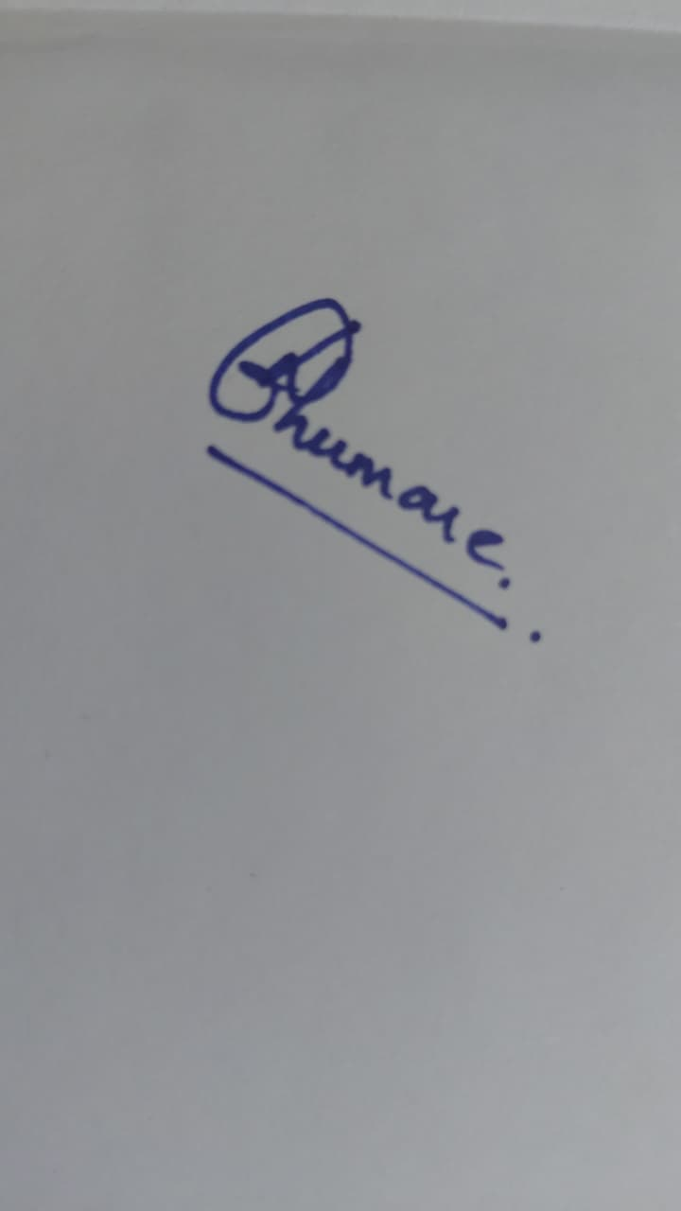 | Yes
Aaryesh Pathare (R045) | Yes | Yes | Yes | 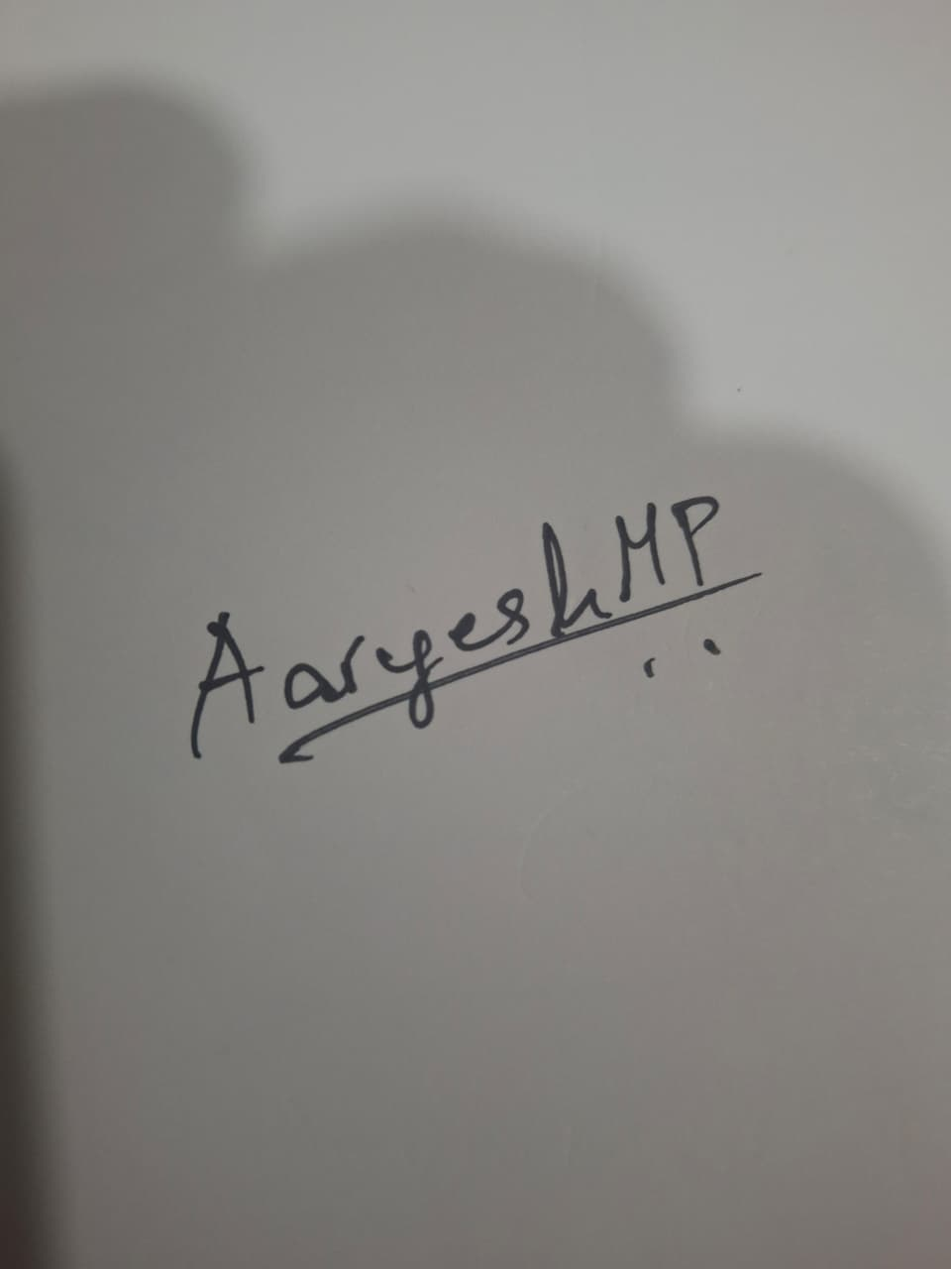 | Yes
Jiya Saxena (R054) | Yes | Yes | Yes | 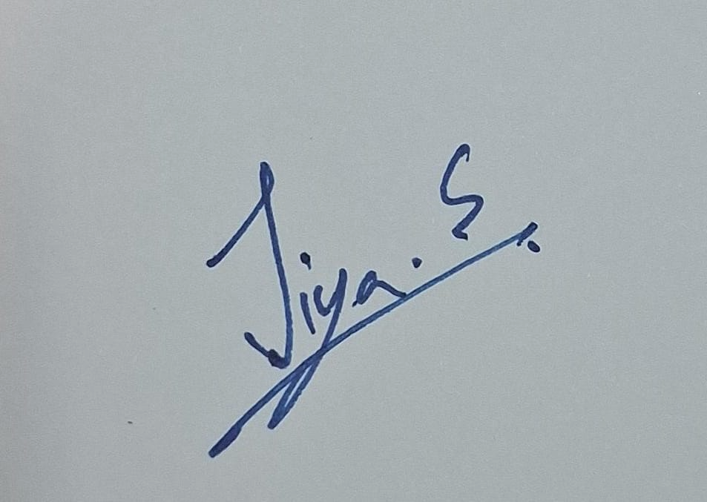 | Yes
*Optional: may Dr. Nanade use anonymised data from this dossier and repository in education research publications? Your answer has no effect on your marks, and you can withdraw until results are published.

