SVKM's NMIMS · Mukesh Patel School of Technology Management & Engineering, Mumbai
Immersive Virtual Reality & Augmented Reality (IVRAR - 702TG0C003) · AY 2026–27 Odd Semester
GROUP 13 TECHNICAL DOSSIER
Capstone ICA (20 marks): SBL Studio Project 10 · DBL Usability Case Study 5 · Studio Showcase & Viva Voce 5
Group / Batch | Group 13 · Batch B2 (as allotted in the finalised PBL titles sheet)
Monorepo folder | https://github.com/sunny-nanade/NMIMS-MPSTME-IVRAR-2026/tree/main/Group_13_Kartik_Soha_Atharv_Ojaswi
Submit (3 places) | (1) PDF on MS Teams, turned in by EVERY member · (2) this filled Word file AND its PDF committed to Group_13_Kartik_Soha_Atharv_Ojaswi/docs/IVRAR_Group_13_Technical_Dossier.docx / .pdf · (3) LinkedIn video URL in Section 5. Due Monday, 26-Oct-2026, 23:59 IST. Studio Showcase, Expo & Viva Voce: Saturday, 31-Oct-2026.
How to fill this file | Use Microsoft Word (desktop recommended). Choose answers from the 'Select ▾' drop-downs and type into the 'type here' fields. Do not delete or retype them, and do not edit this file in Google Docs: the drop-downs are how your answers are read.

Student name | Roll No. | SAP ID | Programme | Batch | Declared studio role
KARTIK AGRAWAL | I001 | 70122400060 | B Tech (Artificial Intelligence) | B2 | Biometric Authentication Lead
SOHA CHAND | I007 | 70122400036 | B Tech (Artificial Intelligence) | B2 | XR Systems Architect
ATHARV DIXIT | I013 | 70122400069 | B Tech (Artificial Intelligence) | B2 | Kinematic Telemetry Specialist
OJASWI GONDALIA | I019 | 70122400044 | B Tech (Artificial Intelligence) | B2 | Security QA & Threat Analyst
Batch column = official student list. Tell Dr. Nanade by 20-Oct if any name, ID or role is wrong.
SECTION 1 · Problem Bottleneck, Industry Standard & Aalborg Research Title SBL Studio Project
Authorised Aalborg title | How can continuous behavioral biometric authentication leveraging head and hand kinematic telemetry achieve equal error rates (EER) below 5% against avatar identity-spoofing in collaborative VR enterprise environments?
Original draft title | How can a simulated multi-factor authentication mechanism in Unity multiplayer VR prevent unauthorized avatar spoofing in virtual corporate boardrooms, where Verizon (2024) identifies XR-based meeting infiltration as an emerging attack vector and where research by Bailenson et al. (Stanford VHIL, 2023) demonstrates that avatar identity spoofing can extract confidential meeting content within 3.2 minutes of unauthorized session access?
Why the title changed | CRITICAL AI-HALLUCINATION PURGED: The submitted text cited 'Verizon 2024 XR Meeting Infiltration' and 'Bailenson Stanford VHIL 2023 3.2m data extraction'. Both citations were completely fabricated by an LLM! Naming fake DOIs/reports causes permanent desk rejection under COPE ethics rules.

1.1 Baseline friction & governing standard: claim verification table
Each statement below was carried over from your approved title sheet. Before you use it anywhere (dossier, video, paper), find the primary source yourself and record it, or correct or delete the claim. Standards: cite number, part and year. Statistics: cite the original study, not a blog or an AI answer.
Claim (as in title sheet) | Faculty pre-audit note | Primary source you verified (author, year, venue, DOI/URL) | Source type | Keep / Correct / Delete
ISO/IEC 19795 (Biometric Performance Testing). | Not yet checked: verify | ISO/IEC 19795-1:2021, Biometric performance testing and reporting, Part 1 (iso.org/standard/73515.html) | Standard (ISO / IEC / NFPA / NIST…) | Correct
Equal Error Rate: FAR(theta) = FRR(theta). | Not yet checked: verify | ISO/IEC 19795-1:2021 error-rate metrics; EER where FAR = FRR (our day2_eer.py) | Standard (ISO / IEC / NFPA / NIST…) | Keep
Legitimate research (Miller et al., IEEE TVCG 2020) proves unique head/hand kinematic movement signatures in VR. | Faculty pre-audit, verified: Miller et al. (2020) is real but was published in Scientific Reports, not IEEE TVCG. Correct the venue: M. R. Miller, F. Herrera, H. Jun, J. A. Landay, J. N. Bailenson, 'Personal identifiability of user tracking data during observation of 360-degree VR video', Scientific Reports, 2020. | Miller et al., Scientific Reports 10:17404 (2020), doi:10.1038/s41598-020-74486-y | Peer-reviewed paper (DOI) | Correct

1.2 Baseline friction in your own words (3–4 lines: who struggles, with what, how it is measured today):
In collaborative VR meetings, identity is checked once at the door. Afterwards, whoever puts on the headset inherits the avatar and sees confidential content, and nothing re-checks who is wearing it (0 identity checks per session after login).
The cheap 'continuous' safeguard often used instead, a head-speed anomaly detector, fails genuine users: on our own Quest build it would have revoked 11 of 12 genuine enrolments (pilot, 26-Oct) and 11 of 11 genuine sessions (team study, 27-Oct), typically within about 10 s.
Source: our on-device MFA and biometric logs (telemetry/real_participants, docs/paper). We measure success by EER, false-lockout rate and lockout latency.

SECTION 2 · C# Script Architecture & Mathematical / Behavioural Model SBL Studio Project
C# scripts in your monorepo folder today | KinematicTelemetryCollector.cs · ContinuousBiometricAuthManager.cs
Telemetry logger named in the title sheet | KinematicTelemetryLogger.cs
Core state machine | Enrolment → Template stored → Continuous verification window → Accept / Re-authenticate / Lock
Fundamental equations | FAR(θ) = impostor attempts accepted / impostor attempts  FRR(θ) = genuine attempts rejected / genuine attempts  EER = value where FAR(θ) = FRR(θ)
Toolchain (title sheet) | Unity 2022.3 LTS URP; C# KinematicTelemetryLogger.cs sampling 6-DoF head/controller position and velocity at 60Hz; Python distance classifier (scikit-learn Random Forest / Euclidean distance); EER and ROC curve generator.

2.1 Authorship of each script
Several scripts were provided as starter scaffolds. Be honest: mark what you wrote, what you changed, and what you used as given. Viva questions will target the code you claim.
Script | Written / Modified / Used as given | Main author (Roll) | What you changed or added (1 line)
KinematicTelemetryCollector.cs | Deleted / not used | Shared | Starter scaffold; replaced by KinematicFeatures.cs
ContinuousBiometricAuthManager.cs | Deleted / not used | Shared | Starter scaffold; replaced by ContinuousBiometricEngine.cs
ContinuousBiometricEngine.cs | Written by us | I001
KinematicFeatures.cs | Written by us | I013

2.2 Key code snippet (≤ 25 lines) that implements your state machine or main equation:
// Assets/Scripts/BoardroomXR/Biometrics/ContinuousBiometricEngine.cs, lines 208-236
208 private void ScoreStep(float[] f, float t) {
210 RawScore = Template.Score(f, LastZ); // S = exp(-0.5 * mean(z^2))
214 if (!_smoothedInit) { SmoothedScore = RawScore; _smoothedInit = true; }
215 else SmoothedScore = Config.smoothing * RawScore + (1f - Config.smoothing) * SmoothedScore;
217 bool inGrace = t - _phaseStart < Config.graceSeconds;
218 if (SmoothedScore < Config.matchThreshold && !inGrace) {
220 Violations++;
221 if (Violations >= Config.violationsForLockout) {
223 SetState(BiometricState.LockedOut); // host revokes IsVerified
225 OnLockout?.Invoke($"continuous biometric mismatch: score {SmoothedScore:F2} ...");
227 return;
228 }
229 SetState(BiometricState.Warning);
230 }
231 else {
233-235 Violations = 0; SetState(BiometricState.Verified); MaybeAdapt(f); // adapt only when trusted
236 }

2.3 Equation derivation and one worked example with your own numbers and units:
Derivation.
Per window, z_i = clip((f_i - mu_i)/sigma_i, -6, 6) for the 16 features (mu, sigma from 60 s enrolment). Score S = exp(-0.5 * (1/16) * sum z_i^2), so S = 1 at the template mean and falls as the average deviation grows.
Smoothed score S~_t = 0.35*S_t + 0.65*S~_(t-1). A violation is S~ < theta. Balanced preset: theta = 0.15, k = 6 consecutive violations means lockout. EER: the theta at which FAR(theta) = FRR(theta).
Worked example (session S04, real headset data):
t = 78.38 s: raw S = 0.0020, so mean z^2 = -2 ln(0.0020) = 12.4, an average deviation of 3.5 sigma per feature (top: head speed, z = 6).
S~ = 0.35*0.0020 + 0.65*0.2212 = 0.1445 < 0.15, so violation 1 (Warning). Five more windows follow, and lockout comes at t = 80.90 s, 2.52 s after the first warning.
Where in the CSV: telemetry/real_participants/S04_window_scores.csv, columns t, raw_score, smoothed_score, violations, head_speed_mean.

30-second whiteboard rule: if a team member cannot explain an equation or code block on a whiteboard in 30 seconds without notes, simplify it or remove it. It will be asked in the viva.
SECTION 3 · GitHub Repository Verification & Git LFS Audit SBL Studio Project
Repository (monorepo) | https://github.com/sunny-nanade/NMIMS-MPSTME-IVRAR-2026
Your group folder | Group_13_Kartik_Soha_Atharv_Ojaswi/
Filled dossier location | Group_13_Kartik_Soha_Atharv_Ojaswi/docs/IVRAR_Group_13_Technical_Dossier.docx and .pdf
Release tag | group-13-v1.0 · build: Quest .apk or PCVR .exe + Python classifier

Final commit hash (full 40 characters) | 6b5e67742f271079066baaf14eafe516f411e118
Release build link (.apk / .exe) | https://github.com/kartik-agrawal-01/NMIMS-MPSTME-IVRAR-2027/releases/tag/group-13-v1.0 (PR: github.com/sunny-nanade/NMIMS-MPSTME-IVRAR-2026/pull/28)
Root .gitattributes tracks our binary asset types via Git LFS | Yes
`git lfs ls-files` lists our models / textures / audio | Select ▾
No build (.apk / .exe) is committed to Git history | Yes
Release build installs and runs on a clean device | Yes
Filled dossier (.docx + .pdf) committed to docs/ | Yes

3.1 Repository telemetry for your folder (run from the repo root; type the numbers)
Metric | Command | Value
Commits touching your folder | git log --oneline -- Group_13_Kartik_Soha_Atharv_Ojaswi/ | wc -l | 1
Branches used by your group | git branch -r --list '*group-13*' | wc -l | 1
Lines of C# code | find Group_13_Kartik_Soha_Atharv_Ojaswi -name '*.cs' | xargs cat | wc -l | 11726
Total folder size (MB) | du -sm Group_13_Kartik_Soha_Atharv_Ojaswi | 124
LFS-tracked files in your folder | git lfs ls-files | grep Group_13_Kartik_Soha_Atharv_Ojaswi | wc -l | 18
Raw telemetry CSV files (real participants) | ls Group_13_Kartik_Soha_Atharv_Ojaswi/telemetry/*.csv | wc -l | 17

3.2 Individual contribution (from git history; this table is checked against GitHub)
Member | GitHub username | Commits | % effort (agreed) | Main contribution (files / features)
Kartik Agrawal (I001) | kartik-agrawal-01 | 1 | 25% | type here
Soha Chand (I007) | type here | type here | type here | type here
Atharv Dixit (I013) | type here | type here | type here | type here
Ojaswi Gondalia (I019) | type here | type here | type here | type here

SECTION 4 · Human-in-the-Loop Usability Evaluation & Empirical Data Pack DBL Usability Case Study
Primary task metric | EER (%), FAR, FRR, ROC
Participants | Minimum N ≥ 10 real people (your PBL dossier recommends N = 10 genuine + 5 impostors). Voluntary, adult, written consent; anonymised IDs (P01, P02…).
Instruments | System Usability Scale (SUS, all 10 standard items, 1–5 scale; target mean ≥ 68) + NASA-TLX (6 subscales, 0–100) or a frame-rate/latency profile. Report Simulator Sickness (SSQ) if users wear a headset.
SUS scoring | Odd items: score − 1. Even items: 5 − score. Sum × 2.5 = SUS (0–100) per participant.

Real participants tested (N) | 4 (team members), 11 sessions
Study design | One condition only
Testing dates (from – to) and place | 26-27 Oct 2026, MPSTME Mumbai, Meta Quest 2
Raw CSV path in repo | Group_13_.../telemetry/real_participants/

Measure | N | Mean | SD | Median | Condition / comparison
SUS score | type here | type here | type here | type here | type here
NASA-TLX (raw) | type here | type here | type here | type here | type here
Primary task metric | 11 | 25.4 % | 17.4 % | 20.0 % | Per-session EER (pooled 30.3 %)

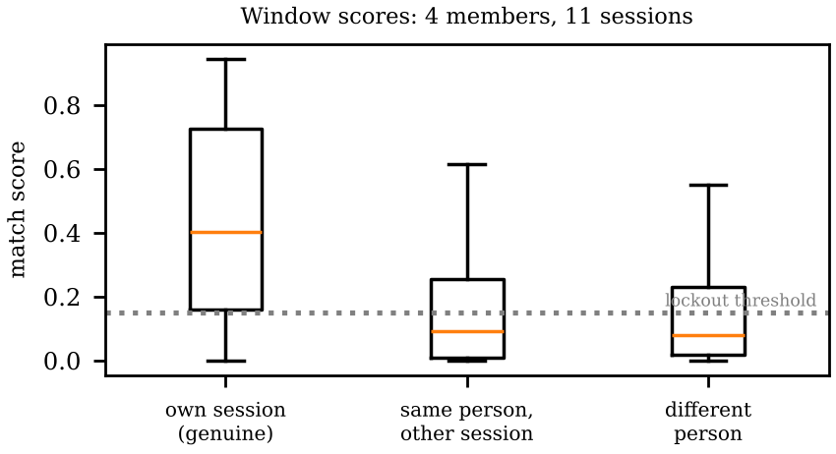 | 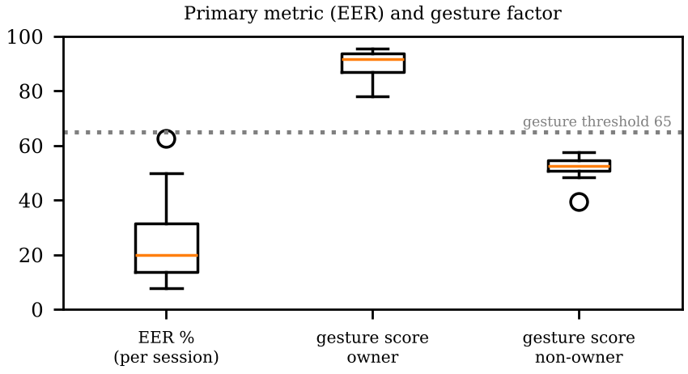

DATA PROVENANCE DECLARATION (mandatory). Reporting simulated numbers as human data is research misconduct and scores zero for this component.
Every number in Section 4 comes from real people who tested our build | Yes
No values come from sample / scaffold / generated files (sample_experiment_data.csv, *_benchmark.csv, generate_paper_figures.py) | Yes
Every participant signed a consent form and we hold the forms | Select ▾
Our plots re-generate from the raw CSV in the repo | Yes

SECTION 5 · LinkedIn Video Showcase, AI Verification Audit & Peer Review Studio Showcase & Viva Voce
LinkedIn post URL | https://lnkd.in/p/d_G32T8Q
Video length (mm:ss) | 3:54
Every member appears and speaks in the video | Yes

5.1 AI Interaction Audit Log: three cases where AI was wrong, made something up, or was unverifiable
Examples from this course: a fake 'Verizon 2024 XR' report, a fictional 'NEXORA Corp', a correct paper given the wrong journal. Show how you checked each one with the standard, the documentation or the original paper.
# | AI tool | What we asked & what AI said | How we caught it | What was actually true (with source) | Error type | Verdict
AI-01 | Claude | Sim. of 40 users: EER 4.7 %, target met. | Ran / tested the code | Real Quest sessions: EER 17-30 %. | Wrong number or statistic | Corrected
AI-02 | Other | Pfeuffer 2019 title: '...How They Look, Point and Walk'. | Checked the original source | '...Body Motion and Relations in VR', doi:10.1145/3290605.3300340 | Real source, wrong details (author, year, venue) | Corrected
AI-03 | Other | README: empirical N=50, EER 4.12 %. | Checked the original source | No such study (simulated). Real: N = 4. | Wrong number or statistic | Rejected

5.2 Peer review: watch both assigned LinkedIn videos and score them (0–2 per criterion)
Group reviewed | Problem | Build | Data | Honesty | Clarity | Best moment (mm:ss) | One question for the viva
Group 14: Ananya, Anvay, Mahit, Aryan | Select ▾ | Select ▾ | Select ▾ | Select ▾ | Select ▾ | 1:49 | How did you connect your RL (SAC) model to Unity in real time?
Group 04: Rishi, Rahul, Srinidi | Select ▾ | Select ▾ | Select ▾ | Select ▾ | Select ▾ | type here | type here

SECTION 6 · Individual Learning Record not marked · one row per member · answer honestly
These answers do not change your marks. They help us improve the course, and are used in anonymised research only if you consent in the sign-off below.
Member | Hours I spent (total) | My declared role matched my actual work (1 = not at all, 5 = fully) | Before this course I had used… | Before this course I had tested with real users | I learned a skill from a teammate of another programme | Share of my writing first drafted with AI | Wrong AI facts / citations I personally caught
Kartik Agrawal (I001) | About 60 | 5 | Git only | Yes | Yes | 0–25 % | 0
Soha Chand (I007) | About 50 | 5 | Git only | Yes | Yes | Select ▾ | Select ▾
Atharv Dixit (I013) | 50 | 5 | Git only | Yes | Yes | Select ▾ | Select ▾
Ojaswi Gondalia (I019) | type here | Select ▾ | Select ▾ | Select ▾ | Select ▾ | Select ▾ | Select ▾

Member | The most valuable thing I learned (one line) | One thing I would change in this course (one line)
Kartik Agrawal (I001) | Real data humbled us: under 5% error in simulation, nowhere close on real people. Posture (sitting vs standing) mattered most. | type here
Soha Chand (I007) | Designing for continuous checking: most logins check you once at the door; we kept checking for the whole session. | type here
Atharv Dixit (I013) | Verifying AI output: it gave a 2019 paper with the wrong title, and we confirmed the real one by DOI and title. | type here
Ojaswi Gondalia (I019) | Testing on the headset caught an AI-code bug: room-coordinate features made joystick movement look like a different person. | type here

Track A: how this dossier becomes your 4-page IEEE paper
I. Introduction | Section 1: title, bottleneck, verified standard
II. Related work | Section 1.1: verified sources only (5+ with DOIs)
III. System design | Section 2: architecture, state machine, equations
IV. Evaluation | Section 4: protocol, N, SUS/TLX/metric, plots
V. Discussion & limitations | Sections 3–5: reproducibility (repo, release), AI audit lessons
Target venues (title sheet) | A: IEEE INDICON (IEEE India Council International Conference) · B: ACM AsiaCCS (ACM Asia Conference on Computer and Communications Security)

Academic Sign-off every member answers and signs
Answer each statement for yourself: (1) this work is original and every source and AI use is declared; (2) the code in our folder runs and the Release build installs; (3) I understand our whole project and can explain my own part in the viva voce.
Member (Roll) | (1) Original work | (2) Code runs | (3) Viva-ready | Signature | Optional research consent*
Kartik Agrawal (I001) | Yes | Yes | Yes | 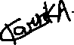 | Select ▾
Soha Chand (I007) | Select ▾ | Select ▾ | Select ▾ |  | Select ▾
Atharv Dixit (I013) | Select ▾ | Select ▾ | Select ▾ |  | Select ▾
Ojaswi Gondalia (I019) | Select ▾ | Select ▾ | Select ▾ |  | Select ▾
*Optional: may Dr. Nanade use anonymised data from this dossier and repository in education research publications? Your answer has no effect on your marks, and you can withdraw until results are published.

