SVKM's NMIMS · Mukesh Patel School of Technology Management & Engineering, Mumbai
Immersive Virtual Reality & Augmented Reality (IVRAR - 702TG0C003) · AY 2026–27 Odd Semester
GROUP 16 TECHNICAL DOSSIER
Capstone ICA (20 marks): SBL Studio Project 10 · DBL Usability Case Study 5 · Studio Showcase & Viva Voce 5
Group / Batch | Group 16 · Batch B2 (as allotted in the finalised PBL titles sheet)
Monorepo folder | Template folder: https://github.com/sunny-nanade/NMIMS-MPSTME-IVRAR-2026/tree/main/Group_16_Bhoomi_Kritivya_Tanvi_Jia · Team repository used for this work: https://github.com/bhoomibhandari88/VR-Disaster-Simulator (branch feature/factory-rescue-vr; dossier under Docs/IVRAR_dossier_DRAFT/)
Submit (3 places) | (1) PDF on MS Teams, turned in by EVERY member · (2) this filled Word file AND its PDF committed to Group_16_Bhoomi_Kritivya_Tanvi_Jia/docs/IVRAR_Group_16_Technical_Dossier.docx / .pdf · (3) LinkedIn video URL in Section 5. Due Monday, 26-Oct-2026, 23:59 IST. Studio Showcase, Expo & Viva Voce: Saturday, 31-Oct-2026.
How to fill this file | Use Microsoft Word (desktop recommended). Choose answers from the 'Select ▾' drop-downs and type into the 'type here' fields. Do not delete or retype them, and do not edit this file in Google Docs: the drop-downs are how your answers are read.

Student name | Roll No. | SAP ID | Programme | Batch | Declared studio role
BHOOMI BHANDARI | I004 | 70122400059 | B Tech (Artificial Intelligence) | B2 | Triage Clinical Protocol Lead
KRITIVYA MISHRA | I037 | 70122400043 | B Tech (Artificial Intelligence) | B2 | XR Systems Architect
TANVI PAITHANKAR | I044 | 70122400056 | B Tech (Artificial Intelligence) | B2 | Spatial Telemetry & Confusion Matrix Specialist
JIA JADHAV | I069 | 70122400084 | B Tech (Artificial Intelligence) | B2 | Human Factors & Usability Engineer
Batch column = official student list. Tell Dr. Nanade by 20-Oct if any name, ID or role is wrong.
SECTION 1 · Problem Bottleneck, Industry Standard & Aalborg Research Title SBL Studio Project
Authorised Aalborg title | How can an AI-driven VR mass-casualty triage simulation improve START protocol categorization accuracy and reduce assessment latency for emergency medical trainees under dynamic industrial hazard conditions?
Original draft title | How can an AI-adaptive VR simulation improve triage decision-making and situational awareness for NDRF trainees responding to simulated industrial explosion scenarios?
Why the title changed | The submitted title was conceptually strong but used generic phrasing ('train to perform accurate triage under chaos'). Needed sharpening into quantitative accuracy and latency metrics.

1.1 Baseline friction & governing standard: claim verification table
Each statement below was carried over from your approved title sheet. Before you use it anywhere (dossier, video, paper), find the primary source yourself and record it, or correct or delete the claim. Standards: cite number, part and year. Statistics: cite the original study, not a blog or an AI answer.
Claim (as in title sheet) | Faculty pre-audit note | Primary source you verified (author, year, venue, DOI/URL) | Source type | Keep / Correct / Delete
START (Simple Triage and Rapid Treatment) algorithm: RPM (Respiration, Perfusion, Mental Status) branches into Red, Yellow, Green, Black. | Not yet checked: verify | CHEMM (US HHS) START Adult Triage Algorithm, chemm.hhs.gov/startadult.htm and /startalgotext.htm (read 2026-10-25): walking, breathing, respiratory rate 30/min, perfusion by radial pulse OR capillary refill, obeys commands, tags green/yellow/red/black; original START used capillary refill, Benson, Koenig, Schultz 1996 (Prehosp Disaster Med, DOI 10.1017/S1049023X0004276X) used radial pulse. Build default = capillary refill > 2 s (2 s not on CHEMM text page; confirm), radial pulse selectable and logged separately. Training aid, not clinically validated. | Official report / documentation | Correct
Under-triage leads to preventable mortality; assessment must take < 60s/victim. | Not yet checked: verify | Kahn et al., Ann Emerg Med 2009;54(3):424-30, DOI 10.1016/j.annemergmed.2008.12.035 (148 pts: 3 under-, 79 over-triaged; no mortality/time data). Time: ~30 s (max 1 min) per IAVOAD START guide. Corrected. | Peer-reviewed paper (DOI) | Correct

1.2 Baseline friction in your own words (3–4 lines: who struggles, with what, how it is measured today):
Responders must sort many victims quickly with a simple method. In a 148-patient train-crash review, START under-triaged 3 and over-triaged 79 (Kahn 2009, DOI above). A time budget of about 30 s per patient appears in the IAVOAD START guide, a secondary source that has not been checked against a primary one (PENDING — TEAM INPUT REQUIRED). Our trainee baseline is NOT yet measured (Section 4).

SECTION 2 · C# Script Architecture & Mathematical / Behavioural Model SBL Studio Project
C# scripts in your monorepo folder today | STARTTriageSimulationManager.cs · TriageTelemetryLogger.cs · STARTEvaluator.cs · TriageSession.cs · TriageMetrics.cs · TriageCsv.cs · TriageScenario.cs · CasualtyProfile.cs · CasualtySelectable.cs · TriageUI.cs · TriageHazardEscalation.cs · TriageDesktopInput.cs · TriageTypes.cs (Assets/_Project/Scripts/Runtime/Triage/)
Telemetry logger named in the title sheet | TriageTelemetryLogger.cs
Core state machine | Casualty selected → Can walk? (Green) → Breathing? If not: reposition airway → breathing returns (Red) / still none (Black) → RR > 30/min? (Red) → Perfusion fails? capillary refill > 2 s [default variant] or radial pulse absent [alternative variant] (Red) → Cannot follow commands? (Red) → otherwise Yellow. Scripted rules in STARTEvaluator.Evaluate; no machine learning.
Fundamental equations | Triage accuracy = correct tags / casualties  Under-triage rate = (true Red tagged Yellow/Green) / true Red  Assessment latency per casualty (s)
Toolchain (title sheet) | Unity 6000.3.21f1 (URP 17.3.0); XR Interaction Toolkit 3.6.1; OpenXR 1.18.0 with Meta OpenXR 2.6.1; Input System 1.20.0. Industrial yard fire with 10 fixed casualties (CasualtyProfile components, colour tags shown on the casualty and chosen with panel buttons; there is no triage belt); TriageTelemetryLogger.cs writes the CSV files. Template entry "Unity 2022.3 LTS" is superseded by the project version.

2.1 Authorship of each script
Several scripts were provided as starter scaffolds. Be honest: mark what you wrote, what you changed, and what you used as given. Viva questions will target the code you claim. DRAFT NOTE: the casualty scenario is scripted (fixed findings, cosmetic hazard escalation); there is no machine-learning or adaptive AI component. The triage code in this repository was drafted with an AI assistant (Claude) in a coding session and reviewed by the team only in part; authorship dropdowns stay unselected until each member states what they actually wrote or changed. Project version: Unity 6000.3.21f1 (see Toolchain); casualties are lying/standing models in an industrial yard fire with colour tags, not a belt. PENDING = PENDING — TEAM INPUT REQUIRED.
Script | Written / Modified / Used as given | Main author (Roll) | What you changed or added (1 line)
STARTTriageSimulationManager.cs | Select ▾ | Select ▾ | AI-drafted (Claude). PENDING — TEAM INPUT REQUIRED
TriageTelemetryLogger.cs | Select ▾ | Select ▾ | AI-drafted (Claude). PENDING — TEAM INPUT REQUIRED
STARTEvaluator.cs | Select ▾ | Select ▾ | AI-drafted (Claude). PENDING — TEAM INPUT REQUIRED
TriageSession.cs | Select ▾ | Select ▾ | AI-drafted (Claude). PENDING — TEAM INPUT REQUIRED

2.2 Key code snippet (≤ 25 lines) that implements your state machine or main equation:
STARTEvaluator.cs Evaluate() lines 39-64 (blank lines omitted)
39 if (v.canWalk)
40 return new StartResult(TriageCategory.Green, TriageBranch.Walking, "Can walk.");
42 if (!v.isBreathing)
43 {
44 if (!airwayRepositioned)
45 return new StartResult(TriageCategory.Red, TriageBranch.ApneaAirwayNotAttempted, "Not breathing: reposition the airway first.");
46 return v.breathingAfterAirwayReposition
47 ? new StartResult(TriageCategory.Red, TriageBranch.ApneaRespondsToAirway, "Not breathing; breathing restored after airway repositioning.")
48 : new StartResult(TriageCategory.Black, TriageBranch.ApneaNoResponseToAirway, "Not breathing and no breathing after airway repositioning.");
49 }
51 if (v.respiratoryRate > RespiratoryRateThreshold)
52 return new StartResult(TriageCategory.Red, TriageBranch.RespiratoryRateAbove30,
53 "Respiratory rate " + v.respiratoryRate.ToString(CultureInfo.InvariantCulture) + "/min is above 30.");
55 if (PerfusionFails(v, criterion))
56 return new StartResult(TriageCategory.Red, TriageBranch.PoorPerfusion,
57 criterion == PerfusionCriterion.CapillaryRefill
58 ? "Capillary refill " + v.capillaryRefillSeconds.ToString("0.#", CultureInfo.InvariantCulture) + " s is above 2 s."
59 : "Radial pulse absent.");
61 if (!v.followsCommands)
62 return new StartResult(TriageCategory.Red, TriageBranch.CannotFollowCommands, "Cannot follow simple commands.");
64 return new StartResult(TriageCategory.Yellow, TriageBranch.AllChecksPassed, "Breathing, perfused and obeys commands but cannot walk.");

2.3 Equation derivation and one worked example with your own numbers and units:
Derivation. For N classified casualties with ground-truth tag g_i (from STARTEvaluator.GroundTruth) and assigned tag a_i: accuracy = (1/N) · Σ [a_i = g_i] = correct / classified. Under-triage rate = U / R, where R = number of casualties with g_i = Red and U = those among them with a_i ∈ {Yellow, Green}. Latency of casualty i: L_i = t_tag,i − t_select,i (s), where t_select is the first time the trainee selects that casualty and t_tag the moment the tag is assigned. Mean = (1/n) Σ L_i and median over the n valid latencies. A zero denominator (N = 0 or R = 0) is written as NA, never 0.
CSV mapping. accuracy, casualties_classified, correct, under_triage_rate, true_red_total, true_red_under_triaged, mean_latency_s, median_latency_s (summary file); assessment_latency_s, ground_truth, assigned, is_correct, true_red_under_triaged (records file).
ILLUSTRATIVE worked example (invented numbers, not measured data). A session tags 5 casualties: 4 are true Red, 1 is true Yellow. The trainee tags two true Reds as Red, one as Yellow, one as Green, and the true Yellow as Red. correct = 2, so accuracy = 2/5 = 0.40. R = 4, U = 2, so under-triage rate = 2/4 = 0.50. Latencies 2, 4, 6, 8, 10 s give mean = 30/5 = 6.0 s and median = 6.0 s. The same case is checked by the unit test Metrics_AccuracyUnderTriageAndLatency_AreCorrect.

2.4 Build configuration, test methodology and results to date; headset test (planned)
Build configuration (from the repository). Unity 6000.3.21f1; Universal Render Pipeline 17.3.0; XR Interaction Toolkit 3.6.1; OpenXR 1.18.0 with the Meta OpenXR feature 2.6.1; Input System 1.20.0. Android player: IL2CPP, ARM64 only, Vulkan graphics API, minimum SDK 29, target SDK automatic, package com.rescuesim.factoryrescue, version 0.1.0. Five scenes in the build: MainMenu, FactoryRescue, EarthquakeRescue, FloodEvacuation, TriageSimulation.
What the software is. A scripted educational START exercise: ten fixed casualties, fixed findings, rule-based tagging in STARTEvaluator, cosmetic smoke/light escalation. It contains no trained model and does no AI classification. It is a training aid built from published START descriptions and is not clinically validated or reviewed by a clinician. Adults only (no JumpSTART).
Protocol variant implemented. START adult, four tags. Perfusion check: capillary refill > 2 s by default (original START formulation); radial pulse absent is a separately selectable variant (Benson et al. 1996). The variant is shown on the start panel and written to every CSV row (protocol_perfusion); the two are never mixed in one session. The 2 s threshold is NOT stated on the CHEMM text page the team could read and must be confirmed in the original source.
Automated test methodology. EditMode tests (pure C#, injected clock) cover every START branch and boundary (respiratory rate 30/31, capillary refill 2.0/2.01 s, both perfusion variants), correct/incorrect and under-triage cases, zero denominators, latency rules, partial sessions, reset and repeat runs, CSV header/escaping/row completeness and file export. PlayMode tests load the real TriageSimulation scene and drive the real manager, UI buttons and logger (full ten-casualty run, partial export on restart, no findings shown before a check, wrong-tag feedback, retag refusal, menu button).
Recorded automated results (Unity Editor on macOS, 2026-10-26). EditMode 109 passed, 0 failed; PlayMode 31 passed, 0 failed (source: Builds/TestSummary.txt; Docs/BUILD_REPORT.md). These are Editor tests, not headset tests.
Recorded build result (2026-10-26). DisasterResponseVR.apk, 242,635,956 bytes, SHA-256 a533c6d08427da2d5268c421d9d6cb5ea64f807248abdce518c7476798ecd6f4, debug-signed, built from the working tree at commit 5f7ac5e (includes fix f054410). Build reported Succeeded with 354 warnings and one NullReferenceException raised in the OpenXR package's Meta Quest validation rules (MetaQuestFeature.CreateValidationRules); the cause is unresolved and it is not proven harmless on a device. The APK has NOT been installed or run on any headset and is NOT validated on a Quest.
Known limitations and safety. Fixed scenario (memorisable); hazards do not change a casualty's findings; single device family; no controller ergonomics, comfort or frame-rate data yet; stop a session at once if a participant feels unwell. Software-test and rehearsal data are labelled SoftwareTest/Pilot and are never human-study data.
Headset test record. [PENDING — COMPLETE AFTER HEADSET TESTING] The headset test is planned for an upcoming class session; nothing below has been done. Fill after the session; do not edit earlier sections to match.
Field | Entry
Headset model and firmware version | [PENDING — COMPLETE AFTER HEADSET TESTING]
Test environment (room, play area, lighting, standing/seated, Wi-Fi/USB) | [PENDING — COMPLETE AFTER HEADSET TESTING]
APK / build tested (file name, bytes, SHA-256, commit) | [PENDING — COMPLETE AFTER HEADSET TESTING] (expected: SHA-256 a533c6d0…ecd6f4 for the APK built 2026-10-26)
Install method and result (adb install -r) | [PENDING — COMPLETE AFTER HEADSET TESTING]
Functions and interactions that worked (menu, select, six checks, tag, results, restart, teleport/turn) | [PENDING — COMPLETE AFTER HEADSET TESTING]
Bugs, crashes, tracking or controller issues (with steps to reproduce) | [PENDING — COMPLETE AFTER HEADSET TESTING]
Frame rate / comfort observations (SSQ or notes) | [PENDING — COMPLETE AFTER HEADSET TESTING]
Fixes applied (commit hashes) and retest results | [PENDING — COMPLETE AFTER HEADSET TESTING]
Tester name(s) and date | [PENDING — COMPLETE AFTER HEADSET TESTING]
Remaining limitations after the test | [PENDING — COMPLETE AFTER HEADSET TESTING]

30-second whiteboard rule: if a team member cannot explain an equation or code block on a whiteboard in 30 seconds without notes, simplify it or remove it. It will be asked in the viva.
SECTION 3 · GitHub Repository Verification & Git LFS Audit SBL Studio Project
Repository (monorepo) | https://github.com/bhoomibhandari88/VR-Disaster-Simulator (team repository, branch feature/factory-rescue-vr). Template monorepo: https://github.com/sunny-nanade/NMIMS-MPSTME-IVRAR-2026
Your group folder | Repository root; code in Assets/_Project/, documents in Docs/
Filled dossier location | Docs/IVRAR_dossier_DRAFT/IVRAR_Group_16_Technical_Dossier_FINAL_CANDIDATE.docx and .pdf (final file name to be agreed by the team)
Release tag | group-16-v1.0 · build: Quest .apk · PENDING: release not published; tag not created

Final commit hash (full 40 characters) | f05441073ed9c3fc794deb61c0e17f1da2e487dc (code commit, pushed; repo bhoomibhandari88/VR-Disaster-Simulator, branch feature/factory-rescue-vr; branch head when this table was filled: 74e92797fdf8aec7370969cdef53d34184b7e1f2)
Release build link (.apk / .exe) | PENDING — TEAM INPUT REQUIRED (release not published)
Root .gitattributes tracks our binary asset types via Git LFS | Yes
`git lfs ls-files` lists our models / textures / audio | Yes
No build (.apk / .exe) is committed to Git history | Yes
Release build installs and runs on a clean device | Select ▾
Filled dossier (.docx + .pdf) committed to docs/ | Select ▾

3.1 Repository telemetry for your folder (run from the repo root; type the numbers)
Metric | Command | Value
Commits touching your folder | git rev-list --count HEAD | 22 at 74e9279: 13 "Claude", 9 Bhoomi Bhandari (+3 Bhoomi on feature/bhoomi-work)
Branches used by your group | git branch -a | wc -l | 8 (2 local + 6 remote-tracking refs)
Lines of C# code | find Assets/_Project -name '*.cs' | xargs cat | wc -l | 10087 (Assets/_Project)
Total folder size (MB) | du -sm --exclude=Library --exclude=Builds --exclude=.git . | 697 (working tree excl. Library/Builds/.git, 2026-10-26)
LFS-tracked files in your folder | git lfs ls-files | wc -l | 249
Raw telemetry CSV files (real participants) | ls telemetry/*.csv | wc -l (no telemetry/ folder exists) | 0 (no participant data exists)

3.2 Individual contribution (from git history; this table is checked against GitHub)
Member | GitHub username | Commits | % effort (agreed) | Main contribution (files / features)
Bhoomi Bhandari (I004) | PENDING: member supplies own username | 12 in git (9 here + 3 on bhoomi-work); confirm | PENDING: agreed by team | Git shows: project setup with Git LFS (22-23 Sep 2026); factory environment import and URP material conversion; early victim/vital-signs data classes (VictimData.cs, VitalSigns.cs, commit ea174c8, branch feature/bhoomi-work). Member to confirm and add work not visible in git. PENDING — TEAM INPUT REQUIRED
Kritivya Mishra (I037) | PENDING: member supplies own username | 0 found in git; confirm | PENDING: agreed by team | No commits under this member's name. PENDING — TEAM INPUT REQUIRED: state your real files/features and how they can be evidenced
Tanvi Paithankar (I044) | PENDING: member supplies own username | 0 found in git; confirm | PENDING: agreed by team | No commits under this member's name. PENDING — TEAM INPUT REQUIRED: state your real files/features and how they can be evidenced
Jia Jadhav (I069) | PENDING: member supplies own username | 0 found in git; confirm | PENDING: agreed by team | No commits under this member's name. PENDING — TEAM INPUT REQUIRED: state your real files/features and how they can be evidenced

3.2 note. Git history cannot show individual effort for most of this work: 13 of the 22 commits on this branch are authored "Claude" (AI-assisted sessions; which member directed each session is not recorded), 9 are Bhoomi Bhandari, and no commit carries Kritivya Mishra's, Tanvi Paithankar's or Jia Jadhav's name. No effort percentages are stated. EACH member must supply: (1) own GitHub username; (2) a list of files/features personally written or changed and how to verify them; (3) hours; (4) agreed effort % (team must sum to 100). PENDING — TEAM INPUT REQUIRED.
SECTION 4 · Human-in-the-Loop Usability Evaluation & Empirical Data Pack DBL Usability Case Study
Primary task metric | Accuracy (%), under-triage (%), 4×4 confusion matrix
Participants | Minimum N ≥ 10 real people (your PBL dossier recommends N = 20). Voluntary, adult, written consent; anonymised IDs (P01, P02…).
Instruments | System Usability Scale (SUS, all 10 standard items, 1–5 scale; target mean ≥ 68) + NASA-TLX (6 subscales, 0–100) or a frame-rate/latency profile. Report Simulator Sickness (SSQ) if users wear a headset.
SUS scoring | Odd items: score − 1. Even items: 5 − score. Sum × 2.5 = SUS (0–100) per participant.

Real participants tested (N) | PENDING
Study design | Select ▾
Testing dates (from – to) and place | PENDING — TEAM INPUT REQUIRED
Raw CSV path in repo | PENDING — TEAM INPUT REQUIRED

Measure | N | Mean | SD | Median | Condition / comparison
SUS score | PENDING | PENDING | PENDING | PENDING | PENDING — TEAM INPUT REQUIRED
NASA-TLX (raw) | PENDING | PENDING | PENDING | PENDING | PENDING — TEAM INPUT REQUIRED
Primary task metric | PENDING | PENDING | PENDING | PENDING | PENDING — TEAM INPUT REQUIRED

[ SUS box-plot (per condition) ] | [ Task-metric / latency plot ]

DATA PROVENANCE DECLARATION (mandatory). Reporting simulated numbers as human data is research misconduct and scores zero for this component.
Every number in Section 4 comes from real people who tested our build | Select ▾
No values come from sample / scaffold / generated files (sample_experiment_data.csv, *_benchmark.csv, generate_paper_figures.py) | Select ▾
Every participant signed a consent form and we hold the forms | Select ▾
Our plots re-generate from the raw CSV in the repo | Select ▾

SECTION 5 · LinkedIn Video Showcase, AI Verification Audit & Peer Review Studio Showcase & Viva Voce
LinkedIn post URL | PENDING — TEAM INPUT REQUIRED
Video length (mm:ss) | PENDING
Every member appears and speaks in the video | Select ▾

5.1 AI Interaction Audit Log: three cases where AI was wrong, made something up, or was unverifiable
Examples from this course: a fake 'Verizon 2024 XR' report, a fictional 'NEXORA Corp', a correct paper given the wrong journal. Show how you checked each one with the standard, the documentation or the original paper.
# | AI tool | What we asked & what AI said | How we caught it | What was actually true (with source) | Error type | Verdict
AI-01 | Select ▾ | (AI-drafted from the session record; member to confirm) We had AI build the triage UI. On selecting a casualty it printed that casualty findings (e.g. "limping but walking") before the trainee ran any START check. | Select ▾ | (AI-drafted from the session record; member to confirm) Findings must appear only after the trainee runs that check. Found in QA and fixed in commit f054410; a PlayMode test now asserts the description stays neutral. | Select ▾ | Select ▾
AI-02 | Select ▾ | (AI-drafted from the session record; member to confirm) AI-written README and release notes quoted 107 EditMode / 29 PlayMode tests and an APK SHA-256 for the pre-fix build. | Select ▾ | (AI-drafted from the session record; member to confirm) Stale, not invented: after the fix the suites were rerun (109 / 31 pass) and the APK rebuilt (SHA-256 a533c6d0...ecd6f4). Docs corrected; see Docs/BUILD_REPORT.md. | Select ▾ | Select ▾
AI-03 | Select ▾ | (AI-drafted from the session record; member to confirm) AI stated that the original START perfusion rule is capillary refill > 2 s but could not open the CHEMM PDF (blocked) to confirm the 2 s figure. | Select ▾ | (AI-drafted from the session record; member to confirm) The 2 s threshold is not on the CHEMM text page the AI could read; it is marked "confirm" in 1.1. The team must check the original source before the viva. | Select ▾ | Select ▾

5.2 Peer review: watch both assigned LinkedIn videos and score them (0–2 per criterion)
Group reviewed | Problem | Build | Data | Honesty | Clarity | Best moment (mm:ss) | One question for the viva
Group 17: Samarth, Ishan, Aarush, Sachi | Select ▾ | Select ▾ | Select ▾ | Select ▾ | Select ▾ | PENDING — TEAM INPUT REQUIRED | PENDING — TEAM INPUT REQUIRED
Group 07: Shirin, Khushi, Pranjal | Select ▾ | Select ▾ | Select ▾ | Select ▾ | Select ▾ | PENDING — TEAM INPUT REQUIRED | PENDING — TEAM INPUT REQUIRED

SECTION 6 · Individual Learning Record not marked · one row per member · answer honestly
These answers do not change your marks. They help us improve the course, and are used in anonymised research only if you consent in the sign-off below.
Member | Hours I spent (total) | My declared role matched my actual work (1 = not at all, 5 = fully) | Before this course I had used… | Before this course I had tested with real users | I learned a skill from a teammate of another programme | Share of my writing first drafted with AI | Wrong AI facts / citations I personally caught
Bhoomi Bhandari (I004) | PENDING — TEAM INPUT REQUIRED | Select ▾ | Select ▾ | Select ▾ | Select ▾ | Select ▾ | Select ▾
Kritivya Mishra (I037) | PENDING — TEAM INPUT REQUIRED | Select ▾ | Select ▾ | Select ▾ | Select ▾ | Select ▾ | Select ▾
Tanvi Paithankar (I044) | PENDING — TEAM INPUT REQUIRED | Select ▾ | Select ▾ | Select ▾ | Select ▾ | Select ▾ | Select ▾
Jia Jadhav (I069) | PENDING — TEAM INPUT REQUIRED | Select ▾ | Select ▾ | Select ▾ | Select ▾ | Select ▾ | Select ▾

Member | The most valuable thing I learned (one line) | One thing I would change in this course (one line)
Bhoomi Bhandari (I004) | PENDING — TEAM INPUT REQUIRED | PENDING — TEAM INPUT REQUIRED
Kritivya Mishra (I037) | PENDING — TEAM INPUT REQUIRED | PENDING — TEAM INPUT REQUIRED
Tanvi Paithankar (I044) | PENDING — TEAM INPUT REQUIRED | PENDING — TEAM INPUT REQUIRED
Jia Jadhav (I069) | PENDING — TEAM INPUT REQUIRED | PENDING — TEAM INPUT REQUIRED

Track A: how this dossier becomes your 4-page IEEE paper
I. Introduction | Section 1: title, bottleneck, verified standard
II. Related work | Section 1.1: verified sources only (5+ with DOIs)
III. System design | Section 2: architecture, state machine, equations
IV. Evaluation | Section 4: protocol, N, SUS/TLX/metric, plots
V. Discussion & limitations | Sections 3–5: reproducibility (repo, release), AI audit lessons
Target venues (title sheet) | A: IEEE INDICON (IEEE India Council International Conference) · B: iLRN (Immersive Learning Research Network)

Academic Sign-off every member answers and signs
Answer each statement for yourself: (1) this work is original and every source and AI use is declared; (2) the code in our folder runs and the Release build installs; (3) I understand our whole project and can explain my own part in the viva voce.
Member (Roll) | (1) Original work | (2) Code runs | (3) Viva-ready | Signature | Optional research consent*
Bhoomi Bhandari (I004) | Select ▾ | Select ▾ | Select ▾ |  | Select ▾
Kritivya Mishra (I037) | Select ▾ | Select ▾ | Select ▾ |  | Select ▾
Tanvi Paithankar (I044) | Select ▾ | Select ▾ | Select ▾ |  | Select ▾
Jia Jadhav (I069) | Select ▾ | Select ▾ | Select ▾ |  | Select ▾
*Optional: may Dr. Nanade use anonymised data from this dossier and repository in education research publications? Your answer has no effect on your marks, and you can withdraw until results are published.

APPENDIX A · Role evidence: code excerpts and screenshots
Each member's declared studio role is paired below with the real code and screenshots that belong to it. An excerpt here does NOT establish who wrote it: authorship is declared by each member in 2.1 and 3.2. Excerpts are verbatim from the repository at commit 74e9279 (blank lines omitted, original line numbers kept, ≤ 25 lines each). Screenshots are Unity Editor captures (Game view in Play mode, and the editor scene camera) — none was taken on a headset. No participant data appears anywhere in this appendix.
A.1 Bhoomi Bhandari (I004) · Triage Clinical Protocol Lead: START rules and the perfusion variant
STARTEvaluator.cs lines 23-29 and 68
23 public const int RespiratoryRateThreshold = 30;
24 public const float CapillaryRefillThresholdSeconds = 2f;
26 public static bool PerfusionFails(VitalSigns v, PerfusionCriterion criterion) =>
27 criterion == PerfusionCriterion.CapillaryRefill
28 ? v.capillaryRefillSeconds > CapillaryRefillThresholdSeconds
29 : !v.hasRadialPulse;
68 public static TriageCategory GroundTruth(VitalSigns v, PerfusionCriterion criterion) => Evaluate(v, criterion, true).category;

What it shows: the respiratory-rate threshold (30/min) and the perfusion criterion are explicit constants, and the two published perfusion variants (capillary refill > 2 s, or absent radial pulse) are switched by one enum so they are never mixed in a session. Ground truth is START with the airway manoeuvre performed. The file header credits the decision-tree idea to Bhoomi's TriageEvaluator (branch feature/bhoomi-work, commit ea174c8); the adaptation in this repository was AI-assisted (Claude).
Verification still owed by this role: PENDING — TEAM INPUT REQUIRED — confirm the 2 s capillary-refill threshold and the order of checks against the original START description (the CHEMM text page read by the team does not state 2 s). The implementation is a training aid and is not clinically validated.
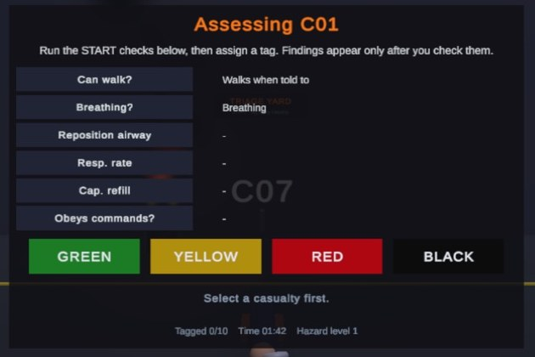
Figure A1. Assessment panel in Play mode (Unity Editor, desktop keys; XR Simulator controller visible). Casualty C01 is selected and two checks have been run: "Can walk?" and "Breathing?" show findings; the other four rows still show "-". The line "Findings appear only after you check them" is the fix in commit f054410. Test settings: participant TEST, data source SoftwareTest.

A.2 Kritivya Mishra (I037) · XR Systems Architect: XR selection and scene
CasualtySelectable.cs lines 8-9, 11-13, 17-20
8 [RequireComponent(typeof(XRSimpleInteractable))]
9 public class CasualtySelectable : MonoBehaviour
11 [SerializeField] STARTTriageSimulationManager manager;
12 [SerializeField] CasualtyProfile casualty;
13 XRSimpleInteractable _interactable;
17 void Awake() { _interactable = GetComponent<XRSimpleInteractable>(); }
18 void OnEnable() { _interactable.selectEntered.AddListener(OnSelect); }
19 void OnDisable() { _interactable.selectEntered.RemoveListener(OnSelect); }
20 void OnSelect(SelectEnterEventArgs _) { if (manager != null && casualty != null) manager.SelectCasualty(casualty); }

What it shows: every casualty is an XR Interaction Toolkit XRSimpleInteractable; a controller ray + trigger (selectEntered) calls the manager, which opens the assessment. Stack from the repository: Unity 6000.3.21f1, URP 17.3.0, XR Interaction Toolkit 3.6.1, OpenXR 1.18.0 + Meta OpenXR 2.6.1, Input System 1.20.0; Android IL2CPP, ARM64, Vulkan, minimum SDK 29.
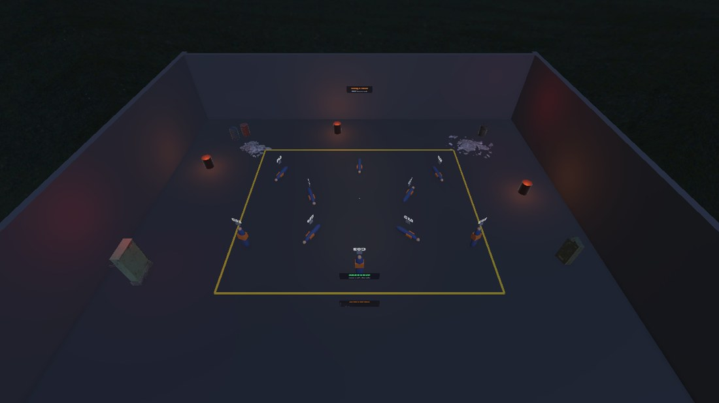  Figure A2. Triage yard from above: ten fixed casualties C01-C10 inside the marked zone, with fire barrels and signs (Unity Editor scene camera, not a headset). | 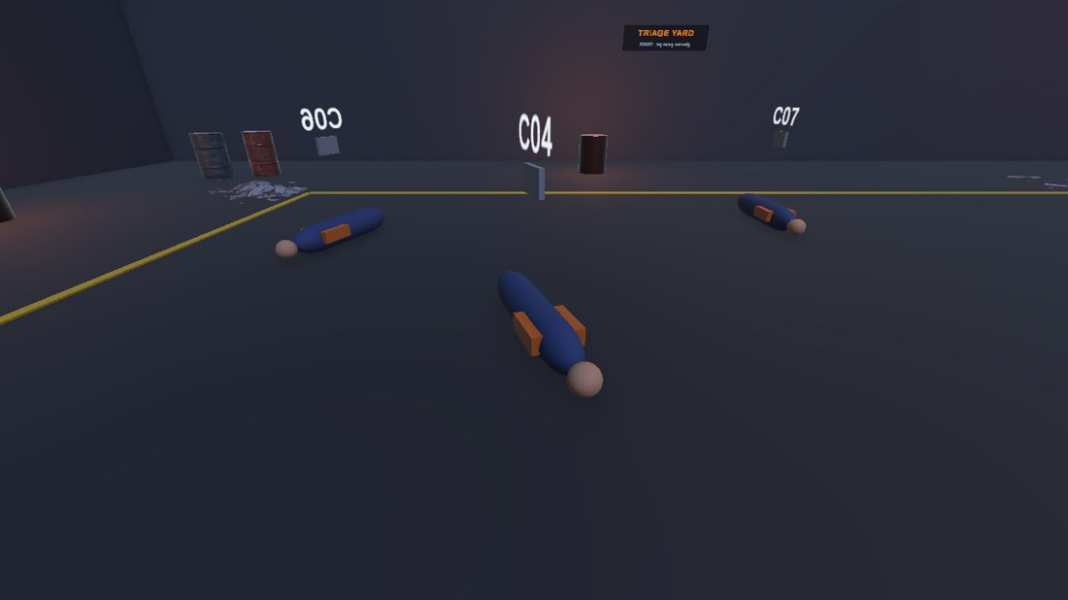  Figure A3. Close view of casualties with floating ID labels (Unity Editor scene camera).

Observations to check on the headset (PENDING — TEAM INPUT REQUIRED): (1) in these Editor captures some casualty ID labels appear mirrored depending on the viewpoint; confirm that labels face the player in VR. (2) In Play mode the feedback line showed "Select a casualty first." after C01 was already selected (Figure A1); confirm and report in the headset-test record. (3) The Meta Quest OpenXR validation NullReferenceException on build is unresolved. Headset interaction, comfort and frame rate are untested.
A.3 Tanvi Paithankar (I044) · Spatial Telemetry & Confusion Matrix Specialist: metrics and CSV
TriageMetrics.cs lines 26-31, 36-37, 39-42
26 foreach (var r in records)
27 {
28 if (r.assigned == TriageCategory.None) continue;
29 s.classified++;
30 if (r.isCorrect) s.correct++;
31 if (r.groundTruth == TriageCategory.Red)
36 if (r.groundTruth != TriageCategory.None) s.confusion[(int)r.groundTruth - 1, (int)r.assigned - 1]++;
37 if (r.latencyValid) lat.Add(r.latencySeconds); else s.invalidLatencyCount++;
39 s.hasAccuracy = s.classified > 0;
40 s.accuracy = s.hasAccuracy ? (double)s.correct / s.classified : 0.0;
41 s.hasUnderTriageRate = s.trueRedTotal > 0;
42 s.underTriageRate = s.hasUnderTriageRate ? (double)s.trueRedUnderTriaged / s.trueRedTotal : 0.0;

TriageCsv.cs lines 11-18 (26 record columns)
11 public static readonly string[] RecordColumns =
12 {
13 "session_id", "data_provenance", "participant_id", "protocol_perfusion", "casualty_id",
14 "ground_truth", "assigned", "is_correct", "true_red_under_triaged", "expected_branch",
15 "assessment_start_utc", "assessment_end_utc", "assessment_start_s", "assessment_end_s", "assessment_latency_s", "latency_valid",
16 "hazard_level", "inputs_examined", "airway_repositioned",
17 "obs_can_walk", "obs_breathing", "obs_breathing_after_airway", "obs_resp_rate", "obs_cap_refill_s", "obs_radial_pulse", "obs_follows_commands"
18 };

What it shows: accuracy = correct / classified; under-triage rate = true-Red tagged Yellow/Green / true-Red; a zero denominator sets Has* = false and is written as "NA", never 0; the 4 x 4 confusion matrix is indexed [ground truth, assigned]. Per session the app writes <session>_records.csv (26 columns), <session>_summary.csv (17) and <session>_confusion.csv (rows = ground truth, columns = assigned; Green, Yellow, Red, Black).
Pooled confusion matrix (rows = ground truth, columns = assigned) | Green | Yellow | Red | Black
Green | PENDING | PENDING | PENDING | PENDING
Yellow | PENDING | PENDING | PENDING | PENDING
Red | PENDING | PENDING | PENDING | PENDING
Black | PENDING | PENDING | PENDING | PENDING

The matrix, the latency plot and any statistics are PENDING — TEAM INPUT REQUIRED: they need real participant files (run Docs/tools/analyze_study.py on them). No values are shown because no human data exists.
A.4 Jia Jadhav (I069) · Human Factors & Usability Engineer: trainee prompts, study instruments, SUS scoring
TriageUI.cs lines 137-140
137 void OnSelected(CasualtyProfile c)
138 {
139 if (headerText != null) headerText.text = "Assessing " + c.Id;
140 if (descriptionText != null) descriptionText.text = "Run the START checks below, then assign a tag. Findings appear only after you check them.";

Docs/tools/analyze_study.py lines 44-48 (SUS = 2.5 x sum of item contributions)
44 def sus_from_items(row):
45 items = [num(row.get("sus_q%d" % i)) for i in range(1, 11)]
46 if any(v is None or v != int(v) or not 1 <= v <= 5 for v in items):
47 return None
48 return 2.5 * sum((v - 1) if i % 2 == 0 else (5 - v) for i, v in enumerate(items)) # i=0 is item 1 (odd)

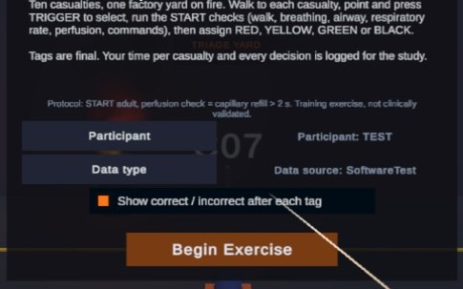
Figure A4. Start panel in Play mode (Unity Editor; title row cropped out): participant ID selector (TEST), data-source selector (SoftwareTest), the feedback toggle, and the protocol line "START adult, perfusion check = capillary refill > 2 s. Training exercise, not clinically validated." The faint text behind the panel is a casualty label seen through the semi-transparent panel.

Instrument / item | Status
Consent form, briefing script, SUS (10 items), NASA-TLX (6 scales), simplified SSQ | Prepared in Docs/PARTICIPANT_PACK.md — blank; none administered
Analysis + validation script | Docs/tools/analyze_study.py (self-test passes on throw-away data; no real data analysed)
Participants, SUS/NASA-TLX scores, latency/accuracy results | PENDING — TEAM INPUT REQUIRED — N = 0 so far
Headset test and usability observations | [PENDING — COMPLETE AFTER HEADSET TESTING] (record table in 2.4)

