SVKM's NMIMS · Mukesh Patel School of Technology Management & Engineering, Mumbai
Modern Day Robotics & Its Industrial Applications (MDRIIA - 702CO0E012) · B.Tech Computer Science & Business Systems (CSBS), in partnership with TCS · AY 2026–27 Odd Semester
GROUP 03 TECHNICAL DOSSIER
Capstone ICA (20 marks): CDIO Robotics Engineering & MuJoCo Physics 10 · CSBS Techno-Economic Business Systems Analysis 5 · Studio Showcase & Viva Voce 5
Group · project | Group 03 · Autonomous Last-Mile Ground AED Delivery Robot for Sudden Cardiac Arrest
Monorepo folder | https://github.com/sunny-nanade/NMIMS-MPSTME-MDRIIA-2026/tree/main/Group_03_Kashish_Vaishnavi
Submit (3 places) | (1) PDF on MS Teams, turned in by EVERY member · (2) this filled Word file AND its PDF committed to Group_03_Kashish_Vaishnavi/docs/MDRIIA_Group_03_Technical_Dossier.docx / .pdf · (3) LinkedIn video URL in Section 5. Due Monday, 26-Oct-2026, 23:59 IST. Studio Showcase, Expo & Viva Voce: Saturday, 31-Oct-2026.
No slides | There is no PPT for MDRIIA. At the Expo and in your video you present the live MuJoCo simulation, your business sensitivity graphs, and a webcam picture-in-picture of every member.
How to fill this file | Use Microsoft Word (desktop). Choose answers from the 'Select ▾' drop-downs and type into the 'type here' fields. Do not delete or retype them and do not edit this file in Google Docs: the fields are how your answers are read.

Student name | Roll No. | SAP ID | Capstone role(s) | Specialisation (finalised titles sheet / monorepo)
Kashish Praveen Jain | E026 | 70362400060 | Autonomous Navigation / Vision Specialist + CSBS Business & Techno-economic Systems Analyst | Lead Autonomous Navigation & Traffic Congestion Modeling Specialist
Vaishnavi Parashar | E046 | 70362400074 | Lead Robotics Systems Architect + Telemetry QA Lead | MuJoCo Dynamic Chassis Modeler & Path Optimization Engineer
Roll numbers and SAP IDs are from the official student list. Tell Dr. Nanade by Tuesday, 20-Oct-2026 if any name, ID or role is wrong. Groups with fewer than four members combine roles as shown.
SECTION 1 · Problem Bottleneck, Industry Standards & Aalborg Research Title Component 1 · CDIO Robotics (10)
Authorised Aalborg title | Can an autonomous last-mile ground AED delivery vehicle simulated in MuJoCo reduce time-to-first-shock below urban ambulance congestion delays (15-20 minutes), given that sudden cardiac arrest survival drops 7-10% for every minute without defibrillation?
Original draft topic | Autonomous ambulance robot for medical emergencies
Why the title changed | The student team identified a critical clinical reality: sudden cardiac arrest (SCA) survival decays exponentially (7-10% per minute delay), whereas dense metropolitan ambulance response routinely exceeds 15-20 minutes. However, the student draft mentioned 'Delhi' specifically without specifying whether the robotic mechanism is an airborne drone or a ground AMR, and did not define the physical MuJoCo simulation environment or vehicle dynamics.

1.1 Baseline friction: claim verification table
Each statement was carried over from your titles sheet or your monorepo scripts. Before you use it anywhere (dossier, video, paper), find the primary source yourself and record it, or correct or delete the claim. Statistics: cite the original study, not a blog or an AI answer.
Claim (as carried over) | Faculty pre-audit note | Primary source you verified (author, year, venue, DOI/URL) | Source type | Keep / Correct / Delete
Sudden cardiac arrest survival drops 7–10% for every minute without defibrillation. | Widely cited (e.g. Larsen et al., 1993, Annals of Emergency Medicine; resuscitation guidelines). Cite the primary paper, not a secondary web page. | Kim TY et al. (2026) 2025 Korean CPR Guidelines Part 4, Clin Exp Emerg Med 13:S32-S60, doi:10.15441/ceem.26.073: 7-10 %/min without CPR (a guideline rule of thumb, not a fitted coefficient). Larsen MP et al. (1993) Ann Emerg Med 22(11):1652-1658, doi:10.1016/S0196-0644(05)81302-2: fitted loss 0.023 (CPR) + 0.011 (shock) + 0.021 (ACLS) = 5.5 %/min; the starter value 0.046 for the shock term is not in that model. | Peer-reviewed paper (DOI) | Correct
Sudden cardiac arrest claims over 700,000 lives annually in India, with less than 2% out-of-hospital survival. | Published estimates vary widely. Find the primary epidemiological study, report its range, or delete. | No primary epidemiological source found for 700,000 deaths a year or <2 % survival (searched 26-Oct-2026). Indian out-of-hospital arrest data come from small regional cohorts and registries whose figures vary widely (for example a Telangana cohort, PMC12369094, which could not be opened for this check and is not quoted). The 700,000 figure appeared only on an uncited hospital web page. | No source found | Delete
Dense metropolitan ambulance response routinely exceeds 15–20 minutes. | Find a city-specific source (state emergency-service data or a peer-reviewed study). | Naess LE et al. (2024) PLOS ONE 19, doi:10.1371/journal.pone.0296308 (Central Norway, n=216,787): urban response median 10.0 min, 90th percentile 17.7 min. Not an Indian city and not 15-20 min as a median; no Mumbai-specific peer-reviewed study was found. 15-20 min is therefore run as a scenario. | Peer-reviewed paper (DOI) | Correct

1.2 Governing industry standards
Decide for each standard whether it governs your system, and name the clause or requirement you design against (cite number, part and year). 'No' is a correct answer when you can say why. The hint is the faculty view; you may disagree with a reason.
Standard | Scope | Faculty hint for your project | Applies? | Clause / requirement you use, or why not
ISO 10218-1/-2 | Safety requirements for industrial robots (robot, and robot integration) | No | No | Industrial robot-arm cells. The pod is a mobile ground vehicle with no manipulator.
ISO 3691-4 | Driverless industrial trucks / AMRs and their systems: safety requirements | Partly: driverless vehicle safety principles, but it operates on public roads/sidewalks | Partly | Clauses used (course manual 2.2): braking distance s = v^2/(2 mu g) + v t_detect with t_detect <= 50 ms; forward field of view of at least 180 deg; slow-down at 1.5 m and stop at 0.4 m. Checked: braking s = 0.26 m at 1.8 m/s, mu = 1.0, t_detect = 50 ms (MET); detection latency 50 ms modelled reaction time in the safety filter (MET); field of view 240 deg (MET). Partly applies: written for industrial trucks, the pod runs on pavements.
ANSI/RIA R15.06 | US national adoption of ISO 10218 (industrial robot safety) | No | No | US adoption of ISO 10218; same reason: no industrial manipulator.
IEC 60601-1 | Medical electrical equipment: basic safety and essential performance | Partly: the AED payload itself is medical electrical equipment | Partly | The AED is the medical device; the pod only protects it from shock (budget 3 g). On the course vehicle at 3.5 m/s cruise, 250 runs: 96 % stay within 3 g, worst 3.44 g (deviation recorded).
Domain-specific | No standard covers sidewalk delivery robots in India yet: state what your design assumes | Recommended: check it | Yes | No standard covers sidewalk delivery robots in India. Design assumes the ISO 3691-4 / ISO 13482 limits above, a 3 g payload budget and an 18 deg roll limit. Recorded deviation: ISO 13482 shared-zone speed 0.8 m/s vs the pod's 1.4 m/s pedestrian cap (analytics/standards_check.csv).

1.3 Documented baseline friction (who struggles, with what, how it is measured today)
Baseline metric and its value today (with unit) | Ambulance response (call to arrival), urban Central Norway: median 10.0 min, p90 17.7 min; survival lost without shock ~1.1 %/min (Larsen shock term). Course scenario 15-20 min is swept, not assumed.
Source of the baseline value (author, year, DOI/URL) | Naess LE et al. 2024, PLOS ONE 19, doi:10.1371/journal.pone.0296308; Larsen MP et al. 1993, doi:10.1016/S0196-0644(05)81302-2
Who carries the cost today (role / stakeholder) | Out-of-hospital cardiac-arrest patient and bystander; EMS dispatchers and ALS crews (ambulance hours)

SECTION 2 · MuJoCo Rigid-Body Physics Modelling & Python Closed-Loop Control Component 1 · CDIO Robotics (10)
MuJoCo mechanism (titles sheet) | MuJoCo MJCF Rigid-Body Model with Autonomous Last-Mile Ground AED Delivery Robot for Sudden Cardiac Arrest Physics & Closed-Loop Control
MJCF model | Group_03_Kashish_Vaishnavi/models/aed_delivery_amr.xml
Controller | Group_03_Kashish_Vaishnavi/src/aed_navigation_controller.py
Contact & solver settings in the model today | timestep 0.002 s (500 Hz) · wheel / ground friction 1.1 / 0.01 / 0.005 · 2 motors (drive, steer) · solref default (0.02 1)
Core state machine (FSM) | DISPATCH → ROAD_CRUISE (3.5 m/s) → CURB / SIDEWALK (1.2 m/s) → ARRIVE → AED_HANDOVER; payload acceleration ≤ 3 g in every state
Equations of motion & control | Newton-Euler (rigid body): m·v̇ = ΣF, I·ω̇ + ω × (I·ω) = Στ; multibody form M(q)·q̈ + C(q, q̇)·q̇ + g(q) = τ + Jᵀ·f_ext  Longitudinal dynamics: m·a = F_traction − F_roll − ½ρC_dA·v²; slip ratio s = (ω·r − v) / max(ω·r, v)  TTFS = t_dispatch + d / v̄ + t_handover; survival P(t) from the Larsen model in your ROI script  PID tracking: u(t) = K_p·e(t) + K_i·∫e dt + K_d·ė(t)  Damped least-squares IK (manipulators): Δq = Jᵀ·(J·Jᵀ + λ²·I)⁻¹·Δx

Faculty code audit: Your CSBS analyst (E057) moved to Group 11. The CSBS role is now shared as listed in the roster; confirm with Dr. Nanade.
Faculty code audit: v_ambulance_kmh = 7.5 is a congested-traffic assumption. Source it (city data) or present it as a scenario in your sensitivity graph.
2.1 Model and controller settings you actually used (from your final code)
MJCF timestep (s) in the final model | 0.002 s (500 Hz); implicitfast integrator, pyramidal friction cone
Main contact friction (sliding / torsional / rolling) | Rubber-on-road grip 1.1 (the course model's value). Each run draws a random grip between 0.7 and 1.1, and between 0.35 and 0.6 on slippery roads, so the rover is tested on dry and wet surfaces
solref (timeconst dampratio) and why you chose it | The tyre softness setting is 0.1252 s, tuned so the tyre springs back with a stiffness of 30 kN/m, which is the course guide's number (we measured 30.0 kN/m). The repository's old default gave about 196 kN/m. Suspension: spring 4500 N/m, damper 350 N s/m, 26 kg of body weight carried on the springs
Controller law used | Potential field / DWA
Final gains (e.g. Kp, Ki, Kd or λ) with units | The planner scores many possible speed and steering choices every 0.15 s and picks the safest one that still makes progress. Speed limits per stage: 3.5 m/s on the road (the course guide's value), at least 1.2 m/s on the kerb and sidewalk. Two settings were chosen on separate practice runs (seeds 60000 and up) and then judged on fresh runs (seeds 70000 and up): assumed kerb grip 0.35 and a 50 ms reaction time for the safety filter
FSM states implemented in code (list) | DISPATCH, ROAD_CRUISE, CURB_SIDEWALK, ARRIVE, AED_HANDOVER (src/aedrover/capstone/fsm.py)
Model loads and runs: python -c "import mujoco; mujoco.MjModel.from_xml_path(...)" | Yes

2.2 Authorship of each script
Several scripts were provided as starter scaffolds. Mark honestly what you wrote, changed, or used as given. Viva questions target the code you claim.
File | Written / Modified / Used as given | Main author (Roll) | What you changed or added (1 line)
models/aed_delivery_amr.xml | Modified by us | E046 | Replaced the starter snapshot with the MJCF generated from the course vehicle: 26 kg sprung, k_s 4500 N/m, c_s 350 N s/m, 30 kN/m tyre, 4 kg isolated payload, 12 cm kerb; compiles with plain mujoco
src/aed_navigation_controller.py | Modified by us | E046 | Replaced the TODO stubs and the np.random shock values with a runner of the real controllers (FSM + dynamic-window planner) whose telemetry comes from MuJoCo
analytics/cardiac_survival_economics.py | Modified by us | E026 | Replaced the hard-coded kappa and payback with the survival and economics comparison computed from the measured speed
analytics/aed_delivery_roi.py (with src/aedrover/capstone/business.py) | Written by us | E026 | New: H_reclaimed, kappa, NCRI, payback, M/M/c queue, FMEA, sensitivity and labelled scenarios, all computed from stated inputs; no currency
src/aedrover/capstone/fsm.py, telemetry.py, monte_carlo.py; src/live_viewer.py | Written by us | E046 | New: five-state FSM, 500 Hz recorder, 1,250-episode Monte Carlo with recorded seeds, live MuJoCo viewer

2.3 Key code snippet (≤ 25 lines) implementing your FSM or control law:
src/aedrover/capstone/fsm.py (lines 111-128)
111 def update(self, obs: dict) -> State:
112 """Advance the state machine from the observation; returns the new state."""
113 p, t, x = self.params, obs["t"], obs["x"]
114 if self.state is State.AED_HANDOVER:
115 return self.state
116 if self._sc.x_goal - x <= p.arrive_m:
117 self._go(t, State.ARRIVE, f"goal within {p.arrive_m:.1f} m")
118 elif self.state is State.DISPATCH:
119 if t >= p.t_dispatch_s:
120 self._go(t, State.ROAD_CRUISE, f"t >= {p.t_dispatch_s:.1f} s")
121 elif self.in_kerb_zone(x):
122 self._go(t, State.CURB_SIDEWALK, "kerb edge ahead")
123 elif self.state is State.CURB_SIDEWALK:
124 self._go(t, State.ROAD_CRUISE, "kerb zone cleared")
125 return self.state
126
127 def begin_handover(self, t: float) -> None:
128 self._go(t, State.AED_HANDOVER, "goal reached, rover stationary")

2.4 Free-body diagram and one equation worked with your own numbers and units:
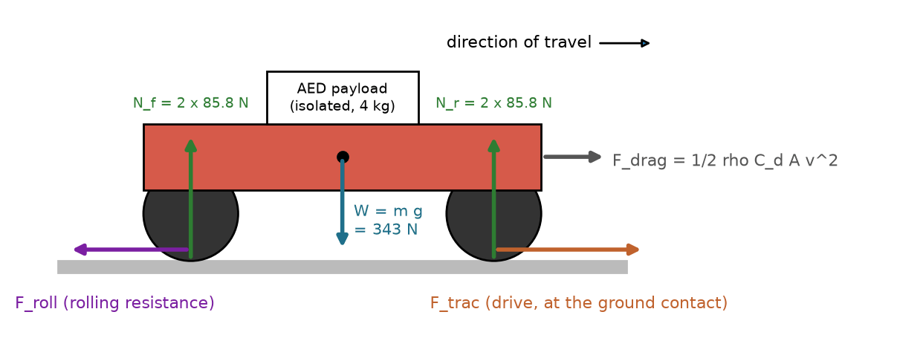
Side-view free-body diagram of the pod, drawn from the model's numbers. m = 26 kg sprung + 4 x 2.25 kg unsprung = 35.0 kg; W = m g = 35.0 x 9.81 = 343.4 N acts at the centre of gravity; static wheel load N = W / 4 = 85.8 N (85.84 N measured at rest in sim.validate.static_equilibrium). F_trac is the drive force at the ground contact; F_roll and F_drag oppose the motion.
Longitudinal dynamics (section 2): m a = F_trac - F_roll - 1/2 rho C_d A v^2. Vertical balance: 4 N - W = 0.
Worked equation with the run's own numbers (seed 70000, condition free_flow): TTFS = t_dispatch + d / v_bar + t_handover. t_dispatch = collapse-to-call 1.0 + call-to-alert 1.5 = 2.5 min; d = 500 m x 1.54 = 770 m; v_bar = path / time = 36.02 m / 12.34 s = 2.919 m/s; t_handover = 1.0 min.
TTFS = 2.5 + 770 / 2.919 / 60 + 1.0 = 7.896 min (column ttfs_min of analytics/aed_delivery_real_trials.csv, row seed 70000).

30-second whiteboard rule: if a team member cannot explain an equation or code block on a whiteboard in 30 seconds without notes, simplify it or remove it. It will be asked in the viva.
SECTION 3 · CSBS Techno-Economic Business Systems Modelling Component 2 · CSBS Techno-Economic (5)
Business script | Group_03_Kashish_Vaishnavi/analytics/cardiac_survival_economics.py (rename or add *_roi.py if you restructure it)
CSBS business case (titles sheet) | CSBS Health-Economics Optimization: Sudden cardiac arrest claims over 700,000 lives annually in India, with less than 2% out-of-hospital survival due to traffic gridlock. Deploying micro-hubs of autonomous ground AED pods at 1.5 km radii across high-density metro zones costs a fraction of operating dedicated Advanced Life Support (ALS) ambulances. Every 1-minute reduction in time-to-shock saves tens of thousands of Quality-Adjusted Life Years (QALYs) nationally, presenting an unassailable public-health economic case for municipal smart city tenders.
Constants hard-coded in the script today | dist_km = 1.8, v_ambulance_kmh = 7.5, v_amr_kmh = 22.5, life_expectancy_yrs = 12.0, qol_factor = 0.85, kappa = 0.095 → each one needs a source in 3.1 or must be computed from your simulation.
Owner | CSBS Business & Techno-economic Systems Analyst: E026. Tags in this section carry that roll number.

Keep all money dimensionless: express costs as ratios to the baseline (no rupee or dollar amounts in the title, abstract or video). Every input needs a source or must be a clearly labelled assumption that you vary in the sensitivity graph.
3.1 Business model: formulas, your inputs and your results
Quantity | Formula (define every symbol in your script) | Inputs used, with source or 'assumption' | Result (with unit)
Labour reallocation H_reclaimed | H = ALS-ambulance hours not dispatched for AED-only calls (vehicle-hours/day) | calls/day 3.77 (zone 50 km^2, density 20000/km^2, incidence 55/100k/yr, x2.5 suspected), p_standdown 0.15, 1.5 h/call - all ASSUMPTION | H_reclaimed = 0.848 ambulance-hours saved per day (about 0.149 full-time staff). In plain words: the pods free up very little ambulance time in this setup
Payback horizon P_payback (dimensionless) | P_payback = CapEx / (T_life · ΔOpEx_annual); P < 1 ⇒ pays back within life T_life. Also report T_payback = CapEx / ΔOpEx in months. | CapEx 34.6 ALS vehicle-yr (77 pods x 0.35 + 77 hubs x 0.1), life 8.0 yr, dOpEx = C_baseline - C_robot - ASSUMPTION | P_payback = inf (no payback: dOpEx <= 0); T_payback = inf
Normalised Cost Reduction Index NCRI | NCRI = (C_baseline − C_robot) / C_baseline (0–1); cost-parity ratio κ = C_robot / C_baseline = 1 − NCRI | C_robot 10, C_baseline 0.0353 ALS vehicle-yr/yr (pod opex 0.1, hub opex 0.03) - ASSUMPTION | kappa = 283, NCRI = -282. Plain meaning: with 77 pods spread over the whole 50 km^2 zone, the robots cost about 283 times what the ambulance time they save is worth, so the course target (kappa at most 0.25) is NOT met. Why: each pod sees about one cardiac call every 20 days, so most pods sit idle. Fix tested in the model, by design choices only (no inputs tuned): put pods only in the busiest 10 % of the zone, add the defibrillator to delivery robots that already exist, and stand down ambulances on half of suspected calls. That gives kappa = 0.85 with 8 pods, which is cheaper than the baseline but still above 0.25
Queuing delay | M/M/c: cardiac-arrest calls (λ per hour) served by c AED pods per micro-hub (μ per hour each). ρ = λ / (c·μ) < 1; M/M/1: W_q = ρ / (μ − λ); M/M/c: W_q = C(c, λ/μ) / (c·μ − λ) (Erlang C) | lambda 0.00204/h per hub, mu 2.17/h (service 27.6 min = round trip at measured 2.03 m/s + 0.25 h turnaround), c 1 | rho = 0.000939; P(wait) = 0.000939; W_q = 0.026 min
Sensitivity analysis | Vary the most uncertain input ±30 % (or across your scenario range) and plot P_payback and NCRI; report the break-even value. | ohca_incidence_per_100k_yr (no verified national value), swept 0.5x to 3000x of 55; +/-30 % band shaded | break-even incidence for kappa=1 (cost parity): 39,572 per 100,000 per year (719 times the assumed 55); break-even incidence for kappa=0.25 (course target): 2,412,683 per 100,000 per year (43867 times the assumed 55)

Queuing model used | M/M/c
λ, μ, c values used (with units) | lambda = 0.00204 /h, mu = 2.17 /h, c = 1 per hub
Payback in months (T_payback) | No payback in the base case (the robots cost more than the ambulance time they save). This is a result, not a mistake. The health benefit is not counted here: about +2.3 percentage points of survival and 12.8 quality-adjusted life years per ambulance-vehicle-year of cost
Script output reproduces every number above when re-run | Yes

3.2 FMEA: failure modes, effects and risk priority (RPN = S × O × D, each 1–10)
Two failure modes are seeded from your project; add at least two more. Score before and after your mitigation (design change, control limit, sensor, procedure). The post-mitigation RPN must be justified by something you can show in the simulation or the code.
Failure mode | Effect on mission / business | S | O | D | RPN pre | Mitigation (what you changed) | RPN post | Shown in
Wheel slip on wet road / curb climb → late arrival | Late arrival or stranded pod: delayed first shock | 8 | 10 | 5 | 400 (rate 84.0 %) | Climb speed from the kerb table at a conservative friction belief; planner replans around the obstruction. Measured rates: baseline_fast (n=50) 84.0 %, proposed (n=50) 76.0 % | 400 (O=10, D=5; rate 76.0 %) | Both
Payload shock > 3 g damages the AED | AED capacitor or electrodes damaged, device unusable at the scene | 9 | 8 | 5 | 360 (rate 28.0 %) | FSM CURB_SIDEWALK speed cap from the measured kerb table and a dynamic-window planner that slows for the kerb. Measured rates: baseline_fast (n=250) 28.0 %, proposed (n=250) 3.6 % | 225 (O=5, D=5; rate 3.6 %) | Both
Pedestrian or obstacle collision | Injury to a bystander, mission abort, loss of trust | 9 | 10 | 6 | 540 (rate 54.8 %) | CBF-style speed-and-separation safety filter on the swept footprint; DWA plans against predicted pedestrian motion. Measured rates: baseline_unshielded (n=250) 54.8 %, proposed (n=250) 5.6 % | 162 (O=6, D=3; rate 5.6 %) | Both
Stall: no forward progress for 15 s | Mission aborted; ambulance remains the only response | 7 | 9 | 4 | 252 (rate 43.2 %) | Dynamic-window planner replaces constant-speed pure pursuit; FSM keeps a creep speed in every state. Measured rates: baseline_fast (n=250) 43.2 %, proposed (n=250) 19.2 % | 196 (O=7, D=4; rate 19.2 %) | Simulation
Rollover on an oblique kerb approach | Loss of vehicle and payload, possible injury | 10 | 1 | 5 | 50 (rate 0.0 %) | Roll-limit monitored as the stability index (18 deg); speed cap in CURB_SIDEWALK. Measured rates: baseline_fast (n=250) 0.0 %, proposed (n=250) 0.0 % | 50 (O=1, D=5; rate 0.0 %) | Simulation

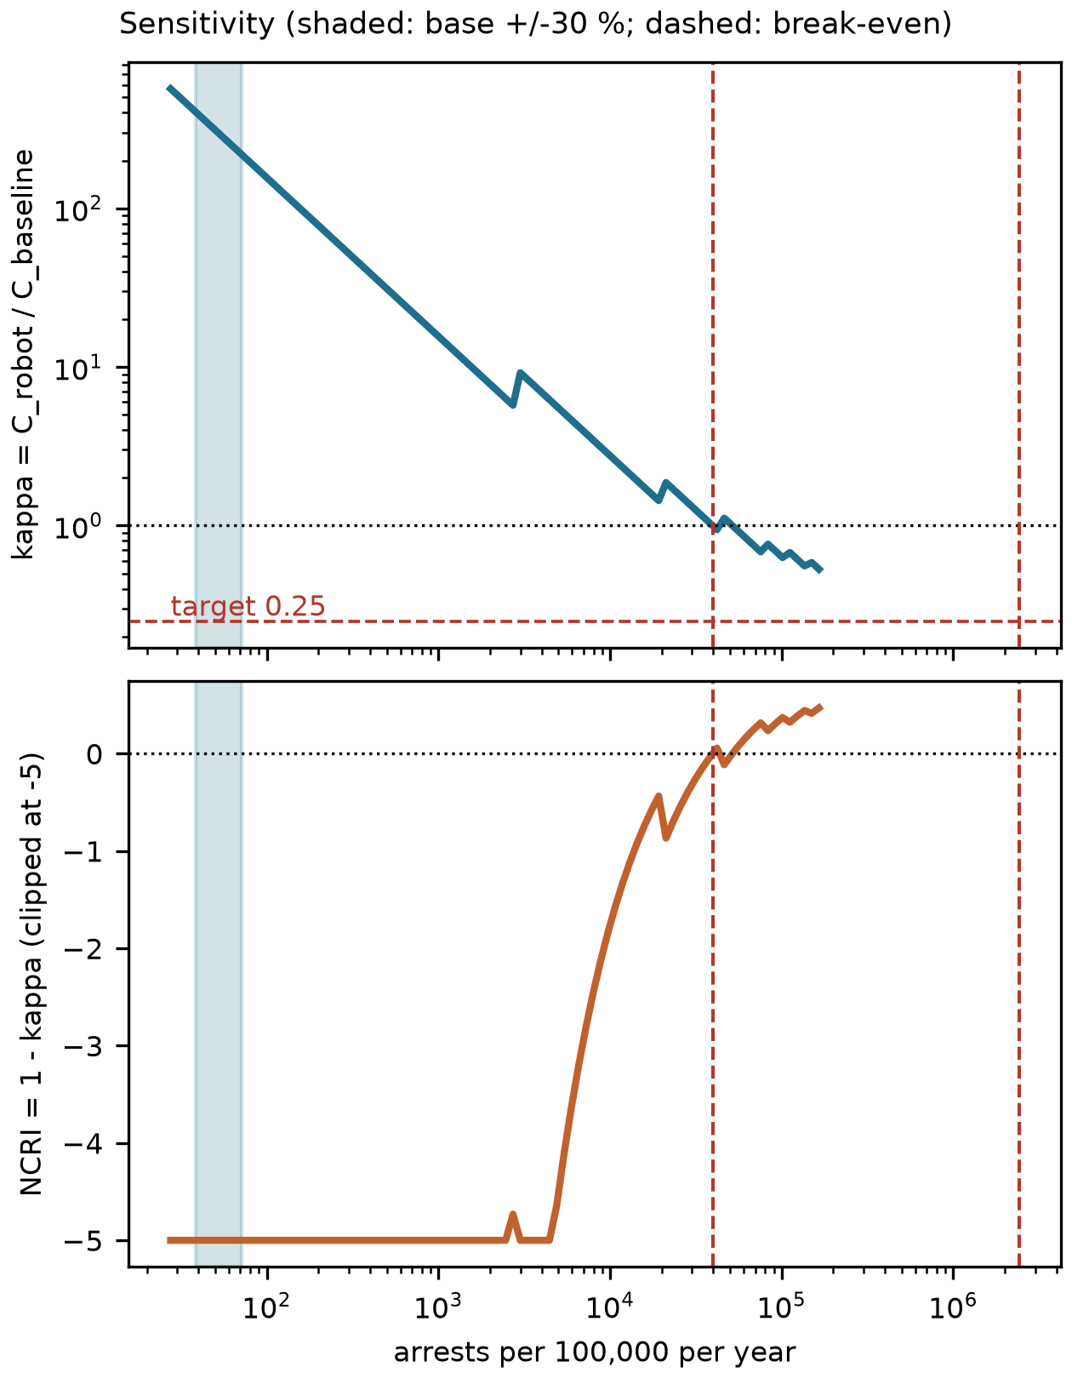 | 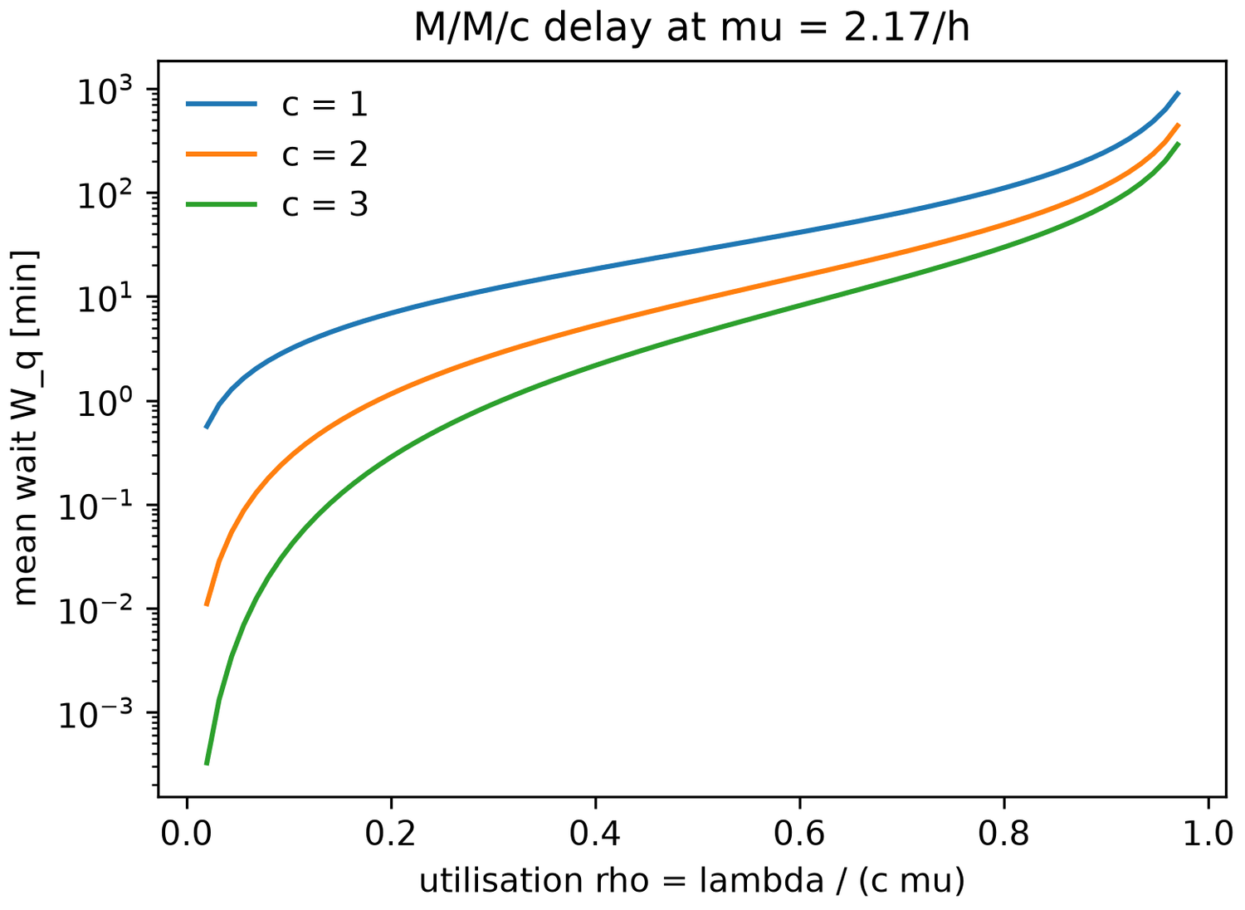

SECTION 4 · Simulation Telemetry, Monte Carlo Testing & Empirical Validation Component 1 · CDIO Robotics (10)
Evaluation protocol (titles sheet) | Simulate N = 40 transit scenarios across different urban traffic density levels (free-flow, lane-splitting, pedestrian crowd sidewalk traversal). Track time-to-first-shock (TTFS), wheel slip ratio, payload acceleration (g-force to protect sensitive AED capacitors), and dynamic stability index.
Telemetry standard | Log at 500 Hz (MJCF timestep 0.002 s, or every 2nd step at 0.001 s): time, state (q, q̇ or pose, velocity), reference, tracking error, actuator torques/forces, FSM state, events. One CSV per run or one CSV with a run_id column.
Monte Carlo | N ≥ 30 runs per condition (more if your protocol says so). Randomise disturbances and initial conditions from stated distributions; record every random seed.
Required measures | Tracking RMSE = √(Σ‖p − p_ref‖² / n) on the planned route centreline vs MuJoCo chassis position; control effort E = ∫τ² dt (sum of τ²·Δt over all actuators); your primary task metric from the protocol.
Statistics | Compare the proposed controller with a baseline condition: Student's / Welch's t-test (two-sided, α = 0.05), Cohen's d = (x̄₁ − x̄₂) / s_pooled, and a 95 % confidence interval.
Where real trial data goes | Group_03_Kashish_Vaishnavi/analytics/*_real_trials.csv, produced by your controller. Files named SIMULATED_* are starter targets, never results.
Owner | Telemetry QA Lead: E046.

Baseline condition you compare against | The comparison design drives at a steady 1.4 m/s with the same safety filter, on the same rover. Two extra reference runs are used in the risk table: one with the filter switched off and one at the fast 3.5 m/s speed
Monte Carlo runs per condition (N) | 50 per condition and controller, 5 conditions (1250 episodes); protocol pool n=150 per controller
Randomised parameters and their distributions | Every run is different but repeatable because its random seed is saved. Randomised each time: kerb height (9 to 15 cm), road grip, payload weight (3 to 5 kg), where obstacles and pedestrians are, how fast they walk, and sensor noise. Conditions: free flow, lane splitting and crowd (the protocol) plus kerb and slippery roads (stress tests)
Logging rate actually achieved (Hz) | 500.0 Hz (min 500.0, max 500.0)
Random seeds recorded for every run | Yes
Real-trials CSV path(s) in the repo | Group_03_Kashish_Vaishnavi/analytics/aed_delivery_real_trials.csv

Measure | N | Baseline mean ± SD | Proposed mean ± SD | Unit | Better? (direction)
Tracking RMSE | 68 / 116 successful of 150 runs each | 0.0232 +/- 0.0128 | 0.808 +/- 0.33 | m | Lower is better
Control effort ∫τ² dt | 68 / 116 successful of 150 runs each | 928.1 +/- 1785 | 5381 +/- 6455 | N^2 m^2 s | Lower is better
Time to first shock (TTFS, from collapse) | 68 / 116 successful of 150 runs each | 13.79 +/- 2.72 | 10.46 +/- 2.792 | min | Lower is better

Test used | Welch's t-test
t statistic, degrees of freedom, p-value (primary metric) | t = 7.945, df = 143.4, p = 5.19e-13 (successful runs, protocol conditions pooled)
Cohen's d (primary metric) | d = 1.205
95 % confidence interval of the difference | [2.504, 4.162] min (baseline - proposed)

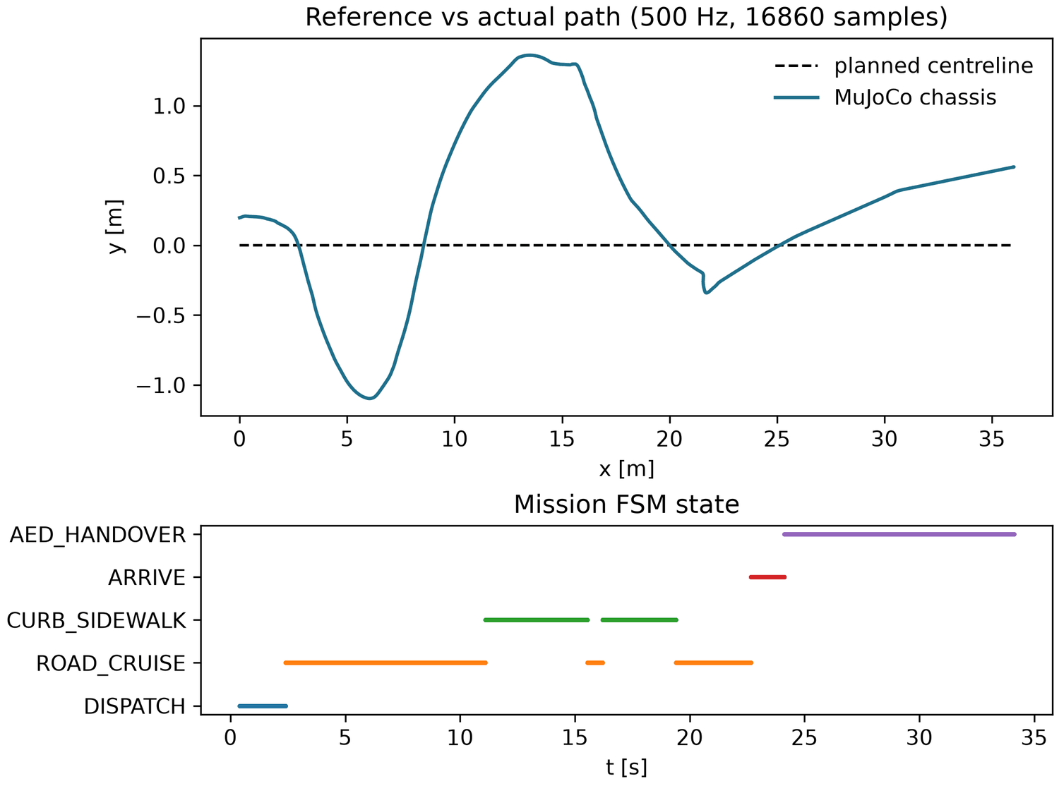 | 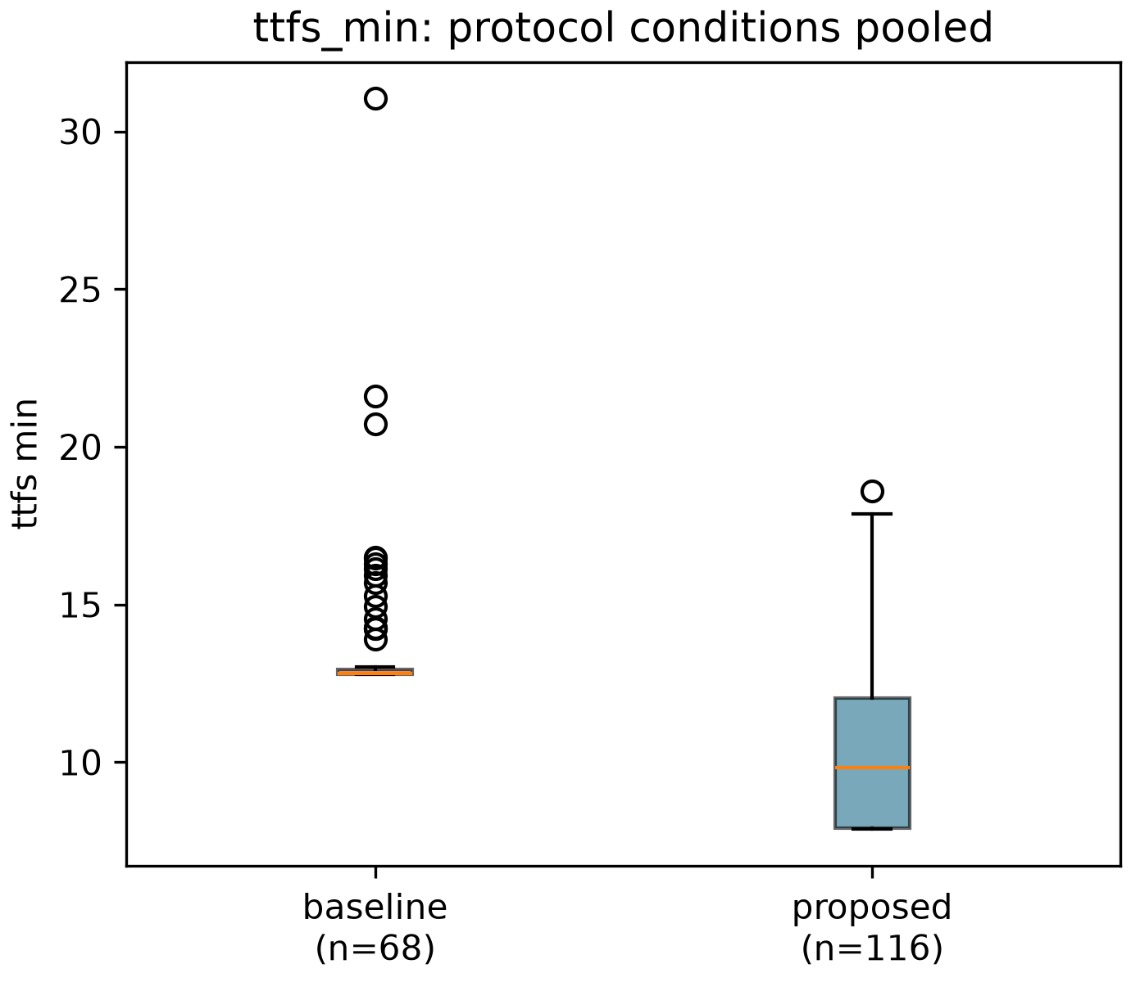

DATA PROVENANCE DECLARATION (mandatory). Reporting generated target numbers as experimental results is research misconduct and scores zero for this component.
Every number in Section 4 comes from MuJoCo runs of OUR controller, logged by our code | Yes
No value comes from SIMULATED_* files, generate_paper_figures.py or any np.random 'target' data | Yes
Our plots re-generate from the *_real_trials.csv files in the repo | Yes
Every input in Section 3 has a source or is labelled as an assumption | Yes

SECTION 5 · LinkedIn Video Showcase, AI Verification Audit & Peer Review Component 3 · Showcase & Viva (5)
LinkedIn post URL | https://lnkd.in/p/eqCdnbrD
Video length (mm:ss) | 7 min 17 s
Video shows the live MuJoCo simulation (not slides) | Yes
Video shows our business sensitivity graph | Yes
Webcam picture-in-picture: every member appears and speaks | Yes

5.1 AI Interaction Audit Log: three cases where AI gave wrong robotics or economic data
Examples: a wrong MuJoCo attribute or API call, an invented statistic, a correct paper given the wrong journal, an economic formula with the wrong units. Show how you checked each one with a textbook, the official documentation or the original paper.
# | AI tool | What we asked & what AI said | How we caught it | What was actually true (with source) | Error type | Verdict
AI-01 | Claude | Asked to build the proposed controller on the course vehicle (30 kN/m tyre). It reused the repository's kerb-speed table, measured for a 196 kN/m tyre, and reported the controller ready. | Ran / tested the code or simulation | The course tyre needs its own table. Tracing why runs stalled at the kerb lip led to measuring one (experiments/02 --design course). With it, payload shock above 3 g fell from 7.6 % to 3.6 % of runs and the worst peak from 4.62 g to 3.44 g (docs/CAPSTONE.md). | Wrong physics / equation | Corrected
AI-02 | Claude | Asked for the health benefit of the pod. The first model compared the pod only with the median ambulance (11.0 min), so the survival gain came out exactly zero. | Ran / tested the code or simulation | The pod is dispatched with the ambulance, so the benefit is the expected gain over the whole response-time distribution (Naess et al. 2024 fit, Larsen model): +2.3 percentage points and 12.8 QALY per ALS vehicle-year (analytics/roi_results.json). | Wrong economics / cost logic | Corrected
AI-03 | Claude | The first dossier box-plot showed only the lane-splitting condition while the text quoted pooled means (13.8 vs 10.5 min, n = 68 vs 116). | Ran / tested the code or simulation | The plot now pools the three protocol conditions (n = 68 vs 116) and matches the statistics table (Welch t = 7.9, d = 1.2). | Wrong number or statistic | Corrected

5.2 Peer review: watch both assigned LinkedIn videos and score them (0–2 per criterion)
Group reviewed | Problem | Physics | Business | Data | Clarity | Best moment (mm:ss) | One question for the viva
Group 04: Multi-Arm Robotic Gripper for Non-Cooperative Space Debris Capture in LEO | 2 | 1 | 1 | 2 | 2 | 01:20 - The controller comparison clearly connects capture success with impact force, showing why gentler contact matters when capturing tumbling debris. | How does your robotic gripper adjust to capture space debris that is tumbling?
Group 09: Autonomous Ground Vehicle (UGV) with LiDAR Perception for Hazardous Terrain Reconnaissance | 1 | 2 | 1 | 2 | 2 | The demo showed the system working, which made the idea easy to follow. | Which single assumption would you check first, and how?

SECTION 6 · Individual Learning Record & Research Consent unmarked · one row per member · answer honestly
These answers do not change your marks. They help improve the course and are used in anonymised research only if you consent in the sign-off below. Commit share: your commits ÷ the group's commits in your folder (git shortlog -sn -- <folder>).
Member | Hours I spent (total) | My declared role matched my actual work (1 = not at all, 5 = fully) | I learned a skill outside my role (robotics ↔ business) | Scripts I mainly wrote (file names) | My commit share (%) | Share of my writing first drafted with AI | Wrong AI facts / code I personally caught
Kashish Praveen Jain (E026) | about 40 hours | 4 | Yes | analytics/aed_delivery_roi.py, src/aedrover/capstone/business.py (money-free cost model, queue, risk table, sensitivity), standards check | 50 % | 26–50 % | 1–2
Vaishnavi Parashar (E046) | about 60 hours | 4 | Yes | src/aedrover/capstone/fsm.py, monte_carlo.py, telemetry.py, the MuJoCo vehicle model and the live viewer | 50 % (12 of 12 commits, pushed from this account) | 26–50 % | 1–2

Member | Before this course I had used a physics simulator | The most valuable thing I learned (one line) | One thing I would change in this course (one line)
Kashish Praveen Jain (E026) | No | I learned that a result you do not like is still a result. Our cost ratio came out very high, and instead of changing the inputs I found out why: too many idle pods. That taught me to test ideas against numbers and to say clearly what does not work. | I would collect real dispatch data early, such as how often ambulances are stood down, because that one assumption decides whether the project pays for itself.
Vaishnavi Parashar (E046) | No | I learned how a real robot model works: springs, tyres, speed limits and a safety layer. The most valuable lesson was that the AI's work must always be tested. A wrong kerb table looked fine until I traced why the rover kept stalling, and fixing it cut dangerous payload shocks from 7.6 % to 3.6 % of runs. | I would add reversing so the rover can back out of a blocked path, and improve wet-kerb driving, where only 24 % of runs reach the patient.

Track A: how this dossier becomes your 4-page IEEE paper
I. Introduction | Section 1: title, verified baseline friction, governing standards
II. Related work | Section 1.1: verified sources only (5+ with DOIs)
III. System model | Section 2: MJCF model, FSM, equations, control law
IV. Techno-economics & evaluation | Sections 3–4: CSBS model, FMEA, Monte Carlo results, statistics
V. Discussion & limitations | Sim-to-real gap, assumptions in the business model, AI audit lessons
Target venues (titles sheet) | A: IEEE INDICON · B: IEEE/RSJ IROS

Individual Academic Sign-off every member answers and signs
Answer each statement for yourself: (1) this work is original and every source and AI use is declared; (2) our model loads and our controller and business scripts run from the repository; (3) I understand our whole project and can explain my own part in the viva voce.
Member (Roll) | (1) Original work | (2) Code runs | (3) Viva-ready | Signature | Optional research consent*
Kashish Praveen Jain (E026) | Yes | Yes | Yes |  | Select ▾
Vaishnavi Parashar (E046) | Yes | Yes | Yes |  | Select ▾
*Optional: may Dr. Nanade use anonymised data from this dossier and repository in education research publications? Your answer has no effect on your marks, and you can withdraw until results are published.

