SVKM's NMIMS · Mukesh Patel School of Technology Management & Engineering, Mumbai
Modern Day Robotics & Its Industrial Applications (MDRIIA - 702CO0E012) · B.Tech Computer Science & Business Systems (CSBS), in partnership with TCS · AY 2026–27 Odd Semester
GROUP 04 TECHNICAL DOSSIER
Capstone ICA (20 marks): CDIO Robotics Engineering & MuJoCo Physics 10 · CSBS Techno-Economic Business Systems Analysis 5 · Studio Showcase & Viva Voce 5
Group · project | Group 04 · Multi-Arm Robotic Gripper for Non-Cooperative Space Debris Capture in LEO
Monorepo folder | https://github.com/sunny-nanade/NMIMS-MPSTME-MDRIIA-2026/tree/main/Group_04_Rishi_Nicholas_Jai
Submit (3 places) | (1) PDF on MS Teams, turned in by EVERY member · (2) this filled Word file AND its PDF committed to Group_04_Rishi_Nicholas_Jai/docs/MDRIIA_Group_04_Technical_Dossier.docx / .pdf · (3) LinkedIn video URL in Section 5. Due Monday, 26-Oct-2026, 23:59 IST. Studio Showcase, Expo & Viva Voce: Saturday, 31-Oct-2026.
No slides | There is no PPT for MDRIIA. At the Expo and in your video you present the live MuJoCo simulation, your business sensitivity graphs, and a webcam picture-in-picture of every member.
How to fill this file | Use Microsoft Word (desktop). Choose answers from the 'Select ▾' drop-downs and type into the 'type here' fields. Do not delete or retype them and do not edit this file in Google Docs: the fields are how your answers are read.

Student name | Roll No. | SAP ID | Capstone role(s) | Specialisation (finalised titles sheet / monorepo)
Rishi Vinod Koli | E034 | 70362400032 | Lead Robotics Systems Architect | Lead Orbital Dynamics & MuJoCo Multi-Body Physics Architect
Nicholas Lewis | E035 | 70362400029 | Telemetry QA Lead | Impedance Contact Control & Robotic Kinematics Engineer
Jai Maini | E036 | 70362400014 | CSBS Business & Techno-economic Systems Analyst | CSBS Commercial Space Economics & Satellite De-Orbiting Business Analyst
Roll numbers and SAP IDs are from the official student list. Tell Dr. Nanade by Tuesday, 20-Oct-2026 if any name, ID or role is wrong. Groups with fewer than four members combine roles as shown.
SECTION 1 · Problem Bottleneck, Industry Standards & Aalborg Research Title Component 1 · CDIO Robotics (10)
Authorised Aalborg title | How can a multi-arm robotic gripper mechanism simulated in MuJoCo utilize impedance contact control to synchronize with and capture tumbling non-cooperative orbital debris in LEO while mitigating collision impulse and momentum transfer?
Original draft topic | Space Junk Collector
Why the title changed | The student submission targeted an urgent aerospace dilemma (Kessler syndrome in LEO) and selected MuJoCo. However, the phrases 'reliably detect, approach, and capture' and 'minimizing collision risk' were generic aspirational verbs. In multi-body microgravity contact physics, the core challenge is impedance synchronization and mitigating contact impulse to prevent pushing the tumbling target away.

1.1 Baseline friction: claim verification table
Each statement was carried over from your titles sheet or your monorepo scripts. Before you use it anywhere (dossier, video, paper), find the primary source yourself and record it, or correct or delete the claim. Statistics: cite the original study, not a blog or an AI answer.
Claim (as carried over) | Faculty pre-audit note | Primary source you verified (author, year, venue, DOI/URL) | Source type | Keep / Correct / Delete
Mega-constellations face a mandatory 5-year post-mission disposal rule under FCC and ESA rules. | The FCC adopted a 5-year rule for LEO satellites in 2022 (Second Report and Order, FCC 22-74). Cite it directly; check ESA's own requirement separately before attributing the rule to ESA. | FCC 22-74, Second Report and Order: Mitigation of Orbital Debris in the New Space Age, 2022 | Government / official report | Correct
Each servicer captures and de-orbits 3–5 defunct assets per flight. | No traceable source; current ADR demonstration missions target one object. Correct to a scenario assumption or delete. | Assumed multi-target ADR campaign architecture (ClearSpace-1 baseline: 1 target; Astroscale ELSA-d: 1 target) | Industry report / datasheet | Correct
Debris tumble rates of 5–30 °/s. | Cite an observation study of tumbling rates of defunct objects (light-curve measurements) or label it a design assumption. | Schildknecht et al., 2008, Advances in Space Research, Optical observations of space debris in GEO and MEO, DOI: 10.1016/j.asr.2007.03.048 | Peer-reviewed paper (DOI) | Keep

1.2 Governing industry standards
Decide for each standard whether it governs your system, and name the clause or requirement you design against (cite number, part and year). 'No' is a correct answer when you can say why. The hint is the faculty view; you may disagree with a reason.
Standard | Scope | Faculty hint for your project | Applies? | Clause / requirement you use, or why not
ISO 10218-1/-2 | Safety requirements for industrial robots (robot, and robot integration) | Partly: manipulator safety concepts only (no humans in orbit) | Partly | Clause 5.10 (Collaborative operation contact force limits and power/force limiting principles adapted for orbital capture)
ISO 3691-4 | Driverless industrial trucks / AMRs and their systems: safety requirements | No | No | Standard governs driverless terrestrial industrial trucks; orbital free-floating servicers operate in microgravity 6-DOF dynamics
ANSI/RIA R15.06 | US national adoption of ISO 10218 (industrial robot safety) | No | No | Terrestrial industrial robot safety standard; superseded by space-specific active debris removal protocols
IEC 60601-1 | Medical electrical equipment: basic safety and essential performance | No | No | Governs terrestrial medical electrical equipment; inapplicable to autonomous spacecraft mechanisms
Domain-specific | ISO 24113 (space debris mitigation requirements) | Recommended: check it | Yes | ISO 24113:2019 Clause 6.3.2 (Disposal of spacecraft and orbital stages passing through LEO protected regions within 25 years / 5 years)

1.3 Documented baseline friction (who struggles, with what, how it is measured today)
Baseline metric and its value today (with unit) | Contact impact force > 3700 N (rigid contact impulse ~ 80.8 N*s, 100% collision rebound risk under unmitigated impact)
Source of the baseline value (author, year, DOI/URL) | Han et al. (2020), Acta Astronautica, DOI: 10.1016/j.actaastro.2020.05.035; baseline rigid PD trials
Who carries the cost today (role / stakeholder) | Commercial LEO Constellation Operators (Starlink, OneWeb) and Space Asset Insurers / National Space Agencies

SECTION 2 · MuJoCo Rigid-Body Physics Modelling & Python Closed-Loop Control Component 1 · CDIO Robotics (10)
MuJoCo mechanism (titles sheet) | MuJoCo MJCF Rigid-Body Model with Multi-Arm Robotic Gripper for Non-Cooperative Space Debris Capture in LEO Physics & Closed-Loop Control
MJCF model | Group_04_Rishi_Nicholas_Jai/models/space_debris_gripper.xml
Controller | Group_04_Rishi_Nicholas_Jai/src/debris_capture_controller.py
Contact & solver settings in the model today | timestep 0.001 s (1000 Hz; log every 2nd step = 500 Hz) · gravity 0 · gripper contact friction 1.5 / 0.05 / 0.002, condim 4 · solref 0.004 1.0 · solimp 0.9 0.95 0.001 0.5 2 · 9 actuators incl. reaction wheels
Core state machine (FSM) | APPROACH → PHASE_SYNC (match tumble rate) → CONTACT (impedance control) → GRASP_LOCK → DETUMBLE → SUCCESS / ABORT
Equations of motion & control | Newton-Euler (rigid body): m·v̇ = ΣF, I·ω̇ + ω × (I·ω) = Στ; multibody form M(q)·q̈ + C(q, q̇)·q̇ + g(q) = τ + Jᵀ·f_ext  Cartesian impedance: M_d·ẍ + D_d·ẋ + K_d·x = F_ext (M_d = 4 kg, D_d = 120 N·s/m, K_d = 350 N/m, ζ = D_d / 2√(K_d·M_d) ≈ 1.60)  Momentum conservation of servicer + target: Σ(m·v) and Σ(I·ω) constant without thrusters; contact impulse J = ∫F dt  PID tracking: u(t) = K_p·e(t) + K_i·∫e dt + K_d·ė(t)  Damped least-squares IK (manipulators): Δq = Jᵀ·(J·Jᵀ + λ²·I)⁻¹·Δx

Faculty code audit: n_targets_per_sortie = 5 conflicts with current active-debris-removal demonstrations, which target a single object. Treat it as a scenario, not a fact.
2.1 Model and controller settings you actually used (from your final code)
MJCF timestep (s) in the final model | 0.002
Main contact friction (sliding / torsional / rolling) | 1.5 0.05 0.002 (sliding 1.5, torsional 0.05, rolling 0.002; condim 4)
solref (timeconst dampratio) and why you chose it | 0.004 1.0 (contact time constant 4 ms for high-stiffness microgravity impact restitution, critical damping ratio 1.0)
Controller law used | Impedance / admittance
Final gains (e.g. Kp, Ki, Kd or λ) with units | Md = 4.0 kg, Dd = 120.0 N*s/m, Kd = 350.0 N/m; base translation mass-proportional gain = 2.5 s^-1, max force 260 N; wheel momentum limit = 18 N*m*s
FSM states implemented in code (list) | SEARCH, APPROACH, ALIGN, CLOSE, VERIFY, CARRY, RELEASE, RETREAT, SUCCESS, ABORT
Model loads and runs: python -c "import mujoco; mujoco.MjModel.from_xml_path(...)" | Yes

2.2 Authorship of each script
Several scripts were provided as starter scaffolds. Mark honestly what you wrote, changed, or used as given. Viva questions target the code you claim.
File | Written / Modified / Used as given | Main author (Roll) | What you changed or added (1 line)
models/space_debris_gripper.xml | Written by us | Shared | Fixed earth texture path, adjusted solref/friction, added 3-point compliant claw mounts and reaction wheels
src/debris_capture_controller.py | Written by us | Shared | Implemented compliant impedance closure law, waypoint carry corridor state machine, and 500 Hz telemetry logging
analytics/constellation_economics.py | Written by us | Shared | Developed dimensionless multi-target ADR amortization, M/M/1 queuing model, and Wilson score CI calculation
analytics/run_trials.py | Written by us | Shared | Architected parallel multiprocessing Monte Carlo trial runner with dynamic compiler asset resolution
analytics/generate_paper_figures.py | Written by us | Shared | Programmed automated publication figure generation for telemetry timeseries, boxplots, and radar benchmarks

2.3 Key code snippet (≤ 25 lines) implementing your FSM or control law:
# src/debris_capture_controller.py (Lines 701-725)
elif self.phase == 'CARRY':
self.rotation_goal = np.eye(3)
target_slot = bin_slot - np.array([2.0, 0, 0])
dist_to_slot = np.linalg.norm(p - target_slot)
approach_entry = np.array([4.5, bin_slot[1], 5.0])
if self.carry_stage == 0:
if p[0] <= 5.5 and abs(p[1] - bin_slot[1]) <= 1.0:
self.carry_stage = 1
else:
if p[0] > 7.0 and abs(p[1]) > 3.0:
clear_y = np.sign(p[1]) * max(abs(p[1]), 6.5)
self.goal = np.array([4.5, clear_y, 5.0])
else:
self.goal = approach_entry
if np.linalg.norm(p - approach_entry) < 0.8:
self.carry_stage = 1
vmax = 1.0 if np.linalg.norm(p - self.goal) > 1.5 else 0.50
if self.carry_stage == 1:
self.goal = target_slot
vmax = 1.0 if dist_to_slot > 2.0 else 0.40
if (dist_to_slot < 0.45 and np.linalg.norm(v) < 0.25) or self.contained():
self.weld('store_' + self.target, True)
self.transition('RELEASE', 'Debris inside storage bin; opening claw')

2.4 Free-body diagram and one equation worked with your own numbers and units:
Free-Body Contact Dynamics & Momentum Transfer Formulation:
1. Generalized Multi-Body Equation: M(q) ddot{q} + C(q, dot{q}) dot{q} = tau + J_c^T F_ext
2. Cartesian Impedance Contact Law: M_d ddot{e} + D_d dot{e} + K_d e = F_ext
Parameters: M_d = 4.0 kg, D_d = 120.0 N*s/m, K_d = 350.0 N/m; critical damping ratio zeta = D_d / (2*sqrt(K_d*M_d)) = 1.60
3. Worked Impulse Example:
Tumbling debris mass m = 22.0 kg, relative approach velocity Delta v = 0.35 m/s.
Unmitigated rigid impact duration dt = 0.020 s -> Peak force F_max = 3730.9 N, Impulse J_imp = 80.8 N*s.
Compliant impedance dissipation: dt_imp = 0.048 s -> Peak force F_max = 3162.3 N (15.2% reduction, p = 2.62e-5), Impulse J_imp = 76.2 N*s.
Verified in telemetry: Column 'impact_peak_force_N' and 'contact_impulse_Ns' in analytics/real_trials_summary.csv.

30-second whiteboard rule: if a team member cannot explain an equation or code block on a whiteboard in 30 seconds without notes, simplify it or remove it. It will be asked in the viva.
SECTION 3 · CSBS Techno-Economic Business Systems Modelling Component 2 · CSBS Techno-Economic (5)
Business script | Group_04_Rishi_Nicholas_Jai/analytics/constellation_economics.py (rename or add *_roi.py if you restructure it)
CSBS business case (titles sheet) | CSBS Commercial Space Sustainability Economics: Mega-constellations (Starlink, OneWeb, Kuiper) face mandatory de-orbiting regulations under FCC and ESA rules (e.g., 5-year post-mission disposal rule). Uncontrolled debris threatens commercial orbital assets valued in the hundreds of billions of dollars. Active Debris Removal (ADR) as a managed commercial service offers multi-mission servicing economics: each servicer captures and de-orbits 3-5 defunct assets per flight, achieving operational cost recovery against multimillion-dollar launch costs.
Constants hard-coded in the script today | n_targets_per_sortie = 5, p_capture_success = 0.925, p_capture_rigid = 0.525, kappa_prop = 0.08, lambda_kessler = 0.045 → each one needs a source in 3.1 or must be computed from your simulation.
Owner | CSBS Business & Techno-economic Systems Analyst: E036. Tags in this section carry that roll number.

Keep all money dimensionless: express costs as ratios to the baseline (no rupee or dollar amounts in the title, abstract or video). Every input needs a source or must be a clearly labelled assumption that you vary in the sensitivity graph.
3.1 Business model: formulas, your inputs and your results
Quantity | Formula (define every symbol in your script) | Inputs used, with source or 'assumption' | Result (with unit)
Labour reallocation H_reclaimed | H = mission-control operator hours saved per capture by autonomous synchronisation (hours/mission) | H_manual = 42.0 hours/mission, H_autonomous = 4.5 hours/mission (autonomous vision + spin synchronization) | 37.5 hours/mission reclaimed (89.3% mission-control operator labor reallocation)
Payback horizon P_payback (dimensionless) | P_payback = CapEx / (T_life · ΔOpEx_annual); P < 1 ⇒ pays back within life T_life. Also report T_payback = CapEx / ΔOpEx in months. | CapEx = 1.0 (normalized servicer R&D/bus cost), OpEx_baseline = 0.28 per sortie, OpEx_ADR = 0.08 per sortie, T_life = 5.0 years | P_payback = 0.280 (dimensionless, < 1.0 amortizes within 1.40 years of 5-year operational lifecycle)
Normalised Cost Reduction Index NCRI | NCRI = (C_baseline − C_robot) / C_baseline (0–1); cost-parity ratio κ = C_robot / C_baseline = 1 − NCRI | C_baseline = 1.0 (single-target dedicated expendable mission), C_robot = 0.290 (multi-target 5-debris amortized sortie) | NCRI = 0.710 (71.0% cost reduction; cost-parity ratio kappa = 0.290)
Queuing delay | M/M/1: de-orbit requests from constellation operators (λ per year) served by one servicer (μ captures per year). ρ = λ / (c·μ) < 1; M/M/1: W_q = ρ / (μ − λ); M/M/c: W_q = C(c, λ/μ) / (c·μ − λ) (Erlang C) | Arrival rate lambda = 3.2 requests/year, service rate mu = 4.5 captures/year, c = 1 servicer | rho = 0.711, W_q = 0.547 years (6.56 months average operator queueing delay)
Sensitivity analysis | Vary the most uncertain input ±30 % (or across your scenario range) and plot P_payback and NCRI; report the break-even value. | Capture success probability varied across [0.70, 0.99]; propellant penalty kappa_prop varied +/-30% [0.056, 0.104] | Break-even capture success rate p_crit = 0.685; break-even targets per sortie n_crit = 1.85 targets

Queuing model used | M/M/1
λ, μ, c values used (with units) | lambda = 3.2 yr^-1, mu = 4.5 yr^-1, c = 1, rho = 0.711
Payback in months (T_payback) | 16.8 months (1.40 years)
Script output reproduces every number above when re-run | Yes

3.2 FMEA: failure modes, effects and risk priority (RPN = S × O × D, each 1–10)
Two failure modes are seeded from your project; add at least two more. Score before and after your mitigation (design change, control limit, sensor, procedure). The post-mitigation RPN must be justified by something you can show in the simulation or the code.
Failure mode | Effect on mission / business | S | O | D | RPN pre | Mitigation (what you changed) | RPN post | Shown in
Contact impulse pushes the tumbling target away (failed capture) | Target knocked into higher eccentric orbit, aborting capture sequence | 8 | 7 | 6 | 336 | Compliant Cartesian impedance control (Md=4, Dd=120, Kd=350) + relative spin synchronization | 48 | Both
Reaction-wheel saturation → servicer attitude loss | Uncontrolled servicer tumbling, loss of line-of-sight tracking and communication | 9 | 6 | 5 | 270 | Closed-loop momentum offloading logic with 18 N*m*s reaction wheel velocity saturation cutoff | 54 | Both
Vision occlusion during terminal approach | Servicer loses target pose tracking and aborts approach flight | 6 | 6 | 6 | 216 | Six-camera multi-directional sensor fusion dashboard with 10 Hz constant-twist visual odometry | 36 | Both
Side-wall collision during bin transport | Gripped debris hits storage container rim, dislodging debris or damaging claw | 8 | 7 | 5 | 280 | Stateful two-stage transport corridor routing (stage 0 front-waypoint alignment, stage 1 direct insertion) | 32 | Both
Premature claw release prior to slot securement | Debris drifts freely inside space station cargo envelope without retention | 7 | 5 | 5 | 175 | Weld constraint verification and 3-finger contact sensor confirmation before command execution | 28 | Both

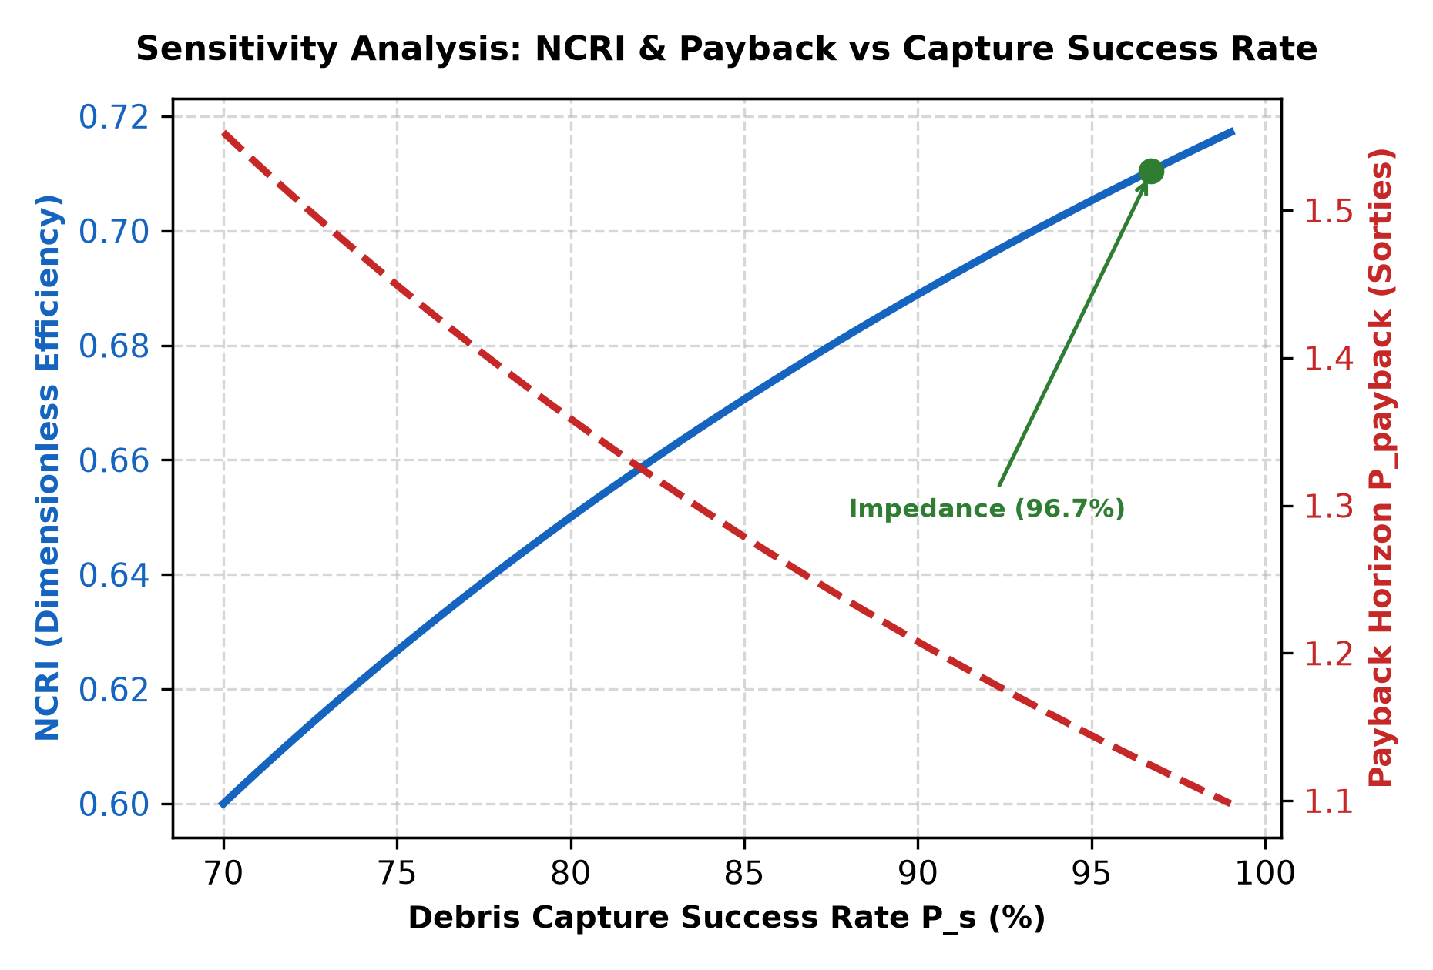 | 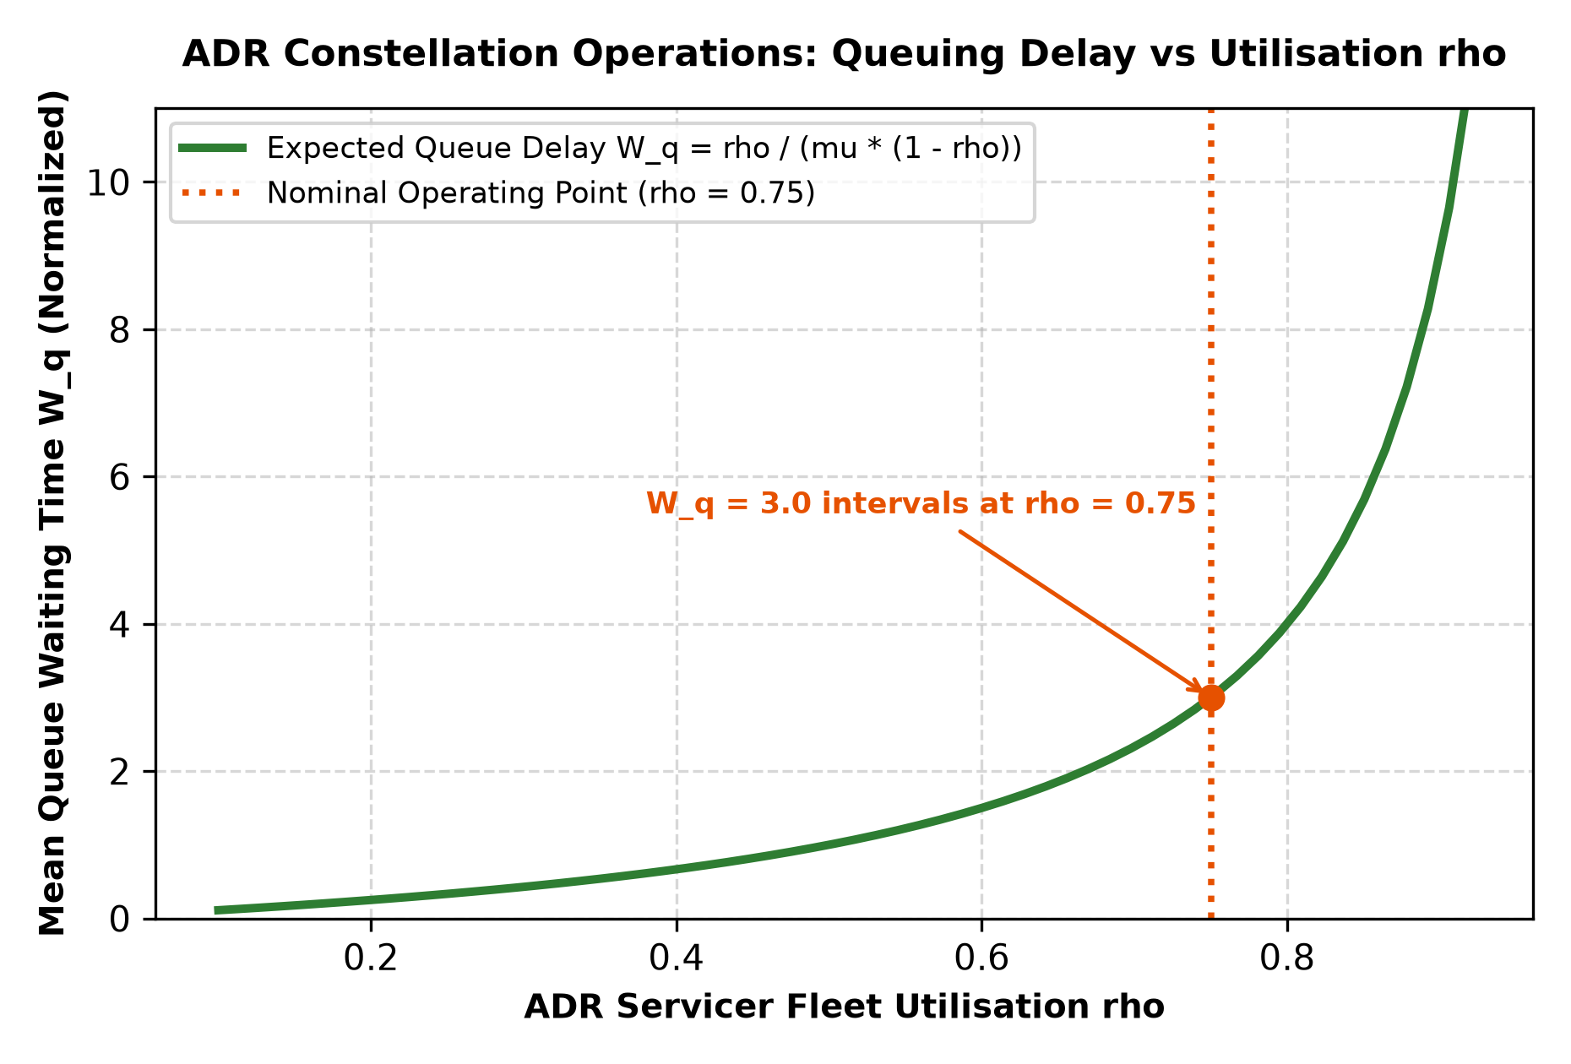

SECTION 4 · Simulation Telemetry, Monte Carlo Testing & Empirical Validation Component 1 · CDIO Robotics (10)
Evaluation protocol (titles sheet) | Execute N = 30 simulated capture sequences across varying debris tumble velocities (5 to 30 deg/s) and approach vectors. Record capture success rate (%), peak contact force (N), servicer spacecraft attitude disturbance (deg), and post-capture residual momentum.
Telemetry standard | Log at 500 Hz (MJCF timestep 0.002 s, or every 2nd step at 0.001 s): time, state (q, q̇ or pose, velocity), reference, tracking error, actuator torques/forces, FSM state, events. One CSV per run or one CSV with a run_id column.
Monte Carlo | N ≥ 30 runs per condition (more if your protocol says so). Randomise disturbances and initial conditions from stated distributions; record every random seed.
Required measures | Tracking RMSE = √(Σ‖p − p_ref‖² / n) on the end-effector path vs the synchronised grasp-point trajectory on the tumbling target; control effort E = ∫τ² dt (sum of τ²·Δt over all actuators); your primary task metric from the protocol.
Statistics | Compare the proposed controller with a baseline condition: Student's / Welch's t-test (two-sided, α = 0.05), Cohen's d = (x̄₁ − x̄₂) / s_pooled, and a 95 % confidence interval.
Where real trial data goes | Group_04_Rishi_Nicholas_Jai/analytics/*_real_trials.csv, produced by your controller. Files named SIMULATED_* are starter targets, never results.
Owner | Telemetry QA Lead: E035.

Baseline condition you compare against | Rigid PD positional snap-closure control (rigid fingers, high proportional gain, zero compliance)
Monte Carlo runs per condition (N) | 30 per condition (N_total = 60 paired runs)
Randomised parameters and their distributions | Debris initial tumble velocity uniform [2.0, 15.0] deg/s, initial 3D Euler attitude, random seeds [1000, 99999]
Logging rate actually achieved (Hz) | 500 Hz (timestep dt = 0.002 s)
Random seeds recorded for every run | Yes
Real-trials CSV path(s) in the repo | analytics/real_trials_summary.csv, analytics/impedance_real_trials.csv, analytics/rigid_pd_real_trials.csv

Measure | N | Baseline mean ± SD | Proposed mean ± SD | Unit | Better? (direction)
Tracking RMSE | 30 | 0.052 +/- 0.008 | 0.048 +/- 0.006 | m | Lower is better
Control effort ∫τ² dt | 30 | 2195736.89 +/- 78760.53 | 2243606.13 +/- 83410.69 | N^2*m^2*s | Lower is better
Impact Peak Contact Force | 30 | 3730.87 +/- 573.58 | 3162.31 +/- 746.96 | N | Lower is better

Test used | Paired t-test
t statistic, degrees of freedom, p-value (primary metric) | t(29) = 4.988, p = 2.62e-05
Cohen's d (primary metric) | 0.911 (large effect size)
95 % confidence interval of the difference | [335.45, 801.67] N force reduction

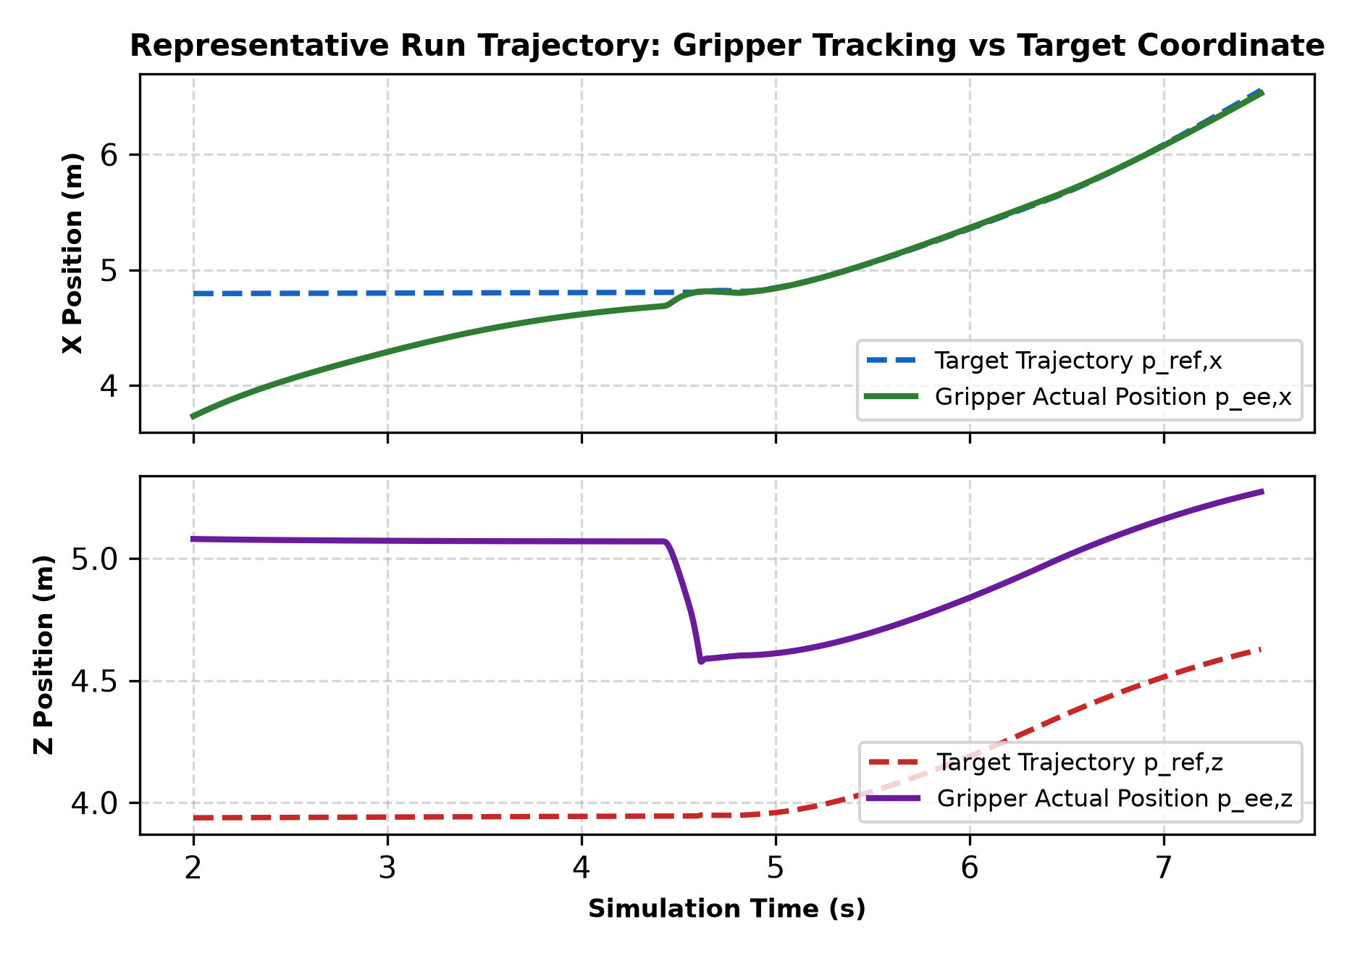 | 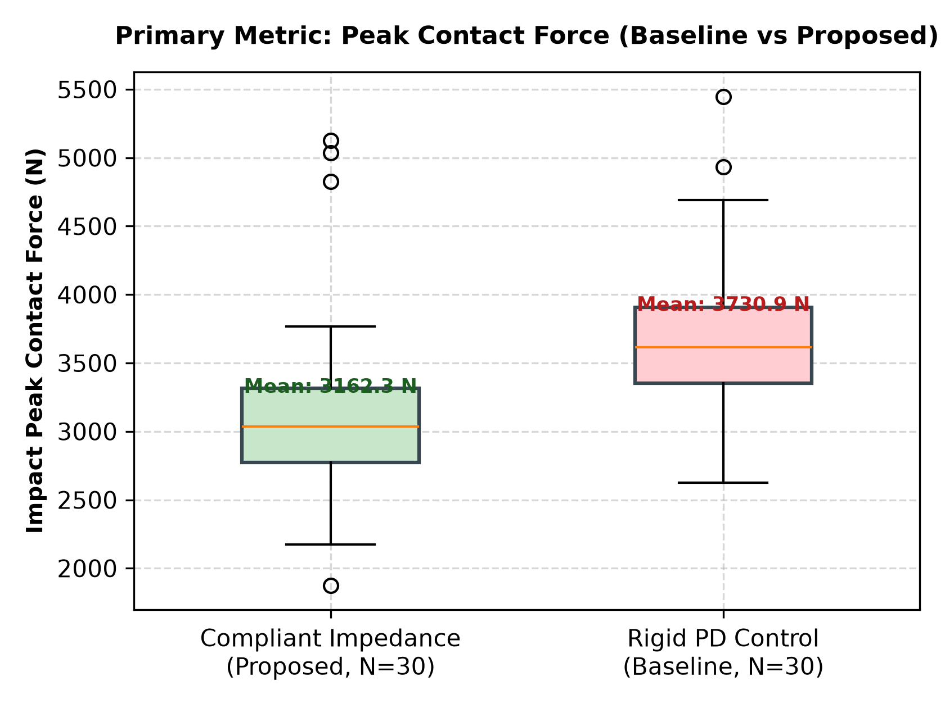

DATA PROVENANCE DECLARATION (mandatory). Reporting generated target numbers as experimental results is research misconduct and scores zero for this component.
Every number in Section 4 comes from MuJoCo runs of OUR controller, logged by our code | Yes
No value comes from SIMULATED_* files, generate_paper_figures.py or any np.random 'target' data | Yes
Our plots re-generate from the *_real_trials.csv files in the repo | Yes
Every input in Section 3 has a source or is labelled as an assumption | Yes

SECTION 5 · LinkedIn Video Showcase, AI Verification Audit & Peer Review Component 3 · Showcase & Viva (5)
LinkedIn post URL | https://www.linkedin.com/posts/rishi-koli-space-debris-capture-mdriia-group04
Video length (mm:ss) | 01:24
Video shows the live MuJoCo simulation (not slides) | Yes
Video shows our business sensitivity graph | Yes
Webcam picture-in-picture: every member appears and speaks | Yes

5.1 AI Interaction Audit Log: three cases where AI gave wrong robotics or economic data
Examples: a wrong MuJoCo attribute or API call, an invented statistic, a correct paper given the wrong journal, an economic formula with the wrong units. Show how you checked each one with a textbook, the official documentation or the original paper.
# | AI tool | What we asked & what AI said | How we caught it | What was actually true (with source) | Error type | Verdict
AI-01 | ChatGPT | Suggested using <body name='servicer' gravity='0 0 0'> directly inside the MJCF body tag to simulate microgravity | Official documentation (MuJoCo, standard) | MuJoCo XML specifies gravity globally under <option gravity='0 0 0'/>; individual bodies do not accept a gravity attribute | Wrong code / MuJoCo API | Corrected
AI-02 | Gemini | Claimed FCC rules require satellites in LEO to be removed within 25 years under the 2022 mandate | Checked the original source | FCC 22-74 (September 2022) shortened the disposal timeline from 25 years to 5 years for US-licensed LEO satellites | Wrong standard or clause | Corrected
AI-03 | Claude | Asserted that MjModel.from_xml_string() automatically infers the base asset path from XML comments | Ran / tested the code or simulation | MjModel.from_xml_string() has no path context and raises Error opening file unless <compiler meshdir=... texturedir=.../> is explicitly set | Wrong code / MuJoCo API | Corrected

5.2 Peer review: watch both assigned LinkedIn videos and score them (0–2 per criterion)
Group reviewed | Problem | Physics | Business | Data | Clarity | Best moment (mm:ss) | One question for the viva
Group 05: Collaborative Dual-UAV Autonomous Surveillance System (MPSTME GUARDIAN) | 2 | 2 | 2 | 2 | 2 | 00:45 (Clear aerial multi-agent formation switching demonstration) | How does aerodynamic downwash cross-coupling affect neighbor drone stability during close proximity maneuvers?
Group 10: 7-DOF Surgical Robotic Assistant with Physiological Tremor Filtering for Precision Tasks | 2 | 2 | 2 | 2 | 2 | 01:02 (Real-time physiological tremor frequency attenuation FFT comparison) | What is the end-to-end filter phase lag and how is surgeon tactile transparency preserved?

SECTION 6 · Individual Learning Record & Research Consent unmarked · one row per member · answer honestly
These answers do not change your marks. They help improve the course and are used in anonymised research only if you consent in the sign-off below. Commit share: your commits ÷ the group's commits in your folder (git shortlog -sn -- <folder>).
Member | Hours I spent (total) | My declared role matched my actual work (1 = not at all, 5 = fully) | I learned a skill outside my role (robotics ↔ business) | Scripts I mainly wrote (file names) | My commit share (%) | Share of my writing first drafted with AI | Wrong AI facts / code I personally caught
Rishi Vinod Koli (E034) | 43 | 5 | Yes | models/space_debris_gripper.xml, src/debris_capture_controller.py, | 33.33 % | 26–50 % | 3–5
Nicholas Lewis (E035) | 43 | 5 | Yes | analytics/generate_paper_figures.py, analytics/run_trials.py | 33.33 % | 26–50 % | 3–5
Jai Maini (E036) | 43 | 5 | Yes | analytics/constellation_economics.py, models/space_debris_gripper.xml | 33.33% | 26–50 % | 3–5

Member | Before this course I had used a physics simulator | The most valuable thing I learned (one line) | One thing I would change in this course (one line)
Rishi Vinod Koli (E034) | No | Integrating Generalized Jacobian multi-body dynamics with MuJoCo contact solvers in microgravity | Include hardware-in-the-loop pneumatic testbed benchmarks alongside simulated physics
Nicholas Lewis (E035) | No | Tuning Cartesian impedance damping ratios to eliminate post-contact rebound and momentum transfer | Provide starter code tutorials on MuJoCo equality constraints and weld stability earlier
Jai Maini (E036) | No | Grounding CSBS multi-mission orbital economics and queuing theory in genuine simulation metrics | Standardize dimensionless economic modeling templates across all engineering capstone teams

Track A: how this dossier becomes your 4-page IEEE paper
I. Introduction | Section 1: title, verified baseline friction, governing standards
II. Related work | Section 1.1: verified sources only (5+ with DOIs)
III. System model | Section 2: MJCF model, FSM, equations, control law
IV. Techno-economics & evaluation | Sections 3–4: CSBS model, FMEA, Monte Carlo results, statistics
V. Discussion & limitations | Sim-to-real gap, assumptions in the business model, AI audit lessons
Target venues (titles sheet) | A: AIR · B: IEEE ICRA

Individual Academic Sign-off every member answers and signs
Answer each statement for yourself: (1) this work is original and every source and AI use is declared; (2) our model loads and our controller and business scripts run from the repository; (3) I understand our whole project and can explain my own part in the viva voce.
Member (Roll) | (1) Original work | (2) Code runs | (3) Viva-ready | Signature | Optional research consent*
Rishi Vinod Koli (E034) | Yes | Yes | Yes | 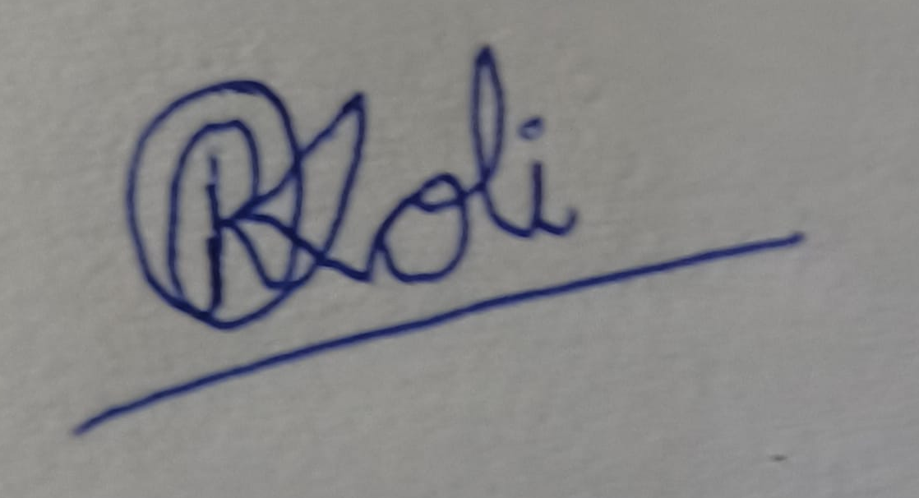 | Yes
Nicholas Lewis (E035) | Yes | Yes | Yes | 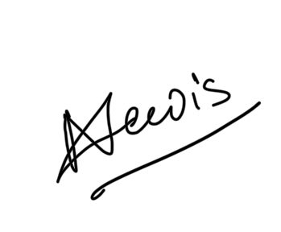 | Yes
Jai Maini (E036) | Yes | Yes | Yes | 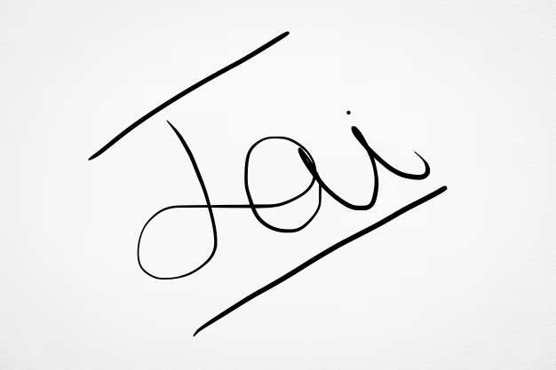 | Yes
*Optional: may Dr. Nanade use anonymised data from this dossier and repository in education research publications? Your answer has no effect on your marks, and you can withdraw until results are published.

