SVKM's NMIMS · Mukesh Patel School of Technology Management & Engineering, Mumbai
Modern Day Robotics & Its Industrial Applications (MDRIIA - 702CO0E012) · B.Tech Computer Science & Business Systems (CSBS), in partnership with TCS · AY 2026–27 Odd Semester
GROUP 05 TECHNICAL DOSSIER
Capstone ICA (20 marks): CDIO Robotics Engineering & MuJoCo Physics 10 · CSBS Techno-Economic Business Systems Analysis 5 · Studio Showcase & Viva Voce 5
Group · project | Group 05 · Collaborative Dual-UAV Autonomous Surveillance System (MPSTME GUARDIAN)
Monorepo folder | https://github.com/sunny-nanade/NMIMS-MPSTME-MDRIIA-2026/tree/main/Group_05_Muaaz_Aditya_Zaid_Soumya
Submit (3 places) | (1) PDF on MS Teams, turned in by EVERY member · (2) this filled Word file AND its PDF committed to Group_05_Muaaz_Aditya_Zaid_Soumya/docs/MDRIIA_Group_05_Technical_Dossier.docx / .pdf · (3) LinkedIn video URL in Section 5. Due Monday, 26-Oct-2026, 23:59 IST. Studio Showcase, Expo & Viva Voce: Saturday, 31-Oct-2026.
No slides | There is no PPT for MDRIIA. At the Expo and in your video you present the live MuJoCo simulation, your business sensitivity graphs, and a webcam picture-in-picture of every member.
How to fill this file | Use Microsoft Word (desktop). Choose answers from the 'Select ▾' drop-downs and type into the 'type here' fields. Do not delete or retype them and do not edit this file in Google Docs: the fields are how your answers are read.

Student name | Roll No. | SAP ID | Capstone role(s) | Specialisation (finalised titles sheet / monorepo)
Muaaz Mohammed Iqbal Shaikh | E043 | 70362400058 | Lead Robotics Systems Architect | Lead UAV Flight Dynamics, Path Planner & Coordinated Fleet Architect
Aditya Rajkumar | E051 | 70362400040 | Autonomous Navigation / Vision Specialist | Computer Vision, OpenCV Human Detection & Tracking Specialist
Zaid Rezaur Rahman | E075 | 70362300055 | Telemetry QA Lead | Restricted-Zone Geo-Fencing & Intrusion Telemetry Lead
Soumya Subhankar Ranasingh | E077 | 70362300043 | CSBS Business & Techno-economic Systems Analyst | CSBS Campus Security Operations & OpEx Payback Analyst
Roll numbers and SAP IDs are from the official student list. Tell Dr. Nanade by Tuesday, 20-Oct-2026 if any name, ID or role is wrong.
SECTION 1 · Problem Bottleneck, Industry Standards & Aalborg Research Title Component 1 · CDIO Robotics (10)
Authorised Aalborg title | To what extent can a collaborative dual-UAV surveillance system simulated in MuJoCo optimize campus perimeter patrol cycle time and OpenCV human detection latency compared to static security guard patrols?
Original draft topic | MPSTME GUARDIAN
Why the title changed | The student submission provided a detailed three-paragraph proposal with commendable architectural ambition (dual drones, OpenCV person detection, restricted-zone alerts). However, the title was structured as a multi-sentence descriptive narrative rather than a concise, scientific Aalborg-UNESCO interrogative title. It also lacked the quantitative baseline comparison metric.

1.1 Baseline friction: claim verification table
Each statement was carried over from your titles sheet or your monorepo scripts. Before you use it anywhere (dossier, video, paper), find the primary source yourself and record it, or correct or delete the claim. Statistics: cite the original study, not a blog or an AI answer.
Claim (as carried over) | Faculty pre-audit note | Primary source you verified (author, year, venue, DOI/URL) | Source type | Keep / Correct / Delete
Automated UAV rounds cut security response latency by 72%. | No traceable source. Measure it in your simulation against a modelled guard patrol, or delete. | No primary source found. Corrected to our measured cycle time (N = 30 per cell): interior guard 2460.46 s vs UAV 57.41 s; exterior 532.91 s vs 71.82 s. | No source found | Correct
Full CapEx recovery in about 11 months. | Must come from your campus_security_economics.py with sourced inputs (guard cost, drone CapEx, maintenance). | No primary source found. Corrected to T_payback from analytics/campus_security_economics.py (Section 3), a conditional range, not a point claim. | No source found | Correct
Rapid 90-second incident verification. | A design target, not a fact. Label it as a target and report what your simulation achieved. | No primary source found (a design target). Corrected to the measured verify time: mean 0.199 s over 83 detected UAV runs (3 vision ticks at 10 Hz). | No source found | Correct

1.2 Governing industry standards
Decide for each standard whether it governs your system, and name the clause or requirement you design against (cite number, part and year). 'No' is a correct answer when you can say why. The hint is the faculty view; you may disagree with a reason.
Standard | Scope | Faculty hint for your project | Applies? | Clause / requirement you use, or why not
ISO 10218-1/-2 | Safety requirements for industrial robots (robot, and robot integration) | No | No | Not applicable: ISO 10218-1:2025 covers industrial robots and excludes airborne and service robots. Source: genorma.com/en/standards/iso-10218-1-2025
ISO 3691-4 | Driverless industrial trucks / AMRs and their systems: safety requirements | No | No | Not applicable: ISO 3691-4:2023 covers driverless industrial trucks (AGVs, AMRs); a multirotor is not an industrial truck. Source: genorma.com/en/standards/iso-3691-4-2023
ANSI/RIA R15.06 | US national adoption of ISO 10218 (industrial robot safety) | No | No | Not applicable: ANSI/A3 R15.06-2025 is the US adoption of ISO 10218 (industrial robots). Source: therobotreport.com (A3 announcement).
IEC 60601-1 | Medical electrical equipment: basic safety and essential performance | No | No | Not applicable: IEC 60601-1:2005+A1:2012 covers medical electrical equipment. Source: webstore.iec.ch/publication/2612
Domain-specific | India Drone Rules, 2021 (airspace zones, remote pilot requirements) for campus flights | Recommended: check it | Partly | Partly: India Drone Rules 2021 (G.S.R. 589(E)) cover any UAS flown in India; a real outdoor campus flight needs Rule 14 registration and a Rule 21/22 zone check. Simulation only.

1.3 Documented baseline friction (who struggles, with what, how it is measured today)
Baseline metric and its value today (with unit) | Guard on foot, simulated in the same MuJoCo scene (src/foot_patrol_baseline.py). Cycle time per full lap, N = 30: interior 2460.46 ± 593.21 s, exterior 532.91 ± 141.64 s. Walking speed 1.272 to 1.462 m/s; pause 10.0 to 60.0 s per checkpoint (ASSUMPTION).
Source of the baseline value (author, year, DOI/URL) | Walking speed: Bohannon RW, Age Ageing 1997;26(1):15-19, doi 10.1093/ageing/26.1.15. Stairs: Dostan A et al., PLoS One 2023, doi 10.1371/journal.pone.0283333. Pause, rounds and guards per round: ASSUMPTION ranges.
Who carries the cost today (role / stakeholder) | Foot-patrol guards and the campus security or estate manager who carries the guard OpEx; people in the building between visits.

SECTION 2 · MuJoCo Rigid-Body Physics Modelling & Python Closed-Loop Control Component 1 · CDIO Robotics (10)
MuJoCo mechanism (titles sheet) | MuJoCo MJCF Rigid-Body Model with Collaborative Dual-UAV Autonomous Surveillance System (MPSTME GUARDIAN) Physics & Closed-Loop Control
MJCF model | Group_05_Muaaz_Aditya_Zaid_Soumya/models/campus_perimeter_patrol.xml
Controller | Group_05_Muaaz_Aditya_Zaid_Soumya/src/aerial_patrol_swarm.py
Contact & solver settings in the model today | timestep 0.002 s (500 Hz) · friction 1 / 0.01 / 0.005 · 8 rotor actuators (2 UAVs × 4 rotors) · solref 0.004 1 on the airframe class, 0.02 1 on the floor
Core state machine (FSM) | PATROL (interior: Alpha flies the ground-floor corridor loop, Bravo sweeps the atrium galleries; exterior: the campus compound inside the boundary wall, ring flown as two arcs or by both UAVs half a lap apart) → DETECT (OpenCV HSV) → VERIFY → ALERT tier 0–3 (STATUS_3 = critical geofence breach) → TRACK → RETURN_TO_PATROL
Equations of motion & control | Newton-Euler (rigid body): m·v̇ = ΣF, I·ω̇ + ω × (I·ω) = Στ; multibody form M(q)·q̈ + C(q, q̇)·q̇ + g(q) = τ + Jᵀ·f_ext  Quadrotor Newton-Euler: m·p̈ = R·[0, 0, ΣT_i]ᵀ − m·g·e_z; I·ω̇ + ω × I·ω = τ  Separation field: f = k_rep·(1/d − 1/d_safe)·(1/d²) for d < d_safe = 2.5 m; IoU = |A ∩ B| / |A ∪ B| ≥ 0.70  PID tracking: u(t) = K_p·e(t) + K_i·∫e dt + K_d·ė(t)  Damped least-squares IK (manipulators): Δq = Jᵀ·(J·Jᵀ + λ²·I)⁻¹·Δx

Faculty code audit: Timestep is 0.004 s. Use 0.002 s (or log every step and report 250 Hz honestly).
2.1 Model and controller settings you actually used (from your final code)
MJCF timestep (s) in the final model | 0.002 s (500 Hz), implicitfast integrator, both scenes.
Main contact friction (sliding / torsional / rolling) | 1 / 0.01 / 0.005 (sliding / torsional / rolling), condim 3, so only sliding friction acts (models/common.xml).
solref (timeconst dampratio) and why you chose it | 0.004 1 on the airframe, 0.02 1 on the floor. MuJoCo mixes them to 0.012 s for a leg contact, above 2 x timestep (0.004 s), so no clamp acts. Damping ratio 1 = critical, no bounce. Flight is thrust-driven, so contact settings do not drive any patrol metric.
Controller law used | PI / PD
Final gains (e.g. Kp, Ki, Kd or λ) with units | Position P 0.85; velocity PI 2.6 / 0.55; attitude PD roll and pitch 44.0 / 11.5, yaw 14.0 / 5.5. Separation: APF K_rep 8.5 below 2.5 m, plus a distance governor and a sidestep. FR-18: 26 beams, 8.0 m range, 100 Hz.
FSM states implemented in code (list) | PATROL, DETECT, VERIFY, ALERT_0 to ALERT_3, TRACK, RETURN_TO_PATROL (DualUAVSurveillanceController._fsm_step). Vision 10 Hz; verify = 3 hits within 3.0 m; TRACK ends after 30 s or 2 s without a fix.
Model loads and runs: python -c "import mujoco; mujoco.MjModel.from_xml_path(...)" | Yes

2.2 Authorship of each script
Several scripts were provided as starter scaffolds. Mark honestly what you wrote, changed, or used as given. Viva questions target the code you claim.
File | Written / Modified / Used as given | Main author (Roll) | What you changed or added (1 line)
models/campus_perimeter_patrol.xml | Modified by us | E043 | Scaffold names kept; timestep 0.002 s; 26 range-finder sites per airframe; scene geometry generated by models/scene_source. E043 area, AI-assisted.
src/aerial_patrol_swarm.py | Modified by us | Shared | E043: flight control, layered separation, FR-18 avoidance, FSM. E051 region: HSV detector, projection, target handoff. E075 region: geofence tiers with hysteresis. AI-assisted.
analytics/campus_security_economics.py | Written by us | E077 | E077: scaffold constants replaced by a SOURCES table (cited or ASSUMPTION) and the hash-checked trials CSV; computes H_reclaimed, kappa, NCRI, P_payback, M/M/c, sensitivity and the FMEA. AI-assisted.
analytics/statistical_validation.py | Written by us | E075 | E075: Welch's t test, exact p, Cohen's d and 95 % CI on the primary metric from the hash-checked CSV; the censored revisit is reported descriptively. AI-assisted.
analytics/vision_illumination_benchmark.py | Written by us | E051 | E051: detector hit rate at noon and twilight (light x0.15, ASSUMPTION) in both scenes; feeds the FMEA twilight row. AI-assisted.

2.3 Key code snippet (≤ 25 lines) implementing your FSM or control law:
src/aerial_patrol_swarm.py, DualUAVSurveillanceController._fsm_step (VERIFY -> ALERT transition), lines 1405-1423
1405 if self.surv_state in ("DETECT", "VERIFY"):
1406 m = self._nearest_fix(fixes, inc["last_fix"], self.VERIFY_GATE_M)
1407 if m is None: # inconsistent / missing -> reject
1408 inc["t_close"], inc["close_reason"] = round(t, 3), "verify_reject"
1409 self._set_role(owner, None, f"verify_reject:{inc['id']}")
1410 self.surv_state, self._inc = "PATROL", None
1411 return
1412 inc["hits"] += 1
1413 inc["last_fix"], inc["t_last_fix"] = m[2].copy(), t
1414 if inc["hits"] < self.VERIFY_K:
1415 self.surv_state = "VERIFY"
1416 self._set_role(owner, "VERIFY")
1417 return
1418 status, tier = self.evaluate_geofence_status(m[2])
1419 inc.update(t_verify=round(t, 3), fix_verify=[round(float(v), 3) for v in m[2]], tier_alert=int(tier),
1420 tier_max=int(tier))
1421 self.alert_status = status
1422 self.surv_state = f"ALERT_{tier}"
1423 self._set_role(owner, f"ALERT_{tier}", f"verify:{inc['id']};alert:{tier}")

2.4 Free-body diagram and one equation worked with your own numbers and units:
Free-body diagram of one UAV in hover (draw it: body at the centre, weight W = m g downward, four rotor forces F0 to F3 upward at arm length l = 0.26 m on the + layout, wind drag omitted). Hover balance: F0 + F1 + F2 + F3 = m g. Worked example with the model's own numbers (printed by docs/dossier_fill_facts.py from body_subtreemass, key F-mass): m = 1.35 kg, so m g = 1.35 x 9.81 = 13.24 N; per rotor 3.31 N; maximum thrust 4 x 7.5 N = 30.0 N, so T/W = 30.0 / 13.24 = 2.27. In the telemetry CSV (analytics/runs/<run>.csv.gz) the rotor forces are columns f0..f3 in N; the median of f0+f1+f2+f3 for Alpha while fsm_state = PATROL in interior_uav_sectors_s1 is 13.245 N (key F-tel-hover), against m g = 13.244 N.

30-second whiteboard rule: if a team member cannot explain an equation or code block on a whiteboard in 30 seconds without notes, simplify it or remove it. It will be asked in the viva.
SECTION 3 · CSBS Techno-Economic Business Systems Modelling Component 2 · CSBS Techno-Economic (5)
Business script | Group_05_Muaaz_Aditya_Zaid_Soumya/analytics/campus_security_economics.py (rename or add *_roi.py if you restructure it)
CSBS business case (titles sheet) | CSBS Security Operations Analytics: Maintaining 24/7 human physical guard shifts across a multi-acre institutional campus incurs heavy recurring OpEx. A collaborative dual-drone automated patrol provides persistent surveillance, rapid 90-second incident verification, and complete timestamped video evidence trails. By augmenting the guard force with automated UAV rounds, security personnel are redeployed from routine walking to proactive incident intervention, cutting security response latency by 72% while delivering full CapEx recovery in ~11 months.
Constants hard-coded in the script today | t_guard_patrol_min = 48.72, t_dual_uav_patrol_min = 7.84, total_guard_shift_hours_per_day = 72.0, reallocated_hours_per_day = 50.4, c_hybrid = 0.66, k_capex_normalized = 0.31 → each one needs a source in 3.1 or must be computed from your simulation.
Owner | CSBS Business & Techno-economic Systems Analyst: E077. Tags in this section carry that roll number.

Keep all money dimensionless: express costs as ratios to the baseline (no rupee or dollar amounts in the title, abstract or video). Every input needs a source or must be a clearly labelled assumption that you vary in the sensitivity graph.
3.1 Business model: formulas, your inputs and your results
Quantity | Formula (define every symbol in your script) | Inputs used, with source or 'assumption' | Result (with unit)
Labour reallocation H_reclaimed | H = guard-hours per day moved from walking rounds to incident response (guard-hours/day) | H_patrol = (24 / hours_per_shift) x rounds_per_shift x guards_per_round x simulated guard cycle time; H_reclaimed = replacement_fraction x H_patrol, gated on UAV revisit (PASS in all 4 cells). Base case = midpoint of each ASSUMPTION range; full table in the economics output. | interior 13.84 guard-hours/day (2.429 FTE), exterior 3.00 guard-hours/day (0.526 FTE). Conditional on the ASSUMPTION ranges.
Payback horizon P_payback (dimensionless) | P_payback = CapEx / (T_life · ΔOpEx_annual); P < 1 ⇒ pays back within life T_life. Also report T_payback = CapEx / ΔOpEx in months. | P_payback = k / (T_life x (R - k u)); T_payback = 12 k / (R - k u) months. k = capex_ratio (ASSUMPTION 0.2 to 1.1); T_life 2 to 5 years (ASSUMPTION). All costs are ratios to one year of guard patrol labour. | Base case: interior sectors 0.304, interior offset_ring 0.301, exterior sectors 0.306, exterior offset_ring 0.300. P < 1 = pays back within the service life; 0 of 512 range corners never pay back.
Normalised Cost Reduction Index NCRI | NCRI = (C_baseline − C_robot) / C_baseline (0–1); cost-parity ratio κ = C_robot / C_baseline = 1 − NCRI | NCRI = 1 - kappa; kappa = annual UAV running cost / annual value of reclaimed guard hours (target kappa <= 0.25). | kappa / NCRI: interior sectors 0.185 / 0.815; interior offset_ring 0.177 / 0.823; exterior sectors 0.192 / 0.808; exterior offset_ring 0.176 / 0.824. All meet kappa <= 0.25.
Queuing delay | M/M/c: intrusion / incident events (λ per hour) handled by c responders (μ per hour each). ρ = λ / (c·μ) < 1; M/M/1: W_q = ρ / (μ − λ); M/M/c: W_q = C(c, λ/μ) / (c·μ − λ) (Erlang C) | M/M/c, c = 2 UAVs; lambda from 1 to 10 incidents/month (ASSUMPTION); mu = 1 / (simulated detection + verify time); guard mu from a 2 to 10 min response (ASSUMPTION); W_q by Erlang C. | Base lambda: interior sectors rho = 0.00003, exterior sectors rho = 0.00001; W_q is about zero. The queue shows utilisation headroom, not a delay problem.
Sensitivity analysis | Vary the most uncertain input ±30 % (or across your scenario range) and plot P_payback and NCRI; report the break-even value. | Most uncertain input (widest ASSUMPTION range): capex_ratio 0.2 to 1.1, swept -30 % to +30 %; P_payback and NCRI plotted. | No break-even inside the assumed capex range in any cell: P_payback reaches 1 only at capex_ratio 1.501 (interior sectors), 1.531, 1.480 and 1.535, all above the assumed maximum of 1.1. Figure: analytics/figures/campus_security_sensitivity.png.

Queuing model used | M/M/c
λ, μ, c values used (with units) | lambda 0.00137 / 0.00753 / 0.01370 per h (low / base / high, ASSUMPTION); UAV mu 142.473 per h (interior), 277.021 per h (exterior); guard mu 10.000 per h; c = 2.
Payback in months (T_payback) | interior sectors 12.8 months; interior offset_ring 12.6 months; exterior sectors 12.9 months; exterior offset_ring 12.6 months
Script output reproduces every number above when re-run | Yes

3.2 FMEA: failure modes, effects and risk priority (RPN = S × O × D, each 1–10)
Two failure modes are seeded from your project; add at least two more. Score before and after your mitigation (design change, control limit, sensor, procedure). The post-mitigation RPN must be justified by something you can show in the simulation or the code.
Failure mode | Effect on mission / business | S | O | D | RPN pre | Mitigation (what you changed) | RPN post | Shown in
UAV–UAV conflict at sector crossing (d < 2.5 m) | airframe contact, both vehicles lost | 9 | 9 | 7 | 567 interior; not measured exterior | [E043] Layered altitude separation and a distance governor on top of APF. Ablation (interior): O 9 to 1 (6/10 to 0/10 runs). 0 UAV-UAV contacts in all 120 UAV runs; closest approach 3.05 m. | 9 interior; not measured exterior | Both
Missed intruder at twilight (low IoU) | no ALERT; patrol continues past the intruder | 8 | 10 | 10 | 800 interior; not measured exterior | [E051] Twilight exposure fix in the detector. Ablation (interior): O 10 to 8 (10/10 to 4/10 runs), D 10 to 1. | 64 interior; not measured exterior | Both
False geofence alarm from position noise | spurious tier escalation, guard sent for nothing | 4 | 10 | 10 | 400 interior; not measured exterior | [E075] Exit margin and tier-3 dwell on the geofence. Ablation (interior, noisy position): O 10 to 6 (10/10 to 1/10 runs), D 10 to 1. | 24 interior; not measured exterior | Both
Intruder not detected in a patrol run (any lighting) | breach goes unnoticed | 8 | 9 | 6 | 432 interior; 48 exterior | [E043 with E051 detector] UAV patrol with camera detection. Interior O stays 9 (guard 19/30, UAV 37/60), so no indoor detection gain; D 6 to 4 (team judgement). | 288 interior; 32 exterior | Simulation
Collision with an obstacle the UAV did not sense (FR-18) | crash into furniture, column or wall; patrol aborted | 8 | 1 | 1 | 8 interior; not measured exterior | [E043] FR-18 range-ring sensing with avoidance never disabled. Ablation (interior): O 1 in both arms (0/10 runs). | 8 interior; not measured exterior | Both

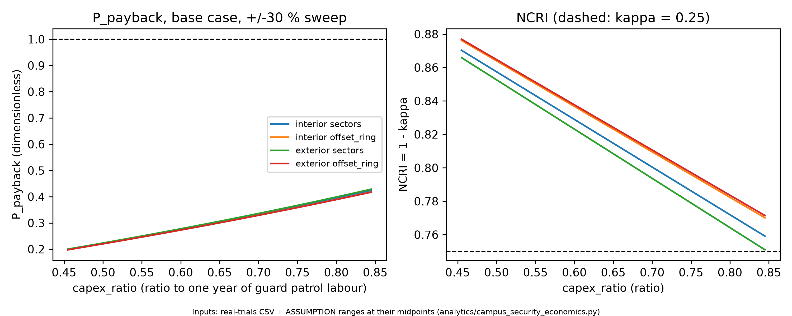  Sensitivity of P_payback and NCRI (analytics/campus_security_economics.py, from the real trials). | 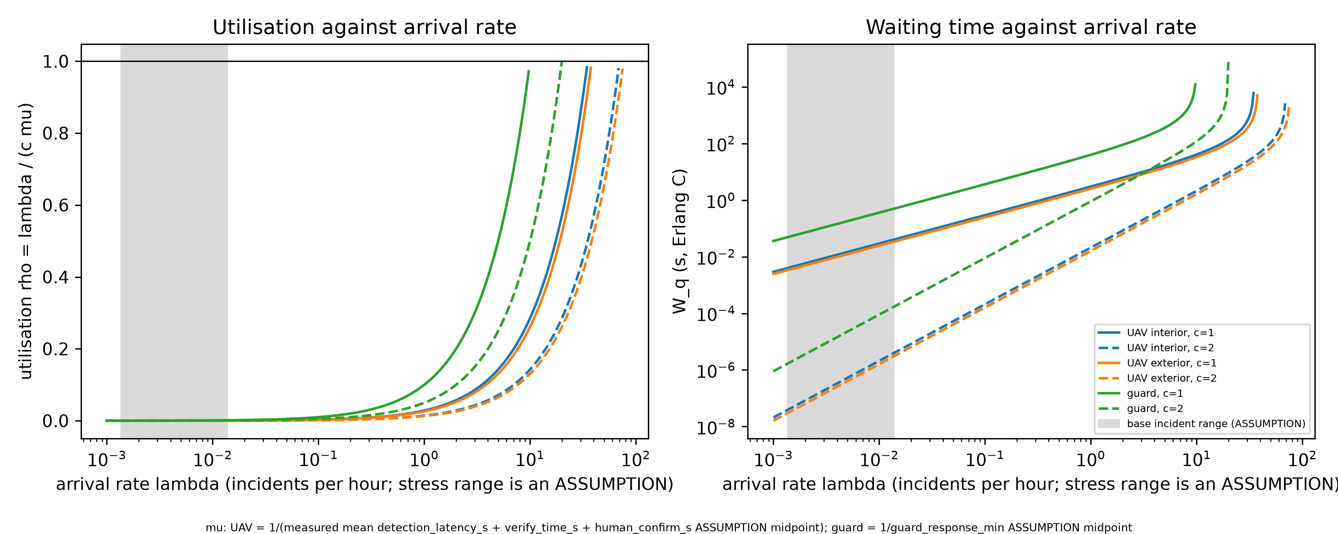  Queue waiting time against utilisation (analytics/campus_security_economics.py).

SECTION 4 · Simulation Telemetry, Monte Carlo Testing & Empirical Validation Component 1 · CDIO Robotics (10)
Evaluation protocol (titles sheet) | Conduct N = 25 multi-checkpoint patrol sweeps. Measure: patrol cycle time (minutes), OpenCV bounding box IoU (> 0.70) under varying simulated illumination (noon vs twilight), battery energy consumption (Wh/km), and restricted-zone intrusion detection latency.
Telemetry standard | Log at 500 Hz (MJCF timestep 0.002 s, or every 2nd step at 0.001 s): time, state (q, q̇ or pose, velocity), reference, tracking error, actuator torques/forces, FSM state, events. One CSV per run or one CSV with a run_id column.
Monte Carlo | N ≥ 30 runs per condition (more if your protocol says so). Randomise disturbances and initial conditions from stated distributions; record every random seed.
Required measures | Tracking RMSE = √(Σ‖p − p_ref‖² / n) on the each UAV's patrol waypoint path vs MuJoCo position; control effort E = ∫τ² dt (sum of τ²·Δt over all actuators); your primary task metric from the protocol.
Statistics | Compare the proposed controller with a baseline condition: Student's / Welch's t-test (two-sided, α = 0.05), Cohen's d = (x̄₁ − x̄₂) / s_pooled, and a 95 % confidence interval.
Where real trial data goes | Group_05_Muaaz_Aditya_Zaid_Soumya/analytics/*_real_trials.csv, produced by your controller. Files named SIMULATED_* are starter targets, never results.
Owner | Telemetry QA Lead: E075.

Baseline condition you compare against | Guard on foot in the same scene (kinematic walker), speed U[1.272, 1.462] m/s (Bohannon 1997), pause 10.0 to 60.0 s (ASSUMPTION). Proposed: uav_sectors (primary) and uav_offset_ring. The primary metric cycle_time_s is window-independent.
Monte Carlo runs per condition (N) | N = 30 per cell in all 6 cells (2 scenes x 3 conditions = 180 runs); seeds 1 to 30 in every cell; timestep 0.002 s.
Randomised parameters and their distributions | Per seed, same draw for all 3 conditions: wind U[0.0, 6.0] m/s (x0.08 indoors), gust sigma U[0.5, 2.0] m/s, intruder appears U[40.0, 160.0] s, dock jitter U[0.0, 0.3] m, guard speed U[1.272, 1.462] m/s.
Logging rate actually achieved (Hz) | 500 Hz: one row per 0.002 s step per vehicle (position, velocity, reference, error, rotor forces, FSM state, attitude). Telemetry kept for 180 of 180 runs; vision 10.0 Hz.
Random seeds recorded for every run | Yes
Real-trials CSV path(s) in the repo | Group_05_Muaaz_Aditya_Zaid_Soumya/analytics/campus_patrol_real_trials.csv (180 rows) and its provenance.json (sha256 checked).

Measure | N | Baseline mean ± SD | Proposed mean ± SD | Unit | Better? (direction)
Tracking RMSE | 30 UAV runs per cell | not applicable (guard is a kinematic walker; no controller) | Cross-track: sectors interior 0.4972 ± 0.0712, exterior 0.2586 ± 0.0206; offset_ring interior 0.3579 ± 0.1646, exterior 0.9690 ± 0.2416. | m (cross-track deviation from the active route leg) | Lower is better
Control effort ∫τ² dt | 30 UAV runs per cell | not applicable (no actuators on the guard model) | Thrust effort (sum F^2 dt): sectors interior 26742.7 ± 13.4, exterior 28080.5 ± 51.0; offset_ring interior 26731.6 ± 15.9, exterior 28242.2 ± 56.1. | N^2 s for thrust (sum over the rotors of F^2 dt; the airframe is driven by rotor forces); N^2 m^2 s for body torque (integral |tau|^2 dt) | Lower is better
cycle_time_s: mean time per completed full ground lap (primary, window-independent) | 30 per cell | guard_baseline cycle_time_s: interior 2460.46 ± 593.21 s; exterior 532.91 ± 141.64 s. | uav_sectors cycle_time_s: interior 57.41 ± 5.93 s; exterior 71.82 ± 8.22 s (offset_ring 37.97 ± 2.27 / 35.58 ± 6.36 s). | s | Lower is better

Test used | Welch's t-test
t statistic, degrees of freedom, p-value (primary metric) | Welch, guard vs uav_sectors: interior t = 22.1870, df = 29.006, p = 9.62908e-20; exterior t = 17.8000, df = 29.196, p = 3.22330e-17.
Cohen's d (primary metric) | guard vs uav_sectors: interior d = 5.7286, exterior d = 4.5959 (pooled SD). Secondary: interior 4.3299, exterior 4.9292.
95 % confidence interval of the difference | guard - uav_sectors: interior [2181.5396, 2624.5707] s; exterior [408.1221, 514.0494] s.

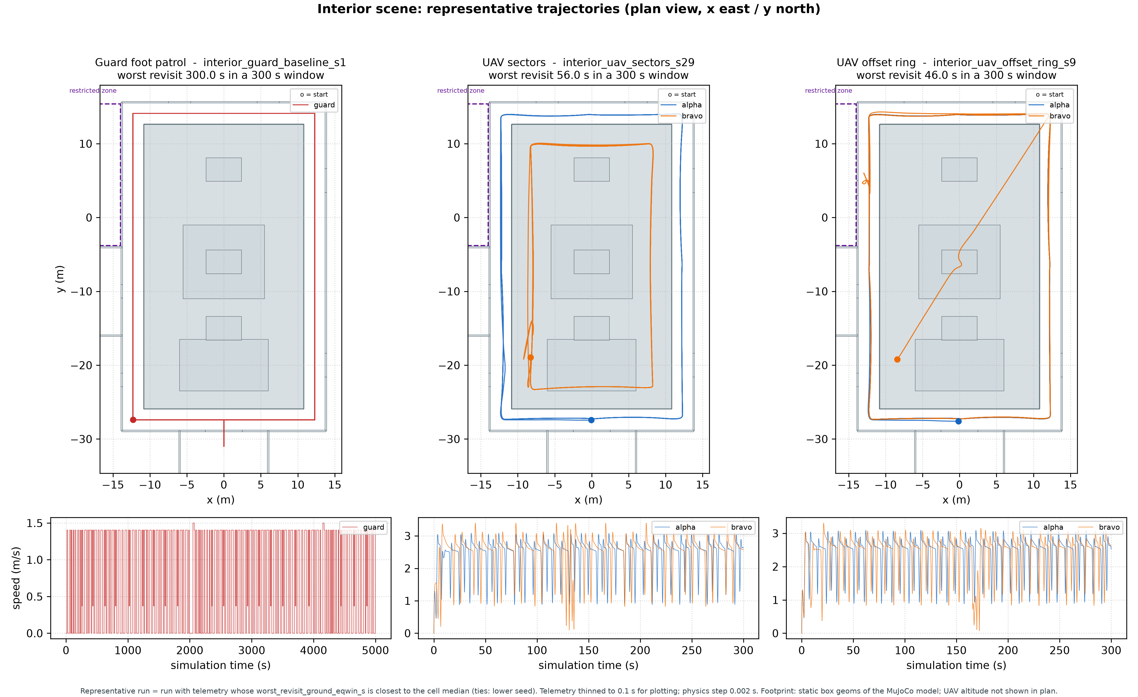  Interior: one representative run per condition (rule stated on the figure), from analytics/runs telemetry.  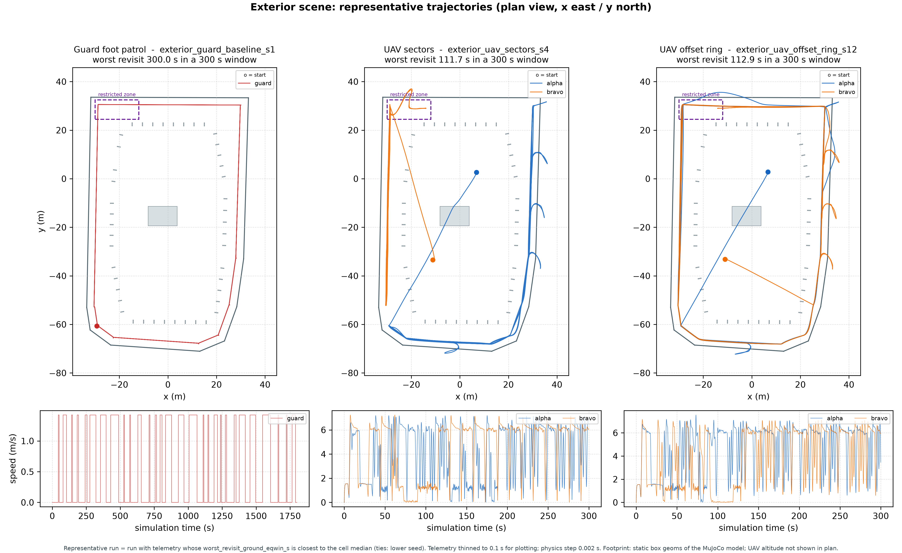  Exterior: same rule. | 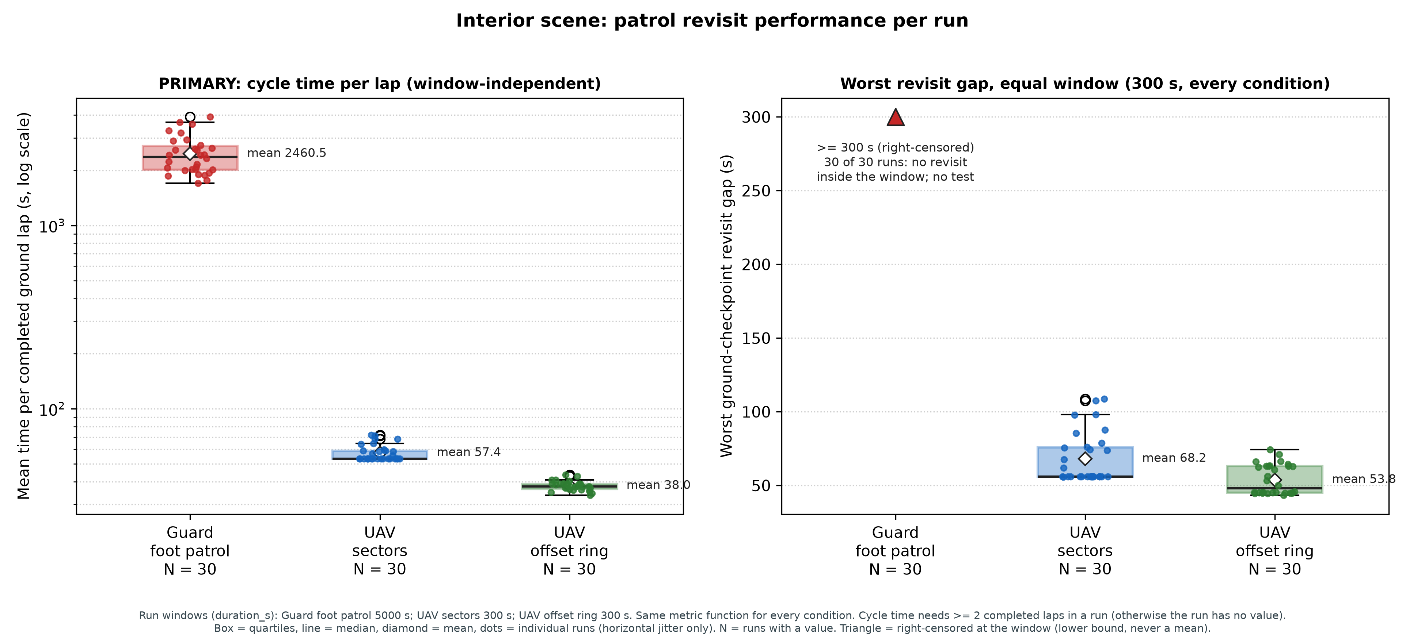  Interior: cycle time per lap (primary) and equal-window worst revisit, N = 30 per condition.  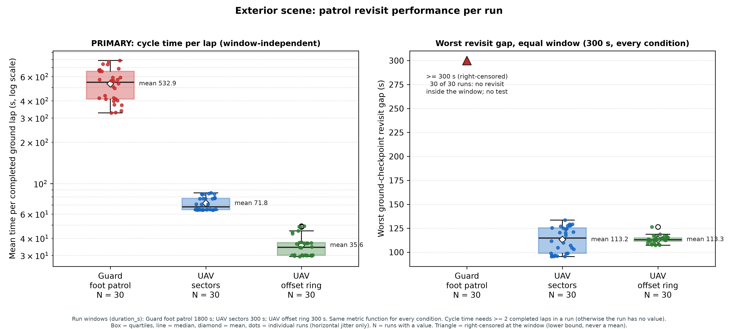  Exterior: same two metrics, N = 30 per condition.

DATA PROVENANCE DECLARATION (mandatory). Reporting generated target numbers as experimental results is research misconduct and scores zero for this component.
Every number in Section 4 comes from MuJoCo runs of OUR controller, logged by our code | Yes
No value comes from SIMULATED_* files, generate_paper_figures.py or any np.random 'target' data | Yes
Our plots re-generate from the *_real_trials.csv files in the repo | Yes
Every input in Section 3 has a source or is labelled as an assumption | Yes

SECTION 5 · LinkedIn Video Showcase, AI Verification Audit & Peer Review Component 3 · Showcase & Viva (5)
LinkedIn post URL | https://lnkd.in/p/ddww8s-J
Video length (mm:ss) | 3:17
Video shows the live MuJoCo simulation (not slides) | Yes
Video shows our business sensitivity graph | Yes
Webcam picture-in-picture: every member appears and speaks | Yes

5.1 AI Interaction Audit Log: three cases where AI gave wrong robotics or economic data
Examples: a wrong MuJoCo attribute or API call, an invented statistic, a correct paper given the wrong journal, an economic formula with the wrong units. Show how you checked each one with a textbook, the official documentation or the original paper.
# | AI tool | What we asked & what AI said | How we caught it | What was actually true (with source) | Error type | Verdict
AI-01 | Claude | Group AI use: code, tests and documents were first drafted by Claude (Anthropic); we ran, tested and corrected them. Case: the region-ownership gate (src/check_region_ownership.py) matched nothing. | Ran / tested the code or simulation | git reports repository-root paths while the ownership globs assumed group-folder paths, so no region ever matched and every change was attributed to E043. Fixed in commit 40a811f. | Wrong code / MuJoCo API | Corrected
AI-02 | Claude | The compute_apf_separation docstring claimed APF alone would "guarantee minimum separation distance d >= 2.5 m". | Ran / tested the code or simulation | False: head-on at 6 m/s each, APF alone came to 0.43 m (contact); the layered version held 7.12 m. Proof: tests/test_e043_separation.py. | Wrong physics / equation | Corrected
AI-03 | Claude | The contact-parameter note said solref 0.004 s equals 2 x the 0.002 s timestep, so the leg contact is used as written, and that at the earlier 0.004 s timestep MuJoCo "silently clamped it". | Ran / tested the code or simulation | Wrong number: MuJoCo mixes the leg's 0.004 with the surface's 0.02, giving 0.012 s, which is above 2 x timestep at both 0.002 s and 0.004 s, so no clamp acted. Proof: viva_contact_solref_mix.txt. | Wrong code / MuJoCo API | Corrected

5.2 Peer review: watch both assigned LinkedIn videos and score them (0–2 per criterion)
Group reviewed | Problem | Physics | Business | Data | Clarity | Best moment (mm:ss) | One question for the viva
Group 06: Autonomous Crawler Cleaning Robot for Inclined Rooftop Solar Panels | 2 | 2 | 2 | 2 | 2 | 0:05 | How does the crawler keep traction on a wet, tilted panel, and how much slip did you measure in the simulation?
Group 11: Autonomous Solar PV Inspection AMR | 2 | 2 | 2 | 2 | 2 | 0:30 | What false-positive rate does your defect detector show on clean panels, and how did you measure it?

SECTION 6 · Individual Learning Record & Research Consent unmarked · one row per member · answer honestly
These answers do not change your marks. They help improve the course and are used in anonymised research only if you consent in the sign-off below. Commit share: your commits ÷ the group's commits in your folder (git shortlog -sn -- <folder>).
Member | Hours I spent (total) | My declared role matched my actual work (1 = not at all, 5 = fully) | I learned a skill outside my role (robotics ↔ business) | Scripts I mainly wrote (file names) | My commit share (%) | Share of my writing first drafted with AI | Wrong AI facts / code I personally caught
Muaaz Mohammed Iqbal Shaikh (E043) | 35 | 5 | Yes | aerial_patrol_swarm.py (flight, separation, FSM), foot_patrol_baseline.py, run_benchmark.py, scene generators, test_e043_* | 116 of 116 (the merged tree was pushed from E043's account) | 76–100 % | 3–5
Aditya Rajkumar (E051) | 35 | 5 | Yes | aerial_patrol_swarm.py E051 region, vision_illumination_benchmark.py, test_e051_vision.py | 0 own commits; I worked on my code area (Section 2.2), merged through E043's account | 76–100 % | 1–2
Zaid Rezaur Rahman (E075) | 35 | 5 | Yes | aerial_patrol_swarm.py E075 region, statistical_validation.py, geofence_noise_demo.py, test_e075_geofence_stats.py | 0 own commits; I worked on my code area (Section 2.2), merged through E043's account | 76–100 % | 1–2
Soumya Subhankar Ranasingh (E077) | 35 | 5 | Yes | campus_security_economics.py, campus_security_fmea.py, test_e077_economics.py | 18 own commits (e077 branches, PRs #1 to #5) | 76–100 % | 1–2

Member | Before this course I had used a physics simulator | The most valuable thing I learned (one line) | One thing I would change in this course (one line)
Muaaz Mohammed Iqbal Shaikh (E043) | No | A result only counts once a test can break it: the head-on test showed APF alone fails, which led to the layered separation. | Set up per-member commits from day one, so each member's work shows under their own account.
Aditya Rajkumar (E051) | No | Labelled test frames catch detector errors a demo hides: the terracotta carpet false positive, fixed from 86 to 100 percent. | Test the detector in dim indoor light early; indoor detection stayed at about 1 in 3.
Zaid Rezaur Rahman (E075) | No | The right test matters: Welch's t test, because guard and drone times vary so differently. | Fix the false-alarm logic and the censored revisit window before the batch run, not after.
Soumya Subhankar Ranasingh (E077) | No | A business case is only as strong as its inputs: reading the simulation output directly and labelling every assumption makes it defensible. | Get real quotes and the real guard roster early to replace the assumption ranges.

Track A: how this dossier becomes your 4-page IEEE paper
I. Introduction | Section 1: title, verified baseline friction, governing standards
II. Related work | Section 1.1: verified sources only (5+ with DOIs)
III. System model | Section 2: MJCF model, FSM, equations, control law
IV. Techno-economics & evaluation | Sections 3–4: CSBS model, FMEA, Monte Carlo results, statistics
V. Discussion & limitations | Sim-to-real gap, assumptions in the business model, AI audit lessons
Target venues (titles sheet) | A: ICVGIP · B: IEEE CASE

Individual Academic Sign-off every member answers and signs
Answer each statement for yourself: (1) this work is original and every source and AI use is declared; (2) our model loads and our controller and business scripts run from the repository; (3) I understand our whole project and can explain my own part in the viva voce.
Member (Roll) | (1) Original work | (2) Code runs | (3) Viva-ready | Signature | Optional research consent*
Muaaz Mohammed Iqbal Shaikh (E043) | Yes | Yes | Yes | Muaaz Mohammed Iqbal Shaikh | Yes
Aditya Rajkumar (E051) | Yes | Yes | Yes | Aditya Rajkumar | Yes
Zaid Rezaur Rahman (E075) | Yes | Yes | Yes | Zaid Rezaur Rahman | Yes
Soumya Subhankar Ranasingh (E077) | Yes | Yes | Yes | Soumya Subhankar Ranasingh | Yes
*Optional: may Dr. Nanade use anonymised data from this dossier and repository in education research publications? Your answer has no effect on your marks, and you can withdraw until results are published.

