WeighApp
- Introduction
WeighApp is a standalone Loader Payload System (LPS) application whose primary responsibility is to calculate the weight of material present in a loader bucket during machine operation. It acts as a middleware layer between physical machine sensors and Caterpillar's payload/weighing algorithms. The application collects raw sensor information, converts it into engineering values, performs machine kinematic calculations, feeds the payload calculation library, manages calibration procedures, stores calibration data in NVM, generates diagnostics, and publishes payload information to other applications and operator interfaces.
The application itself does not directly implement the payload mathematics. Instead, it functions as the orchestration layer around the external LPS Weigh Library and LPS Calibration Library. It prepares inputs, manages calibration workflows, validates sensor data, persists parameters, and exposes results to the rest of the ECU software.

- Primary Purpose
The ultimate objective of WeighApp is to answer a single question:
How much payload is currently in the bucket?
To answer this, the application continuously monitors:
- Lift cylinder position
- Tilt cylinder position
- Lift cylinder head-end pressure
- Lift cylinder rod-end pressure
- Hydraulic oil temperature
- Machine geometry/linkage configuration
- Machine calibration state
and converts them into payload weight information.

- Major Functionalities
The application can be logically divided into seven major functions.
1. Sensor Acquisition
2. Signal Processing
3. Kinematic Conversion
4. Payload Calculation
5. Calibration Management
6. Diagnostics and Events
7. NVM Persistence
into:
Plain Text
Duty Cycle
Frequency
and subsequently into engineering values.
- Several transfer functions perform these conversions:
- Hydraulic pressure conversion
- Lift extension conversion
- Tilt extension conversion
- Lift velocity calculation
- Tilt velocity calculation
The application also applies filtering to stabilize measurements and eliminate noise before they reach the weighing algorithm. C library

- Kinematic Conversion Functionality
The payload calculation cannot be performed solely from sensor duty cycles.
The application contains machine-specific linkage tables that model loader geometry. These tables convert sensor readings into actual bucket geometry information.
- Check ruby configurations

- The transformation chain is approximately:
PWM Signal
↓
Cylinder Extension
↓
Cylinder Angle
↓
Lift Angle
↓
Tilt Angle
↓
Bucket Angle
↓
Bucket Position
Using these linkage mappings the application understands exactly where the bucket is relative to the machine and which portion of the lift cycle is occurring.

- Payload Calculation Functionality
This is the core business function.
After preparing all required engineering data, the application feeds information into the external LPS weigh library.

- The weigh library produces:
Raw Instantaneous Weight
Instantaneous payload estimate at the current moment.
Best Available Bucket Weight
The highest-quality payload estimate. This is the primary weight reported to operators.
Dig State
Indicates whether the machine is actively digging.
Dump State
Indicates current dumping activity.
Weigh Range Indicator
Shows whether the machine is operating within an acceptable weighing region.
Payload Calculation Method
Indicates which internal weighing method was used to generate the result.
-> check Configuration

- Calibration Management Functionality
Payload systems are only accurate after proper calibration.
WeighApp manages every calibration workflow
The application supports four major calibrations.

Empty Bucket Calibration
This calibration characterizes machine behavior with an empty bucket.
Purpose:
Establish Empty Machine Reference

Performed using:
LpsCalEmptyCalMain()

Full Bucket Calibration
This calibration characterizes machine behavior with a known payload.
Purpose:
Establish Loaded Machine Reference
Performed using:
LpsCalFullCalMain()

Lift Linkage Calibration
Used to determine physical limits of lift cylinder movement.
Workflow:
Full Raise
→ Full Rack
→ Full Lower
→ Validation
→ Save
The resulting calibration values are stored into NVM.
Tilt Linkage Calibration
Used to identify tilt cylinder operating limits.
Workflow:
Full Rack
→ Full Lower
→ Full Raise
→ Full Dump
→ Validation
→ Save
Results are stored into NVM

- Diagnostics and Event Management
The application continuously supervises sensor health and payload system health.
It generates autonomy conditions and fault indicators when abnormal situations occur.
- Need to check AIS autonomy condition
Examples include:
Sensor Diagnostics
- Lift sensor voltage high
- Lift sensor voltage low
- Lift sensor frequency abnormal
- Tilt sensor voltage high
- Tilt sensor voltage low
- Tilt sensor frequency abnormal
Calibration Diagnostics
- Lift linkage calibration invalid
- Tilt linkage calibration invalid
- Payload system calibration invalid
Payload Events
- Bucket too heavy to zero
- Payload system needs re-zero
- Overload limit exceeded
Machine Configuration Diagnostics
- Machine model not selected
- Configuration invalid
- Need to check the workflow

- NVM Persistence Functionality
The application maintains long-term configuration and calibration data.
All important information survives power cycles through NVM storage.
Stored blocks include:
Machine Configuration
Stores:
- Weigh range
- Calibration weight
- Payload targets
- Calibration factors
Zero Weight
Stores payload zero references.
Payload Calibration Data
Stores complete payload calibration information.
Lift Calibration
Stores lift limits and calibration status.
Tilt Calibration
Stores tilt limits and calibration status.

Runtime Workflow
The complete operational workflow is:
External Sensors
↓
PWM Input Application
↓
WeighApp
↓
Signal Conversion
↓
Filtering
↓
Kinematic Tables
↓
LPS Weigh Library
↓
Payload Calculation
↓
Diagnostics
↓
Publish Results
↓
Store Updates In NVM

Typical Use Case
Consider a loader operator filling a bucket.
- Lift and tilt sensors begin changing.
- Pressure sensors measure lift force.
- WeighApp receives PWM data.
- Sensor processing converts PWM to extensions and pressures.
- Linkage tables calculate bucket geometry.
- Weigh library calculates payload.
- Dig and dump state are determined.
- Best bucket weight is generated.
- Payload information is sent to Job Manager/operator displays.
- Diagnostics are checked.
- Updated calibration statistics are stored in NVM if required.

Summary
In simple terms, WeighApp is the payload-system controller of the ECU. It receives sensor measurements from other applications, converts them into meaningful machine geometry, invokes payload algorithms, manages all calibration procedures, supervises diagnostics, stores persistent parameters, and publishes the final payload information to the rest of the machine software. The application itself is primarily an orchestration and integration layer around the weighing and calibration libraries, making it the central coordinator of the complete loader payload measurement system.

Long running Task.
task_1x() <-- RTOS NVM task
LpsSaWeighApp::executive() <-- Main application loop
LpsSaUpdt() <-- Main processing
LpsSaWeighingScsRx() <-- Request listener
while(PwmIn->get()) <-- Sensor listener
LpsJobMgrTxRead() <-- Job Manager listener
LpsSaBmiCdlRead() <-- CDL listener
UpdateEvents() <-- Diagnostics/Event engine
LpsSaWeighCalReqstCallback() <-- Calibration listener

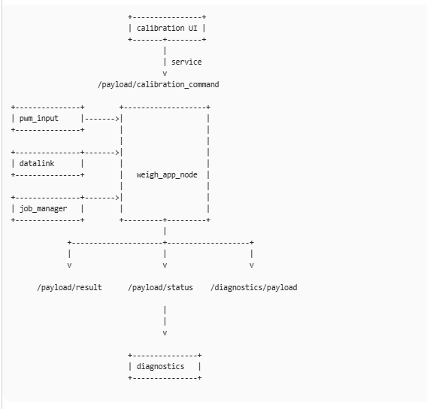

SUBSCRIBE
----------
/sensors/pwm
/sensors/hydraulic_oil_temp
/job_manager/state
/machine/config

PUBLISH
--------
/payload/result
/payload/status
/diagnostics/payload

SERVICE
--------
/payload/calibration_command

