AUTOMATION TESTING FOR BMI-CDL APPLICATON

Environment Preconditions.
- Install the Latest Vbench version from the link below.

http://wkc001705229:8080/job/VBench_Installer/1131/
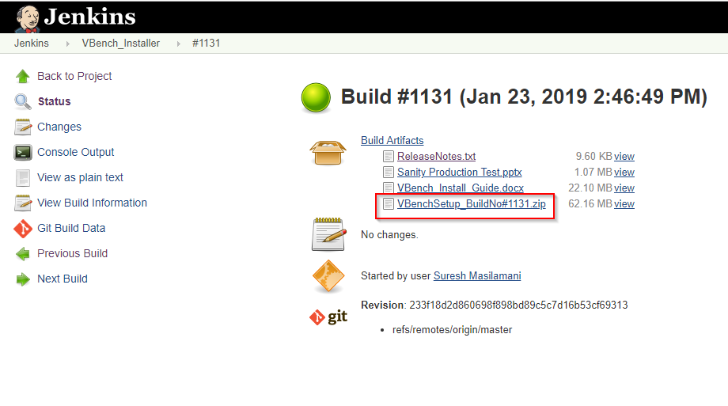

- Install the Python packages – xlrd, xlwt, xlsxwriter
Step 1: Run Command prompt as administrator
Step 2 : Change the path to C:\Python27\Scripts\
Step 3 : Give the Command -> pip install xlrd
-> pip install xlwt
-> pip install xlsx writer
OR
If the above doesn’t work, then copy the folders xlrd, xlwt, xlsxwriter to the path below
C:\Python27\Lib\site-packages
The folders xlrd, xlwt & xlsxwriter are available in the below path or in the GIT:
\\ACGFS01.mw.na.cat.com\SharesAC\Eproject\cc_information\Payload\
TES_Test_Automation\BMI_CDL\Package
remotes/origin/cpm_tpms2_US748445_rebase

- The Simulator Interface must be initialized in Vbench.

Step 1: Open the Vbench application.

Step 2 : Select the Simulator Icon from Vbench

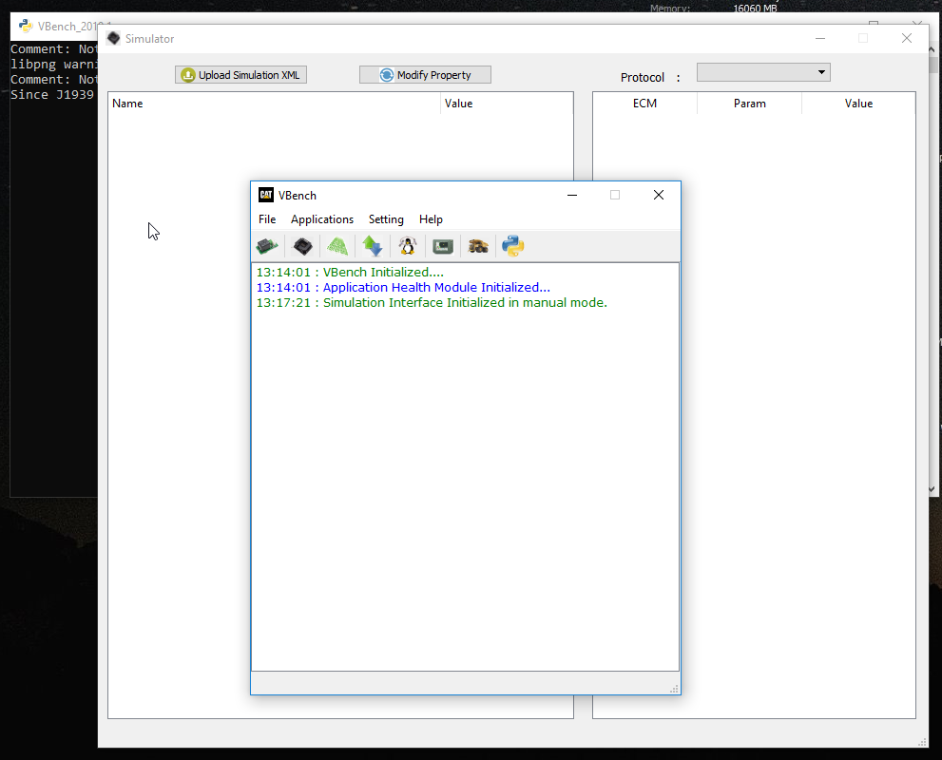
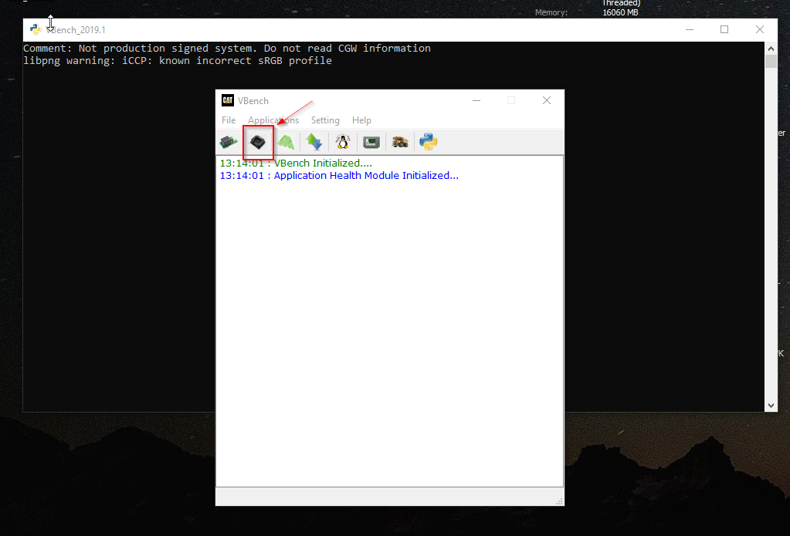

- Open the Config.py script from the BMI_CDL folder and change the below:

- Path for input and output files.
- Host IP address
- Test Data count
- Path for the backup CPM folder
- Verity name

- Create a folder CPM inside the folder BMI_CDL. If the file already exists delete the contents in CPM folder before running BMI_CDL.py.

- If there is test data available to be entered in vertical columns for PIDs. Then run the Interchange_rows.py to copy the test data from TEST_INPUT.xlsx into input_data.xlsx in the Input_Files folder.
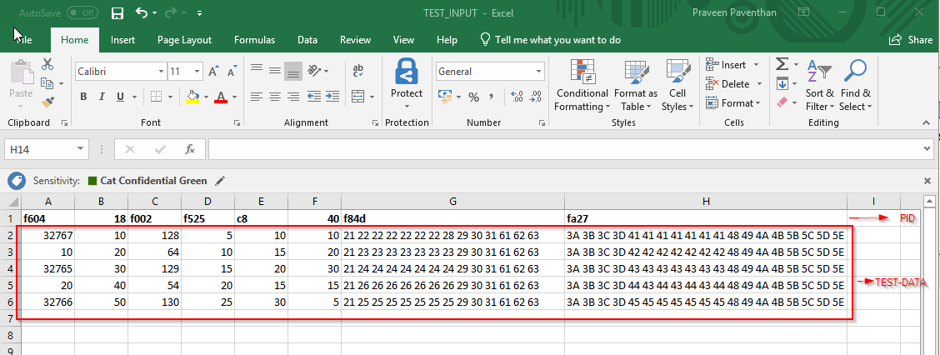

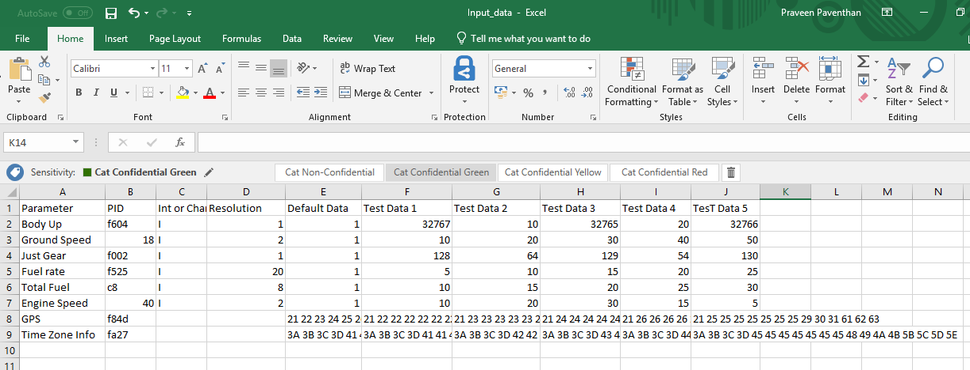

- Flash the ECM with the software. Verity present in the below path:
\\ACGFS01.mw.na.cat.com\SharesAC\Eproject\cc_information\Payload\
TES_Test_Automation\BMI_CDL\Input_Files\Automation_verity

- Run the BMI_CDL.py script for Test automation.
NOTE :
INPUT EXCEL FILE
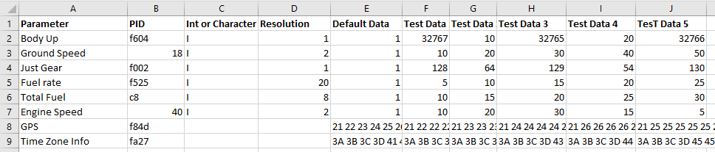
- PID list in the input excel file should be in the same order as that in the JSON config file.
- Parameter column in the input excel file should have the same parameter as that in the XML file.
- PID column in the input excel file should have all lower-case alphabets.
- In the Int or Character column, all the PIDs except for variable length PIDs it should be given as ‘I’. And leave it blank for the variable length PIDs.
- The Resolution column must contain the correct resolution for each PID.
- Default data is always to be the same and not to be changed. Default data is simulated after simulation of each test data to recognize the data change.
- Test Data value should not be repeated for each PID i.e the Test data should not have duplicate values for a PID, only unique test values to be simulated for PID. For non-variable length PID data should be the engineering value in decimal. Test data for variable length PID should contain hex values from “21” only (Not less than “0x21”). Hex value ‘’27” & “0” not be used for variable length test data. Hex values less than “0x7F” to be used.

RESOLUTION
Simulates
Engineering value
VBench
BMI-CDL app
Sends raw data
Simulator

Vbench Simulator simulates data for the PID with its resolution applied. But the data transmitted from Vbench is the raw data. BMI - CDL application receives the raw data sent by Vbench. So, while validating the output values of the PID it should be multiplied with its respective resolution to match with the Input test data.

TEST-INPUT EXCEL FILE
The order of the test data of PIDs stored in the TEST_INPUT.xlsx should be in the same order as that in the JSON config file.

