**a)Create a XMLHttpRequest with a callback function and retrieve data from a TXT file by using AJAX.**

Step 1**:**First create a html file

<html>  
<script>  
function fun()  
{  
document.getElementById("x2").innerHTML="HELLO";  
const xhttp=new XMLHttpRequest();  
xhttp.open("GET","sample.txt");  
xhttp.onreadystatechange=function()  
{  
 if(this.readyState === 4 && this.status === 200)  
 {  
 document.getElementById("x2").innerHTML=this.responseText;  
}  
};  
xhttp.send();  
}  
</script>  
<body>  
<h1>The HTMLRequest object example</h1>  
<button id="x1" onclick="fun()">Click here to get the data from the file</button>  
<p id="x2"></p>  
</body>  
</html>

**Output:**

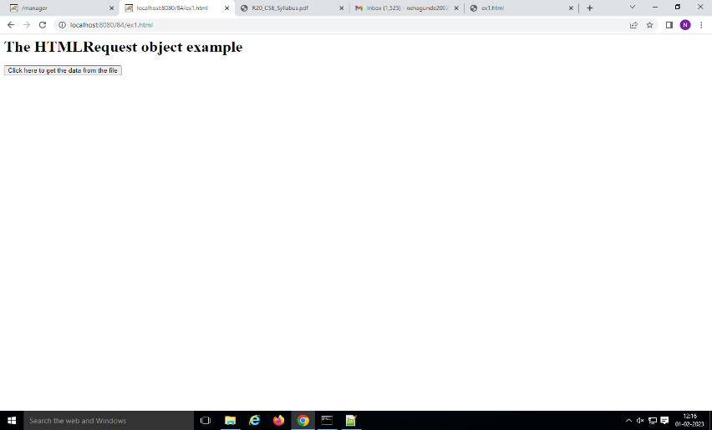

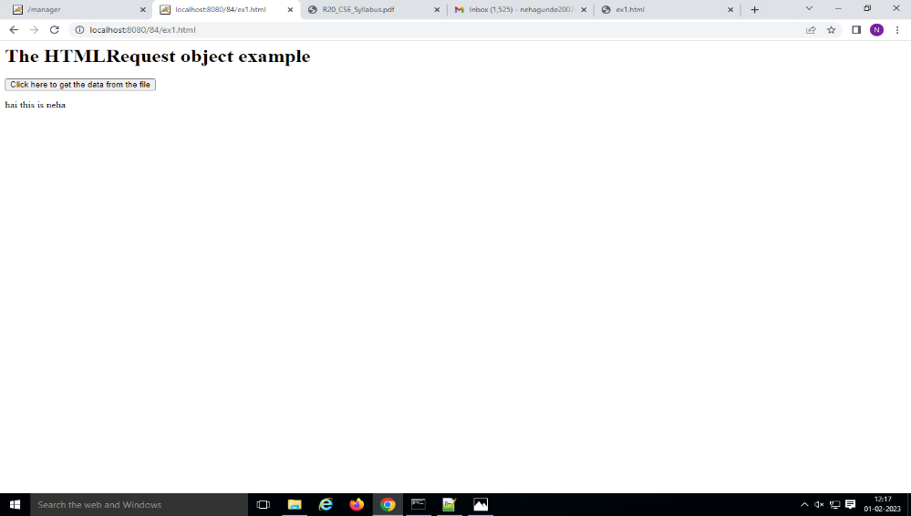

**Step 2:**Generate .war file

->jar cvf 84.war .

**Step 3:**Open apache tomcat and go to manager app.

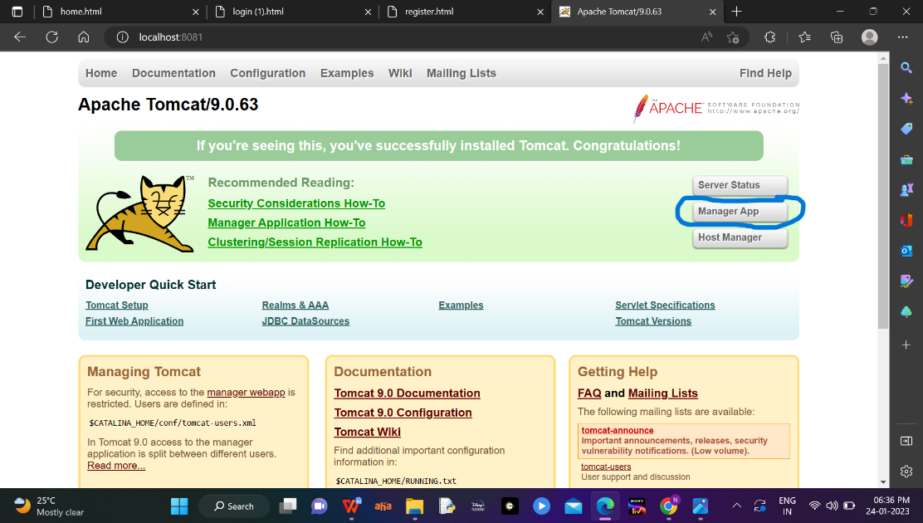

**Step 4:**Now deploy the generated war file .

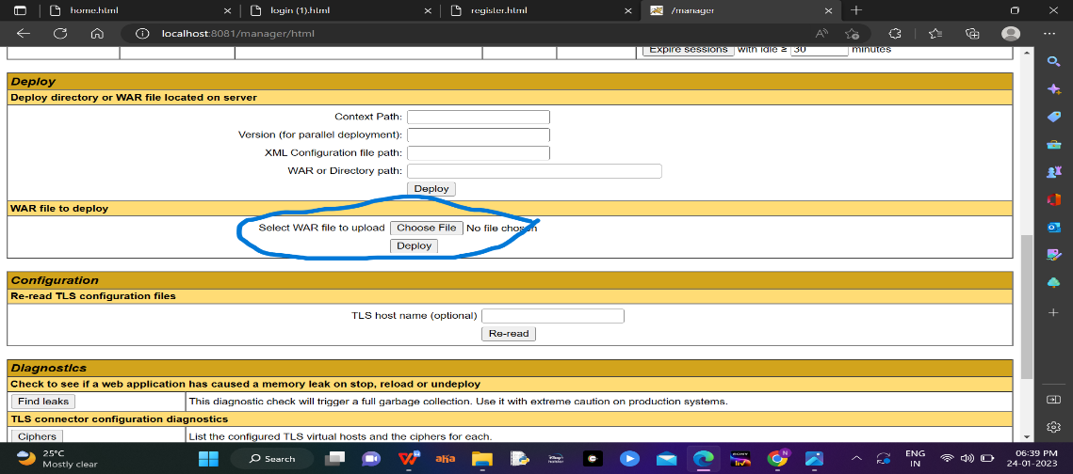

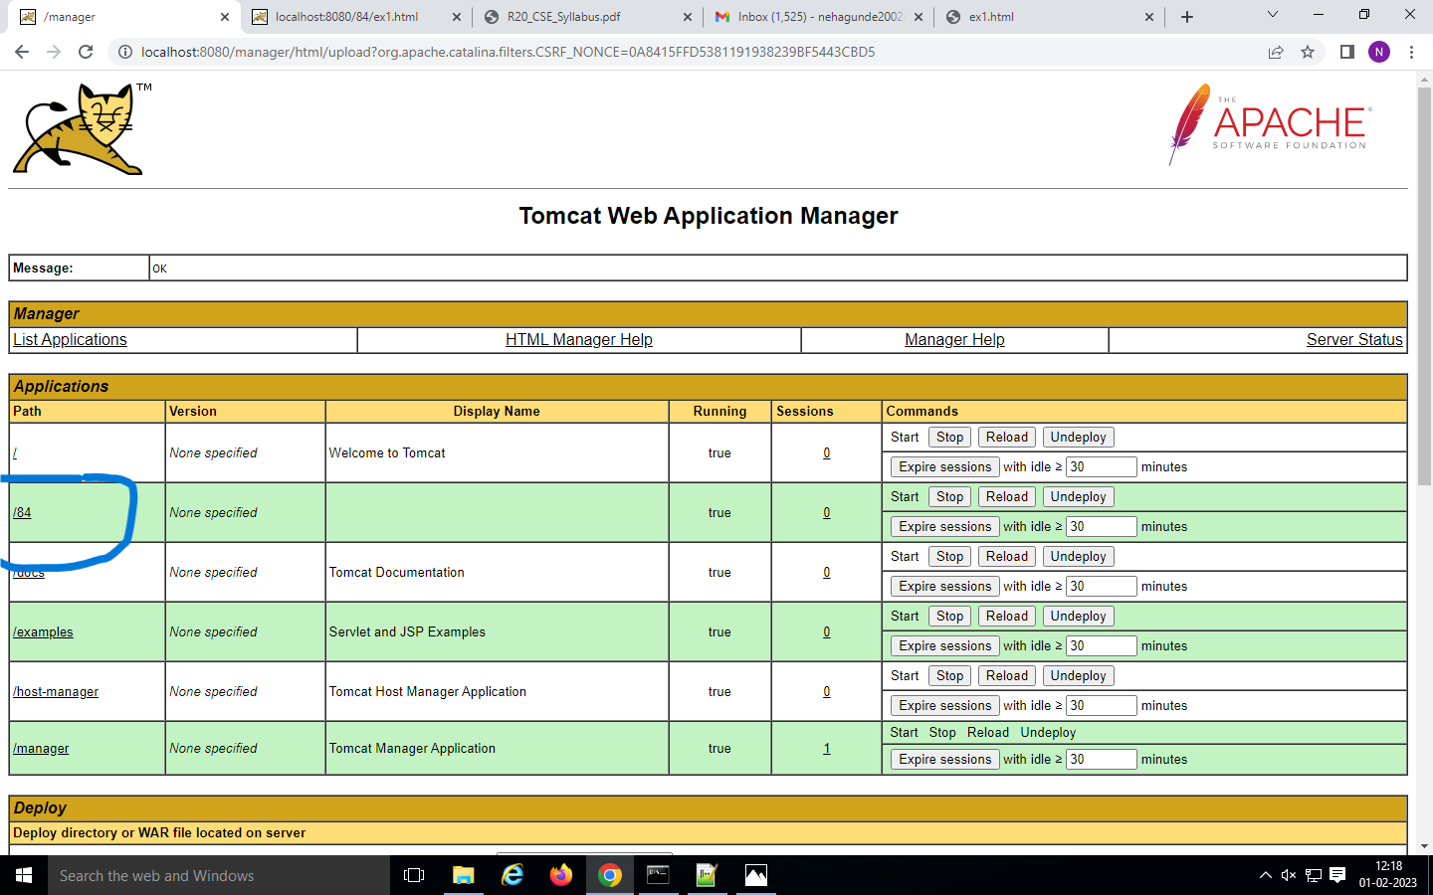

**Step 5:**Open the browser and type

->localhost:8080/84/ex1.html



**b) Create an XMLHttpRequest to retrieve data from an XML file and display the data in an HTML table by using AJAX.**

**Step 1:** Create xml file

<bookstores>  
<book category ="Programming">  
<title>Java Programming</title>  
<author>James Gosling</author>  
<year>1990</year>  
<price>$25</price>  
</book>  
<book category ="DataBase">  
<title>DataBase Management System</title>  
<author>Elmasri</author>  
<year>2002</year>  
<price>$35</price>  
</book>

</bookstores>

**Output:**

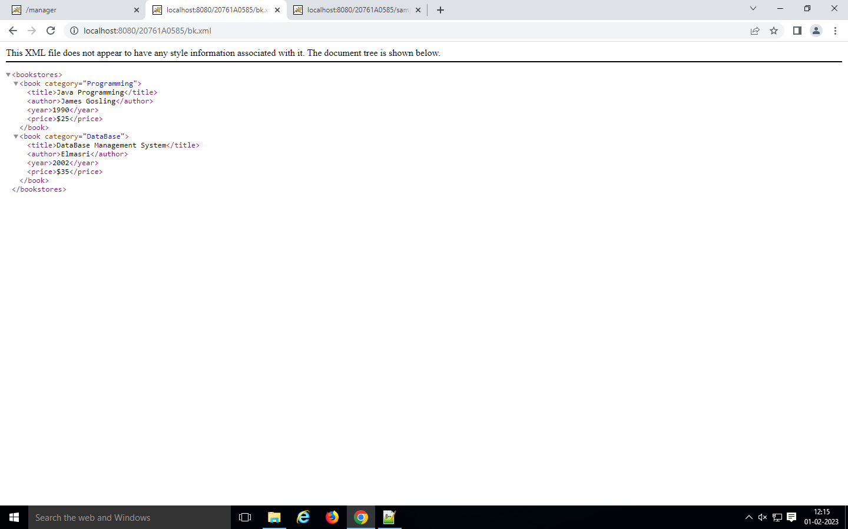

**Step 2:**Create html file

<html>  
<script>  
function fun2()  
{  
const xhttp=new XMLHttpRequest();  
xhttp.onreadystatechange=function()  
{  
 if(this.readyState === 4 && this.status === 200)  
 {  
 myFunction(this):  
}  
};  
xhttp.open("GET","book.xml",true);  
xhttp.send();  
}  
function myFunction(xml)  
{  
 var xmldoc=xml.responseXML;  
 var x= xmldoc.getElementByTagName("title");  
 document.getElementById("x1").innetHTML=x[0].childNodes[0].nodeValue;  
 }  
</script>  
<body>  
<button id="ff" onclick="fun()">Click here to get the data from the file</button>  
<p id="x1"></p>  
</body>  
</html>

**Output:**



  
  
  