Sorting Algorithm Comparison Report
Performance tables + charts

Experiment design
- Algorithms: bubble, selection, insertion, merge.
- Dataset types: random, sorted, reverse_sorted, partially_sorted.
- Sizes: 1,000; 5,000; 10,000; 50,000.
- Timing: perf_counter; one trial per scenario for a clean side-by-side comparison.
- Timeouts: enforced in a subprocess for non-viable scenarios; recorded as TIMEOUT.

Results (seconds) or TIMEOUT
index | dataset_type | n | bubble | insertion | merge | selection
0 | partially_sorted | 1000 | 0.055991 | 0.005882 | 0.002268 | 0.026543
1 | partially_sorted | 5000 | TIMEOUT | 0.192588 | 0.033326 | TIMEOUT
2 | partially_sorted | 10000 | TIMEOUT | TIMEOUT | 0.033501 | TIMEOUT
3 | partially_sorted | 50000 | TIMEOUT | TIMEOUT | 0.197770 | TIMEOUT
4 | random | 1000 | 0.078010 | 0.025361 | 0.002696 | 0.029841
5 | random | 5000 | TIMEOUT | TIMEOUT | 0.015090 | TIMEOUT
6 | random | 10000 | TIMEOUT | TIMEOUT | 0.031265 | TIMEOUT
7 | random | 50000 | TIMEOUT | TIMEOUT | 0.238488 | TIMEOUT
8 | reverse_sorted | 1000 | 0.100215 | 0.075177 | 0.022350 | 0.036724
9 | reverse_sorted | 5000 | TIMEOUT | TIMEOUT | 0.023387 | TIMEOUT
10 | reverse_sorted | 10000 | TIMEOUT | TIMEOUT | 0.042746 | TIMEOUT
11 | reverse_sorted | 50000 | TIMEOUT | TIMEOUT | 0.148357 | TIMEOUT
12 | sorted | 1000 | 0.000090 | 0.000151 | 0.001794 | 0.027748
13 | sorted | 5000 | 0.000668 | 0.000714 | 0.010964 | 0.887744
14 | sorted | 10000 | 0.001019 | 0.001645 | 0.041528 | TIMEOUT
15 | sorted | 50000 | 0.004259 | 0.009608 | 0.180195 | TIMEOUT

Best algorithm per scenario
dataset_type | 1000 | 5000 | 10000 | 50000
partially_sorted | merge | merge | merge | merge
random | merge | merge | merge | merge
reverse_sorted | merge | merge | merge | merge
sorted | bubble | bubble | bubble | bubble

Charts
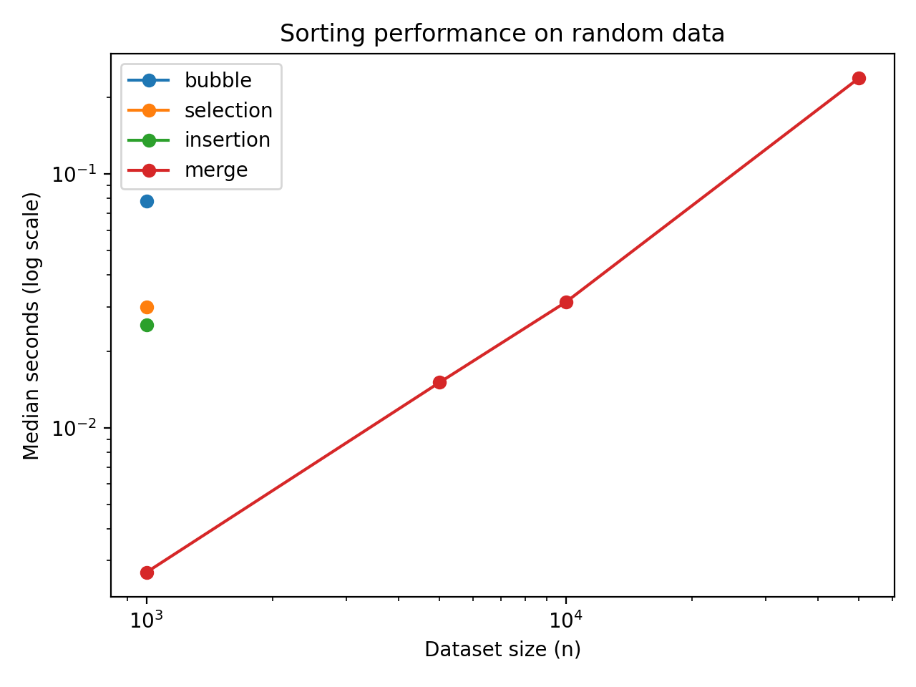
Figure: Runtime vs size on random data (log-log scale).
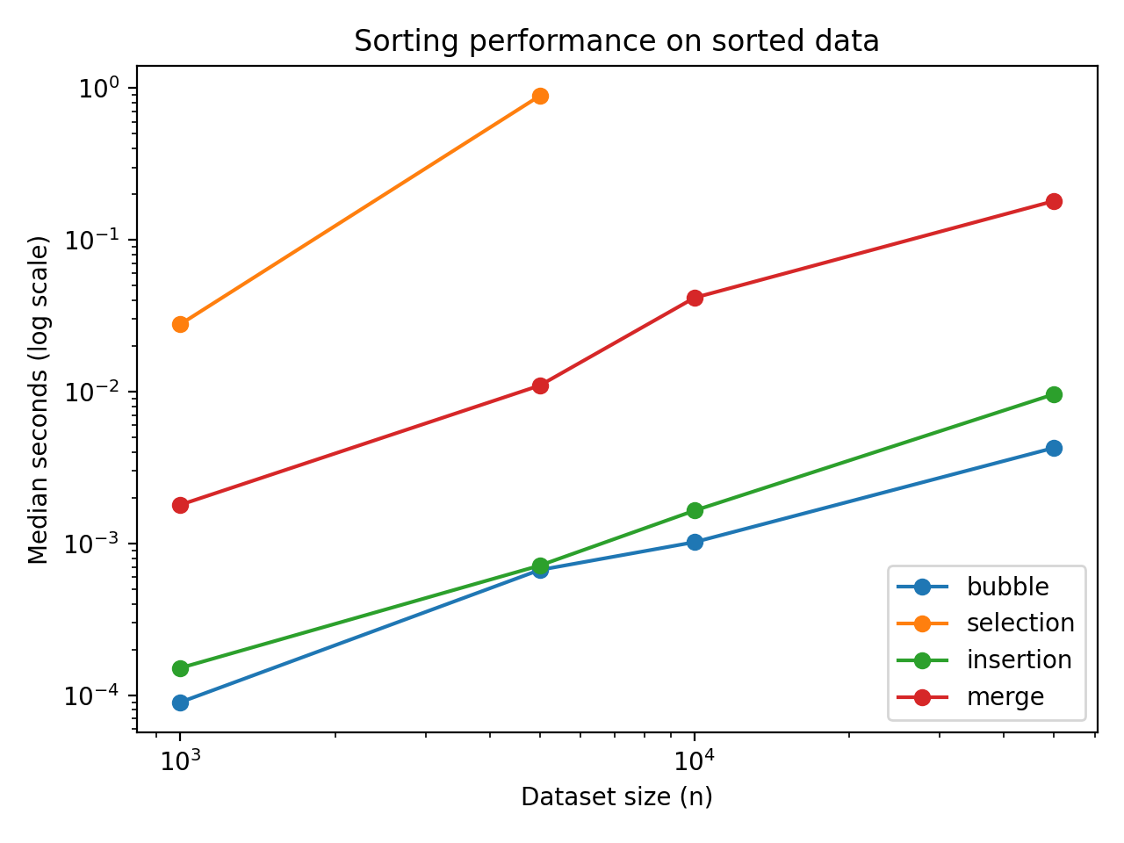
Figure: Runtime vs size on sorted data (log-log scale).
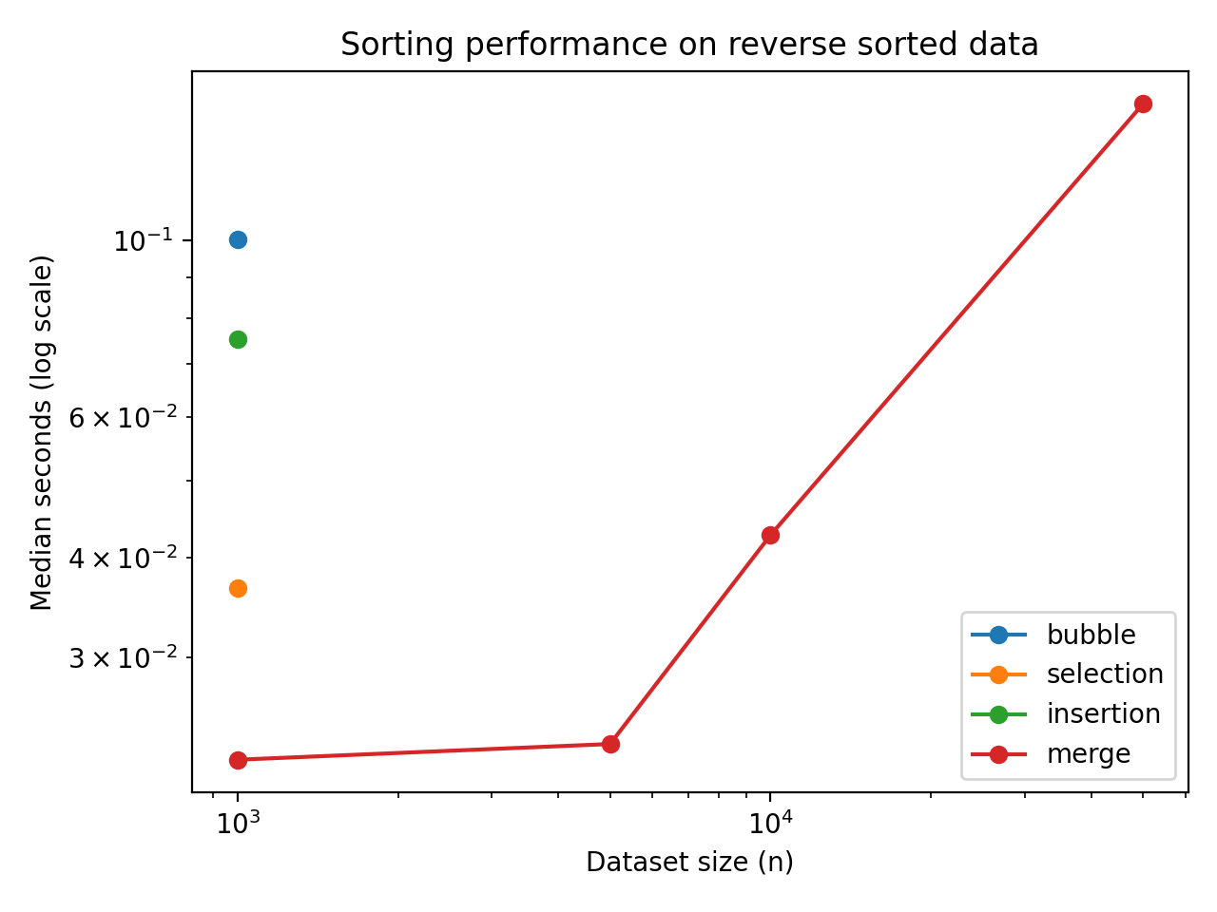
Figure: Runtime vs size on reverse sorted data (log-log scale).
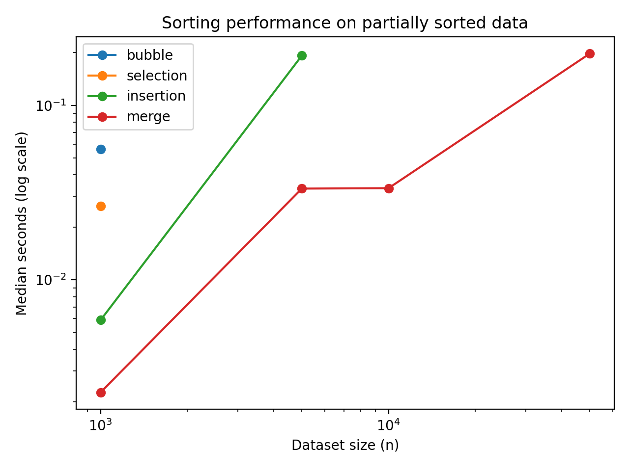
Figure: Runtime vs size on partially sorted data (log-log scale).

Interpretation
Merge sort is the only method in this set that stays practical as data becomes large and disordered. Insertion sort shines when the input already has order. Bubble and selection are dominated at scale, so they are best treated as learning tools or niche choices for small inputs.

References
Cormen, T. H., Leiserson, C. E., Rivest, R. L., & Stein, C. (2022). Introduction to Algorithms (4th ed.). MIT Press.
Sedgewick, R., & Wayne, K. (2011). Algorithms (4th ed.). Addison-Wesley Professional.
Python Software Foundation. (2025). Sorting HOW TO. Python 3 Documentation.

