TV Show / Movie Genre Prediction
Model Evaluation & Explainability Report

1. Objective
Predict the primary genre of a Netflix or Disney+ title using classic machine learning models, based on metadata such as type, cast, country, rating, duration, release year, and description. This report covers data understanding, preprocessing, two trained models, their evaluation, and explainability analysis.

2. Dataset
Source: github.com/vinayak-ensemble/Dataset-TV-Shows-OTT — 9,338 titles (7,926 Netflix, 1,412 Disney+), 13 columns: id, type, title, director, cast, country, date_added, release_year, rating, duration, listed_in, description, platform.

2.1 Missing values
Column | Missing rows | % missing
director | 2,855 | 30.6%
cast | 938 | 10.0%
country | 962 | 10.3%
date_added | 13 | 0.1%
rating | 7 | 0.1%
duration | 3 | 0.03%

director and country have the most missing values. These are handled with an explicit "missing" category / a has_director flag rather than dropped, since missingness itself can carry signal (e.g. many stand-up specials have no listed director).

3. Data Understanding & Preprocessing

3.1 Target: primary genre
The listed_in column is multi-label (e.g. "Dramas, International Movies"). The target used is the FIRST genre listed, reduced to the 10 most frequent genres with everything else grouped as "Other", framing genre prediction as a single-label, multi-class classification problem.
Key EDA finding: Netflix and Disney+ label the same genre differently — e.g. Netflix says "Action & Adventure", Disney+ says "Action-Adventure"; "Comedies" vs "Comedy"; "Documentaries" vs "Documentary". These were normalized to a single spelling before selecting the top 10 classes, otherwise one genre would be artificially split into two.

3.2 Features
- type (Movie / TV Show), platform (Netflix / Disney) — one-hot encoded
- country — first listed country, kept as its own category for the top 10 most frequent, everything else grouped as "Other"
- rating — one-hot encoded (3 malformed rows where a duration value had landed in the rating column were detected and fixed)
- release_year, duration (parsed to a number), cast_count (number of cast members), has_director (flag), year_added (parsed from date_added) — numeric, median-imputed, standardized
- description — TF-IDF, 300 terms, English stop-words removed
- listed_in is dropped from the features — it is the source of the target, so using it would leak the answer

3.3 Train/test split
80/20 random split, seed=42. The split happens BEFORE the "top 10 genres" / "top 10 countries" decisions are made, and those decisions are computed only from the training data, so the test set stays genuinely unseen.

4. Model Development
Two traditional ML models were trained, both on the same preprocessed features:
- Logistic Regression — linear, fast, and coefficients are directly interpretable (class_weight="balanced" to counter genre imbalance).
- Random Forest — an ensemble of decision trees; captures non-linear feature interactions and provides built-in feature importances (300 trees, max_depth=20, class_weight="balanced").

5. Model Evaluation
Metrics on the held-out test set (1,868 titles):
Model | Accuracy | Macro F1 | Weighted F1
Logistic Regression | 0.595 | 0.644 | 0.584
Random Forest | 0.603 | 0.653 | 0.588

Both models land in a similar range. Macro F1 (which treats every genre class equally regardless of size) is reported alongside accuracy because the genre classes are imbalanced — accuracy alone would be dominated by the largest classes (Dramas, Comedies, "Other").

5.1 Confusion matrices
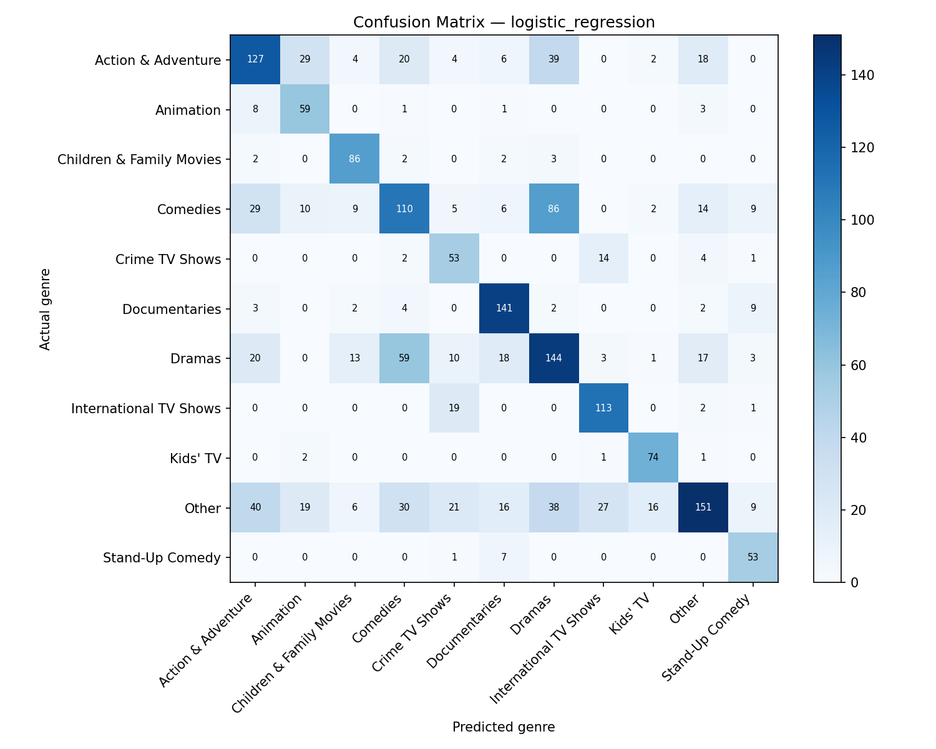
Figure 1. Logistic Regression confusion matrix.
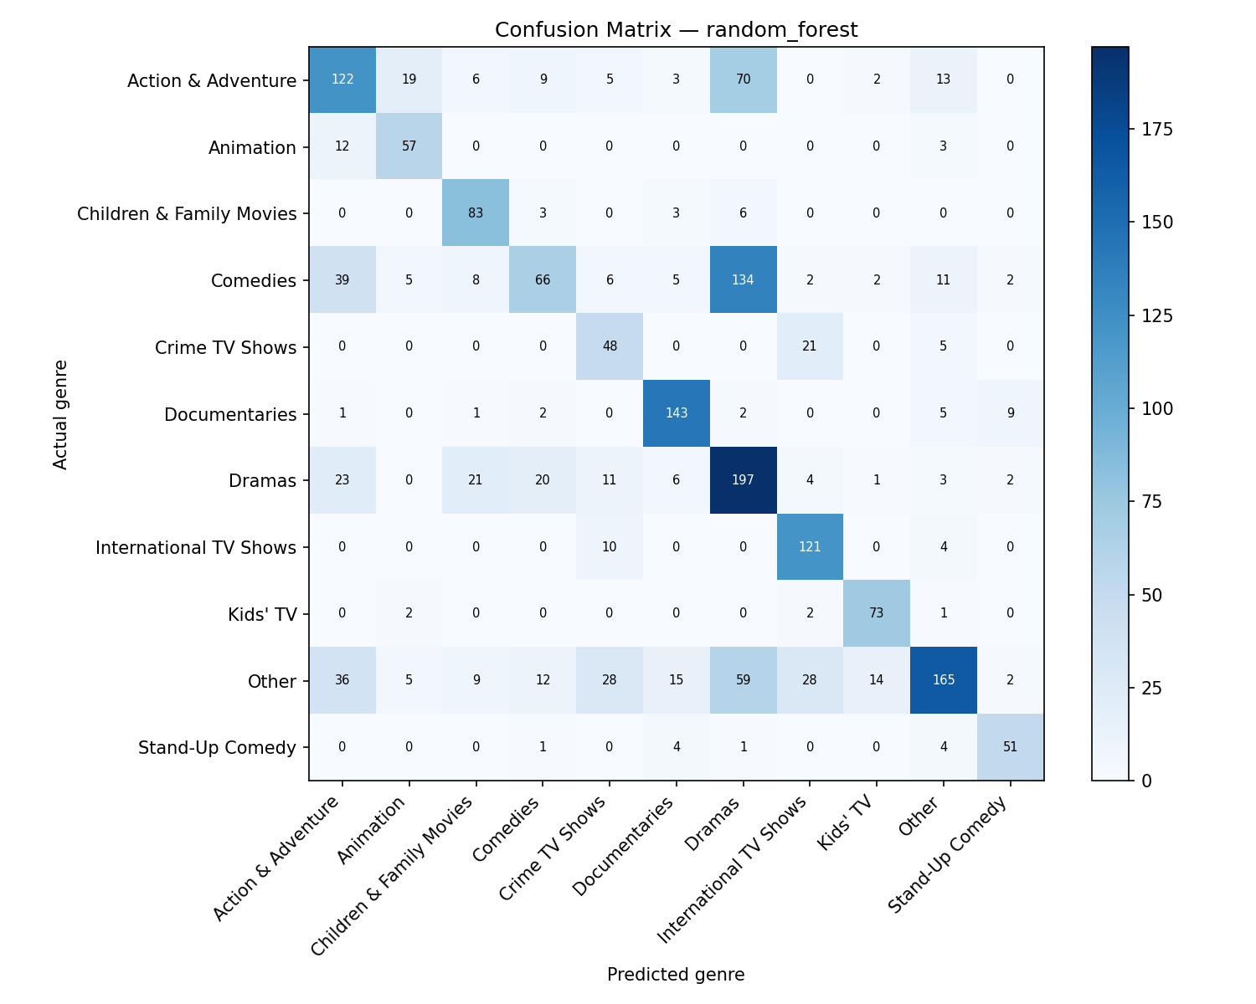
Figure 2. Random Forest confusion matrix.
Both models most often confuse Dramas / Comedies / Action & Adventure with each other and with "Other" — expected, since these genres share a lot of vocabulary in the description text and often co-occur as secondary genres for the same title.

6. Explainability
Feature importance is read directly from each model's built-in attributes: feature_importances_ for Random Forest, and coef_ for Logistic Regression.
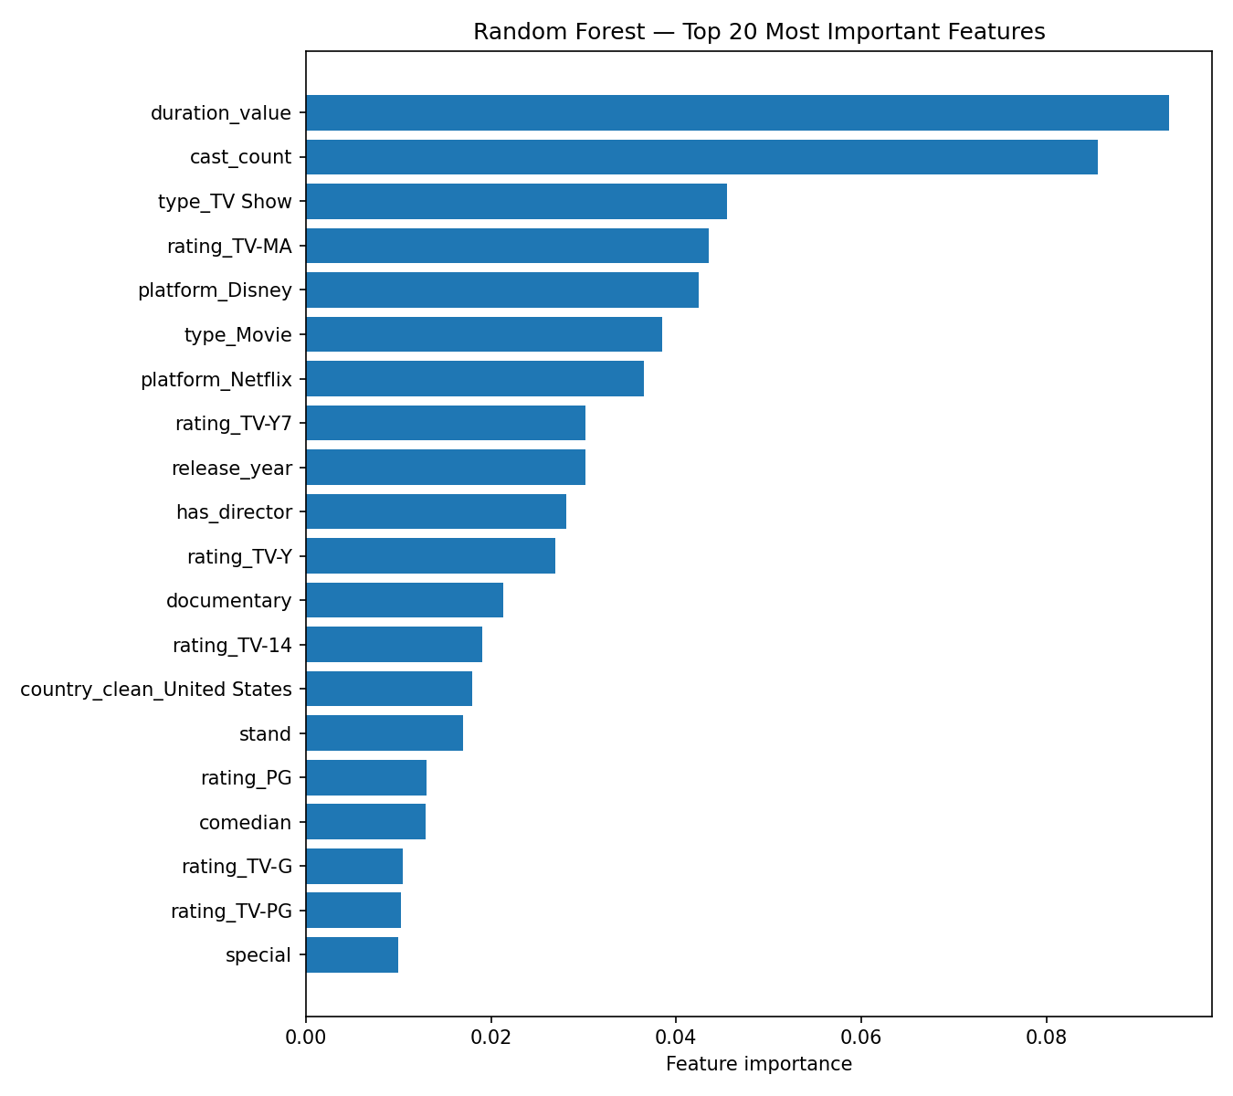
Figure 3. Random Forest — top 20 features by importance.
cast_count and duration_value are the strongest overall signals for Random Forest, followed by platform and content rating — sensible, since movies vs. TV shows and kids' content vs. mature content correlate strongly with genre.
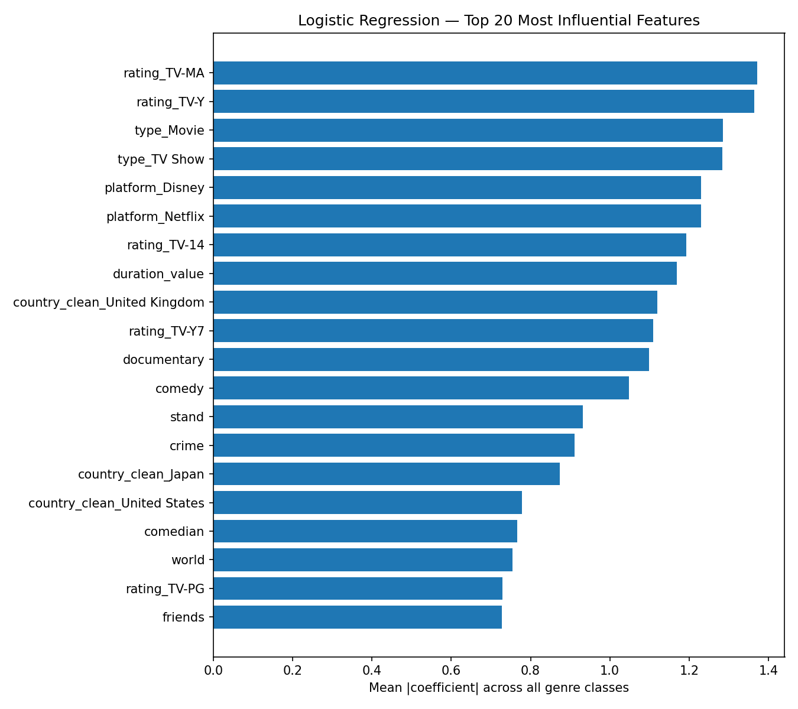
Figure 4. Logistic Regression — top 20 features by mean |coefficient| across all classes.
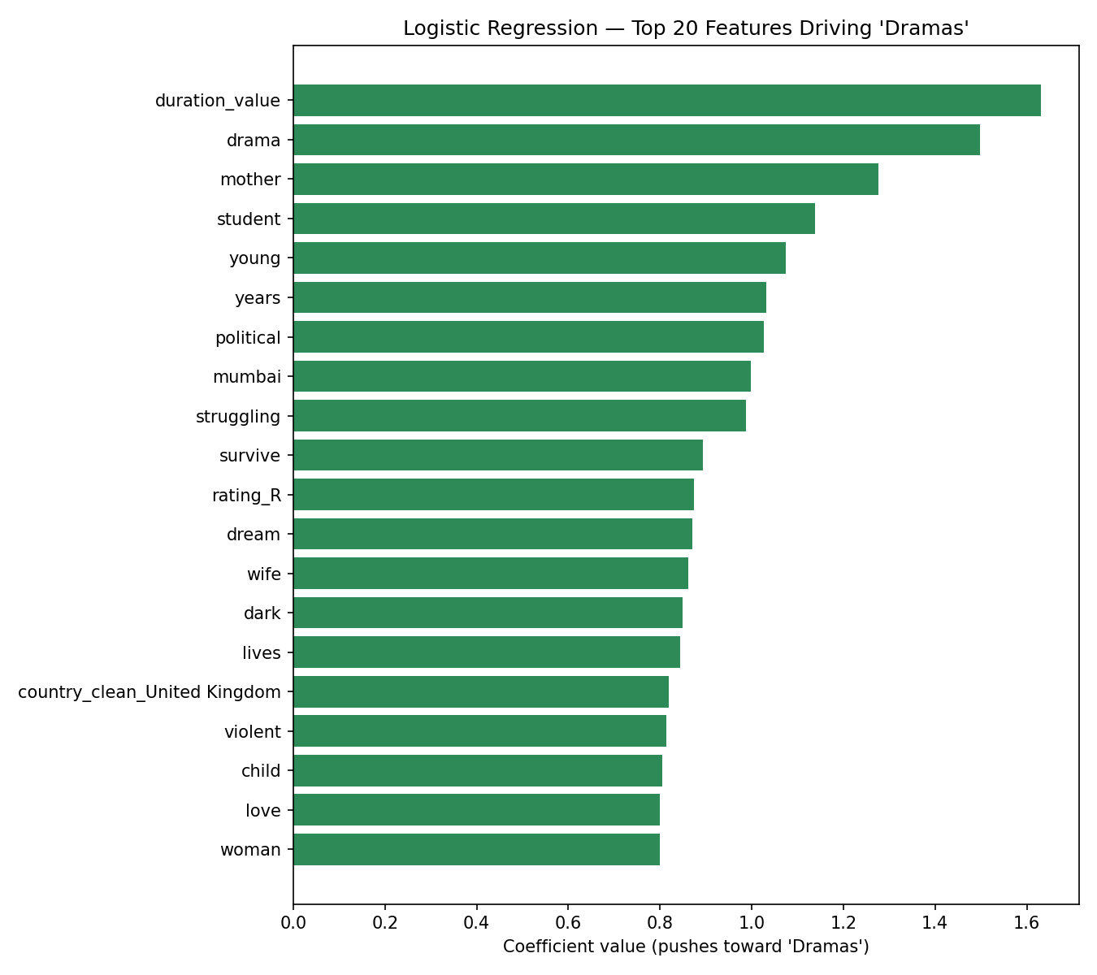
Figure 5. Words that push Logistic Regression most strongly toward predicting "Dramas" — e.g. "drama", "mother", "student", "struggling", "survive", consistent with how drama synopses are typically written.

7. Recommendation
Random Forest is the recommended model. It has a slightly higher accuracy (0.603 vs 0.595) and macro F1 (0.653 vs 0.644), meaning it does a bit better across the smaller, less frequent genres too, not just the largest ones. It is also robust to the mix of one-hot, numeric, and TF-IDF features without needing careful scaling.
Logistic Regression remains valuable as a baseline: it trains faster, its coefficients give direct interpretability (Figures 4-5), and its accuracy is close enough to Random Forest that it is a reasonable, more transparent alternative when interpretability matters more than the last few points of accuracy.
Main limitation of both models: genre is not fully determined by the metadata used here — many titles could plausibly belong to more than one genre (that's exactly why listed_in is multi-label in the source data), so a meaningful share of "errors" are really just the model picking a different, also-reasonable genre. A natural next step would be to treat this as multi-label classification instead of single-label.

