miChecker build instruction

1. System Requirements

- Operating Systems
Windows 7, Windows 8.1, Windows 10 (Windows 10 is recommended)

- Software
- Eclipse Mars (4.5.x) (Windows 32-bit)
https://www.eclipse.org/downloads/packages/release/mars/2
(RCP and RAP Developers version is recommended)

- Java Runtime Environment (JRE) 7.0 or above (Version 8 is recommended)
In this document, we introduce JRE download sites from AdoptOpenJDK and Oracle reference purposes. Please confirm term of use before start using the JRE.

- JRE from AdopetOpenJDK
  - https://adoptopenjdk.net/releases.html?variant=openjdk8&jvmVariant=openj9

- JRE from Oracle
  - https://www.java.com/en/download/manual.jsp

- Internet Explorer 11.0 or above
Note: Please use 32-bit version (X86 version) of Eclipse and JRE whether your OS is 64-bit or 32-bit.

2 Installation of ACTF Visualization SDK
You can install ACTF Visualization SDK by using Eclipse Update mechanism.
Step 1: Select Help -> Install New Software menu.
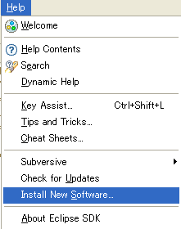

Step 2: Type ACTF update-site URL (http://download.eclipse.org/technology/actf/1.5/update-site) into “Work with:” input box.
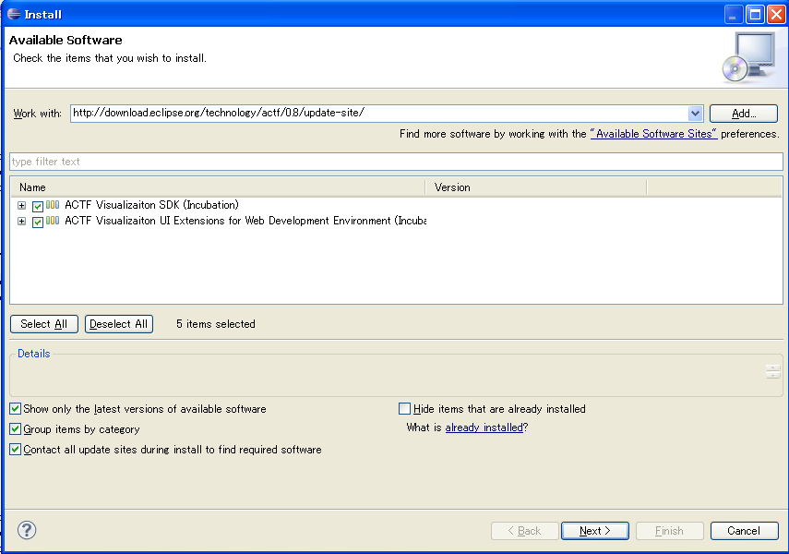
Step 3: Select ACTF Visualization SDK, and press Next button. Then, please follow instruction of the update wizard.

ACTF Visualization SDK includes developer guide (API references, etc.). Please open Eclipse Help from ‘Help’ -> ‘Help Contents’ menu and select ‘Eclipse Visualization SDK Developer Guide’.

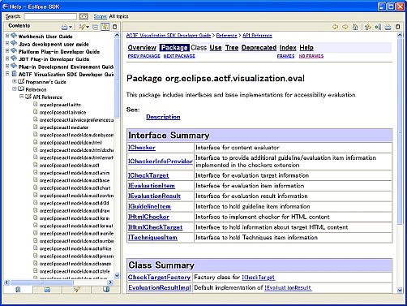

3. Download miChecker source code
1. Download zipped Team Project Set file for miChecker.
http://www.eclipse.org/downloads/download.php?file=/technology/actf/psf/anonymous/miChecker.zip

2. Unzip the downloaded file and import Team Project Set file (miChecker.psf) from Eclipse's 'File' -> 'Import' -> 'Team' -> 'Team Project Set' menu.

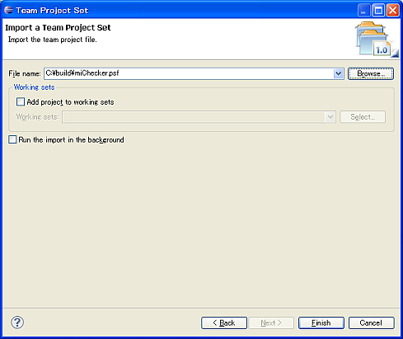

4. Launch miChecker
Select and open “org.eclipse.actf.examples.michecker” project.

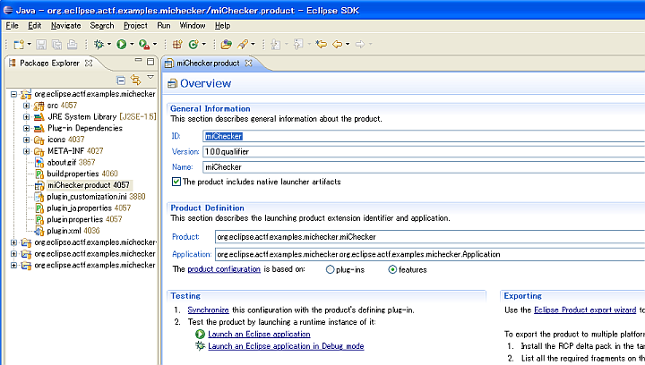

Then, select (double click) miChecker.product file and open it in a product editor. In the editor, select 'Launch an Eclipse Application' under 'Testing' section.

5. Install internationalization packages

By installing internationalization packages from Eclipse Babel project, we can internationalize some portions of miChecker UI.

a. Download appropriate language pack from URL below
（For example, BabelLanguagePack-eclipse-ja_4.5.0.v***.zip for Japanese）
http://download.eclipse.org/technology/babel/babel_language_packs/R0.13.1/mars/mars.php#ja

b. Unzip the zip file and copy two foldes (plugins and features) into your Eclipse’s dropins folder.

c. Restart your Eclipse and then launch miChecker.

6. Build miChecker
Select and open “org.eclipse.actf.examples.michecker” project as in step 4.
Open an export product wizard by selecting 'Eclipse product export wizard' under 'Exporting' section and follow the wizard.
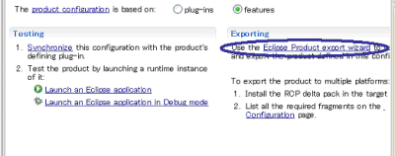
Please turn off all options in “Export Options” section.
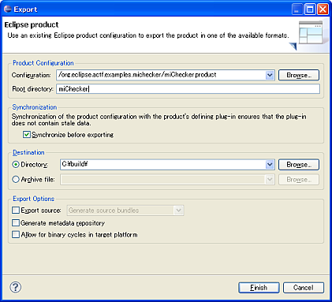

7. Access to ACTF source code
Anyone can access to ACTF CVS repository. Please visit the ACTF Contributors Information page below and get ACTF source code.
http://www.eclipse.org/actf/contributors.php

8. Communication with ACTF team

8.1 Bug report

If you find any issues, please submit a bug report from URL below:
https://bugs.eclipse.org/bugs/enter_bug.cgi?product=ACTF

(Please create your bugzilla account from https://bugs.eclipse.org/bugs/createaccount.cgi )
You can also attach your change as patch file.
Please export your change by using “Team”->”Create Patch” menu, and attach the file to bugzilla entry.
(Please create your bugzilla account from https://bugs.eclipse.org/bugs/createaccount.cgi )

8.2 Questions and feedbacks

If you have any questions or feedbacks about ACTF, please post it to our News Group.

http://www.eclipse.org/forums/index.php/f/136/

You can post your message by using “NEW TOPIC” menu.

8.3 Development discussions

If you want to get more involved into ACTF development discussions, please join the actf-dev Mailing List from URL below.

https://dev.eclipse.org/mailman/listinfo/actf-dev

We are looking forward to working with you!!

