4.(1)AVG of age

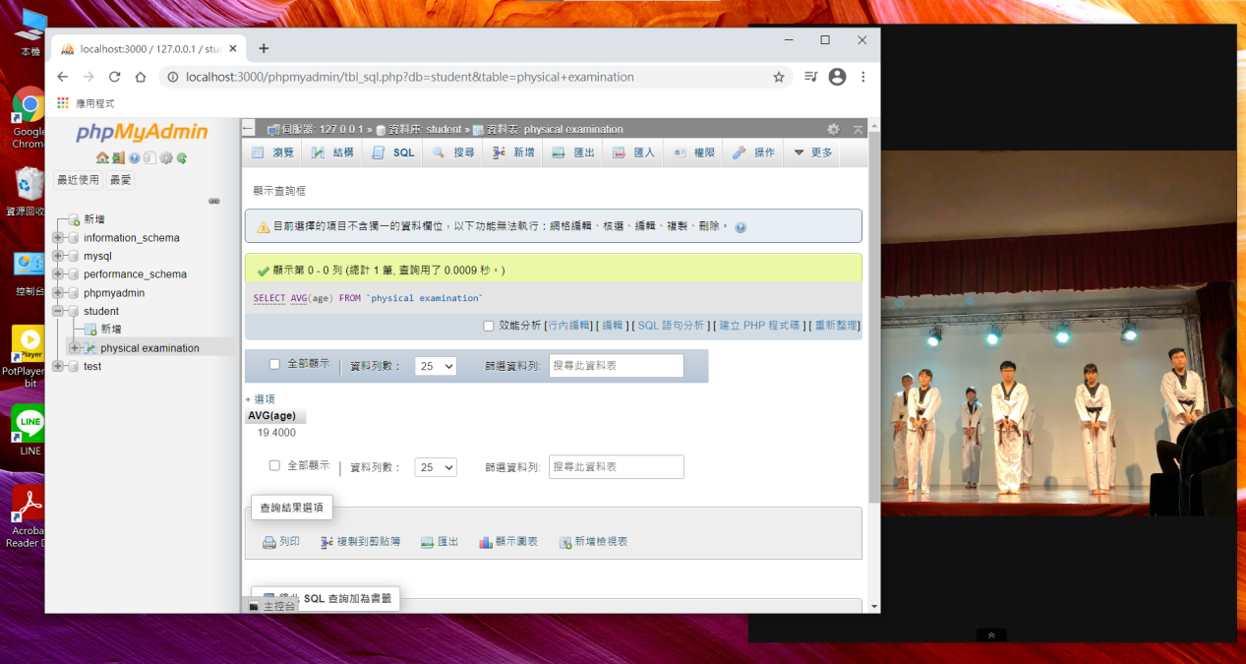

4.(1)SUM of age

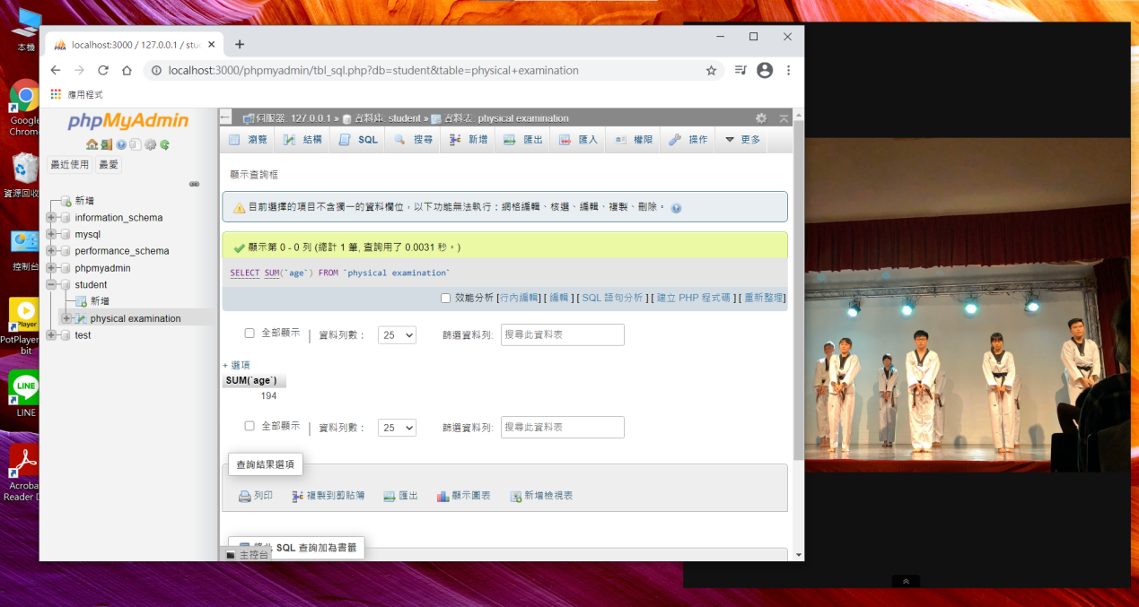

4.(1)COUNT of student number

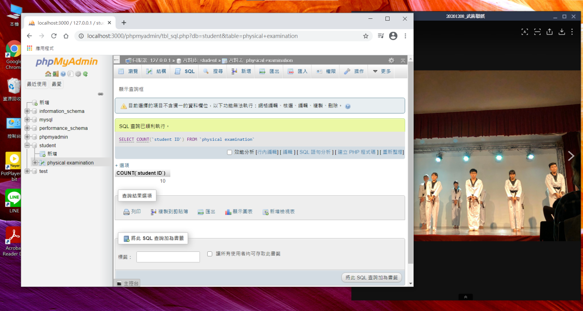

4.(2) The students with poor eye sight

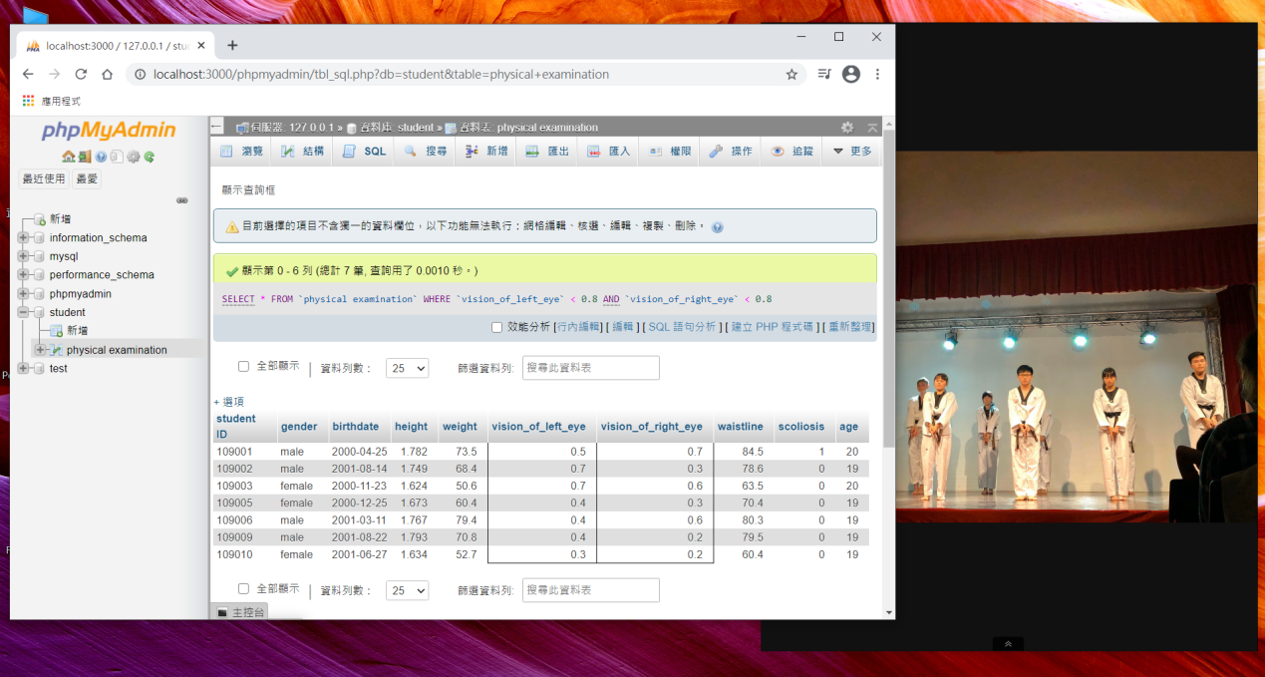

4.(3) The students with unideal BMI values

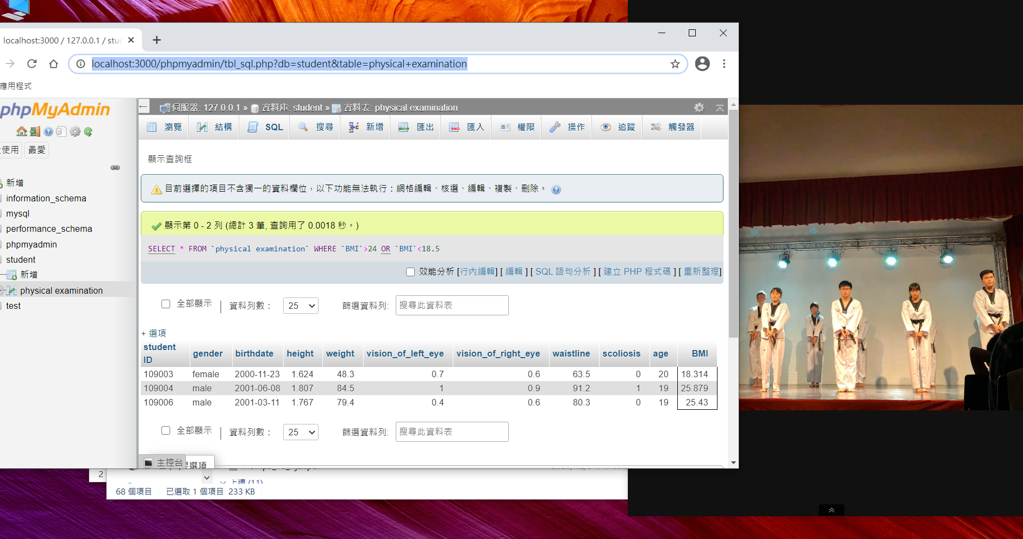

4.(4) The students with unideal waistline

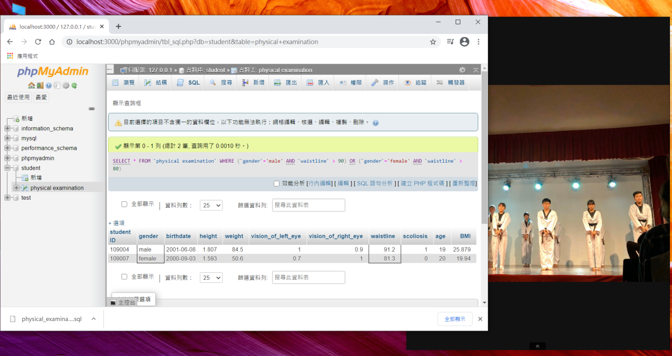

/\*\*\*\*\*\*\*\*\*\*\*\*\*\*\*\*\*\*\*\*\*\*\*\*\*\*\*

4108040040 魯姵妤 第七次作業 12/9

4108040040 PeiYuLuThe seventh Homework 12/9

\*\*\*\*\*\*\*\*\*\*\*\*\*\*\*\*\*\*\*\*\*\*\*\*\*\*\*/