**Journal**

**Title:** (Times New Roman, Font size-24, Bold)

**About Authors:**

* Name: Time New Roman, Font Size-11
* Details: Time New Roman, Font Size-11,Italic

**Abstract**- (Heading: Times New Roman, Font size-10, Bold, Italic;

Content: Times New Roman, Font size-10, Bold)

**Keywords:** (Heading: Times New Roman, Font size-10, Bold, Italic;

Content: Times New Roman, Font size-10, Bold)

**Introduction:** (Heading: Times New Roman, Font size-9, all caps;

Content: Times New Roman, Font size-10)

**Related works:** (Heading: Times New Roman, Font size-9, all caps;

Content: Times New Roman, Font size-10)

**Implementation:** (Heading: Times New Roman, Font size-9, all caps;

Content: Times New Roman, Font size-10)

**Results and Discussions:** (Heading: Times New Roman, Font size-9, all caps;

Content: Times New Roman, Font size-10)

**Conclusion:** (Heading: Times New Roman, Font size-9, all caps;

Content: Times New Roman, Font size-10)

**References:** (Heading: Times New Roman, Font size-9, all caps;

Content: Times New Roman, Font size-10)

**Citations:** The citations should be serial, should match with the content and might be recent. For example [1] after the specific content. These are in Time New Roman, Font Size-10.

**Figures and Table Name:** Times New Roman, Font size-8

* Page Layout: Top, Left, Right: 0.6” , Bottom 0.2” , Orientation : Portrait,

Page Layout- Size- A4, Alignment: Full page Justify, Line Spacing – 1.5

* Page Layout: Page setup-Columns-Two.
* The journal should have a minimum of 5 pages and a maximum of 9 pages.

Preparation of a Formatted Technical Work for an IEEE Power & Energy Society Transactions/Journal Publication

Nagarjuna*1, Akhil\***2**

*1 *M.tech Student, Dept of ECE (Digital electronics and communication systems),*

[*\*\*\*\*\*\*\*\*\*\*\*\*\*@gmail.com*](mailto:*************@gmail.com)

*2 ****************************************************************.*

[*\*\*\*\*\*\*\*\*\*\*\*\*\*\*\*\*\*\*@gmail.com*](mailto:******************@gmail.com) *2*

***Abstract*--Basic guidelines for the preparation of a technical work for an IEEE Power & Energy Society Transactions/Journal Publication are presented. This document is itself an example of the desired layout (inclusive of this abstract) and can be used as a template. It contains information regarding desktop publishing format, type sizes, and typefaces. Style rules are provided that explains how to handle equations, units, figures, tables, abbreviations, and acronyms. Sections are also devoted to the preparation of acknowledgments, references, and authors' biographies. The abstract is limited to 150–200 words and cannot contain equations, figures, tables, or references. It should concisely state what was done, how it was done, principal results, and their significance.**

***Key words*--The author shall provide up to 10 keywords (in alphabetical order) to help identify the major topics of the paper. The thesaurus of IEEE indexing keywords should be referenced prior to selecting the keywords to ensure that the words selected are acceptable. The thesaurus is posted at https://**[**www.ieee.org/**](http://www.ieee.org/) **publications/services/thesaurus-access-page.html.**

1. INTRODUCTION < main headings>

This document is an example of the desired layout for a PES Transactions/Journal paper. It contains information regarding desktop publishing format, type sizes, and typefaces. Style rules are provided that explain how to handle equations, units, figures, tables, abbreviations, and acronyms.

Sections are also devoted to the preparation of acknowledgments, references, and authors’ biographies.

1. *Template < side headings>*

This document may be used as a template for preparing your Transactions/Journal paper. You may type over sections of the document, cut and paste into it, and/or use markup styles.

A secondary section heading is enumerated by a capital letter followed by a period and is flush left above the section. The first letter of each important word is capitalized and the heading is italicized.

A tertiary section heading is enumerated by an arabic numeral followed by a parenthesis. It is indented and is followed by a colon. The first letter of each important word is. quaternary section heading is rarely necessary, but is perfectly acceptable if required. It is enumerated by a lowercase letter followed by a parenthesis. It is indented and is followed by a colon. Only the first letter of the heading is capitalized and the heading is italicized.

TABLE I

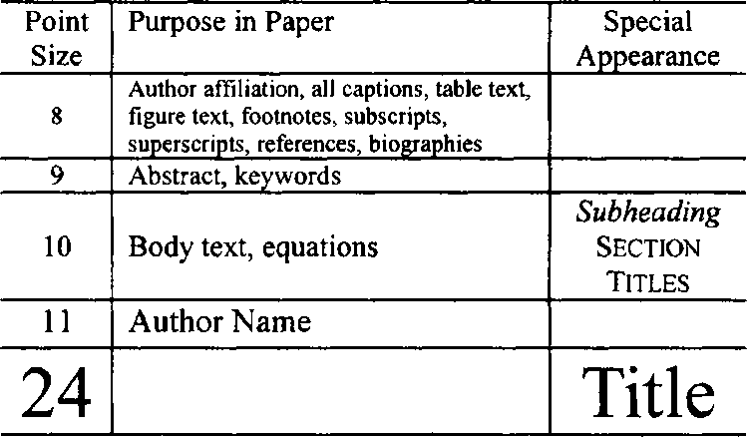 Samples of Times Roman Type Sizes and Styles

Figure captions should be below the figures; table captions should be above the tables. Do not put captions in “text boxes” linked to the figures.

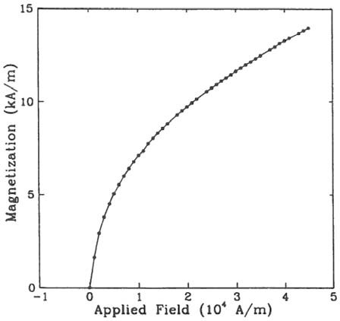

Fig. 1. Magnetization as a function of applied field. (Note that “Fig.” is abbreviated and there is a period after the figure number followed by two spaces.)

V. REFERENCES

[1]Transmission Systems for Communications, 3rd ed., Western Electric Co., Winston-Salem, NC, 1985, pp. 44–60.

[2] Motorola Semiconductor Data Manual, Motorola Semiconductor Products Inc., Phoenix, AZ, 1989.