**EXP NO: 9**

**AIM:** To find the factorial of a given number using 8085 microprocessor.

**ALGORITHM:**  
1)    Load the data into register B  
2)    To start multiplication set D to 01H  
3)    Jump to step 7  
4)   Decrements B to multiply previous number  
5)   Jump to step 3 till value of B>0  
6)  Take memory pointer to next location and store result  
7)    Load E with contents of B and clear accumulator  
8)  Repeatedly add contents of D to accumulator E times  
9) Store accumulator content to D  
10) Go to step 4

**PROGRAM:**  
LDA 2001  
MOV B,A  
MVI C,01H  
MVI E,01H  
LOOP: MOV D,C  
MVI A,00H  
LP: ADD E  
DCR D  
JNZ LP  
MOV E,A  
INR C  
DCR B  
JNZ LOOP  
MOV A,E  
STA 2010  
HLT

**INPUT & OUTPUT**  
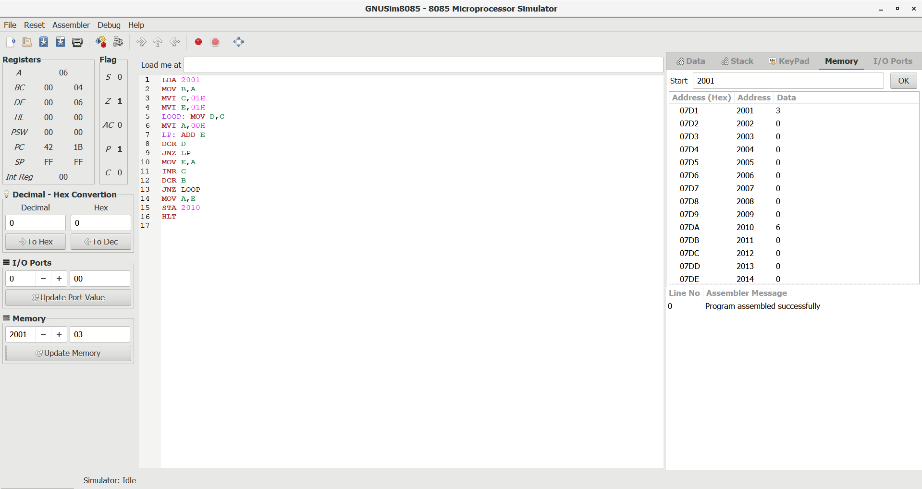  
  
   
  
**RESULT:**Thus the program was executed successfully using 8085 processor simulator